

SZABIST UNIVERSITY

# Bachelor's of Computing Science Department

Research Report

Database Management System Lab By

Syed Hassan Ali

Humza Hussain

Abdullah Shaikh

Mustafa Ahmed Zaidi

Umair Rasheed

# SUBMITTED TO

Miss.Sadia Aziz

## ACKNOWLEDGEMENT

I would like to express my deepest appreciation to all those who provided me the possibility to complete this report. A special thanks goes to my team mate, [Hamza Hussain, Mustafa Ahmed

Zaidi, Umair Rasheed, Abdullah Shaikh], who help me to assemble the parts and gave suggestion about the project “FACTORY ROASTER”. Last but not least, many thanks go to the head of the project, [Hamza Hussain] whose have invested his full effort in guiding the team in

achieving the goal. I have to appreciate the guidance given by other Teachers especially Ma’am

Marjan Sikandar, as well as the seniors especially in our project presentation that has improved our presentation skills thanks to their comment and advices.

## ABSTRACT

Project Details:

* The factory has various floors.
* Each floor runs a specific number of shifts per day (1 or 2 or 3) with their start and end time specified. Each floor also specifies whether there are any weekly holidays (weekends)
* The factory has many employees. Each employee has a designation/rank.
* Each floor has various stations and for each station, the number of employees of each rank required to run the station are specified.
* When a roster is created (for a week or fortnight or a month), employee assignments are made to different shifts and at different stations belonging to various floors.
* On the basis of assignments, the actual attendance and hours of each employee would be tracked by storing the sign in and sign out timings of employees.
* Employee leaves and also maintained in the system. In addition, public and company holidays are also maintained.

Expected Volume:

* + 3 floors * 2 shifts * 10 stations per floor * avg. 5 employees per station * 250 days (365 excluding weekends &amp; public holidays) * 1 years of assignments = 75,000

assignments in the roster.

* + Sign in and out times of each employee for each day

## TABLE OF CONTENTS

ACKNOWLEDGEMENT .................................................................................

ABSTRACT ......................................................................................................

TABLE OF CONTENTS ...................................................................................

1. INTRODUCTION ...........................................................................................
   1. MOTIVATION FOR THE PROJECT ............................................................
2. BACKGROUND................................................................................................
3. WORKING OF PROJECT..................................................................................
   1. QUERIES..........................................................................
   2. ERD..........................................................................
4. SCOPE OF PROJECT..........................................................................
5. CONCLUSION..........................................................................
6. REFERENCES..........................................................................

### 1 INTRODUCTION

This intention behind creating this database was to ease storing and retrieving of data associated with employees working in a factory. We have employed many techniques to resolve and normalize our database design as much as it was possible, so we can have a functioning and robust database when once implemented.

#### 1.1 MOTIVATION FOR THE PROJECT

The factor that motivated us a lot was fluent db design and use of tools such as Microsoft Visio to make a robust database. We wanted to experiment with different tools for creating data definition language and modelling relationships in our database. No opportunity was better than this project to get hands on experience on all of the various tools out there.

### 2 BACKGROUND

The factory has various floors. Each floor runs a specific number of shifts per day (1 or 2 or 3) with their start and end time specified. Each floor also specifies whether there are any weekly holidays (weekends) factory has many employees. Each employee has a designation/rank. Each floor has various stations and for each station, the number of employees of each rank required to run the station are specified. The employees are stationed such that their rank increases with the number of stations.

### 3 WORKING OF PROJECT

When a roster is created (for a week or fortnight or a month), employee assignments are made to different shifts and at different stations belonging to various floors. On the basis of assignments, the actual attendance and hours of each employee would be tracked by storing the sign in and sign out timings of employees. Employee leaves and also maintained in the system. In addition, public and company holidays are also maintained. Project can work efficiently with two shifts a day at most, one starting from 06:00:00 to 12:00:00 and second shift starting from 12:00:00 to 18:00:00. Project makes use of many data types especially those of date time and time.

#### 3.1 QUERIES

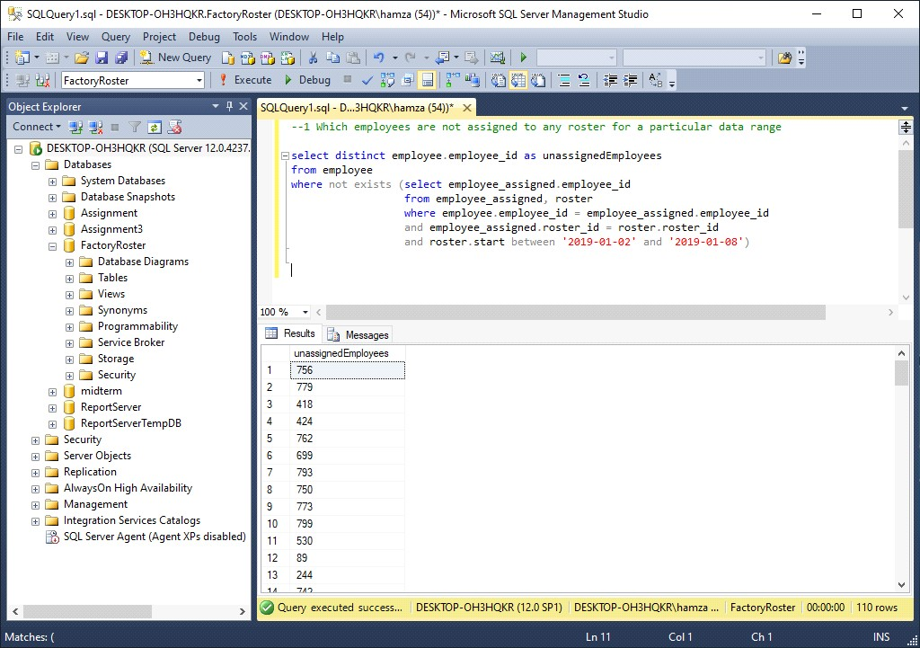

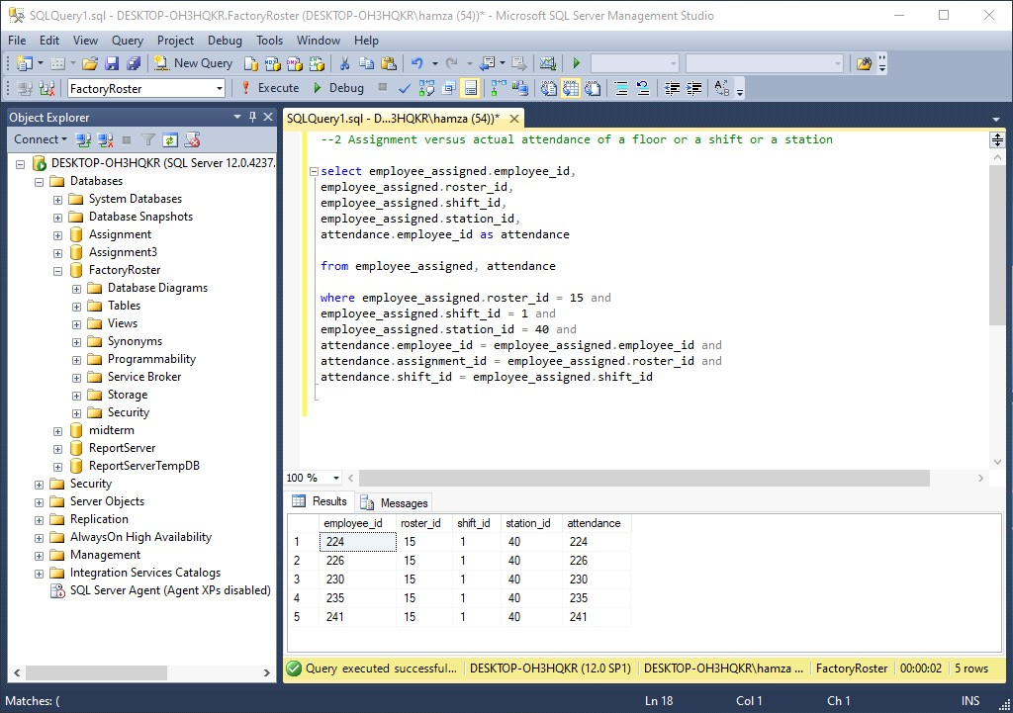

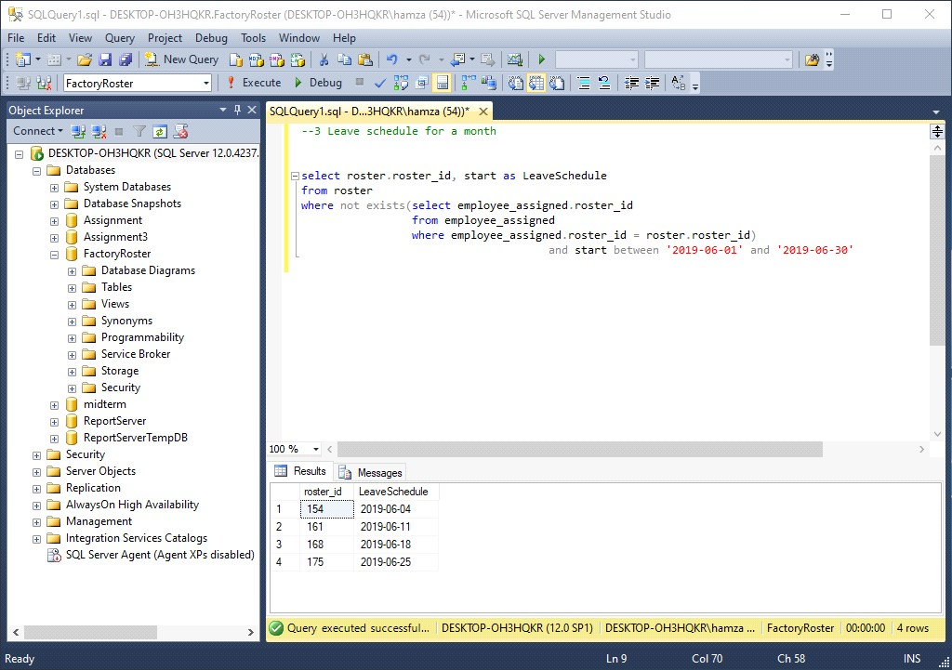

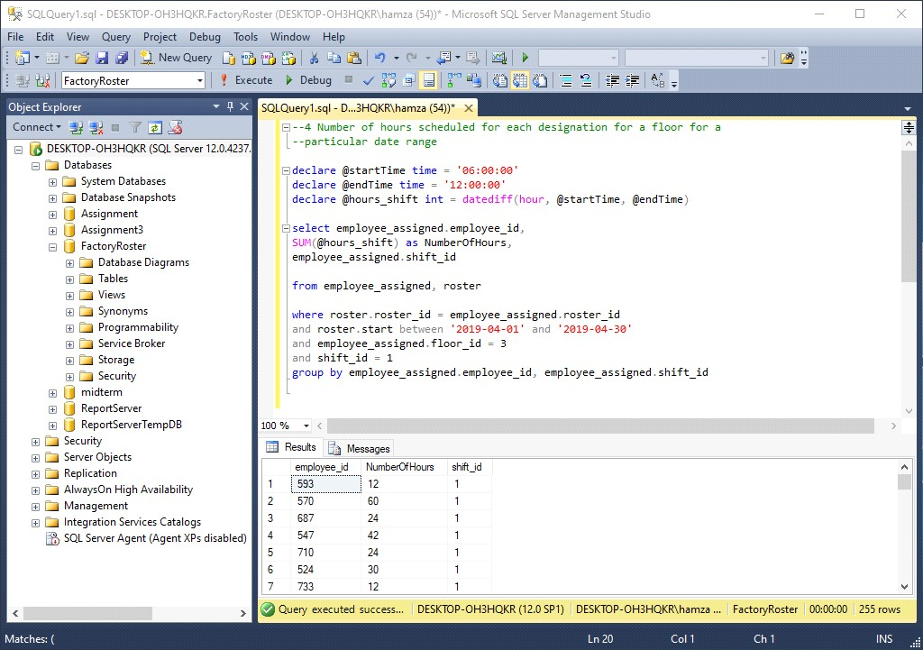

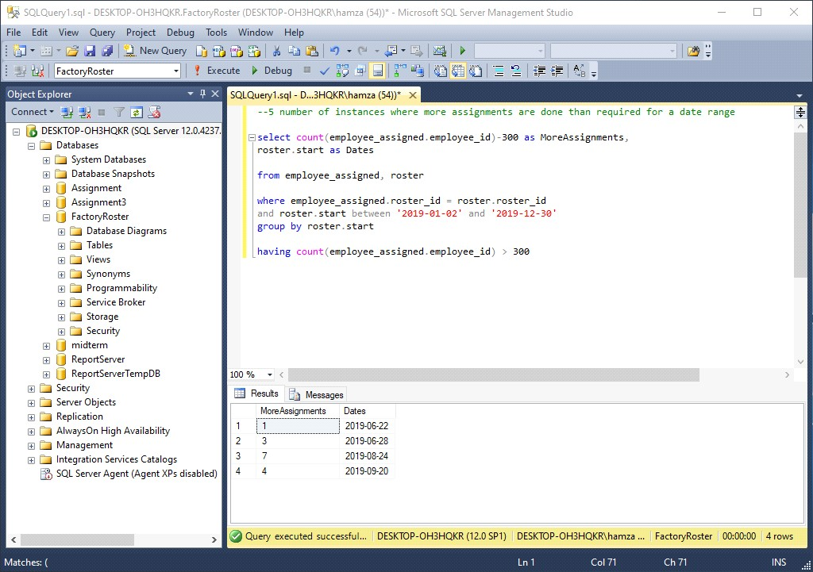

#### 3.2 ERD

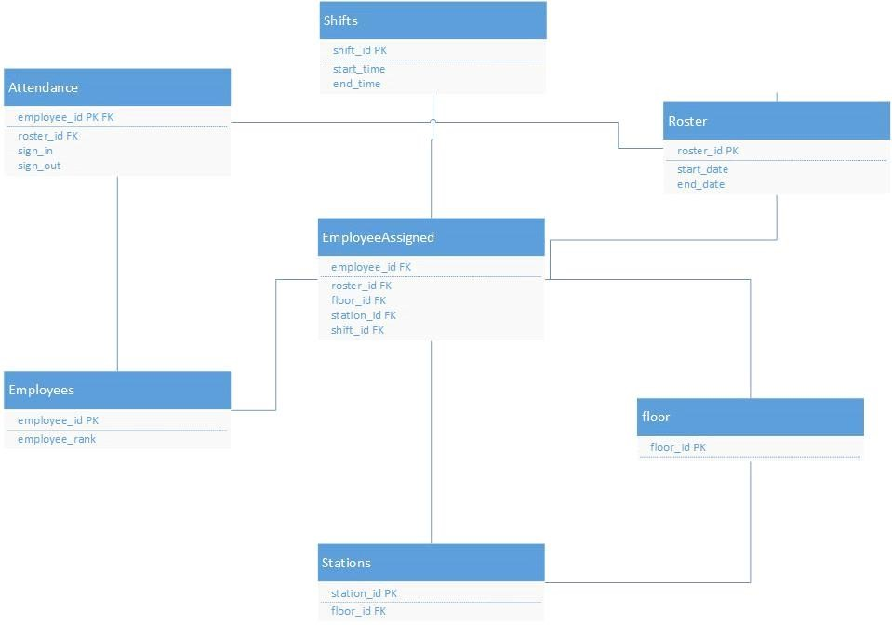

### 3 SCOPE OF PROJECT

This project can work very efficiently and will satisfy most of the industry standards. It can be tweaked a little to fit to any factory’s specific requirements and will prove very optimal in organizing and maintaining factory’s data.

### 4 CONCLUSION

I will conclude this project with the various tools, things, and techniques we learned along the way. Before starting out we didn’t know much about transact-SQL, data base design tools and advanced normalization but after completing the project successfully we do have a good grasp and understanding of the fundamentals behind these things.

### 6 REFERENCES

<https://www.geeksforgeeks.org/sql-join-set-1-inner-left-right-and-full-joins/>

[https://docs.microsoft.com/en-us/sql/t-sql/functions/date-and-time-data-types-and-functions-trans act-sql?view=sql-server-ver15](https://docs.microsoft.com/en-us/sql/t-sql/functions/date-and-time-data-types-and-functions-transact-sql?view=sql-server-ver15)

<https://www.mssqltips.com/sqlservertip/1145/date-and-time-conversions-using-sql-server/><https://www.w3schools.com/sql/>