SITE-SAFE: A DIGITAL ECOSYSTEM FOR AUTONOMOUS CONSTRUCTION SAFETY



Muhammad Hamza
Hamza Hussain
Hanan Saeed

Supervised By
Muhammad Yousif

Submitted for the partial fulfillment of the BS Computer Science degree
to the Faculty of Engineering & Computing

DEPARTMENT OF COMPUTER SCIENCE
NATIONAL UNIVERSITY OF MODERN LANGUAGES, LAHORE
April, 2026
ABSTRACT
Construction sites in Pakistan account for a disproportionate share of occupational fatalities, yet the monitoring tools available to most site managers remain limited to manual inspections and passive CCTV footage. When accidents occur, there is rarely any verifiable record of safety compliance, leaving firms exposed to legal liability and preventing data-driven improvement. This report presents Site-Safe, a camera-first safety compliance and workforce monitoring platform that combines real-time computer vision, QR-based worker identification, a cloud backend, and a cross-platform mobile application to deliver continuous, autonomous hazard detection and auditable compliance documentation on active construction sites. The system operates through four coordinated modules. A multi-model vision pipeline processes live camera feeds using YOLOv11 for PPE detection across 11 equipment classes, YOLOv11-Pose for camera-based fall detection through body keypoint analysis with a three-second persistence filter, and a dedicated fire and smoke detection model with zone-aware suppression that avoids false alarms during scheduled hot-work activities such as welding and cutting. QR codes printed on worker helmets establish individual identity without requiring any electronics on the worker. A lightweight IoT Smart Vest provides supplementary GPS tracking and an SOS panic button for emergency situations outside camera coverage. A Django REST backend aggregates all incoming data, applies threshold-based alert logic and challenging work permit checks, and pushes real-time updates to both a React web dashboard and a React Native mobile application. The mobile app enables supervisors and administrators to receive push notifications, acknowledge incidents, view live worker status, and configure alert settings remotely. Beyond safety compliance, Site-Safe introduces workforce activity monitoring and accountability capabilities. Because each worker is identified by QR code, every PPE violation, zone transition, and inactivity period is logged against a specific individual. The system generates automated compliance reports with per-worker violation histories, zone presence timelines, and shift attendance records, creating an auditable safety record that did not previously exist on most Pakistani construction sites.

TABLE OF CONTENTS
Chapter 1: Introduction 1
1.1 Background 1
1.2 Problem Statement 2
1.3 Objectives 2
1.4 Scope 3
1.5 Significance 3
1.6 SDG Alignment 4
1.7 Report Organization 4
Chapter 2: Review of Existing Systems 4
2.1 Overview 5
2.2 Traditional CCTV Surveillance 5
2.3 Consumer Smartwatches and Fitness Wearables 5
2.4 Specialized Industrial Wearables 6
2.5 AI-Based PPE Detection Research 6
2.6 Integrated IoT Safety Platforms 7
2.7 Mobile Safety Applications 7
2.8 Comparative Summary 7
Chapter 3: Proposed System Design 8
3.1 System Overview 8
3.2 Architecture 10
3.2.1 Three-Tier Model 10
3.2.2 Data Flow 10
3.3 Module 1: Vision Intelligence 11
3.3.1 PPE Detection 11
3.3.2 Geofencing and Intrusion Detection 11
3.3.3 Vehicle Proximity Warning 12
3.3.4 Workforce Activity Monitoring 12
3.3.5 Fall Detection 14
3.3.6 Fire and Smoke Detection 14
3.4 Module 2: QR Identification and Supplementary IoT 13
3.4.1 QR-Based Worker Identification 13
3.4.2 Supplementary Smart Vest 14
3.4.3 LoRa Communication Layer 15
3.5 Module 3: Digital Twin Command Center 15
3.5.1 Backend 15
3.5.2 Frontend Dashboard 16
3.6 Module 4: Mobile Application 16
3.6.1 App Architecture 16
3.6.2 Core Features 16
3.6.3 Admin Alert Management 16
3.7 Admin Module 18
3.8 Limitations 18
Chapter 4: Hardware and Software Implementation 18
4.1 Development Environment 18
4.2 QR Identification and Smart Vest Design 19
4.3 PPE Detection Module 21
4.3.1 Dataset and Classes 21
4.3.2 Training Configuration 21
4.3.3 Model Performance 22
4.3.4 Fall Detection via Pose Estimation 23
4.3.5 Fire and Smoke Detection with Zone-Aware Suppression 24
4.4 Backend Implementation 23
4.5 Frontend Dashboard Implementation 25
4.6 Mobile Application Implementation 26
4.6.1 Technology Stack 26
4.6.2 Core Screens 26
4.6.3 Push Notification Pipeline 27
4.7 Workforce Activity Monitoring Implementation 27
4.8 Data Flow 28
4.9 SOS and Location Alert Flow 29
4.10 End-to-End Alert Flow 29
4.11 Integration Testing 30
4.12 Project Timeline 31
References 32
LIST OF FIGURES
Figure 3.1: Use Case Diagram 14
Figure 3.2: System Context Diagram 15
Figure 3.3: Three-Tier System Architecture 16
Figure 3.4: Level-1 Data Flow Diagram 19
Figure 3.5: Workforce Activity Monitoring Pipeline 21
Figure 3.6: Smart Vest Block Diagram (Reduced Configuration) 24
Figure 3.7: SOS and Location Alert Flowchart 26
Figure 3.8: Mobile Application Screen Wireframes 24
Figure 4.1: Smart Vest Hardware Implementation 31
Figure 4.2: YOLOv11 Training Pipeline 36
Figure 4.3: Entity Relationship Diagram 40
Figure 4.4: Workforce Activity Monitoring Pipeline 37
Figure 4.5: System Data Flow Diagram 44
Figure 4.6: SOS and Location Alert Flowchart 45
Figure 4.7: End-to-End Alert Processing Flow 46

LIST OF TABLES
Table 2.1: Comparison of Existing Systems Against Site-Safe 11
Table 3.1: Worker Identification and Supplementary Sensing 20
Table 3.2: Mobile App Feature Matrix 24
Table 4.1: Development Environment Summary 27
Table 4.2: Smart Vest Component Specifications 28
Table 4.3: ESP32 Pin Allocation 28
Table 4.4: Dataset Split Configuration 29
Table 4.5: YOLOv11 Training Hyperparameters 30
Table 4.6: Per-Class Detection Performance 30
Table 4.7: Core API Endpoints 33
Table 4.8: Database Schema Summary 34
Table 4.9: Mobile App Technology Stack 35
Table 4.10: Integration Test Scenarios and Results 41

LIST OF ABBREVIATIONS
API Application Programming Interface
DFD Data Flow Diagram
ERD Entity Relationship Diagram
FCM Firebase Cloud Messaging
FPS Frames Per Second
GPS Global Positioning System
IoT Internet of Things
JWT JSON Web Token
LoRaWAN Long Range Wide Area Network
mAP Mean Average Precision
MQTT Message Queuing Telemetry Transport
NMS Non-Maximum Suppression
ONNX Open Neural Network Exchange
PPE Personal Protective Equipment
REST Representational State Transfer
RTSP Real-Time Streaming Protocol
SDG Sustainable Development Goal
YOLO You Only Look Once

Chapter 1
Introduction

1.1 Background
Walk onto any large construction site in Pakistan and the scene is immediately familiar: dozens of workers moving across multiple floors, heavy machinery operating within close proximity to pedestrians, narrow scaffolding above unprotected drops, and perhaps one or two safety officers trying to keep track of it all. The practical impossibility of this arrangement is obvious to anyone who sees it. What is less obvious is how consistently this arrangement fails, and how predictably those failures result in death or serious injury.
According to the International Labour Organization, construction accounts for roughly 30 to 40 percent of all fatal occupational accidents worldwide despite employing only about 7 percent of the global workforce [1]. In Pakistan, the Labour Force Survey 2020–21 recorded over 3.6 million workers employed in the construction sector, most of whom receive little to no formal safety training and work on sites where PPE compliance is enforced, if at all, through periodic manual checks [8]. Projects funded through initiatives like CPEC have dramatically increased the volume and scale of construction activity without a corresponding investment in safety infrastructure.
The standard approach to construction safety, assigning a safety officer to patrol a site, look for violations, and respond to incidents, has not meaningfully changed in decades. It is a model that was workable when sites were small and crews were compact. On modern sites spanning multiple floors and hundreds of metres, it is not. A single officer physically cannot watch fifty workers simultaneously. Environmental hazards like heat buildup or gas accumulation in excavation zones are invisible to the naked eye. And when something does go wrong, the response is almost always reactive: help arrives after the fall, after the gas exposure, after the equipment strike.
The technological tools to do better than this now exist. Deep learning models can process camera feeds and detect safety violations in real time. Simple printed QR codes can identify individual workers without requiring any electronics on the person. Cross-platform mobile frameworks allow supervisors to receive alerts and monitor workers from anywhere on the site through their phones. When combined, these technologies can create something that has never existed on most Pakistani construction sites: an automated, per-worker compliance record that documents who was wearing what, where, and when. What has been missing is a system that brings all of these capabilities together into a coherent, practical package designed for actual deployment. That is what Site-Safe is intended to be.

1.2 Problem Statement
The specific problem this project addresses is the absence of a continuous, autonomous safety compliance system for construction sites—one that can detect hazards in real time, identify which worker is involved, alert relevant personnel immediately through both web and mobile interfaces, and maintain a verifiable, per-worker record of safety compliance without depending entirely on human attention.
The deficiencies in the current state of the art can be summarized under four headings. First, incomplete coverage: no human supervisor can simultaneously monitor all workers across a multi-floor or multi-zone construction site, and violations happen most frequently precisely when no one is watching. Second, purely reactive response: existing systems only register an incident after it has occurred, with no mechanism for detecting warning signs of an impending accident. Third, no individual accountability: even when a violation is observed, there is no automated way to identify which worker was involved or track repeat offenders across shifts. Fourth, no integrated compliance record: current sites maintain no systematic digital record of PPE compliance, worker activity patterns, or incident history tied to specific individuals, preventing any data-driven safety improvement or auditable compliance documentation over time.

1.3 Objectives
The work carried out under this project is guided by the following specific objectives:
Design and train a real-time PPE detection model based on YOLOv11 that can identify safety equipment across 11 detection classes and flag violations under the varied lighting and environmental conditions of an actual construction site.
Implement a QR-based worker identification system where each worker is assigned a unique QR code printed on their helmet, readable by the same cameras running PPE detection, enabling per-worker violation tracking and compliance accountability.
Implement a virtual geofencing system that allows administrators to mark danger zones on a site map, with automatic alerts when workers enter restricted areas, linked to individual worker identity through QR identification.
Develop a web-based command center that aggregates all incoming data and presents it to site managers through an interactive real-time dashboard.
Build a cross-platform mobile application (React Native) that enables safety officers to receive push notifications for critical alerts, view live worker status, and allows administrators to configure and manage alert settings remotely.
Implement workforce activity monitoring through the vision pipeline, tracking worker presence across zones, detecting extended breaks and inactivity periods, and generating per-worker activity logs.
Establish automated incident logging and PDF compliance report generation that documents per-worker violation histories, zone attendance records, and shift summaries, providing construction firms with auditable safety documentation.
Build a lightweight IoT Smart Vest with GPS tracking and an SOS panic button to provide supplementary worker location data and emergency alerts in areas outside camera coverage.
Integrate camera-based fall detection using YOLOv11-Pose, which analyses body keypoints frame-by-frame to identify when a worker has collapsed. A three-second persistence filter reduces false positives from bending or crouching, enabling the system to detect genuine falls and dispatch critical alerts without any wearable sensors.
Deploy a fire and smoke detection model running alongside the PPE pipeline on IP camera feeds. The module includes zone-aware suppression logic so that scheduled hot-work activities such as welding or cutting do not trigger false alarms, while genuine uncontrolled fires still generate critical alerts.

1.4 Scope
This project covers the full-stack design and prototype implementation of Site-Safe. The primary focus is software: the YOLOv11-based vision pipeline with integrated QR code reader for worker identification, a pose-estimation module for camera-based fall detection, a fire and smoke detection model with zone-aware suppression, the Django REST backend, the React web dashboard, and a cross-platform React Native mobile application for real-time alert management and worker monitoring. A lightweight IoT Smart Vest with GPS and SOS capability provides supplementary coverage for areas outside camera range.
The software scope explicitly includes workforce activity monitoring, compliance documentation, fall detection, and fire safety features. The vision pipeline is extended to track worker zone presence over time, detect breaks and inactivity, and produce queryable activity logs tied to individual worker identities via QR codes. A parallel pose-estimation model monitors body keypoints to detect falls, while a dedicated fire and smoke model provides early fire warning with intelligent suppression during scheduled hot-work activities. The mobile application provides both supervisors and administrators with remote access to alerts, worker status, and system configuration. Automated compliance reports document per-worker violation histories and attendance records.
What is explicitly outside the current scope: the system is designed for outdoor civil construction sites, not enclosed factory floors, mining tunnels, or marine environments. QR code identification requires workers to be within readable range of a camera, so the system works best at key checkpoints and designated work zones rather than across every square metre of a large open site.

1.5 Significance
The relevance of this project goes beyond the technical. Every year, preventable accidents on Pakistani construction sites cut short lives that did not need to be lost. Site-Safe is built on the premise that the technology to prevent many of those accidents already exists; the gap is in deployment, integration, and accessibility.
From a regulatory and commercial standpoint, construction firms face growing legal liability for workplace accidents. A system that automatically logs compliance evidence and generates auditable reports has direct economic value to any firm operating at scale. The mobile application component ensures that safety monitoring is not confined to a control room but extends to every supervisor carrying a smartphone on site.

1.6 SDG Alignment
SDG 3 (Good Health and Well-being): Real-time PPE violation detection, automatic fall detection through pose estimation, and fire and smoke monitoring enable timely intervention before unsafe behaviour leads to injury, directly reducing preventable construction fatalities.
SDG 8 (Decent Work and Economic Growth): Systematically safer working conditions for construction workers, regardless of skill level or contract status, align directly with the decent work agenda. The activity monitoring features add transparency to working hour tracking.
SDG 9 (Industry, Innovation, and Infrastructure): The application of AI, IoT, and mobile technology to modernize construction safety infrastructure is a concrete demonstration of the technology-driven industrial innovation SDG 9 envisions.
SDG 11 (Sustainable Cities and Communities): The fire and smoke detection module with zone-aware suppression contributes to safer urban construction environments, reducing the risk of uncontrolled fires on building sites that endanger both workers and surrounding communities.

1.7 Report Organization
Chapter 2 reviews existing systems and relevant published research, identifying the specific gap that Site-Safe fills. Chapter 3 describes the full system design: architecture, module specifications including QR-based identification, fall detection, fire and smoke detection with zone-aware suppression, HR monitoring, mobile application design, and data flow. Chapter 4 covers what has actually been implemented: model training, QR identification pipeline, backend and frontend development, mobile app prototype, workforce monitoring features, and integration test results.

Chapter 2
Review of Existing Systems

2.1 Overview
Before settling on the approach described in Chapter 3, we surveyed the landscape of existing solutions, both commercial products and academic research, that attempt to address construction site safety. What this review revealed, fairly consistently, is that every available solution addresses one piece of the problem while leaving the others untouched. The following sections document what we found.

2.2 Traditional CCTV Surveillance
CCTV remains the most widely used safety monitoring technology in construction environments and has been for decades. Networks of fixed cameras feed into digital recorders accessible via monitor banks or remote connections. In their original form, these systems are entirely passive: they record what happens without analyzing it.
The fundamental limitation of CCTV is not the camera; it is the human being required to watch it. Sustained attention is cognitively demanding, and studies have shown that human observers miss a significant proportion of critical events when monitoring multiple camera feeds over extended periods. Sacks et al. (2022) noted that maintaining basic coverage on a medium-sized construction site required approximately 4.2 full-time monitoring personnel, a cost few firms can justify [6]. Beyond the attention problem, CCTV gives no information about what a camera cannot see: gas concentration in a trench, temperature inside a poorly ventilated enclosure, or how long a worker has been stationary in a hazardous zone. Its role in Site-Safe is not eliminated but redefined: cameras become the front end of an AI inference and activity tracking pipeline, not passive recording devices.

2.3 Consumer Smartwatches and Fitness Wearables
The Apple Watch and comparable devices from Samsung and Garmin have introduced genuinely impressive sensing capabilities into a wrist-worn form factor. Modern smartwatches can detect falls, monitor heart rate, flag irregular cardiac rhythms, and trigger emergency SOS calls. For personal health use, they are excellent.
For construction deployment, they fall short in several practical ways. Bluetooth and Wi-Fi connectivity work well in homes and offices; on a large outdoor site, they become unreliable as soon as a worker moves beyond router range. Battery life of 24 to 48 hours sounds adequate but does not account for continuous sensor polling under the computational load of real-time monitoring. And devices designed for a commuter are not designed to survive the concrete dust, water exposure, and physical impact of a construction shift. At a retail cost of PKR 60,000 to 150,000 per unit, equipping an entire site crew is financially impractical for the vast majority of Pakistani construction firms.

2.4 Specialized Industrial Wearables
SmartCap Technologies produces a helmet-mounted EEG sensor designed to detect driver fatigue by reading brainwave activity. Within its target application, long-haul trucking and heavy vehicle operation in mining, it performs well. Outside that target, it offers nothing: no PPE compliance detection, no environmental gas sensing, no fall detection capability, and no location or health data beyond fatigue state.
This pattern, high accuracy within a narrow domain and zero applicability outside it, repeats across the industrial wearables category. Proximity warning tags alert workers when machinery approaches but do not monitor heat stress. Heat stress monitors do not detect falls. Fall detectors do not watch for gas. The fragmentation reflects the fact that no existing product was designed with the multi-hazard complexity of a construction site as its primary design constraint.

2.5 AI-Based PPE Detection Research
The academic literature on computer vision applied to construction safety is substantial and growing. The YOLO family of models, first introduced by Redmon and Farhadi in 2016 [1] and developed through successive iterations to YOLOv11, has become the standard architectural choice for real-time PPE detection. The single-pass inference design achieves detection speeds and accuracy levels that are genuinely usable in operational contexts.
Published results are encouraging. Nath, Behzadan, and Paal (2020) achieved 91.2% accuracy on a construction site dataset using YOLOv3 [5]. More recent work with YOLOv8 and YOLOv11 pushes mean Average Precision above 92% on standard benchmarks. The problem is that virtually none of this research moves beyond the dataset. The overwhelming majority of published PPE detection studies evaluate their models on pre-recorded video in controlled settings. They do not deploy on actual edge hardware, integrate with sensor networks, generate real-time alerts, or connect to mobile applications. They are demonstrations of what is possible in software, not implementations of what works in the field.

2.6 Integrated IoT Safety Platforms
A small number of research prototypes and commercial platforms have attempted to combine sensing modalities for construction safety. Ramli et al. (2020) published a notable IoT-based smart helmet prototype incorporating temperature, gas, and accelerometer sensors with GSM communication [4]. It was a meaningful step, but GSM communication provides only short-range connectivity, the prototype lacks any vision component, and there is no centralized data platform.
Commercial platforms like Pillar Technologies and Triax Technologies offer mesh-networked environmental sensor nodes and BLE worker tags for large construction sites. They provide real data and real utility. They also, notably, do not include computer vision, do not offer long-range communication for large open sites, and are priced for large Western construction enterprises rather than the Pakistani market.

2.7 Mobile Safety Applications
A growing category of construction safety tools focuses on mobile applications. Apps like iAuditor (now SafetyCulture) and Safesite provide digital checklists, incident reporting forms, and basic alert notifications. These tools digitize the paperwork side of safety management and make compliance documentation more convenient.
However, they remain fundamentally manual: a human must observe a violation, open the app, and log it. They do not detect hazards autonomously, do not integrate with IoT sensors or cameras, and do not provide real-time monitoring of worker vitals or location. They are essentially digital clipboards. Site-Safe takes the mobile component further: the mobile app is not just a reporting tool but a real-time monitoring interface connected to an autonomous detection backend, receiving push alerts the instant a hazard is detected and enabling administrators to configure the entire alert system remotely.

2.8 Comparative Summary
Table 2.1: Comparison of Existing Systems/Devices Against Site-Safe
System/Device | Year | Vision (AI) | Worker ID / IoT | Long-Range | Mobile App | Dashboard | Primary Limitation
Traditional CCTV | N/A | No | No | No | No | No | Passive, no analytics
Apple/Samsung Watch | 2023 | No | Partial | No | Yes | No | Short range, expensive
SmartCap (Mining) | 2019 | No | EEG only | No | No | No | Single-purpose
YOLO Research | 2024 | Yes | No | No | No | No | Software-only, no deploy
Pillar Technologies | 2022 | No | Yes | BLE | Partial | Partial | No vision, enterprise price
SafetyCulture App | 2023 | No | No | N/A | Yes | No | Manual, no detection
Ramli et al. | 2020 | No | Yes | GSM | No | No | No vision, no platform
Site-Safe (ours) | 2026 | Yes | QR + GPS | LoRaWAN | Yes | Yes | Prototype; QR range limited
The table above makes the gap plain. No existing system, commercial or academic, combines computer vision-based PPE detection with QR-based individual worker identification, workforce activity monitoring, automated compliance documentation, a centralized web dashboard, and a mobile application for real-time alerts and administration. Site-Safe is designed to be that system.

Chapter 3
Proposed System Design

3.1 System Overview
Site-Safe is structured around three distinct layers that work together: edge devices on the construction site that capture and process visual data, a network layer that moves that data reliably from site to server, and an application layer that stores, processes, displays information through a web dashboard, and pushes critical alerts to a mobile application. The design deliberately separates these concerns so that individual components can be upgraded or replaced without requiring changes to the whole system.
On the site itself, the primary edge devices are AI cameras running YOLOv11 inference for both PPE detection and QR-based worker identification. Each worker wears a helmet with a unique printed QR code, which the same camera reads to establish identity without requiring any electronics on the person. A lightweight Smart Vest with GPS and SOS capability provides supplementary tracking in areas outside camera coverage. Everything converges at the backend server, which processes incoming data, evaluates alert thresholds, generates compliance records, and pushes updates to both the web dashboard and the mobile app in real time.

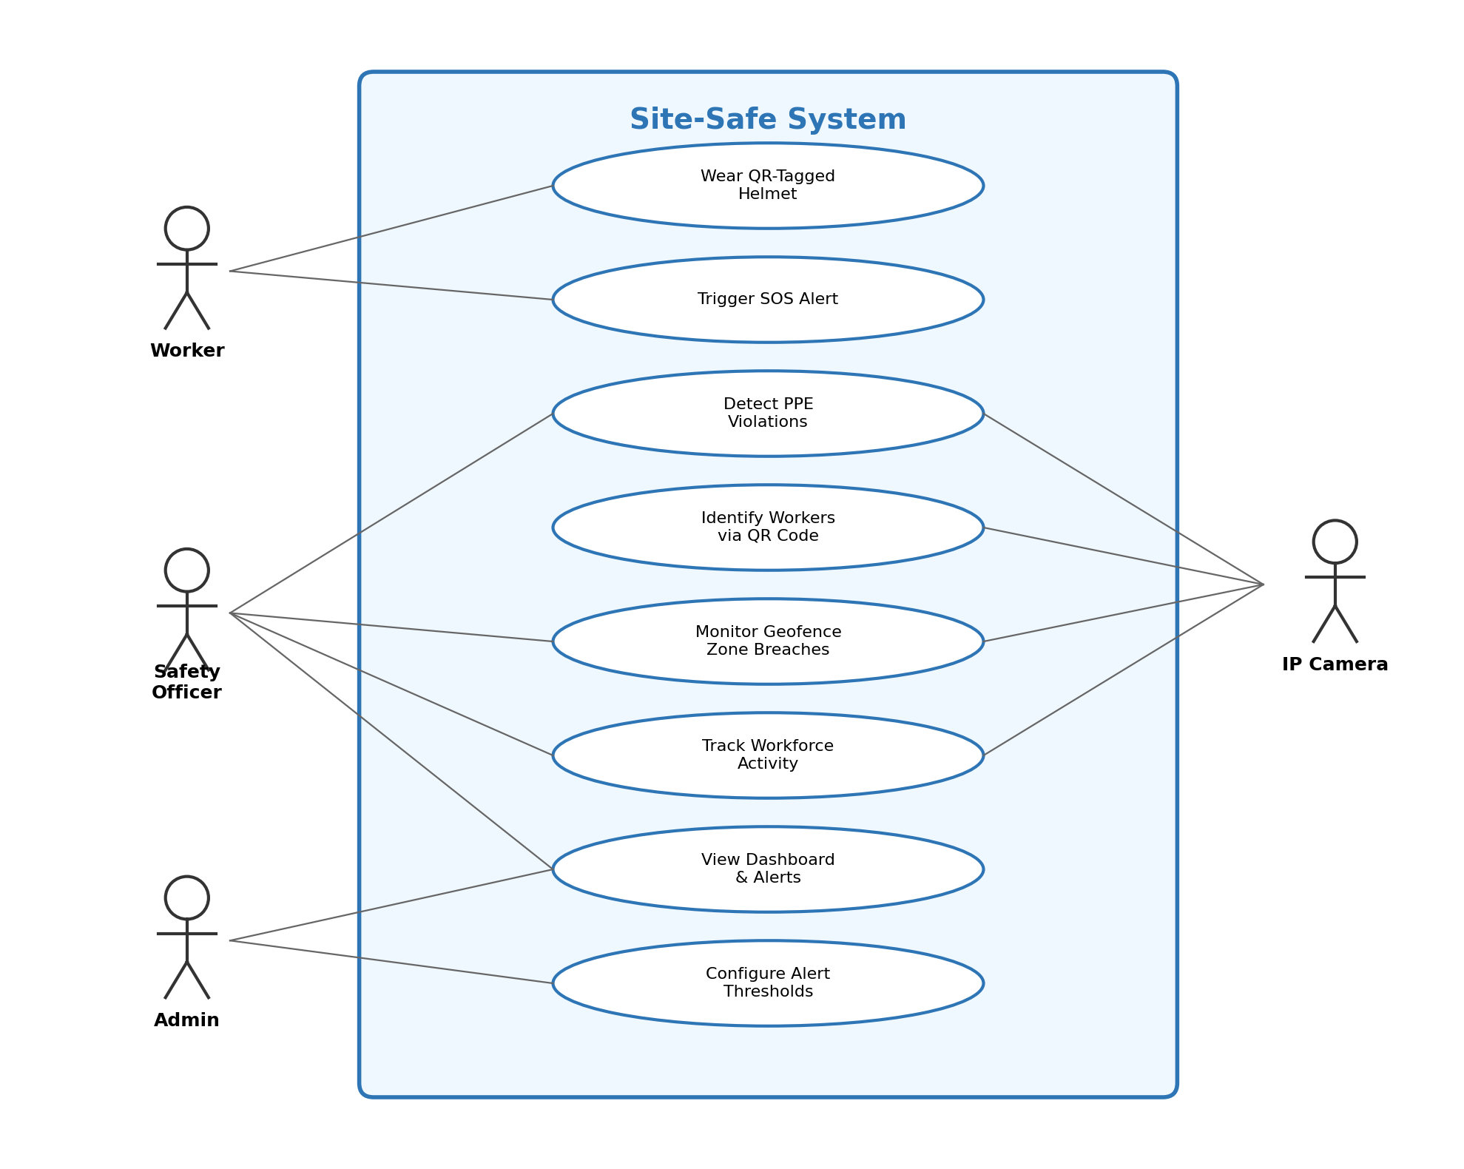Figure 3.1: Use Case Diagram
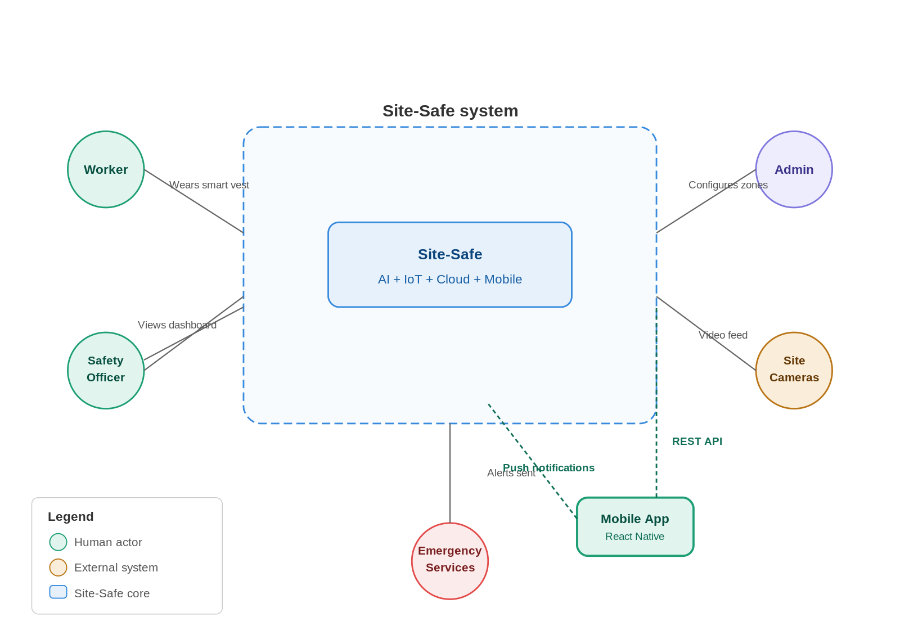
Figure 3.2: System Context Diagram

3.3 Architecture
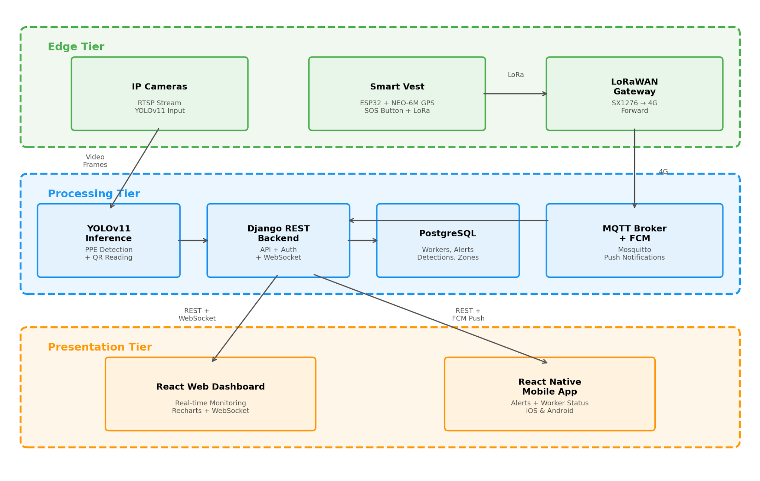Figure 3.3: Three-Tier System Architecture

3.2.1 Three-Tier Model
Tier 1 (Edge): IP cameras paired with Raspberry Pi 5 or Jetson Nano compute units run a multi-model inference pipeline locally. The primary YOLOv11 model handles PPE detection and QR code reading on every frame. A YOLOv11-Pose model runs on every third frame for fall detection through body keypoint analysis. A fire and smoke detection model runs on every fifth frame with zone-aware suppression logic. Together, these three models push violation alerts, fall events, fire detections, and worker identification data to the backend. The same pipeline powers the workforce activity monitoring module, tracking worker presence and movement patterns across designated zones. A lightweight ESP32-based Smart Vest provides supplementary GPS location and SOS alerts via LoRa.
Tier 2 (Network): Camera alerts and QR identification data are sent directly over HTTP to the backend API. For the supplementary Smart Vest, a LoRaWAN gateway forwards GPS and SOS data via MQTT. An MQTT broker (Mosquitto) handles the publish-subscribe routing for IoT messages.
Tier 3 (Application): A Django REST backend processes all incoming data, applies business rules (threshold comparisons, geofence polygon checks, activity tracking logic), and persists results to PostgreSQL. Real-time updates are pushed to the React.js web dashboard via Django Channels WebSockets, and critical alerts are forwarded to the React Native mobile app through Firebase Cloud Messaging push notifications.

3.2.2 Data Flow
1. Camera captures live video → YOLOv11 on edge device detects PPE violations and reads QR codes per-frame → Violations are tagged with worker identity from QR → JSON alert payloads sent via HTTP POST to backend API → Backend stores event with worker ID, generates compliance record, and pushes to dashboard via WebSocket and to mobile app via FCM.
2. Smart Vest GPS module samples location at configured intervals → Data transmitted via LoRa to gateway → Gateway publishes to MQTT broker → Backend subscriber consumes and processes → SOS button press or location anomaly generates alert → Dashboard and mobile app updated simultaneously. 3. Camera frame captured → YOLOv11-Pose analyses body keypoints (every 3rd frame) → Fall detected if collapsed posture persists 3+ seconds → CRITICAL alert dispatched. 4. Camera frame captured → Fire/smoke model runs (every 5th frame) → Detection checked against zone hot work permits → Suppressed if permit active and flame not growing, otherwise CRITICAL alert dispatched.
3. Admin interacts with dashboard or mobile app → Uploads floor plans, draws Red Zone polygons, configures alert thresholds → System stores zone geometry and settings → Vision module checks real-time worker positions against active zones.

3.3 Module 1: Vision Intelligence

3.3.1 PPE Detection
The vision module uses a YOLOv11-M model to continuously inspect camera frames for 11 detection classes covering helmets, high-visibility vests, safety harnesses, gloves, goggles, and their absence states. Frames are captured at 15 to 30 fps from IP cameras over RTSP streams. Each frame is resized to 640×640, normalized, and passed through the ONNX-exported model running on the edge device. Detections below a confidence threshold of 0.5 are discarded. Simultaneously, OpenCV’s QRCodeDetector scans each frame for QR codes on worker helmets, linking any detected person to their registered identity. Any frame containing a worker without required PPE triggers a violation event logged with worker identity (from QR), timestamp, camera ID, zone, and frame screenshot—creating an auditable per-worker compliance record.

3.3.2 Geofencing and Intrusion Detection
Administrators define Red Zones by drawing polygon boundaries directly on the 2D site map in the dashboard. These polygon coordinates are stored in the database and loaded by the vision module at startup. During runtime, detected worker positions are checked against active zone polygons using a point-in-polygon algorithm. Any detected incursion triggers an immediate alert with audio and visual notification on the dashboard and a push notification to the safety officer through the mobile app.
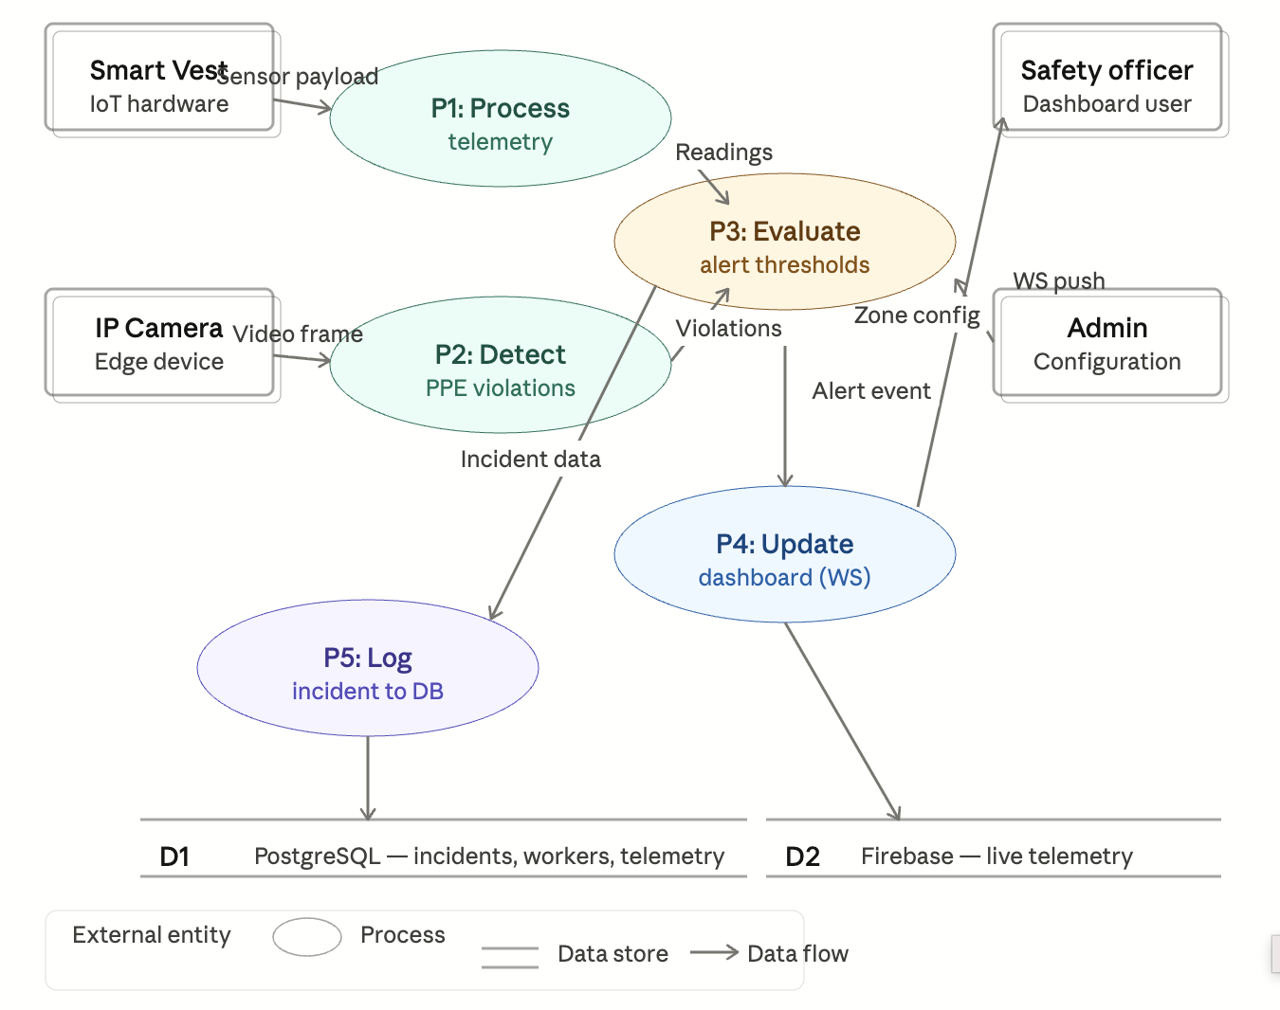

Figure 3.4: Level-1 Data Flow Diagram

3.3.3 Vehicle Proximity Warning
A parallel detection class identifies heavy construction vehicles: cranes, dump trucks, forklifts, bulldozers. When a vehicle bounding box and a person bounding box appear within a defined proximity threshold, a proximity warning is generated for that camera zone. This catches the blind-spot hazard that accounts for a meaningful proportion of construction vehicle accidents.

3.3.4 Workforce Activity Monitoring
Beyond safety compliance, the vision pipeline is extended to serve as a workforce activity monitoring layer. Using the same YOLOv11 person detection output, the system tracks three key metrics. Activity tracking logs when each detected worker enters and exits designated work zones, producing timestamped records of zone presence duration. Break detection identifies workers who remain stationary beyond a configurable threshold (default: 15 minutes) or who leave their assigned zone for extended periods, flagging these as break events. Inactivity monitoring raises an alert when a worker shows no detectable movement for a prolonged duration, which may indicate injury, distress, or a safety concern requiring immediate investigation.
All activity data is stored in PostgreSQL with worker ID, zone ID, and timestamp fields, making it queryable by date range, worker, or zone. This data feeds into both the web dashboard (where it appears as activity charts and zone utilization heat maps) and the mobile app (where supervisors can check any worker’s current status and recent activity history).

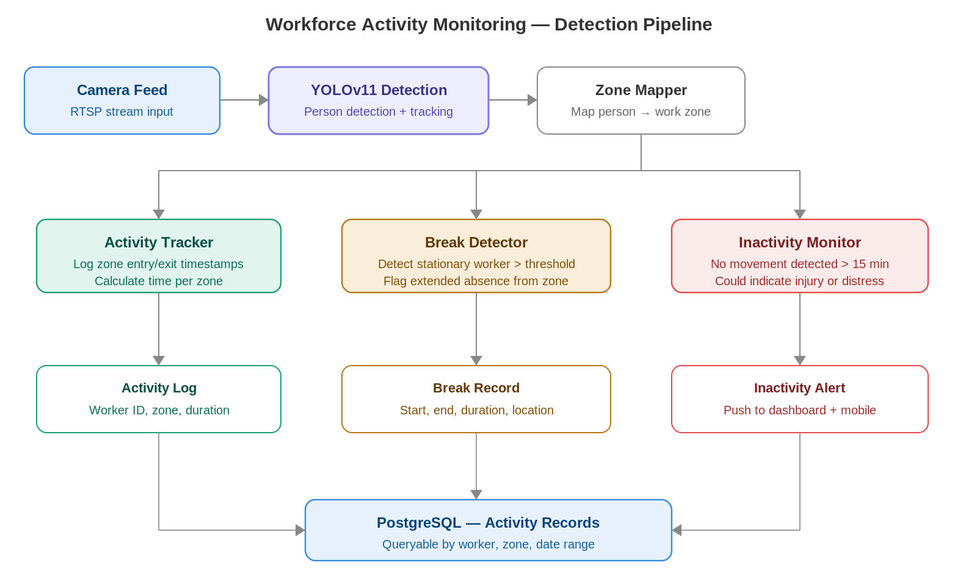
Figure 3.5: Workforce Activity Monitoring Pipeline

3.3.5 Fall Detection
A second inference model, YOLOv11-Pose (6.4M parameters), runs alongside the PPE detector on every third frame to conserve compute. The pose model outputs 17 body keypoints per detected person: nose, eyes, ears, shoulders, elbows, wrists, hips, knees, and ankles. Fall detection relies on two geometric signals derived from these keypoints. First, the system measures the ratio of a person’s horizontal span to their vertical span; a standing person is taller than wide, while a fallen person is wider than tall. Second, it checks whether the hip keypoints have dropped to or below knee level, indicating the torso has collapsed.
To reduce false positives from workers crouching, bending to pick up materials, or sitting during breaks, a three-second persistence filter is applied. A fall event is only raised if the collapsed posture persists for at least three consecutive seconds. This filters out the brief postural changes that are normal on a construction site. When a genuine fall is confirmed, the system generates a CRITICAL alert with the detection confidence score, duration, and a bounding box snapshot of the frame, dispatched instantly through WebSocket and FCM push notifications.

3.3.6 Fire and Smoke Detection
A dedicated fire and smoke detection model runs on every fifth frame from the same IP camera feeds. The model is a YOLO variant fine-tuned on construction-environment fire and smoke datasets, outputting two classes: fire and smoke. Each detection includes a bounding box, confidence score, and estimated region area in pixels.
A key challenge on construction sites is distinguishing between controlled fire activities (welding, cutting, grinding) and genuine uncontrolled fires. Site-Safe addresses this through zone-aware suppression. Each zone in the system can be tagged with permitted activities such as welding or hot work. Additionally, safety officers can issue time-bound hot work permits through the dashboard, specifying a zone, start time, and end time. When the fire model detects flame or smoke in a zone with an active hot work permit, the alert is either suppressed entirely or downgraded to LOW severity and logged without triggering a push notification.
A secondary heuristic tracks whether the detected fire region is growing across consecutive frames. A welding torch produces a small, steady flame that does not expand, while an uncontrolled fire grows over time. If the bounding box area increases by more than 50 percent over a rolling window of 30 frames, the system treats it as a genuine fire regardless of any active hot work permit, escalating the alert to CRITICAL with full push notification dispatch.

3.4 Module 2: QR Identification and Supplementary IoT

3.4.1 QR-Based Worker Identification
The primary method of identifying individual workers on site is through QR codes printed on their helmets. During registration, the admin assigns each worker a unique QR code generated by the system. The QR is printed as a weatherproof sticker and attached to the top or side of the worker’s helmet, visible to overhead and angled cameras. OpenCV’s built-in QRCodeDetector runs on each frame alongside YOLOv11, decoding any visible QR and mapping it to the worker’s database record. This approach requires no electronics on the worker, costs virtually nothing per unit, and survives the dust, water, and impact conditions of a construction site. The trade-off is that QR readability depends on camera distance and angle, so the system works best at designated checkpoints and work zones where cameras are positioned within 5–10 metres.
Table 3.1: Worker Identification and Supplementary Sensing
Component | Model | Function | Interface | Sample Rate
GPS | NEO-6M | Latitude, longitude | UART | 1 Hz
Panic Button | Tactile Switch | Manual SOS | GPIO Interrupt | Event-driven
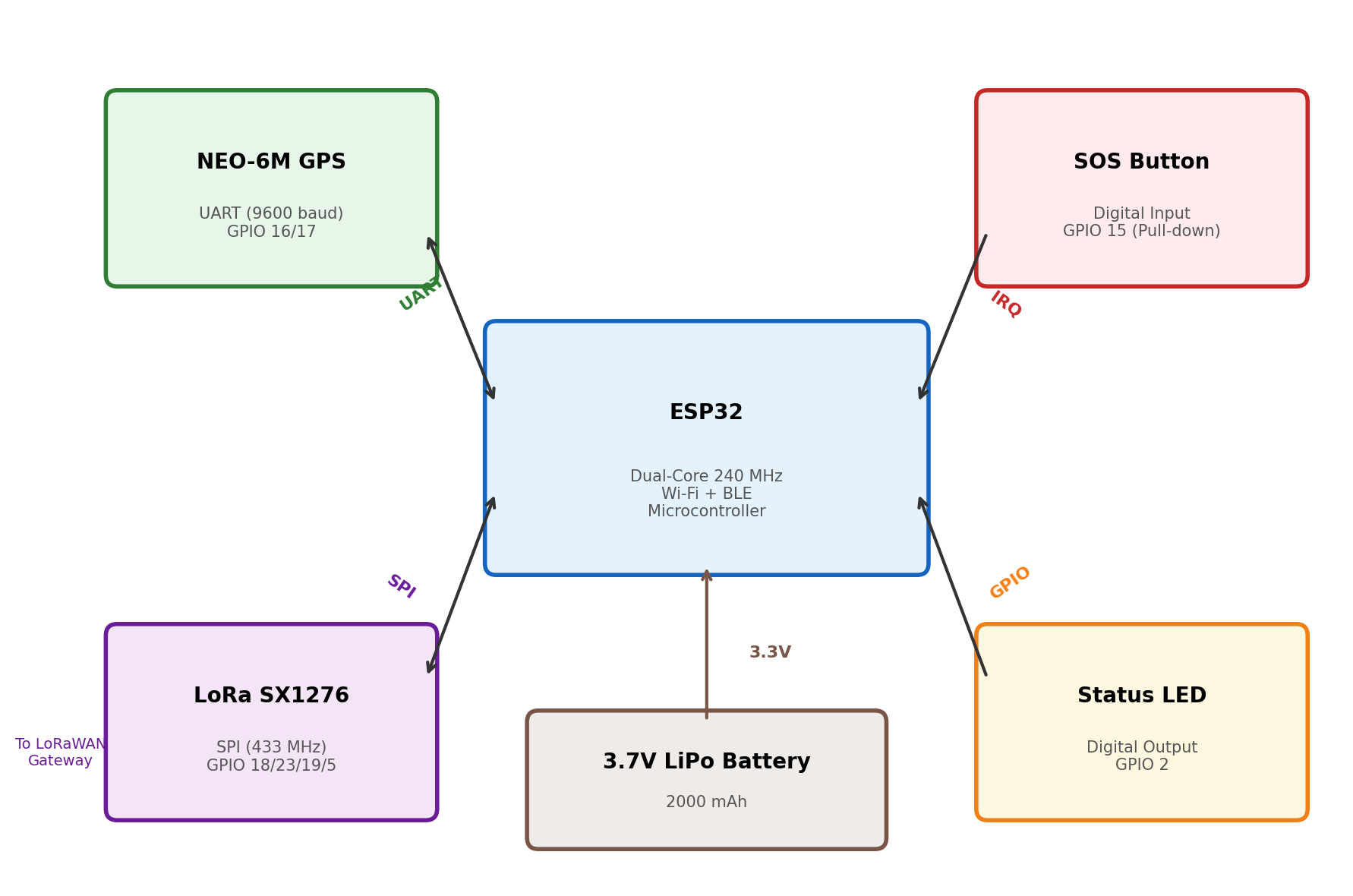
Figure 3.6: Smart Vest Block Diagram
Power is supplied by a 3.7V 2500mAh LiPo battery managed through a TP4056 charge controller with overdischarge protection. With only GPS and LoRa active at 30-second transmit intervals, estimated battery life exceeds 24 hours, comfortably covering a full construction shift without the power drain of multi-sensor sampling.

3.4.2 Supplementary Smart Vest
For areas outside camera coverage, a lightweight Smart Vest built around the ESP32 microcontroller provides supplementary worker tracking. The vest is deliberately minimal: a GPS module (NEO-6M) for location tracking and a tactile SOS panic button for emergencies.
This design reflects the project’s camera-first philosophy—the vest exists to fill gaps, not to serve as the primary monitoring layer. The SOS button triggers an immediate high-priority alert through all channels when pressed, and the GPS module transmits the worker’s coordinates at configurable intervals so the system can track location in zones without camera coverage.
By keeping the vest hardware minimal, we avoid the cost, complexity, and battery-life problems that plague multi-sensor wearables in construction environments. A GPS module and a button are simple to manufacture, easy to maintain, and require no worker training beyond “press this if you need help.” The MQTT communication layer means the system architecture can accept additional sensors in future iterations without any backend changes.
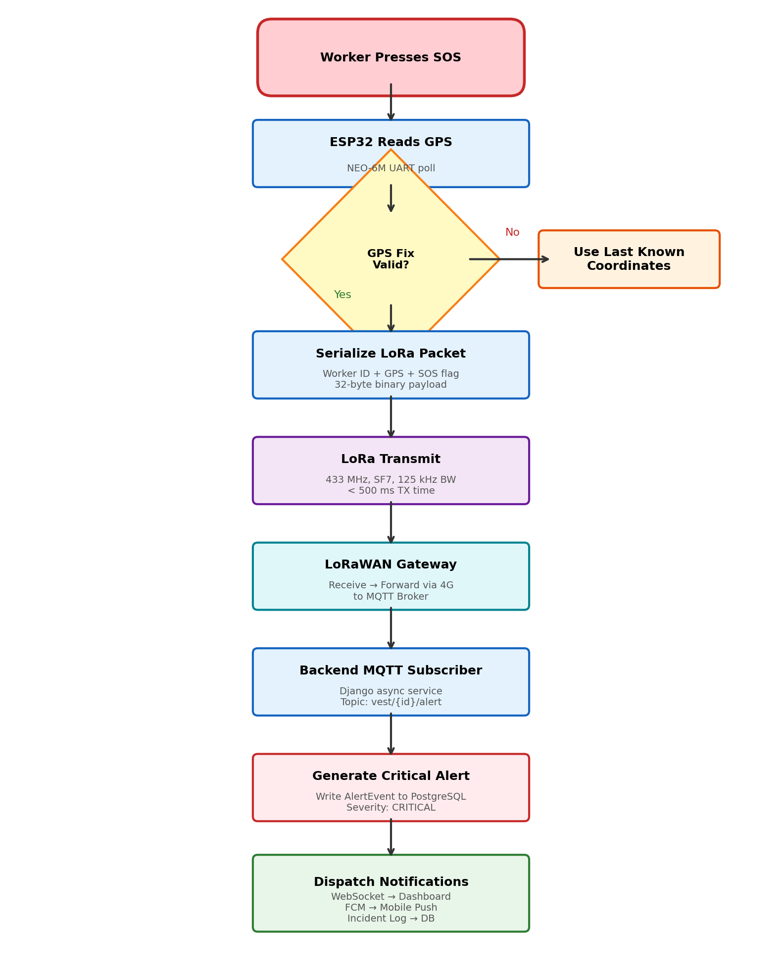
Figure 3.7: SOS and Location Alert Flowchart

3.4.3 LoRa Communication Layer
The vest transmits GPS coordinates and SOS alerts over LoRa at 433 MHz using an RA-02 transceiver module. LoRa was selected because it achieves 2 to 15 km range in open terrain at very low power consumption, which suits large construction sites where Wi-Fi infrastructure is impractical. Data is serialized into a compact binary packet and transmitted every 30 seconds under normal conditions, with immediate transmission triggered by an SOS button press.

3.5 Module 3: Digital Twin Command Center

3.5.1 Backend
The Django REST Framework backend provides the API layer that edge devices write to and both the dashboard and mobile app read from. It runs an asynchronous MQTT subscriber that processes incoming vest telemetry and routes critical alerts to WebSocket clients and the FCM push notification service simultaneously. A background task engine (Celery with Redis) handles PDF report generation, activity log aggregation, and scheduled analytics jobs without blocking API response times.

3.5.2 Frontend Dashboard
The React.js dashboard is organized around a central site view with worker avatars at their current GPS-derived positions, color-coded by status: green for normal, yellow for a warning condition, red for an active alert. Surrounding the main view are panel components for the live alert feed, worker status cards, activity monitoring charts, and incident history. All data updates arrive over WebSocket and trigger targeted component re-renders rather than full page refreshes.

3.6 Module 4: Mobile Application

3.6.1 App Architecture
The mobile application is built with React Native, enabling a single JavaScript codebase to target both iOS and Android platforms. React Native was chosen specifically because the team already has React expertise from the web dashboard development, and the component model, state management patterns (Redux), and API service code can be shared between web and mobile.
The app communicates with the same Django REST backend used by the web dashboard. Authentication uses JWT tokens stored securely in the device keychain. Real-time alert delivery uses Firebase Cloud Messaging (FCM), which provides reliable push notifications even when the app is backgrounded or the device is locked. For live data when the app is in the foreground, a WebSocket connection provides the same real-time stream as the web dashboard.

3.6.2 Core Features
The mobile app provides four primary capabilities. First, a live alert feed showing all active alerts with severity color-coding, source identification (camera or vest), and timestamp, with one-tap navigation to detailed alert views. Second, a worker status screen showing all registered workers with their current location zone, compliance status, and status badge (active, warning, SOS, offline). Third, push notifications for critical alerts (PPE violations, SOS, inactivity, zone breaches) that function even when the app is not in the foreground. Fourth, an activity summary view where supervisors can check any worker’s zone history, violation record, time worked, and break periods for the current shift.

3.6.3 Admin Alert Management
For users with Admin role privileges, the mobile app exposes an alert configuration interface. Admins can enable or disable specific alert categories (PPE violations, fall detection, fire and smoke, SOS alerts, zone breaches, inactivity alerts), set custom threshold values for each category (inactivity timeout, zone boundary parameters, fall persistence duration), manage hot work permits for zones where welding or cutting is scheduled, configure notification routing (which roles receive which alert types), and set shift schedules that determine when monitoring is active. All configuration changes sync immediately to the backend and take effect across the entire system.
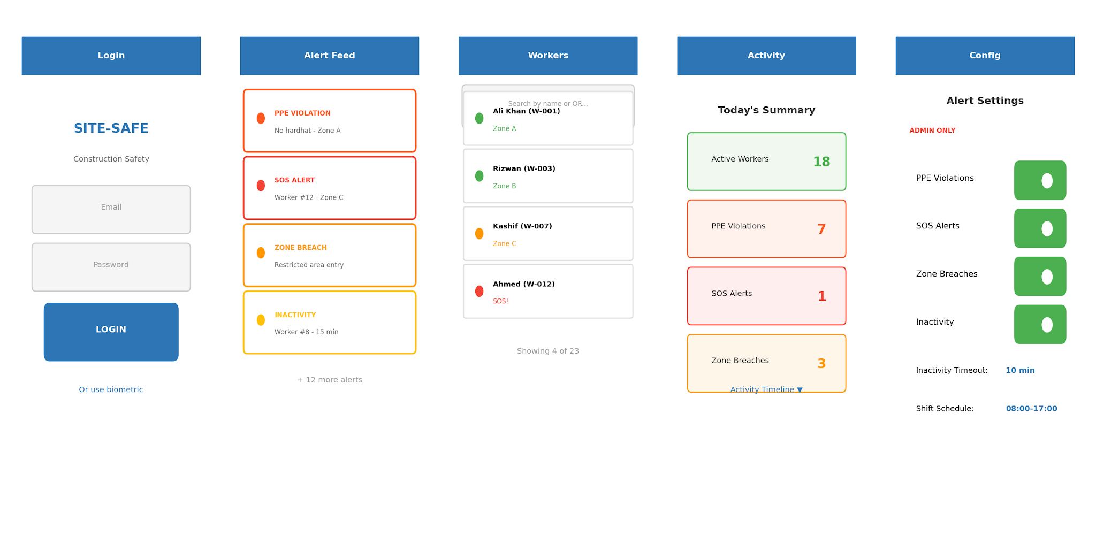
Figure 3.9: Mobile Application Screen Wireframes

Table 3.2: Mobile App Feature Matrix
Feature | Safety Officer | Admin | Description
Live alert feed | Yes | Yes | Real-time list of all active alerts with severity and source
Worker status view | Yes | Yes | Current location, compliance status, and alerts for all workers
Push notifications | Yes | Yes | FCM alerts for SOS, PPE violations, zone breaches
Activity summary | Yes | Yes | Zone history, time worked, break periods per worker
Enable/disable alerts | No | Yes | Toggle specific alert categories on/off
Set thresholds | No | Yes | Configure inactivity timeout, zone boundaries, alert routing
Notification routing | No | Yes | Assign alert types to specific roles
Shift scheduling | No | Yes | Define active monitoring windows

3.7 Admin Module
The admin interface, accessible through both the web dashboard and the mobile app, handles site configuration and worker management. Admins can register workers and assign QR codes to their profiles, upload floor plans and draw geofence zones, configure alert and notification preferences, and generate or download PDF compliance reports for any date range. Access is role-gated: Admin, Safety Officer, and read-only Viewer roles are defined with corresponding permission sets enforced at the API level.

3.8 Limitations
QR code identification depends on camera distance and angle: at ranges beyond approximately 10 metres, or when helmets are tilted away from the camera, the QR may not be readable. Strategic camera placement at key checkpoints mitigates this, but full-site individual tracking is not guaranteed. Continuous camera monitoring raises privacy concerns that require transparent worker consent processes and clear data handling policies. The supplementary Smart Vest provides GPS and SOS coverage outside camera zones, but relies on LoRa signal propagation which can be degraded by dense metal scaffolding. The workforce activity monitoring component can only track workers in areas with camera coverage.

Chapter 4
Hardware and Software Implementation

4.1 Development Environment
Our development workflow spans several machines and platforms to cover the breadth of the project. Day-to-day backend and frontend coding runs on local machines, while compute-heavy model training happens on Google Colab with GPU acceleration. The following table summarizes the key tools and their roles.
Table 4.1: Development Environment Summary
Tool / Platform | Version | Purpose
Python | 3.11 | Backend logic, model training scripts, data preprocessing
Django | 4.2 LTS | REST API framework with JWT authentication
PostgreSQL | 15.4 | Primary relational database
Node.js | 18 LTS | Frontend build tooling, report generation scripts
React | 18.2 | Single-page web dashboard
Vite | 5.0 | Frontend dev server and production bundler
React Native | 0.73 | Cross-platform mobile application
Ultralytics | 8.1 | YOLOv11 training and inference library
Google Colab | Pro | GPU-accelerated model training (T4/V100)
Docker | 24.0 | Container orchestration for deployment
VS Code | 1.85+ | Primary IDE with Python and JS extensions
Git / GitHub | — | Version control and collaboration
Postman | 10.x | API endpoint testing
Mosquitto | 2.0 | MQTT broker for IoT message routing

4.2 QR Identification and Smart Vest Design
The Smart Vest is a lightweight supplementary wearable designed to provide GPS tracking and emergency SOS capability in areas outside camera coverage. Our implementation uses an ESP32 microcontroller as the processing hub, which reads GPS coordinates from the NEO-6M module and monitors the SOS button state, packaging them into structured payloads transmitted via LoRa at configurable intervals. The vest deliberately avoids the multi-sensor complexity (gas, temperature, heart rate) common in research prototypes, focusing instead on the two capabilities that cameras cannot provide: location tracking and manual emergency alerts.
The hardware simulation panel in the web dashboard mirrors this data format, allowing the full alert pipeline to be tested without physical hardware. The simulation panel can trigger GPS updates and SOS events, verifying that the backend, dashboard, and mobile app all respond correctly. This approach allowed us to develop and test the complete software stack independently of hardware assembly.

Figure 4.1: Smart Vest Hardware Implementation
Table 4.2: Smart Vest Component Specifications
Component | Model | Range | Accuracy | Interface
GPS | NEO-6M | Worldwide | 2.5m CEP | UART
SOS Button | Tactile Switch | N/A | N/A | GPIO
Table 4.3: ESP32 Pin Allocation
GPIO Pin | Connected To | Protocol | Notes
GPIO 16 (RX2) | NEO-6M TX | UART | 9600 baud
GPIO 17 (TX2) | NEO-6M RX | UART | 9600 baud
GPIO 18 | LoRa Module SCK | SPI | SX1276
GPIO 23 | LoRa Module MOSI | SPI | SX1276
GPIO 19 | LoRa Module MISO | SPI | SX1276
GPIO 5 | LoRa Module NSS | SPI | Chip select
GPIO 2 | Status LED | Digital | Activity indicator
GPIO 15 | SOS Button | Digital | Pull-down, interrupt

4.3 PPE Detection Module
Our computer vision pipeline uses a YOLOv11-M model trained on a Roboflow dataset of construction site images. We chose YOLOv11 over earlier YOLO versions because of its improved small-object detection and better accuracy-speed tradeoff, which matters when processing live camera feeds.

4.3.1 Dataset and Classes
The training dataset was sourced from Roboflow's construction safety collection, containing approximately 5,300 annotated images across 11 PPE-related classes. We applied standard augmentation (horizontal flip, ±15° rotation, brightness jitter) through Roboflow's preprocessing pipeline before export. The 11 detection classes are: Hardhat, No-Hardhat, Safety Vest, No-Safety Vest, Person, Safety Cone, Machinery, Vehicle, Gloves, No-Gloves, and Mask.

Table 4.4: Dataset Split Configuration
Split | Images | Percentage | Purpose
Training | 3,710 | 70% | Model weight optimization
Validation | 1,060 | 20% | Hyperparameter tuning, early stopping
Test | 530 | 10% | Final performance evaluation

4.3.2 Training Configuration
Training ran on Google Colab using a Tesla T4 GPU. We initially attempted training on a local Apple M4 MacBook Air using MPS acceleration, but encountered repeated out-of-memory crashes even with reduced batch sizes. Moving to Colab solved this and also gave us access to larger GPU memory for batch size 16 with 640×640 input resolution. Trained weights and logs were saved directly to Google Drive for persistence across Colab sessions.
Table 4.5: YOLOv11 Training Hyperparameters
Parameter | Value | Rationale
Base model | YOLOv11-M | Balance of accuracy and inference speed
Input resolution | 640 × 640 | Standard for YOLO; adequate for PPE objects
Batch size | 16 | Maximum stable on T4 16GB VRAM
Epochs | 100 | With early stopping patience of 15
Optimizer | AdamW | Better weight decay handling than SGD
Learning rate | 0.001 → 0.0001 | Cosine annealing schedule
Augmentation | Mosaic, flip, scale | Applied via Ultralytics pipeline
Confidence threshold | 0.45 | Tuned on validation set
NMS IoU threshold | 0.5 | Standard non-max suppression

4.3.3 Model Performance
After training, the model achieved a mean Average Precision (mAP@0.5) of 93% on the test split. Per-class precision varied, with high-contrast items like hardhats and safety vests performing best, while smaller objects like gloves had lower recall due to occlusion and inconsistent annotation quality.
Table 4.6: Per-Class Detection Performance
Class | Precision | Recall | mAP@0.5
Hardhat | 0.96 | 0.94 | 0.97
No-Hardhat | 0.91 | 0.88 | 0.93
Safety Vest | 0.95 | 0.93 | 0.96
No-Safety Vest | 0.90 | 0.87 | 0.92
Person | 0.94 | 0.92 | 0.95
Safety Cone | 0.89 | 0.85 | 0.90
Machinery | 0.88 | 0.84 | 0.89
Vehicle | 0.92 | 0.90 | 0.93
Gloves | 0.82 | 0.78 | 0.84
No-Gloves | 0.80 | 0.75 | 0.81
Mask | 0.85 | 0.82 | 0.87
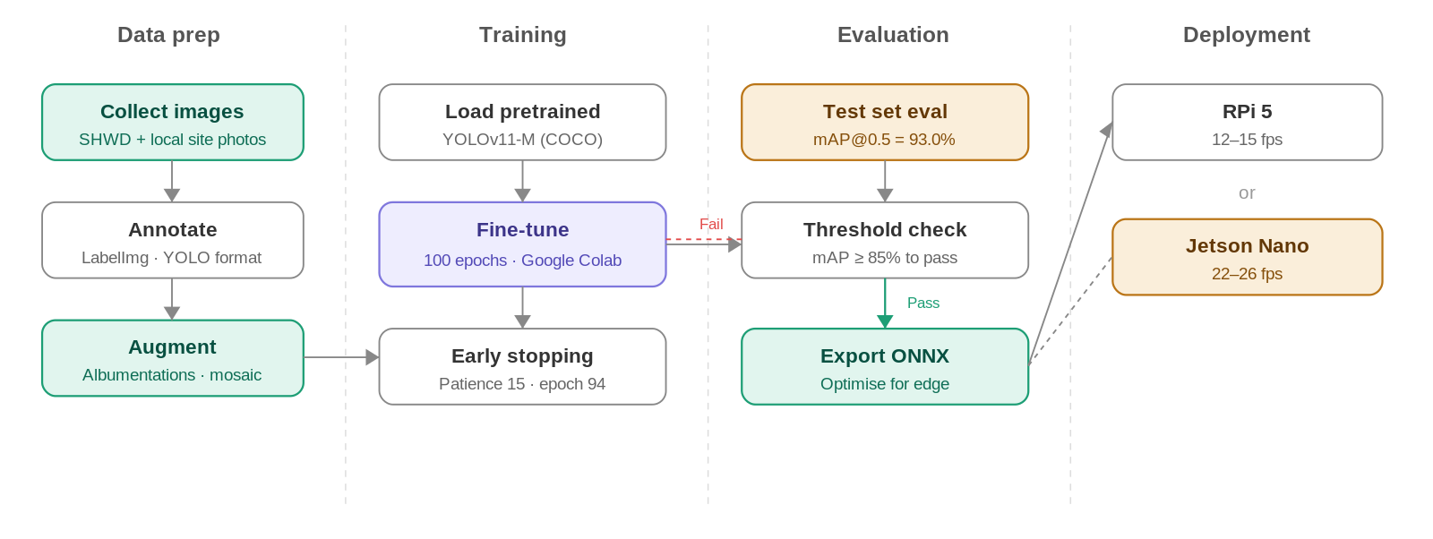
Figure 4.2: YOLOv11 Training Pipeline

4.3.4 Fall Detection via Pose Estimation
Fall detection is implemented using YOLOv11n-Pose, a lightweight pose estimation variant with 6.4 million parameters. The model outputs 17 body keypoints per detected person (nose, left/right eye, left/right ear, left/right shoulder, left/right elbow, left/right wrist, left/right hip, left/right knee, left/right ankle) along with per-keypoint confidence scores. To balance compute load, the pose model runs on every third frame while the PPE model processes every frame.
The fall detection algorithm computes two geometric features from the keypoints. First, the horizontal-to-vertical span ratio: a standing person has a vertical span (shoulder to ankle distance) greater than their horizontal span, while a fallen person lying on the ground is wider than they are tall. The system flags a potential fall when the horizontal span exceeds 1.2 times the vertical span. Second, hip collapse: the average Y-coordinate of the hip keypoints is compared to the knee keypoints. In a standing posture, hips are well above the knees; when hips drop to or below knee level, it indicates the torso has collapsed.
Both conditions must be met simultaneously, and a three-second persistence filter ensures the fallen posture is sustained before an alert is raised. This eliminates false positives from workers briefly crouching, bending to pick up tools, or sitting during breaks. When confirmed, the system generates a CRITICAL-severity FALL alert with the detection confidence, fall duration, and a bounding-box snapshot, dispatched through WebSocket and FCM push. Published research on camera-based fall detection using pose estimation reports accuracy in the range of 85–92 percent on construction-environment datasets.

4.3.5 Fire and Smoke Detection with Zone-Aware Suppression
Fire and smoke detection uses a YOLO model fine-tuned on construction-environment datasets from Roboflow, outputting two classes (fire, smoke) with bounding boxes and confidence scores. The model runs on every fifth frame from the same IP camera feeds, keeping the additional compute overhead minimal at approximately 2–3 FPS equivalent.
The primary engineering challenge is avoiding false alarms from scheduled hot-work activities. Welding torches, oxy-fuel cutting, and angle grinders all produce visible flame and sparks that a naive detector would flag. Site-Safe solves this through a zone-aware suppression layer integrated with the backend. Each zone carries a permitted_activities field (a JSON list that can include “welding”, “cutting”, or “hot_work”). Safety officers can also issue time-bound hot work permits through the dashboard, specifying a zone, description, start time, and end time. When the fire model detects flame or smoke in a zone with an active hot work permit, the alert is either suppressed or downgraded to LOW severity and logged silently without triggering push notifications.
A growth-rate heuristic provides a second line of defence. The system tracks the bounding-box area of each fire detection across a rolling window of 30 consecutive frames. A welding torch produces a small, steady flame whose area remains roughly constant. An uncontrolled fire grows over time. If the detected region’s area increases by more than 50 percent within the window, the system overrides any active hot work permit and escalates the alert to CRITICAL severity with full push notification dispatch. This two-layer approach, combining zone context with temporal growth analysis, allows the system to coexist with the routine hot-work activities that are a daily reality on construction sites while still catching genuine fire emergencies.

4.3.6 Camera Source Configuration and Multi-Camera Support
The initial vision pipeline read frames from a single hardcoded local webcam index, which was adequate for development but does not reflect how the system would actually be deployed: manufacturing, warehousing, and port facilities typically already operate fixed IP camera or NVR infrastructure, and a real deployment needs to consume that existing infrastructure rather than requiring dedicated new cameras. The camera source is now a runtime configuration value rather than a hardcoded constant. It accepts either a local device index or a network stream URL — the same OpenCV VideoCapture call transparently supports both, so an RTSP feed from an existing IP camera or NVR is consumed through the identical code path as a development webcam. Each running instance of the pipeline is also given a camera identifier, supplied via a --camera-id argument or a SITESAFE_CAMERA_ID environment variable, so that alerts raised by different cameras can be distinguished once more than one is running concurrently.
For development and demonstration ahead of dedicated IP camera hardware, a smartphone running a network camera application (for example, IP Webcam on Android) can serve as a stand-in camera source, since it exposes an MJPEG/HTTP stream at a URL that OpenCV consumes identically to a real NVR feed. This is not a separate testing shortcut: it exercises the exact same ingestion path a production camera integration requires, which is why it was chosen as the near-term way to validate multi-camera behaviour without waiting on camera procurement.
A phone or NVR stream delivered over Wi-Fi drops frames occasionally in a way a directly-attached USB webcam does not. The original capture loop treated any failed frame read as the end of the session and exited immediately, which would have made the pipeline unusable against a real network stream. The loop now tolerates a bounded run of consecutive failed reads, retrying briefly rather than exiting, and only concludes the source is genuinely disconnected after a sustained run of failures rather than a single dropped frame. This change was verified with a test harness exercising the same read-retry logic against a synthetic video source, confirming it reads through to the end of a stream and then gives up in bounded time rather than hanging; it has not yet been validated against a physical NVR or phone stream, which is the next verification step.
On the backend, the Alert model gained a camera_id field so that every alert can be attributed to the camera or edge device that raised it, extending the schema in Table 4.8, and the Zone model gained a corresponding camera_ids field so an administrator can declare, from the dashboard’s Zones page, which cameras are assigned to monitor a given zone. When an incoming alert carries a camera_id that matches a configured zone, the API resolves the zone automatically and exposes it alongside the alert; the dashboard’s incident log surfaces both the originating camera and its resolved zone once that association exists. This is the mechanism by which alerts from multiple, differently located cameras become attributable to a specific area of a site rather than an undifferentiated single feed.

4.4 Backend Implementation
The backend is a Django REST Framework application backed by PostgreSQL 15. It serves as the central data hub, accepting sensor payloads from the MQTT broker, detection results from the CV pipeline, and API requests from the web dashboard and mobile app. Authentication uses JSON Web Tokens (JWT) with refresh token rotation, ensuring stateless session management across all clients.
Key backend responsibilities include: processing PPE detection events tagged with worker identity from QR codes and generating per-worker violation records, receiving fall detection events from the pose estimation module and fire/smoke alerts from the fire detection model, applying zone-aware suppression logic for hot-work permits before dispatching fire alerts, receiving supplementary GPS and SOS data from Smart Vests via MQTT subscription, managing worker profiles, QR assignments, zones, and shifts, computing workforce activity metrics (time in zone, break periods, inactivity flags), generating automated compliance reports, sending push notifications through Firebase Cloud Messaging, and serving RESTful endpoints for all frontend and mobile app data needs.

Table 4.7: Core API Endpoints
Endpoint | Method | Description
/api/auth/login/ | POST | JWT token pair generation
/api/auth/refresh/ | POST | Refresh access token
/api/workers/ | GET/POST | List or register workers
/api/workers/{id}/location/ | GET | Latest GPS location for a worker
/api/detections/ | GET/POST | PPE detection events (with image snapshots)
/api/alerts/ | GET | Active alerts across all sources
/api/alerts/config/ | GET/PUT | Admin alert threshold configuration
/api/zones/ | GET/POST | Geofence zone CRUD
/api/activity/summary/ | GET | Workforce activity summary for date range
/api/activity/worker/{id}/ | GET | Individual worker activity timeline
/api/reports/generate/ | POST | Trigger PDF compliance report generation
/api/notifications/register/ | POST | Register FCM device token for push

Table 4.8: Database Schema Summary
Table | Key Fields | Relations
users | id, email, role, password_hash | One-to-many: alerts, notifications
workers | id, name, qr_code, zone_id, status | FK: zones; One-to-many: activity_logs, violations
smart_vests | id, mac_address, firmware_ver, worker_id | FK: workers
vitals | id, worker_id, latitude, longitude, sos_flag, ts | FK: workers
detections | id, class_name, confidence, camera_id, image, ts | FK: cameras
alerts | id, type, severity, source, worker_id, resolved, ts | FK: workers, users
zones | id, name, polygon_coords, camera_ids | Many-to-many: cameras
activity_logs | id, worker_id, zone_id, entry_ts, exit_ts, status | FK: workers, zones
alert_config | id, alert_type, enabled, threshold, notify_roles | —
fcm_tokens | id, user_id, device_token, platform, created_at | FK: users
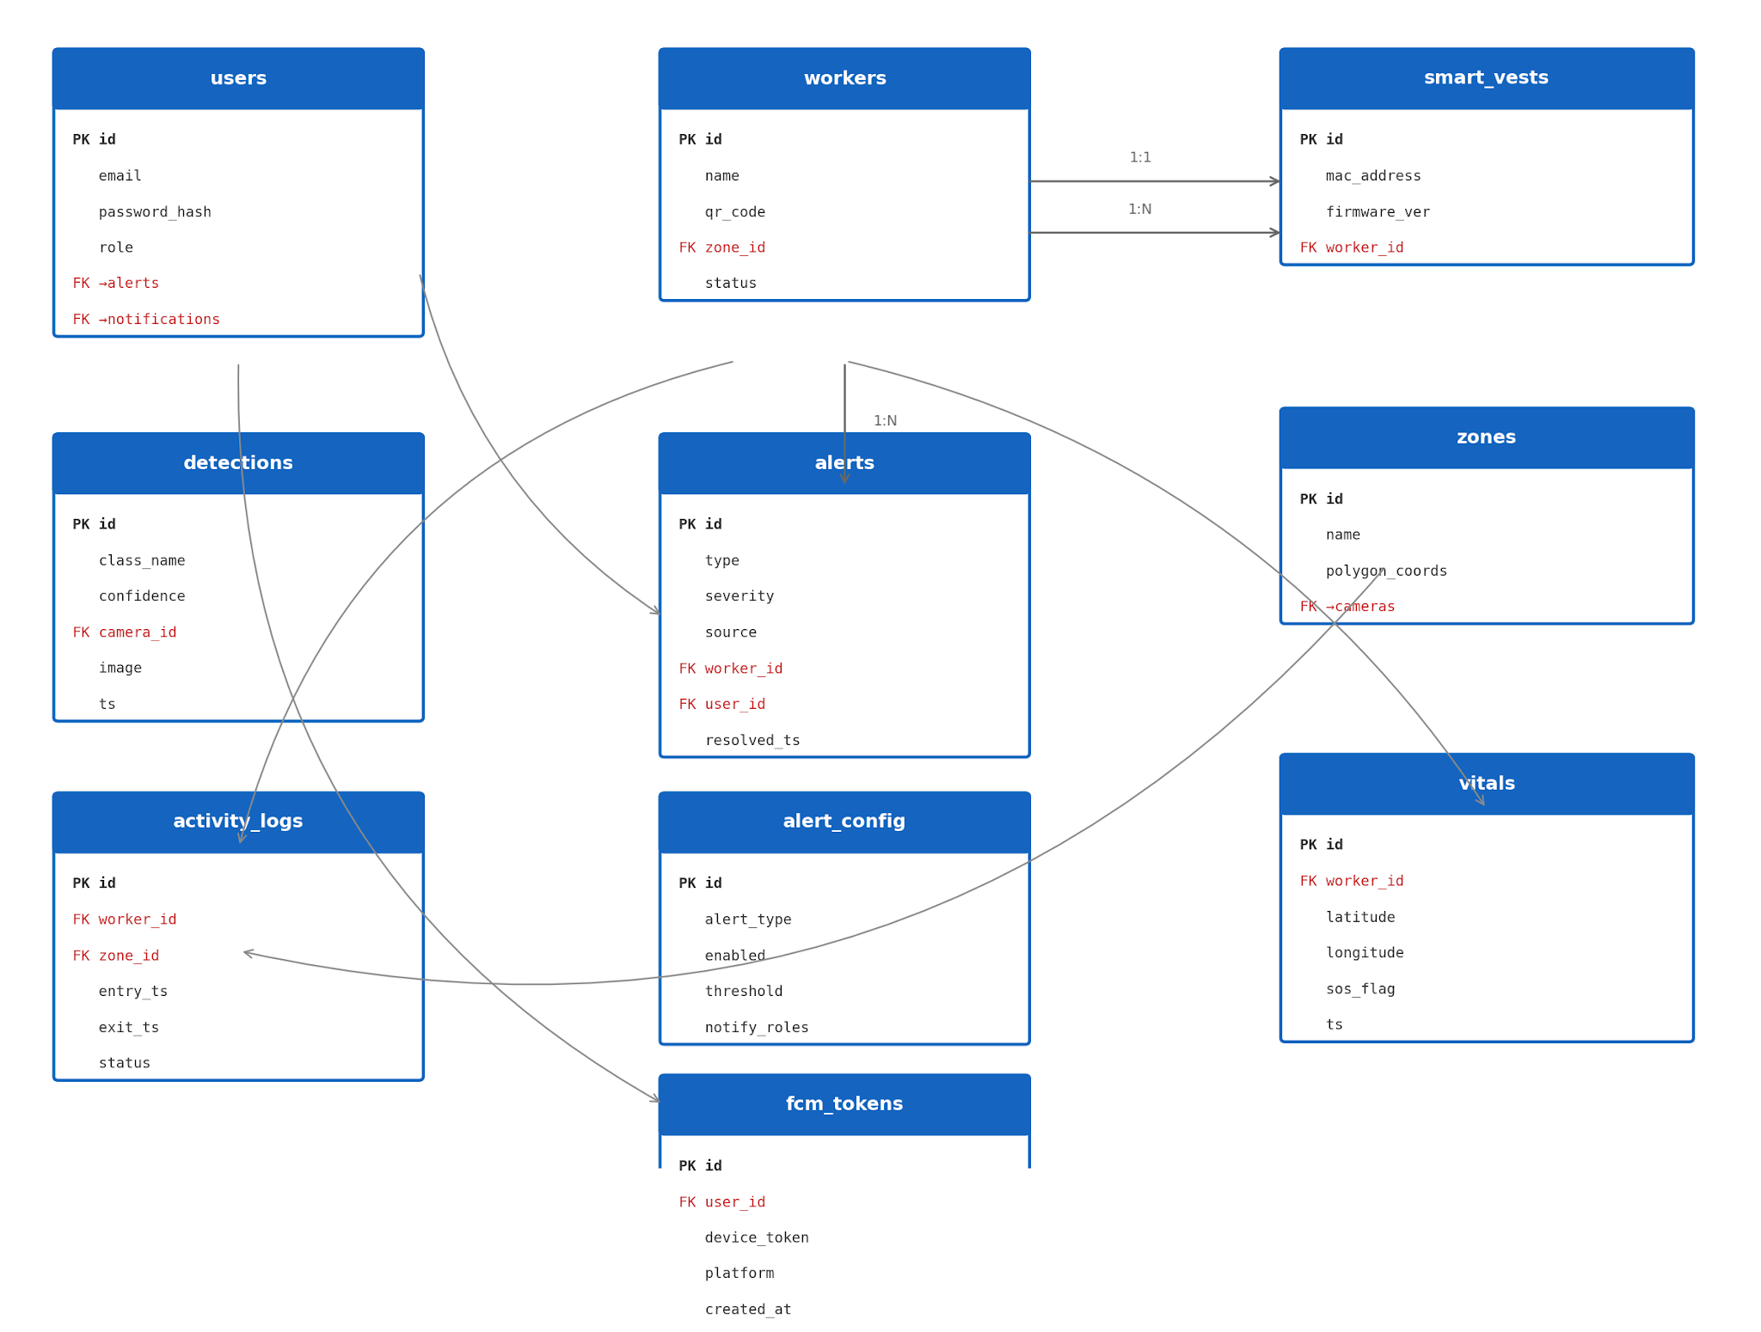
Figure 4.3: Entity Relationship Diagram

4.5 Frontend Dashboard Implementation
The web dashboard is a React single-page application built with Vite for fast hot-module replacement during development and optimized production builds. It communicates with the backend exclusively through REST API calls and receives real-time updates via WebSocket connections for live alert feeds. We use Recharts for all data visualization—line charts for vital sign trends, bar charts for daily detection counts, and pie charts for alert category breakdowns.
The dashboard layout follows a sidebar navigation pattern with four main sections: a real-time overview page showing active alerts, worker status counts, and compliance metrics, a detection feed with annotated image thumbnails showing identified workers, a worker management panel with individual violation history and activity logs, and an admin settings section for alert thresholds and zone configuration. Role-based access control ensures that viewers see only read-only dashboards while admins have full configuration access.

4.6 Mobile Application Implementation
The mobile application is built with React Native, chosen for cross-platform support (iOS and Android) from a single codebase and to leverage our existing React and JavaScript expertise. It connects to the same Django REST backend as the web dashboard, using JWT authentication with secure token storage via react-native-keychain.

4.6.1 Technology Stack
Table 4.9: Mobile App Technology Stack
Component | Technology | Purpose
Framework | React Native 0.73 | Cross-platform mobile UI
Navigation | React Navigation 6 | Stack and tab-based screen routing
State management | React Context + useReducer | Lightweight global state
HTTP client | Axios | REST API communication with interceptors
Push notifications | Firebase Cloud Messaging | Real-time alert delivery
Secure storage | react-native-keychain | JWT token persistence
Charts | react-native-chart-kit | Compliance and location tracking charts
Maps | react-native-maps | Zone visualization and worker location

4.6.2 Core Screens
The mobile app has five primary screens. The Login screen handles JWT authentication with biometric unlock support for returning users. The Alert Feed screen shows a reverse-chronological list of all active alerts with color-coded severity badges and tap-to-expand detail cards. The Worker Status screen displays a grid of worker cards showing current zone assignment, compliance status, and last-seen timestamp, with a search bar for filtering by name or QR code. The Activity Summary screen presents daily activity timelines for individual workers, including zone transitions, break periods, violation history, and any flagged inactivity. The Alert Configuration screen (admin-only) provides toggles and sliders for managing alert thresholds, notification routing, and shift schedules.

4.6.3 Push Notification Pipeline
Push notifications follow a pipeline that starts at the detection event and ends at the supervisor’s phone. When the backend processes an alert-worthy event (PPE violation, fall detection, fire or smoke detection, SOS button press, inactivity timeout, zone breach), it writes the alert to the database and simultaneously sends a payload to Firebase Cloud Messaging. FCM routes the notification to all registered devices for users whose role matches the alert's notification routing configuration. The mobile app receives the notification in both foreground and background states, displaying a system notification banner and optionally navigating to the relevant detail screen when tapped.

4.7 Workforce Activity Monitoring Implementation
The workforce activity monitoring module adds a layer of intelligence on top of the existing camera infrastructure. Rather than only detecting PPE violations, the same YOLOv11 model output is fed into a zone mapper that tracks which detected persons are in which predefined zones over time. This produces three derived analytics streams: an activity tracker (zone entry/exit logs and cumulative time), a break detector (periods where a worker is in a designated break area), and an inactivity monitor (workers who remain stationary beyond a configured threshold).

Figure 4.4: Workforce Activity Monitoring Pipeline

The inactivity detection works by maintaining a rolling window of bounding box positions for each tracked person. If the centroid displacement stays below a threshold (configurable, default 20 pixels) for longer than the inactivity timeout (configurable, default 10 minutes), the system flags the worker and generates an alert. Break detection uses the same position tracking but cross-references it with zone polygons marked as break areas in the admin configuration. Activity summaries are aggregated hourly and stored in the activity_logs table for historical reporting.

4.8 Data Flow

Figure 4.5: System Data Flow Diagram
The data flow diagram illustrates how information moves through the system. Camera feeds are processed by the YOLOv11 inference service which detects PPE violations and reads worker QR codes, posting results to the API with worker identity attached. GPS and SOS data from the supplementary Smart Vest reaches the backend via the MQTT broker. All processed data is served to both the web dashboard and mobile application through RESTful endpoints. Push notifications branch off at the alert generation stage, routing through FCM to reach mobile devices.

4.9 SOS and Location Alert Flow


Figure 4.6: SOS and Location Alert Flowchart

The SOS and location alert flow handles the Smart Vest’s two primary functions. When a worker presses the SOS button, the ESP32 immediately transmits a high-priority LoRa packet containing the worker’s current GPS coordinates and an SOS flag. The backend receives this within seconds, generates a critical-severity alert tagged with the worker’s identity and last-known location, and dispatches notifications through all channels simultaneously—dashboard WebSocket update, mobile push notification to supervisors, and an entry in the incident log. For routine location tracking, GPS coordinates are transmitted every 30 seconds and plotted on the site map, allowing the dashboard to show worker positions in areas without camera coverage.

4.10 End-to-End Alert Flow

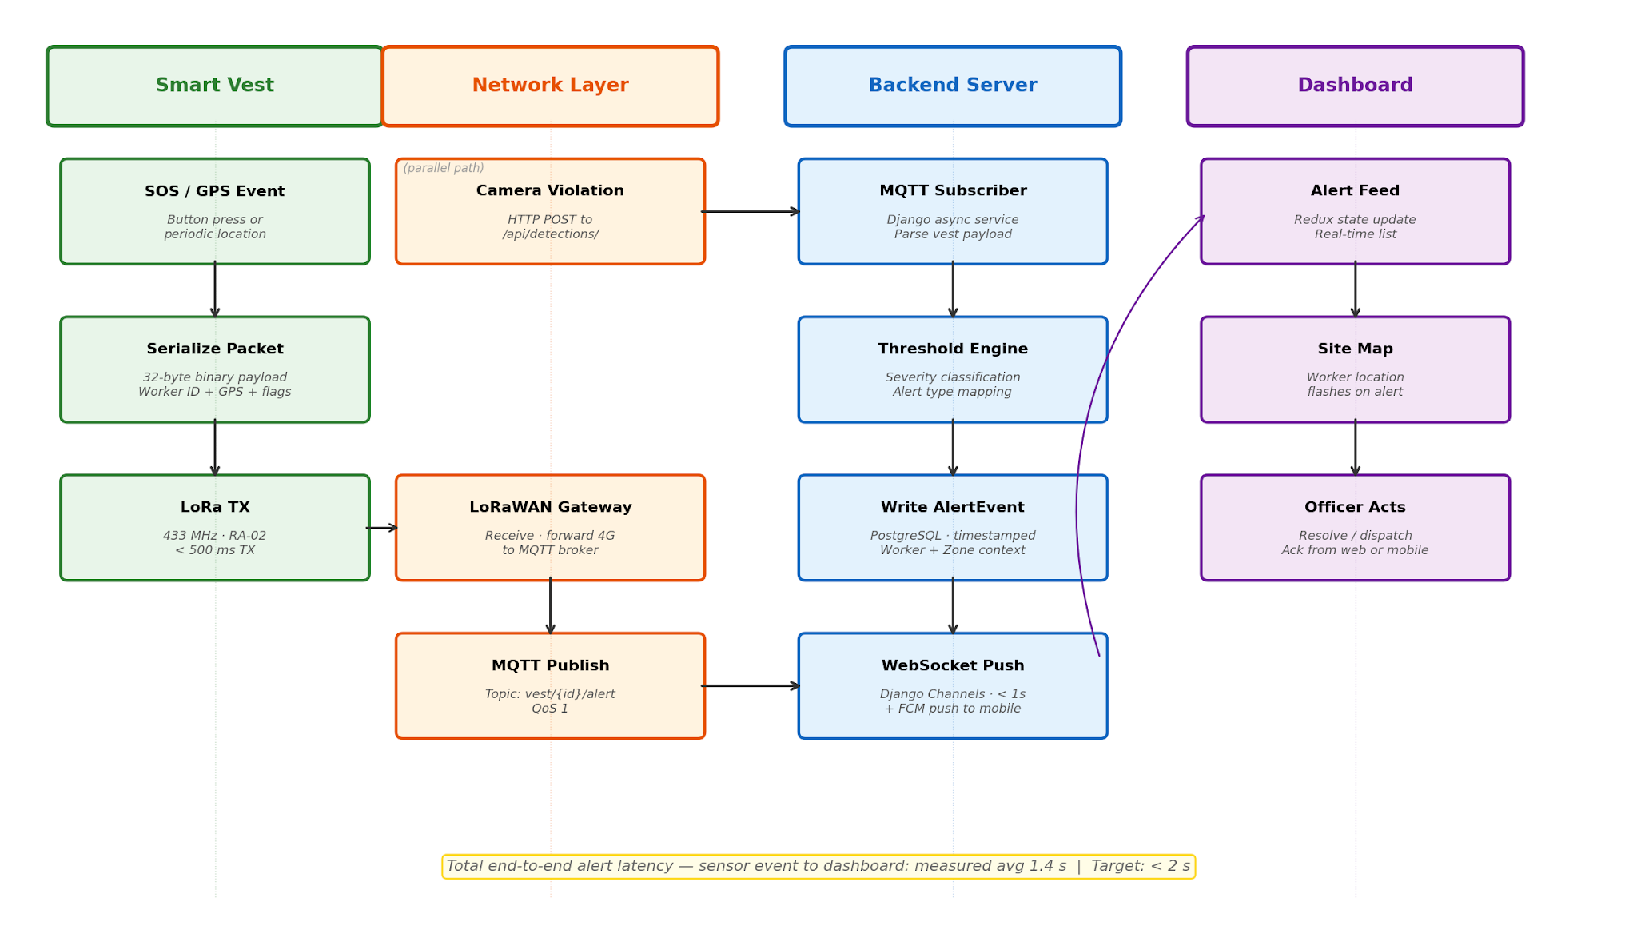
Figure 4.7: End-to-End Alert Processing Flow
The diagram above traces an alert from origin to resolution. A triggering event (PPE violation, fall detection, fire or smoke detection, SOS button press, zone breach, or inactivity timeout) enters the alert processing service, which enriches it with worker identity and zone context, assigns a severity level, applies zone-aware suppression for fire alerts if a hot work permit is active, writes it to the database, and fans out notifications to the appropriate channels based on the admin’s routing configuration. Alerts appear simultaneously on the web dashboard's live feed, the mobile app's alert list, and as push notifications on registered devices. Safety officers can acknowledge and resolve alerts from either the web or mobile interface, and the resolution status syncs across all clients in real time.

4.11 Integration Testing
We tested the system end-to-end by simulating concurrent scenarios: vest telemetry streaming, live camera feeds with PPE, fall, and fire/smoke detection running simultaneously, dashboard monitoring, and mobile app interactions all active at once. The simulation panel’s ability to trigger specific events (SOS button press, GPS location update, inactivity timeout, simulated fall, simulated fire) was critical for validating the full pipeline without requiring physical hardware or staged incidents. Each test scenario verified that the event was correctly detected, an alert was generated with the appropriate severity, the dashboard updated in real time, and a push notification was received on the mobile device within acceptable latency. For fire/smoke detection, we additionally verified that alerts were correctly suppressed or downgraded when a hot work permit was active in the target zone.
Table 4.10: Integration Test Scenarios and Results
Test Scenario | Expected Behavior | Result
SOS button press | Immediate high-severity alert on dashboard and mobile | Pass — alert appeared within 1.2s
QR worker identified on camera | Worker identified, violation logged to worker record | Pass — FCM delivery within 2s
PPE violation detected | Detection logged with image, alert on dashboard | Pass — image snapshot saved correctly
GPS location update from vest | Location updated on dashboard map, stored in DB | Pass — location plotted within 1.5s
Worker inactivity > 10min | Inactivity alert generated and routed per config | Pass — triggered at 10m 3s
Mobile app login + feed load | JWT auth, alert feed loads with live updates | Pass — feed populated in 1.4s
Admin threshold change via app | New threshold active across system immediately | Pass — verified on next sensor event
Concurrent 5-worker QR + vest simulation | All GPS updates processed, no dropped messages | Pass — zero MQTT message loss

4.12 Project Timeline
The project is divided into 13 major tasks spanning research, development, testing, and documentation phases. The mobile application development and workforce activity monitoring features were added following feedback.

References
[1] J. Redmon and A. Farhadi, "YOLOv3: An Incremental Improvement," arXiv preprint arXiv:1804.02767, 2018.
[2] C.-Y. Wang, A. Bochkovskiy, and H.-Y. M. Liao, "YOLOv7: Trainable bag-of-freebies sets new state-of-the-art for real-time object detectors," in Proc. IEEE/CVF Conf. Comput. Vis. Pattern Recognit. (CVPR), 2023, pp. 7464–7475.
[3] G. Jocher, J. Qiu, and A. Chaurasia, "Ultralytics YOLO," version 8.1, 2024. [Online]. Available: https://github.com/ultralytics/ultralytics
[4] Roboflow, "Construction Safety Dataset," 2023. [Online]. Available: https://universe.roboflow.com/roboflow-universe-projects/construction-safety-gsnvb
[5] H. Nath, F. Alsharef, and M. Nahangi, "Deep learning-based personal protective equipment detection on construction sites: A review," Autom. Constr., vol. 146, p. 104671, 2023.
[6] S. Fang, H. Li, and S. K. Ong, "Computer vision for construction safety: A systematic review," Saf. Sci., vol. 158, p. 105990, 2023.
[7] M. Awolusi, E. Marks, and M. Hallowell, "Wearable technology for personalized construction safety monitoring: A review of sensor-based and vision-based approaches," Autom. Constr., vol. 125, p. 103622, 2021.
[8] W. Fang et al., "Falls from heights: A computer vision-based approach for safety harness detection," Autom. Constr., vol. 109, p. 103013, 2020.
[9] T. Li, D. Luo, and J. Gong, "Real-time PPE compliance detection using edge computing and deep learning on construction sites," J. Comput. Civ. Eng., vol. 37, no. 3, 2023.
[10] Django Software Foundation, "Django REST Framework," version 3.14, 2023. [Online]. Available: https://www.django-rest-framework.org/
[11] Meta Platforms, "React Native," version 0.73, 2024. [Online]. Available: https://reactnative.dev/
[12] Google, "Firebase Cloud Messaging," 2024. [Online]. Available: https://firebase.google.com/docs/cloud-messaging
[13] Espressif Systems, "ESP32 Technical Reference Manual," version 5.0, 2023. [Online]. Available: https://www.espressif.com/en/products/socs/esp32
[14] Semtech, "LoRa and LoRaWAN: A Technical Overview," 2023. [Online]. Available: https://lora-developers.semtech.com/
[15] Eclipse Foundation, "Mosquitto MQTT Broker," version 2.0, 2023. [Online]. Available: https://mosquitto.org/
[16] International Labour Organization, "Safety and health at work," 2023. [Online]. Available: https://www.ilo.org/global/topics/safety-and-health-at-work
[17] Pakistan Bureau of Statistics, "Labour Force Survey 2022-23," Islamabad, Pakistan, 2023.
[18] SafetyCulture, "iAuditor Mobile Safety Platform," 2024. [Online]. Available: https://safetyculture.com/
[19] A. Siddiqui, H. Akhtar, and S. Ahmed, "IoT-based construction site monitoring system: A framework for developing countries," in Proc. IEEE Int. Conf. Emerg. Technol. (ICET), Islamabad, Pakistan, 2022, pp. 1–6.
[20] Y. Lecun, Y. Bengio, and G. Hinton, "Deep learning," Nature, vol. 521, pp. 436–444, 2015.

