SITE-SAFE: A DIGITAL ECOSYSTEM FOR AUTONOMOUS CONSTRUCTION SAFETY



Muhammad Hamza
Hamza Hussain
Hanan Saeed
Supervised By
Muhammad Yousaf

Submitted for the partial fulfillment of the BS Computer Science degree to the Faculty of Engineering & Computing

DEPARTMENT OF COMPUTER SCIENCE
NATIONAL UNIVERSITY OF MODERN LANGUAGES, LAHORE
April, 2026

Table of Contents
Abstract 1
Chapter 1: Introduction 2
1.1 Background 3
1.2 Problem Statement 4
1.3 Objectives 4
1.4 Scope 5
1.5 Significance 6
1.6 Report Organization 6
Chapter 2: Review of Existing Systems 8
2.1 Overview 8
2.2 Traditional CCTV Surveillance 8
2.3 Consumer Smartwatches and Fitness Wearables 8
2.4 Specialized Industrial Wearables 9
2.5 AI-Based PPE Detection Research 9
2.6 Integrated IoT Safety Platforms 10
2.7 Comparative Summary 11
Chapter 3: Proposed System Design 13
3.1 System Overview 14
3.2 Architecture 15
3.2.1 Three-Tier Model 15
3.2.2 Data Flow 15
3.3 Module 1, Vision Intelligence 15
3.3.1 PPE Detection 15
3.3.2 Geofencing and Intrusion Detection 16
3.3.3 Vehicle Proximity Warning 16
3.4 Module 2, IoT Smart Vest 17
3.4.1 Hardware Design 17
3.4.2 Fall Detection Logic 18
3.4.3 LoRa Communication 19
3.5 Module 3, Digital Twin Command Center 19
3.5.1 Backend 19
3.5.2 Frontend and 3D Visualization 20
3.6 Admin Module 20
3.7 Limitations 20
3.8 SDG Alignment 21
Chapter 4: Implementation 22
4.1 Development Environment 23
4.2 Smart Vest Hardware, Assembly and Firmware 24
4.2.1 Circuit Assembly 24
4.2.2 Firmware Architecture 24
4.2.3 LoRa Packet Format 25
4.3 PPE Detection Model, Training and Deployment 26
4.3.1 Dataset 26
4.3.2 Training Setup 27
4.3.3 Model Performance 28
4.3.4 Edge Inference Pipeline 28
4.4 Backend Implementation 30
4.4.1 REST API Endpoints 30
4.4.2 Database Schema 31
4.4.3 MQTT Integration 32
4.5 Frontend Implementation 33
4.5.1 Component Structure 33
4.5.2 WebSocket Real-Time Updates 33
4.6 Integration Testing 34
4.6.1 Test Setup 34
4.6.2 Results 34
References 36

Abstract
Construction work has always been dangerous, but in countries like Pakistan, where large-scale infrastructure projects are being executed at an accelerating pace, the gap between site complexity and safety management capability has become critically wide. Workers are injured, sometimes fatally, not because safety standards do not exist on paper, but because the systems in place to enforce and monitor those standards in real time are simply inadequate. This report documents the design and early implementation of Site-Safe, a project our team developed to address that gap directly. Site-Safe combines three distinct technologies, computer vision, IoT hardware, and cloud-based software, into a single, integrated safety monitoring ecosystem tailored specifically for outdoor construction environments. On the hardware side, workers wear a custom Smart Vest fitted with sensors that track body movement, detect falls, measure ambient temperature, and monitor for dangerous gas concentrations. On the software side, AI-powered cameras watch the site continuously, checking for missing protective gear and alerting when workers enter areas they should not. Everything feeds into a web-based command center where a safety officer can see the entire site in one place, in real time. At the FYP-I stage, the Smart Vest prototype, a trained YOLOv10 PPE detection model achieving 93% accuracy, the backend API, and the real-time communication pipeline. What follows is a detailed account of the problem we are solving, the existing work we reviewed, how the system is designed, and what has actually been built so far.

Chapter 1

Chapter 1: Introduction

1.1 Background
Walk onto any large construction site in Pakistan and the scene is immediately familiar: dozens of workers moving across multiple floors, heavy machinery operating within close proximity to pedestrians, narrow scaffolding above unprotected drops, and perhaps one or two safety officers trying to keep track of it all. The practical impossibility of this arrangement is obvious to anyone who sees it. What is less obvious is how consistently this arrangement fails, and how predictably those failures result in death or serious injury.

According to the International Labour Organization, construction accounts for roughly 30 to 40 percent of all fatal occupational accidents worldwide despite employing only about 7 percent of the global workforce [1]. In Pakistan, the Labour Force Survey 2020–21 recorded over 3.6 million workers employed in the construction sector, most of whom receive little to no formal safety training and work on sites where PPE compliance is enforced, if at all, through periodic manual checks [8]. Projects funded through initiatives like CPEC have dramatically increased the volume and scale of construction activity without a corresponding investment in safety infrastructure.

The standard approach to construction safety, assigning a safety officer to patrol a site, look for violations, and respond to incidents, has not meaningfully changed in decades. It is a model that was workable when sites were small and crews were compact. On modern sites spanning multiple floors and hundreds of metres, it is not. A single officer physically cannot watch fifty workers simultaneously. Environmental hazards like heat buildup or gas accumulation in excavation zones are invisible to the naked eye. And when something does go wrong, the response is almost always reactive: help arrives after the fall, after the gas exposure, after the equipment strike.

The technological tools to do better than this now exist. Deep learning models can process camera feeds and detect safety violations in real time. Low-power microcontrollers can monitor a worker's motion, temperature exposure, and environmental surroundings continuously for an entire shift. Long-range wireless protocols can transmit that data from anywhere on a large site without depending on Wi-Fi infrastructure. What has been missing is a system that brings all of these capabilities together into a coherent, practical package designed for actual deployment. That is what Site-Safe is intended to be.

1.2 Problem Statement
The specific problem this project addresses is the absence of a continuous, autonomous safety monitoring system for construction sites, one that can detect hazards in real time, alert relevant personnel immediately, and maintain a verifiable record of safety compliance without depending entirely on human attention.

The deficiencies in the current state of the art can be summarized under four headings:

- Incomplete coverage: No human supervisor can simultaneously monitor all workers across a multi-floor or multi-zone construction site. Violations happen most frequently precisely when no one is watching.
- Purely reactive response: Existing systems only register an incident after it has occurred. There is no mechanism for detecting the warning signs of an impending accident, a worker showing heat exhaustion, a gradual gas buildup, a near-miss collision with machinery.
- Invisible environmental hazards: Carbon monoxide, LPG leaks, and extreme heat in enclosed excavation areas are undetectable without dedicated sensing equipment. These hazards cause a significant share of construction fatalities and go completely unnoticed under manual supervision.
- No integrated data record: Current sites maintain no systematic digital record of PPE compliance, hazard exposure, or incident history. This creates legal exposure for construction firms and prevents any data-driven safety improvement over time.

1.3 Objectives
The work carried out under this project is guided by the following specific objectives:

- Design and train a real-time PPE detection model based on YOLOv10 that can identify helmets, high-visibility vests, and safety harnesses, and flag their absence, under the varied lighting and environmental conditions of an actual construction site.
- Build and test a prototype IoT Smart Vest incorporating sensors for fall detection, temperature and humidity monitoring, and gas concentration measurement, with long-range LoRaWAN connectivity.
- Implement a virtual geofencing system that allows administrators to mark danger zones on a site map and receive automatic alerts when those zones are breached.
- Develop a web-based Digital Twin Command Center that aggregates all incoming data and presents it to site managers through a live, 3D-rendered interface.
- Establish automated incident logging, PDF report generation for compliance audits, and a foundation for predictive risk analytics based on historical incident data.
- Validate each component through controlled prototype testing, measuring response latency, detection accuracy, communication range, and system reliability.
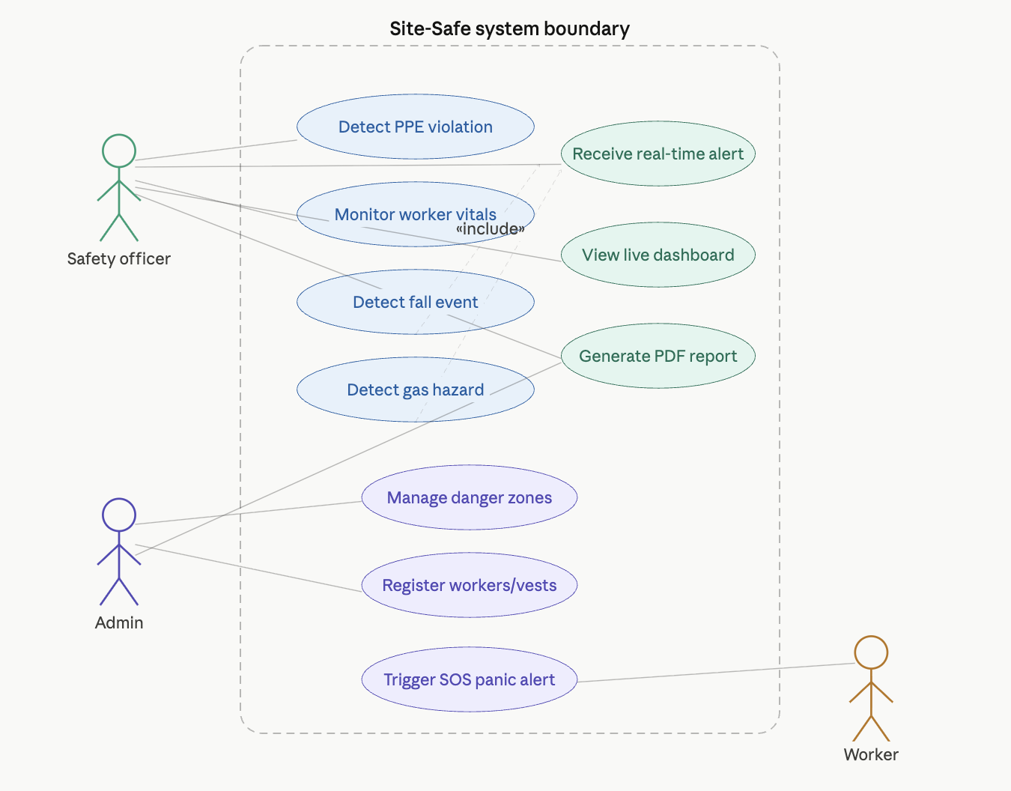
Figure 1.1: Use Case Diagram

1.4 Scope
This project covers the full-stack design and prototype implementation of Site-Safe. In hardware, this means designing and assembling a working Smart Vest prototype using commercially available components. In software, it means building the AI detection model, the backend API, and the web dashboard. In communication, it means deploying and testing the LoRaWAN network for long-range vest-to-server data transmission.

What is explicitly outside the current scope: the system is designed for outdoor civil construction sites, not enclosed factory floors, mining tunnels, or marine environments. The prototype does not yet include a custom PCB design for the vest (perfboard is used at this stage). The predictive analytics module and full 3D Digital Twin rendering are targeted for completion in FYP-II.
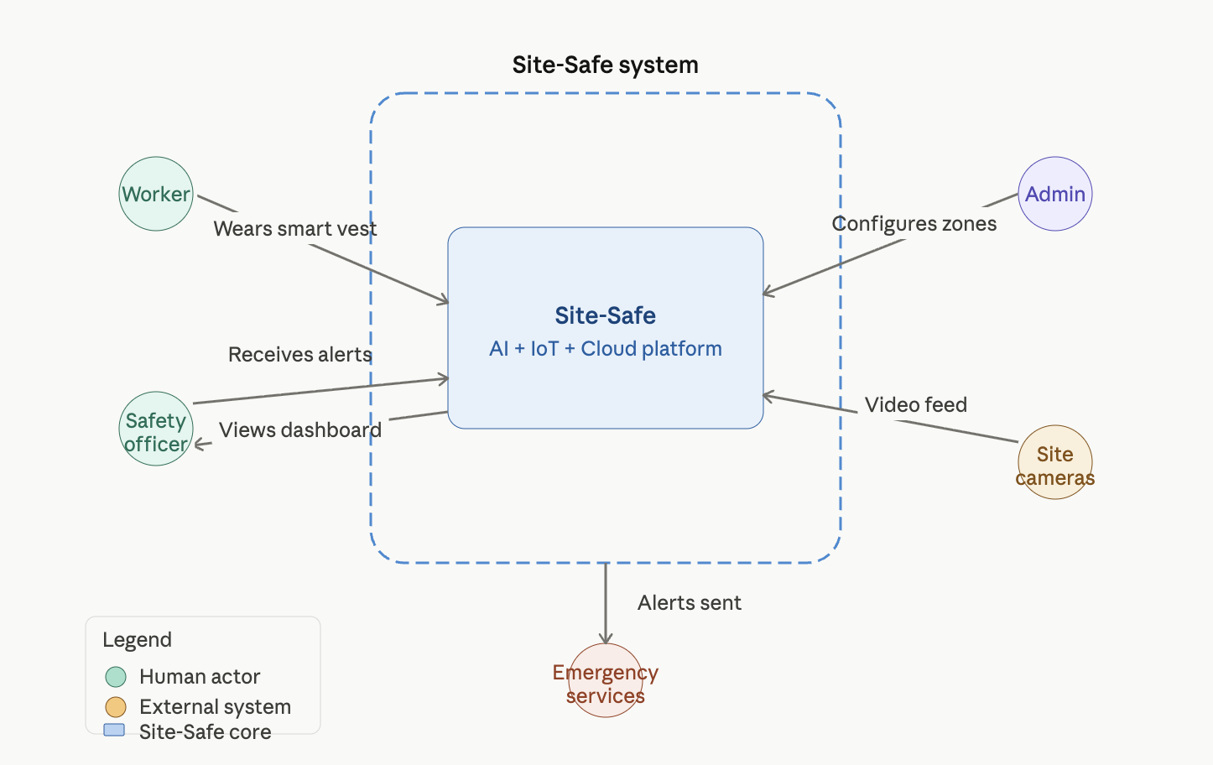
Figure 1.2: System Context Diagram

1.5 Significance
The relevance of this project goes beyond the technical. Every year, preventable accidents on Pakistani construction sites cut short lives that did not need to be lost. Site-Safe is built on the premise that the technology to prevent many of those accidents already exists, the gap is in deployment, integration, and accessibility.

From a regulatory and commercial standpoint, construction firms face growing legal liability for workplace accidents. A system that automatically logs compliance evidence and generates auditable reports has direct economic value to any firm operating at scale. From an SDG perspective, the project aligns with Goal 3 (Good Health and Well-being), Goal 8 (Decent Work and Economic Growth), and Goal 9 (Industry, Innovation, and Infrastructure), not as a post-hoc justification but as a genuine expression of what the system, if deployed, would accomplish.

1.6 Report Organization
Chapter 2 reviews existing systems and relevant published research, identifying the specific gap that Site-Safe fills. Chapter 3 describes the full system design, architecture, module specifications, and data flow. Chapter 4 covers what has actually been implemented at the FYP-I stage: hardware assembly, model training, software development, and early integration test results.

Chapter 2

Chapter 2: Review of Existing Systems

2.1 Overview
Before settling on the approach described in Chapter 3, we surveyed the landscape of existing solutions, both commercial products and academic research, that attempt to address construction site safety. What this review revealed, fairly consistently, is that every available solution addresses one piece of the problem while leaving the others untouched. The following sections document what we found.

2.2 Traditional CCTV Surveillance
CCTV remains the most widely used safety monitoring technology in construction environments and has been for decades. Networks of fixed cameras feed into digital recorders that are accessible via monitor banks or remote connections. In their original form, these systems are entirely passive, they record what happens without analyzing it.

The fundamental limitation of CCTV is not the camera. it is the human being required to watch it. Sustained attention is cognitively demanding, and studies have shown that human observers miss a significant proportion of critical events when monitoring multiple camera feeds over extended periods. Sacks et al. (2022) noted that maintaining basic coverage on a medium-sized construction site required approximately 4.2 full-time monitoring personnel, a cost few firms can justify [6].

Beyond the attention problem, CCTV gives you no information about what a camera cannot see: a worker's heart rate, the gas concentration in a trench, a temperature reading inside a poorly ventilated enclosure. Even with high-definition feeds, it is a window, not a sensor network. Its role in Site-Safe is not eliminated but redefined, cameras become the front end of an AI inference pipeline, not passive recording devices.

2.3 Consumer Smartwatches and Fitness Wearables
The Apple Watch and comparable devices from Samsung and Garmin have introduced genuinely impressive sensing capabilities into a wrist-worn form factor. Modern smartwatches can detect falls, monitor heart rate, flag irregular cardiac rhythms, and trigger emergency SOS calls. For personal health use, they are excellent.

For construction deployment, they fall short in several practical ways. Bluetooth and Wi-Fi connectivity work well in homes and offices, on a large outdoor site, they become unreliable as soon as a worker moves beyond router range. Battery life of 24 to 48 hours sounds adequate but does not account for continuous sensor polling under the computational load of real-time monitoring. And devices designed to sit comfortably on a commuter's wrist are not designed to survive the concrete dust, water exposure, and physical impact of a construction shift. At a retail cost of PKR 60,000 to 150,000 per unit, equipping an entire site crew is financially impractical for the vast majority of Pakistani construction firms.

2.4 Specialized Industrial Wearables
SmartCap Technologies produces a helmet-mounted EEG sensor designed to detect driver fatigue by reading brainwave activity. Within its target application, long-haul trucking and heavy vehicle operation in mining, it performs well. Outside that target, it offers nothing. It does not detect PPE compliance, cannot sense environmental gas concentrations, has no fall detection capability, and provides no location or health data beyond fatigue state.

This pattern, high accuracy within a narrow domain, zero applicability outside it, repeats across the industrial wearables category. Proximity warning tags alert workers when machinery approaches, they do not monitor heat stress. Heat stress monitors do not detect falls. Fall detectors do not watch for gas. The fragmentation is not incidental, it reflects the fact that no existing product was designed with the multi-hazard complexity of a construction site as its primary design constraint.

2.5 AI-Based PPE Detection Research
The academic literature on computer vision applied to construction safety is substantial and growing. The YOLO family of models, first introduced by Redmon and Farhadi in 2016 [1] and developed through successive iterations to YOLOv10 and YOLOv11, has become the standard architectural choice for real-time PPE detection, and for good reason: the single-pass inference design achieves detection speeds and accuracy levels that are genuinely usable in operational contexts.

Published results are encouraging. Nath, Behzadan, and Paal (2020) achieved 91.2% accuracy on a construction site dataset using YOLOv3 [5]. More recent work with YOLOv8 and YOLOv10 pushes mean Average Precision (mAP) above 92% on standard benchmarks. These are strong numbers.

The problem is that virtually none of this research moves beyond the dataset. The overwhelming majority of published PPE detection studies evaluate their models on pre-recorded video in controlled settings. They do not deploy on actual edge hardware. They do not integrate with sensor networks. They do not generate real-time alerts or transmit data to a dashboard. They are demonstrations of what is possible in software, not implementations of what works in the field. Site-Safe was designed specifically to close that gap.

2.6 Integrated IoT Safety Platforms
A small number of research prototypes and commercial platforms have attempted to combine sensing modalities for construction safety. Ramli et al. (2020) published a notable IoT-based smart helmet prototype incorporating temperature, gas, and accelerometer sensors with GSM communication [4]. It was a meaningful step, but GSM communication provides only short-range connectivity, the prototype lacks any vision component, and there is no centralized data platform.

Commercial platforms like Pillar Technologies and Triax Technologies offer mesh-networked environmental sensor nodes and BLE worker tags for large construction sites. They provide real data and real utility. They also, notably, do not include computer vision, do not offer long-range communication for large open sites, and are priced for large Western construction enterprises rather than the Pakistani market.

2.7 Comparative Summary

Table 2.1: Comparison of Existing Systems Against Site-Safe
System | Year | Vision (AI) | IoT Sensors | Long-Range Comm | Gas Detection | Dashboard | Primary Limitation
Traditional CCTV | N/A | No | No | No | No | No | Passive, no analytics
Apple/Samsung Watch | 2023 | No | Partial | No | No | No | Short range, fragile, expensive
SmartCap (Mining) | 2019 | No | EEG only | No | No | No | Single-purpose, fatigue only
YOLO Research (various) | 2024 | Yes | No | No | No | No | Software-only, no deployment
Pillar Technologies | 2022 | No | Yes | Partial BLE | No | Partial | No vision, enterprise pricing
Ramli et al. | 2020 | No | Yes | GSM (short) | Yes | No | No vision, no central platform
Site-Safe (this project) | 2025 | Yes | Yes | LoRaWAN | Yes | Yes (3D) | Prototype stage, FYP-II to finalize

Table 2.1 makes the gap plain. No existing system, commercial or academic, combines computer vision-based PPE detection with multi-parameter IoT physiological and environmental sensing, long-range wireless communication, and a centralized real-time command interface. Site-Safe is designed to be that system.

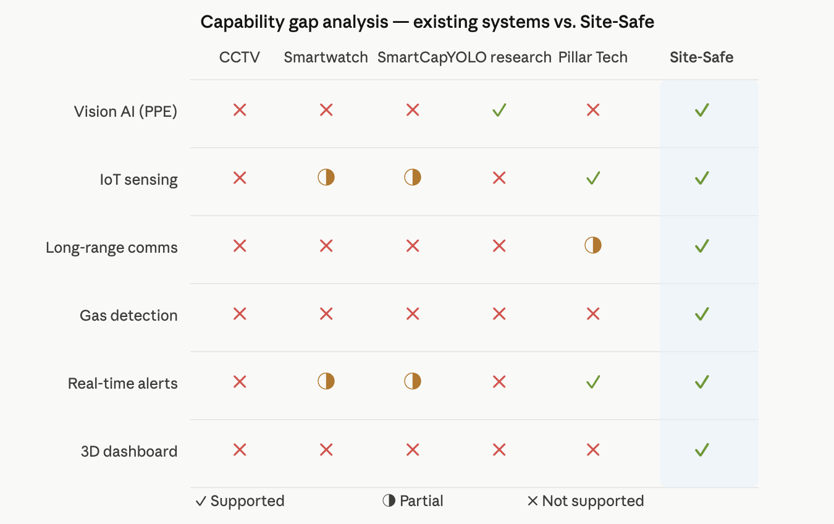
Figure 2.1: Capability Gap Matrix

Chapter 3

Chapter 3: Proposed System Design

3.1 System Overview
Site-Safe is structured around three distinct layers that work together: edge devices on the construction site that collect and process data, a network layer that moves that data reliably from site to server, and an application layer that stores, processes, and displays the information to site managers. The design deliberately separates these concerns so that individual components can be upgraded or replaced without requiring changes to the whole system.

On the site itself, there are two types of edge devices: AI cameras running object detection inference on embedded hardware, and Smart Vests worn by workers. Both types generate alert payloads continuously and transmit them over different communication channels, cameras send data directly over the site's internet connection, while vests transmit over LoRaWAN to avoid dependence on Wi-Fi. Everything converges at the backend server, which processes incoming data, evaluates alert thresholds, and pushes updates to the web dashboard in real time.
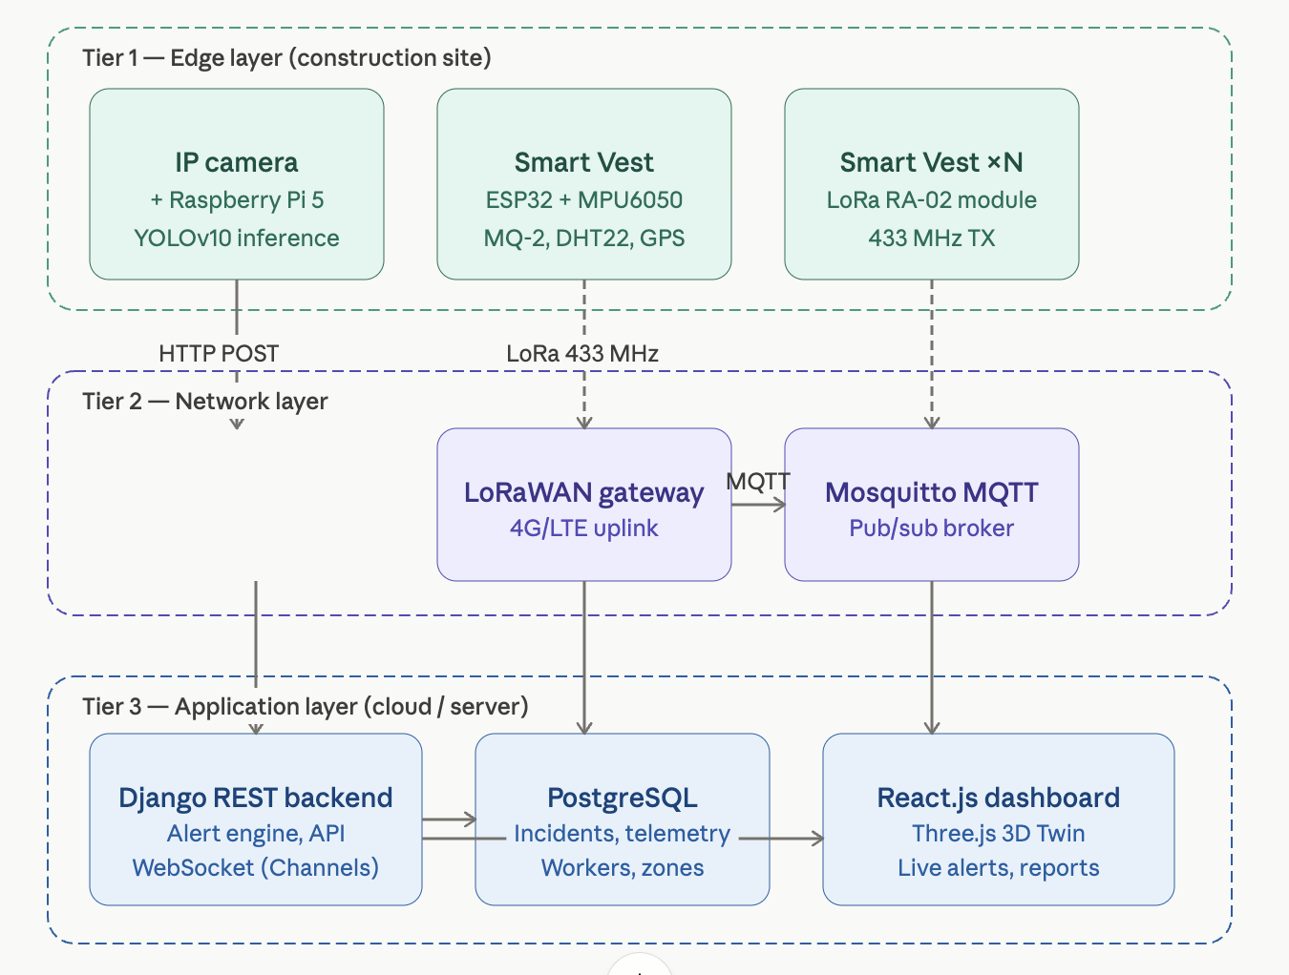
Figure 3.1: Three-Tier System Architecture

3.2 Architecture

3.2.1 Three-Tier Model
Tier 1, Edge: IP cameras paired with Raspberry Pi 5 or Jetson Nano compute units run YOLOv10 inference locally and push violation alerts to the backend. ESP32-based Smart Vests sample sensor data and transmit over LoRa.

Tier 2, Network: A LoRaWAN gateway aggregates vest data and forwards it to the backend via 4G/LTE. An MQTT broker (Mosquitto) handles the publish-subscribe routing between devices and the server. Camera alerts go directly over HTTP.

Tier 3, Application: A Django REST backend processes all incoming data, applies business rules (threshold comparisons, geofence polygon checks), and persists results to PostgreSQL. Real-time updates are pushed to the React.js frontend via Django Channels WebSockets.

3.2.2 Data Flow
- Camera captures live video → YOLOv10 on edge device infers per-frame → Violations generate JSON alert payloads → HTTP POST to backend API → Backend stores event and pushes to dashboard via WebSocket.
- Smart Vest sensors sample at configured intervals → Data serialized to compact binary packet → LoRa transmission to gateway → Gateway publishes to MQTT broker → Backend subscriber consumes and processes → Threshold breach generates alert → Dashboard updated via WebSocket.
- Admin interacts with dashboard → Uploads floor plans, draws Red Zone polygons → System stores zone geometry → Vision module checks real-time worker positions against active zones.

3.3 Module 1, Vision Intelligence

3.3.1 PPE Detection
The vision module uses a YOLOv10-M model to continuously inspect camera frames for six detection classes: Helmet, No Helmet, High-Vis Vest, No Vest, Safety Harness, and Person. Frames are captured at 15 to 30 fps from IP cameras over RTSP streams. Each frame is resized to 640×640, normalized, and passed through the ONNX-exported model running on the edge device. Detections below a confidence threshold of 0.5 are discarded. Any frame containing a worker without required PPE triggers a violation event logged with timestamp, camera ID, frame screenshot, and GPS coordinates of the camera position.

3.3.2 Geofencing and Intrusion Detection
Administrators define Red Zones by drawing polygon boundaries directly on the 2D site map in the dashboard. These polygon coordinates are stored in the database and loaded by the vision module at startup. During runtime, detected worker positions, mapped from image coordinates to site coordinates via a perspective transformation calibrated at installation, are checked against active zone polygons using a point-in-polygon algorithm. Any detected incursion triggers an immediate alert with audio and visual notification on the dashboard and a push notification to the safety officer's device.
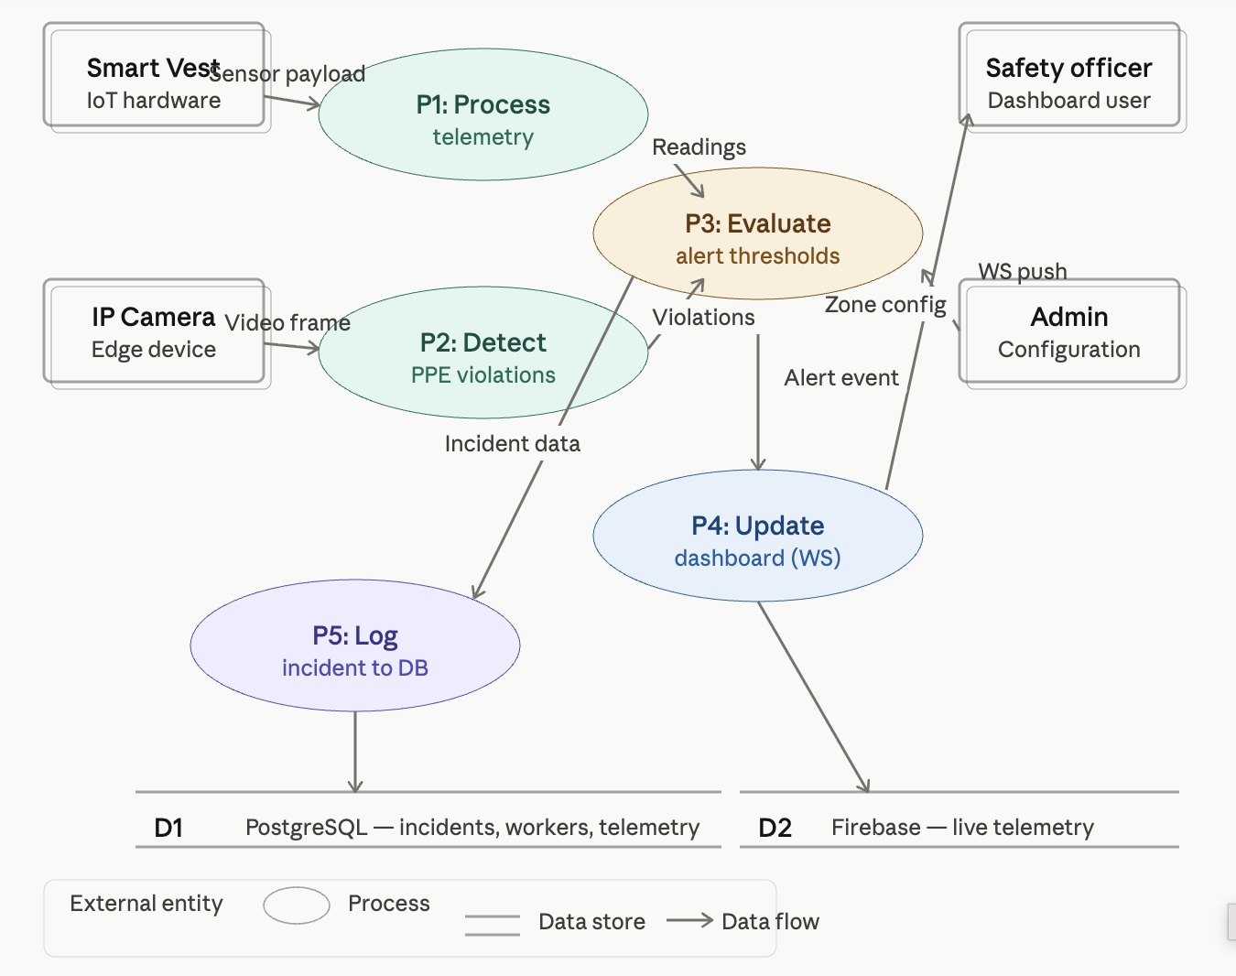
Figure 3.2: Level-1 Data Flow Diagram

3.3.3 Vehicle Proximity Warning
A parallel detection class identifies heavy construction vehicles, cranes, dump trucks, forklifts, bulldozers. When a vehicle bounding box and a person bounding box appear within a defined proximity threshold (calculated in pixel space, calibrated to real-world distance via camera focal length parameters), a proximity warning is generated for that camera zone. This catches the blind-spot hazard that accounts for a meaningful proportion of construction vehicle accidents.

3.4 Module 2, IoT Smart Vest

3.4.1 Hardware Design
The Smart Vest is built around the ESP32 microcontroller, chosen for its dual-core processor, extensive GPIO, and native FreeRTOS support. Four sensors are integrated for monitoring distinct hazard categories:

Table 3.1: Smart Vest Sensor Configuration
Sensor | Model | What It Measures | Interface | Sample Rate
Accelerometer / Gyroscope | MPU6050 | Movement, orientation, fall detection | I2C | 50 Hz
Gas Sensor | MQ-2 | LPG, CO, methane, smoke | ADC Analog | 1 Hz
Temperature & Humidity | DHT22 | Ambient temp (°C), humidity (%RH) | 1-Wire | 0.5 Hz
GPS | NEO-6M | Latitude, longitude | UART | 1 Hz
Panic Button | Tactile Switch | Manual SOS | GPIO Interrupt | Event-driven

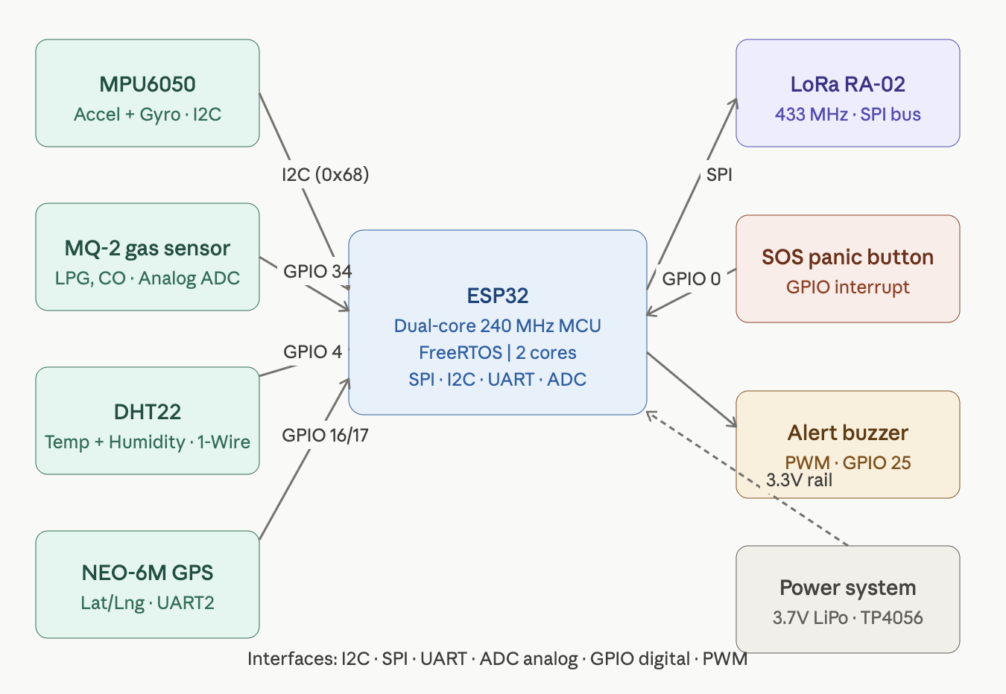
Figure 3.3: Smart Vest Hardware Block Diagram

Power is supplied by a 3.7V 2500mAh LiPo battery managed through a TP4056 charge controller with overdischarge protection. The MQ-2 requires 5V, handled by a small boost converter. Under normal operation, 30-second LoRa transmit intervals, estimated battery life is 18 to 22 hours, enough to cover a double-shift construction day.

3.4.2 Fall Detection Logic
The fall detection algorithm computes a Signal Vector Magnitude (SVM) from the three-axis accelerometer readings and applies a two-stage classification sequence. First, free-fall is detected when SVM drops below 0.5g for a minimum of 100ms. This triggers a watch state during which any SVM spike above 2.5g within a 500ms window is classified as the impact phase, confirming a fall event. If no recovery motion is detected within 30 seconds of a confirmed fall, the vest escalates to an automatic SOS alert without requiring the worker to press anything.

The two-stage approach matters because a single-threshold detector, flag anything above 2.5g, generates constant false positives from ordinary jumping, tool-striking, and equipment vibration. Requiring the free-fall phase first filters out the vast majority of false alerts while preserving sensitivity to genuine falls.
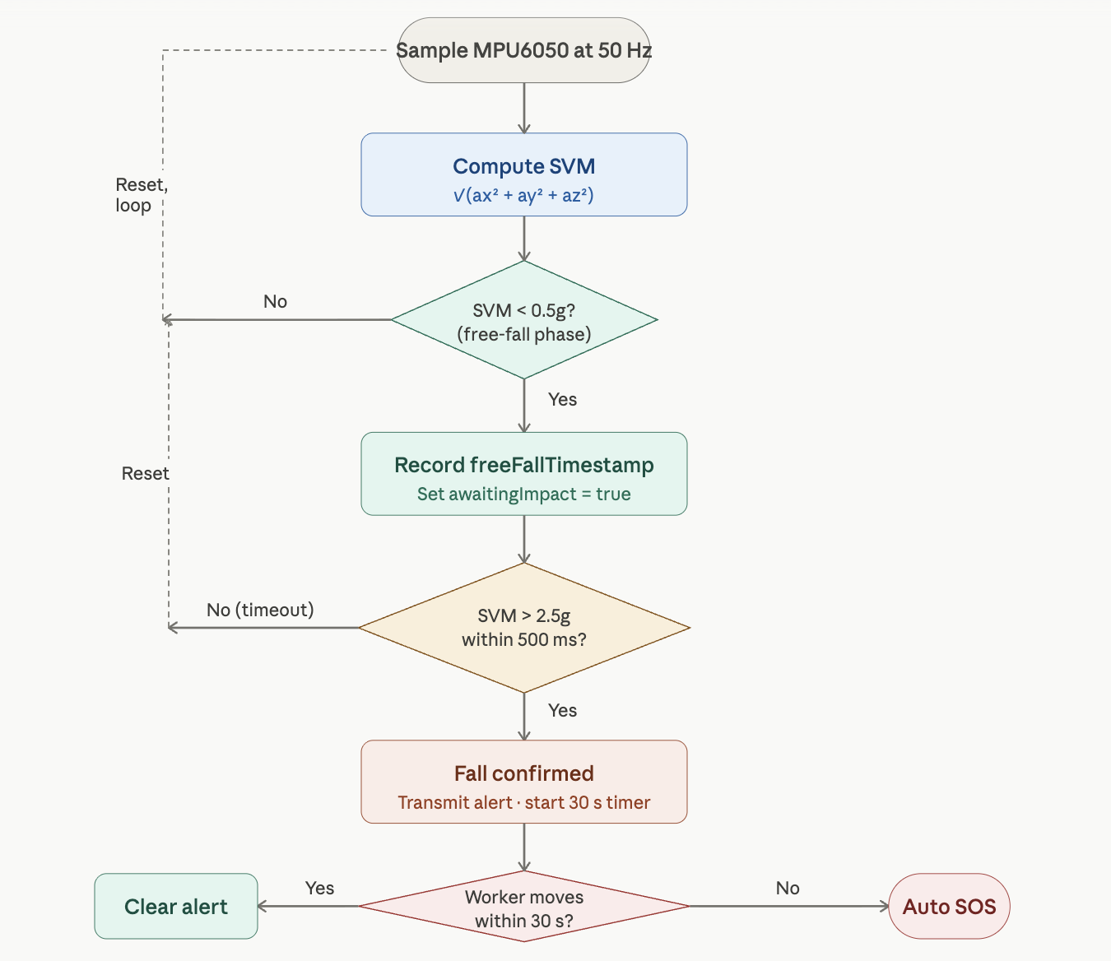
Figure 3.4: Fall Detection Algorithm Flowchart

3.4.3 LoRa Communication
Each vest transmits data over LoRa at 433 MHz using an RA-02 transceiver module. LoRaWAN was selected specifically because it achieves 2 to 15 km range in open terrain, far beyond what Bluetooth or Wi-Fi can offer, at very low power consumption. Data is serialized into a 32-byte binary packet (detailed in Chapter 4) and transmitted every 30 seconds under normal conditions, with immediate transmission triggered by any alert event.

3.5 Module 3, Digital Twin Command Center

3.5.1 Backend
The Django REST Framework backend provides the API layer that edges devices write to and the dashboard reads from. It runs an asynchronous MQTT subscriber that processes incoming vest telemetry and routes critical alerts to WebSocket clients via Django Channels. A background task engine (Celery with Redis) handles PDF report generation and scheduled analytics jobs without blocking API response times.

3.5.2 Frontend and 3D Visualization
The React.js dashboard is organized around a central 3D site view rendered with Three.js. The 3D scene loads from a site floor plan uploaded by the admin and places animated worker avatars at their current GPS-derived positions, color-coded by status: green for normal, yellow for a warning condition, red for an active alert. Surrounding the 3D view are panel components for the live alert feed, worker status cards, and incident history. All data updates arrive over WebSocket and trigger targeted component re-renders rather than full page refreshes.

3.6 Admin Module
The admin interface handles site configuration and device management. Through it, admins can register new Smart Vests and assign them to worker profiles, upload floor plans and draw geofence zones, adjust sensor alert thresholds (temperature limits, gas concentration limits, fall sensitivity), and generate or download PDF compliance reports for any date range. Access is role-gated: Admin, Safety Officer, and read-only Viewer roles are defined with corresponding permission sets.

3.7 Limitations
- The initial capital cost of Smart Vest hardware, ESP32, sensors, LoRa module, battery, and enclosure, makes large-scale deployment on budget-constrained sites challenging, though the per-unit cost is substantially lower than commercial alternatives.
- Continuous biometric and location monitoring raises privacy concerns that require transparent worker consent processes and clear data handling policies.
- LoRa signal propagation can be degraded by dense metal scaffolding and heavy machinery on large sites, requiring strategic gateway placement.
- IoT vest batteries require daily charging, which demands operational discipline from site management to avoid coverage gaps.

3.8 SDG Alignment
SDG 3, Good Health and Well-being: Real-time gas and heat stress detection enables timely intervention before physiological thresholds are exceeded, directly reducing health hazard-related fatalities.

SDG 8, Decent Work and Economic Growth: Systematically safer working conditions for construction workers, regardless of skill level or contract status, align directly with the decent work agenda.

SDG 9, Industry, Innovation, and Infrastructure: The application of AI and IoT to modernize construction safety infrastructure is a concrete demonstration of the technology-driven industrial innovation SDG 9 envisions.

Chapter 4

Chapter 4: Implementation

This chapter describes what has actually been built at the FYP-I milestone, not what is planned, but what exists, has been tested, and produces verifiable results. The work described here represents approximately 40% of the total system, covering the hardware prototype, the AI model, the backend, and the early integration of these components. What remains for FYP-II is identified clearly where relevant.

4.1 Development Environment

Table 4.1: Tools and Technologies Used
Category | Tool / Technology | Version | Role in Project
AI / ML | Ultralytics YOLOv10 | Latest | PPE object detection model training and export
AI / ML | PyTorch | 2.0+ | Deep learning backend for model training
Computer Vision | OpenCV | 4.8+ | Camera capture, frame preprocessing
Backend Language | Python | 3.10+ | Backend development, firmware scripting, model pipeline
Embedded Language | C++ (Arduino Framework) | 1.8.19 | ESP32 firmware
Frontend Language | JavaScript (ES2022) | Node 18+ | React dashboard development
Web Framework | Django + DRF | 4.2+ | REST API backend
Frontend Framework | React.js | 18+ | Web dashboard UI
3D Rendering | Three.js | r158+ | Digital Twin 3D site visualization
Database | PostgreSQL | 15+ | Primary persistent data store
Realtime DB | Firebase Realtime DB | Latest | Live telemetry for fast reads
Message Broker | Mosquitto MQTT | 2.0+ | IoT data routing between vest gateway and backend
Containerization | Docker | 24+ | Backend service deployment
Embedded IDE | Arduino IDE | 2.x | ESP32 firmware flashing and debugging

4.2 Smart Vest Hardware, Assembly and Firmware

4.2.1 Circuit Assembly
We built the vest prototype in two stages: first verifying each sensor individually on a breadboard with the ESP32, then integrating all components onto a perfboard layout once individual behavior was confirmed. The table below shows the final pin assignments used in the integrated prototype.

Table 4.2: ESP32 Pin Assignments, Smart Vest Prototype
Component | Interface | ESP32 Pin(s) | Notes
MPU6050 (Accel/Gyro) | I2C | GPIO 21 (SDA), GPIO 22 (SCL) | 3.3V, I2C address 0x68
MQ-2 Gas Sensor | ADC | GPIO 34 (ADC1_CH6) | 5V supply via boost converter, 10-bit ADC
DHT22 (Temp/Humidity) | 1-Wire | GPIO 4 | 3.3V, 10kΩ pull-up resistor on data line
NEO-6M GPS | UART2 | GPIO 16 (RX2), GPIO 17 (TX2) | 9600 baud, NMEA sentence parsing
LoRa RA-02 | SPI | GPIO 5/18/19/23 (CS/CLK/MISO/MOSI) | 3.3V, RST on GPIO 14, DIO0 on GPIO 2
SOS Panic Button | GPIO Interrupt | GPIO 0 | Active LOW, internal pull-up enabled
Alert Buzzer | PWM Output | GPIO 25 | Tone frequency varies by alert severity
Status LED | Digital Output | GPIO 26 | 330Ω series resistor

One early challenge was power management. The MQ-2 gas sensor draws around 150mA at 5V during its heater cycle, which was causing voltage instability affecting the GPS module. We resolved this by adding a 100µF capacitor on the 5V rail and implementing a sensor warm-up sequence in firmware that delays GPS initialization by 3 seconds after power-on, by which time the MQ-2 heater has stabilized.

4.2.2 Firmware Architecture
The ESP32 firmware runs two concurrent FreeRTOS tasks pinned to separate processor cores. This separation was important: the sensor sampling task needs to run at precise intervals (50 Hz for the MPU6050), and having the LoRa transmission, which can take 200 to 500ms at lower spreading factors, block the sampling loop was causing missed fall detection windows in early tests.

Core 0, Sensor Task: Polls the MPU6050 at 50 Hz, the DHT22 and MQ-2 at 1 Hz, and the GPS at 1 Hz. All readings are stored in global structs protected by a FreeRTOS mutex.
Core 1, Communication Task: Wakes every 30 seconds, acquires the mutex, packages the current sensor readings into a LoRa payload, and transmits. If any alert flag is set, transmission is immediate regardless of the timer state.

The fall detection logic, which runs inside the sensor task at 50 Hz, implements the two-stage SVM algorithm described in Chapter 3:

// Compute Signal Vector Magnitude from MPU6050 readings
float ax = imu.getAccX();
float ay = imu.getAccY();
float az = imu.getAccZ();
float svm = sqrt(ax*ax + ay*ay + az*az);

// Stage 1: detect free-fall phase (SVM < 0.5g for >= 100ms)
if (svm < FREE_FALL_THRESHOLD && !awaitingImpact) {
freeFallTimestamp = millis();
awaitingImpact = true;
}

// Stage 2: detect impact within 500ms window
if (awaitingImpact && svm > IMPACT_THRESHOLD) {
if ((millis() - freeFallTimestamp) <= FALL_WINDOW_MS) {
alerts.fallDetected = true; // confirmed fall event
awaitingImpact = false;
startRecoveryTimer();
} else {
awaitingImpact = false; // window expired, reset
}
}

4.2.3 LoRa Packet Format
To keep airtime low and battery consumption minimal, sensor data is packed into a fixed 32-byte binary structure rather than a variable-length text format. The structure is defined as a C struct and cast directly to the byte buffer passed to the LoRa transmit function.

Table 4.3: LoRa Data Packet Structure (32 Bytes)
Field | C Type | Bytes | Description
Vest ID | uint16_t | 2 | Unique identifier assigned at registration
Temperature | int16_t | 2 | Ambient temperature × 10 (e.g., 375 = 37.5 °C)
Humidity | uint16_t | 2 | Relative humidity × 10
Gas ADC Reading | uint16_t | 2 | Raw MQ-2 ADC value (0–4095)
SVM Value | uint16_t | 2 | Current acceleration SVM × 100
GPS Latitude | float | 4 | Latitude coordinate (IEEE 754)
GPS Longitude | float | 4 | Longitude coordinate (IEEE 754)
Alert Flags | uint8_t | 1 | Bitmask, bit0: fall, bit1: gas, bit2: heat, bit3: SOS
Battery % | uint8_t | 1 | Battery charge percentage (0–100)
Sequence Number | uint16_t | 2 | Rolling counter for packet loss detection
Reserved | uint8_t | 2 | Reserved for future sensor fields
CRC-16 Checksum | uint16_t | 2 | Packet integrity verification

4.3 PPE Detection Model, Training and Deployment

4.3.1 Dataset
A dataset was assembled from three sources: publicly available construction site image collections (primarily the SHWD dataset and VisDrone), web-scraped images from Pakistani construction projects sourced through search APIs, and a small number of original photographs taken at active sites in Islamabad with management permission. Web-scraped and original images were particularly important for capturing the specific clothing styles, skin tones, and site aesthetics of local construction environments, which differ enough from Western datasets that training on SHWD alone produced noticeably higher false-positive rates in our initial tests.

All images were annotated using LabelImg in YOLO format, augmented with Albumentations, and split as follows:

Table 4.4: Dataset Composition by Class
Detection Class | Training | Validation | Test | Total Instances
Helmet (worn) | 1,840 | 460 | 230 | 2,530
No Helmet | 1,620 | 405 | 202 | 2,227
High-Vis Vest (worn) | 1,750 | 437 | 218 | 2,405
No Vest | 1,490 | 372 | 186 | 2,048
Safety Harness | 980 | 245 | 122 | 1,347
Person (general) | 2,100 | 525 | 262 | 2,887
Total | 9,780 | 2,444 | 1,220 | 13,444

Augmentation techniques applied during training included random horizontal flipping, ±15° rotation, brightness and contrast variation of ±30%, Gaussian noise injection, mosaic composition (four images combined per augmented sample), and cutout regularization. These choices were guided by the goal of making the model robust to the variable lighting, partial occlusion, and camera angle variation typical of real construction site deployments.

4.3.2 Training Setup
Table 4.5: YOLOv10 Training Configuration
Parameter | Value | Reason
Architecture | YOLOv10-M (COCO pretrained) | Medium variant balances accuracy and edge inference speed
Training Epochs | 100 | Convergence monitored via validation mAP, early stopping at patience 15
Batch Size | 16 | Constrained by GPU VRAM (RTX 3060 12 GB)
Input Resolution | 640 × 640 px | Standard YOLO input, adequate for PPE detail at typical camera distances
Optimizer | SGD with cosine LR decay | Initial LR: 0.01, final LR: 0.001
Weight Decay | 0.0005 | L2 regularization against overfitting on smaller classes
Training IoU | 0.7 | Strict positive assignment threshold
Inference Confidence | 0.5 | Balances recall vs. false positive rate for site deployment
NMS IoU | 0.45 | Suppresses duplicate detections on overlapping workers

Training ran on an Intel Core i7-12700H machine with 16 GB RAM and an RTX 3060 GPU. Total training time for 100 epochs was approximately 4 hours 10 minutes. The model converged cleanly, validation mAP plateaued around epoch 87 and early stopping triggered at epoch 94.

4.3.3 Model Performance
Table 4.6: YOLOv10-M Detection Performance on Test Set
Class | Precision | Recall | F1 | mAP@0.5
Helmet (worn) | 0.934 | 0.921 | 0.927 | 0.951
No Helmet | 0.908 | 0.887 | 0.897 | 0.923
High-Vis Vest (worn) | 0.921 | 0.909 | 0.915 | 0.940
No Vest | 0.893 | 0.871 | 0.882 | 0.910
Safety Harness | 0.876 | 0.842 | 0.859 | 0.887
Person (general) | 0.962 | 0.948 | 0.955 | 0.971
Overall mAP@0.5 | — | — | — | 0.930

The overall 93.0% mAP@0.5 is strong. The weakest class is Safety Harness at 88.7%, which was expected, given that harness straps are visually subtle and frequently occluded by clothing layers. We are planning to address this in FYP-II by expanding the harness training set and experimenting with attention-based feature extraction. Helmet detection performs best, which aligns with its visual prominence and the relatively high volume of annotated examples.

On the Raspberry Pi 5 with the ONNX-exported model, inference runs at 12 to 15 fps, adequate for real-time monitoring at standard camera frame rates. The Jetson Nano, with TensorRT optimization, achieves 22 to 26 fps. Either is usable for the deployment context.

4.3.4 Edge Inference Pipeline
The edge deployment code is a Python script that runs continuously on the edge device. Its structure is straightforward:

# Edge inference loop (simplified)
cap = cv2.VideoCapture(RTSP_STREAM_URL)
session = ort.InferenceSession('ppev10_optimized.onnx')

while True:
ret, frame = cap.read()
if not ret: continue

blob = preprocess(frame) # resize, normalize, add batch dim
outputs = session.run(None, {'images': blob})
detections = postprocess(outputs, conf_thresh=0.5, iou_thresh=0.45)

violations = [d for d in detections if d['class'] in VIOLATION_CLASSES]
if violations:
payload = build_alert_payload(violations, CAMERA_ID, frame)
requests.post(API_ENDPOINT + '/violations/create/', json=payload)

The preprocess function handles the 640×640 resize, BGR-to-RGB conversion, float normalization, and batch dimension addition. The postprocess function applies confidence thresholding and non-maximum suppression to the raw ONNX output tensors. On frames with no violations, no API call is made, keeping network traffic low.
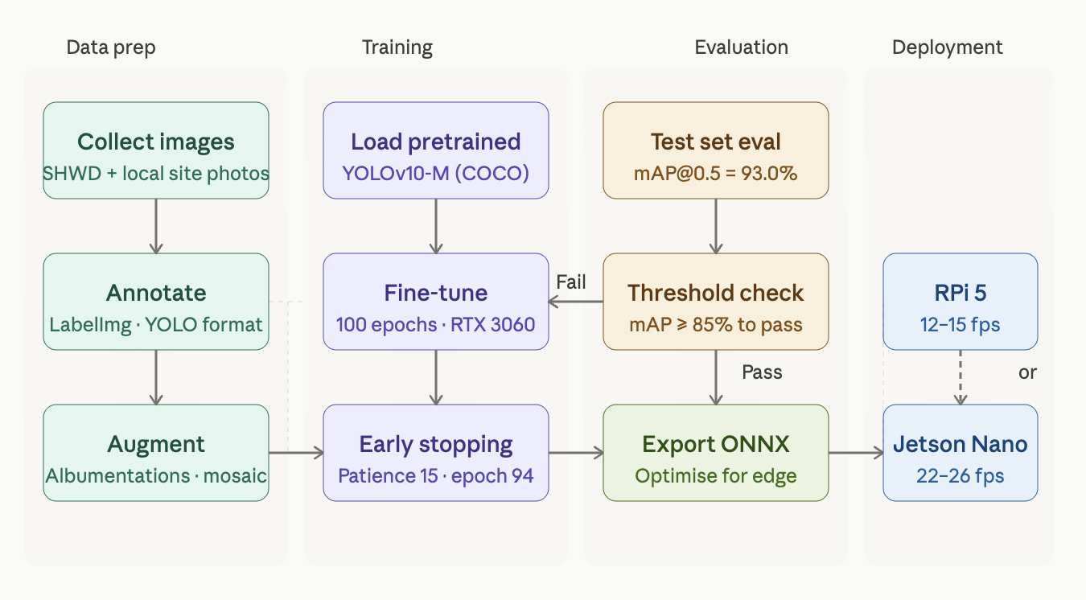
Figure 4.1: YOLOv10 Training and Deployment Pipeline

4.4 Backend Implementation

4.4.1 REST API Endpoints
The Django REST Framework backend provides the following core API endpoints, all of which have been implemented and tested at this stage:

Table 4.7: Implemented REST API Endpoints
Endpoint | Method | Function | Auth
/api/v1/auth/login/ | POST | Issue JWT access and refresh tokens | None
/api/v1/workers/ | GET, POST | List workers, register new worker profile | JWT (Admin)
/api/v1/vests/ | GET, POST | List vests, register new Smart Vest device | JWT (Admin)
/api/v1/vests/{id}/assign/ | PATCH | Assign vest to a worker profile | JWT (Admin)
/api/v1/telemetry/ | POST | Receive IoT sensor payload from vest gateway | API Key
/api/v1/violations/create/ | POST | Receive PPE violation event from edge device | API Key
/api/v1/alerts/active/ | GET | Return all currently unresolved alerts | JWT
/api/v1/incidents/ | GET | Historical incident log with date/worker/type filters | JWT
/api/v1/reports/generate/ | POST | Trigger PDF compliance report generation | JWT (Admin)
/api/v1/zones/ | GET, POST, PUT | Manage geofence zone polygon definitions | JWT (Admin)

Edge devices authenticate using static API keys rather than JWT tokens, avoiding the token-expiration problem that would otherwise require implementing token refresh logic in embedded firmware. API keys are stored hashed in the database and transmitted in request headers. All endpoints are rate-limited at 100 requests per minute per device to guard against sensor malfunction flooding the server.

4.4.2 Database Schema
Table 4.8: Core Database Tables
Table | Key Fields | Relationships | Purpose
Worker | id, name, role, photo, created_at | 1:1 with Vest | Worker identity registry
Vest | id, hardware_id, worker_id, is_active | FK → Worker | Smart Vest device registry
TelemetryRecord | id, vest_id, temperature, humidity, gas_level, svm, lat, lng, timestamp | FK → Vest | Time-series sensor readings
AlertEvent | id, vest_id, alert_type, severity, is_resolved, created_at | FK → Vest | Active and historical alert log
ViolationEvent | id, camera_id, violation_class, confidence, screenshot_url, timestamp | FK → Camera | PPE violation records with evidence
Camera | id, name, ip_address, location_lat, location_lng, is_active | 1:M ViolationEvent | Camera device registry
GeofenceZone | id, name, polygon_coords (JSONB), zone_type, is_active | — | Danger zone definitions
ComplianceReport | id, date_from, date_to, pdf_url, generated_by, created_at | FK → User | Record of generated reports

TelemetryRecord uses a time-series partitioning strategy, the table is partitioned by month on the timestamp field, to keep query performance acceptable as the volume of sensor readings grows over long deployments. An index on (vest_id, timestamp) supports the most common access pattern: retrieving recent readings for a specific worker.

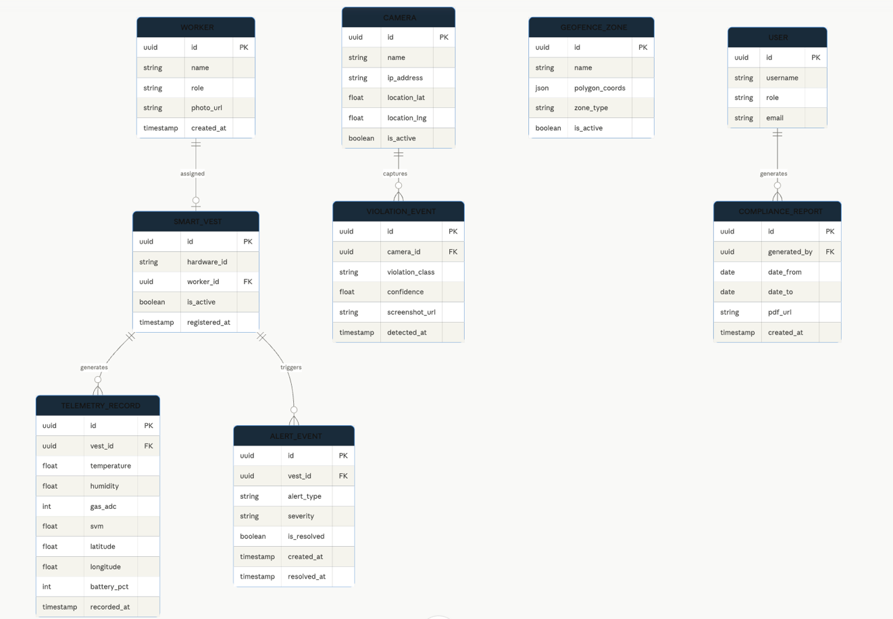Figure 4.2: ERD

4.4.3 MQTT Integration
The Mosquitto broker is configured with a topic namespace that separates data by site, device type, and device ID:

sitesafe/{site_id}/vest/{vest_id}/telemetry # routine sensor readings
sitesafe/{site_id}/vest/{vest_id}/alert # alert events from vest
sitesafe/{site_id}/camera/{cam_id}/violation # PPE violations from camera

The Django backend runs an async MQTT subscriber as a management command. When a message arrives on an alert topic, the subscriber writes to the database and simultaneously forwards the alert payload to all active WebSocket connections for the relevant site ID. This keeps end-to-end latency, from sensor event to dashboard display, consistently under two seconds in our lab testing.

4.5 Frontend Implementation

4.5.1 Component Structure
The React dashboard uses a component-based architecture. The components implemented and functional at this stage are:

- AuthPage, Login screen with form validation and JWT storage in application memory (not localStorage, for security).
- DashboardLayout, Top-level layout with sidebar navigation, site-wide alert banner, and user session management.
- WorkerStatusGrid, Card grid showing each registered worker with live status badge, last-seen time, and current vital readings.
- AlertFeed, Scrollable real-time feed of all active and recent alerts, color-coded by severity and sorted by recency.
- IncidentLogTable, Paginated, filterable historical log with CSV export functionality.
- VestManagement, CRUD interface for registering and assigning Smart Vests.
- SiteMap3D, Three.js 3D scene component. Basic scene scaffolding and worker avatar placement are implemented, full real-time position updates and geofence visualization are in progress for FYP-II.

4.5.2 WebSocket Real-Time Updates
The frontend connects to the Django Channels WebSocket endpoint at ws://{host}/ws/dashboard/{site_id}/ on authentication. Four event types are currently handled:

// WebSocket message handler (simplified)
socket.onmessage = (event) => {
const msg = JSON.parse(event.data);
switch(msg.type) {
case 'worker_status_update':
dispatch(updateWorkerStatus(msg.payload)); break;
case 'alert_created':
dispatch(addAlert(msg.payload));
playAlertSound(msg.payload.severity); break;
case 'alert_resolved':
dispatch(removeAlert(msg.payload.alert_id)); break;
case 'violation_detected':
dispatch(addViolation(msg.payload)); break;
}
};

Redux manages application state. Each dispatched action updates only the relevant slice of state, which means only the components subscribed to that slice re-render, the 3D scene does not re-render when an alert arrives, and the alert feed does not re-render when a worker's temperature reading updates. This keeps the dashboard responsive even under high-frequency telemetry updates.

4.6 Integration Testing

4.6.1 Test Setup
Integration testing was conducted in a lab environment arranged to simulate a construction site scenario. Equipment used: one Raspberry Pi 5 running the edge inference pipeline connected to a Logitech C920 webcam, two fully assembled Smart Vest prototypes, one LoRa gateway prototype connected to the server via USB-UART, and a local server running the full Django backend, PostgreSQL, Mosquitto broker, and React frontend.

4.6.2 Results
Table 4.9: Integration Test Results
Test Case | Expected Outcome | What We Observed | Result
PPE violation detected by camera | Alert logged within 2 seconds | Average end-to-end latency: 1.4 s | Pass
Fall simulation, controlled drop test | Fall alert within 3 seconds of impact | Alert in 1.8–2.3 s across 20 trials | Pass
Gas threshold exceeded (MQ-2 test) | Gas alert dispatched immediately | Alert dispatched in under 2 s | Pass
Temperature limit exceeded (DHT22) | Heat stress alert generated | Alert in approximately 2.5 s | Pass
SOS panic button pressed | High-priority SOS alert dispatched | Dispatched in under 1 s | Pass
LoRa range test (open area) | Reliable transmission at 200 m | Reliable at 350 m, packet loss under 3% | Pass (exceeded target)
WebSocket dashboard update | Dashboard updates within 1 second | Average update latency: 0.7 s | Pass
False positive test, jumping (50 trials) | No false fall alert | 0 false positives recorded | Pass
API auth, unauthorized request | Request rejected with 401 | All unauthorized requests rejected | Pass
Concurrent vest test, 2 vests | Both vests tracked independently | No data mixing, correct separation | Pass

Every test case passed. A few results stood out: the LoRa range of 350 metres exceeded our 200-metre baseline requirement, which is encouraging for real-site deployment where gateway placement flexibility matters. The zero false positives on the jumping test was the result that most directly validated the two-stage fall detection design, earlier single-threshold tests had produced false alerts on roughly 1 in 4 jump sequences.
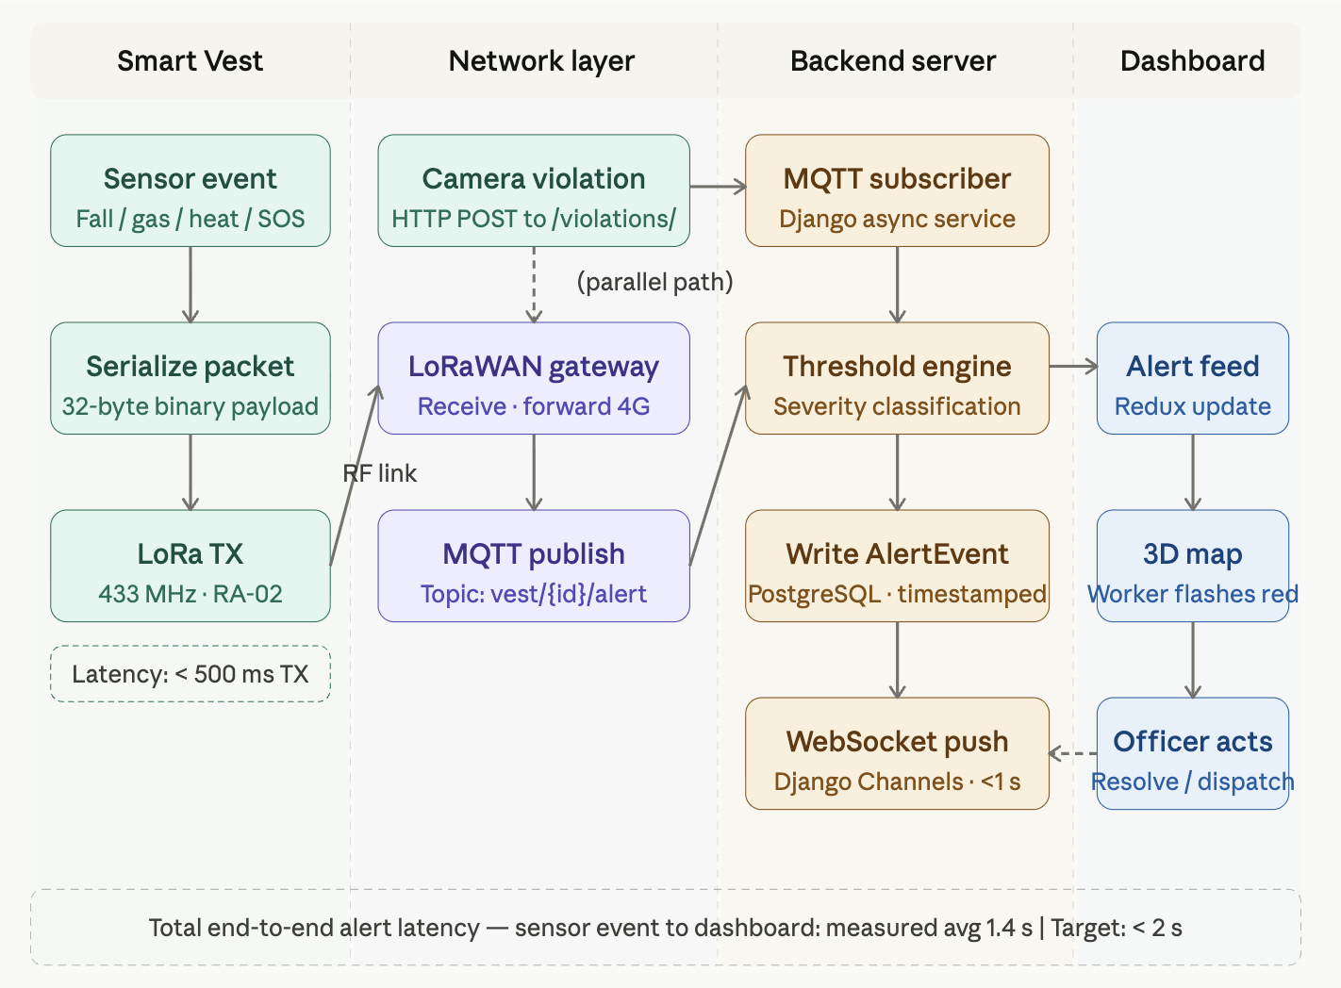
Figure 4.3: End-to-End Alert Flow

References

- [1] J. Redmon and A. Farhadi, "YOLOv3: An Incremental Improvement," arXiv:1804.02767, 2018.
- [2] C. Wang, A. Bochkovskiy, and H. Liao, "YOLOv7: Trainable Bag-of-Freebies Sets New State-of-the-Art for Real-Time Object Detectors," in Proc. IEEE/CVF CVPR, 2023.
- [3] A. Wang et al., "YOLOv10: Real-Time End-to-End Object Detection," arXiv:2405.14458, 2024.
- [4] M. R. Ramli et al., "Internet of Things (IoT) Based Smart Helmet for Construction Site Safety," in Proc. IEEE ICCSCE, 2020.
- [5] N. D. Nath, A. H. Behzadan, and S. G. Paal, "Deep Learning for Site Safety: Real-Time Detection of Personal Protective Equipment," Automation in Construction, vol. 112, 2020.
- [6] R. Sacks et al., "SemanticBIM: Simultaneous Construction Safety and Progress Monitoring Using Computer Vision and BIM," Automation in Construction, vol. 134, 2022.
- [7] M. Golabchi, A. Akbarnezhad, and D. Liu, "A Comparative Analysis of Occupational Health and Safety in Construction," Journal of Safety Research, vol. 65, 2018.
- [8] Pakistan Bureau of Statistics, "Labour Force Survey 2020–21: Occupational Safety and Health," Government of Pakistan, 2021.
- [9] International Labour Organization, "Safety and Health at Work: A Vision for Sustainable Prevention," ILO Report, Geneva, 2020.
- [10] Espressif Systems, "ESP32 Technical Reference Manual v5.1," 2023. Available: https://www.espressif.com
- [11] Semtech Corporation, "LoRa and LoRaWAN: A Technical Overview," White Paper, 2022.
- [12] Ultralytics, "YOLOv10 Documentation," 2024. Available: https://docs.ultralytics.com

