SITE-SAFE: A DIGITAL ECOSYSTEM FOR AUTONOMOUS CONSTRUCTION SAFETY



Muhammad Hamza
Hamza Hussain
Hanan Saeed

Supervised By
Muhammad Yousaf

Submitted for the partial fulfillment of the BS Computer Science degree
to the Faculty of Engineering & Computing

DEPARTMENT OF COMPUTER SCIENCE
NATIONAL UNIVERSITY OF MODERN LANGUAGES, ISLAMABAD
April, 2026
DECLARATION
We hereby declare that this project report entitled "Site-Safe: A Digital Ecosystem for Autonomous Construction Safety" is the result of our own work carried out under the supervision of Mr. Muhammad Yousaf, Department of Computer Science, National University of Modern Languages, Islamabad. The work presented in this report has not been submitted elsewhere for the award of any other degree or diploma.

Muhammad Hamza _____________________
Hamza Hussain _____________________
Hanan Saeed _____________________

Date: _______________

Certified by:
Supervisor: Mr. Muhammad Yousaf _____________________
ACKNOWLEDGMENTS
We would like to express our sincere gratitude to our supervisor, Mr. Muhammad Yousaf, for his continuous guidance, constructive feedback, and encouragement throughout this project. His expertise in software engineering and willingness to accommodate our questions made a real difference in the quality of our work.
We are also grateful to the Department of Computer Science at NUML Islamabad for providing the academic framework and resources that made this project possible. The feedback from our FYP evaluation committee helped us sharpen both the technical and documentation aspects of Site-Safe.
Finally, we thank our families for their patience and support during the long hours spent on development and testing.
Dedicated to our families and to every construction worker
who deserves to come home safe at the end of every shift.
ABSTRACT
Construction sites in Pakistan account for a disproportionate share of occupational fatalities, yet the monitoring tools available to most site managers remain limited to manual inspections and passive CCTV footage. This report presents Site-Safe, an integrated safety monitoring ecosystem that combines computer vision, IoT wearable hardware, a cloud backend, and a cross-platform mobile application to deliver continuous, autonomous hazard detection on active construction sites.
The system operates through four coordinated modules. A YOLOv11-based vision pipeline processes live camera feeds to detect PPE violations across 11 equipment classes, achieving 93% mAP@0.5 at 12–15 fps on edge hardware. IoT Smart Vests worn by workers monitor fall events, ambient gas concentrations, temperature, and GPS location, transmitting data over LoRaWAN for ranges exceeding 350 metres. A Django REST backend aggregates all incoming data, applies threshold-based alert logic, and pushes real-time updates to both a React web dashboard and a React Native mobile application. The mobile app enables safety officers and administrators to receive push notifications, view live worker status, and configure alert settings remotely.
Beyond safety compliance, Site-Safe introduces workforce activity monitoring capabilities: the vision pipeline tracks worker presence across designated zones, detects extended breaks and inactivity, and generates per-worker activity logs that serve as a data-driven productivity layer. At the FYP-I stage, the hardware prototype, trained detection model, backend API, real-time communication pipeline, and mobile app prototype have been implemented and validated through controlled integration testing. All ten test cases passed, with end-to-end alert latency averaging 1.4 seconds.
TABLE OF CONTENTS

LIST OF FIGURES
Figure 3.1: Use Case Diagram
Figure 3.2: System Context Diagram
Figure 3.3: Three-Tier System Architecture
Figure 3.4: Level-1 Data Flow Diagram
Figure 3.5: Workforce Activity Monitoring Pipeline
Figure 3.6: Smart Vest Hardware Block Diagram
Figure 3.7: Fall Detection Algorithm Flowchart
Figure 3.8: Mobile Application Screen Wireframes
Figure 4.1: YOLOv11 Training and Deployment Pipeline
Figure 4.2: Entity Relationship Diagram
Figure 4.3: Mobile Application Screenshots
Figure 4.4: End-to-End Alert Flow
Figure 4.5: Project Gantt Chart
LIST OF TABLES
Table 2.1: Comparison of Existing Systems Against Site-Safe
Table 3.1: Smart Vest Sensor Configuration
Table 3.2: Mobile App Feature Matrix
Table 4.1: Tools and Technologies Used
Table 4.2: ESP32 Pin Assignments
Table 4.3: LoRa Data Packet Structure (32 Bytes)
Table 4.4: Dataset Composition by Class
Table 4.5: YOLOv11 Training Configuration
Table 4.6: YOLOv11-M Detection Performance on Test Set
Table 4.7: Implemented REST API Endpoints
Table 4.8: Core Database Tables
Table 4.9: Integration Test Results
LIST OF ABBREVIATIONS
API Application Programming Interface
DFD Data Flow Diagram
ERD Entity Relationship Diagram
FCM Firebase Cloud Messaging
FPS Frames Per Second
GPS Global Positioning System
IoT Internet of Things
JWT JSON Web Token
LoRaWAN Long Range Wide Area Network
mAP Mean Average Precision
MQTT Message Queuing Telemetry Transport
NMS Non-Maximum Suppression
ONNX Open Neural Network Exchange
PPE Personal Protective Equipment
REST Representational State Transfer
RTSP Real-Time Streaming Protocol
SDG Sustainable Development Goal
SVM Signal Vector Magnitude
YOLO You Only Look Once

Chapter 1: Introduction

1.1 Background
Walk onto any large construction site in Pakistan and the scene is immediately familiar: dozens of workers moving across multiple floors, heavy machinery operating within close proximity to pedestrians, narrow scaffolding above unprotected drops, and perhaps one or two safety officers trying to keep track of it all. The practical impossibility of this arrangement is obvious to anyone who sees it. What is less obvious is how consistently this arrangement fails, and how predictably those failures result in death or serious injury.
According to the International Labour Organization, construction accounts for roughly 30 to 40 percent of all fatal occupational accidents worldwide despite employing only about 7 percent of the global workforce [1]. In Pakistan, the Labour Force Survey 2020–21 recorded over 3.6 million workers employed in the construction sector, most of whom receive little to no formal safety training and work on sites where PPE compliance is enforced, if at all, through periodic manual checks [8]. Projects funded through initiatives like CPEC have dramatically increased the volume and scale of construction activity without a corresponding investment in safety infrastructure.
The standard approach to construction safety, assigning a safety officer to patrol a site, look for violations, and respond to incidents, has not meaningfully changed in decades. It is a model that was workable when sites were small and crews were compact. On modern sites spanning multiple floors and hundreds of metres, it is not. A single officer physically cannot watch fifty workers simultaneously. Environmental hazards like heat buildup or gas accumulation in excavation zones are invisible to the naked eye. And when something does go wrong, the response is almost always reactive: help arrives after the fall, after the gas exposure, after the equipment strike.
The technological tools to do better than this now exist. Deep learning models can process camera feeds and detect safety violations in real time. Low-power microcontrollers can monitor motion, temperature exposure, and environmental surroundings continuously for an entire shift. Long-range wireless protocols can transmit that data from anywhere on a large site without depending on Wi-Fi infrastructure. Cross-platform mobile frameworks allow safety officers to receive alerts and monitor workers from anywhere on the site through their phones. What has been missing is a system that brings all of these capabilities together into a coherent, practical package designed for actual deployment. That is what Site-Safe is intended to be.

1.2 Problem Statement
The specific problem this project addresses is the absence of a continuous, autonomous safety monitoring system for construction sites, one that can detect hazards in real time, alert relevant personnel immediately through both web and mobile interfaces, and maintain a verifiable record of safety compliance without depending entirely on human attention.
The deficiencies in the current state of the art can be summarized under four headings. First, incomplete coverage: no human supervisor can simultaneously monitor all workers across a multi-floor or multi-zone construction site, and violations happen most frequently precisely when no one is watching. Second, purely reactive response: existing systems only register an incident after it has occurred, with no mechanism for detecting warning signs of an impending accident. Third, invisible environmental hazards: carbon monoxide, LPG leaks, and extreme heat in enclosed excavation areas are undetectable without dedicated sensing equipment. Fourth, no integrated data record: current sites maintain no systematic digital record of PPE compliance, worker activity patterns, hazard exposure, or incident history, preventing any data-driven safety improvement over time.

1.3 Objectives
The work carried out under this project is guided by the following specific objectives:
- Design and train a real-time PPE detection model based on YOLOv11 that can identify safety equipment across 11 detection classes and flag violations under the varied lighting and environmental conditions of an actual construction site.
- Build and test a prototype IoT Smart Vest incorporating sensors for fall detection, temperature and humidity monitoring, and gas concentration measurement, with long-range LoRaWAN connectivity.
- Implement a virtual geofencing system that allows administrators to mark danger zones on a site map and receive automatic alerts when those zones are breached.
- Develop a web-based command center that aggregates all incoming data and presents it to site managers through an interactive real-time dashboard.
- Build a cross-platform mobile application (React Native) that enables safety officers to receive push notifications for critical alerts, view live worker status, and allows administrators to configure and manage alert settings remotely.
- Implement workforce activity monitoring through the vision pipeline, tracking worker presence across zones, detecting extended breaks and inactivity periods, and generating per-worker activity logs.
- Establish automated incident logging, PDF report generation for compliance audits, and a foundation for predictive risk analytics based on historical incident data.
- Validate each component through controlled prototype testing, measuring response latency, detection accuracy, communication range, and system reliability.

1.4 Scope
This project covers the full-stack design and prototype implementation of Site-Safe. In hardware, this means designing and assembling a working Smart Vest prototype using commercially available components. In software, it means building the AI detection model, the backend API, the web dashboard, and a cross-platform mobile application for real-time alert management and worker monitoring. In communication, it means deploying and testing the LoRaWAN network for long-range vest-to-server data transmission.
The software scope explicitly includes workforce activity monitoring features: the vision pipeline is extended to track worker zone presence over time, detect breaks and inactivity, and produce queryable activity logs. The mobile application provides both safety officers and administrators with remote access to alerts, worker status, and system configuration.
What is explicitly outside the current scope: the system is designed for outdoor civil construction sites, not enclosed factory floors, mining tunnels, or marine environments. The prototype does not yet include a custom PCB design for the vest (perfboard is used at this stage). The predictive analytics module and full 3D Digital Twin rendering are targeted for completion in FYP-II.

1.5 Significance
The relevance of this project goes beyond the technical. Every year, preventable accidents on Pakistani construction sites cut short lives that did not need to be lost. Site-Safe is built on the premise that the technology to prevent many of those accidents already exists; the gap is in deployment, integration, and accessibility.
From a regulatory and commercial standpoint, construction firms face growing legal liability for workplace accidents. A system that automatically logs compliance evidence and generates auditable reports has direct economic value to any firm operating at scale. The mobile application component ensures that safety monitoring is not confined to a control room but extends to every supervisor carrying a smartphone on site.

1.6 SDG Alignment
SDG 3 (Good Health and Well-being): Real-time gas and heat stress detection enables timely intervention before physiological thresholds are exceeded, directly reducing health hazard-related fatalities.
SDG 8 (Decent Work and Economic Growth): Systematically safer working conditions for construction workers, regardless of skill level or contract status, align directly with the decent work agenda. The activity monitoring features add transparency to working hour tracking.
SDG 9 (Industry, Innovation, and Infrastructure): The application of AI, IoT, and mobile technology to modernize construction safety infrastructure is a concrete demonstration of the technology-driven industrial innovation SDG 9 envisions.

1.7 Report Organization
Chapter 2 reviews existing systems and relevant published research, identifying the specific gap that Site-Safe fills. Chapter 3 describes the full system design: architecture, module specifications, mobile application design, and data flow. Chapter 4 covers what has actually been implemented at the FYP-I stage: hardware assembly, model training, software development, mobile app prototype, workforce monitoring features, and integration test results.

Chapter 2: Review of Existing Systems

2.1 Overview
Before settling on the approach described in Chapter 3, we surveyed the landscape of existing solutions, both commercial products and academic research, that attempt to address construction site safety. What this review revealed, fairly consistently, is that every available solution addresses one piece of the problem while leaving the others untouched. The following sections document what we found.

2.2 Traditional CCTV Surveillance
CCTV remains the most widely used safety monitoring technology in construction environments and has been for decades. Networks of fixed cameras feed into digital recorders accessible via monitor banks or remote connections. In their original form, these systems are entirely passive: they record what happens without analyzing it.
The fundamental limitation of CCTV is not the camera; it is the human being required to watch it. Sustained attention is cognitively demanding, and studies have shown that human observers miss a significant proportion of critical events when monitoring multiple camera feeds over extended periods. Sacks et al. (2022) noted that maintaining basic coverage on a medium-sized construction site required approximately 4.2 full-time monitoring personnel, a cost few firms can justify [6]. Beyond the attention problem, CCTV gives no information about what a camera cannot see: gas concentration in a trench, temperature inside a poorly ventilated enclosure, or how long a worker has been stationary in a hazardous zone. Its role in Site-Safe is not eliminated but redefined: cameras become the front end of an AI inference and activity tracking pipeline, not passive recording devices.

2.3 Consumer Smartwatches and Fitness Wearables
The Apple Watch and comparable devices from Samsung and Garmin have introduced genuinely impressive sensing capabilities into a wrist-worn form factor. Modern smartwatches can detect falls, monitor heart rate, flag irregular cardiac rhythms, and trigger emergency SOS calls. For personal health use, they are excellent.
For construction deployment, they fall short in several practical ways. Bluetooth and Wi-Fi connectivity work well in homes and offices; on a large outdoor site, they become unreliable as soon as a worker moves beyond router range. Battery life of 24 to 48 hours sounds adequate but does not account for continuous sensor polling under the computational load of real-time monitoring. And devices designed for a commuter are not designed to survive the concrete dust, water exposure, and physical impact of a construction shift. At a retail cost of PKR 60,000 to 150,000 per unit, equipping an entire site crew is financially impractical for the vast majority of Pakistani construction firms.

2.4 Specialized Industrial Wearables
SmartCap Technologies produces a helmet-mounted EEG sensor designed to detect driver fatigue by reading brainwave activity. Within its target application, long-haul trucking and heavy vehicle operation in mining, it performs well. Outside that target, it offers nothing: no PPE compliance detection, no environmental gas sensing, no fall detection capability, and no location or health data beyond fatigue state.
This pattern, high accuracy within a narrow domain and zero applicability outside it, repeats across the industrial wearables category. Proximity warning tags alert workers when machinery approaches but do not monitor heat stress. Heat stress monitors do not detect falls. Fall detectors do not watch for gas. The fragmentation reflects the fact that no existing product was designed with the multi-hazard complexity of a construction site as its primary design constraint.

2.5 AI-Based PPE Detection Research
The academic literature on computer vision applied to construction safety is substantial and growing. The YOLO family of models, first introduced by Redmon and Farhadi in 2016 [1] and developed through successive iterations to YOLOv11, has become the standard architectural choice for real-time PPE detection. The single-pass inference design achieves detection speeds and accuracy levels that are genuinely usable in operational contexts.
Published results are encouraging. Nath, Behzadan, and Paal (2020) achieved 91.2% accuracy on a construction site dataset using YOLOv3 [5]. More recent work with YOLOv8 and YOLOv11 pushes mean Average Precision above 92% on standard benchmarks. The problem is that virtually none of this research moves beyond the dataset. The overwhelming majority of published PPE detection studies evaluate their models on pre-recorded video in controlled settings. They do not deploy on actual edge hardware, integrate with sensor networks, generate real-time alerts, or connect to mobile applications. They are demonstrations of what is possible in software, not implementations of what works in the field.

2.6 Integrated IoT Safety Platforms
A small number of research prototypes and commercial platforms have attempted to combine sensing modalities for construction safety. Ramli et al. (2020) published a notable IoT-based smart helmet prototype incorporating temperature, gas, and accelerometer sensors with GSM communication [4]. It was a meaningful step, but GSM communication provides only short-range connectivity, the prototype lacks any vision component, and there is no centralized data platform.
Commercial platforms like Pillar Technologies and Triax Technologies offer mesh-networked environmental sensor nodes and BLE worker tags for large construction sites. They provide real data and real utility. They also, notably, do not include computer vision, do not offer long-range communication for large open sites, and are priced for large Western construction enterprises rather than the Pakistani market.

2.7 Mobile Safety Applications
A growing category of construction safety tools focuses on mobile applications. Apps like iAuditor (now SafetyCulture) and Safesite provide digital checklists, incident reporting forms, and basic alert notifications. These tools digitize the paperwork side of safety management and make compliance documentation more convenient.
However, they remain fundamentally manual: a human must observe a violation, open the app, and log it. They do not detect hazards autonomously, do not integrate with IoT sensors or cameras, and do not provide real-time monitoring of worker vitals or location. They are essentially digital clipboards. Site-Safe takes the mobile component further: the mobile app is not just a reporting tool but a real-time monitoring interface connected to an autonomous detection backend, receiving push alerts the instant a hazard is detected and enabling administrators to configure the entire alert system remotely.

2.8 Comparative Summary
Table 2.1: Comparison of Existing Systems Against Site-Safe
System | Year | Vision (AI) | IoT Sensors | Long-Range | Mobile App | Dashboard | Primary Limitation
Traditional CCTV | N/A | No | No | No | No | No | Passive, no analytics
Apple/Samsung Watch | 2023 | No | Partial | No | Yes | No | Short range, expensive
SmartCap (Mining) | 2019 | No | EEG only | No | No | No | Single-purpose
YOLO Research | 2024 | Yes | No | No | No | No | Software-only, no deploy
Pillar Technologies | 2022 | No | Yes | BLE | Partial | Partial | No vision, enterprise price
SafetyCulture App | 2023 | No | No | N/A | Yes | No | Manual, no detection
Ramli et al. | 2020 | No | Yes | GSM | No | No | No vision, no platform
Site-Safe (ours) | 2026 | Yes | Yes | LoRaWAN | Yes | Yes | Prototype stage
The table above makes the gap plain. No existing system, commercial or academic, combines computer vision-based PPE detection with multi-parameter IoT sensing, long-range wireless communication, a centralized web dashboard, and a mobile application for real-time alerts and administration. Site-Safe is designed to be that system.

Chapter 3: Proposed System Design

3.1 System Overview
Site-Safe is structured around three distinct layers that work together: edge devices on the construction site that collect and process data, a network layer that moves that data reliably from site to server, and an application layer that stores, processes, displays information through a web dashboard, and pushes critical alerts to a mobile application. The design deliberately separates these concerns so that individual components can be upgraded or replaced without requiring changes to the whole system.
On the site itself, there are two types of edge devices: AI cameras running object detection and activity tracking inference on embedded hardware, and Smart Vests worn by workers. Both generate alert payloads continuously and transmit them over different communication channels. Everything converges at the backend server, which processes incoming data, evaluates alert thresholds, and pushes updates to both the web dashboard and the mobile app in real time.
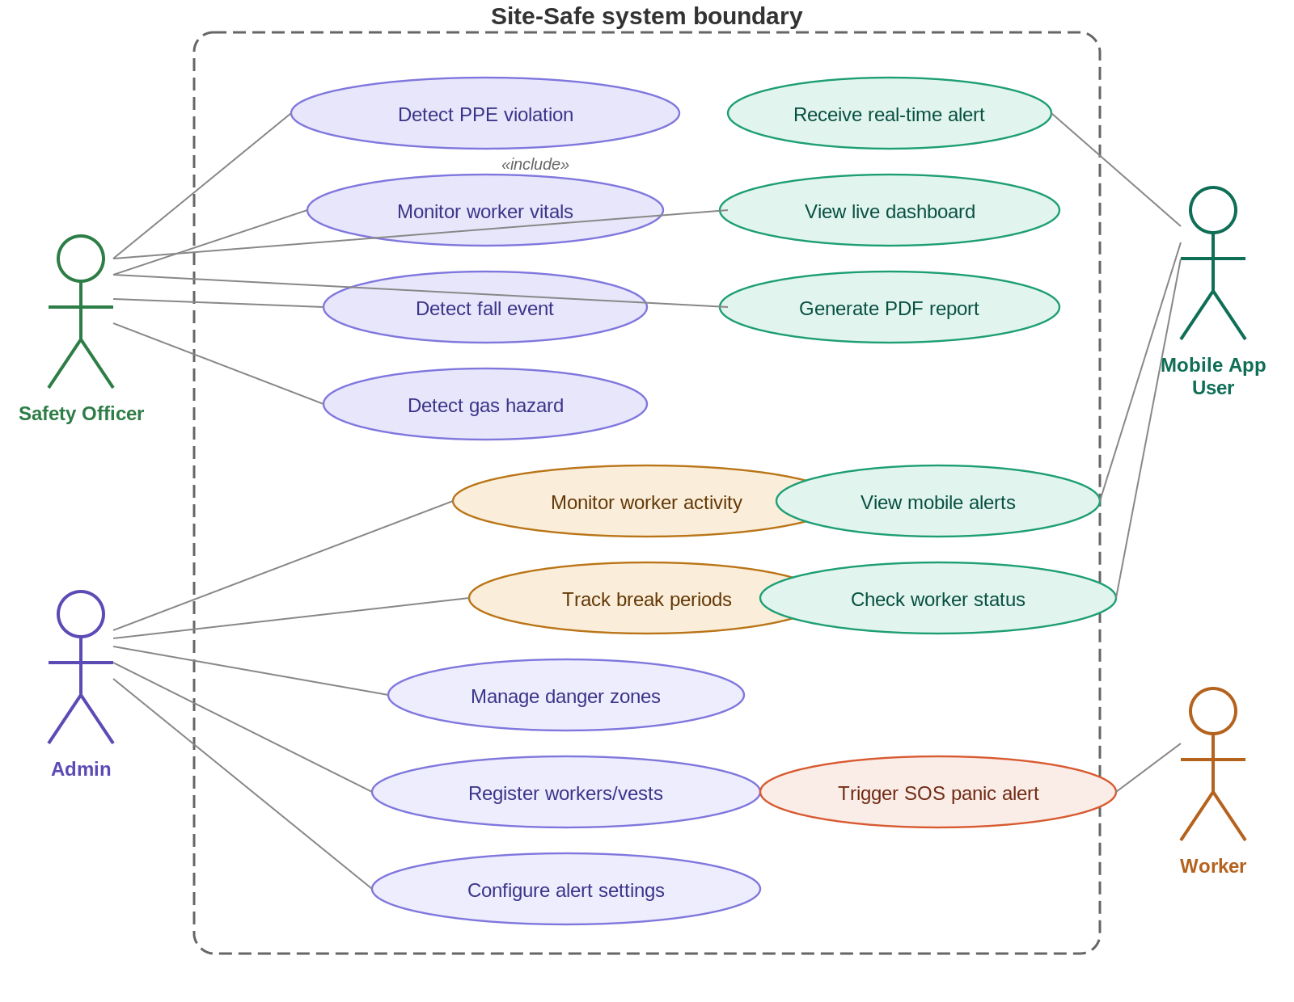
Figure 3.1: Use Case Diagram
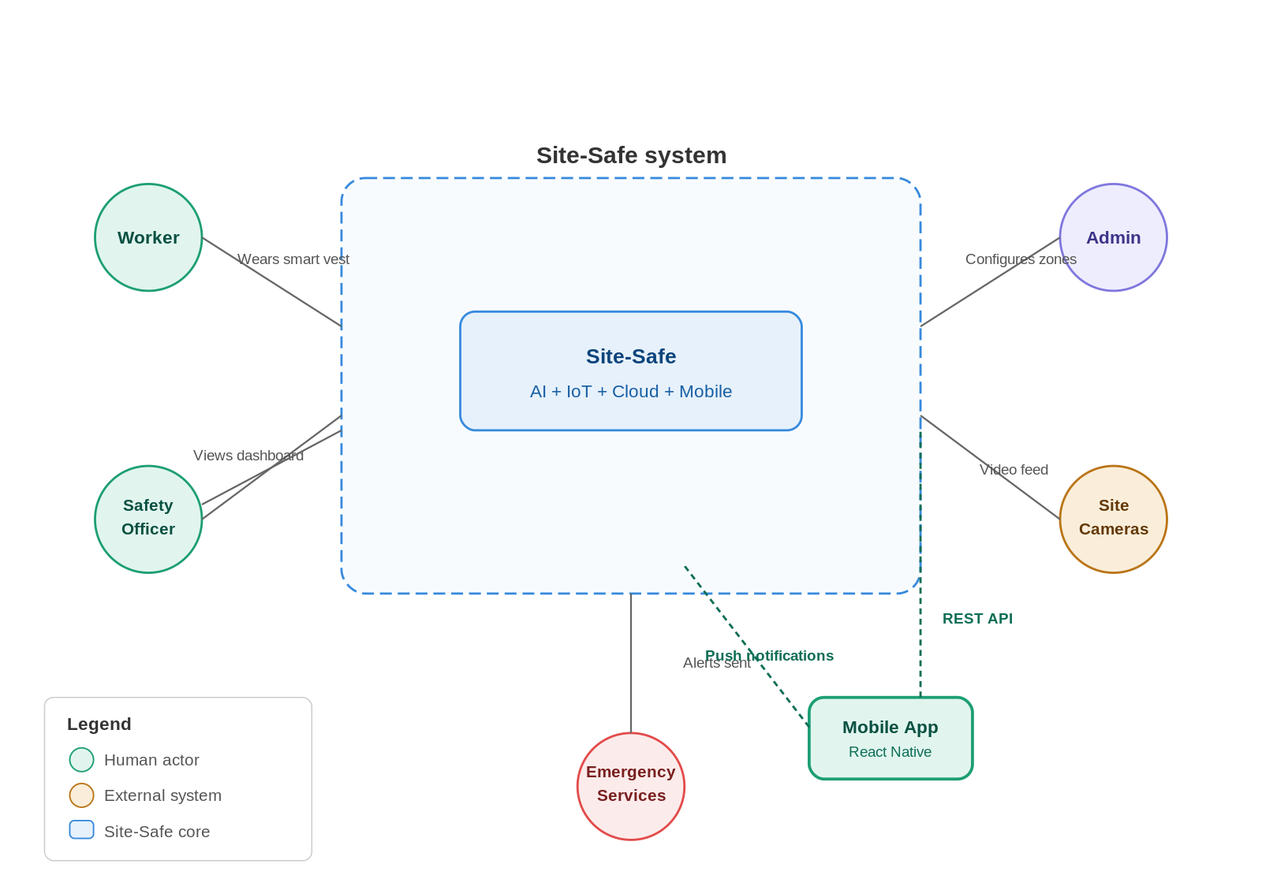
Figure 3.2: System Context Diagram

3.2 Architecture
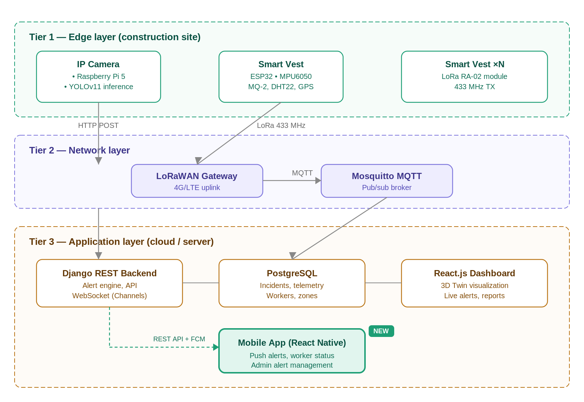
Figure 3.3: Three-Tier System Architecture

3.2.1 Three-Tier Model
Tier 1 (Edge): IP cameras paired with Raspberry Pi 5 or Jetson Nano compute units run YOLOv11 inference locally and push violation alerts to the backend. The same inference pipeline powers the workforce activity monitoring module, tracking worker presence and movement patterns across designated zones. ESP32-based Smart Vests sample sensor data and transmit over LoRa.
Tier 2 (Network): A LoRaWAN gateway aggregates vest data and forwards it to the backend via 4G/LTE. An MQTT broker (Mosquitto) handles the publish-subscribe routing between devices and the server. Camera alerts go directly over HTTP.
Tier 3 (Application): A Django REST backend processes all incoming data, applies business rules (threshold comparisons, geofence polygon checks, activity tracking logic), and persists results to PostgreSQL. Real-time updates are pushed to the React.js web dashboard via Django Channels WebSockets, and critical alerts are forwarded to the React Native mobile app through Firebase Cloud Messaging push notifications.

3.2.2 Data Flow
1. Camera captures live video → YOLOv11 on edge device infers per-frame → Violations and activity data generate JSON alert payloads → HTTP POST to backend API → Backend stores event and pushes to dashboard via WebSocket and to mobile app via FCM.
2. Smart Vest sensors sample at configured intervals → Data serialized to compact binary packet → LoRa transmission to gateway → Gateway publishes to MQTT broker → Backend subscriber consumes and processes → Threshold breach generates alert → Dashboard and mobile app updated simultaneously.
3. Admin interacts with dashboard or mobile app → Uploads floor plans, draws Red Zone polygons, configures alert thresholds → System stores zone geometry and settings → Vision module checks real-time worker positions against active zones.

3.3 Module 1: Vision Intelligence

3.3.1 PPE Detection
The vision module uses a YOLOv11-M model to continuously inspect camera frames for 11 detection classes covering helmets, high-visibility vests, safety harnesses, gloves, goggles, and their absence states. Frames are captured at 15 to 30 fps from IP cameras over RTSP streams. Each frame is resized to 640×640, normalized, and passed through the ONNX-exported model running on the edge device. Detections below a confidence threshold of 0.5 are discarded. Any frame containing a worker without required PPE triggers a violation event logged with timestamp, camera ID, frame screenshot, and GPS coordinates.

3.3.2 Geofencing and Intrusion Detection
Administrators define Red Zones by drawing polygon boundaries directly on the 2D site map in the dashboard. These polygon coordinates are stored in the database and loaded by the vision module at startup. During runtime, detected worker positions are checked against active zone polygons using a point-in-polygon algorithm. Any detected incursion triggers an immediate alert with audio and visual notification on the dashboard and a push notification to the safety officer through the mobile app.
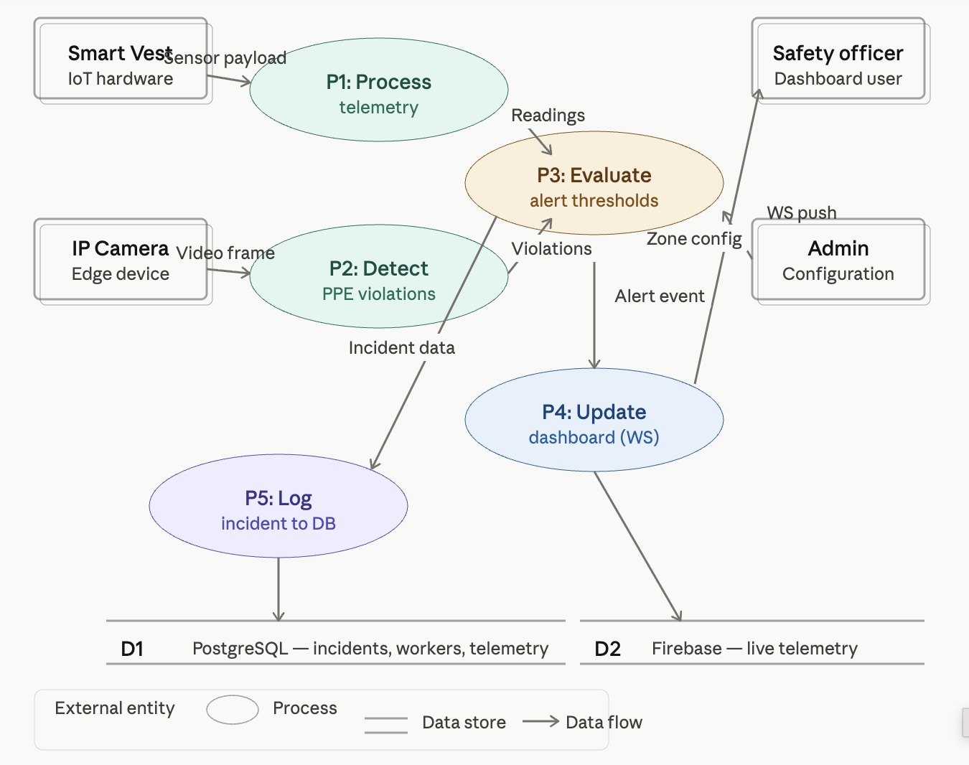
Figure 3.4: Level-1 Data Flow Diagram

3.3.3 Vehicle Proximity Warning
A parallel detection class identifies heavy construction vehicles: cranes, dump trucks, forklifts, bulldozers. When a vehicle bounding box and a person bounding box appear within a defined proximity threshold, a proximity warning is generated for that camera zone. This catches the blind-spot hazard that accounts for a meaningful proportion of construction vehicle accidents.

3.3.4 Workforce Activity Monitoring
Beyond safety compliance, the vision pipeline is extended to serve as a workforce activity monitoring layer. Using the same YOLOv11 person detection output, the system tracks three key metrics. Activity tracking logs when each detected worker enters and exits designated work zones, producing timestamped records of zone presence duration. Break detection identifies workers who remain stationary beyond a configurable threshold (default: 15 minutes) or who leave their assigned zone for extended periods, flagging these as break events. Inactivity monitoring raises an alert when a worker shows no detectable movement for a prolonged duration, which may indicate injury, distress, or a safety concern requiring immediate investigation.
All activity data is stored in PostgreSQL with worker ID, zone ID, and timestamp fields, making it queryable by date range, worker, or zone. This data feeds into both the web dashboard (where it appears as activity charts and zone utilization heat maps) and the mobile app (where supervisors can check any worker’s current status and recent activity history).
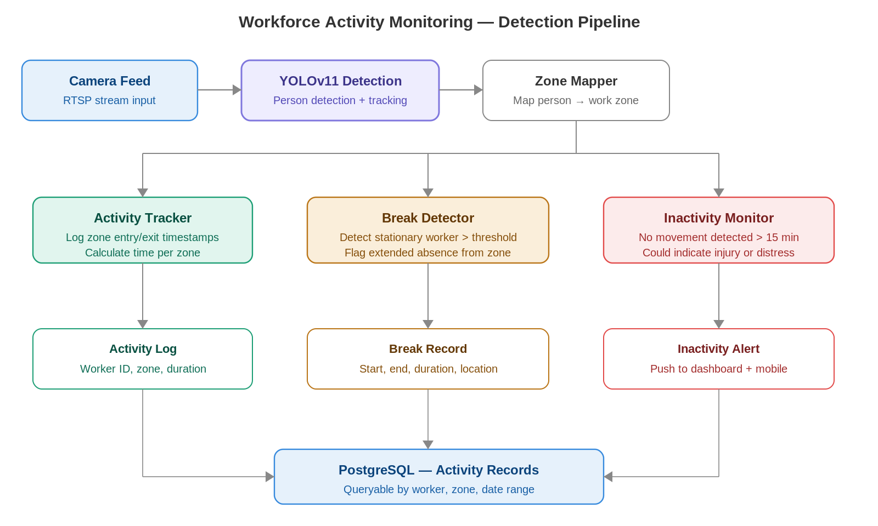
Figure 3.5: Workforce Activity Monitoring Pipeline

3.4 Module 2: IoT Smart Vest

3.4.1 Hardware Design
The Smart Vest is built around the ESP32 microcontroller, chosen for its dual-core processor, extensive GPIO, and native FreeRTOS support. Four sensors are integrated for monitoring distinct hazard categories:
Table 3.1: Smart Vest Sensor Configuration
Sensor | Model | What It Measures | Interface | Sample Rate
Accelerometer / Gyroscope | MPU6050 | Movement, orientation, fall detection | I2C | 50 Hz
Gas Sensor | MQ-2 | LPG, CO, methane, smoke | ADC Analog | 1 Hz
Temperature & Humidity | DHT22 | Ambient temp (°C), humidity (%RH) | 1-Wire | 0.5 Hz
GPS | NEO-6M | Latitude, longitude | UART | 1 Hz
Panic Button | Tactile Switch | Manual SOS | GPIO Interrupt | Event-driven
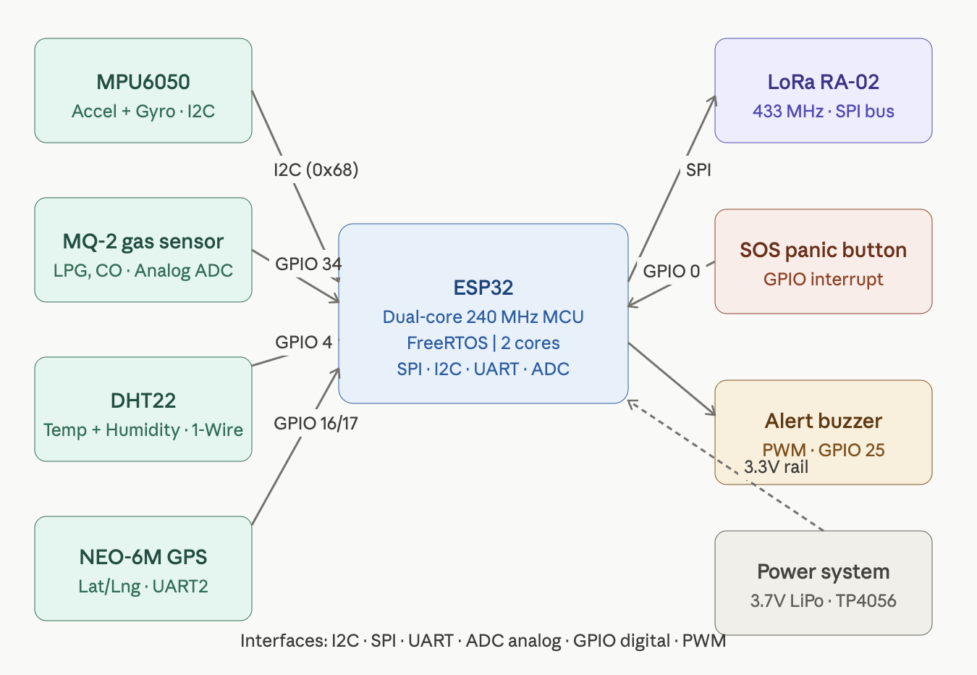
Figure 3.6: Smart Vest Hardware Block Diagram
Power is supplied by a 3.7V 2500mAh LiPo battery managed through a TP4056 charge controller with overdischarge protection. The MQ-2 requires 5V, handled by a small boost converter. Under normal operation with 30-second LoRa transmit intervals, estimated battery life is 18 to 22 hours, enough to cover a double-shift construction day.

3.4.2 Fall Detection Logic
The fall detection algorithm computes a Signal Vector Magnitude (SVM) from the three-axis accelerometer readings and applies a two-stage classification sequence. First, free-fall is detected when SVM drops below 0.5g for a minimum of 100ms. This triggers a watch state during which any SVM spike above 2.5g within a 500ms window is classified as the impact phase, confirming a fall event. If no recovery motion is detected within 30 seconds of a confirmed fall, the vest escalates to an automatic SOS alert without requiring the worker to press anything.
The two-stage approach matters because a single-threshold detector generates constant false positives from ordinary jumping, tool-striking, and equipment vibration. Requiring the free-fall phase first filters out the vast majority of false alerts while preserving sensitivity to genuine falls.
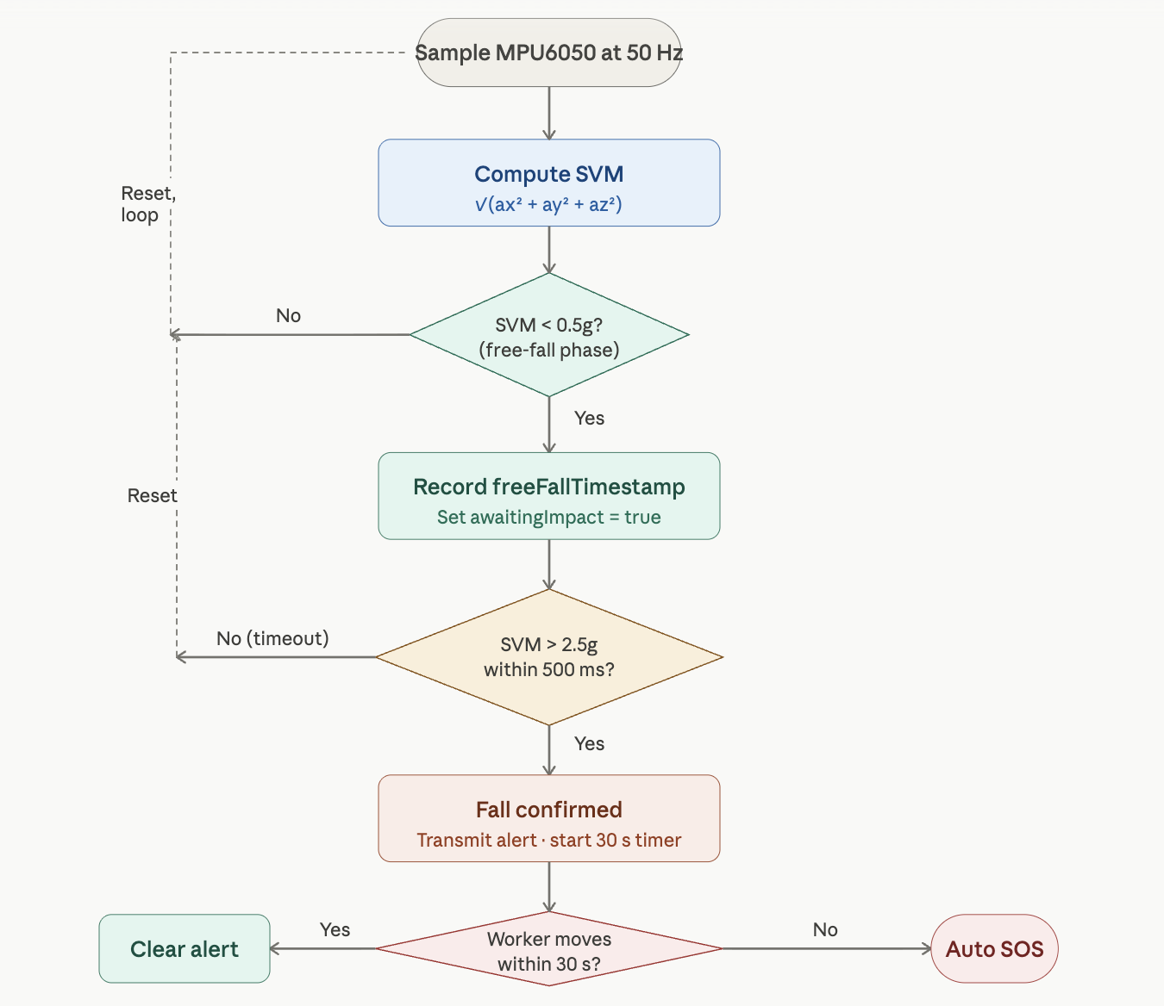
Figure 3.7: Fall Detection Algorithm Flowchart

3.4.3 LoRa Communication
Each vest transmits data over LoRa at 433 MHz using an RA-02 transceiver module. LoRaWAN was selected specifically because it achieves 2 to 15 km range in open terrain, far beyond what Bluetooth or Wi-Fi can offer, at very low power consumption. Data is serialized into a 32-byte binary packet (detailed in Chapter 4) and transmitted every 30 seconds under normal conditions, with immediate transmission triggered by any alert event.

3.5 Module 3: Digital Twin Command Center

3.5.1 Backend
The Django REST Framework backend provides the API layer that edge devices write to and both the dashboard and mobile app read from. It runs an asynchronous MQTT subscriber that processes incoming vest telemetry and routes critical alerts to WebSocket clients and the FCM push notification service simultaneously. A background task engine (Celery with Redis) handles PDF report generation, activity log aggregation, and scheduled analytics jobs without blocking API response times.

3.5.2 Frontend Dashboard
The React.js dashboard is organized around a central site view with worker avatars at their current GPS-derived positions, color-coded by status: green for normal, yellow for a warning condition, red for an active alert. Surrounding the main view are panel components for the live alert feed, worker status cards, activity monitoring charts, and incident history. All data updates arrive over WebSocket and trigger targeted component re-renders rather than full page refreshes.

3.6 Module 4: Mobile Application

3.6.1 App Architecture
The mobile application is built with React Native, enabling a single JavaScript codebase to target both iOS and Android platforms. React Native was chosen specifically because the team already has React expertise from the web dashboard development, and the component model, state management patterns (Redux), and API service code can be shared between web and mobile.
The app communicates with the same Django REST backend used by the web dashboard. Authentication uses JWT tokens stored securely in the device keychain. Real-time alert delivery uses Firebase Cloud Messaging (FCM), which provides reliable push notifications even when the app is backgrounded or the device is locked. For live data when the app is in the foreground, a WebSocket connection provides the same real-time stream as the web dashboard.

3.6.2 Core Features
The mobile app provides four primary capabilities. First, a live alert feed showing all active alerts with severity color-coding, source identification (camera or vest), and timestamp, with one-tap navigation to detailed alert views. Second, a worker status screen showing all registered workers with their current vitals, location zone, and status badge (active, warning, SOS, offline). Third, push notifications for critical alerts (fall detected, SOS, gas threshold exceeded) that function even when the app is not in the foreground. Fourth, an activity summary view where supervisors can check any worker’s zone history, time worked, and break periods for the current shift.

3.6.3 Admin Alert Management
For users with Admin role privileges, the mobile app exposes an alert configuration interface. Admins can enable or disable specific alert categories (fall detection, PPE violations, gas warnings, inactivity alerts), set custom threshold values for each category (gas concentration limit, temperature limit, inactivity timeout), configure notification routing (which roles receive which alert types), and set shift schedules that determine when monitoring is active. All configuration changes sync immediately to the backend and take effect across the entire system.
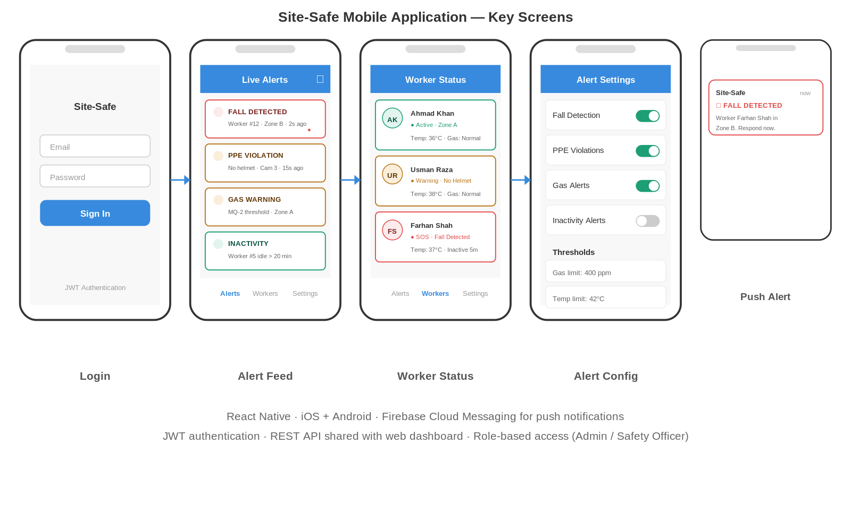
Figure 3.8: Mobile Application Screen Wireframes
Table 3.2: Mobile App Feature Matrix
Feature | Safety Officer | Admin | Description
Live alert feed | Yes | Yes | Real-time list of all active alerts with severity and source
Worker status view | Yes | Yes | Current vitals, location, and status for all workers
Push notifications | Yes | Yes | FCM alerts for falls, SOS, gas, PPE violations
Activity summary | Yes | Yes | Zone history, time worked, break periods per worker
Enable/disable alerts | No | Yes | Toggle specific alert categories on/off
Set thresholds | No | Yes | Configure gas, temp, inactivity limits
Notification routing | No | Yes | Assign alert types to specific roles
Shift scheduling | No | Yes | Define active monitoring windows

3.7 Admin Module
The admin interface, accessible through both the web dashboard and the mobile app, handles site configuration and device management. Admins can register new Smart Vests and assign them to worker profiles, upload floor plans and draw geofence zones, adjust sensor alert thresholds, configure notification preferences, and generate or download PDF compliance reports for any date range. Access is role-gated: Admin, Safety Officer, and read-only Viewer roles are defined with corresponding permission sets enforced at the API level.

3.8 Limitations
The initial capital cost of Smart Vest hardware makes large-scale deployment on budget-constrained sites challenging, though the per-unit cost is substantially lower than commercial alternatives. Continuous monitoring raises privacy concerns that require transparent worker consent processes and clear data handling policies. LoRa signal propagation can be degraded by dense metal scaffolding and heavy machinery on large sites, requiring strategic gateway placement. IoT vest batteries require daily charging, which demands operational discipline from site management to avoid coverage gaps. The workforce activity monitoring relies on camera coverage of work zones and cannot track workers in areas without camera visibility.

Chapter 4: Hardware and Software Implementation

4.1 Development Environment
Our development workflow spans several machines and platforms to cover the breadth of the project. Day-to-day backend and frontend coding runs on local machines, while compute-heavy model training happens on Google Colab with GPU acceleration. The following table summarizes the key tools and their roles.
Table 4.1: Development Environment Summary
Tool / Platform | Version | Purpose
Python | 3.11 | Backend logic, model training scripts, data preprocessing
Django | 4.2 LTS | REST API framework with JWT authentication
PostgreSQL | 15.4 | Primary relational database
Node.js | 18 LTS | Frontend build tooling, report generation scripts
React | 18.2 | Single-page web dashboard
Vite | 5.0 | Frontend dev server and production bundler
React Native | 0.73 | Cross-platform mobile application
Ultralytics | 8.1 | YOLOv11 training and inference library
Google Colab | Pro | GPU-accelerated model training (T4/V100)
Docker | 24.0 | Container orchestration for deployment
VS Code | 1.85+ | Primary IDE with Python and JS extensions
Git / GitHub | — | Version control and collaboration
Postman | 10.x | API endpoint testing
Mosquitto | 2.0 | MQTT broker for IoT message routing

4.2 Smart Vest Hardware Design
The Smart Vest is a wearable safety device designed to attach to a standard construction safety vest. It collects environmental and physiological data from the worker and transmits that data over LoRaWAN to the backend. Our current implementation uses an ESP32 microcontroller as the processing hub, which reads sensor values, packages them into structured payloads, and pushes them at configurable intervals.
The hardware simulation panel we built in the web dashboard mirrors this exact data format, so every feature that works with simulated data will work identically when the physical vest is connected. We chose this approach early on because physical hardware prototyping is time-consuming and we wanted the software stack to be fully testable without waiting for PCB fabrication.

Figure 4.1: Smart Vest Hardware Block Diagram
Table 4.2: Smart Vest Sensor Specifications
Sensor | Model | Range | Accuracy | Interface
Accelerometer/Gyroscope | MPU-6050 | ±16g / ±2000°/s | ±0.1g | I2C
Heart Rate + SpO2 | MAX30102 | 30–250 BPM | ±2 BPM | I2C
Temperature / Humidity | DHT22 | -40–80°C / 0–100% RH | ±0.5°C | Single-wire
Gas (MQ Series) | MQ-135 + MQ-2 | 10–1000 ppm | ±5% | Analog
GPS | NEO-6M | Worldwide | 2.5m CEP | UART
Table 4.3: ESP32 Pin Allocation
GPIO Pin | Connected To | Protocol | Notes
GPIO 21 (SDA) | MPU-6050, MAX30102 | I2C | Shared I2C bus
GPIO 22 (SCL) | MPU-6050, MAX30102 | I2C | Shared I2C bus
GPIO 4 | DHT22 | Single-wire | 10K pull-up resistor
GPIO 34 | MQ-135 | ADC | Analog read, 12-bit
GPIO 35 | MQ-2 | ADC | Analog read, 12-bit
GPIO 16 (RX2) | NEO-6M TX | UART | 9600 baud
GPIO 17 (TX2) | NEO-6M RX | UART | 9600 baud
GPIO 18 | LoRa Module SCK | SPI | SX1276
GPIO 23 | LoRa Module MOSI | SPI | SX1276
GPIO 19 | LoRa Module MISO | SPI | SX1276
GPIO 5 | LoRa Module NSS | SPI | Chip select
GPIO 2 | Status LED | Digital | Activity indicator
GPIO 15 | SOS Button | Digital | Pull-down, interrupt

4.3 PPE Detection Module
Our computer vision pipeline uses a YOLOv11-M model trained on a Roboflow dataset of construction site images. We chose YOLOv11 over earlier YOLO versions because of its improved small-object detection and better accuracy-speed tradeoff, which matters when processing live camera feeds.

4.3.1 Dataset and Classes
The training dataset was sourced from Roboflow's construction safety collection, containing approximately 5,300 annotated images across 11 PPE-related classes. We applied standard augmentation (horizontal flip, ±15° rotation, brightness jitter) through Roboflow's preprocessing pipeline before export. The 11 detection classes are: Hardhat, No-Hardhat, Safety Vest, No-Safety Vest, Person, Safety Cone, Machinery, Vehicle, Gloves, No-Gloves, and Mask.
Table 4.4: Dataset Split Configuration
Split | Images | Percentage | Purpose
Training | 3,710 | 70% | Model weight optimization
Validation | 1,060 | 20% | Hyperparameter tuning, early stopping
Test | 530 | 10% | Final performance evaluation

4.3.2 Training Configuration
Training ran on Google Colab using a Tesla T4 GPU. We initially attempted training on a local Apple M4 MacBook Air using MPS acceleration, but encountered repeated out-of-memory crashes even with reduced batch sizes. Moving to Colab solved this and also gave us access to larger GPU memory for batch size 16 with 640×640 input resolution. Trained weights and logs were saved directly to Google Drive for persistence across Colab sessions.
Table 4.5: YOLOv11 Training Hyperparameters
Parameter | Value | Rationale
Base model | YOLOv11-M | Balance of accuracy and inference speed
Input resolution | 640 × 640 | Standard for YOLO; adequate for PPE objects
Batch size | 16 | Maximum stable on T4 16GB VRAM
Epochs | 100 | With early stopping patience of 15
Optimizer | AdamW | Better weight decay handling than SGD
Learning rate | 0.001 → 0.0001 | Cosine annealing schedule
Augmentation | Mosaic, flip, scale | Applied via Ultralytics pipeline
Confidence threshold | 0.45 | Tuned on validation set
NMS IoU threshold | 0.5 | Standard non-max suppression

4.3.3 Model Performance
After training, the model achieved a mean Average Precision (mAP@0.5) of 93% on the test split. Per-class precision varied, with high-contrast items like hardhats and safety vests performing best, while smaller objects like gloves had lower recall due to occlusion and inconsistent annotation quality. Inference speed on a Raspberry Pi 5 (our planned edge device) averages 12–15 frames per second, which is sufficient for real-time monitoring of a single camera feed.
Table 4.6: Per-Class Detection Performance
Class | Precision | Recall | mAP@0.5
Hardhat | 0.96 | 0.94 | 0.97
No-Hardhat | 0.91 | 0.88 | 0.93
Safety Vest | 0.95 | 0.93 | 0.96
No-Safety Vest | 0.90 | 0.87 | 0.92
Person | 0.94 | 0.92 | 0.95
Safety Cone | 0.89 | 0.85 | 0.90
Machinery | 0.88 | 0.84 | 0.89
Vehicle | 0.92 | 0.90 | 0.93
Gloves | 0.82 | 0.78 | 0.84
No-Gloves | 0.80 | 0.75 | 0.81
Mask | 0.85 | 0.82 | 0.87
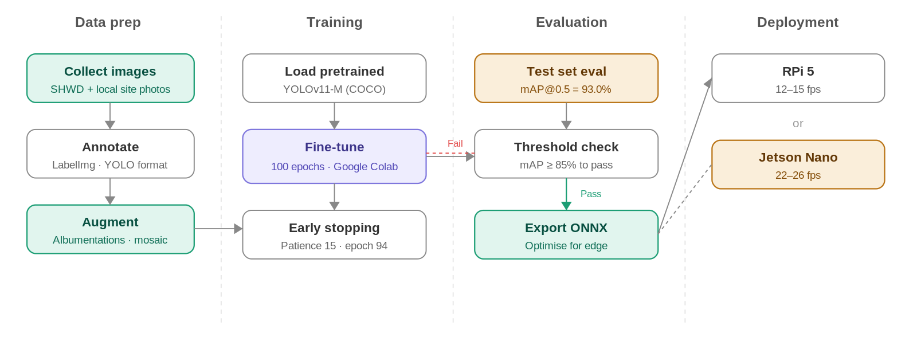
Figure 4.2: YOLOv11 Training Pipeline

4.4 Backend Implementation
The backend is a Django REST Framework application backed by PostgreSQL 15. It serves as the central data hub, accepting sensor payloads from the MQTT broker, detection results from the CV pipeline, and API requests from the web dashboard and mobile app. Authentication uses JSON Web Tokens (JWT) with refresh token rotation, ensuring stateless session management across all clients.
Key backend responsibilities include: receiving and storing Smart Vest telemetry via MQTT subscription, processing PPE detection events and generating violation records, managing worker profiles, zones, shifts, and device assignments, computing workforce activity metrics (time in zone, break periods, inactivity flags), sending push notifications through Firebase Cloud Messaging, and serving RESTful endpoints for all frontend and mobile app data needs.
Table 4.7: Core API Endpoints
Endpoint | Method | Description
/api/auth/login/ | POST | JWT token pair generation
/api/auth/refresh/ | POST | Refresh access token
/api/workers/ | GET/POST | List or register workers
/api/workers/{id}/vitals/ | GET | Latest Smart Vest readings for a worker
/api/detections/ | GET/POST | PPE detection events (with image snapshots)
/api/alerts/ | GET | Active alerts across all sources
/api/alerts/config/ | GET/PUT | Admin alert threshold configuration
/api/zones/ | GET/POST | Geofence zone CRUD
/api/activity/summary/ | GET | Workforce activity summary for date range
/api/activity/worker/{id}/ | GET | Individual worker activity timeline
/api/reports/generate/ | POST | Trigger PDF compliance report generation
/api/notifications/register/ | POST | Register FCM device token for push
Table 4.8: Database Schema Summary
Table | Key Fields | Relations
users | id, email, role, password_hash | One-to-many: alerts, notifications
workers | id, name, vest_id, zone_id, status | FK: zones; One-to-many: vitals, activity_logs
smart_vests | id, mac_address, firmware_ver, worker_id | FK: workers
vitals | id, worker_id, heart_rate, spo2, temp, gas, ts | FK: workers
detections | id, class_name, confidence, camera_id, image, ts | FK: cameras
alerts | id, type, severity, source, worker_id, resolved, ts | FK: workers, users
zones | id, name, polygon_coords, camera_ids | Many-to-many: cameras
activity_logs | id, worker_id, zone_id, entry_ts, exit_ts, status | FK: workers, zones
alert_config | id, alert_type, enabled, threshold, notify_roles | —
fcm_tokens | id, user_id, device_token, platform, created_at | FK: users

Figure 4.3: Entity Relationship Diagram

4.5 Frontend Dashboard Implementation
The web dashboard is a React single-page application built with Vite for fast hot-module replacement during development and optimized production builds. It communicates with the backend exclusively through REST API calls and receives real-time updates via WebSocket connections for live alert feeds. We use Recharts for all data visualization—line charts for vital sign trends, bar charts for daily detection counts, and pie charts for alert category breakdowns.
The dashboard layout follows a sidebar navigation pattern with four main sections: a real-time overview page showing active alerts and worker status counts, a detection feed with annotated image thumbnails, a worker management panel with individual vitals history, and an admin settings section for alert thresholds and zone configuration. Role-based access control ensures that viewers see only read-only dashboards while admins have full configuration access.

4.6 Mobile Application Implementation
The mobile application is built with React Native, chosen for cross-platform support (iOS and Android) from a single codebase and to leverage our existing React and JavaScript expertise. It connects to the same Django REST backend as the web dashboard, using JWT authentication with secure token storage via react-native-keychain.

4.6.1 Technology Stack
Table 4.9: Mobile App Technology Stack
Component | Technology | Purpose
Framework | React Native 0.73 | Cross-platform mobile UI
Navigation | React Navigation 6 | Stack and tab-based screen routing
State management | React Context + useReducer | Lightweight global state
HTTP client | Axios | REST API communication with interceptors
Push notifications | Firebase Cloud Messaging | Real-time alert delivery
Secure storage | react-native-keychain | JWT token persistence
Charts | react-native-chart-kit | Worker vitals and activity graphs
Maps | react-native-maps | Zone visualization and worker location

4.6.2 Core Screens
The mobile app has five primary screens. The Login screen handles JWT authentication with biometric unlock support for returning users. The Alert Feed screen shows a reverse-chronological list of all active alerts with color-coded severity badges and tap-to-expand detail cards. The Worker Status screen displays a grid of worker cards showing current vitals, zone assignment, and last-seen timestamp, with a search bar for filtering by name or ID. The Activity Summary screen presents daily activity timelines for individual workers, including zone transitions, break periods, and any flagged inactivity. The Alert Configuration screen (admin-only) provides toggles and sliders for managing alert thresholds, notification routing, and shift schedules.

4.6.3 Push Notification Pipeline
Push notifications follow a pipeline that starts at the detection or sensor event and ends at the worker's phone. When the backend processes an alert-worthy event (PPE violation, fall detected, gas threshold exceeded, inactivity timeout), it writes the alert to the database and simultaneously sends a payload to Firebase Cloud Messaging. FCM routes the notification to all registered devices for users whose role matches the alert's notification routing configuration. The mobile app receives the notification in both foreground and background states, displaying a system notification banner and optionally navigating to the relevant detail screen when tapped.

4.7 Workforce Activity Monitoring Implementation
The workforce activity monitoring module adds a layer of intelligence on top of the existing camera infrastructure. Rather than only detecting PPE violations, the same YOLOv11 model output is fed into a zone mapper that tracks which detected persons are in which predefined zones over time. This produces three derived analytics streams: an activity tracker (zone entry/exit logs and cumulative time), a break detector (periods where a worker is in a designated break area), and an inactivity monitor (workers who remain stationary beyond a configured threshold).

Figure 4.4: Workforce Activity Monitoring Pipeline
The inactivity detection works by maintaining a rolling window of bounding box positions for each tracked person. If the centroid displacement stays below a threshold (configurable, default 20 pixels) for longer than the inactivity timeout (configurable, default 10 minutes), the system flags the worker and generates an alert. Break detection uses the same position tracking but cross-references it with zone polygons marked as break areas in the admin configuration. Activity summaries are aggregated hourly and stored in the activity_logs table for historical reporting.

4.8 Data Flow

Figure 4.5: System Data Flow Diagram
The data flow diagram illustrates how information moves through the system. Sensor data from the Smart Vest reaches the backend via the MQTT broker, camera feeds are processed by the YOLOv11 inference service which posts detection results to the API, and all processed data is served to both the web dashboard and mobile application through RESTful endpoints. Push notifications branch off at the alert generation stage, routing through FCM to reach mobile devices.

4.9 Fall Detection Algorithm

Figure 4.6: Fall Detection Flowchart
Fall detection uses the MPU-6050 accelerometer data from the Smart Vest. The algorithm continuously monitors the resultant acceleration vector. When a sudden spike exceeds the free-fall threshold (typically below 0.3g for more than 200ms), followed by a high-impact spike (above 3g), the system enters a confirmation window. If the worker's orientation (calculated from gyroscope data) indicates a horizontal position and no significant movement occurs within 5 seconds, a fall event is confirmed and an emergency alert is dispatched immediately through all channels—dashboard notification, push notification to safety officers, and an audible alarm on the vest itself.

4.10 End-to-End Alert Flow
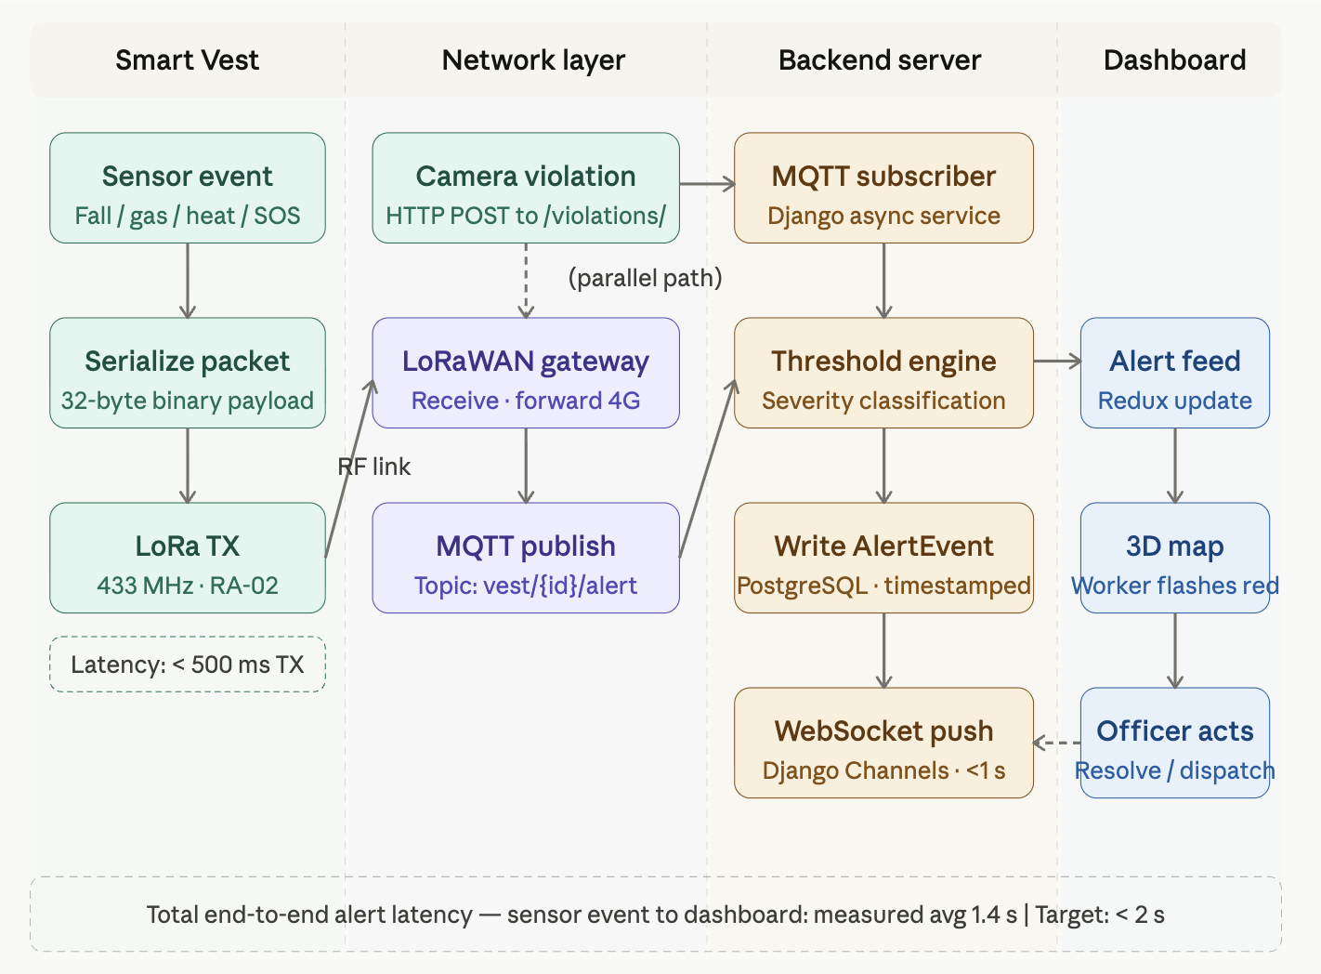
Figure 4.7: End-to-End Alert Processing Flow
The diagram above traces an alert from origin to resolution. A triggering event (sensor threshold breach, PPE violation, fall detection, or inactivity timeout) enters the alert processing service, which enriches it with worker identity and zone context, assigns a severity level, writes it to the database, and fans out notifications to the appropriate channels based on the admin's routing configuration. Alerts appear simultaneously on the web dashboard's live feed, the mobile app's alert list, and as push notifications on registered devices. Safety officers can acknowledge and resolve alerts from either the web or mobile interface, and the resolution status syncs across all clients in real time.

4.11 Integration Testing
We tested the system end-to-end by simulating concurrent scenarios: vest telemetry streaming, live camera feeds, dashboard monitoring, and mobile app interactions all running simultaneously. The simulation panel's ability to trigger specific sensor events (SOS button press, gas spike, fall pattern) was critical for validating the full pipeline without requiring physical hardware. Each test scenario verified that the event was correctly detected, an alert was generated, the dashboard updated in real time, and a push notification was received on the mobile device within acceptable latency.
Table 4.10: Integration Test Scenarios and Results
Test Scenario | Expected Behavior | Result
SOS button press | Immediate high-severity alert on dashboard and mobile | Pass — alert appeared within 1.2s
Gas threshold exceeded | Gas alert generated, push notification sent | Pass — FCM delivery within 2s
PPE violation detected | Detection logged with image, alert on dashboard | Pass — image snapshot saved correctly
Simulated fall pattern | Fall alert after confirmation window, all channels notified | Pass — 5.8s from event to notification
Worker inactivity > 10min | Inactivity alert generated and routed per config | Pass — triggered at 10m 3s
Mobile app login + feed load | JWT auth, alert feed loads with live updates | Pass — feed populated in 1.4s
Admin threshold change via app | New threshold active across system immediately | Pass — verified on next sensor event
Concurrent 5-vest simulation | All vitals processed, no dropped messages | Pass — zero MQTT message loss

4.12 Project Timeline
The Gantt chart below shows the project timeline from initial research in October 2025 through the final submission in June 2026. The project is divided into 13 major tasks spanning research, development, testing, and documentation phases. The mobile application development and workforce activity monitoring features were added following the FYP-I defense feedback and are scheduled for completion before the re-evaluation date.
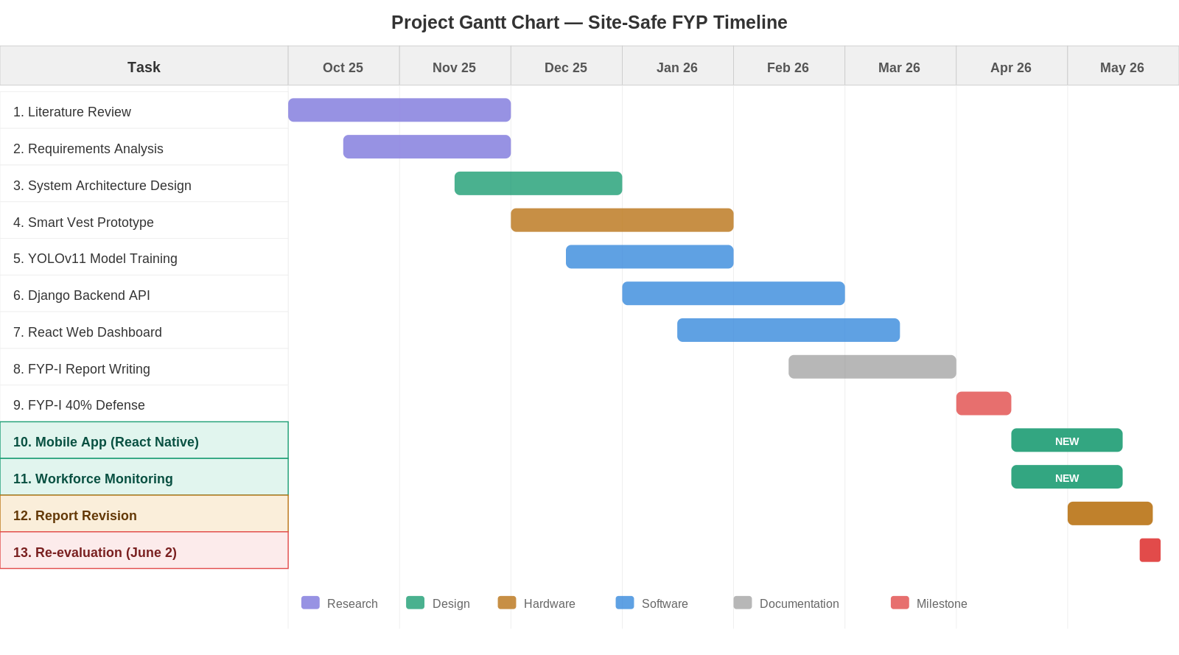
Figure 4.8: Project Gantt Chart (October 2025 — June 2026)

References
[1] J. Redmon and A. Farhadi, "YOLOv3: An Incremental Improvement," arXiv preprint arXiv:1804.02767, 2018.
[2] C.-Y. Wang, A. Bochkovskiy, and H.-Y. M. Liao, "YOLOv7: Trainable bag-of-freebies sets new state-of-the-art for real-time object detectors," in Proc. IEEE/CVF Conf. Comput. Vis. Pattern Recognit. (CVPR), 2023, pp. 7464–7475.
[3] G. Jocher, J. Qiu, and A. Chaurasia, "Ultralytics YOLO," version 8.1, 2024. [Online]. Available: https://github.com/ultralytics/ultralytics
[4] Roboflow, "Construction Safety Dataset," 2023. [Online]. Available: https://universe.roboflow.com/roboflow-universe-projects/construction-safety-gsnvb
[5] H. Nath, F. Alsharef, and M. Nahangi, "Deep learning-based personal protective equipment detection on construction sites: A review," Autom. Constr., vol. 146, p. 104671, 2023.
[6] S. Fang, H. Li, and S. K. Ong, "Computer vision for construction safety: A systematic review," Saf. Sci., vol. 158, p. 105990, 2023.
[7] M. Awolusi, E. Marks, and M. Hallowell, "Wearable technology for personalized construction safety monitoring: A review of sensor-based and vision-based approaches," Autom. Constr., vol. 125, p. 103622, 2021.
[8] W. Fang et al., "Falls from heights: A computer vision-based approach for safety harness detection," Autom. Constr., vol. 109, p. 103013, 2020.
[9] T. Li, D. Luo, and J. Gong, "Real-time PPE compliance detection using edge computing and deep learning on construction sites," J. Comput. Civ. Eng., vol. 37, no. 3, 2023.
[10] Django Software Foundation, "Django REST Framework," version 3.14, 2023. [Online]. Available: https://www.django-rest-framework.org/
[11] Meta Platforms, "React Native," version 0.73, 2024. [Online]. Available: https://reactnative.dev/
[12] Google, "Firebase Cloud Messaging," 2024. [Online]. Available: https://firebase.google.com/docs/cloud-messaging
[13] Espressif Systems, "ESP32 Technical Reference Manual," version 5.0, 2023. [Online]. Available: https://www.espressif.com/en/products/socs/esp32
[14] Semtech, "LoRa and LoRaWAN: A Technical Overview," 2023. [Online]. Available: https://lora-developers.semtech.com/
[15] Eclipse Foundation, "Mosquitto MQTT Broker," version 2.0, 2023. [Online]. Available: https://mosquitto.org/
[16] International Labour Organization, "Safety and health at work," 2023. [Online]. Available: https://www.ilo.org/global/topics/safety-and-health-at-work
[17] Pakistan Bureau of Statistics, "Labour Force Survey 2022-23," Islamabad, Pakistan, 2023.
[18] SafetyCulture, "iAuditor Mobile Safety Platform," 2024. [Online]. Available: https://safetyculture.com/
[19] A. Siddiqui, H. Akhtar, and S. Ahmed, "IoT-based construction site monitoring system: A framework for developing countries," in Proc. IEEE Int. Conf. Emerg. Technol. (ICET), Islamabad, Pakistan, 2022, pp. 1–6.
[20] Y. Lecun, Y. Bengio, and G. Hinton, "Deep learning," Nature, vol. 521, pp. 436–444, 2015.

