**STEP #1:** Review our “Listening Tips” page to get started [located on the menu bar].

**STEP #2:** Log into your account and click the menu button in the top left-hand corner of the screen [pictured below]:



**STEP #3:** You will see a list of pages under the menu bar. To explore our full library of subliminals, click the “Subliminals” tab pictured below:

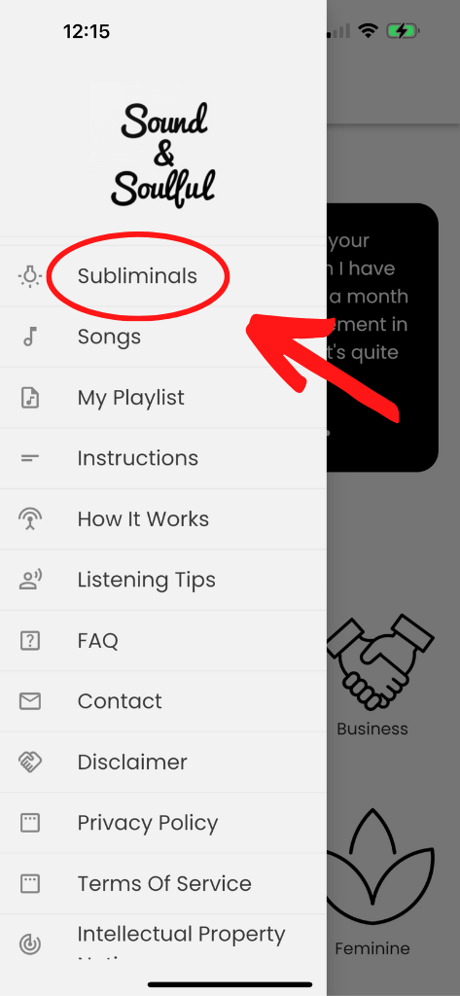

Scroll down on the page, and you will see a list of all the different categories of subliminals we currently have available on the app [pictured below].



**STEP #4:** Click on any of the category icons and you will be taken to a list of subliminals within that category.

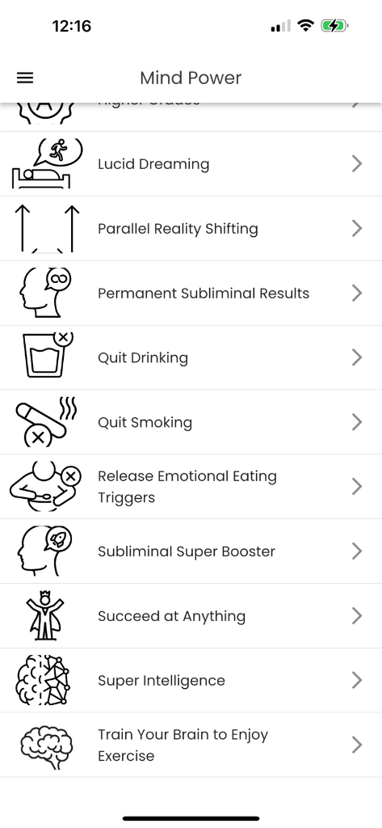

**STEP #5:** Click on any of the subliminals on the list, and you will be taken to the audio player page.

Here, you can start listening to the subliminal, access the affirmations, and explore the variety of different background sound options to find the perfect version of the subliminal for you.

Below is an instructional guide on how to use the subliminal audio player page:

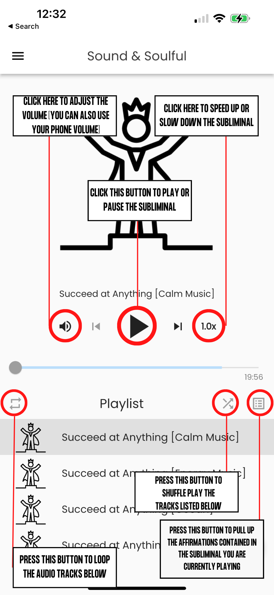

**STEP #5:** [Optional] Once you’ve found a background sound option you like, you can then add the subliminal to one of your playlists by clicking the “+” icon pictured below.

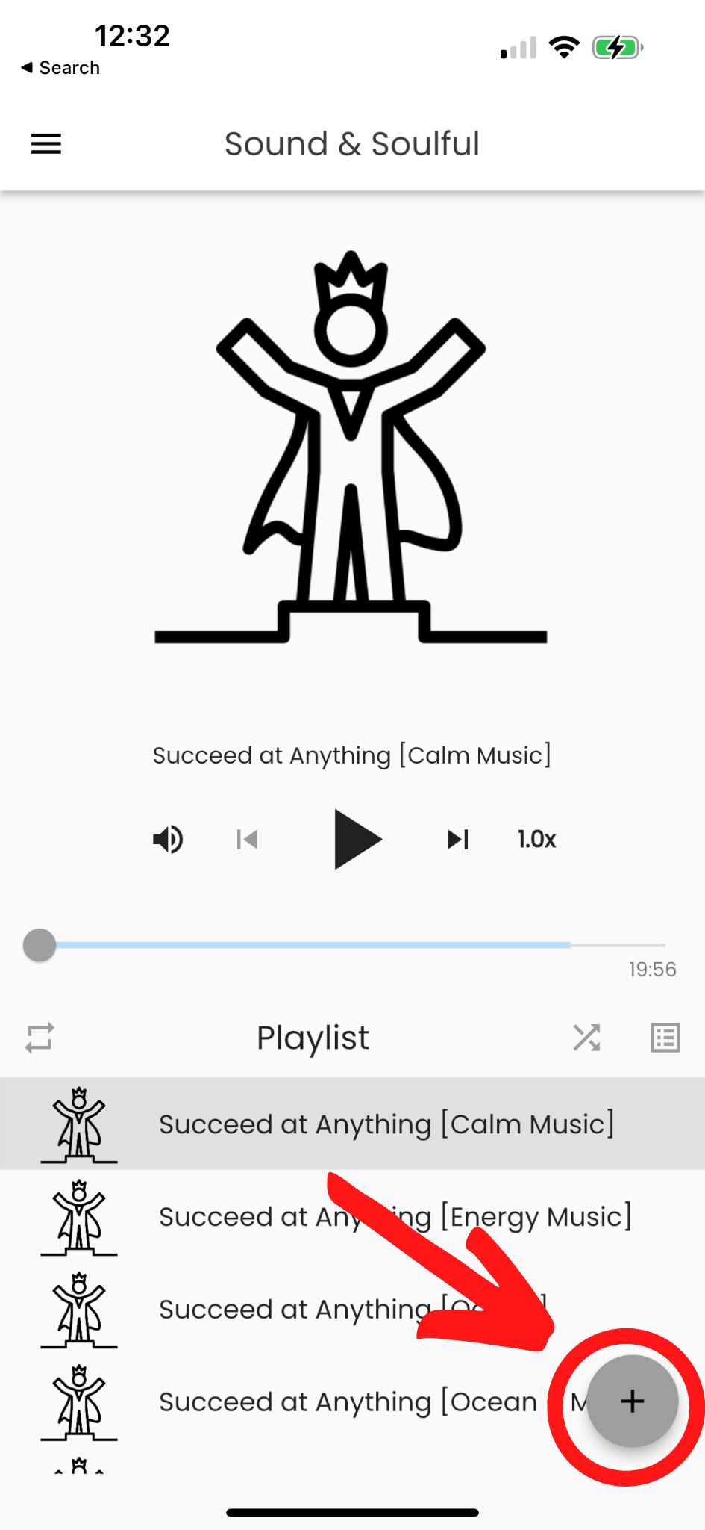

**STEP #5:** Once you name a playlist, you will then need to click the “+” icon again to add a song to that playlist. You can then access your playlists by clicking the “Playlists” tab on the left-hand menu bar, pictured below:

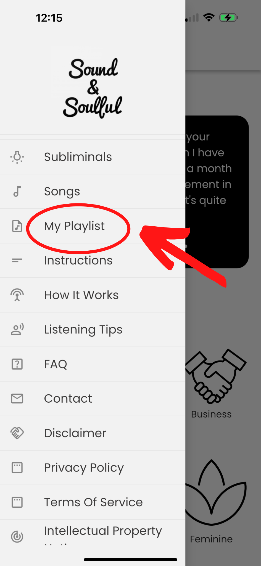

***If you still have questions, explore our "***[***Frequently Asked Questions***](https://soundandsoulful.com/pages/faq)***" page for more information.***