Auto Parts Shop

Home Page:

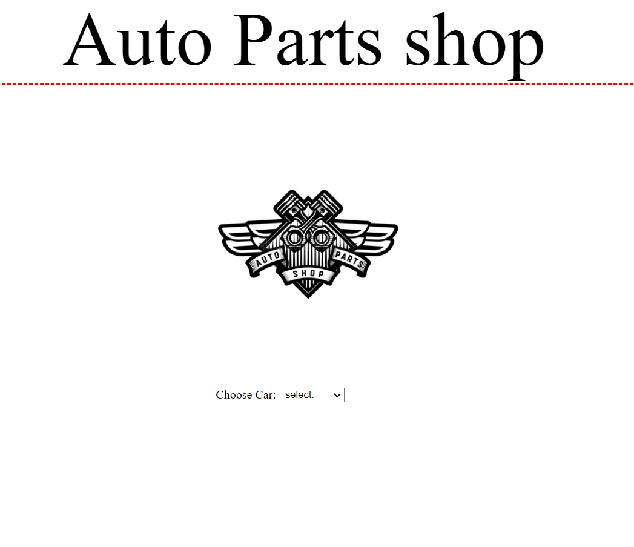

Here we can see a header level 1 with a border, A logo of the website And a drop down menu that has multiple car brands and when you click on one it will redirect to the parts for the car you selected.

Parts page:

Here we can see the logo of the car that we selected and the parts and its pictures with the prices. There is an add to cart button which adds the item to the car + calculates the price and how many items are listed.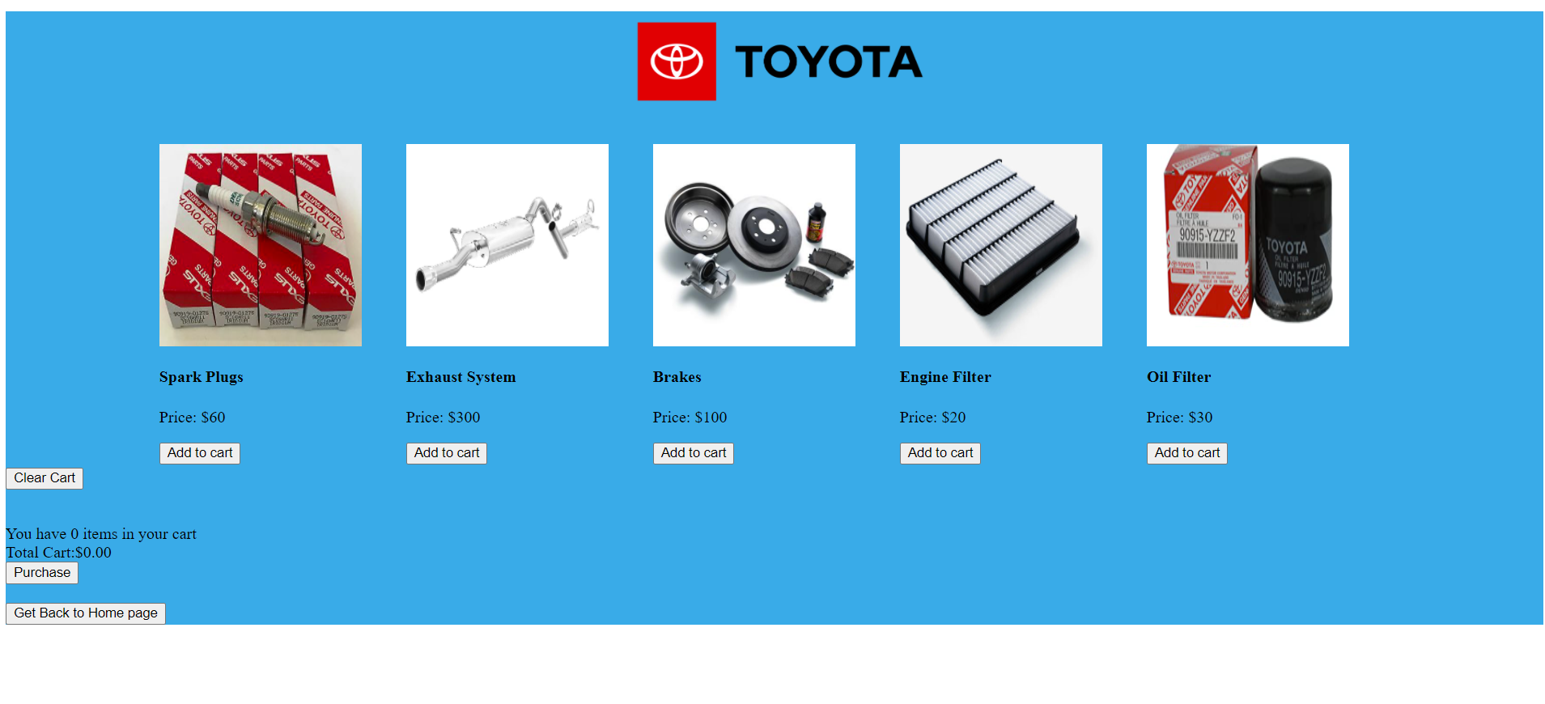

A clear cart button which clear the items of the cart.

Purchase button which redirects to a thank you page.

Get back to home page button which redirects you to the home page.

Purchase page:

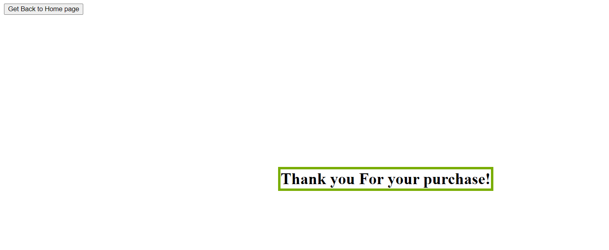

Here we thank the customer for buying the products and also a get back to home page button.