

Assingnment 4

19F0107-DS-7A



[Date]

[Company name]

[Company address]

**Question:-**

**Love or materialistic stuff which Is true?**

men<-read.csv("https://raw.githubusercontent.com/fivethirtyeight/data/master/marriage/men.csv")

both_sexes<-read.csv("https://raw.githubusercontent.com/fivethirtyeight/data/master/marriage/both_sexes.csv")

divorce<-read.csv("https://raw.githubusercontent.com/fivethirtyeight/data/master/marriage/divorce.csv")

women<-read.csv("https://raw.githubusercontent.com/fivethirtyeight/data/master/marriage/women.csv")

head(divorce)

library("ggplot2")

ggplot(divorce, aes(x=mid_3544,y=rich_3544,position = "identity"))+

geom_density_2d() +geom_point()

**Graph between poor and rich at the age from 45-54**

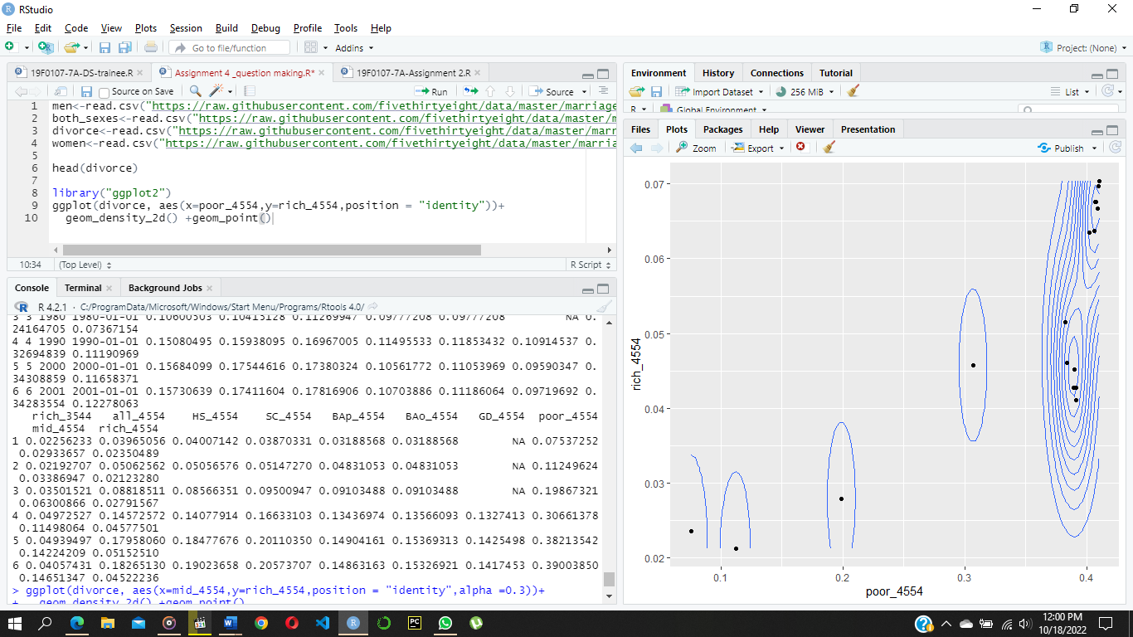

**Graph between poor and rich at the age from 34-45**

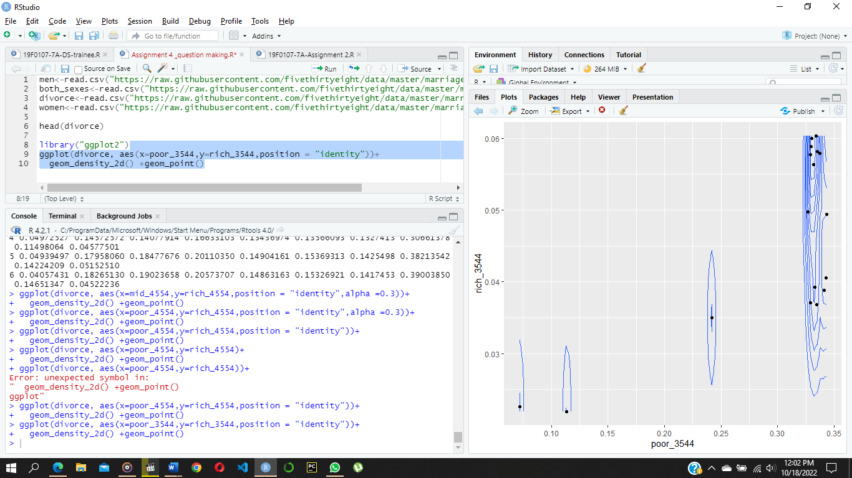

**Graph between middle and rich at the age from 45-54**

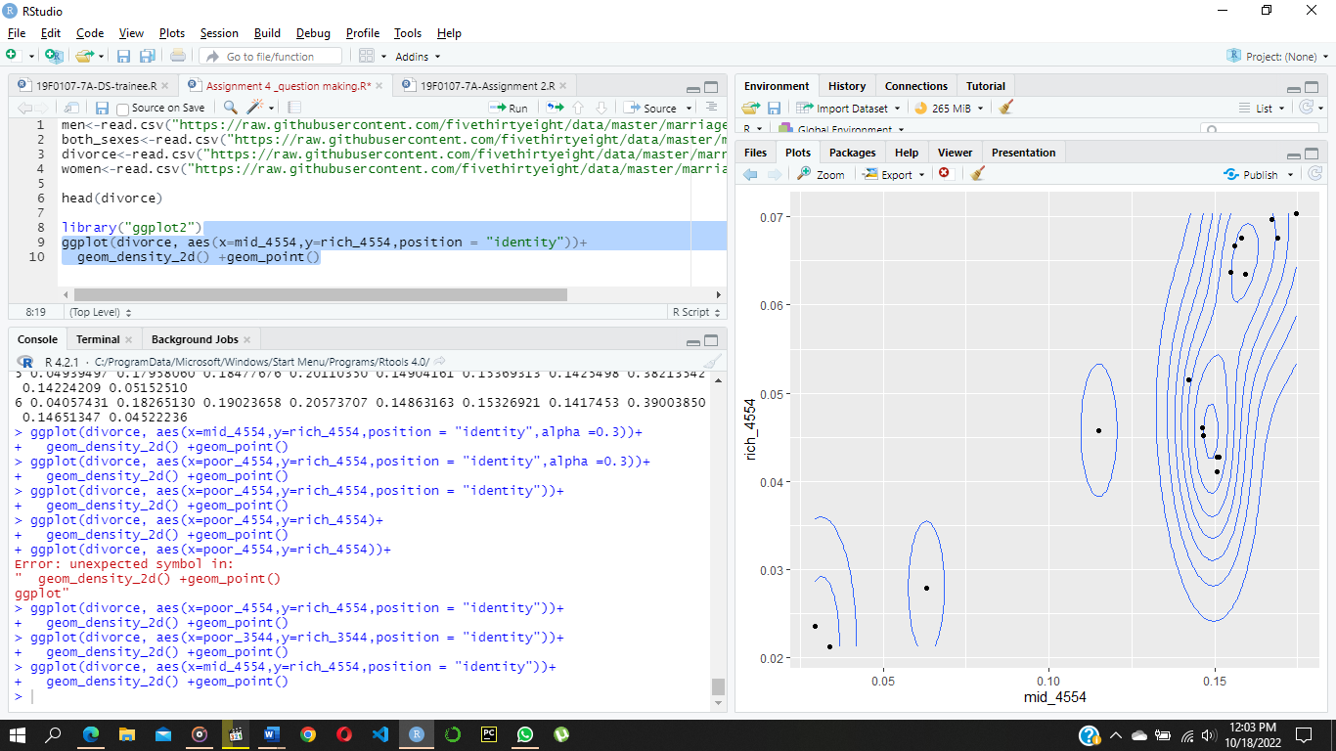

**Graph between middle and rich at the age from 35-44**

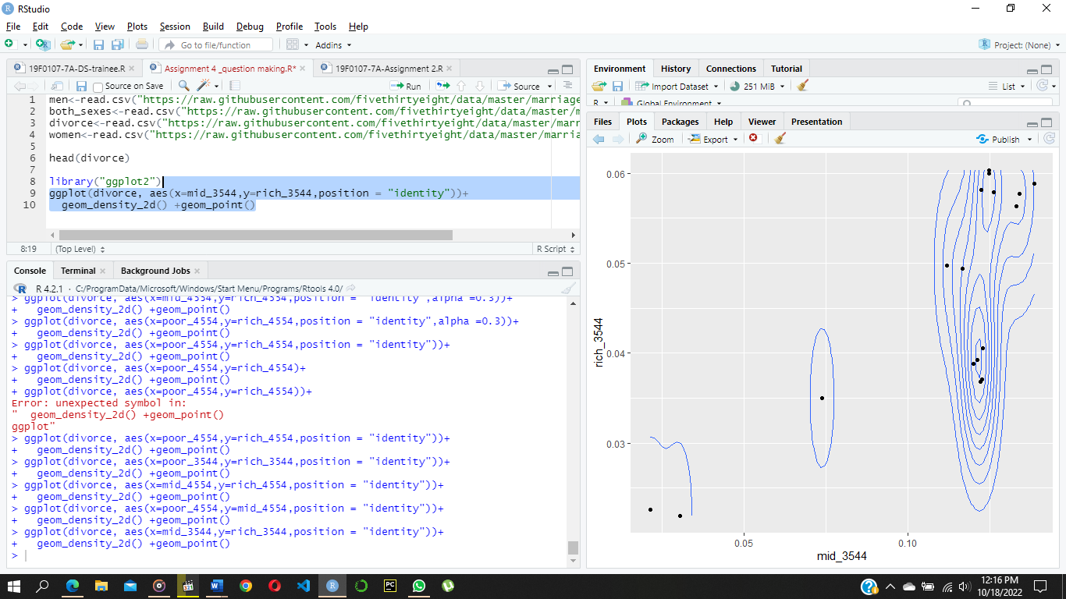

This shows that poor people always suffer from the most divorce compared to middle being second most and rich being second most ,but at the same time it is also a bit baised as rich people may also be seeing there benefits as the wealth they will have would be split between there partner when divorced so they might also spend there lifes together as middle and poor people has the less of a problem with that.