**Get data from Last 5 years:-**

library("purrr")

library("tidyverse")

library("jsonlite")

library("dplyr")

library("base")

library("vctrs")

data<-read.csv("C:/Users/humza/OneDrive/Desktop/ALL_data.csv")

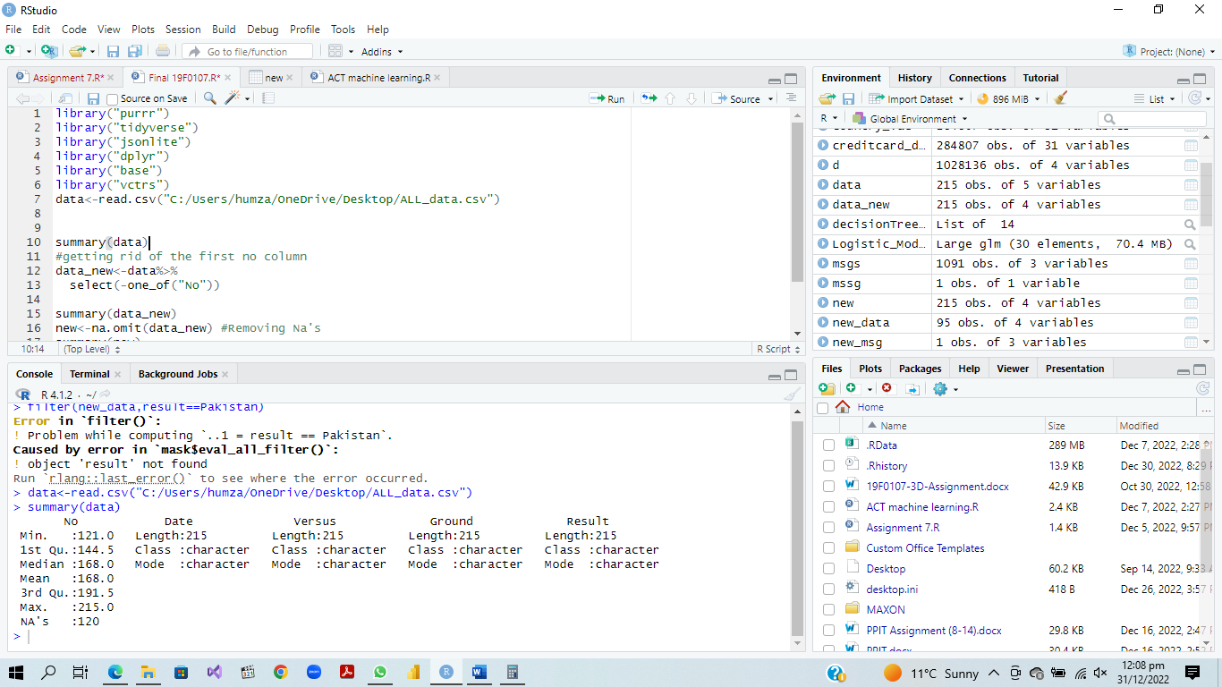

summary(data)

**EDA Process:-**

summary(data)

#getting rid of the first no column

data_new<-data%>%

select(-one_of("No"))

summary(data_new)

new<-na.omit(data_new) #Removing Na's

summary(new)

new_data<-tail(new,n=95) #Getting the last rows that we need data for

head(new_data) #got the data

new_new<-mutate(new_data,Won=if_else(word(new_data$Result, 1)=="Pakistan",1,0))#Getting data of who won

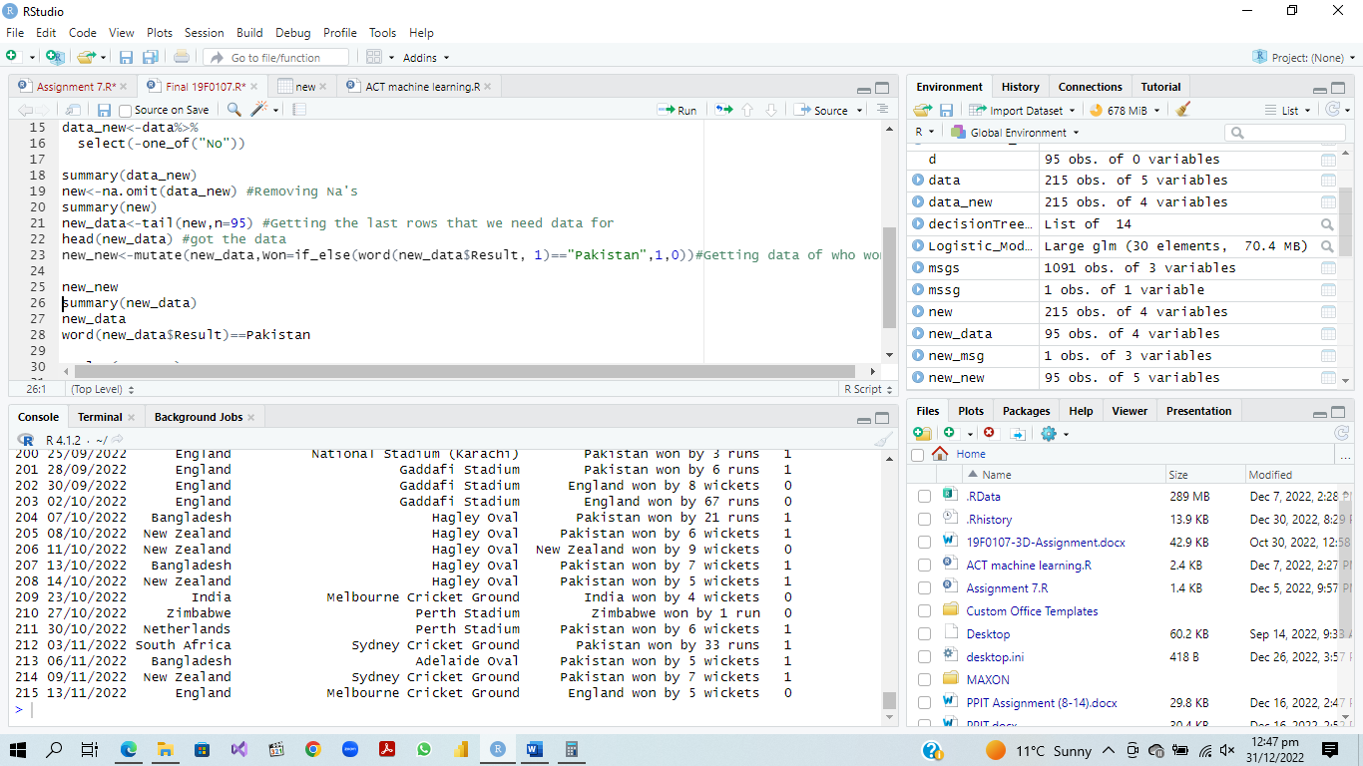

**Visualizations:-**

ggplot(new_new, aes(Won)) +

geom_bar(fill = "#0073C2FF")

#this graph show the percentage of winning of pakistan versus others

