

**WEB ENGINEERING**

**LAB 2**

**HTML5 and CSS**

**NAME:** HAMZA IQTADAR

**REG. NO.** 05700

**CLASS:** BESE 4-A

**DATE:** 22ND SEPTEMBER 2015

**INSTRUCTOR:** FAHAD AHMAD SATTI

**LAB ENGINEER:** AHSAN GUL

A responsive image Browser was made in this lab. HTML 5 was used to construct the page and CSS was used for its styling. The page was made responsive without the use of JavaScript. A heading was given using the h1 tag and an instruction was given to the user by using the p tag. Font color, weight, background color etc. were set using external CSS.

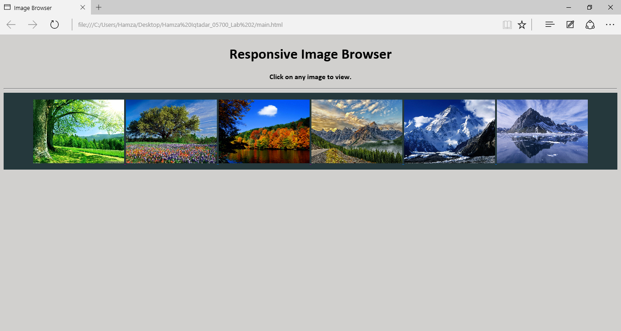

All the images were shown to the user as thumbnails and when the user clicks on the image, that image is viewed since all the thumbnail images were made into anchors.

Initially, no image is displayed. This was achieved by using the following code:

.options div{display:none}

Whenever a user clicks on an image, the image is displayed because the target is the “options” div in which the image is displayed. This was made possible by using the following code:

.options div:target{display: block}

The image scales itself according to the size of the browser window because the max-width is set to 100% and the height is set to auto. Following are some screen shots:

