

**WEB ENGINEERING**

**LAB 3**

**HTML5 and CSS**

**NAME:** HAMZA IQTADAR

**REG. NO.** 05700

**CLASS:** BESE 4-A

**DATE:** 29TH SEPTEMBER 2015

**INSTRUCTOR:** FAHAD AHMAD SATTI

**LAB ENGINEER:** AHSAN GUL

**Repository Link:** <https://github.com/hamzaiqtadar/HamzaIqtadar_05700_Lab3>

A 2-D flight simulator was made in this lab. HTML 5 was used to construct the page and CSS was used for its styling. The page was made responsive without the use of JavaScript. An instruction was given to the user using a div tag located on the top of the page. Font size, weight, family etc. were set using external CSS.

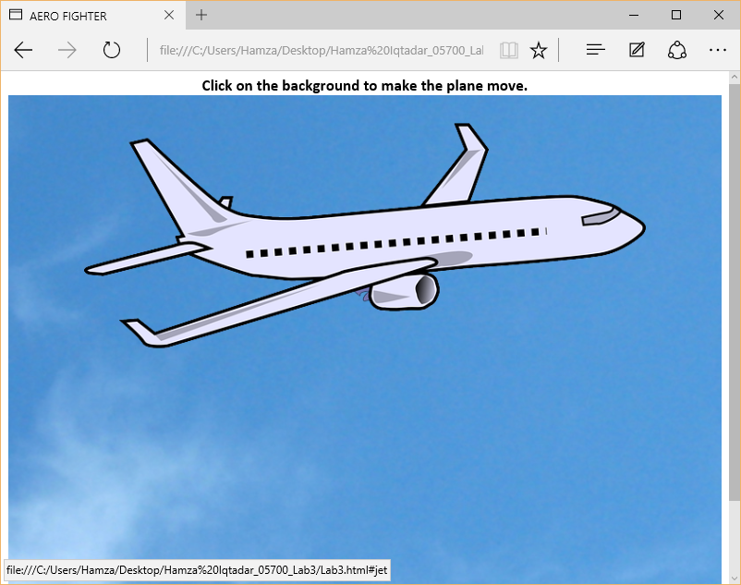

A background image was set for the div following the instruction. The background image was set using CSS. An image of a plane was also placed in the div.

The animation was made possible by adding an effect on the background image so that the image would start to move. This would give the illusion that the plane was flying in a forward direction.

Initially, the plane would appear to be static and start moving only when the user clicks on the image. This was achieved by targeting the div containing the background image, which was made into an anchor tag. When the user clicks on the image, the animation comes into effect. The animation was added using the following code:

@-webkit-keyframes moveright

{

From {background-position: 0 0;}

to {background-position: 100% 0;}

}

#jet:target

{

-webkit-animation:moveright 2s linear infinite

}

, where “jet” is the id of the div containing the background image.