

**WEB ENGINEERING**

**LAB 4**

**JAVASCRIPT**

**NAME:** HAMZA IQTADAR

**REG. NO.** 05700

**CLASS:** BESE 4-A

**DATE:** 6TH OCTOBER 2015

**INSTRUCTOR:** FAHAD AHMAD SATTI

**LAB ENGINEER:** AHSAN GUL

**Repository Link:** <https://github.com/hamzaiqtadar/HamzaIqtadar_05700_Lab4>

A 2-D flight simulator was made in this lab. HTML 5 was used to construct the page and CSS was used for its styling. The page was made responsive without the use of JavaScript. An instruction was given to the user using a div tag located on the top of the page. Font size, weight, family etc. were set using external CSS.

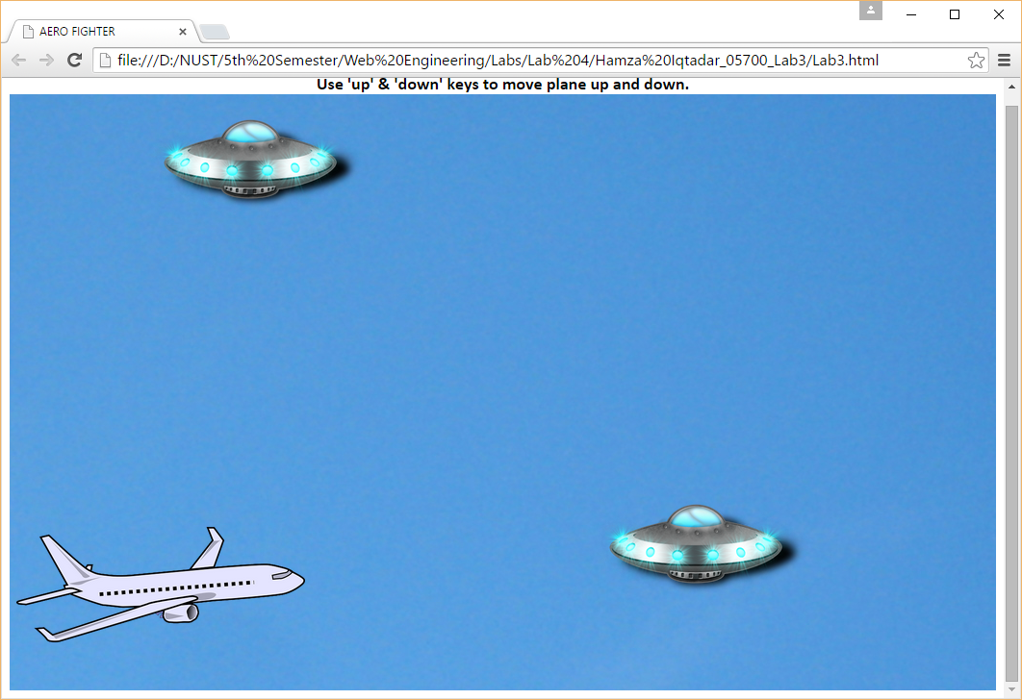

A background image was set for the div following the instruction. The background image was set using CSS. An image of a plane was also placed in the div, along with images of an alien spaceship.

The animation to move the spaceships and to allow the plane to move up and down to avoid them was added using JavaScript. JavaScript functions were extensively used. Conditions to inform user and reload the game in case of a collision was also added.

The animation for the background was made possible by adding an effect on the background image so that the image would start to move. This would give the illusion that the plane was flying in a forward direction.