# **System Documentation**

**I220583**

## **Table of Contents:**

## Classes

* Specifications and Implementations;

## Relationships

## Program Flow

## Characteristics

## **Classes:**

* **Specifications and Implementations;**

**User:**

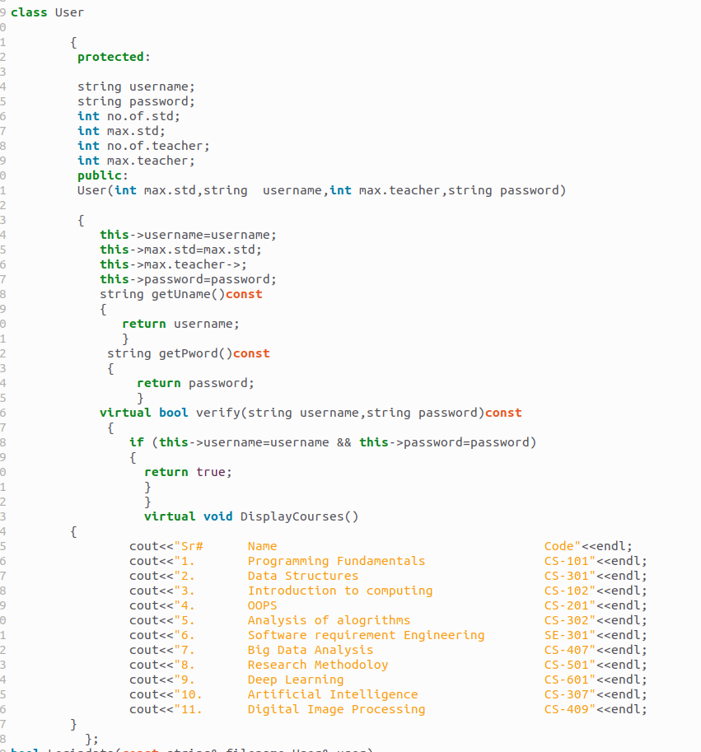

**Teacher:**

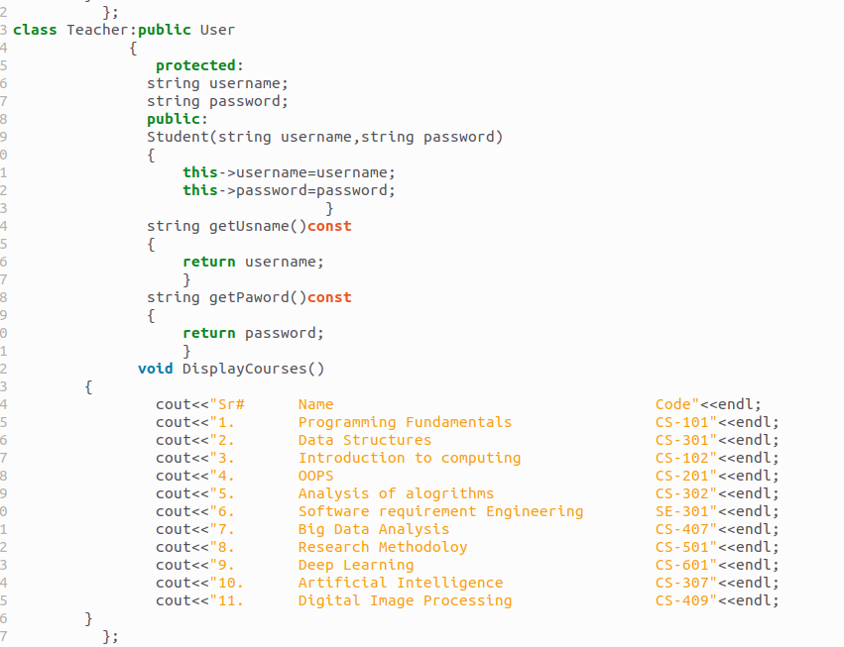

**S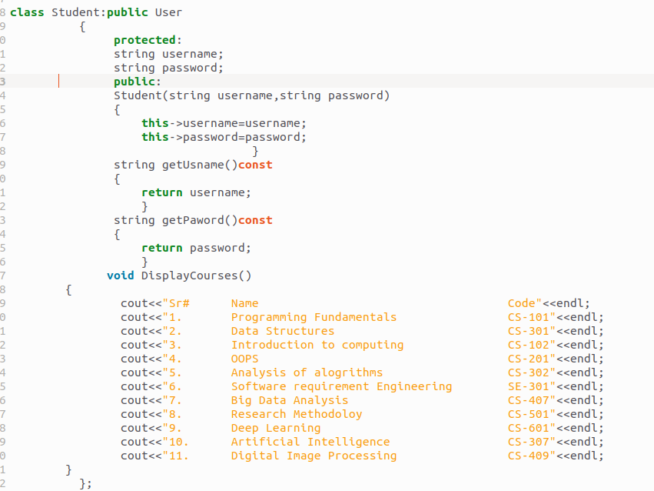tudent:**

**Course:**

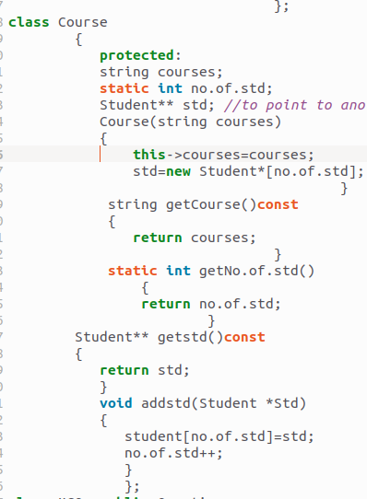

**Question:**

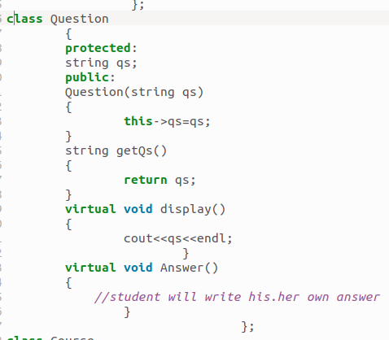

**Date:**

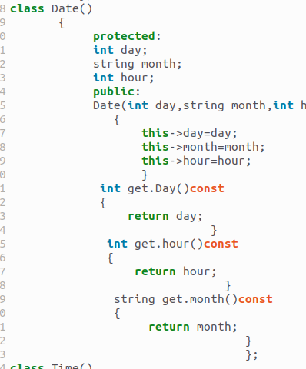

**Time:**

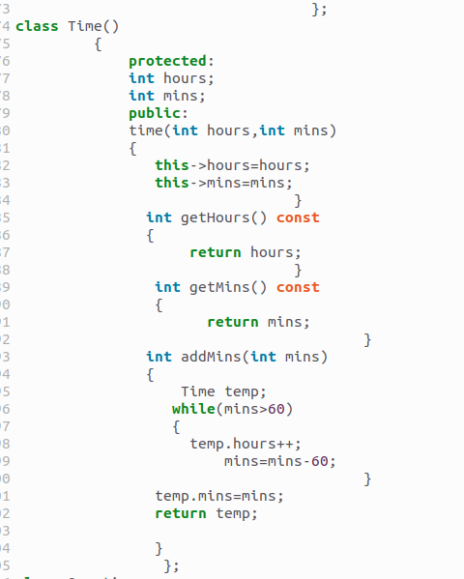

## **Relationships:**

**User:** This class represents a user in the academic system. It serves as a base class for both teachers and students.

**Teacher:** This class represents a teacher in the academic system. It inherits from the User class. It has a relationship with the Course and QuestionBank classes.

**Student:** This class represents a student in the academic system. It inherits from the User class. It has an aggregation relationship with the Course class.

**Course:** This class represents a course in the academic system. It is associated with both the Teacher and Student classes. It has a composite relationship with the QuestionBank class.

**Question:** This class represents a question in the question bank. It is aggregated by the QuestionBank class.

**Date:** This class represents a specific date. It has an aggregation relationship with the Task class.

**Time:** This class represents a specific time. It has a composite relationship with the Date class.

## **Program Flow:**

In the Academic System, the program flow can be logically explained as follows:

Users, including both teachers and students, interact with the system.

Teachers, being derived from the User class, can access and manage courses and question banks. They can create and update courses, add questions to the question bank, and create tasks for students.

Students, also derived from the User class, can enroll in courses. They have access to the courses and can view tasks assigned to them.

The Task class represents an assignment given to students. It has composite relationships with the QuestionBank, Teacher, and Student classes. This means a task consists of questions from a question bank and is assigned by a teacher to specific students.

The Date and Time classes are used to represent specific dates and times associated with tasks. The Task class has an aggregation relationship with the Date class, and the Date class has a composite relationship with the Time class.

The Report class represents the reports generated for tasks. It has a composite relationship with the Task class, indicating that a report is associated with a specific task.