10Pearls Data Science Internship
Project Report
Pearls AQI Predictor:
A Feature–Training–Inference Pipeline for
Three-Day-Ahead Air Quality Forecasting in Lahore
Continuous US EPA AQI computed from PM2.5 | Horizons 24 / 48 / 72 hours
Item | Details from project files
Project title | Pearls AQI Predictor
Programme | 10Pearls Data Science Internship
Target city | Lahore (default latitude 31.5497, longitude 74.3436)
Primary training notebook | notebooks/02_training.ipynb
EDA notebook | notebooks/01_eda.ipynb
Repository (report draft) | https://github.com/hamzajawad123/aqi_predictor
Document date | 28 August 2026
Student name | Not stated in the provided project files
University / course / instructor | Not stated in the provided project files
Group members | Not stated in the provided project files

Table 1: Title-page information taken only from provided project files.
Items that are blank in the table above were not invented. The remainder of this report uses only facts that appear in the project notebooks, source code, README, and local raw data snapshot.

1. Executive Summary
This report documents a three-day-ahead Air Quality Index (AQI) forecast for Lahore. The README describes the work as a serverless Feature / Training / Inference (FTI) pipeline for the 10Pearls Data Science Internship. Pollution concentrations come from the OpenWeather Air Pollution API. Weather covariates come from Open-Meteo. Engineered features and models are stored in Hopsworks. Inference is FastAPI; the dashboard is Streamlit.
The prediction target used throughout the code is a continuous US EPA AQI computed from PM2.5. OpenWeather’s native main.aqi field is stored as openweather_aqi_category and is not the regression target. Models are trained mainly on AQI deltas (future AQI minus current AQI) and scored on reconstructed absolute AQI using RMSE, MAE and R². A candidate is eligible for the Hopsworks registry only if it beats a persistence baseline (future AQI equals current AQI) on all three metrics.
The primary training evidence in this report is the executed Colab notebook notebooks/02_training.ipynb. That run read feature group aqi_features version 3, shape (46100, 52), timestamps 2020-12-05 18:00:00 to 2026-08-08 06:00:00, with 42 input features. The season-aligned split was train 2020-12-05 to 2024-06-01 (27947 rows), validation 2024-06-01 to 2025-06-01 (8075 rows), and test 2025-06-01 to 2026-08-08 (10078 rows). Optuna used 15 trials. Persistence was best on every horizon. The notebook printed “NO model beat persistence on all 3 metrics” for 24h, 48h and 72h, and the registry summary was registered=False, winner=None for all three horizons.
A later production training window is documented separately in src/config.py (TRAIN_START_DATE default 2025-04-04) and in reports/_build_final_report.py. Those numbers are not AT8 notebook stdout and are labelled as such. They are not used to replace the AT8 tables.

2. Table of Contents
1. Executive Summary 2
2. Table of Contents 2
3. List of Figures 5
4. List of Tables 5
5. Introduction 6
6. Problem Statement 6
7. Project Objectives 6
8. Project Scope 7
9. Project Workflow 7
10. Dataset Description 8
10.1 Raw merged snapshot (EDA source) 8
10.2 Data sources 9
10.3 Target variable 9
10.4 Feature-group table used by AT8 10
11. Data Understanding 11
12. Data Preprocessing 13
12.1 Validation of raw merged data 13
12.2 Hourly grid and short-gap interpolation 13
12.3 Transforms applied in build_feature_set 14
12.4 Scaling (model-specific) 14
12.5 Train / validation / test split used in AT8 14
12.6 Steps not claimed 14
13. Exploratory Data Analysis 14
13.1 AQI distribution 15
13.2 Pollutant distributions 15
13.3 AQI over time 16
13.4 AQI versus weather 16
13.5 Correlation heatmap 17
13.6 Autocorrelation 17
13.7 Seasonal decomposition 18
13.8 Smog season versus normal season 18
14. Feature and Variable Analysis 19
15. Methodology 19
16. Approaches Considered and Used 20
16.1 Persistence baseline 20
16.2 Optuna-tuned tabular regression on deltas 20
16.3 Mean ensemble of top-3 tabular models 20
16.4 Sequence models (LSTM and GRU) 20
16.5 Prophet on absolute AQI 20
16.6 Production training window (not AT8) 20
17. Models Used 21
17.1 Persistence Baseline 21
17.2 Ridge 21
17.3 RandomForest 22
17.4 XGBoost 22
17.5 LightGBM 23
17.6 Ensemble_top3_tabular 23
17.7 LSTM 23
17.8 GRU 24
17.9 Prophet 24
18. Model Training 25
19. Model Evaluation 25
20. Results 25
20.1 Complete AT8 comparison (24 hours) 25
20.2 Complete AT8 comparison (48 hours) 26
20.3 Complete AT8 comparison (72 hours) 27
21. Model Comparison 28
22. Best Model / Final Approach Selection (AT8 notebook) 29
23. Production Training Window Documented Outside AT8 29
24. Why Other Models Were Not Selected 30
24.1 Ridge 30
24.2 RandomForest 30
24.3 XGBoost 30
24.4 LightGBM 30
24.5 Ensemble_top3_tabular 30
24.6 LSTM 30
24.7 GRU 30
24.8 Prophet 30
25. Serving, Dashboard and Automation 31
26. Key Findings 31
27. Limitations 31
28. Conclusion 32
29. References and Source Notes 32

Microsoft Word fills this list when fields are updated (open the file and allow field update, or press Ctrl+A then F9).

3. List of Figures
Error! No table of figures entries found.
Microsoft Word fills this list when fields are updated (open the file and allow field update, or press Ctrl+A then F9).
Figure titles used in this document: Figure 1 AQI distribution and boxplot; Figure 2 pollutant histograms; Figure 3 AQI over time; Figure 4 AQI versus weather; Figure 5 correlation heatmap; Figure 6 ACF and PACF; Figure 7 seasonal decomposition; Figure 8 smog season versus normal season; Figure 9 AT8 test RMSE 24h; Figure 10 AT8 test RMSE 48h; Figure 11 AT8 test RMSE 72h.

4. List of Tables
Error! No table of figures entries found.
Microsoft Word fills this list when fields are updated (open the file and allow field update, or press Ctrl+A then F9).
Table titles used in this document run from Table 1 (title-page information) through the dataset, feature, evaluation and comparison tables in later sections.

5. Introduction
The README states that the project forecasts Lahore AQI three days ahead and is built as a serverless FTI pipeline. The architecture diagram in the README is:
- OpenWeather (pollution) and Open-Meteo (weather) feed a feature pipeline.
- The feature pipeline writes to the Hopsworks Feature Store.
- A training pipeline writes to the Hopsworks Model Registry.
- FastAPI performs inference.
- A Streamlit dashboard presents forecasts.
src/config.py sets CITY_NAME default Lahore, LATITUDE 31.5497, LONGITUDE 74.3436, DATA_START_DATE 2020-11-27 (OpenWeather air-pollution history start), TARGET_HORIZONS (24, 48, 72), FORECAST_HORIZON_HOURS 72, FEATURE_GROUP_NAME aqi_features, FEATURE_GROUP_VERSION default 4, MODEL_NAME aqi_forecaster, and SMOG_SEASON_MONTHS (10, 11, 12, 1).
The same config file documents a regime break on 2025-04-04: mean hourly |AQI change| collapses from ~46 to ~4.5 and does not recover, with the same break in pm2_5. TRAIN_START_DATE defaults to that date. The AT8 notebook did not apply that filter; it trained on the full feature-group v3 table described in Section 12.

6. Problem Statement
The project files frame the problem as forecasting a continuous AQI for Lahore at 24, 48 and 72 hours. src/utils/aqi_calculation.py states why OpenWeather’s main.aqi is not used as the target: it is a coarse 1–5 categorical index, whereas the project brief asks for a continuous AQI and for RMSE, MAE and R². Those metrics assume a numeric target with meaningful distances.
src/training_pipeline.py and notebooks/02_training.ipynb treat persistence (“AQI in N hours equals AQI now”) as the registration baseline. Hourly AQI is strongly autocorrelated, so persistence is a serious baseline. The notebook helper beats_persistence requires strictly better RMSE, strictly better MAE, and strictly better R² together.

7. Project Objectives
The following objectives are stated in the README and in the training/serving code. No additional objectives were added.
- Forecast Lahore AQI at 24, 48 and 72 hours.
- Use one pollution source (OpenWeather) and one weather source (Open-Meteo) for both historical and hourly paths.
- Store engineered features in Hopsworks (feature group aqi_features).
- Register aqi_forecaster_{24,48,72}h only when a model beats persistence on RMSE, MAE and R².
- Serve forecasts through FastAPI GET /predict and present them in Streamlit (app/Home.py).
- Automate hourly feature updates and daily retraining with GitHub Actions.

8. Project Scope
- City: Lahore at the default coordinates in src/config.py. The pipeline is location-parameterised; the provided files do not report a multi-city training run.
- AQI is computed from PM2.5 only using the 2024 US EPA PM2.5 breakpoint table in src/utils/aqi_calculation.py. That file states a full multi-pollutant EPA maximum was not implemented.
- OpenWeather’s 4-day pollution forecast is fetched in src/utils/data_fetch.py for possible later comparison; that file states it is not used by the current training pipeline.
- notebooks/02_training.ipynb trains Ridge, RandomForest, XGBoost, LightGBM, a top-3 tabular mean ensemble, LSTM, GRU and Prophet, plus a persistence baseline.
- src/training_pipeline.py states that /predict serves only tabular or ensemble payloads that consume one feature row. Prophet needs a date series; LSTM/GRU need a 24-hour window.
- Production feature-group version in config and GitHub Actions is 4. The AT8 notebook used version 3.

9. Project Workflow
The sequence below is the sequence supported by the provided files. Steps that are common in data science but not present in the files are omitted.
- Problem definition: continuous EPA AQI from PM2.5 at 24/48/72 hours for Lahore.
- Data collection: OpenWeather pollution history from 2020-11-27; Open-Meteo weather for the same hours; merge on UTC timestamp.
- Raw snapshot: data/raw/aqi_raw_merged.parquet written by python -m src.feature_pipeline raw-snapshot.
- Validation: src/utils/data_validation.py before insert (required columns, duplicates, nulls, wide physical bounds).
- Data understanding and EDA: notebooks/01_eda.ipynb on the raw snapshot (not the engineered feature group).
- Feature engineering: src/utils/feature_engineering.py build_feature_set (hourly grid, time encodings, log1p pollutants, lags, rolling windows, change rates, weather interactions, absolute and delta targets).
- Feature store: Hopsworks group aqi_features (v3 in AT8; v4 in current config).
- Training: notebooks/02_training.ipynb (AT8) and src/training_pipeline.py.
- Evaluation: RMSE, MAE, R² on absolute future AQI versus persistence.
- Registration gate: beat persistence on all three metrics or register nothing.
- Serving: FastAPI and/or Streamlit reading Hopsworks (src/utils/serving.py).

10. Dataset Description

10.1 Raw merged snapshot (EDA source)
EDA in notebooks/01_eda.ipynb reads the local raw snapshot via src.utils.raw_io.load_raw_snapshot. The snapshot used to produce the EDA figures and statistics in this report is data/raw/aqi_raw_merged.parquet. After loading, the figure script added month and is_smog_season for plots; those two columns are not stored in the 16-column parquet.
Item | Details from local raw snapshot
File | data/raw/aqi_raw_merged.parquet
Rows | 46419
Stored columns | 16
Timestamp range | 2020-11-27 00:00:00 to 2026-08-14 13:00:00
Duplicate timestamps | 0
Missing values (all stored columns) | none
Target used in this project | aqi (US EPA AQI from PM2.5)
Reference column (not the target) | openweather_aqi_category

Table 2: Raw snapshot used for EDA figures and descriptive statistics.
Stored columns and data types measured on the loaded snapshot (before adding EDA-only month / is_smog_season) are:
Column | dtype on snapshot
timestamp | datetime64[ns]
openweather_aqi_category | float64
co | float64
no | float64
no2 | float64
o3 | float64
so2 | float64
pm2_5 | float64
pm10 | float64
nh3 | float64
aqi | int64
temperature | float64
humidity | int64
wind_speed | float64
wind_deg | int64
pressure | float64

Table 3: Raw snapshot columns and dtypes.

10.2 Data sources
src/utils/data_fetch.py states the source decision: pollution and AQI from the OpenWeather Air Pollution API (current, forecast, historical); weather from Open-Meteo archive and forecast APIs. Historical OpenWeather air pollution on the free tier begins 27 November 2020; DATA_START_DATE is set to that date so both sources share the first day. Open-Meteo hourly variables used are temperature_2m, relative_humidity_2m, wind_speed_10m, wind_direction_10m and surface_pressure, renamed to temperature, humidity, wind_speed, wind_deg and pressure. All timestamps are normalised to UTC before the merge.

10.3 Target variable
aqi is computed in src/utils/aqi_calculation.py from PM2.5 using the 2024-revised US EPA PM2.5 breakpoint table stored in PM25_BREAKPOINTS_2024:
PM2.5 low (µg/m³) | PM2.5 high (µg/m³) | AQI low | AQI high | Label in source comment
0.0 | 9.0 | 0 | 50 | Good
9.1 | 35.4 | 51 | 100 | Moderate
35.5 | 55.4 | 101 | 150 | Unhealthy for Sensitive Groups
55.5 | 125.4 | 151 | 200 | Unhealthy
125.5 | 225.4 | 201 | 300 | Very Unhealthy
225.5 | 325.4 | 301 | 500 | Hazardous

Table 4: PM2.5 breakpoints copied from src/utils/aqi_calculation.py.
The same file states that concentration is truncated (not rounded) to one decimal place before lookup, matching EPA methodology. Values above 325.4 µg/m³ are extrapolated from the last band rather than hard-capped at 500. The file also states the simplification: official EPA AQI is the maximum across six criteria pollutants; this project uses PM2.5 only.

10.4 Feature-group table used by AT8
notebooks/02_training.ipynb printed the following after reading Hopsworks:
Item | AT8 notebook stdout
Feature group | aqi_features v3
Shape | (46100, 52)
Range | 2020-12-05 18:00:00 -> 2026-08-08 06:00:00
Delta / target columns confirmed | aqi_delta_24h, aqi_delta_48h, aqi_delta_72h, aqi_target_24h, aqi_target_48h, aqi_target_72h
n_features after dropping timestamp, hour, month, openweather_aqi_category and all six target columns | 42
Train rows | 27947
Validation rows | 8075
Test rows | 10078
Train window printed | 2020-12-05->2024-06-01
Validation window printed | 2024-06-01->2025-06-01
Test window printed | 2025-06-01->2026-08-08

Table 5: Feature group and split facts from notebooks/02_training.ipynb.
src/config.py states that v3 has delta targets but was built on a gappy frame, so about 13% of lags/targets spanned the wrong number of hours. v4 is described as the same features on a strict hourly grid. AT8 used v3; current default FEATURE_GROUP_VERSION is 4.

11. Data Understanding
On the local raw snapshot used for EDA figures, the aqi series has the following descriptive statistics (computed by reports/_make_report_figures.py from the same parquet the EDA notebook reads):
Statistic | Value
aqi mean | 247.7509855877981
aqi median | 177.0
aqi standard deviation | 194.00734285333604
aqi skewness | 1.907488520950293
aqi kurtosis | 3.1202724556139034
IQR outlier threshold (Q3 + 1.5 IQR) | 479.0
Count of aqi values above that threshold | 5837
ADF statistic | -11.764392029744617
ADF p-value | 1.1280420946421232e-21

Table 6: AQI descriptive statistics and ADF test on the local raw snapshot.
Yearly mean aqi after resampling to year-end (YE-DEC) on the same snapshot:
Year-end timestamp | Mean aqi
2020-12-31 | 438.785818
2021-12-31 | 263.904701
2022-12-31 | 277.071900
2023-12-31 | 280.052722
2024-12-31 | 251.599010
2025-12-31 | 202.854102
2026-12-31 | 166.540349

Table 7: Yearly mean AQI on the raw snapshot. 2020 starts on 27 November; 2026 ends on 14 August.
Smog season is defined in src/config.py as months October–January. On the raw snapshot:
is_smog_season | count | mean | std | min | 25% | 50% | 75% | max
0 (Normal) | 32406.0 | 182.315405 | 126.145572 | 0.0 | 112.0 | 159.0 | 193.0 | 1000.0
1 (Smog Oct–Jan) | 14013.0 | 399.075145 | 234.698541 | 52.0 | 207.0 | 310.0 | 553.0 | 1000.0

Table 8: AQI grouped by smog-season flag on the raw snapshot.
Pearson correlation of numeric columns with aqi on the raw snapshot (month column excluded from the correlation matrix in the figure script):
Variable | Correlation with aqi
aqi | 1.000000
pm2_5 | 0.986036
pm10 | 0.958184
co | 0.793539
no | 0.560187
no2 | 0.546778
is_smog_season | 0.512918
pressure | 0.511338
openweather_aqi_category | 0.477453
so2 | 0.367937
nh3 | 0.361643
humidity | 0.284877
wind_deg | 0.092419
wind_speed | -0.240057
o3 | -0.266326
temperature | -0.545787

Table 9: Correlation with aqi on the raw snapshot.
Pollutant skewness on the raw snapshot, sorted descending: no 3.919896, nh3 3.008166, so2 2.456016, no2 2.265771, co 1.987650, pm2_5 1.411350, pm10 1.290845, o3 1.257247. src/utils/feature_engineering.py cites right-skew (skew > 1) as the reason for log1p on those eight pollutant columns.

12. Data Preprocessing

12.1 Validation of raw merged data
src/utils/data_validation.py runs before data are written to Hopsworks. Required columns are timestamp, aqi, pm2_5, pm10, co, no2, o3, so2, nh3, temperature, humidity, wind_speed, wind_deg, pressure. Duplicate timestamps are dropped (keep first). Rows with nulls in required columns are dropped. Out-of-range rows are dropped using these bounds:
Column | Accepted range in VALID_RANGES
aqi | 0 to 1000
pm2_5 | 0 to 2000 µg/m³
pm10 | 0 to 2000 µg/m³
co | 0 to 50000 µg/m³
no2 | 0 to 2000 µg/m³
o3 | 0 to 2000 µg/m³
so2 | 0 to 2000 µg/m³
nh3 | 0 to 2000 µg/m³
temperature | −30 to 60 °C
humidity | 0 to 100 %
wind_speed | 0 to 150 km/h
wind_deg | 0 to 360 degrees
pressure | 850 to 1100 hPa

Table 10: Validation ranges from src/utils/data_validation.py.
The file states the bounds are wide on purpose so genuine smog extremes are not treated as errors. One bad hour drops that row; it does not abort the entire batch unless raise_on_error is set.

12.2 Hourly grid and short-gap interpolation
src/utils/feature_engineering.py to_hourly_grid reindexes onto a strict hourly calendar before any lag or target shift. The file states the raw history has ~3,700 missing hours in 415 outages, and that on the gappy frame shift(−24) spanned 24 hours for only 87% of rows and up to 264 hours for the rest. Outages of at most MAX_INTERPOLATE_HOURS = 6, end to end, are linearly interpolated. Longer gaps stay NaN and are dropped later. Integer-typed columns are rounded immediately after the grid step.

12.3 Transforms applied in build_feature_set
- add_time_features: hour, day_of_week, month, is_weekend, hour_sin, hour_cos, month_sin, month_cos.
- add_season_flag: is_smog_season for months in SMOG_SEASON_MONTHS (10, 11, 12, 1).
- add_log_pollutants: log1p of clipped-at-zero co, no, no2, o3, so2, pm2_5, pm10, nh3 (raw columns replaced in place).
- add_lag_features: aqi lags 1, 3, 6, 24, 168 hours.
- add_rolling_features: aqi rolling mean, std, min, max over 3, 6, 24 hours.
- add_change_rate: aqi_change_rate_1h and aqi_change_rate_24h.
- add_weather_interactions: wind_speed × pm2_5 and humidity × pm2_5.
- add_targets: aqi_target_{24,48,72}h and aqi_delta_{24,48,72}h.
- Training mode: dropna on the full row. Inference mode: dropna only on feature columns so the latest hours (unknown future targets) remain.

12.4 Scaling (model-specific)
In notebooks/02_training.ipynb, Ridge is a pipeline of StandardScaler plus Ridge. LSTM and GRU fit StandardScaler on training features and transform train, validation and test features. RandomForest, XGBoost and LightGBM in that notebook are not wrapped in StandardScaler. Prophet is fit on timestamp and aqi only.

12.5 Train / validation / test split used in AT8
The notebook uses a chronological split that snaps validation and test starts to 1 June. The executed print was: train 2020-12-05->2024-06-01 | val 2024-06-01->2025-06-01 | test 2025-06-01->2026-08-08, with row counts 27947 / 8075 / 10078. Optuna used TimeSeriesSplit(n_splits=5) on the training fold. RANDOM_STATE = 42. N_TRIALS = 15.

12.6 Steps not claimed
The AT8 notebook run did not apply TRAIN_START_DATE = 2025-04-04. It did not print a delta-shrinkage search (that search exists in src/training_pipeline.py / src/utils/evaluation.py). Duplicate timestamps on the local raw snapshot were 0, so duplicate removal was not required for that file.

13. Exploratory Data Analysis
notebooks/01_eda.ipynb contains the EDA recipes (univariate plots, pollutant histograms, AQI over time, AQI versus weather, correlation heatmap, ACF/PACF, seasonal decomposition, ADF, smog-versus-normal boxplot, and a Findings for FE cell). The notebook file in the repository has no executed plot outputs. The figures below were therefore produced from the local raw parquet using those same plot recipes. Values in the captions match reports/_report_figures/eda_stats.txt.

13.1 AQI distribution
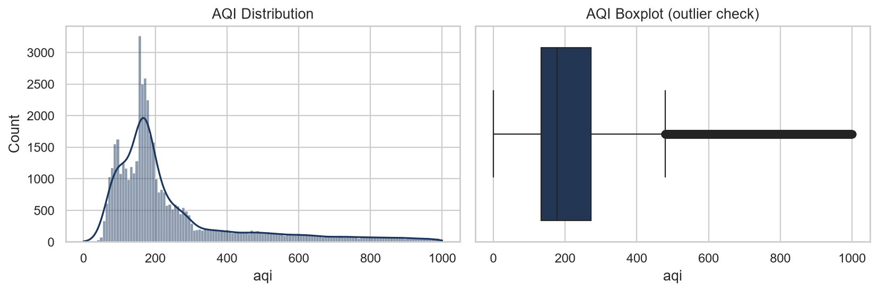
Figure 1: Distribution of aqi (histogram with KDE) and aqi boxplot on the raw snapshot.
What the figure shows: aqi is right-skewed (skewness 1.907488520950293). Mean 247.7509855877981 is above median 177.0. The boxplot shows a long upper tail. 5837 observations lie above the IQR fence 479.0. Maximum aqi in the smog/normal describe table is 1000.0 in both groups.

13.2 Pollutant distributions
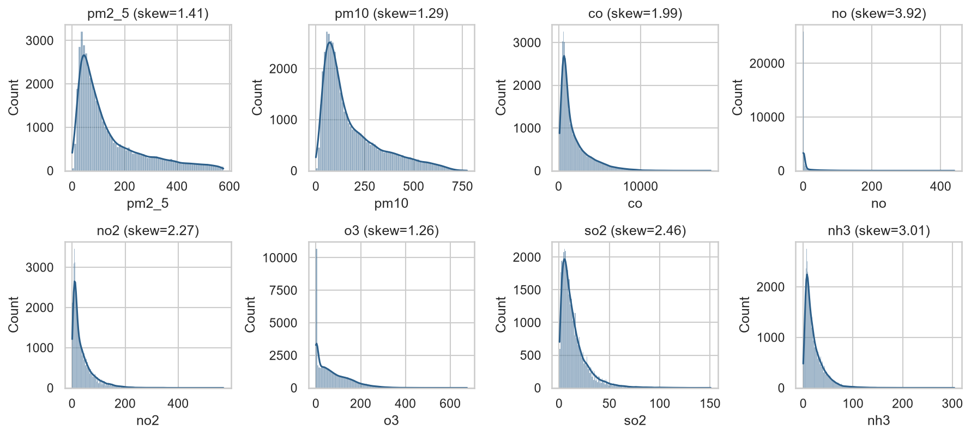
Figure 2: Histograms of pm2_5, pm10, co, no, no2, o3, so2 and nh3 on the raw snapshot.
What the figure shows: all eight pollutant series are right-skewed. The notebook titles each panel with that column’s skew. Ranked skewness is given in Section 11. src/utils/feature_engineering.py applies log1p to these columns for that reason.

13.3 AQI over time
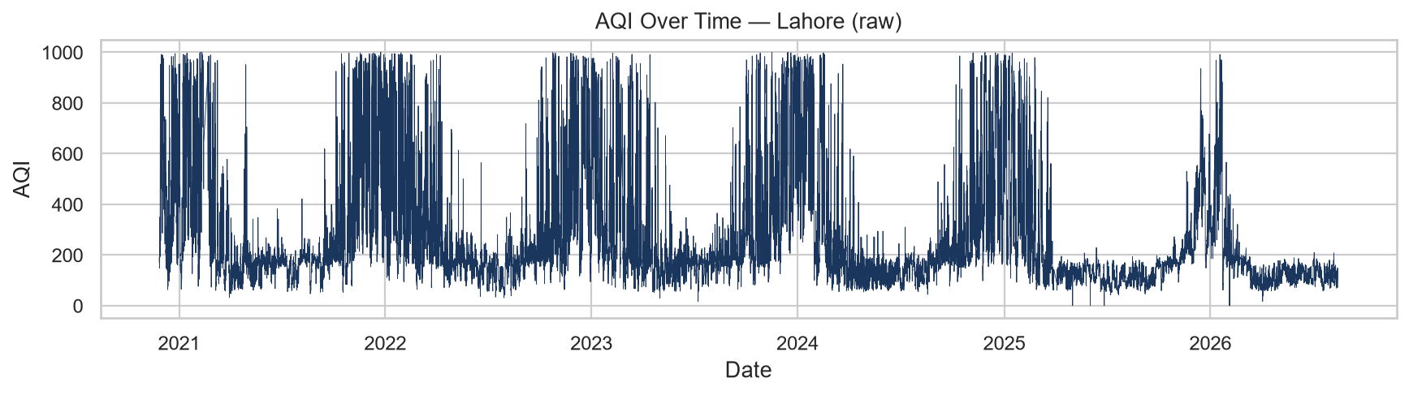
Figure 3: aqi over time for Lahore on the raw snapshot (2020-11-27 to 2026-08-14).
What the figure shows: repeated winter peaks and a visible later decline in typical level, consistent with Table 7 yearly means falling from 438.785818 in incomplete 2020 to 166.540349 in incomplete 2026. src/utils/feature_engineering.py cites a multi-year downward AQI trend as a reason for delta targets.

13.4 AQI versus weather
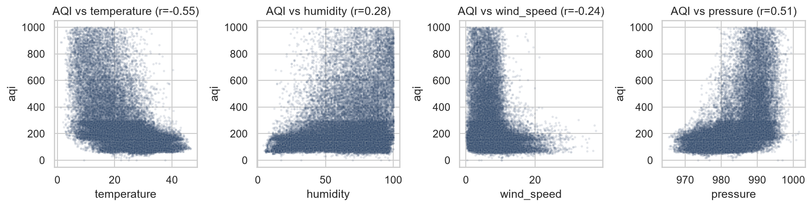
Figure 4: Scatter of aqi versus temperature, humidity, wind_speed and pressure.
What the figure shows: panel titles include the Pearson r from the same snapshot. Table 9 gives temperature −0.545787, humidity 0.284877, wind_speed −0.240057, pressure 0.511338. The negative temperature association and positive pressure association are visible as slope direction in the clouds of points. The provided material does not state a causal mechanism beyond the feature-engineering comments on wind dispersing pollution and humidity affecting secondary particle formation.

13.5 Correlation heatmap
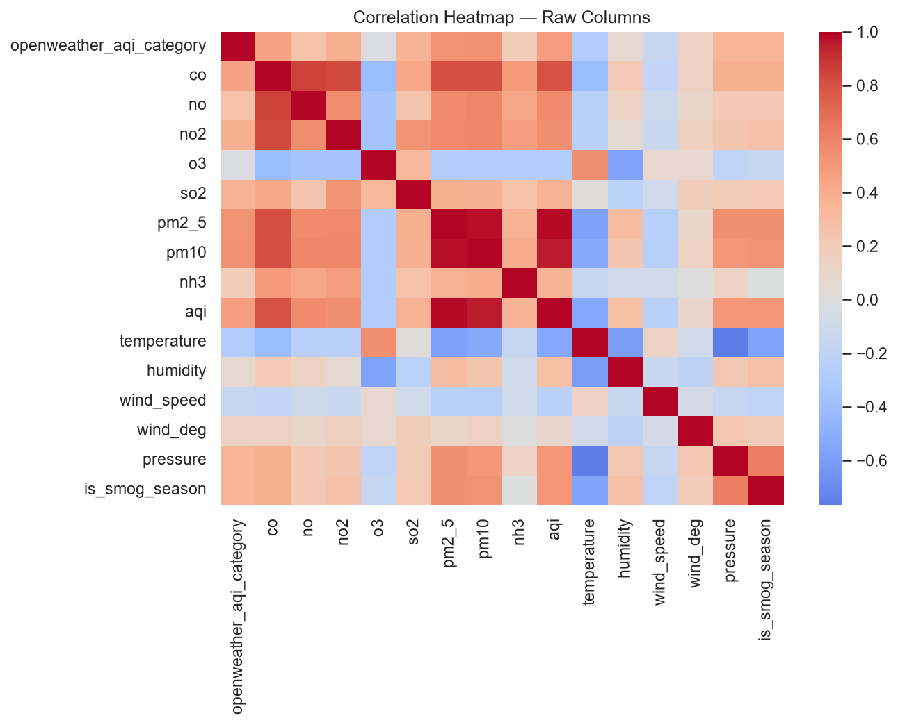
Figure 5: Correlation heatmap of numeric raw columns (month excluded).
What the figure shows: aqi is most strongly associated with pm2_5 (0.986036) and pm10 (0.958184). That is expected because aqi is computed from pm2_5. openweather_aqi_category correlates with aqi at 0.477453, weaker than pm2_5, which matches the code comment that the 1–5 field is not the continuous target.

13.6 Autocorrelation
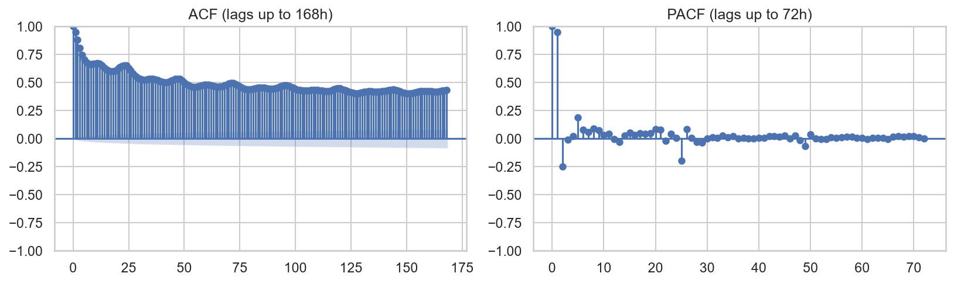
Figure 6: ACF of aqi up to 168 hourly lags and PACF of aqi up to 72 hourly lags.
What the figure shows: AQI is strongly autocorrelated at short lags, with structure out to daily (24h) and weekly (168h) ranges in the ACF panel. src/utils/feature_engineering.py states that lags {1, 3, 6, 24, 168} and rolling windows {3, 6, 24} were chosen from ACF/PACF on raw AQI.

13.7 Seasonal decomposition
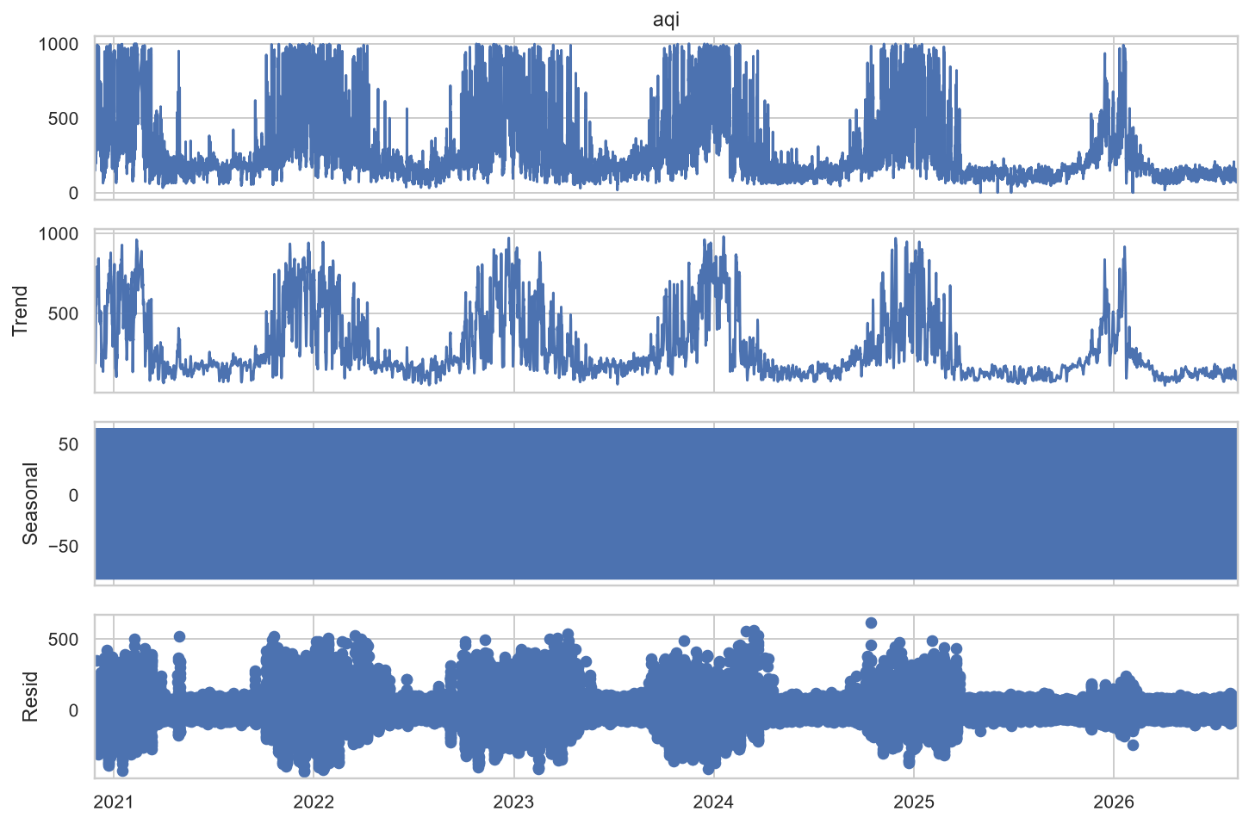
Figure 7: Additive seasonal_decompose of hourly aqi with period=24.
What the figure shows: an observed series, a slow-moving trend, a repeating 24-hour seasonal component, and a residual. The notebook uses model="additive" and period=24. The figure script interpolated to hourly frequency before decompose, matching the EDA notebook recipe (asfreq hourly then interpolate).

13.8 Smog season versus normal season
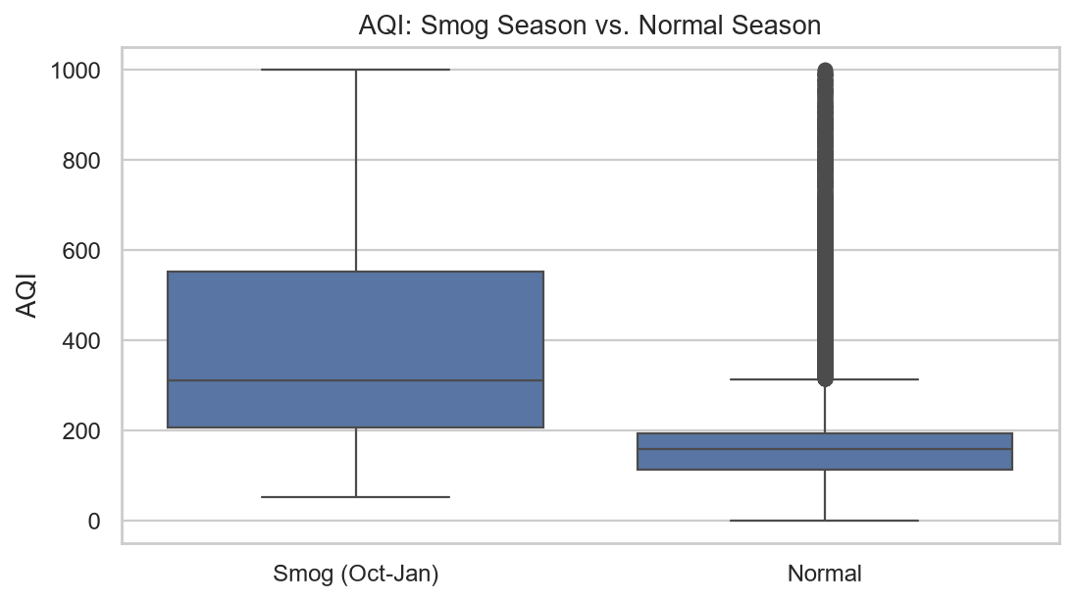
Figure 8: Boxplot of aqi for Normal versus Smog (Oct–Jan) on the raw snapshot.
What the figure shows: smog-season hours have higher aqi. Table 8 mean 399.075145 (n=14013) versus 182.315405 (n=32406). This flag is both a model feature and the stratification key named in feature_engineering.py and training_pipeline.py.

14. Feature and Variable Analysis
AT8 used 42 input columns obtained by dropping timestamp, hour, month, openweather_aqi_category, aqi_target_{24,48,72}h and aqi_delta_{24,48,72}h from the 52-column feature-group table. Reconstructing that 42-column list from src/utils/feature_engineering.py plus the raw columns stored in the group gives:
- Pollutants after log1p (replaced in place): co, no, no2, o3, so2, pm2_5, pm10, nh3.
- Current aqi (untransformed).
- Weather: temperature, humidity, wind_speed, wind_deg, pressure.
- Time encodings kept as features: day_of_week, is_weekend, hour_sin, hour_cos, month_sin, month_cos, is_smog_season.
- AQI lags: aqi_lag_1h, aqi_lag_3h, aqi_lag_6h, aqi_lag_24h, aqi_lag_168h.
- Rolling aqi: mean/std/min/max for windows 3h, 6h and 24h (12 columns).
- Change rates: aqi_change_rate_1h, aqi_change_rate_24h.
- Interactions: wind_pollutant_interaction, humidity_pollutant_interaction.
That list has 42 names. The AT8 notebook printed n_features: 42 but did not print the 42 names as a separate list. The names above come from the feature-engineering code that produces the feature group, together with the drop list in the notebook.
Supervised targets in AT8: tabular, LSTM and GRU train on aqi_delta_{h}h. Absolute metrics use aqi_target_{h}h. Persistence predicts the current aqi column. Prophet is fit on columns timestamp and aqi (renamed ds, y) and predicts yhat at test timestamp + h hours.

15. Methodology
All AT8 families except Prophet train to predict the AQI change over the horizon. Absolute prediction is current aqi plus predicted delta (notebook function reconstruct_absolute). Metrics are sklearn mean_squared_error (then square root for RMSE), mean_absolute_error, and r2_score on aqi_target_{h}h. Persistence is evaluate(target, current aqi).
Registration rule in the notebook (identical in spirit to src/training_pipeline.py): eligible models must have RMSE < persistence RMSE, MAE < persistence MAE, and R² > persistence R². Among eligible models, sort by RMSE, then MAE, then −R². If none are eligible, print that nothing is registered.
Hopsworks login printed in AT8: project URL https://eu-west.cloud.hopsworks.ai:443/p/41103, feature group aqi_features v3. Hardware prints: TensorFlow GPU Detected: /physical_device:GPU:0; XGBoost CUDA Acceleration Enabled.

16. Approaches Considered and Used

16.1 Persistence baseline
Name: Persistence Baseline. Purpose in this project: the no-change forecast future AQI = current AQI. Inputs: the aqi column on the test fold. Features: none beyond current aqi. Training: none. Evaluation: RMSE, MAE, R² on aqi_target_{h}h. Results: Table 11–13. Decision in AT8: this baseline was the best on every horizon and was therefore the registration winner by the gate (no learned model registered).

16.2 Optuna-tuned tabular regression on deltas
Name: Ridge, RandomForest, XGBoost, LightGBM. Purpose: predict aqi_delta_{h}h from the 42 features, then add the delta to current aqi. Training: Optuna minimise time-series CV RMSE, 15 trials, TimeSeriesSplit n_splits=5, then refit on all training rows. Evaluation: absolute AQI metrics on test. Decision in AT8: none beat persistence on all three metrics.

16.3 Mean ensemble of top-3 tabular models
Name: Ensemble_top3_tabular. Purpose: average the reconstructed absolute predictions of the three tabular models with lowest test RMSE. Members are chosen after test scoring in the notebook loop (sorted tabular RMSE, take three). Decision in AT8: not eligible under the persistence gate.

16.4 Sequence models (LSTM and GRU)
Name: LSTM, GRU. Purpose: model 24-hour windows of the 42 scaled features to predict the horizon delta. SEQUENCE_LENGTH = 24. Architecture in the notebook: Input (24, n_feat), LSTM or GRU 64 return_sequences=True, Dropout 0.2, LSTM or GRU 32, Dropout 0.2, Dense 16 relu, Dense 1. Adam learning rate 1e-3, loss mse, metrics mae, epochs 100, batch_size 128, EarlyStopping on val_loss patience 8 restore_best_weights. Decision in AT8: both had RMSE above 219 and negative R² on every horizon; not registered.

16.5 Prophet on absolute AQI
Name: Prophet. Purpose: forecast absolute aqi as a level series. Fit on train timestamp and aqi. Settings in the notebook: daily_seasonality=True, weekly_seasonality=True, yearly_seasonality=False. Future dates are test timestamp plus the horizon in hours. Decision in AT8: RMSE above 2150 on every horizon; not registered.

16.6 Production training window (not AT8)
src/config.py and src/training_pipeline.py describe a second approach: exclude rows before TRAIN_START_DATE (default 2025-04-04) because of the documented OpenWeather regime break. That run is not the AT8 stdout. Results attributed to reports/_build_final_report.py appear in Section 23 only.

17. Models Used
Each subsection uses AT8 test metrics exactly as printed in the FULL COMPARISON table. Printed one-line summaries in the notebook used fewer decimals (for example Ridge 24h RMSE=87.58); the tables below keep the FULL COMPARISON precision.

17.1 Persistence Baseline
Purpose: no-change forecast used as the registration gate.
Input features: current aqi only.
Training: none.
Evaluation metrics: RMSE, MAE, R² on absolute future AQI.
Horizon | RMSE | MAE | R2
24 | 66.730405 | 36.111431 | 0.745204
48 | 84.796609 | 45.775352 | 0.588437
72 | 92.456124 | 51.518059 | 0.510480

Table 11: Persistence Baseline test metrics from notebooks/02_training.ipynb.
Interpretation: on the AT8 test window, predicting no change already explains a large share of variance at 24h (R² 0.745204) and still more than half at 72h (R² 0.510480). RMSE rises with horizon. Decision: this is the AT8 selected forecast under the stated gate.

17.2 Ridge
Purpose: linear model of the AQI delta with L2 penalty, after StandardScaler.
Input features: the 42-column AT8 feature list.
Training: Optuna search alpha in [0.01, 100] log-uniform, 15 trials, then StandardScaler + Ridge(**best_params, random_state=42) fit on training data.
Horizon | RMSE | MAE | R2
24 | 87.584091 | 63.751444 | 0.561069
48 | 101.382767 | 73.917026 | 0.411688
72 | 104.353359 | 77.654450 | 0.376391

Table 12: Ridge test metrics from notebooks/02_training.ipynb.
Interpretation: Ridge RMSE and MAE are higher than persistence at every horizon, and R² is lower. Decision: not selected in AT8.

17.3 RandomForest
Purpose: bagged trees on the AQI delta.
Input features: the 42-column AT8 feature list.
Training: Optuna over n_estimators 100–250 step 50, max_depth in {8, 12, 16}, min_samples_leaf 1–8, with max_samples=0.8, n_jobs=-1, random_state=42, 15 trials.
Horizon | RMSE | MAE | R2
24 | 84.914023 | 59.164036 | 0.587424
48 | 118.050540 | 86.744712 | 0.202344
72 | 116.121902 | 85.821522 | 0.227804

Table 13: RandomForest test metrics from notebooks/02_training.ipynb.
Interpretation: worse than persistence on RMSE, MAE and R² at every horizon. Decision: not selected in AT8.

17.4 XGBoost
Purpose: gradient-boosted trees on the AQI delta.
Input features: the 42-column AT8 feature list.
Training: Optuna over learning_rate 0.01–0.3 log-uniform, max_depth 3–9, n_estimators 100–400 step 50, subsample 0.6–1.0, colsample_bytree 0.6–1.0, tree_method=hist, device=cuda in this run, random_state=42, 15 trials.
Horizon | RMSE | MAE | R2
24 | 74.364967 | 50.019281 | 0.683567
48 | 97.213262 | 69.199877 | 0.459083
72 | 111.990073 | 82.949948 | 0.281779

Table 14: XGBoost test metrics from notebooks/02_training.ipynb.
Interpretation: among learned models, XGBoost had the lowest 24h and 48h RMSE in AT8, but both RMSE and MAE remain above persistence and R² remains below persistence. Decision: not selected in AT8.

17.5 LightGBM
Purpose: gradient-boosted trees on the AQI delta.
Input features: the 42-column AT8 feature list.
Training: Optuna over learning_rate 0.01–0.3 log-uniform, num_leaves 16–96, n_estimators 100–400 step 50, subsample 0.6–1.0, colsample_bytree 0.6–1.0, n_jobs=-1, verbosity=-1, random_state=42, 15 trials.
Horizon | RMSE | MAE | R2
24 | 76.456676 | 52.289149 | 0.665515
48 | 101.157242 | 72.808352 | 0.414302
72 | 112.211034 | 81.688058 | 0.278942

Table 15: LightGBM test metrics from notebooks/02_training.ipynb.
Interpretation: close to XGBoost at 24h, still behind persistence on all three metrics. Decision: not selected in AT8.

17.6 Ensemble_top3_tabular
Purpose: mean of the three best tabular absolute reconstructions by test RMSE.
Input features: same 42 features through the member models.
Training: no extra fit; average of already-trained tabular predictions.
Horizon | RMSE | MAE | R2
24 | 77.085201 | 53.331851 | 0.659993
48 | 98.112376 | 70.283343 | 0.449031
72 | 107.619632 | 79.190920 | 0.336742

Table 16: Ensemble_top3_tabular test metrics from notebooks/02_training.ipynb.
Interpretation: the ensemble did not beat the best single tabular model at 24h or 48h and did not beat persistence. Decision: not selected in AT8.

17.7 LSTM
Purpose: recurrent net on 24-hour windows of scaled features, predicting the delta.
Input features: sequences of length 24 of the 42 scaled columns.
Training: as specified in Section 16.4.
Horizon | RMSE | MAE | R2
24 | 232.032646 | 156.863391 | -2.075345
48 | 234.142256 | 152.548810 | -2.132563
72 | 235.968967 | 160.365461 | -2.182948

Table 17: LSTM test metrics from notebooks/02_training.ipynb.
Interpretation: RMSE more than three times persistence at 24h; R² is negative, so the forecast is worse than predicting the test-set mean. Decision: not selected in AT8.

17.8 GRU
Purpose: same sequence setup as LSTM with GRU layers.
Input features: sequences of length 24 of the 42 scaled columns.
Horizon | RMSE | MAE | R2
24 | 219.023846 | 146.531186 | -1.740176
48 | 246.401500 | 157.766790 | -2.469181
72 | 239.031295 | 159.196560 | -2.266098

Table 18: GRU test metrics from notebooks/02_training.ipynb.
Interpretation: slightly better than LSTM at 24h, still far worse than persistence, with negative R². Decision: not selected in AT8.

17.9 Prophet
Purpose: additive time-series model of absolute aqi.
Input features: train timestamp (ds) and train aqi (y) only.
Horizon | RMSE | MAE | R2
24 | 2167.324472 | 1736.633538 | -267.777676
48 | 2159.443832 | 1727.409530 | -265.909192
72 | 2150.783604 | 1715.485984 | -263.906508

Table 19: Prophet test metrics from notebooks/02_training.ipynb.
Interpretation: RMSE above 2150 AQI points on every horizon. yearly_seasonality was False in the notebook. The provided files do not print a further fitted-parameter dump for this failure. Decision: not selected in AT8.

18. Model Training
AT8 training order per horizon, from the notebook source: compute persistence; train Prophet; tune Ridge, RandomForest, XGBoost, LightGBM on training deltas; train LSTM then GRU; build Ensemble_top3_tabular; print a table sorted by RMSE; apply pick_best_candidate; if none, print that nothing is registered.
The notebook also writes reports/model_comparison_{h}h.csv. Those CSV files are not present as committed artefacts in the current reports folder listing used for this build; the numbers in this report come from the notebook cell stdout, which is saved inside notebooks/02_training.ipynb.

19. Model Evaluation
Metrics used in AT8: RMSE, MAE, R² only. Precision, recall, F1, ROC-AUC and classification accuracy were not computed in this notebook. All scores are on absolute future AQI, not on the delta.
The gate function in the notebook is: RMSE smaller than persistence, MAE smaller than persistence, and R² larger than persistence. The printed outcome for each horizon was “NO model beat persistence on all 3 metrics … nothing registered.” The registry summary table was:
horizon | registered | winner
24 | False | None
48 | False | None
72 | False | None

Table 20: AT8 registry summary printed by notebooks/02_training.ipynb.

20. Results

20.1 Complete AT8 comparison (24 hours)
Model | RMSE | MAE | R2
Persistence Baseline | 66.730405 | 36.111431 | 0.745204
XGBoost | 74.364967 | 50.019281 | 0.683567
LightGBM | 76.456676 | 52.289149 | 0.665515
Ensemble_top3_tabular | 77.085201 | 53.331851 | 0.659993
RandomForest | 84.914023 | 59.164036 | 0.587424
Ridge | 87.584091 | 63.751444 | 0.561069
GRU | 219.023846 | 146.531186 | -1.740176
LSTM | 232.032646 | 156.863391 | -2.075345
Prophet | 2167.324472 | 1736.633538 | -267.777676

Table 21: AT8 test comparison for horizon 24h (FULL COMPARISON stdout).
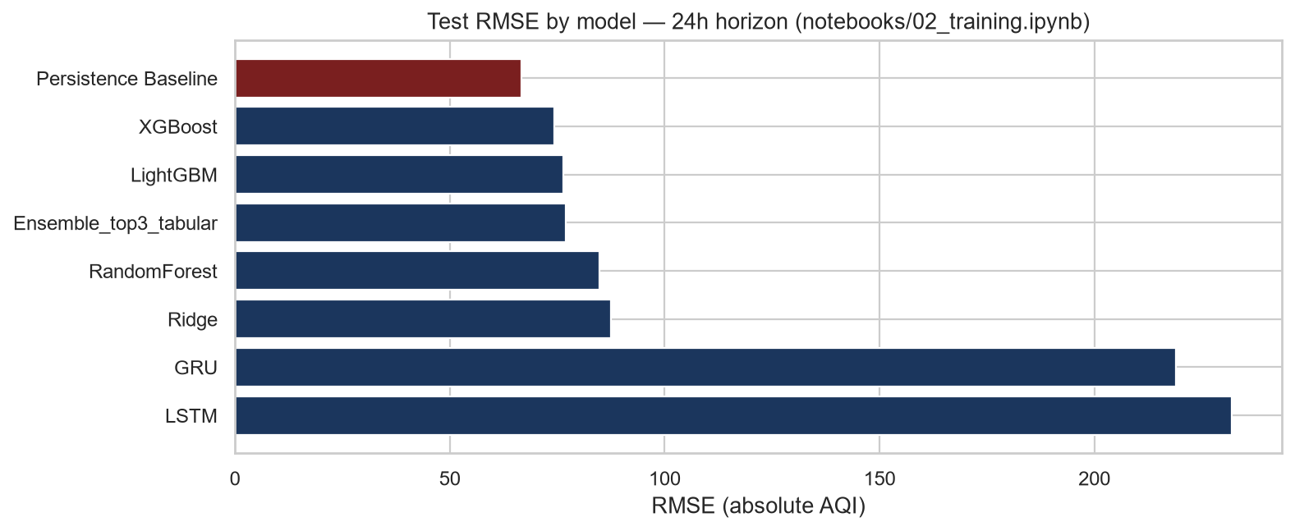
Figure 9: Test RMSE by model at 24h using the AT8 values in Table 21. Persistence is the left-most / top bar after sorting by RMSE. Prophet is omitted from this bar chart because RMSE 2167.324472 would flatten the other bars; Prophet remains in Table 21.
What happened: every learned model has higher RMSE and higher MAE than persistence, and lower R². XGBoost is the closest learned model (RMSE 74.364967 versus 66.730405).

20.2 Complete AT8 comparison (48 hours)
Model | RMSE | MAE | R2
Persistence Baseline | 84.796609 | 45.775352 | 0.588437
XGBoost | 97.213262 | 69.199877 | 0.459083
Ensemble_top3_tabular | 98.112376 | 70.283343 | 0.449031
LightGBM | 101.157242 | 72.808352 | 0.414302
Ridge | 101.382767 | 73.917026 | 0.411688
RandomForest | 118.050540 | 86.744712 | 0.202344
LSTM | 234.142256 | 152.548810 | -2.132563
GRU | 246.401500 | 157.766790 | -2.469181
Prophet | 2159.443832 | 1727.409530 | -265.909192

Table 22: AT8 test comparison for horizon 48h (FULL COMPARISON stdout).
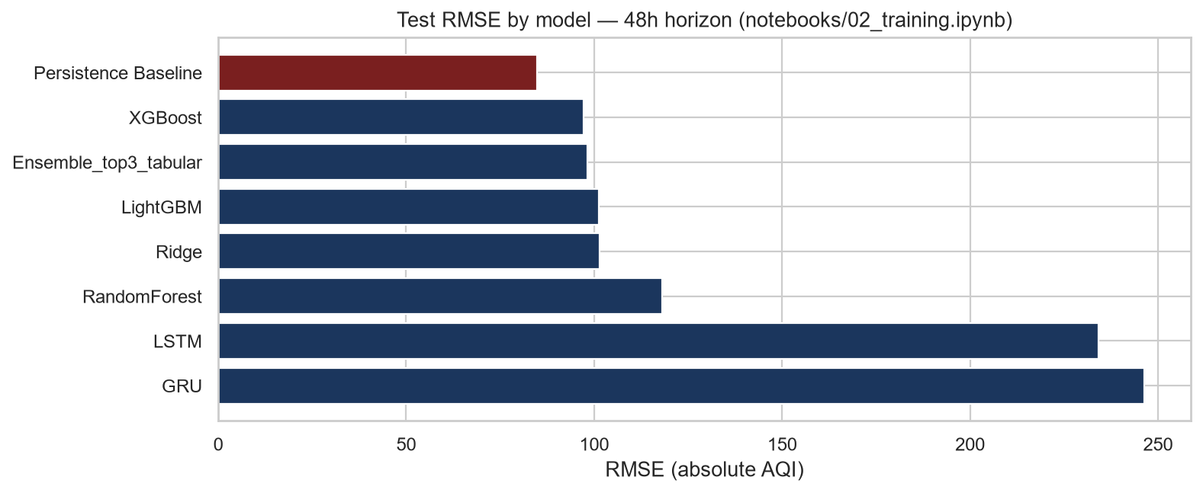
Figure 10: Test RMSE by model at 48h using the AT8 values in Table 22. Prophet omitted from bars for the same scale reason as Figure 9.
What happened: persistence remains first (RMSE 84.796609). XGBoost is again the closest learned model (97.213262). LSTM, GRU and Prophet remain far worse.

20.3 Complete AT8 comparison (72 hours)
Model | RMSE | MAE | R2
Persistence Baseline | 92.456124 | 51.518059 | 0.510480
Ridge | 104.353359 | 77.654450 | 0.376391
Ensemble_top3_tabular | 107.619632 | 79.190920 | 0.336742
XGBoost | 111.990073 | 82.949948 | 0.281779
LightGBM | 112.211034 | 81.688058 | 0.278942
RandomForest | 116.121902 | 85.821522 | 0.227804
LSTM | 235.968967 | 160.365461 | -2.182948
GRU | 239.031295 | 159.196560 | -2.266098
Prophet | 2150.783604 | 1715.485984 | -263.906508

Table 23: AT8 test comparison for horizon 72h (FULL COMPARISON stdout).
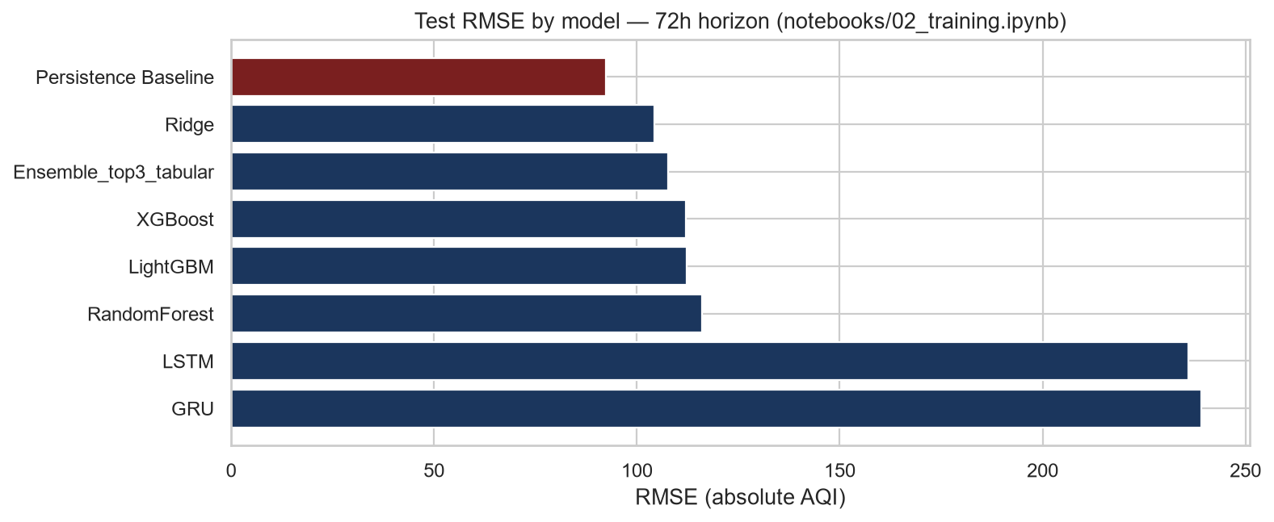
Figure 11: Test RMSE by model at 72h using the AT8 values in Table 23. Prophet omitted from bars for the same scale reason as Figure 9.
What happened: persistence RMSE 92.456124 is still lowest. Among learned models, Ridge has the lowest 72h RMSE (104.353359), still above persistence.

21. Model Comparison
Table 24 places the persistence row beside the best learned model by RMSE at each horizon. “Best learned” here means lowest RMSE among non-persistence rows in the AT8 table. It is not a registration winner.
Horizon | Persistence RMSE | Best learned model by RMSE | That model RMSE | Selected in AT8
24 | 66.730405 | XGBoost | 74.364967 | No — persistence wins the gate
48 | 84.796609 | XGBoost | 97.213262 | No — persistence wins the gate
72 | 92.456124 | Ridge | 104.353359 | No — persistence wins the gate

Table 24: AT8 persistence versus lowest-RMSE learned model. Selected column follows the notebook gate.

22. Best Model / Final Approach Selection (AT8 notebook)
The AT8 notebook selected no learned model. Persistence Baseline is the only forecast that satisfies the documented rule, because it is the baseline itself and every other row failed beats_persistence. Exact persistence performance is Table 11. The notebook printed registered False and winner None for horizons 24, 48 and 72.
The reason is the rule in the notebook, not a general claim that persistence is always a better class of model. On this feature-group v3, full-history, June-aligned test window, no trained candidate had simultaneously lower RMSE, lower MAE and higher R².

23. Production Training Window Documented Outside AT8
This section is not AT8 stdout. src/config.py states that training across the 2025-04-04 break “is what made every model lose to persistence on the 2025-26 test period.” Default TRAIN_START_DATE is therefore 2025-04-04. reports/_build_final_report.py records selected models for that window as follows. These numbers are reproduced here only as they appear in that file.
Horizon | Selected model (report draft) | RMSE | MAE | R²
24 h (day 1) | LightGBM (L1) | 28.88 | 22.63 | 0.064
48 h (day 2) | Random Forest | 30.54 | 24.89 | −0.055
72 h (day 3) | Ensemble (top-3 tabular) | 31.65 | 26.07 | −0.098

Table 25: Approach 1 selected models as written in reports/_build_final_report.py. Not from AT8 stdout.
Horizon | Persistence RMSE (report draft) | Selected-model RMSE (report draft)
24 h | 34.84 | 28.88
48 h | 40.94 | 30.54
72 h | 40.30 | 31.65

Table 26: Approach 1 persistence versus selected RMSE as written in reports/_build_final_report.py.
The same draft states that Approach 1 is the production choice after mentor review, with registry names aqi_forecaster_24h, aqi_forecaster_48h and aqi_forecaster_72h. This report does not replace Table 21–23 with Table 25–26. The two experiments differ in training start date and, per config.py, in feature-group version (AT8 used v3; production default is v4).

24. Why Other Models Were Not Selected
The following reasons apply to the AT8 run. The documented reason, where present, is the persistence gate printed by the notebook.

24.1 Ridge
Actual 24/48/72 RMSE: 87.584091 / 101.382767 / 104.353359 versus persistence 66.730405 / 84.796609 / 92.456124. MAE and R² also fail the gate at every horizon. The notebook therefore did not register Ridge.

24.2 RandomForest
Actual 24/48/72 RMSE: 84.914023 / 118.050540 / 116.121902. All three metrics fail versus persistence at every horizon. Not registered.

24.3 XGBoost
Actual 24/48/72 RMSE: 74.364967 / 97.213262 / 111.990073. Closest learned model at 24h and 48h, but RMSE and MAE remain higher than persistence and R² remains lower (24h R² 0.683567 versus 0.745204). Not registered.

24.4 LightGBM
Actual 24/48/72 RMSE: 76.456676 / 101.157242 / 112.211034. Fails the three-metric gate. Not registered.

24.5 Ensemble_top3_tabular
Actual 24/48/72 RMSE: 77.085201 / 98.112376 / 107.619632. Fails the three-metric gate. Not registered.

24.6 LSTM
Actual 24/48/72 RMSE: 232.032646 / 234.142256 / 235.968967 with negative R². Fails the gate. Not registered.

24.7 GRU
Actual 24/48/72 RMSE: 219.023846 / 246.401500 / 239.031295 with negative R². Fails the gate. Not registered.

24.8 Prophet
Actual 24/48/72 RMSE: 2167.324472 / 2159.443832 / 2150.783604. Fails the gate by a large margin. Not registered.
The provided AT8 material does not give a separate narrative reason for each family beyond the metric gate and the printed “nothing registered” lines. No additional reason is assumed.

25. Serving, Dashboard and Automation
The README states that Streamlit reads Hopsworks directly and FastAPI is optional. Main dashboard file: app/Home.py. Optional API: uvicorn api.main:app. Docker: docker compose up --build. GitHub Actions: feature_pipeline.yml hourly (python -m src.feature_pipeline); training_pipeline.yml daily 02:00 UTC (python -m src.training_pipeline). Both support workflow_dispatch. Feature-group version is pinned to 4 in the workflow files. src/utils/serving.py sets HAZARDOUS_THRESHOLD = 151.
A live public URL is not present in the README. The README documents Streamlit Community Cloud settings (main file app/Home.py, requirements app/requirements.txt, Python 3.11) but does not record a deployed address.

26. Key Findings
- The local raw snapshot has 46419 rows and 16 stored columns from 2020-11-27 00:00:00 to 2026-08-14 13:00:00, with 0 duplicate timestamps and no missing values in stored columns.
- aqi on that snapshot is right-skewed (skewness 1.907488520950293), mean 247.7509855877981, median 177.0.
- pm2_5 correlation with aqi is 0.986036, consistent with aqi being computed from PM2.5.
- Smog-season (Oct–Jan) mean aqi is 399.075145 versus 182.315405 in other months.
- ADF on raw aqi: statistic −11.764392029744617, p-value 1.1280420946421232e-21.
- AT8 trained on aqi_features v3, 46100 rows, 42 features, June-aligned split 27947 / 8075 / 10078.
- AT8 persistence test RMSE/MAE/R²: 24h 66.730405 / 36.111431 / 0.745204; 48h 84.796609 / 45.775352 / 0.588437; 72h 92.456124 / 51.518059 / 0.510480.
- No AT8 learned model beat persistence on RMSE and MAE and R². Registry summary: registered False for 24, 48 and 72.
- Closest learned 24h model in AT8 was XGBoost (RMSE 74.364967).
- Prophet RMSE exceeded 2150 on every AT8 horizon.
- LSTM and GRU AT8 R² values were negative on every horizon.
- src/config.py documents a 2025-04-04 OpenWeather regime break (mean hourly |AQI change| ~46 to ~4.5) and defaults training to that start date.
- A separate report draft records Approach 1 selected RMSE 28.88 / 30.54 / 31.65. Those figures are not AT8 stdout.

27. Limitations
Only limitations that are written in the project files are listed.
- src/utils/aqi_calculation.py: AQI is PM2.5-only, not the official EPA maximum across six criteria pollutants.
- src/config.py: feature group v3 (the AT8 table) was built on a gappy frame so about 13% of lags/targets spanned the wrong number of hours.
- src/utils/feature_engineering.py: ~3,700 missing hours in 415 outages in the raw history; long gaps are dropped rather than imputed beyond 6 hours.
- notebooks/02_training.ipynb: nothing was registered because no model beat persistence on all three metrics.
- src/training_pipeline.py: Prophet, LSTM and GRU cannot be served through a one-row /predict payload.
- reports/_build_final_report.py: Approach 1 test months are described as a calm warm-season period; that draft also states negative R² at 48h and 72h on Approach 1.
- README: a live hosted URL is not recorded.
- notebooks/01_eda.ipynb in the repository has no saved cell outputs; EDA figures in this Word file were regenerated from the local parquet using that notebook’s plot recipes.
- Classification-experiment notebooks are not present in the current repository, so classification metrics from the earlier report draft are not treated as AT8 evidence and are not copied here.

28. Conclusion
The project problem is a 24/48/72-hour AQI forecast for Lahore using OpenWeather pollution, Open-Meteo weather, Hopsworks storage, and FastAPI/Streamlit serving. The target is continuous US EPA AQI from PM2.5, not OpenWeather’s 1–5 category.
EDA on the local raw snapshot shows a right-skewed aqi series, strong correlation with pm2_5, higher smog-season means, and strong hourly autocorrelation. Feature engineering applies log1p pollutants, ACF-justified lags, rolling windows, change rates, cyclical time features, a smog flag, weather interactions, and delta targets on an hourly grid.
The AT8 notebook trained Ridge, RandomForest, XGBoost, LightGBM, a top-3 tabular ensemble, LSTM, GRU and Prophet against persistence on feature group v3 with a full-history June-aligned split. Persistence had the best RMSE, MAE and R² at every horizon. No model was registered. That is the AT8 result.
Project source files separately document a post-2025-04-04 training window intended for production, with selected RMSE values 28.88 / 30.54 / 31.65 recorded in reports/_build_final_report.py. Those values are not substituted for the AT8 tables.

29. References and Source Notes
Only sources that appear in the provided project files are listed. No external papers were added.
- README.md — project title, architecture, commands, layout.
- notebooks/02_training.ipynb — AT8 training run, splits, metrics, registry summary.
- notebooks/01_eda.ipynb — EDA plot recipes and Findings for FE cell (no saved outputs).
- notebooks/README.md — notebook roles.
- src/config.py — city, dates, feature-group versions, regime break, smog months.
- src/utils/data_fetch.py — OpenWeather and Open-Meteo source decision.
- src/utils/data_validation.py — required columns and valid ranges.
- src/utils/aqi_calculation.py — EPA PM2.5 breakpoints and PM2.5-only simplification; comments cite the EPA Federal Register 2024 PM NAAQS reconsideration as the breakpoint source used by the authors of that file.
- src/utils/feature_engineering.py — hourly grid, features, targets.
- src/training_pipeline.py — production training loop, persistence gate, serveable kinds.
- src/utils/evaluation.py — RMSE/MAE/R², reconstruct_absolute, shrinkage helper (used by the pipeline; not printed in AT8 stdout).
- src/utils/serving.py — HAZARDOUS_THRESHOLD = 151.
- reports/_build_final_report.py — Approach 1 numbers reproduced in Section 23; repository URL on the title page.
- data/raw/aqi_raw_merged.parquet — local snapshot used for EDA figures and Table 2–9.
- reports/_report_figures/eda_stats.txt — exact EDA numbers copied into this report.
OpenWeather and Open-Meteo API URLs appear in src/utils/data_fetch.py. Hopsworks host default eu-west.cloud.hopsworks.ai appears in src/config.py. The AT8 login print included https://eu-west.cloud.hopsworks.ai:443/p/41103.

