Our Work

Dataset
- We used dataset provided in the research paper: “Fingertip Video Dataset for Non-Invasive Diagnosis of Anemia Using ResNet-18 Classifier”.
- Dataset is already split in 80-20 train-test ratio
- 130 training samples of 1 minute recording of fingertip videos
- 30 testing sample of same length
- Ground truth of hemoglobin level provided against each video file path in csv.

Implementation

Dataset class
- Dataset class implemented for performing preprocessing.
- For each fingertip video, it sample N number of frames. Number of frames sampled are equidistant from one another. If a frame fails to load, then the immediate next frame is loaded.
- All the frames are then center cropped (224, 224, 3) size as that’s the input our models require.
- All the frames are normalized. [ (pixel value – mean of channel)/standard deviation of channel ]
- Stack all the preprocessed frame into one.
- This preprocessing is different in research paper: ““Fingertip Video Dataset for Non-Invasive Diagnosis of Anemia Using ResNet-18 Classifier”. They skip first 100 frames and get all the rest frames. i.e. 1800 frames are extracted which required a lot of resources and time.

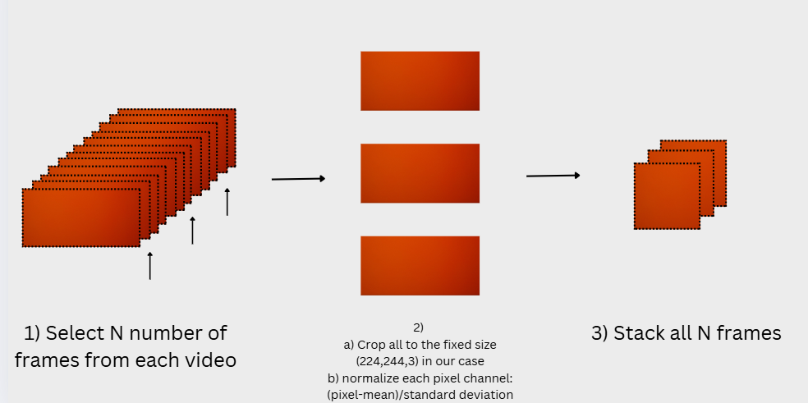

Models Implementation
- We used 4 models for our custom approach. Namely: ResNet-18, VGG16, EfficientNet and ResNet18 – LSTM Hybrid model.(all pretrained)
- For the first 3, similar approach were developed.

ResNet-18, VGG16, EfficientNet
- N frames were fed to each model sequentially.
- Model produced N feature vectors (size vary depending on model)
- These N feature vectors were concatenated into one feature vector.
- A full connected layer was used to connect the feature vector to regression head.
- Again this approach is different is different in research paper:” “Fingertip Video Dataset for Non-Invasive Diagnosis of Anemia Using ResNet-18 Classifier”.”
- They use all the 1800 extracted frames as channels (equivalent to 5100 channels). Then they modify the first conv2d layer of ResNet-18 to match these channels.
- Again, this is impractical as it increased by 2.3 times.
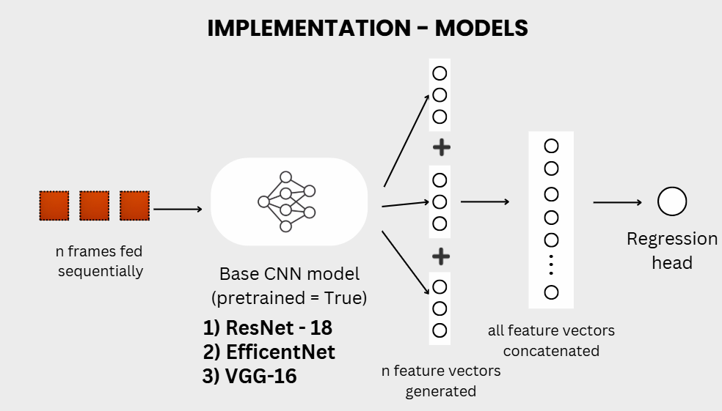

ResNet18-LSTM Hybrid model
- Similar to previous approach;
- N frames were fed to each model sequentially.
- Model produced N feature vectors (size vary depending on model)
- These N feature vectors were concatenated into one feature vector.
- These N feature vectors were then passed to 2 LSTM layers
- These convert the input sequence into a richer representation that incorporates temporal and contextual information.
- The last sequence generated of size 512 was used.
- It was connected to regression head via fully connected layer.

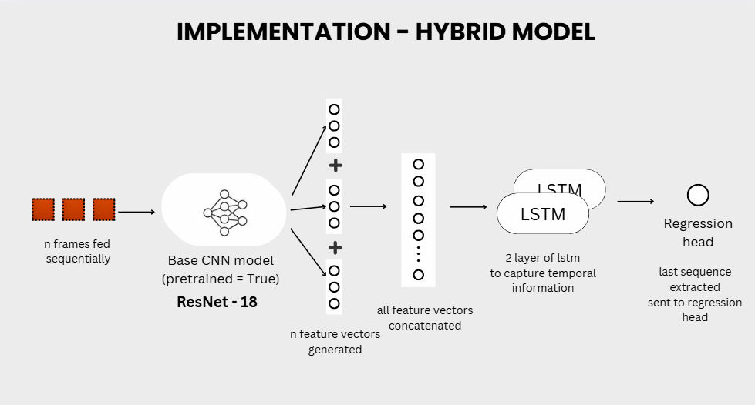

Training
- Following parameters were set across all experiments:
  - Number of frame : [5, 10, 15]
  - epoch: 10
  - frame size: 224
  - batch size: 8
  - learning rate: 1e-4
  - loss function: Mean Squared Error
  - optimizer: Adam with Weight decay
- Each model was training 3 times for 3 different number of frames extracted: 5,10 and 15.
- So we perform a total of 12 experiments.
- Training was perform on Kaggle Notebook using T4 GPU.

For 5 Frames
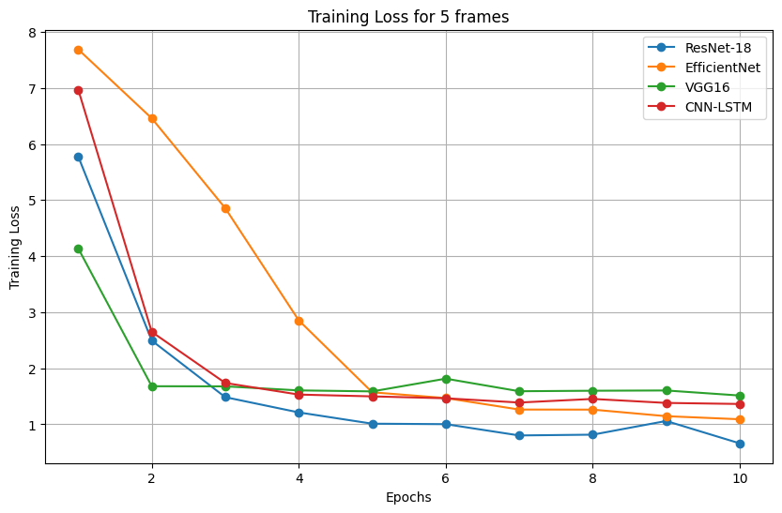

For 10 Frames
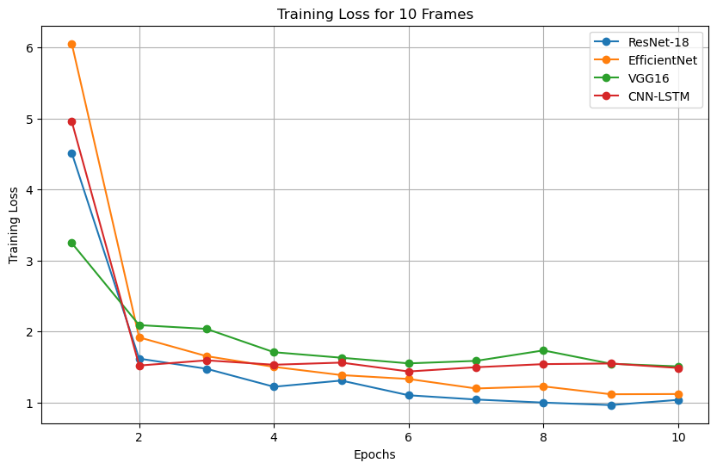

For 15 Frames
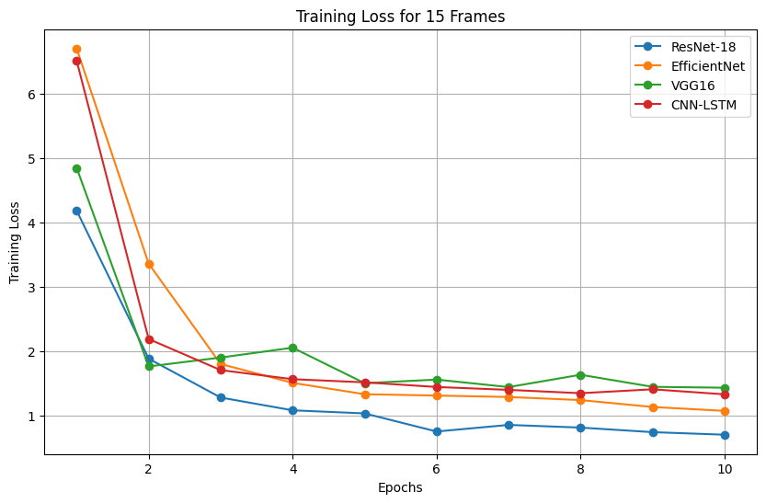

Testing

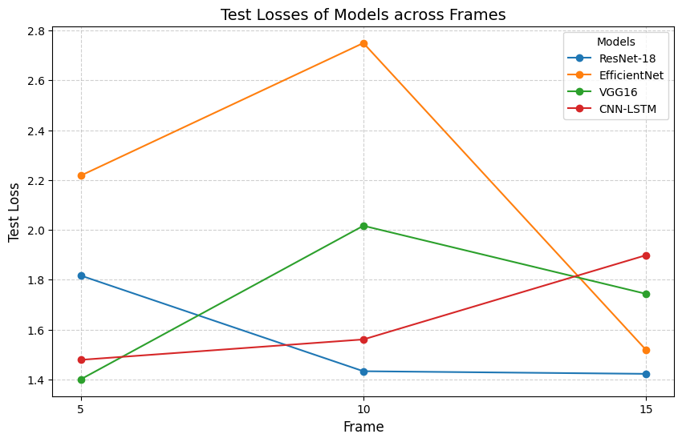

Results Explanation
- During training when all models fully converged,
- Training loss was always in following order ResNet-18 < Efficient Net<CNN-LSTM<VGG16
- Clearly demonstrating each models capacity to learn for this specific task.
- During testing, each model behaved differently,
- ResNet18’s performance increase as the number of frames were increased.
- ResNet18-LSTM model performance decreased as the number of frames were increased. It shows temporal information in this case hold no values.
- EfficientNet model’s performance deteriorated when increased from 5 to 10 frames. However it gave better performance when number of frames were increased to 15.
- VGG16’S model’s performance alsodeteriorated when increased from 5 to 10 frames. Altough it became better as the number of frames were increased to 15, its best performance was on 5 frames.
- Overall, ResNet18 gave most favorable results to us.

Comparison with previous experiments

Research Paper | Train-Test samples | Model | Num_frames | Epochs | model size(MB) | RMSE (Training) | RMSE (Testing)
Fingertip Video Dataset for Non-Invasive Diagnosis of Anemia Using ResNet-18 Classifier | 73 (females only) | ResNet-18 | 1800 | 50 | 105.57 | 2.9
Fingertip Video Dataset for Non-Invasive Diagnosis of Anemia Using ResNet-18 Classifier | all 150 samples | ResNet-18 | 450 | 50 | 60.71 | 2.1
Our Approach | all 150 samples | ResNet-18 | 15 | 10 | 44.62 | 0.70 | 1.42
Fingertip Video Dataset for Non-Invasive Diagnosis of Anemia Using ResNet-18 Classifier | all 150 samples | ResNet-18 | 1800 | 50 | 105.57 | 1.23 | 1.39

Contribution
- Experimenting with different CNN models indepth in this domain
- Coming up with an efficient preprocessing technique.
- Coming up with more efficient architecture using embeddings from pretrained CNN model. Which keeps the model size small while producing almost equally good results as best performing model approach mentioned in paper “Fingertip Video Dataset for Non-Invasive Diagnosis of Anemia Using ResNet-18 Classifier”.

