**National University of Sciences & Technology (NUST)**

**School of Electrical Engineering and Computer Science Department of Computing Generative AI and Applications - CSE-848**

By submitting your assignment, you acknowledge that you have read, understood, and agreed to abide by this

**Honor Code**.

**Group Member Names with CMS IDs:**

1. Hamza Khan – 495991
2. Muhammad Asif Iqbal - 452097

**Group Member Signatures:**

1. Hamza Khan : 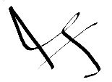
2. Muhammad Asif Iqbal: 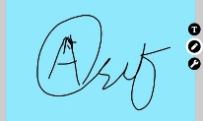

**Github Repo Link:** https://github.com/hamzak11111/hamzak11111-Pokemon_generation_using_DCGAN

**Live demo link:** We created a local Streamlit app already present in the repo and the submission.