# csy1018-assign1

**The README File**

This assignment will include a **README** file that describes the work. This description must:

1. Identify what aspects of the work have been correctly implemented and what have not.
2. Identify anyone with whom you have collaborated or discussed the assignment.
3. Say approximately how many hours you have spent completing the assignment.
4. Be written in either text format (**README.txt**) or in Markdown (**README.md**). .Doc will be accepted. Please use all capital letters for **README**

**Hamza Khan**

**16436205**

Contents

Introduction 3

Wireframes 3

Sketches 3

Navigation 4

Structure Diagram 6

Testing 7

References 7

# Introduction

The website I have made is a very simple site, as we did not require to make a fully advanced website I decided to keep it simple. I worked independently and did not get my code from anyone else or off the internet (code has been referenced).

I could have improved on a number of different things like:

1. The colour I used could have been better, for example I could have used darker colours for the header and footer which would maybe give a more professional look to my website.

I would say that I worked between 18 - 22 hours on the website. I has to divide my time for other assignments and revising for the exams therefore I only spent a specific time on the website.

The logo links back to the homepage so I have made that functional instead of it just being an image.

# Wireframes

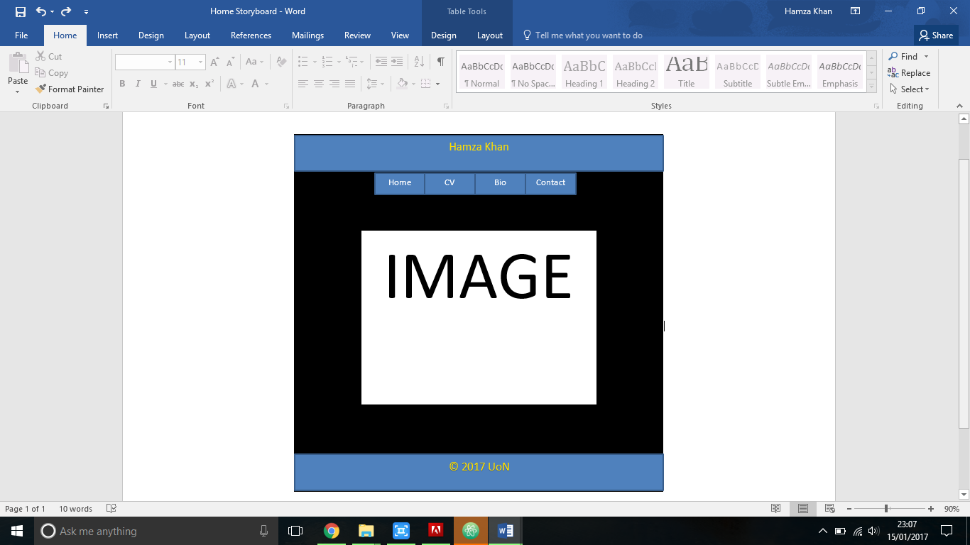

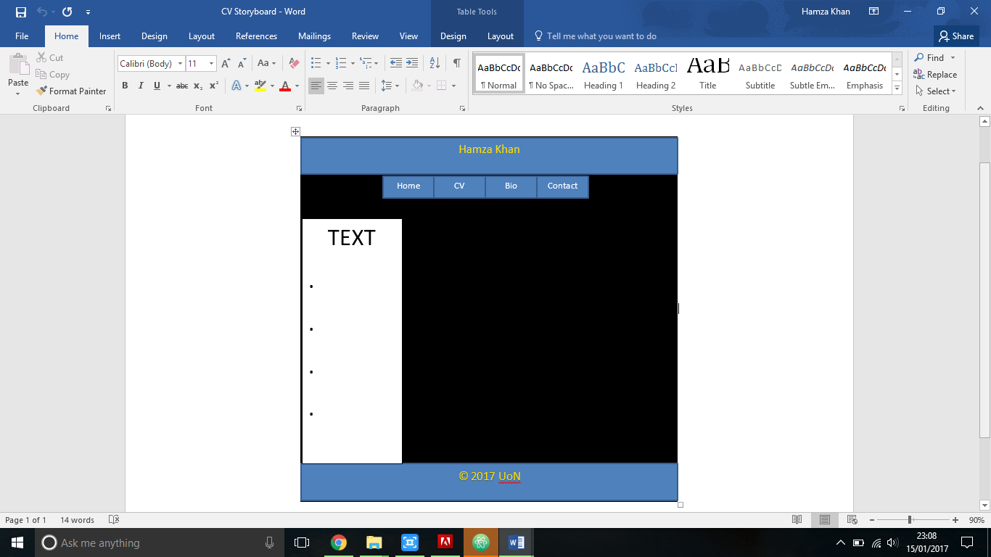

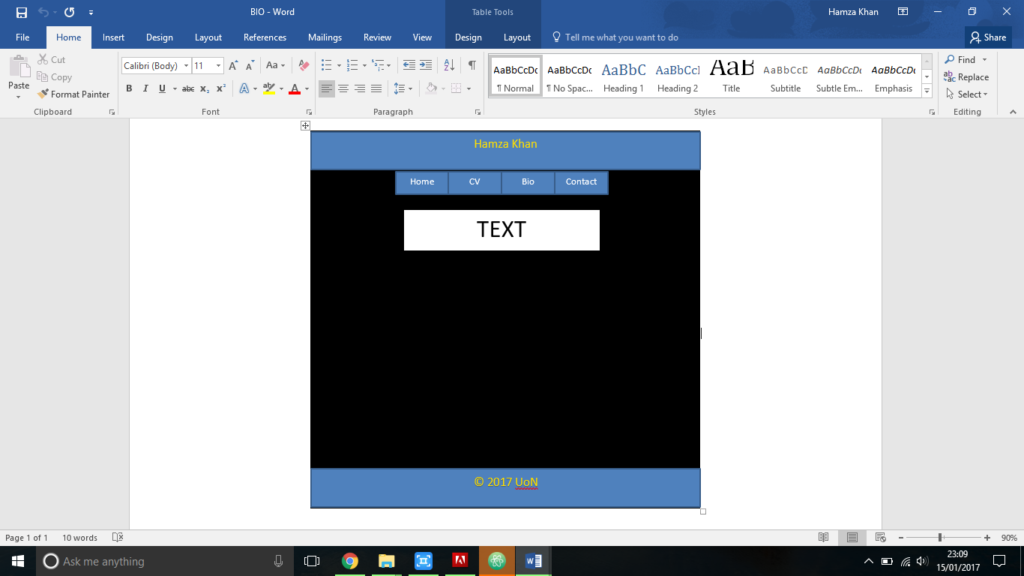

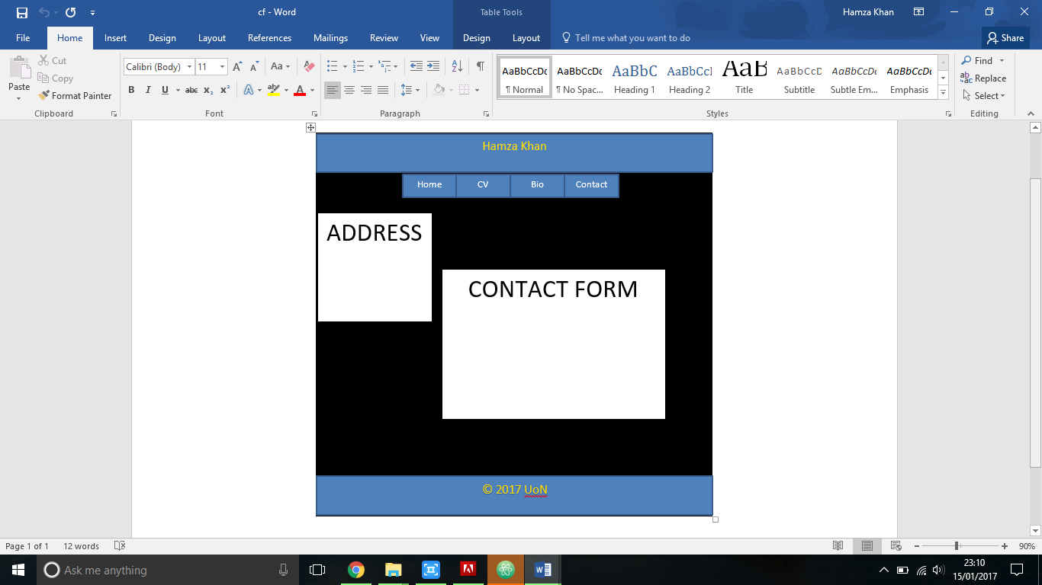

# Sketches

# Navigation

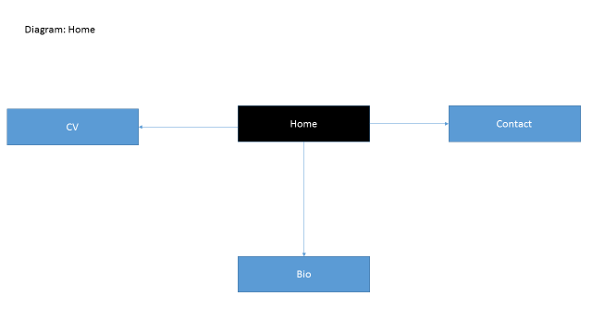

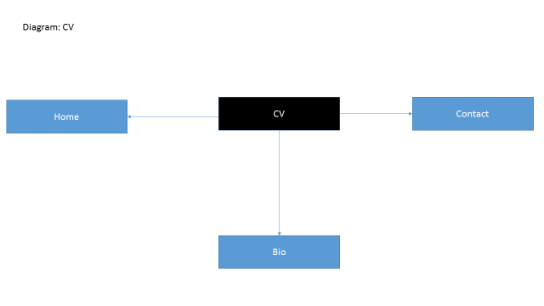

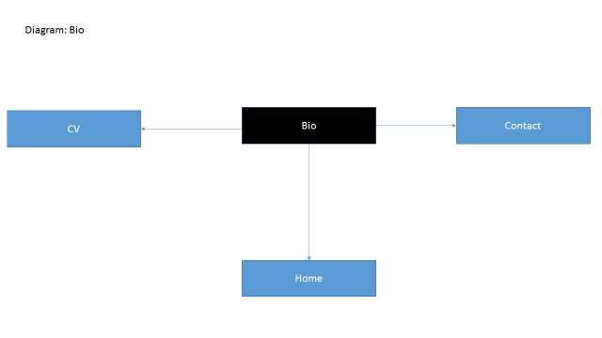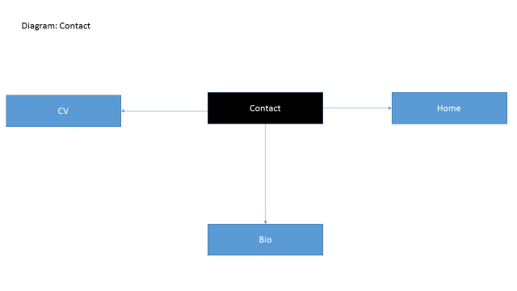

# Structure Diagram

CV

Bio

Contact

Home

# References

NILE