Laboratory Work #2 — Normalization
1. Violation Identification Table Booking_receipt violates 1NF because the column seat_numbers contains non-atomic values (comma-separated lists like "12A, 12B").
2. Functional Dependencies (FDs)
- booking_id, seat_number → passenger_full_name, passenger_passport_number, ticket_price
- flight_number → departure_airport_name, arrival_airport_name, airline_name
- departure_airport_name → departure_city
- arrival_airport_name → arrival_city
- booking_id → flight_number
3. Step-by-Step Normalization
- 1NF: Unroll comma-separated seats to atomic rows. Primary Key: (booking_id, seat_number).
  - Receipt_1NF (booking_id, seat_number, passenger_full_name, passenger_passport_number, flight_number, departure_airport_name, departure_city, arrival_airport_name, arrival_city, airline_name, ticket_price)
- 2NF: Remove partial dependencies on the composite key:
  - Passenger_Ticket (booking_id, seat_number, passenger_full_name, passenger_passport_number, ticket_price)
  - Booking (booking_id, flight_number*)
  - Flight_Details (flight_number, departure_airport_name, departure_city, arrival_airport_name, arrival_city, airline_name)
- 3NF: Remove transitive dependencies:
  - Passengers (passenger_id, passenger_full_name, passport_number)
  - Airports (airport_name, city)
  - Airlines (airline_name)
  - Flights (flight_number, departure_airport_name*, arrival_airport_name*, airline_name*)
  - Bookings (booking_id, flight_number*)
  - Tickets (booking_id, seat_number, passenger_id, ticket_price)
4. Flights Table 3NF Check The Flights table is in 3NF. Primary Key is flight_id. All non-key attributes directly depend on flight_id. The columns departing_airport_id, arriving_airport_id, and airline_id are Foreign Keys to their respective tables, so there are no transitive dependencies between non-key fields.
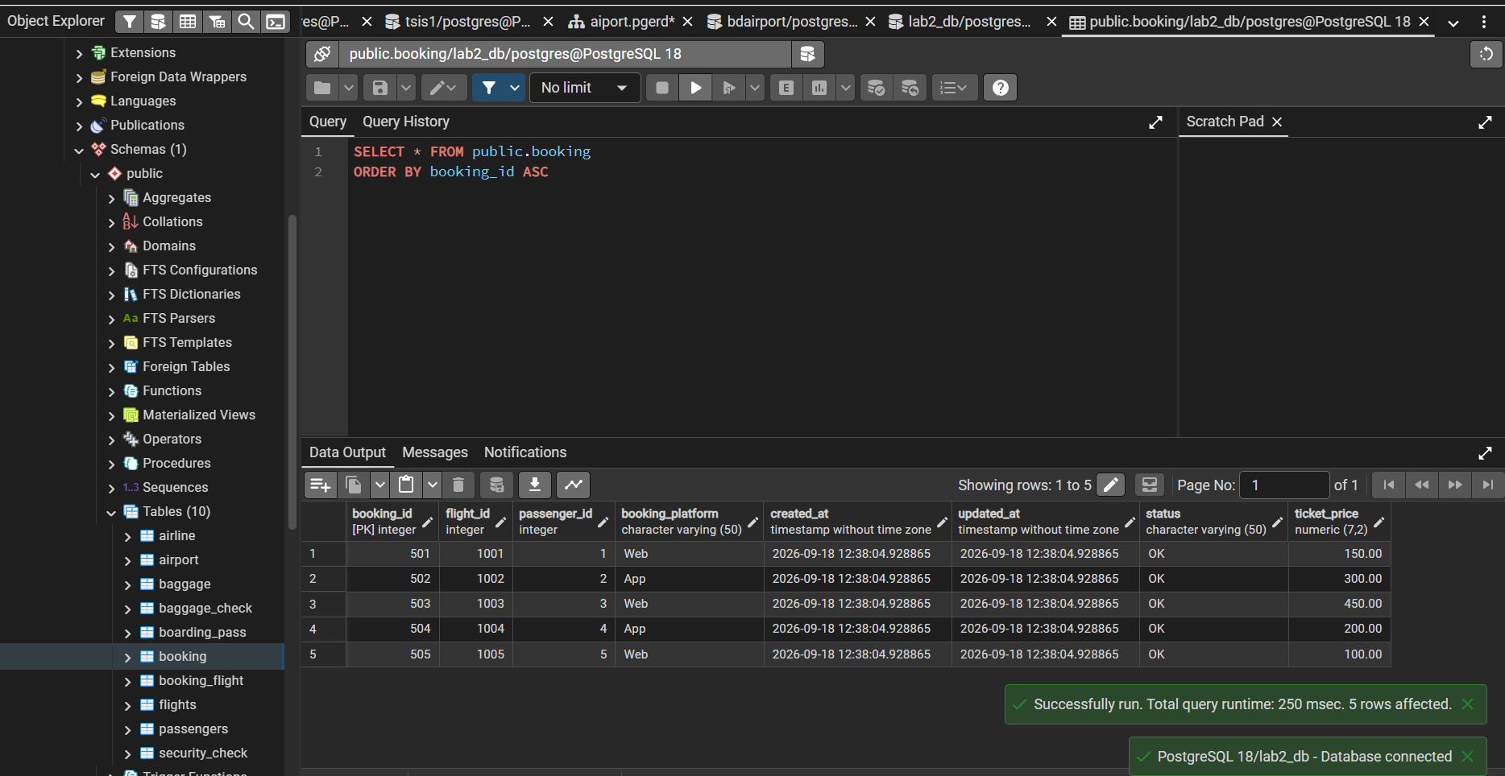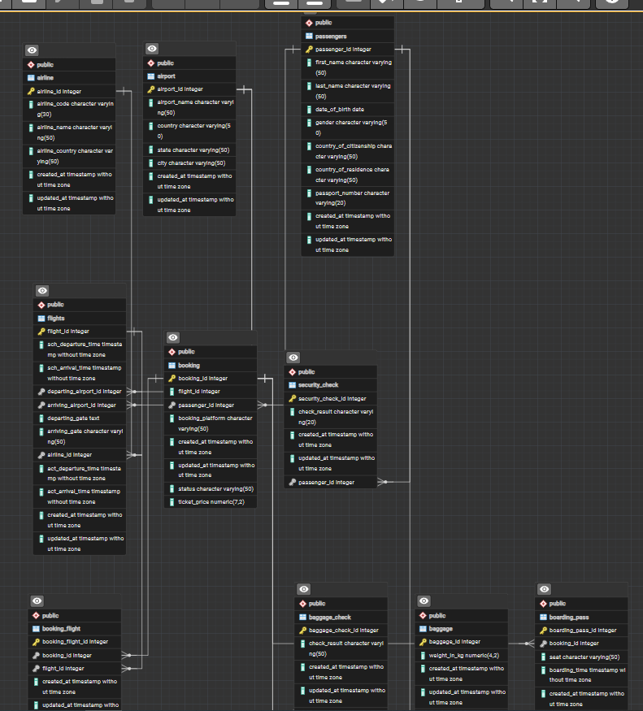
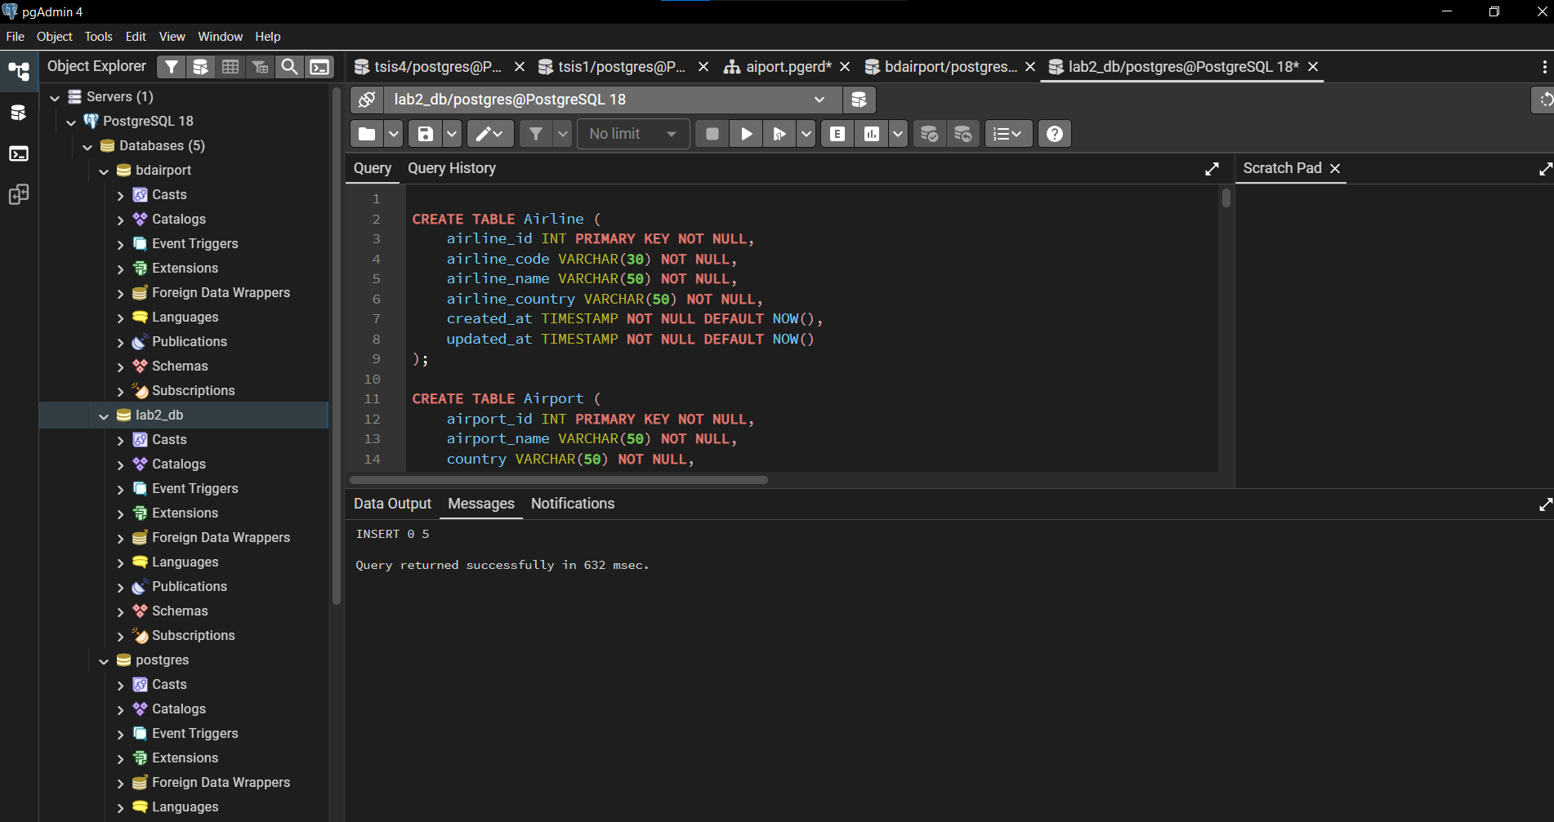
CREATE TABLE Airline (
airline_id INT PRIMARY KEY NOT NULL,
airline_code VARCHAR(30) NOT NULL,
airline_name VARCHAR(50) NOT NULL,
airline_country VARCHAR(50) NOT NULL,
created_at TIMESTAMP NOT NULL DEFAULT NOW(),
updated_at TIMESTAMP NOT NULL DEFAULT NOW()
);

CREATE TABLE Airport (
airport_id INT PRIMARY KEY NOT NULL,
airport_name VARCHAR(50) NOT NULL,
country VARCHAR(50) NOT NULL,
state VARCHAR(50) NOT NULL,
city VARCHAR(50) NOT NULL,
created_at TIMESTAMP NOT NULL DEFAULT NOW(),
updated_at TIMESTAMP NOT NULL DEFAULT NOW()
);

CREATE TABLE Passengers (
passenger_id INT PRIMARY KEY NOT NULL,
first_name VARCHAR(50) NOT NULL,
last_name VARCHAR(50) NOT NULL,
date_of_birth DATE NOT NULL,
gender VARCHAR(50) NOT NULL,
country_of_citizenship VARCHAR(50) NOT NULL,
country_of_residence VARCHAR(50) NOT NULL,
passport_number VARCHAR(20) NOT NULL,
created_at TIMESTAMP NOT NULL DEFAULT NOW(),
updated_at TIMESTAMP NOT NULL DEFAULT NOW()
);

CREATE TABLE Flights (
flight_id INT PRIMARY KEY NOT NULL,
sch_departure_time TIMESTAMP NOT NULL,
sch_arrival_time TIMESTAMP NOT NULL,
departing_airport_id INT NOT NULL,
arriving_airport_id INT NOT NULL,
departing_gate TEXT NOT NULL,
arriving_gate VARCHAR(50) NOT NULL,
airline_id INT NOT NULL,
act_departure_time TIMESTAMP NOT NULL,
act_arrival_time TIMESTAMP NOT NULL,
created_at TIMESTAMP NOT NULL DEFAULT NOW(),
updated_at TIMESTAMP NOT NULL DEFAULT NOW()
);

CREATE TABLE Booking (
booking_id INT PRIMARY KEY NOT NULL,
flight_id INT NOT NULL,
passenger_id INT NOT NULL,
booking_platform VARCHAR(50) NOT NULL,
created_at TIMESTAMP NOT NULL DEFAULT NOW(),
updated_at TIMESTAMP NOT NULL DEFAULT NOW(),
status VARCHAR(50) NOT NULL,
ticket_price DECIMAL(7,2) NOT NULL
);

CREATE TABLE Booking_flight (
booking_flight_id INT PRIMARY KEY NOT NULL,
booking_id INT NOT NULL,
flight_id INT NOT NULL,
created_at TIMESTAMP NOT NULL DEFAULT NOW(),
updated_at TIMESTAMP NOT NULL DEFAULT NOW()
);

CREATE TABLE Boarding_pass (
boarding_pass_id INT PRIMARY KEY NOT NULL,
booking_id INT NOT NULL,
seat VARCHAR(50) NOT NULL,
boarding_time TIMESTAMP NOT NULL,
created_at TIMESTAMP NOT NULL DEFAULT NOW(),
updated_at TIMESTAMP NOT NULL DEFAULT NOW()
);

CREATE TABLE Baggage (
baggage_id INT PRIMARY KEY NOT NULL,
weight_in_kg DECIMAL(4,2) NOT NULL,
created_at TIMESTAMP NOT NULL DEFAULT NOW(),
updated_at TIMESTAMP NOT NULL DEFAULT NOW(),
booking_id INT NOT NULL
);

CREATE TABLE Baggage_check (
baggage_check_id INT PRIMARY KEY NOT NULL,
check_result VARCHAR(50) NOT NULL,
created_at TIMESTAMP NOT NULL DEFAULT NOW(),
updated_at TIMESTAMP NOT NULL DEFAULT NOW(),
booking_id INT NOT NULL,
passenger_id INT NOT NULL
);

CREATE TABLE Security_check (
security_check_id INT PRIMARY KEY NOT NULL,
check_result VARCHAR(20) NOT NULL,
created_at TIMESTAMP NOT NULL DEFAULT NOW(),
updated_at TIMESTAMP NOT NULL DEFAULT NOW(),
passenger_id INT NOT NULL
);
ALTER TABLE Security_check ADD CONSTRAINT fk_sec_pass FOREIGN KEY (passenger_id) REFERENCES Passengers(passenger_id);
ALTER TABLE Booking ADD CONSTRAINT fk_book_pass FOREIGN KEY (passenger_id) REFERENCES Passengers(passenger_id);
ALTER TABLE Baggage_check ADD CONSTRAINT fk_bagcheck_pass FOREIGN KEY (passenger_id) REFERENCES Passengers(passenger_id);

ALTER TABLE Baggage_check ADD CONSTRAINT fk_bagcheck_book FOREIGN KEY (booking_id) REFERENCES Booking(booking_id);
ALTER TABLE Baggage ADD CONSTRAINT fk_bag_book FOREIGN KEY (booking_id) REFERENCES Booking(booking_id);
ALTER TABLE Boarding_pass ADD CONSTRAINT fk_board_book FOREIGN KEY (booking_id) REFERENCES Booking(booking_id);
ALTER TABLE Booking_flight ADD CONSTRAINT fk_bf_book FOREIGN KEY (booking_id) REFERENCES Booking(booking_id);

ALTER TABLE Booking_flight ADD CONSTRAINT fk_bf_flight FOREIGN KEY (flight_id) REFERENCES Flights(flight_id);
ALTER TABLE Flights ADD CONSTRAINT fk_fl_dep FOREIGN KEY (departing_airport_id) REFERENCES Airport(airport_id);
ALTER TABLE Flights ADD CONSTRAINT fk_fl_arr FOREIGN KEY (arriving_airport_id) REFERENCES Airport(airport_id);
ALTER TABLE Flights ADD CONSTRAINT fk_fl_air FOREIGN KEY (airline_id) REFERENCES Airline(airline_id);

INSERT INTO Airline (airline_id, airline_code, airline_name, airline_country) VALUES
(1, 'KC', 'Air Astana', 'Kazakhstan'),
(2, 'DV', 'SCAT', 'Kazakhstan'),
(3, 'TK', 'Turkish Airlines', 'Turkey'),
(4, 'LH', 'Lufthansa', 'Germany'),
(5, 'QR', 'Qatar Airways', 'Qatar');

INSERT INTO Airport (airport_id, airport_name, country, state, city) VALUES
(101, 'Almaty Airport', 'Kazakhstan', 'Almaty', 'Almaty'),
(102, 'Astana Airport', 'Kazakhstan', 'Astana', 'Astana'),
(103, 'Istanbul Airport', 'Turkey', 'Istanbul', 'Istanbul'),
(104, 'Frankfurt Airport', 'Germany', 'Hesse', 'Frankfurt'),
(105, 'Doha Airport', 'Qatar', 'Doha', 'Doha');

INSERT INTO Passengers (passenger_id, first_name, last_name, gender, date_of_birth, country_of_citizenship, country_of_residence, passport_number) VALUES
(1, 'Khamza', 'Kassym', 'Male', '2004-05-15', 'Kazakhstan', 'Kazakhstan', 'N123456'),
(2, 'Tomiris', 'Aben', 'Female', '2005-08-20', 'Kazakhstan', 'Kazakhstan', 'N654321'),
(3, 'John', 'Doe', 'Male', '1995-05-05', 'USA', 'USA', 'N987654'),
(4, 'Anna', 'Lee', 'Female', '2001-03-15', 'UK', 'UK', 'N112233'),
(5, 'Omar', 'Ali', 'Male', '1992-07-20', 'Qatar', 'Qatar', 'N445566');

INSERT INTO Flights (flight_id, airline_id, departing_airport_id, arriving_airport_id, departing_gate, arriving_gate, sch_departure_time, sch_arrival_time, act_departure_time, act_arrival_time) VALUES
(1001, 1, 101, 102, 'A1', 'B1', NOW(), NOW(), NOW(), NOW()),
(1002, 3, 101, 103, 'A2', 'B2', NOW(), NOW(), NOW(), NOW()),
(1003, 4, 102, 104, 'A3', 'B3', NOW(), NOW(), NOW(), NOW()),
(1004, 5, 103, 105, 'A4', 'B4', NOW(), NOW(), NOW(), NOW()),
(1005, 2, 102, 101, 'A5', 'B5', NOW(), NOW(), NOW(), NOW());

INSERT INTO Booking (booking_id, flight_id, passenger_id, status, booking_platform, ticket_price) VALUES
(501, 1001, 1, 'OK', 'Web', 150.00),
(502, 1002, 2, 'OK', 'App', 300.00),
(503, 1003, 3, 'OK', 'Web', 450.00),
(504, 1004, 4, 'OK', 'App', 200.00),
(505, 1005, 5, 'OK', 'Web', 100.00);

