**Setup**

**Skip directly to 8 if you have already loaded the project and all its dependencies perfectly (in an editor).**

1. Extract RevIt.zip
2. Download all Selenium Client & WebDriver Language Bindings for JAVA.
3. Download Third part browser driver for google chrome.
4. Open your java editor and load the RevIT extracted folder as a project.
5. Go to the editor’s workspace and right click on the RevIT project and then press “Properties”. 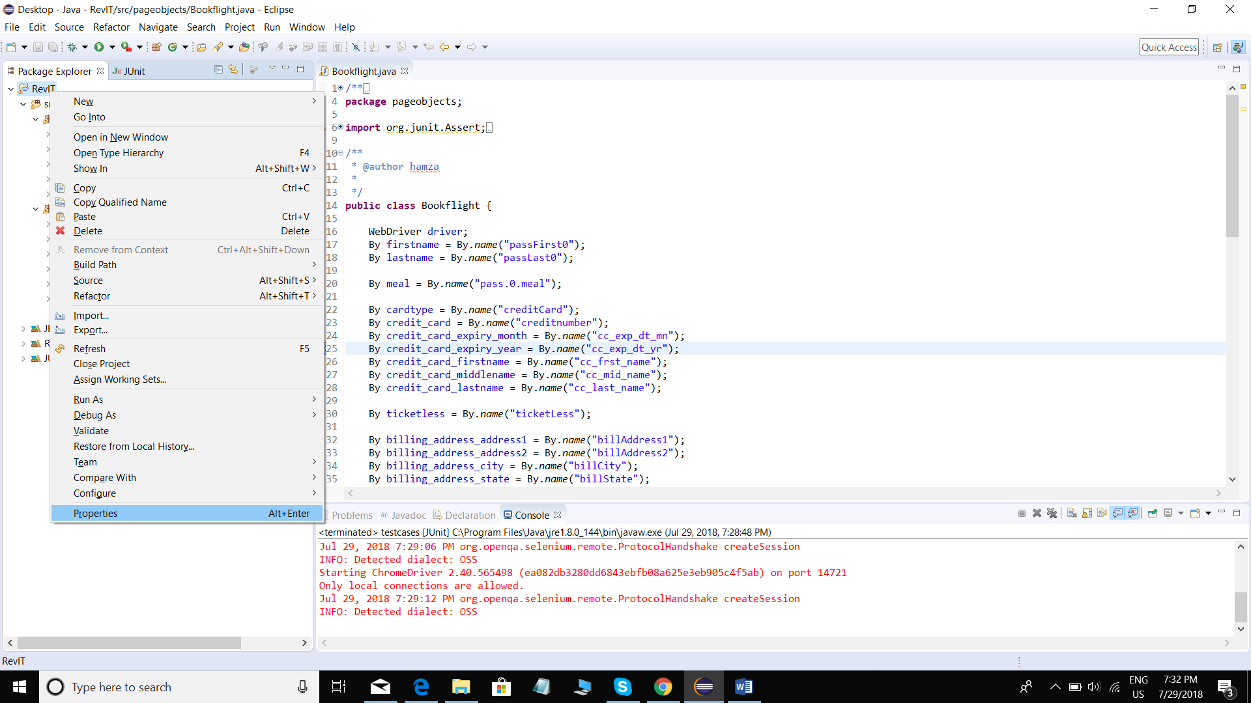
6. Open properties and then click libraries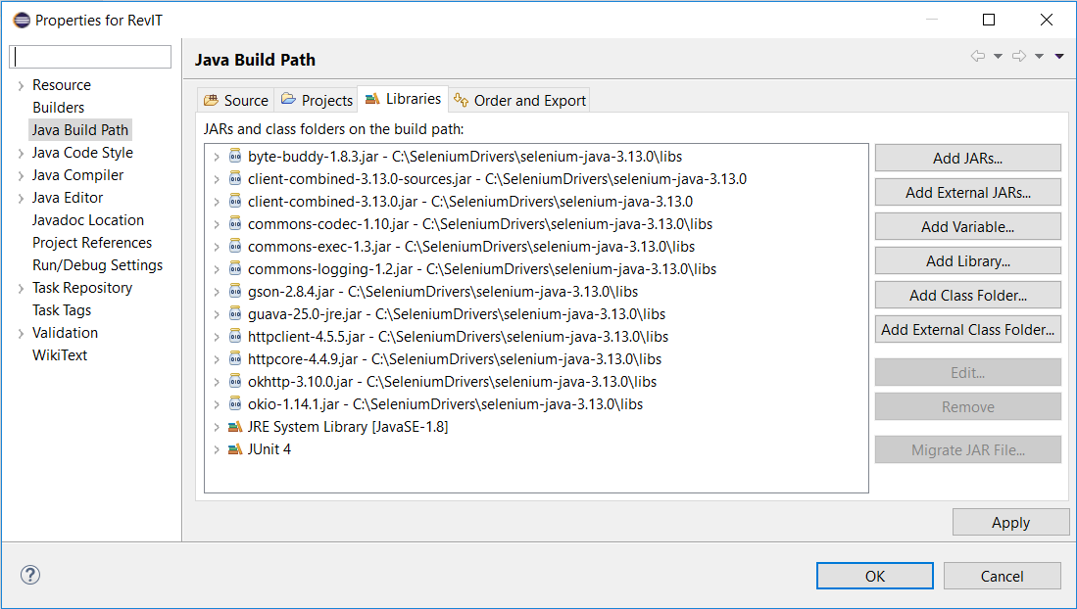
7. Go to add External JARs and load all the JAR files in “Selenium Client & WebDriver Language Bindings” for JAVA and press OK.
8. You might need to import “JUNIT 4” in your project if you receive an error.

After loading the project

1. Open “CredentialsConfig.properties” file.
2. Change the value of “driverpath” to the location where you have downloaded Third part browser driver for google chrome.

Finally

1. Run the package called “testcases”.
2. Once all tests are completed. You will receive a report on their success/failure.

**Description of Implementation**

1. There are two packages in this project namely “pageobjects” and “testcases”.
2. Pageobjects: This package has 5 classes, each representing a different webpage that is rendered one after the other.
3. Testcases: This package has 6 classes. One class called the “BaseClass” which acts as a super class for all other classes. The remaining 5 classes are test classes, each of them has a one-one relation with their corresponding classes in “pageobjects”.
4. These test classes have Unit tests which help check the different aspect of the rendered page.
5. @before statements implement the task in the assignment.
6. @before in the “BookflightTest” goes through each step in the assignment task from start to end. As it has to reach the final booking page.

Some Test cases fail which are designed to show the glitches in the website. E.g. even when the user selects “one way” booking. The system generates a roundtrip.