# Grazioso Salvare Animal Shelter Dashboard

## Description

A web-based tool called the Grazioso Salvare Animal Shelter Dashboard offers an interactive interface for viewing and analyzing data from animal shelters. It enables visitors to go through the records of the shelter's animals, filter data based on rescue scenarios, display breed-specific statistics, and locate certain animals on a map.

The Dash framework and Python were used to build the dashboard, which gives administrators and workers at the shelter an easy-to-use interface. With the dashboard, users can quickly access and examine crucial data regarding the animals in the shelter, assisting them in making decisions and increasing operational effectiveness.

## Features

* Data from animal shelters are displayed in an interactive table with filtering options.
* Allows users to filter the data database based on different sorts of rescue.
* Breed statistics graph: Employs a bar graph to show the distribution of animal breeds.
* Visualization of a map that places the locations of chosen animals on a workable map.

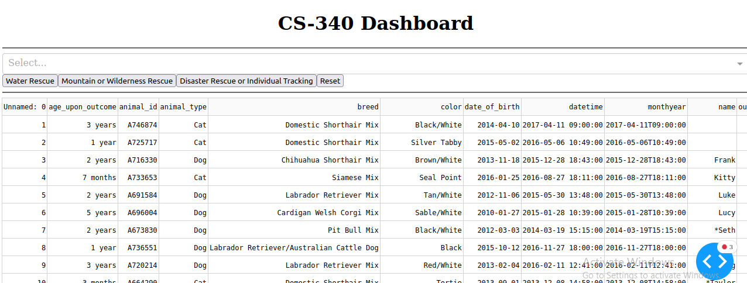

**Figure no 1: Dashboard Visual**

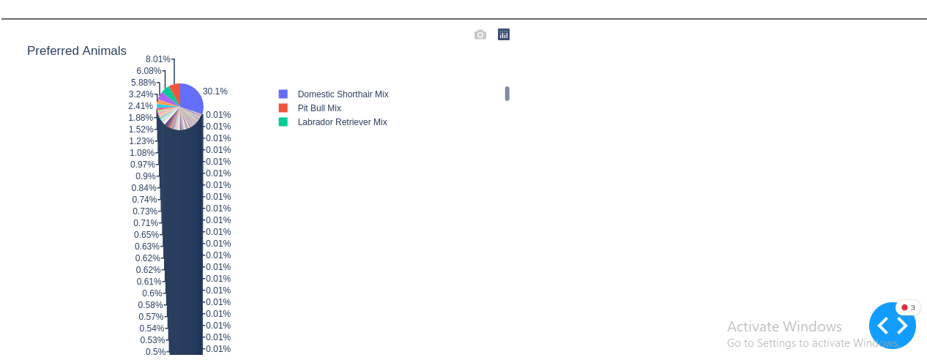

**Figure no 2: Pie-Graph Visualization**

## Installation

1. Clone the repository:

git clone <repository-url>

1. Install the required dependencies:

pip install -r requirements.txt

1. Open the Jupyter Notebook
2. Open the ProjectDashboard.ipynb file
3. Run the sell by pressing the shift + enter.
4. Press the link of the local host:

## Usage

* You will see the interactive data table with information on animal shelters when you open the dashboard.
* Refine the data table based on rescue types by using the filtering options.
* Based on the filtered data, the breed statistics chart will automatically update.
* An animal's location on a map can be seen by clicking on it in the data table.

## Roadmap

For the Grazioso Salvare Animal Shelter Dashboard, upcoming improvements and features include:

* integration with outside APIs to retrieve data on live animals.
* Options for improved data visualization that provide deeper insights.
* Access control and user authentication for various roles.
* Downloading filtered data is possible using the export feature.

## Contributing

Submissions are encouraged! Please fork the repository and submit a pull request with your improvements if you would want to contribute to the Grazioso Salvare Animal Shelter Dashboard. Make sure to adhere to the coding conventions and standards listed in the repository.

## Authors and Acknowledgment

Hamza Malik and Dr. Tad Kellog created this project. We would like to express our gratitude for the support and direction given by the Grazioso Salvare company during the development phase.

## License

The Grazioso Salvare Animal Shelter Dashboard is open source and is licensed under the MIT License.

## Project Status

The Grazioso Salvare Animal Shelter Dashboard is still being developed. To develop and improve the dashboard, we encourage community suggestions and comments.