**TOURISM INSTITUTE OF EAST AFRICA**

**Internship Report**

Duration: September 4th, 2019 - December 15th, 2019

Location: Sheraton Kampala Hotel

(Submitted by)

Judith Rebecca Namwebya

(Submitted to)

Academic Registrar

# **Acknowledgement**

I would love to take this opportunity and thank the Almighty God, who has been there for me through thick and thin, my mother Mrs. Biribawa Rebecca who has been in charge of paying my tuition fees, rent fees, transport fares to mention but a few. I want to appreciate my lectures Mr.Francis Mugoga, Mrs. Judith Kigundu, Mrs. Dorothy Kasujja, Mr. Ochieno Lawrence, Mr. James Salongo and Mrs. Olivia Mwesigwa who have taken their at most and precious time to impact more knowledge in my personality thus hoe to decently dress, socialize with people, do the work on time, always keeping in a clean environment to mention but a few.

Last but not least, my colleagues diploma classmates that took responsibility of finding out why I was at times absent from school, shared with me their notes, Yasin Mugabo, Samuel Kirya Lucky, Maggrete Adong, Patricia Nansamba, Gloria Nambasa and Diana Nalugwo I thank you guys for standing with me even when I had less and I couldn’t give back to appreciate whole heartedly.

Table of Contents

**Acknowledgement** i

**Summary** iii

**1.** **Introduction** 1

**2.** **Challenges** 2

**2.1. Sickness**. 2

**2.2. Transport Fare.** 2

**2.3. Weather Changes.** 2

**2.4. Rough and tough employees** 2

**2.5. Intimidation.** 3

**2.6. Starvation.** 3

**2.7. Rumors/Gossiping.** 3

**2.8** **Unsatisfied Guests.** 3

**3. Main body** 4

**3.1 Victoria Breakfast Room.** 4

**3.2 Paradise Grill Restaurant.** 4

**3.3 Temptations.** 4

**3.4 Seven Seas Restaurant.** 4

**3.5 Equator Bar.** 4

**3.6 Park square Café.** 5

**3.7 Kyoga Pool Bar.** 5

**3.8 La Terrasse.** 5

**3.9 Club Lounge.** 5

**3.10 Banqueting.** 5

**3.11 Kitchen.** 6

**3.12 Other departments.** 6

**4.** **Conclusion** 7

**5.** **Recommendation** 8

**6.** **Appendix** 10

**7.** **My Experience** 16

# **Summary**

Sheraton Kampala Hotel is centered right from the city of Kampala at Ternan Avenue. This is a place of happening and at the same time it accommodates with fresh rooms. There is an Equator bar that only accepts people aged eighteen years and above due to the sale of alcoholic beverages. It also provides soft beverages, there are several restaurants preparing breakfast, lunch and dinner for their esteemed guests.

At Sheraton Kampala Hotel, there elevators used to access rooms and back to ground floor, the reception is flourish and parking yard also accommodates so many cars due to its being large and the security is tight, cameras are installed and so, the cases of robbery are very low to scare away guests.

Sheraton Kampala is a home of very different people in the whole world despite of nationality like African Descents, Europeans, Asians to mention but a few, despite of sex, religion and others.

The employers and the employees are hospitable smartly dressed up in their uniforms according to different departments, they are so helpful and respectful not because of wanting to secure their jobs but due to brief meetings carried out by their managers and supervisors.

The purpose of this report is to compile results of my study experience that I gained while at Sheraton Kampala Hotel during my internship.

# **Introduction**

Sheraton Kampala Hotel is one of the remarkable oldest five star hotels offering accommodation to up-class travelers in Uganda including those on Uganda safaris and tours

Operating in Uganda for the fifty years following its opening on October 8th 1967, Sheraton Kampala Hotel has experiences several managing company operators up to the present day constellation Hotels and Resorts which runs it under Franchise of Sheraton. This up market facility popular among the affluent business travelers and the Uganda tour undertakers was first named **Apollo Hotel** generating the name from Dr. Apollo Milton Obote then Prime Minister of Uganda and later became Kampala International Hotel following the overthrow of Obote by Amin before it was renamed back to its former name after the fall Amin in 1979.

At the launch of the Kampala Sheraton Hotel, Golden Jubilee celebrations, the General Manager Jean-Philippe Bitten Court applauded the facility for making it through all these years and disclosed its interests in capitalizing on its experience strength to be the leader of innovations and memorable service delivery to the guests including those holiday safaris in Uganda.

In a bid to commemorate the Jubilee year, Sheraton Kampala Hotel came up with various activities including Art exhibitions, Vintage car shows, food and cultural festivals, special day’s celebrations including Christmas, Easter, Eid Alfitr among others and the helm of these jubilations will be in October and will be officiated by H.E The President if the Republic of Uganda.

This historical hotel features a total of 236 rooms categorized as Executive rooms, Club rooms and Diplomatic Suites and enjoys a wide range amenities including conference centers, swimming pool, wedding venues including lounge, bars and restaurants among others.

# **Challenges**

A challenge is an obstacles that comes between an activity and the person carrying it at.

A challenge can cause fear, low self-esteem, not being confident, anxiety, feeling of a failure and so many others.

As a trainee during my internship at Sheraton Kampala Hotel, I experienced quite a good number of challenges as discussed below;

## **2.1. Sickness**.

At 9th of September, just right after a week we had started our internship, I massively fell sick on Sunday [Day off], and started my medication on Monday. I requested my nurse to grant me the medical form to go to my manager and request for a sick leave. Fortunately, it was granted to me and at the end of my medication, I went back to work on a Saturday, but the bad news I received were that I was disqualified from continuing my internship with Sheraton Kampala Hotel. I died my heart out but I was sick, I had done what it needed me to be absent from work. My ex-leader removed the name tag from me, colleagues at La Terrace stopped me from handling on any Sheraton property and that it would cause me more trouble. The pressure had increased in my nerves and almost striking ma heart. I rushed to the Director of Training to defend myself and she requested me to get to her office on Monday. Fortunately, I reached on time plus my supporting medical documents and she gave me a chance to continue with my internship.

## **2.2. Transport Fare.**

Getting to the hotel on time wasn’t a problem but money was. Everyday boarding a safe boda was too expensive, three thousand was needed. But the good thing, after work, the Hotel provided a safe means of transport “Blue Cruize”. What I hated about it was, we were so many people who took the North direction and always ended up carrying one another, of course the males in the van had that character and of which its somehow helped and at the end of it, it left people flattering at their friends that so loves the other, that is why they carry themselves on their way back home.

## **2.3. Weather Changes.**

During the rainy season, business got destructed, guests were to be transferred from outlet to the other. It was only Equator Bar that accommodated guests due to the rain that left everyone unexcited but still we were needed at work from the start of the shift till the end.

**2.4. Rough and tough employees.**

There were that offered assistance unconditionally and some of employees laughed at the slight mistakes that made. This freaked my training. I felt like I wasn’t a good student, I wouldn’t learn, but there was one of the Paradise employee who taught me in the hard way always. I could get angry and never wanted to look at him but fortunately he started with a “oh Judith, how you doing? Did you learn something yesterday?” oh my God, I could say yes, this taught me how to control my temper and always stay focused. I learnt every one personality and it helped me on how to deal with each and every person that I faced.

## **2.5. Intimidation.**

Once one wore black and white, this uniform was/is mainly for the trainees and the pool staff [Banqueting], you are looked as inferior [less knowledgeable] referred to as thieves, you were not supposed to have a locker of yourself. It is so bad that all this happens without the concerns of the big persons in the hotel.

## **2.6. Starvation.**

Its not that a five star starved us but the challenge came when the hotel got so busy during dinner time and of course it was inappropriate to leave the floor without attending to the guests and also those that were attended to, needed to be checked on after a little while. Those with ulcers faced it rough but had to be strong and later got what to eat.

## **2.7. Rumors/Gossiping.**

This is common between both female and male associates [employees]. In most cases, they talk of you engaging into sexual intercourse with even the person that has never crossed your mind. This is really uncomfortable since everyone in the hotel looks at you as being cheap yet the people who always take time to correct and assist you were talked about you and them behind their backs.

## **Unsatisfied Guests.**

Plenty of guests from the global come to Sheraton, everyone with different cultures. For instance, you meet the calm, peaceful and appreciative ones. And on the other side, some guests are rude, they don’t accept what is even right before them but they love making their decisions permanent. This puts on associates at stake and also loading to dismissal/discontinument from Sheraton Kampala Hotel.

# **3. Main body**

Sheraton Kampala Hotel has got so many different working and performing departments with their different activities, employees, managers and so many others that I am going to present below;

## **3.1 Victoria Breakfast Room.**

This located on the first floor next to the elevators. It features on American breakfast buffet and not to forget an excellent panoramic view looking the gardens.

## **3.2 Paradise Grill Restaurant.**

This is located by the breezy botanical gardens, this fun eatery offers mouth-watering themed lunches and dinners from across the globe every day of the week.

It also offers live band performances starting from Thursdays to Sundays. It’s noticed that the paradise Grill Restaurants is crowed by Guests on such days come and eat dine and wine plus having entertainment. In here, there’s no fine dining, whatever meal equipment the quests on the table have finished to use must be cleared off the table.

## **3.3 Temptations.**

It is located in the hotel lobby, Temptations has a wide selection of freshly-baked mouthy watering pastries, with over different types of cakes to choose from. For instance the Black forest cake, Banana flavored cake and so many others.

This is a place of placing orders to have gaur cakes baked for particular functions such as birthday’s cakes, Graduation cakes and so on and so forth. A guest that has come to take their order always presents a card showing the names and payment made.

## **3.4 Seven Seas Restaurant.**

This is a one of the kind specially restaurant in the heart of Kampala that centers to your sea food, pasta and steak cravings. It is open to both lunch and dinner, the service is fine dining I mean, you have to wait for all guests on the table to complete eating and then start clearing the table.

## **3.5 Equator Bar.**

This is an ordinary night bar, found on the ground floor and which features nightly themed evenings.

It has got discounts on all alcoholic drinks and the term is referred to as **“Happy Hour”** that runs from Sundays to Thursdays from 5:00pm to 8:00pm.

All food menus are available to any guests willing to have drinks while eating.

The Equator Bar restricts persons under the age of 18 years to access it.

## **3.6 Park square Café.**

This cafe will treat guests to high tea, freshly brewed coffee, delicious snacks and pastries.

In most cases, Pack square café accommodates people of business class that have come to relax from work and also involve in meetings.

It serves breakfast and dinner to guests, alcoholic drinks, soft drinks are available.

## **3.7 Kyoga Pool Bar.**

This is an exclusive place to relax after a refreshing swim in the circular kyoga pool.

There are also trainers to those who feel should learn swimming. It is open to lunch and dinner. It is open 24 hours and closes at 10pm exactly.

Alcoholic drinks and soft drinks are available to different guests from the whole global of the world.

It provides shower rooms before one accesses the room. There are two sections of the pool, for both children and also the adults. It is open to taking photographs.

## **3.8 La Terrasse.**

This is more of a garden because it is in an open place, it has good flowers that send out scents attracting guests to get over and relax. The disco lights add light of the decor and makes the La Terrasse to look more like a paradise.

La Terrasse is open to dinners only, serves both alcoholic and soft drinks.

Guests are accepted to take photographs and it is a place that also attracts functions of a few number of people, let’s say from 0-200 people. For instance functions carried out include Graduation parties, Birthday parties, End of year parties to mention but a few.

## **3.9 Club Lounge.**

This is found on the twelfth floor, neighboring the guest rooms. It is so quiet, tranquiller and also accommodates business oriented guests. It is open to serving breakfast, lunch and dinner.

## **3.10 Banqueting.**

This is found on the first floor and offers services such as outside catering and hotel services depending on booked functions. It has the largest number of employees and of which are casual. Cash paid at the moment of making books for the halls like meeting rooms which are the river room, balls room and contains functions of large number and small number of people like weeding, receptions, business meetings, political meetings. In most cases, it is a buffet served in such section of service.

## **3.11 Kitchen.**

Apart from the main kitchen found on the first floor, the other three kitchens are found on the ground floor, making Alacat orders and Pizzaria kitchen focusing on the pizza baking and muchomo roasting.

The main kitchen prepares foods going to guest rooms, outside catering and Banqueting service.

## **3.12 Other departments.**

* Engineering department.

This deals with repairing the hotel products that gotten mechanical problem such as showers in guests’ rooms, replacing the bulbs that aren’t functioning, welding the warn out water pipes, dealing in electricity and so on and so forth.

* Health Club

This is found on the ground floor offering services like the fitness services, dance classes and so many others.

This assists building the body strong, and fit, leaves the skin to looking clear and attractive.

* Security

Installed cameras everywhere in the hotel to maintain peace and order through protecting the lives of guests, the employers and the employees. This also reduces on crime rates that can be plotted and be carried out in the hotel such as robbery, bomb set ups.

* Housekeeping

In this department, there are two hundred and thirty six rooms. These rooms are divided into many different lavish styles as seen in the discussion like Executive rooms, Presidential suites, Twin rooms, Single rooms to mention but a few. They come with amenities such as free parking, on-site gym, contemporary and classic décor with high degree of comfort in an atmosphere of easy elegance, flat screen satellite TV, WIFI, coffee and tea making facilities as well as an in-room safe and minibar, local newspapers available on request, a smoke free space at the back of La Terrasse gardens.

# **Conclusion**

On the whole, this internship was a useful experience. I have gained new knowledge, skills and met many new people. I achieved several of my learning goals, however for some the conditions did not permit.

I got insight into professional practice. I learned the different facets of working within a five start hotel. Related to my study, I learned more about the cooking, welcoming guests and how to confidently approach and talk to new people. There is still a lot to discover and to improve. The methods used at the moment are still not standardized and a consistent method is in development.

In Uganda, education is an important aspect of the conservation of the nature. I have seen that hotels can also contribute to the attraction of the tourists in the country, for example with the warm welcome and comfortable accommodation in the Hotel. Furthermore I experienced that it is of importance that the education is objective and that you have to be aware of the view of other people. Tourism education is not one sided, but it is a way of sharing knowledge, ideas and opinions.

The internship was also good to find out what my strengths and weaknesses are. This helped me to define what skills and knowledge I have to improve in the coming time. It would be better that the knowledge level of the language is sufficient to contribute fully to my profession. After my study I think that I could start my working career. It would also be better if I can present and express myself more confidently.

At last this internship has given me new insights and motivation to pursue a career in tourism abroad.

# **Recommendation**

My recommendation to Sheraton Kampala Hotel are discussed below;

* **More published menus.** In most cases, both the food and beverage menus are shared by every outlet. On the busy days, associates run out of menus which keeps guests waiting to be attended to, which is unfair, the impatient guests start complaining and others look at associates as people who valuing their money to the hotel interns of buying the food and drinks.
* **More furniture.** Some outlets like the Equator bar runs short of furniture on Fridays and Saturdays since they are weekends and everyone gets in to wine and dance to the coolest music in the Kampala city. To add more, Paradise Restaurant runs out of seats on the day of live band entertainment, hence leaving most of the guests disappointed and angry since there is no place they can borrow more seats to comfort them.
* **More entertainment.** For instance a Cinemax added as an outlet in the Sheraton Kampala Hotel could fetch some profit to the hotel. This is a capture to the youths interested in watching new HD Movies and Music and not forgetting the football matches. This could really work for the hotel.
* **More employees [associates].** Outlets like Paradise Restaurant and La Terrasse need a few more associates so that guests are attended to on time, their orders taken so they cannot have to be waiting thus becoming impatient and rude.

Last but not least, also the house keeping outlet needs some more associates to have the guests’ rooms cleaned on time.

* **Brief meetings.** Paradise Restaurant should always be appreciated for always holding meetings before work. If every outlet could do this, a few mistakes made would be solved by putting hands together. This is why guests have less or no complaints staged against Paradise Restaurant for a good period of time.
* **Trainee follow-ups.** Some trainees dodge tend to dodge to reporting to work after getting used to the hotel environment. I suggest there should be a register’s book for trainees to reduce on their absenteeism so that much is learnt and not just taken for granted.
* **Refreshment of drinks.** In most cases, beverage drinks tend to expire and become stale. So, the bar men should be supervised and reminded to see that such drinks are pulled out of refrigerator to dust bins and to have guests complain at such minor things.
* **One on one talk.** The idea of managers shouting at fellow associates in front of the guests is uneducated. Talking behind in the outlet place is a good suggestion since it leaves everyone with respect of the other rather than a shaming themselves in front of the guests hence, can leave a question mark and many may think that’s what happens at a five star hotel which is not true. This can tarnish everyone’s name at the hotel if issues at the concern are not handled so carefully.

# **Appendix**

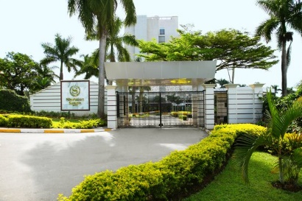

Sheraton Kampala Hotel Entrance

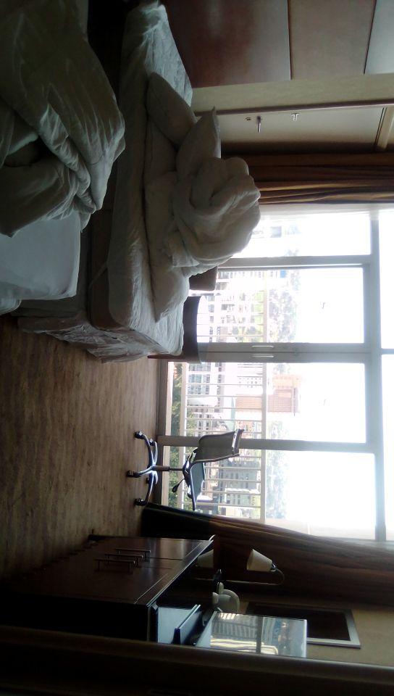

Unoccupied Sheraton Kampala Hotel Room

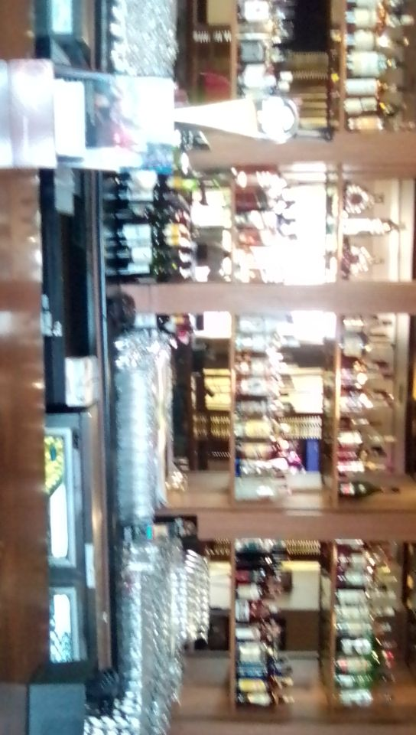

Equator Bar counter

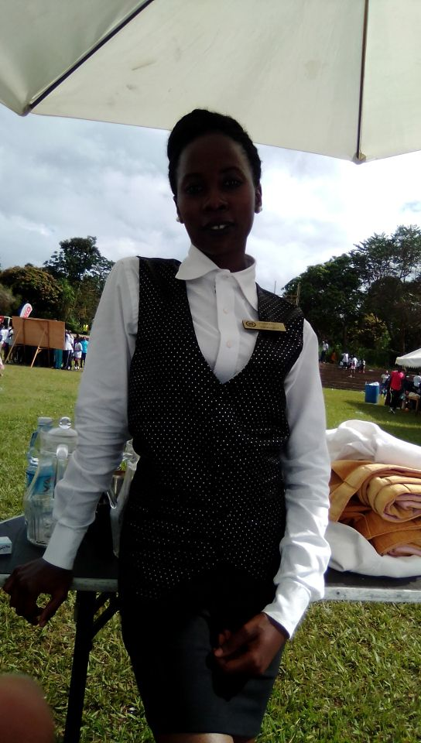

Banqueting Training

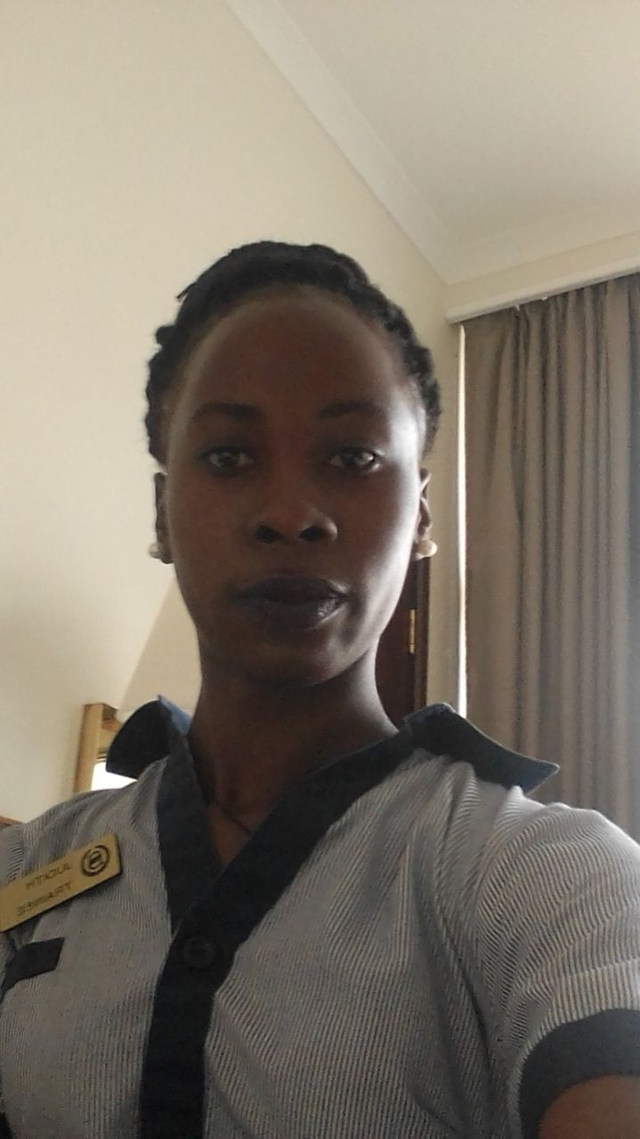

Housekeeping training

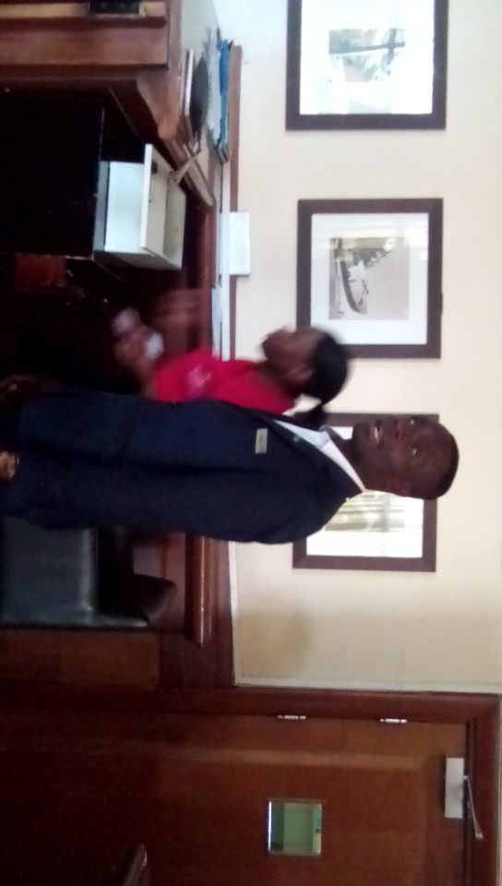

Equator bar manager and staff member

# **My Experience**

**Paradise Restaurant.**

I learnt how to make different types of teas and cuppiciono. For instance black tea, African tea, hot chocolate, Hot milk, Dawa tea, Herbal tea which includes paper mine, comer mine, lemon tea.

I learnt how to interact with guests, asking if they are fine with their orders.

I learnt how to air host guests. That is to say welcoming guests, assisting them with finding seats that are comfortable for them, handing over the beverage and food menus to them so as their orders are taken.

**La Terrasse.**

This being my first outlet to train in, I learnt the following;

I learnt to clean cattery through using lemon and hot water, plates you only make a cloth dumb a little with hot water only and clean.

I learn how to prepare a four course main table preparing mostly for buffet on some special functions like dinner, graduation parties to mention but a few.

To add on, I learn how wipe seats and tables without leaving any stains for guests to complain.

I learn to always keep alert, stand firm and walk around guests to see if everything is fine.

I learnt how to take orders and have them to guests on time.

**House Keeping.**

The uniforms in housekeeping were at start uncomfortable for my body but fortunately, I learnt how to be comfortable in them and carryout my work.

I learnt how to straighten the bed, dressing the duvet, dressing the pillows, drawing the curtains before and after work.

I learnt how to clean the toilets but before gloves had be worn. I also learnt how to clean showers leaving them spotless, cleaning the floor ensuring there were no stains and hair left on the floor.

I learnt how to clean balcones by mapping and wiping.

I learnt how to wipe the mirrors, television sets, refrigerators, ware drops to mention but a few.

**Equator Bar.**

I had never worked in a bar, it being my first time. I got the opportunity of being a bar woman attending to each and every guest that came at the counter and needed assistance.

To add on, I learnt different types of alcoholic beverages that even stood out as imported and exported. For example the house wines, imported wines, tequilas, liquors, imported beers, house beers, gins, shots, mock tails and cocktails.

From Equator bar, I learnt how to make or fry popcorns.

I learnt how to be confident in front of the guest that had lost control over alcohol.

I learnt how to make cocktails like Equator sunset, long island, Sheraton pride and how to make a non-alcoholic and alcoholic mojito.

**Banqueting outlet**

Here it was hard for me to copy up with people attitudes and the same time it became so possible for me to copy up with different people I worked with on my way.

I learnt on how to make a coffee set up.

I learnt how to prepare breakfast tea.

I learnt more on the set of four main course.

Cleaning of cattery with lemon and hot clean water.

I learnt how to wipe glasses by Deeping them in a tray of clean hot water.