Supplementary Material

Early Breast Cancer Detection and Differentiation Tool Based on Tissue Impedance Characteristics and Machine Learning
Soumaya Ben Salem^{1,2,}*, Samar Zahra Ali², Anyik John Leo², Zied Lachiri¹, Martin Mkandawire²*
¹SITI Laboratory, National School of Engineers of Tunis, University of Tunis El Manar, Tunis, Tunisia
²Department of Chemistry, School Science and Technology, Cape Breton University, Sydney, Nova Scotia, Canada B1P 6L2
* Correspondence: Soumaya Ben Salem@cbu.ca; martin_mkandawire@cbu.ca

Supplementary Figures 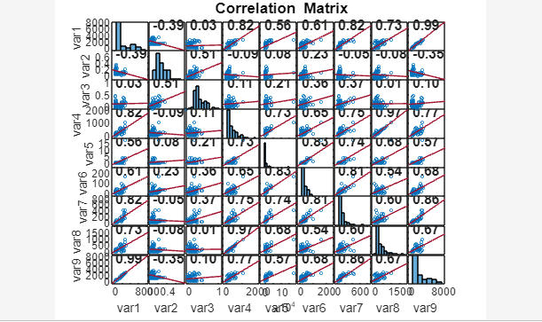
Supplementary Figure 1. The correlation matrix of the feature.
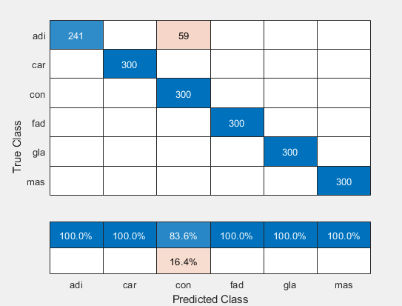
Supplementary Figure 2. The confusion matrix of the feature
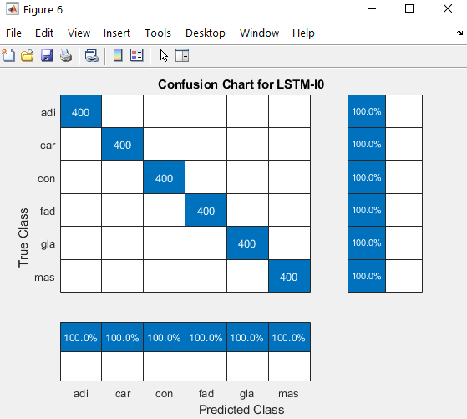
Supplementary Figure 2. The confusion matrix of the features I0 and DR. I0 and DR impedance features carry the most relevant EIS characterization that can separate every single tissue of the breast and hence detect the cancerous ones.

