EE-313 | Complex Engineering Problem
Design and Implementation of an Arduino-Based Closed-Loop DC-DC Buck Converter
12 V (10–15 V) to 5 V, 2 A regulator with input-voltage feedforward
Consolidated report: Preliminary Plan and Design · Intermediate Design and Progress · Final Design and Progress

Project Team
S.No. | Name | Roll No. | Section | Role / demonstrable skills
1 | [Name] * | [Roll no.] | [Sec.] | Team Lead. Power-stage design, component selection, project management. [confirm skills]
2 | [Name] | [Roll no.] | [Sec.] | Simulation and analysis (circuit simulation, MATLAB/Python). [confirm skills]
3 | [Name] | [Roll no.] | [Sec.] | Arduino firmware and control implementation (C/C++). [confirm skills]
4 | [Name] | [Roll no.] | [Sec.] | Hardware assembly, soldering, oscilloscope testing, enclosure, documentation. [confirm skills]

* Team Lead. Highlighted fields in yellow are the only items that must be completed by the team: names, roll numbers, photographs, oscilloscope captures, measured values and receipt-based costs. All other content is complete.

Part A: Preliminary Plan and Design

A1. Abstract
This project designs, simulates, builds and tests an Arduino-controlled DC-DC buck converter that regulates a 5 V, 2 A output from an unregulated 10–15 V supply. The power stage uses a high-side IRF540N MOSFET driven by an IR2104 gate driver, an SB560 Schottky freewheeling diode, a 220 µH inductor and 960 µF of low-ESR output capacitance, switching at 31.25 kHz. The design gives a calculated inductor-current ripple of 0.42 A, an output ripple of about 15 mV and a predicted efficiency of 92% at full load. An Arduino Uno generates a 9-bit dithered PWM signal, measures the output through a filtered voltage divider and ADC, and regulates it with an integral controller plus input-voltage feedforward running at 2 kHz, with soft-start, duty limits and over-voltage/over-current shutdown. A switched-circuit simulation predicts 5.00 V regulation, 0.14–0.17 V deviation for 3–5 V input steps and 0.41–0.44 V deviation for a 1 A to 2 A load step, with recovery to within 50 mV in under 10 ms. Hardware measurements are reported in Section C6.

A2. Task Identification

Literature Review
Operating principle. A buck converter steps a DC voltage down by chopping the input with a switch and smoothing the result with an LC filter. While the switch is on, the inductor current rises and the inductor stores energy; when the switch turns off, the freewheeling diode carries the inductor current and the stored energy is delivered to the load [1], [2]. In continuous conduction mode (CCM) the inductor volt-second balance gives the ideal conversion ratio
Vout = D · Vin
where D is the duty cycle. The inductor ripple current and output-voltage ripple follow from the same balance [2], [10]:
ΔIL = (Vin − Vout) · D / (L · fsw) ΔVC = ΔIL / (8 · fsw · C) ΔVESR = ESR · ΔIL
The converter stays in CCM while the load current exceeds half of the ripple, Iout,crit = ΔIL/2. Below that level the current reaches zero during the off-time (discontinuous conduction mode, DCM), the gain depends on the load and the output voltage rises for a given duty cycle. Practical designs choose L for a ripple of 20–40% of the maximum load current, and size the capacitor so that the ESR term dominates the voltage ripple [10].
Closed-loop regulation. With a fixed duty cycle the output follows the input and the load, because of switch and diode drops. Regulation therefore needs feedback: the output is sensed, compared with a reference and the duty cycle is corrected. In voltage-mode control the duty cycle is the control input and the small-signal duty-to-output transfer function is a second-order low-pass with a resonance at f0 = 1/(2π√(LC)) and a damping set by the load, inductor resistance and capacitor ESR [2]. Integral action removes the steady-state error, proportional action adds speed, and derivative action can add damping, but a lightly damped LC resonance limits the usable gain, particularly at light load. Feedforward of the input voltage (D = Vref/Vin) makes the loop insensitive to line variations, so feedback only has to correct load changes and component losses [2], [4]. Digital implementations add sampling delay, ADC quantisation and duty-cycle resolution, which must be accounted for when tuning, because quantisation can excite limit cycles in a high-Q plant.
Arduino PWM and ADC sensing. The ATmega328P on the Arduino Uno has a 16-bit Timer1 that can generate fast PWM on pin 9 at 16 MHz/(TOP+1). A TOP value of 511 gives 31.25 kHz with 9-bit duty-cycle resolution [5]. The 10-bit ADC, referenced to 5 V, resolves 4.9 mV per count at the pin, and is accurate when the source impedance is below about 10 kΩ. Its default clock gives a 112 µs conversion, which can be reduced to about 13 µs by selecting a prescaler of 16. The ADC input is limited to 5 V, so the output is scaled by a resistive divider, filtered by an RC low-pass to attenuate switching ripple, and clamped by a zener diode for protection.
Component selection and losses. The switch is an N-channel MOSFET chosen for a drain–source rating well above the input voltage and a low on-resistance; a high-side N-MOSFET needs a bootstrap gate driver such as the IR2104 to raise the gate above the source [7]. The freewheeling element can be a Schottky diode, which has a low forward drop and no reverse recovery, but its forward drop dominates the loss in a low-voltage converter [3]. The main loss terms are MOSFET conduction (Irms²·Rds(on)), switching (½·Vin·I·(tr+tf)·fsw), gate drive (Qg·Vgs·fsw), diode conduction (Vf·Iout·(1−D)) and inductor winding loss (Iout²·DCR). An inductor must be rated above the peak current (Iout + ΔIL/2) to avoid saturation. Output capacitors with low ESR reduce ripple, and a fuse and duty-cycle limits protect against faults [1], [3].

List of Tasks Needed to Fulfil the Problem Statement
Task | Description | Stage | Tangible outcome
1 | Buck-converter analytical design and component selection | Intermediate | Design calculations, component list with ratings
2 | Simulation and open-loop validation of the power stage | Intermediate | Circuit model, waveforms, simulation vs. analytical comparison
3 | Arduino PWM / gate-drive implementation and open-loop hardware prototype | Intermediate | Working open-loop prototype, scope captures, photos
4 | Output-voltage sensing and Arduino ADC feedback | Final | Calibrated sensing circuit and feedback measurements
5 | Closed-loop control algorithm and PWM duty-cycle adjustment | Final | Arduino source code, tuned controller, flow-chart
6 | Complete system integration, regulation testing and final validation | Final | Regulated converter in enclosure, test report with line/load/efficiency data

A3. Resource Identification

Human Resource (Project Team)
The team members are listed on the title page. The skill-set column should list only skills that each member can demonstrate (for example a previous circuit, a simulation file or a code repository).

Human Resource Skill Gap
The collective skill gaps identified before starting, and how each is closed, are listed below. Each member should edit the entry for their own role to reflect their own candid assessment.
Skill area | Gap identified | How the gap is closed
Power-stage design (Member 1) | Has solved buck-converter problems on paper but not selected real components against ripple, saturation and loss limits. | Follow TI application note [10] and Erickson & Maksimović [2]; cross-check with simulation by Member 2.
Switched-circuit simulation (Member 2) | Limited experience modelling diode, ESR and DCR non-idealities and closed-loop behaviour. | Build the model in stages (ideal, then losses, then closed loop) and compare each stage with hand calculations.
Embedded control (Member 3) | Has used Arduino for basic I/O; has not configured Timer1/Timer2 registers, ADC prescaler or fixed-point duty dithering. | Study the ATmega328P datasheet [5]; test PWM with an oscilloscope before connecting any power stage.
Hardware and measurement (Member 4) | Little experience with high-side gate drivers, grounding and low-noise oscilloscope probing of a switching node. | Use a probe ground spring, short ground loops and a bench supply with current limit; follow safe-start checklist in Task 3.

Hardware Resource Identification
S.No. | Hardware component / equipment | Where / how to acquire
1 | Arduino Uno R3 (ATmega328P) | Online vendor / local electronics market
2 | IRF540N N-channel power MOSFET, IR2104 half-bridge gate driver, UF4007 and 1N4148 diodes | Local electronics market (Hall Road) / online vendor
3 | SB560 Schottky diode (60 V, 5 A) | Local electronics market
4 | 220 µH, ≥5 A power inductor (toroid; wound if not available) | Online vendor, or wind on a powdered-iron core
5 | Capacitors: 470 µF/25 V low-ESR (×3), 10 µF, 1 µF and 100 nF ceramics | Local electronics market
6 | ACS712-05B current-sensor module | Online vendor
7 | Resistors, 5.1 V zener, 3 A fuse and holder, small heat sink, veroboard, terminal blocks, wires | Local electronics market
8 | Power load: 2 × 5 Ω, 10 W wire-wound resistors (switchable) | Local electronics market
9 | 12 V, 3 A DC supply (bench supply or adapter, adjustable 10–15 V) | University power-electronics lab / purchase
10 | Oscilloscope with two probes, digital multimeters (×2), electronic load or rheostat | University lab
11 | Enclosure (plastic project box) with ventilation slots | Local electronics market

Software Resource Identification
S.No. | Software | Where / how to acquire
1 | Arduino IDE 2.x (programming, serial monitor) | arduino.cc (free)
2 | Circuit simulator (LTspice, or Python/NumPy switched-model) | Analog Devices (free) / python.org
3 | MATLAB or Python (control analysis, plots, Bode) | University licence / free
4 | MS Excel (Gantt chart, BOM, data tables) | University licence
5 | Schematic / drawing tool (KiCad, draw.io) | Free download

A4. Project Objectives
- O1 – Regulated output: Vout = 5.0 V ± 2% (±0.1 V) for Vin = 10–15 V and Iout = 0.5–2 A.
- O2 – Low ripple: peak-to-peak output ripple ≤ 50 mV (1% of Vout) at full load; inductor ripple ≤ 25% of Iout,max.
- O3 – Efficiency: ≥ 88% at Vin = 12 V for Iout = 1–2 A, with no component exceeding a safe temperature.
- O4 – Dynamic response: deviation ≤ 10% of Vout for a 1 A to 2 A load step or 3–5 V input step, recovering to within ±1% in ≤ 50 ms.
- O5 – Arduino closed-loop control: voltage feedback via ADC, soft-start, duty-cycle limits, anti-windup and over-voltage/over-current shutdown implemented in firmware.
- O6 – Safe, complete hardware: fused input, gate pull-down, enclosed hardware and a documented safe start-up procedure.

A5. Project Deliverables
- Working closed-loop buck-converter prototype in an enclosure.
- Final circuit schematic and simulation files with design calculations.
- Arduino source code (printed and on file) with flow-chart.
- Measured regulation, ripple, transient and efficiency results with oscilloscope screenshots.
- Gantt chart (Excel source), BOM with proof of vendor survey, and the equipment bought.
- This consolidated report.

A6. Resource Allocation and Time Scheduling

Human Resource Allocation
Task | Lead | Support | Skill-gap support
1 Analytical design | Member 1 | Member 2 | Member 2 checks calculations by simulation
2 Simulation / open-loop | Member 2 | Member 1 | Member 1 reviews model against hand design
3 PWM, gate drive, prototype | Member 3, Member 4 | Member 1 | Member 4 trained on gate-driver wiring by Member 1
4 Sensing / ADC feedback | Member 3 | Member 4 | Member 4 calibrates divider against multimeter
5 Control algorithm | Member 3 | Member 2 | Member 2 provides loop analysis and tuning in simulation
6 Integration / validation | Member 4, Member 1 | All | All members attend final tests; Member 1 signs safety checklist

Hardware/Software Resource Allocation
Task | Hardware | Software
1 | Datasheets, calculator | Excel, Python/MATLAB
2 | – | LTspice / Python simulation, Excel
3 | Arduino, IRF540N, IR2104, SB560, inductor, capacitors, supply, oscilloscope, resistive load | Arduino IDE
4 | Resistors, zener, 100 nF, ACS712, multimeter | Arduino IDE, serial monitor
5 | Arduino, full power stage, oscilloscope | Arduino IDE, MATLAB/Python
6 | Complete prototype, load resistors, supply, DMMs, oscilloscope, enclosure | Excel (data), Arduino IDE

Time Scheduling (Gantt Chart)
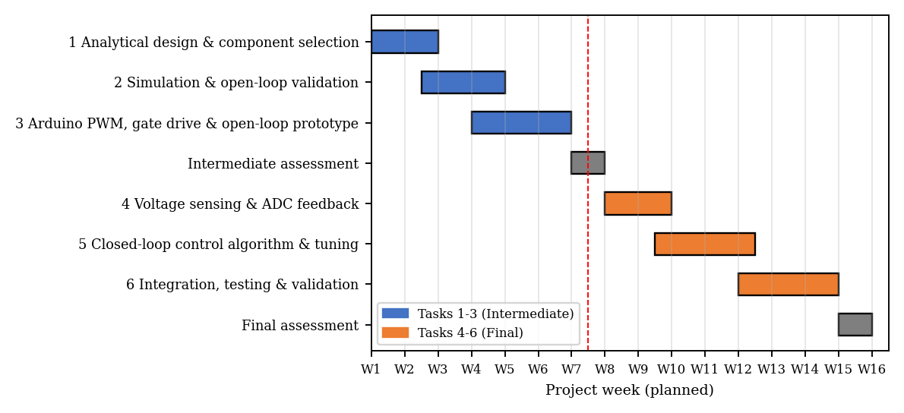
Figure 1: Planned Gantt chart for Tasks 1–6 (Tasks 1–3 form the Intermediate stage, Tasks 4–6 the Final stage). The Excel source is submitted at evaluation.
The planned schedule is shown above. Actual start/finish dates are recorded on the Excel Gantt chart submitted at evaluation: [insert actual dates].

A7. Budgeting and Bill of Materials (BOM)

Estimated BOM
S.No. | Equipment / component | Estimated cost (PKR) | Reference of cost estimate
1 | Arduino Uno R3 | 1,800 | Online vendor price
2 | IRF540N MOSFET | 150 | Local market
3 | IR2104 gate driver (DIP-8) | 250 | Online vendor
4 | SB560 Schottky diode (×2, one spare) | 120 | Local market
5 | UF4007 + 1N4148 diodes | 30 | Local market
6 | 220 µH, 5 A inductor | 450 | Online vendor
7 | Capacitors: 3 × 470 µF/25 V low-ESR | 240 | Local market
8 | Ceramic capacitors (10 µF, 1 µF, 100 nF) | 120 | Local market
9 | Resistors, 5.1 V zener (assorted) | 110 | Local market
10 | ACS712-05B module | 650 | Online vendor
11 | Power resistors 5 Ω, 10 W (×2) | 300 | Local market
12 | Veroboard, terminal blocks, headers, wire | 400 | Local market
13 | Fuse holder + 3 A fuse | 150 | Local market
14 | Small heat sink (TO-220/diode) | 100 | Local market
15 | 12 V, 3 A DC adapter | 1,200 | Online vendor
16 | Plastic enclosure | 500 | Local market
 | Total Cost | 6,570

Costs are indicative market estimates. Proof of the vendor survey (screenshots or quotations) is submitted at evaluation: [attach vendor screenshots].

Budget Funding
Source | Amount (PKR) | Items covered
Equal contribution of team members (4 members) | 5,000 (≈ 1,250 each) | Electronic components, sensor, load resistors, enclosure
University laboratory (loan, no cost) | – | Oscilloscope, DMMs, bench supply (substitutes for the adapter)
Contingency (≈ 25%, shared) | 1,570 | Spare MOSFET/driver, replacements after faults

Part B: Intermediate Design and Progress (Tasks 1–3)

B1. Summary of Progress
Tasks 1–3 produced a complete power-stage design, a validated simulation model and the firmware and gate-drive design for an open-loop prototype. The analytical design (12 V → 5 V, 2 A, 31.25 kHz) uses a 220 µH inductor, 960 µF of output capacitance, an IRF540N MOSFET, an SB560 diode and an IR2104 driver, giving a calculated inductor ripple of 0.42 A, output ripple of 14.5 mV and efficiency of 92%. A switched-circuit simulation reproduces the analytical design: output ripple 13.1 mV, inductor ripple 0.44 A, and mean output voltage 4.65 V at D = 0.416, matching the loss-corrected prediction of 4.65 V. Arduino Timer1 generates the 31.25 kHz PWM with 9-bit resolution and drives the MOSFET through the IR2104. Open-loop bench measurements at fixed duty cycles are given in Section B5.

B2. Tasks Completed
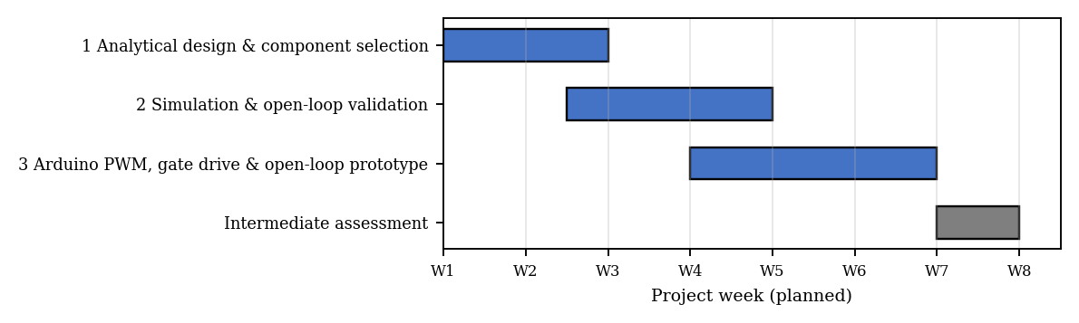
Figure 2: Gantt chart portion for Tasks 1–3 (weeks 1–7), with the Intermediate assessment in week 7.
Task | Planned | Work completed / outcome
1 Analytical design | Specifications, D, f, L, C, device selection | Complete design with ripple, losses and ratings (Section B3). Outcome: component list and calculations.
2 Simulation | Fixed-duty simulation vs. analytical | Switched model with ESR, DCR, diode and MOSFET drops; waveforms and duty sweep (Section B4).
3 Arduino PWM and prototype | Timer PWM, gate driver, open-loop build | Timer1 31.25 kHz PWM, IR2104 interface and test procedure (Section B5). Outcome: open-loop prototype [attach photos].

Changes in execution
- Switching frequency was set to 31.25 kHz (Timer1, TOP = 511) instead of the 62.5 kHz default, because 8-bit PWM at 62.5 kHz gives 0.39% duty steps (about 47 mV of output step), too coarse for regulation to ±2%. The 9-bit mode halves this step; a firmware dithering scheme later refines it further (Section C4).
- The inductor was changed from the first estimate of 100 µH (valid at 62.5 kHz) to 220 µH to keep ripple near 20% at the lower frequency.
- An ACS712 current sensor and an input-voltage divider were added to the design to support protection and feedforward in the Final stage.

B3. Task 1: Buck Converter Analytical Design and Component Selection

Specifications
Parameter | Value
Input voltage Vin | 12 V nominal, 10–15 V range
Output voltage Vout | 5 V
Load current Iout | 0.5–2 A (maximum output power 10 W)
Switching frequency fsw | 31.25 kHz (Timer1 TOP = 511)
Target ripple | ΔIL ≈ 20–25% of Iout,max; ΔVout ≤ 50 mV (1%)
Efficiency target | ≥ 88% at 12 V, 1–2 A

Duty cycle and inductor
In CCM the ideal duty cycle is D = Vout/Vin: 0.417 at 12 V, 0.333 at 15 V and 0.500 at 10 V. Including the diode drop and the MOSFET and inductor resistance at 2 A, the required duty at 12 V is
D = (Vout + Vf + Iout·DCR) / (Vin − Iout·Rds + Vf) = (5 + 0.5 + 0.08)/(12 − 0.088 + 0.5) = 0.450
For a ripple of 0.4 A (20% of 2 A) at 12 V, the minimum inductance is
L = (Vin − Vout)·D / (fsw·ΔIL) = 7 × 0.4167 / (31 250 × 0.4) = 233 µH
A standard 220 µH inductor is selected. Its actual ripple is ΔIL = 2.917/(31 250 × 220 µH) = 0.424 A at 12 V (21% of 2 A) and 0.485 A at 15 V (24%, the worst case). The peak inductor current is Iout + ΔIL/2 = 2.24 A at 2 A load, so an inductor with a saturation current of at least 3.2 A (1.4× margin) is needed; a 5 A part is selected. The converter remains in CCM for Iout > ΔIL/2 = 0.21 A at 12 V (0.24 A at 15 V), so the 0.5 A minimum load is always in CCM.

Output and input capacitors
The capacitive ripple term is ΔIL/(8·fsw·C) = 0.485/(8 × 31 250 × 960 µF) = 2.0 mV, whereas the ESR term, with two 470 µF low-ESR capacitors (about 30 mΩ combined), is 30 mΩ × 0.485 A = 14.6 mV. The total worst-case ripple is therefore about 16.6 mV (0.33%), well inside the 50 mV limit (at 12 V: 14.5 mV). A 10 µF ceramic capacitor in parallel absorbs the high-frequency switching spikes. The input capacitor carries an RMS current Iout·√(D(1−D)) = 2 × √(0.417 × 0.583) = 0.99 A, so a 470 µF/25 V low-ESR electrolytic with a ripple rating above 1 A and a 100 nF ceramic are used; the resulting input ripple is Iout·D(1−D)/(fsw·Cin) ≈ 33 mV.

Semiconductor and driver selection
Component | Selected part | Key ratings | Stress in this design / justification
MOSFET (high side) | IRF540N | 100 V, 33 A, Rds(on) = 44 mΩ, Qg ≈ 71 nC | Vds = 15 V max, Irms = 1.34 A → ample margin; low conduction loss (0.08 W)
Freewheeling diode | SB560 Schottky | 60 V, 5 A, Vf ≈ 0.5 V at 2 A | VR = 15 V, IF,avg = 1.1 A; largest single loss (0.55 W)
Gate driver | IR2104 | 10–20 V supply, 130/270 mA, bootstrap high side | Drives the high-side N-MOSFET from Arduino logic; average gate current Qg·fsw = 2.2 mA
Bootstrap | UF4007 + 1 µF | Fast diode, ≥ 25 V ceramic | Charges when the switch node falls to ground through the diode (duty < 95%)
Current sensor | ACS712-05B | ±5 A, 185 mV/A | Over-current shutdown and efficiency measurement

Loss budget and efficiency
Loss element | Expression | Power at 2 A (W)
MOSFET conduction | Iout²·Rds·D | 0.079
MOSFET switching | ½·Vin·Iout·(tr+tf)·fsw, tr+tf ≈ 80 ns | 0.030
Gate drive | Qg·Vgs·fsw | 0.027
Diode conduction | Vf·Iout·(1−D) | 0.550
Inductor winding (DCR = 40 mΩ) | Iout²·DCR | 0.160
Total loss |  | 0.846

The predicted efficiency is 92.2% at 2 A and 93.0% at 1 A (Vin = 12 V), excluding the Arduino and driver supply. The diode is the dominant loss; at 0.55 W it needs a small heat sink or copper area, whereas the MOSFET (0.14 W total) needs none. A synchronous rectifier would improve efficiency but is outside the scope of the Arduino timer resources used here.
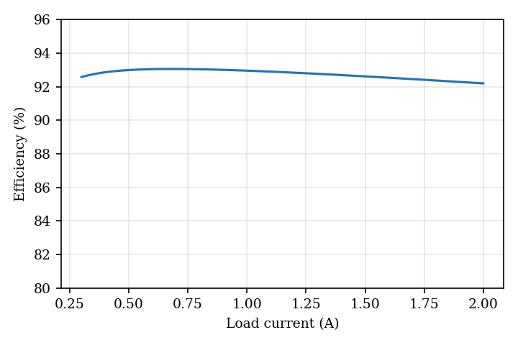
Figure 3: Predicted converter efficiency versus load current (Vin = 12 V, Vout = 5 V).

B4. Task 2: Simulation and Open-Loop Validation
The power stage was simulated as a switched circuit with 0.4 µs time steps (80 steps per switching period) in a Python model that includes the MOSFET on-resistance, diode forward drop, inductor DCR, capacitor ESR and discontinuous-conduction behaviour. The circuit is shown in Figure 4. The same component values can be entered directly in LTspice for cross-checking: [attach LTspice schematic if used].
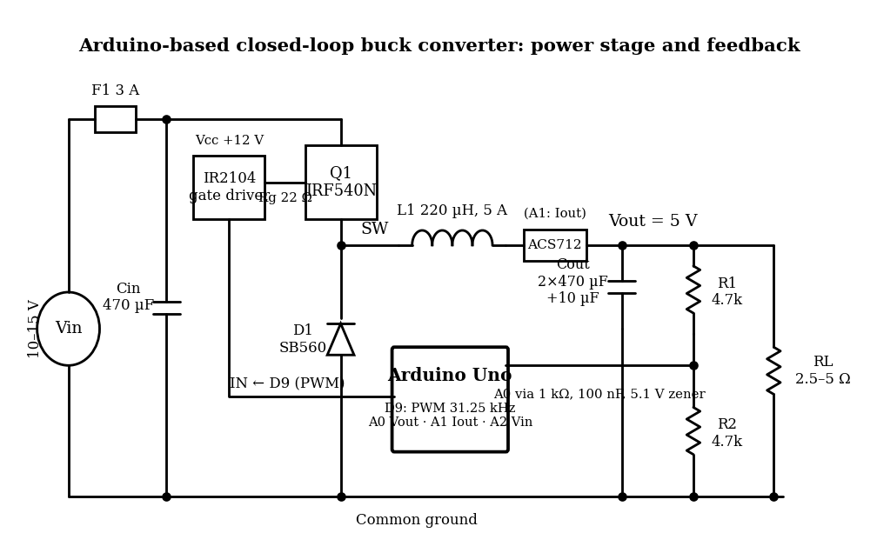
Figure 4: Complete circuit diagram of the buck converter, gate driver, sensing circuits and Arduino interface.
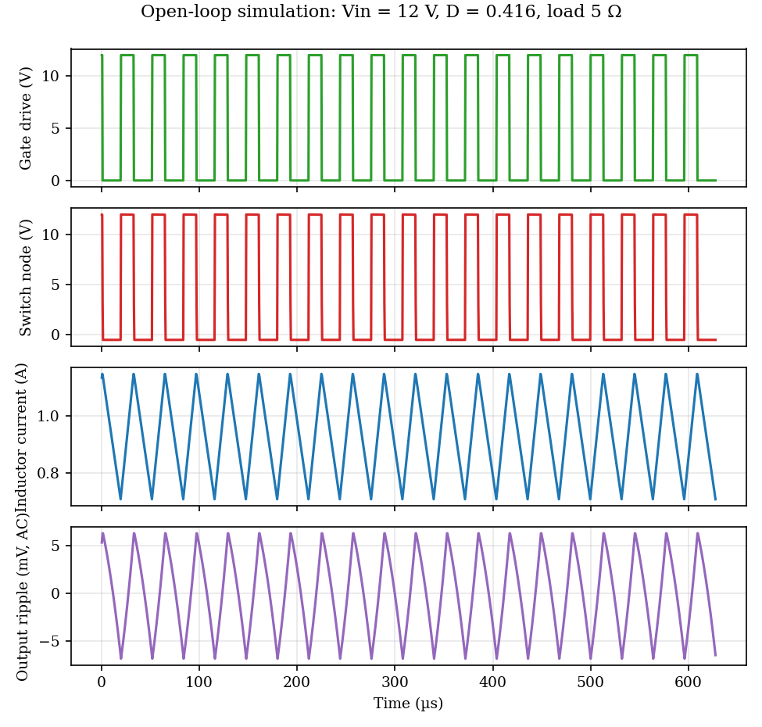
Figure 5: Open-loop waveforms at D = 0.416, Vin = 12 V, 5 Ω load: gate signal, switching-node voltage, inductor current and AC output ripple.
The switching node swings between about 12 V and −0.5 V (diode drop), the inductor current is a triangular waveform around its 0.93 A mean value, and the output ripple has the triangular shape expected when the ESR term dominates.
Duty cycle D | Ideal Vin·D (V) | Simulated Vout (V) | Difference (V) | Ripple (mV pp)
0.199 | 2.39 | 1.97 | -0.42 | 9.3
0.301 | 3.61 | 3.23 | -0.38 | 10.4
0.400 | 4.80 | 4.45 | -0.35 | 12.8
0.416 | 4.99 | 4.65 | -0.35 | 13.1
0.500 | 6.00 | 5.68 | -0.32 | 14.6
0.600 | 7.20 | 6.90 | -0.29 | 11.0
0.699 | 8.39 | 8.13 | -0.27 | 10.3

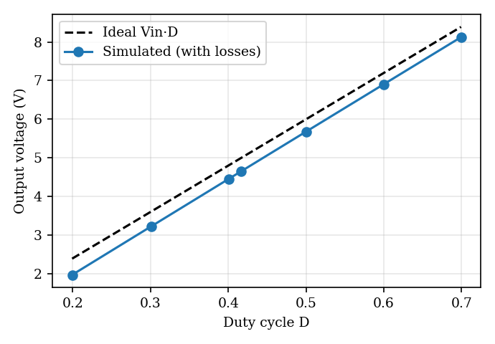
Figure 6: Simulated open-loop output voltage versus duty cycle (Vin = 12 V, 5 Ω load).
Quantity (D = 0.416, Vin = 12 V, 5 Ω) | Analytical | Simulation
Mean output voltage | 4.65 V (loss-corrected); 4.99 V (ideal) | 4.65 V
Inductor current ripple ΔIL | 0.424 A | 0.437 A
Mean inductor current | 0.93 A | 0.93 A
Output ripple (peak-to-peak) | 14.5 mV | 13.1 mV

The simulation agrees with the analytical design within a few percent. The open-loop output is about 0.35 V below the ideal Vin·D because of the diode and winding drops, which confirms the need for feedback. For D ≥ 0.6 the output exceeds 5 V, so the firmware limits the maximum duty to 0.80 and the open-loop tests are restricted to D ≤ 0.50.

B5. Task 3: Arduino PWM, Gate Drive and Basic Hardware Prototype
PWM generation. Timer1 of the ATmega328P is configured in fast-PWM mode 14 with ICR1 = 511 and no prescaler, giving a 31.25 kHz PWM on pin 9 (OC1A) with 512 duty steps (0.195% per step). The output pin is held low by a 10 kΩ pull-down resistor on the driver input so that the MOSFET stays off while the Arduino resets or boots.
Gate drive. The IR2104 is supplied from the 12 V input (a separate 12 V supply for the driver can be used when Vin is below 10 V). Its IN pin is driven from pin 9, its SD pin is tied high, and its HO output drives the IRF540N gate through a 22 Ω resistor. The bootstrap capacitor (1 µF) is charged through a UF4007 diode when the switch node is pulled to ground by the freewheeling diode. The low-side output LO is left unconnected because the converter is asynchronous. A 100 nF ceramic capacitor decouples the driver supply, and the logic and power grounds meet at one point.
Open-loop test procedure. (1) Check wiring and polarity with the supply off. (2) Program a fixed duty cycle of 0.20 and verify the 31.25 kHz gate waveform on the oscilloscope with no power applied. (3) Connect the supply with the current limit set to 0.5 A and a 10 Ω load; raise the supply to 12 V. (4) Measure the switching node, output voltage and ripple at D = 0.20, 0.30, 0.40 and 0.50. (5) Increase the load to 5 Ω and repeat. (6) Check MOSFET, diode and inductor temperatures after 5 minutes. Closed-loop control is not used in this stage.
Duty D | Expected Vout (V, simulation) | Measured Vout (V) | Measured ripple (mV pp) | Gate / switch-node capture
0.20 | 1.97 | [measure] | [measure] | [figure]
0.30 | 3.23 | [measure] | [measure] | [figure]
0.40 | 4.45 | [measure] | [measure] | [figure]
0.50 | 5.68 | [measure] | [measure] | [figure]

[Insert photographs of the open-loop prototype and oscilloscope screenshots of the gate signal, switching node and output voltage.]

B6. Updated Resources, Schedule and Risk
No new equipment was required beyond the Preliminary BOM except the ACS712 sensor and input-voltage divider resistors, already included in the BOM above. The schedule is unchanged apart from the extra design iteration on the switching frequency noted in B2. Risks relevant to Tasks 1–3 are tabulated in Section D1.

Part C: Final Design and Progress (Tasks 4–6)

C1. Summary of Progress
Tasks 4–6 add output-voltage feedback, the closed-loop control algorithm and full system integration on the power stage designed in Part B. The output is sensed through a 4.7 kΩ/4.7 kΩ divider, a 1 kΩ/100 nF filter and a 5.1 V zener clamp, giving 9.8 mV per ADC count. The Arduino runs a 2 kHz control loop: an integral controller (Ki = 6) combined with input-voltage feedforward D = Vref/Vin, 9-bit PWM with fractional dithering, duty limits of 0.05–0.80, a 100 ms soft start, and trips at 6.5 V and 3 A. Analysis gives an 11 Hz crossover with 85° phase margin and more than 22 dB gain margin; the simulation holds 5.00 V with 1.6% start-up overshoot, 0.14–0.17 V deviation for input steps and 0.41–0.44 V for a 1 A ↔ 2 A load step, each recovering in under 10 ms. Hardware results are in Section C6.

C2. Tasks Completed
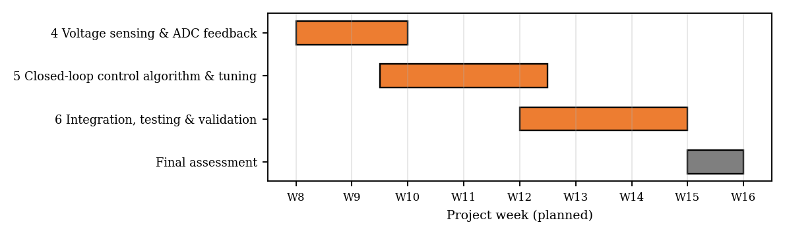
Figure 7: Gantt chart portion for Tasks 4–6 (weeks 7–15), with the Final assessment in week 15.
Task | Planned | Work completed / outcome
4 Sensing and ADC feedback | Divider, filter, ADC scaling, protection, calibration | Circuit designed (Section C3); calibration procedure defined; calibration table to be filled with bench data.
5 Closed-loop control | PI control, duty adjustment, tuning | Integral + feedforward controller, flow-chart, firmware (Section C4 and Appendix); tuned by analysis and simulation.
6 Integration and validation | Line/load tests, ripple, efficiency, heating, enclosure | Test plan and simulated performance (Section C5); measured results to be entered in Section C6.

Changes in execution
- Controller changed from PI to integral + feedforward. Simulation of the switched circuit showed that a proportional gain of 0.005 or an integral gain above about 10 produced a sustained oscillation near the 350 Hz LC resonance at 5–10 Ω loads, driven by the ±1 LSB duty-cycle steps of the 9-bit PWM acting on a lightly damped plant. The proportional term was therefore set to zero, the integral gain to 6, and input-voltage feedforward was added to restore fast line response.
- Fractional duty dithering added. The Timer1 overflow interrupt now accumulates the fractional duty each switching period, so the average duty has 17-bit resolution and quantisation steps are no longer visible at the loop frequency.
- Input-voltage sensing (A2) was added for feedforward and under-voltage lock-out.

C3. Task 4: Output-Voltage Sensing and Arduino Feedback Interface
Divider and ADC scaling. The Arduino ADC accepts 0–5 V. A 4.7 kΩ/4.7 kΩ divider scales the 5 V output to 2.5 V, giving headroom to measure up to 10 V and 9.78 mV per count at the output:
Vout = 2 × ADC × 5 / 1023
The divider draws 0.53 mA. Its Thevenin resistance is 2.35 kΩ, below the 10 kΩ recommended for the ADC. A series 1 kΩ resistor and a 100 nF capacitor to ground form the anti-aliasing filter; the total source resistance of 3.35 kΩ gives a cut-off
fc = 1/(2π · 3.35 kΩ · 100 nF) = 475 Hz
which attenuates the 31.25 kHz switching ripple by about 36 dB while adding only 0.34 ms of lag at the control frequency. The ADC clock prescaler is set to 16 (13 µs per conversion) and four conversions are averaged for each sample.
Protection. A 5.1 V zener diode from the ADC pin to ground and the 1 kΩ series resistor limit the pin voltage if the output rises or the divider fails. The firmware independently shuts down the PWM if the measured output exceeds 6.5 V. The input voltage is measured on A2 through a 22 kΩ/10 kΩ divider (ratio 3.2, 15 V → 4.7 V) with a 100 nF filter, and the load current through the ACS712 (185 mV/A, offset measured with the PWM off at start-up).
Calibration procedure. (1) With the converter running open loop at several duty cycles, record the output measured by a calibrated multimeter and the value reported over the serial port. (2) Fit the line Vmeas = a·Vreported + b; if the divider resistors have tolerance error, replace K_VOUT = 2.0 in the code by the fitted slope. (3) Repeat at 3, 4, 5 and 6 V. (4) Verify the ACS712 zero offset with no load and the sensitivity with a known 1 A and 2 A load.
Multimeter Vout (V) | Arduino reading (V) | Error (mV) | ADC counts
3.00 | [measure] | [calc] | [read]
4.00 | [measure] | [calc] | [read]
5.00 | [measure] | [calc] | [read]
6.00 | [measure] | [calc] | [read]

The expected resolution is 9.78 mV (0.2% of 5 V), so after calibration the reading should agree with the multimeter within ±1–2 counts (±20 mV).

C4. Task 5: Closed-Loop Control Algorithm and PWM Adjustment
Control method. The reference is Vref = 5.0 V, ramped from zero over 100 ms for soft start. Every 0.5 ms the controller reads the output and computes the error e = Vref − Vout. The duty cycle is the sum of three terms:
D = Vref/Vin + Kp·e + I , I(k+1) = I(k) + Ki·Ts·e(k)
The feedforward term sets the duty required for the measured input voltage; the integral term, limited to ±0.25 (anti-windup), removes the error caused by diode and resistive drops; Kp = 0 and Ki = 6 per volt-second. The result is clamped to 0.05 ≤ D ≤ 0.80. The duty is applied through Timer1: the overflow interrupt adds the fractional part of the commanded duty each period, so the average duty has 1/131 072 resolution while the hardware compare value has 9 bits. Over-voltage (> 6.5 V), over-current (> 3 A) or low-input (< 6 V) conditions turn the PWM off, clear the integrator and retry with soft start after 1 s.
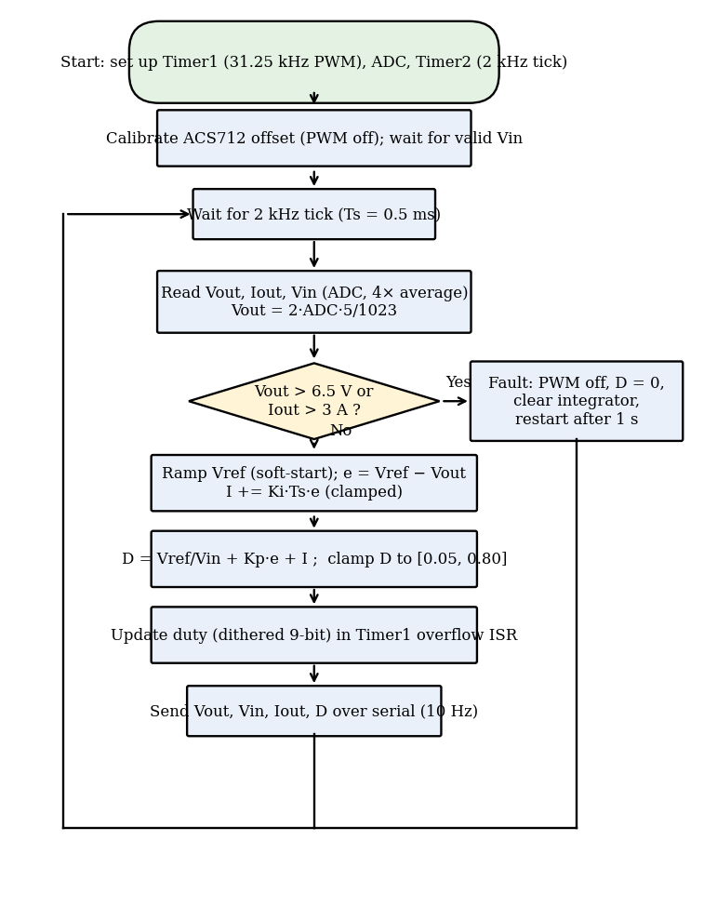
Figure 8: Flow-chart of the Arduino control program.
Tuning. The plant is the duty-to-output transfer function Gvd(s) = Vin·Zo/(Zo + sL + DCR), with Zo the parallel combination of the load and the capacitor with its ESR. With the 2 kHz sampling delay (1.5 Ts) and the ADC filter, the loop gain T(s) = Gvd·(Ki/s)·e^(−1.5Ts·s)/(1+sτ) was evaluated for loads from 2.5 Ω to 20 Ω. For Ki = 6 the crossover frequency is 11.4 Hz with a phase margin of 85° and a gain margin of 22 dB at all loads (Figure 9). Higher gains were tried in simulation and rejected as described in C2. The low crossover frequency is acceptable because the feedforward term handles line changes and the LC filter itself limits the load-step deviation.
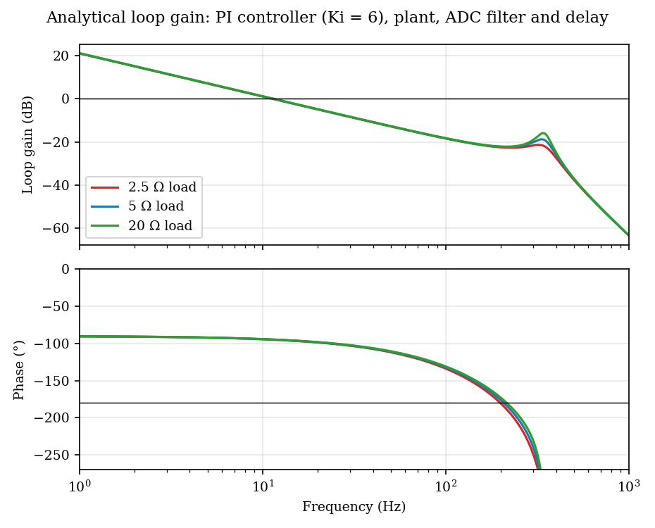
Figure 9: Analytical loop gain and phase for loads of 2.5, 5 and 20 Ω.
Observed closed-loop response (simulation). Figure 10 shows the start-up with soft start: the output follows the ramp and settles at 5.005 V with a peak of 5.08 V (1.6% overshoot). The input and load step responses are given in Section C5.
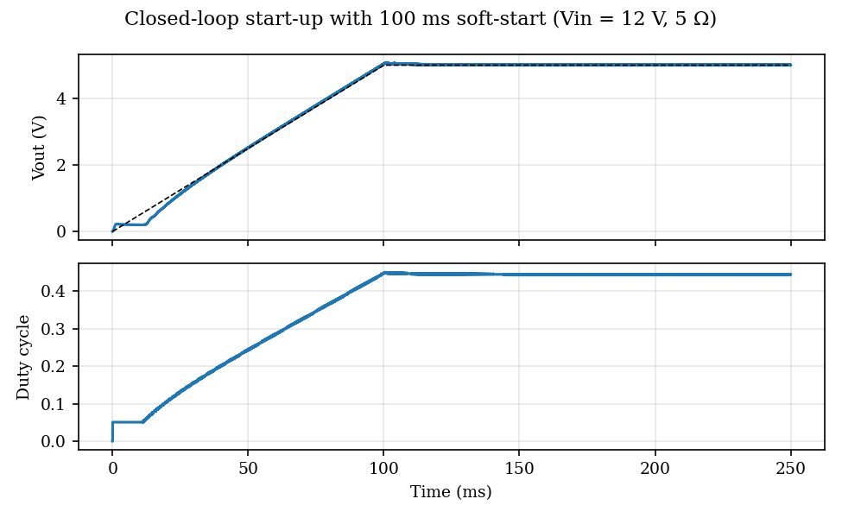
Figure 10: Simulated closed-loop start-up with 100 ms soft start (Vin = 12 V, 5 Ω load).
The main control code is listed below; the complete source is in Appendix 1.
const float KP = 0.0, KI = 6.0, TS = 0.0005; // controller gains, 2 kHz loop
...
float e = vref - vout; // feedback error
integ += KI * TS * e; // integral term
integ = constrain(integ, -0.25f, 0.25f); // anti-windup
float d = vref / vin + KP * e + integ; // feedforward + feedback
d = constrain(d, DMIN, DMAX); // duty-cycle limits 0.05 ... 0.80
setDuty(d); // dithered 9-bit PWM

C5. Task 6: Complete System Integration and Performance Validation
Integration. The power stage of Part B, the sensing circuits of Task 4 and the Arduino firmware of Task 5 are assembled on one board, with a single ground point between the power and logic grounds, short high-current loops (input capacitor – MOSFET – diode), and the sensing lines routed away from the switching node. The Arduino is powered from the 12 V rail through its onboard regulator (or a separate 9 V supply if the input is below 10 V). Input fuse: 3 A. The assembly is placed in a ventilated plastic enclosure with the load resistors outside, and with front-panel terminals for Vin, Vout and the test points. [Insert photographs of completed hardware].
Start-up and safety procedure. (1) Set the supply to 12 V with a 2 A current limit and connect the 10 Ω load. (2) Power the board; verify the output ramps to 5 V in 100 ms. (3) Increase the load stepwise to 2.5 Ω. (4) Vary the supply from 10 V to 15 V. (5) Verify that the output is switched off when the load is shorted briefly or the output is raised above 6.5 V with a lab supply through a series resistor. (6) Record temperatures after 10 minutes at full load.

Response to input-voltage variation
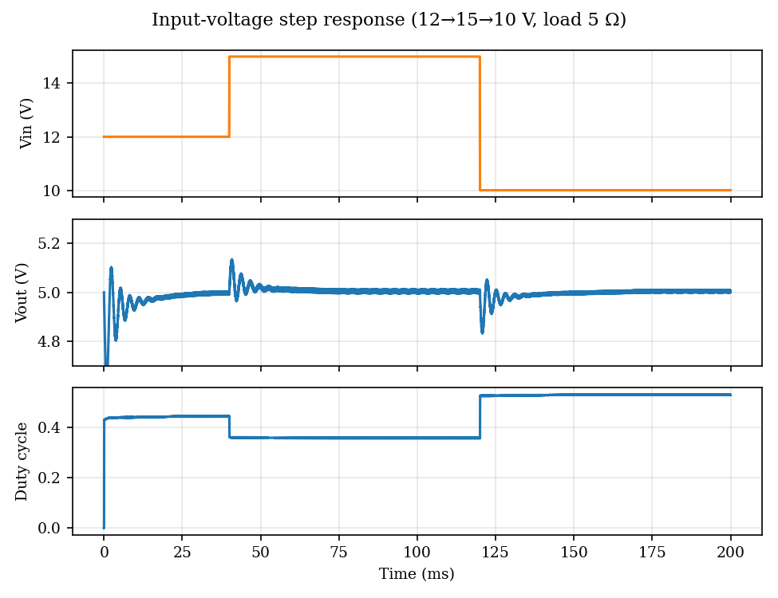
Figure 11: Simulated response to input steps 12 → 15 → 10 V (5 Ω load).

Response to load variation
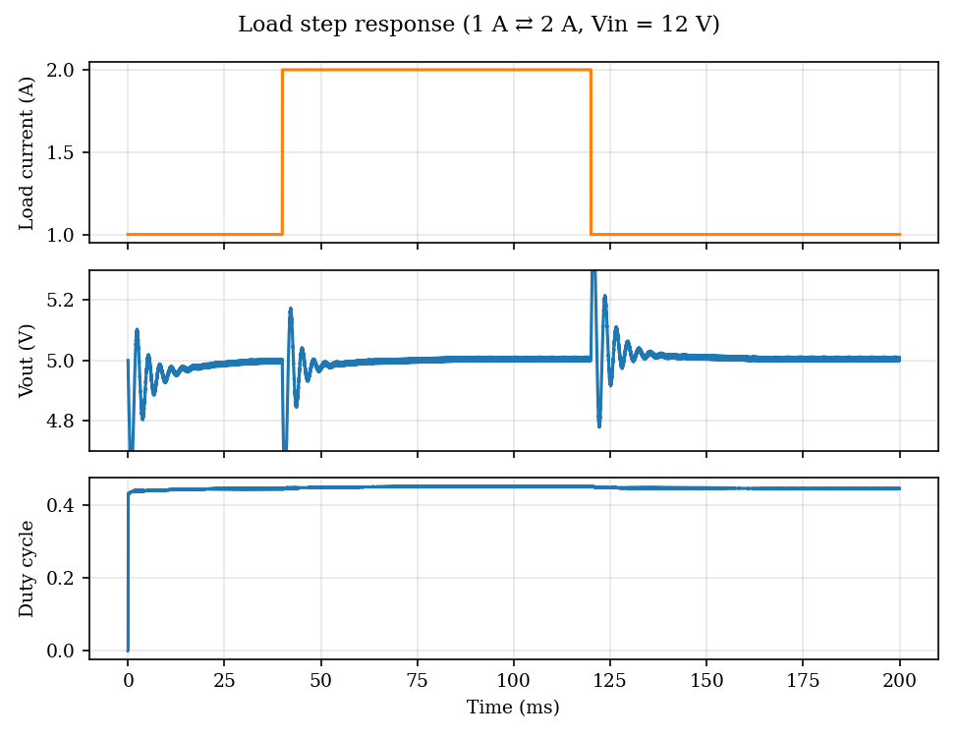
Figure 12: Simulated response to load steps 1 A → 2 A → 1 A (Vin = 12 V).
Disturbance (simulation) | Steady Vout before → after (V) | Peak deviation (V) | Settling to ±50 mV (ms)
Vin 12 → 15 V | 4.997 → 5.005 | 0.138 (2.8%) | 4.2
Vin 15 → 10 V | 5.005 → 5.005 | 0.173 (3.5%) | 6.9
Load 1 A → 2 A | 4.997 → 5.005 | 0.410 (8.2%) | 7.1
Load 2 A → 1 A | 5.005 → 5.005 | 0.440 (8.8%) | 9.8

The steady-state output stays within 5.00 ± 0.01 V for all conditions. The load-step deviation of about 8% is set by the output LC filter, since the loop crossover (11 Hz) is far below the 350 Hz resonance; it can be reduced with more output capacitance, and it meets objective O4 (≤ 10%, recovery in ≤ 50 ms).
Output ripple. Simulated ripple is 13.1 mV peak-to-peak at 12 V (0.26%), and the analysis predicts at most 16.6 mV at 15 V, below the 50 mV limit. Efficiency. The loss model predicts 92.2% at 2 A and 93.0% at 1 A (Figure 3). Heating. Losses are 0.55 W in the diode, 0.16 W in the inductor and 0.14 W in the MOSFET; with the diode on a small heat sink and natural convection in the ventilated enclosure, the expected temperature rise is below 40 °C for the diode and below 15 °C for the MOSFET (estimates; to be verified by measurement). Safe operation. The 3 A fuse, duty limits, soft start, 6.5 V and 3 A trips, input under-voltage lock-out and the gate pull-down protect the converter and the load.

C6. Results
Simulated results are given in Sections B4, C4 and C5. The bench results should be recorded as listed in the tables and figures below and compared with the objectives.
[Insert: (a) photographs of the completed hardware; (b) oscilloscope screenshot of the regulated output (AC-coupled, 20 mV/div) showing ripple; (c) gate/PWM and switching-node waveforms at 5 V output; (d) output response to a 1 A → 2 A load step (load switched with a MOSFET or relay); (e) output response to a 12 → 15 V input step.]

Measured performance versus objectives
Objective | Target | Simulation / analysis | Measured | Met?
O1 Output at Vin 10–15 V, 0.5–2 A | 5.0 ± 0.1 V | 5.00 V (±0.01 V) | [measure] | [Y/N]
O2 Output ripple (pp) | ≤ 50 mV | 13 mV (12 V); ≤ 17 mV (15 V) | [measure] | [Y/N]
O2 Inductor ripple | ≤ 25% of 2 A | 0.42–0.44 A (21–22%) | [measure] | [Y/N]
O3 Efficiency at 12 V, 2 A / 1 A | ≥ 88% | 92.2% / 93.0% (model) | [measure] | [Y/N]
O4 Load-step deviation / recovery | ≤ 10% / ≤ 50 ms | 8.2% / 7 ms | [measure] | [Y/N]
O4 Line-step deviation / recovery | ≤ 10% / ≤ 50 ms | 3.5% / 7 ms | [measure] | [Y/N]
O5 Protection (OV/OC trip) | Trips at 6.5 V / 3 A | By design | [test] | [Y/N]
O6 Component temperature after 10 min | Diode < 80 °C | < 70 °C (estimate) | [measure] | [Y/N]

Efficiency measurements
Vin (V) | Iout (A) | Pin (W) | Pout (W) | Efficiency (%) | Model (%)
12 | 1.0 | [measure] | [measure] | [calc] | 93.0
12 | 1.5 | [measure] | [measure] | [calc] | [model]
12 | 2.0 | [measure] | [measure] | [calc] | 92.2
15 | 2.0 | [measure] | [measure] | [calc] | [model]

C7. Final Bill of Materials (BOM)
S.No. | Equipment / component | Estimated (PKR) | Actual cost (PKR)
1 | Arduino Uno R3 | 1,800 | [receipt]
2 | IRF540N MOSFET | 150 | [receipt]
3 | IR2104 gate driver (DIP-8) | 250 | [receipt]
4 | SB560 Schottky diode (×2, one spare) | 120 | [receipt]
5 | UF4007 + 1N4148 diodes | 30 | [receipt]
6 | 220 µH, 5 A inductor | 450 | [receipt]
7 | Capacitors: 3 × 470 µF/25 V low-ESR | 240 | [receipt]
8 | Ceramic capacitors (10 µF, 1 µF, 100 nF) | 120 | [receipt]
9 | Resistors, 5.1 V zener (assorted) | 110 | [receipt]
10 | ACS712-05B module | 650 | [receipt]
11 | Power resistors 5 Ω, 10 W (×2) | 300 | [receipt]
12 | Veroboard, terminal blocks, headers, wire | 400 | [receipt]
13 | Fuse holder + 3 A fuse | 150 | [receipt]
14 | Small heat sink (TO-220/diode) | 100 | [receipt]
15 | 12 V, 3 A DC adapter | 1,200 | [receipt]
16 | Plastic enclosure | 500 | [receipt]
 | Total Cost | 6,570 | [total]

Replace the "Actual cost" entries with the amounts on the purchase receipts and add any items bought during the project (spares, replacement parts).

Part D: Risk, References and Attachments

D1. Risk Assessment and Mitigation

Tasks 1–3 (design, simulation, open-loop prototype)
S.No. | Risk | Likelihood / impact | Mitigation (planned or used)
1 | Wrong component ratings (voltage/current) | Low / High | Derating margins of ≥ 2× on voltage and 1.4× on current (Section B3); datasheets checked.
2 | MOSFET or diode overheating | Medium / Medium | Loss budget computed; heat sink on diode; temperature checked after 5 min at each test.
3 | Inductor saturation | Medium / High | 5 A inductor for 2.24 A peak; check ripple waveform for current knee.
4 | Gate-drive faults (bootstrap not charging, shoot-through) | Medium / High | Asynchronous topology (LO unused); gate pull-down; scope check of gate before power.
5 | Wiring errors / reversed polarity | Medium / High | Wiring check with supply off; fused input; bench supply current limit at 0.5 A.
6 | Unsafe open-loop duty cycle | Medium / High | Open-loop tests limited to D ≤ 0.50; firmware duty cap 0.80.
7 | Component availability or delay | Medium / Medium | Early purchase, spares of MOSFET, driver and diode in budget.

Tasks 4–6 (feedback, control, integration)
S.No. | Risk | Likelihood / impact | Mitigation (planned or used)
1 | Incorrect feedback scaling | Medium / High | Calibration against multimeter (Task 4); firmware OV trip at 6.5 V as a backstop.
2 | ADC noise from switching | High / Medium | RC filter (475 Hz), 4× averaging, short sense wires, ground spring probing.
3 | Control-loop instability / limit cycle | High / High | Analytical margins (PM 85°, GM 22 dB); limit cycle found in simulation and removed by Kp = 0, Ki = 6 and duty dithering.
4 | Duty-cycle saturation or integrator wind-up | Medium / Medium | Duty clamp 0.05–0.80; integrator clamp ±0.25; clear integrator on fault.
5 | Over-voltage / over-current during transients | Medium / High | Soft start, 6.5 V and 3 A trips, 3 A fuse, input under-voltage lock-out.
6 | Component heating at full load | Medium / Medium | Heat sink, enclosure ventilation, 10-minute thermal test.
7 | Software faults (watchdog, ISR timing) | Low / High | Interrupt service routines kept to a few instructions; faults shut the PWM off and retry after 1 s.
8 | Schedule slippage | Medium / Medium | Weekly review against Gantt chart; Task 5 firmware tested on simulation before hardware.

D2. References
[1] N. Mohan, T. M. Undeland and W. P. Robbins, Power Electronics: Converters, Applications, and Design, 3rd ed. Hoboken, NJ: Wiley, 2003.
[2] R. W. Erickson and D. Maksimović, Fundamentals of Power Electronics, 2nd ed. New York: Springer, 2001.
[3] M. H. Rashid, Power Electronics Handbook, 4th ed. Oxford: Butterworth-Heinemann, 2017.
[4] K. Ogata, Modern Control Engineering, 5th ed. Upper Saddle River, NJ: Prentice Hall, 2010.
[5] Microchip Technology, ATmega328P Data Sheet (8-bit AVR microcontroller), including Timer/Counter1 and ADC chapters.
[6] Infineon (International Rectifier), IRF540N HEXFET Power MOSFET Data Sheet.
[7] Infineon (International Rectifier), IR2104(S) Half-Bridge Driver Data Sheet.
[8] Allegro MicroSystems, ACS712 Fully Integrated, Hall-Effect Based Linear Current Sensor IC Data Sheet.
[9] SB560 Schottky Barrier Rectifier Data Sheet (Vishay / Diodes Inc.).
[10] Texas Instruments, "Basic Calculation of a Buck Converter's Power Stage," Application Report SLVA477.
Datasheet revisions and the application-note number should be confirmed against the manufacturer websites before final submission.

D3. Submissions and Attachments at Evaluation
- Original Excel source file of the Gantt chart
- Proof of survey of market / online vendors for the BOM
- Equipment bought for the project (complete set)
- Print of the final Arduino source code (Appendix 1) and any additional files

Appendix 1: Final Arduino Source Code
/* Arduino-based closed-loop DC-DC buck converter (Arduino Uno, ATmega328P)
* Control: integral controller + input-voltage feedforward, 2 kHz loop
* Power stage: 12 V (10-15 V) -> 5 V, 2 A, fsw = 31.25 kHz
*/
#include <Arduino.h>

// ---------------- pin map ----------------
const uint8_t PIN_PWM = 9; // OC1A -> IR2104 IN (10k pull-down to GND)
const uint8_t PIN_VOUT = A0; // 4.7k/4.7k divider, 1k + 100 nF filter, 5.1 V zener
const uint8_t PIN_IOUT = A1; // ACS712-05B output
const uint8_t PIN_VIN = A2; // 22k/10k divider, 100 nF filter

// ---------------- design constants ----------------
const float VREF_OUT = 5.0; // regulated output (V)
const float KP = 0.0; // proportional gain (duty per volt)
const float KI = 6.0; // integral gain (duty per volt-second)
const float TS = 0.0005; // control period (s) = 2 kHz
const float DMIN = 0.05; // duty-cycle limits
const float DMAX = 0.80;
const float VOUT_OV = 6.5; // over-voltage trip (V)
const float IOUT_OC = 3.0; // over-current trip (A)
const float SOFT_START = 0.10; // reference ramp time (s)
const uint16_t RETRY_MS = 1000; // restart delay after a fault
const float ADC_VREF = 5.0;
const float K_VOUT = 2.0; // (R1+R2)/R2
const float K_VIN = 3.2; // (22k+10k)/10k
const float ACS_SENS = 0.185; // V/A for ACS712-05B

// ---------------- state ----------------
volatile bool tick = false; // set every 0.5 ms by Timer2
volatile uint32_t dFix = 0; // duty in 1/(512*256) units
uint32_t acc = 0; // duty dither accumulator
float integ = 0.0, tRun = 0.0, iOffset = 2.5, iOut = 0.0;
bool running = false;
uint32_t faultMs = 0;
uint8_t prn = 0;

// Timer1 overflow (every PWM period): 9-bit duty with 8-bit fractional dither
ISR(TIMER1_OVF_vect) {
acc += dFix;
OCR1A = acc >> 8;
acc &= 0xFF;
}
// Timer2 compare (2 kHz): trigger the control loop
ISR(TIMER2_COMPA_vect) { tick = true; }

static inline float readAdcV(uint8_t pin) { // 4-sample average, volts at pin
uint16_t s = 0;
for (uint8_t i = 0; i < 4; i++) s += analogRead(pin);
return (s * 0.25f) * ADC_VREF / 1023.0f;
}
static inline void setDuty(float d) {
uint32_t v = (uint32_t)(d * 512.0f * 256.0f);
noInterrupts(); dFix = v; interrupts();
}

void setup() {
pinMode(PIN_PWM, OUTPUT); digitalWrite(PIN_PWM, LOW);
Serial.begin(115200);
ADCSRA = (ADCSRA & 0xF8) | 0x04; // ADC clock = 16 MHz/16 = 1 MHz (13 us / conversion)

// Timer1: Fast PWM, TOP = ICR1 = 511 -> 16 MHz/512 = 31.25 kHz on pin 9
TCCR1A = _BV(COM1A1) | _BV(WGM11);
TCCR1B = _BV(WGM13) | _BV(WGM12) | _BV(CS10);
ICR1 = 511; OCR1A = 0; TIMSK1 = _BV(TOIE1);

// Timer2: CTC, 16 MHz/64/125 = 2 kHz
TCCR2A = _BV(WGM21); TCCR2B = _BV(CS22);
OCR2A = 124; TIMSK2 = _BV(OCIE2A);

// ACS712 zero-current offset, measured with PWM off
delay(200);
float s = 0; for (uint8_t i = 0; i < 32; i++) { s += readAdcV(PIN_IOUT); delay(2); }
iOffset = s / 32.0f;
setDuty(0.0); running = false; faultMs = millis() - RETRY_MS; // start immediately
}

void loop() {
if (!tick) return;
tick = false;

float vout = readAdcV(PIN_VOUT) * K_VOUT;
float vin = readAdcV(PIN_VIN) * K_VIN;
float iNow = (readAdcV(PIN_IOUT) - iOffset) / ACS_SENS;
iOut += 0.05f * (iNow - iOut); // light IIR filter on current

// ---- protection ----
if (running && (vout > VOUT_OV || iOut > IOUT_OC || vin < 6.0f)) {
running = false; setDuty(0.0); integ = 0.0; faultMs = millis();
}
if (!running) { // wait, then soft-start again
if (millis() - faultMs >= RETRY_MS && vin > 8.0f) { running = true; tRun = 0.0; integ = 0.0; }
return;
}

// ---- reference with soft-start ----
tRun += TS;
float vref = VREF_OUT;
if (tRun < SOFT_START) vref = VREF_OUT * tRun / SOFT_START;

// ---- control law: duty = feedforward + KP*e + integral ----
float e = vref - vout;
integ += KI * TS * e;
integ = constrain(integ, -0.25f, 0.25f); // anti-windup
float d = vref / vin + KP * e + integ;
d = constrain(d, DMIN, DMAX); // duty-cycle limits
setDuty(d);

// ---- telemetry at 10 Hz ----
if (++prn >= 200) {
prn = 0;
Serial.print(vout, 3); Serial.print(','); Serial.print(vin, 2); Serial.print(',');
Serial.print(iOut, 2); Serial.print(','); Serial.println(d, 3);
}
}

Appendix 2: Simulation and Analysis Method
Switched-circuit simulation: forward-Euler integration with 0.4 µs time step of the inductor current iL and the capacitor voltage vC. During the on-time the switch-node voltage is Vin − iL·Rds; during the off-time it is −Vf while iL > 0 (diode conducting), otherwise the inductor current is held at zero (DCM). The output voltage is vC plus the ESR drop. The PWM edge position is resolved within a time step. The digital controller is executed every 0.5 ms using the ADC-quantised output and input voltages (after the 475 Hz filter) and the same dithering and limits as the firmware. Parameters: L = 220 µH, DCR = 40 mΩ, C = 960 µF, ESR = 30 mΩ, Rds(on) = 44 mΩ, Vf = 0.5 V, fsw = 31.25 kHz. The loop-gain analysis uses the same parameters in the frequency domain.
[Optionally attach the LTspice / simulation files used to cross-check this model.]

