TASK1

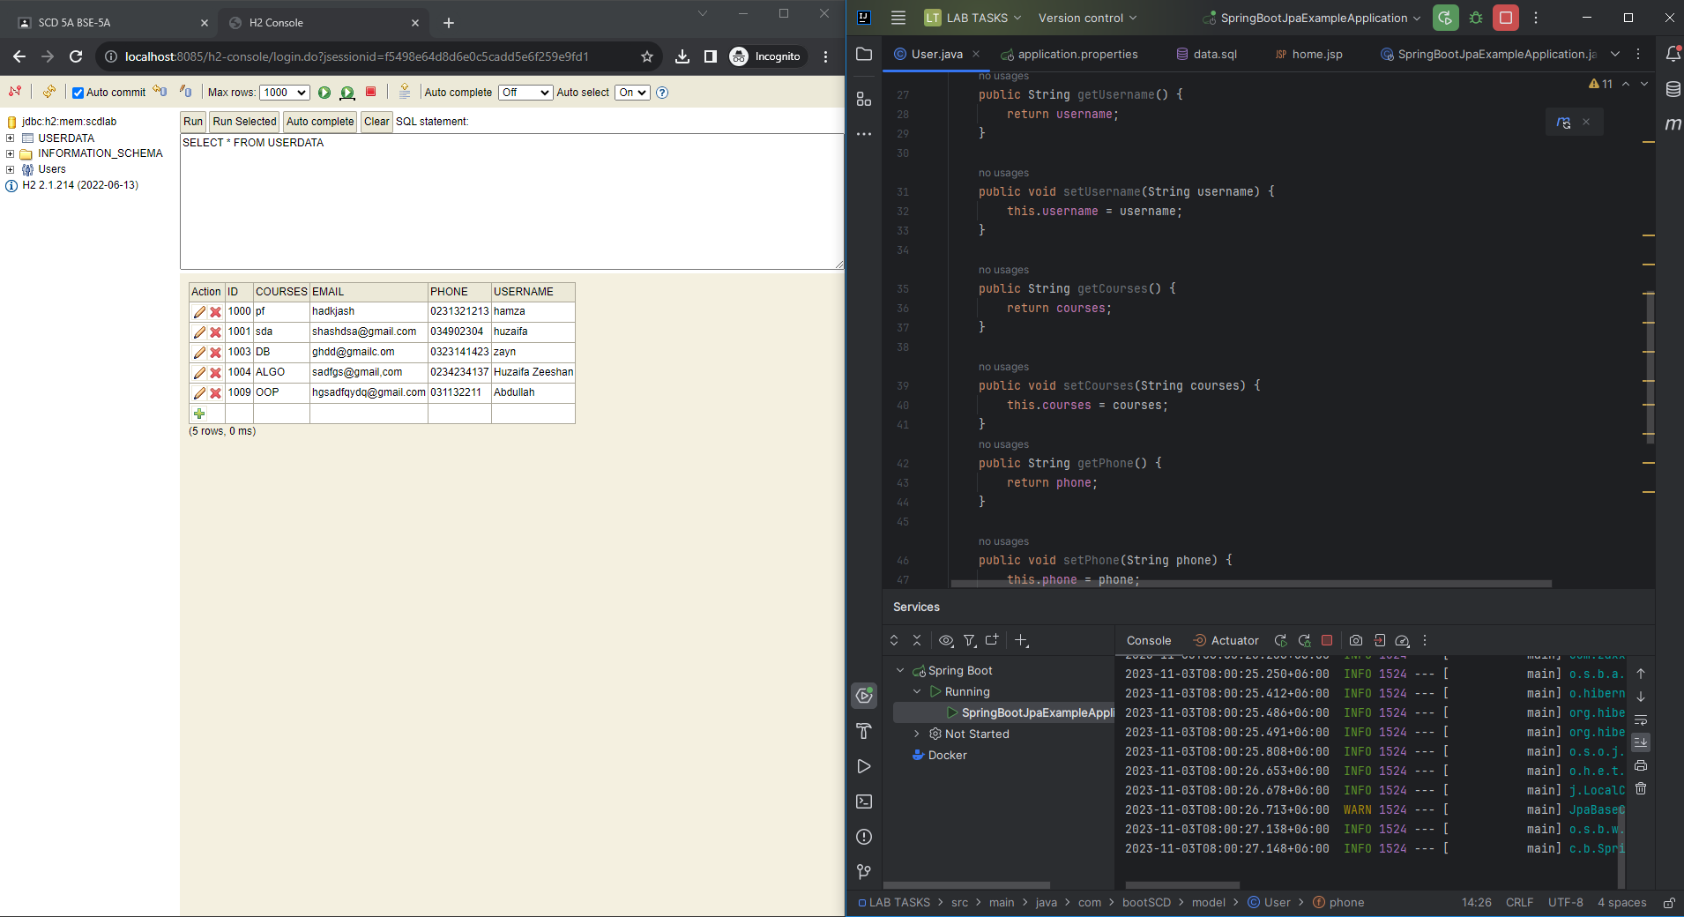

package com.bootSCD.model;  
  
import jakarta.persistence.Entity;  
import jakarta.persistence.Id;  
import jakarta.persistence.Table;  
  
@Entity  
@Table(name="userdata")  
public class User {  
 @Id  
 private int id;  
 private String username;  
 private String courses;  
 private String phone;  
 private String email;  
  
  
  
 public int getId() {  
 return id;  
 }  
  
 public void setId(int id) {  
 this.id = id;  
 }  
  
 public String getUsername() {  
 return username;  
 }  
  
 public void setUsername(String username) {

this.username = username;  
 }  
  
 public String getCourses() {  
 return courses;  
 }  
  
 public void setCourses(String courses) {  
 this.courses = courses;  
 }  
 public String getPhone() {  
 return phone;  
 }  
  
 public void setPhone(String phone) {  
 this.phone = phone;  
 }  
  
 public String getEmail() {  
 return email;  
 }  
  
 public void setEmail(String email) {  
 this.email = email;  
 }  
  
  
 @Override  
 public String toString(){  
 return "User [id=" +id+ ",uname="+ username+",courses="+courses+",phone="+phone+",email="+email+"]";  
 }  
}

CREATE TABLE userdata  
(  
 ID INT PRIMARY KEY,  
 NAME VARCHAR(255),  
 Courses VARCHAR(255),  
 phone varchar(255),  
 email varchar(255)  
  
);