**STUDYDOORWAY.COM**



**Developed by**

**Amir Sohail 3283-FBAS/BSSE/F16**

**Hamza Qazi 3224-FBAS/BSSE/F16**

Supervisedb𝘺

**Dr. Imran Khan**





**FINAL APPROVAL**

**Date:** __________

It is affirmed that we have examined the Project report title "Studydoorway.com" presented by Hamza Qazi 3224-FBAS/BSSE/F16 and Amir Sohail 3283-FBAS/BSSE/F16 under the management of our respected Teacher Dr. Imran Khan from DCS&SE, FBAS, IIUI. It is our thought that this errand is of enough principles to finish the satisfaction of DCS and SE, International Islamic University Islamabad for the long term confirmation of Software Engineering.

**Dedication**

We give this humble exertion to our cherished guardians and respectable instructors for their unending bolster, warmth, believe, supplications and support. With completion of our last year venture after committing this achievement and exertion to our dazzling guardians who have always backed and given all the conceivable offices that we might total our considers and the extend.

**Declaration**

We as a results of this document mention the advancement of this undertaking and its report is completely rely upon our own diligent effort and learning achieved under the outright help and guidance of the assigned supervisor Dr. Imran Khan. Not a solitary piece of this work showed up in this ancient rarity has been proposed for some other degree or some other college or college or some other instructive establishment. We further declare that this task, all code, and related antiques and reports are submitted as partial requirements for the level of Bachelors in Software Engineering.

**Hamza Qazi**

3224-FBAS/BSSE/F16

**Amir Sohail**

3283-FBAS/BSSE/F16

**Acknowledgement**

All praise to **Allah Almighty** for his countless blessings and for helping us and giving us courage in completing this project and also blessings upon our last Prophet Muhammad (PBUH).

We need to pay our honest and real appreciation to Dr. Imran Khan for his significant and persistent back and inspiration in our venture. We are appreciative of his brilliant supervision all through the completion of the project.

**Hamza Qazi**

3224-FBAS/BSSE/F16

**Amir Sohail**

3283-FBAS/BSSE/F16

Contents

**Chapter 1: Introduction** 13

1.1 Purpose 14

1.2 Scope 14

1.3 Overview 14

1.4 Problem Statement 14

1.5 Proposed Solution 15

1.6 Major Functionality and Modules 15

1.6.1 Login 15

1.6.2 Create Classroom 15

1.6.3 Different Interfaces 15

1.6.4 Student Interface 16

1.6.5 Make Announcement and Upload Study materials 16

1.6.7 Create Quiz 16

1.6.8 Create and Submit Assignment 16

1.6.9 Chat room 16

1.6.10 Internet Form 17

1.6.11 Check Plagiarism 17

1.6.12 Comment system 17

1.7 Constraints 17

1.8 Quality of System 17

1.9 Precedence and Priority 18

1.10 Requirements 18

1.10.1 Accessibility 18

1.10.2 System Requirements 18

1.10.3 Performance Requirements 18

1.10.4 Environmental Requirements 19

1.10.5 Conclusion 19

**Chapter 2: System Analysis** 21

2 Use Case Diagram 21

2.1 Use Case Description in Detail Format 22

2.1.1 Login 22

2.1.2 Create Classroom 23

2.1.3 Join Class Room 24

2.1.4 Submit Class Work 25

2.1.5 Assign Class Work 26

2.1.6 Create Assignment 27

2.1.7 Create Quiz 28

2.1.8 Submit Class Work 29

2.1.9 Submit Assignment 30

2.1.10 Submit Quiz 31

2.1.11 Join Chat Room 32

2.1.12 Ask a question 33

2.1.13 Check Plagiarism 34

2.1.14 Assign Marks 35

2.1.15 Check Result 36

2.1.16 Review Course 37

2.1.17 Review Teacher 38

2.2 Sequence Diagrams 39

2.2.1Login 39

2.2.2 Create Class Room 40

2.2.3 Join Class Room 41

2.2.4 Create Quiz 42

2.2.5 Create Assignment 43

2.2.6 Submit Assignment 44

2.2.7 Submit Quiz 45

2.2.8 Join Chat room 46

2.2.9 Ask Question 47

2.2.10 Check Plagiarism 48

2.2.11 Assign Marks 49

2.2.12 Check Result 50

2.2.13 Review Course 51

2.2.14 Review Teacher 52

Chapter 3: System Sequence Design 54

3.1 Teacher 54

3.2 Student 55

3.3 Class Diagram 56

3.4 Entity Relationship Diagram 57

Chapter 4: Implementation 59

4.1 Features of Model 59

4.2 Deployment Diagram 60

Chapter 5: TESTING 62

5.1 Software Testing 62

5.2 Unit Testing 62

5.3 System Testing 62

5.4 Black Box Testing 62

5.5 Advantages 63

5.6 Disadvantages 63

5.7 White Box Testing 63

5.8 Acceptance Testing 63

5.9 Verification 63

5.10 Validation 64

5.11 Test Cases 64

5.11.1 Test Case 01: Registration 64

5.11.2 Test Case 02: Login 65

5.11.3 Test Case 03: Create Classroom 66

5.11.4 Test Case 04: Join Classroom 67

5.11.5 Test Case 5: Assign Marks 68

5.11.6 Test Case 6: Check Result 69

5.11.7 Test Case 07: Assign Class Work 70

5.11.8 Test Case 08: Submit Class Work 71

5.11.9 Test Case 09: Join Chat room 72

5.11.10 Test Case 10: Ask a Question 73

5.11.11 Test Case 11: Review Course 74

5.11.12 Test Case 12: Review Teacher 75

5.11.13 Test Case 13: Create Assignment 76

5.11.14 Test Case 14: Create Assignment 77

5.11.15 Test Case 15: Submit Assignment 78

5.11.16 Test Case 16: Submit Quiz 79

5.12 Results 80

Chapter 6: Conclusion 82

Appendix-A User Manual 84

A.1 Registration 84

A.2 Login 84

A.3 Landing Page 85

A.4 User Profile 86

A.5 Classes Management 87

A.5.1 Create Class 88

A.5.2 Join Class 89

A.6 Manage Created Classes (Teacher) 90

A.6.1 Stream 90

A.6.2 Class Work 92

A.6.3 People 95

A.6.4 Grades 96

A.7 Manage Joined Classes (Student) 97

A.7.1 Class Work 98

A.7.2 People 100

A.8 Internet Form 101

A.8.1 Ask Question 102

A.8.2 Tags 102

A.8.3 Dashboard 103

A.9 Logout 103

Appendix-B References 106

**CHAPTER 1**

**INTRODUCTION**

# **Chapter 1: Introduction**

Studydoorway.com is online Portal for University Students and Teachers where Teachers can create a Class just like Google Class Room and can give it’s access to the Students.it is a web application which connect teachers and student .This web portal is a basic need for teachers and students specially in covid-19.It connect students to class and their syllabus in various ways ,connect students through Internet Form to ask a Question ,comment on a certain syllabus part ,review on a course materials ,chat room is available in every class room student on connect to each other and discus a topic with each other.

This portal is globally accessible and this is a central space for all tasks it has twenty four hours accessibility User friendly, secure and Personalized Faster and better communications

The main idea behind the construction of this portal is to provide a better platform and single place for students where they can do all study related activities and without login to different website and applications, In other words to provide a single place for all kinds of work .Main advantage of proposed students is not only for students but can also facilitate teachers to provide study materials to students on time.

It contain all the stuff of security related measures and also control the access of the portal

When a teacher create a classroom .Every Classroom has unique key password and only student who has this id can enter a class room and participate in a classroom. This portal provide functionality for student for maintaining their schedule online.

The teacher will upload the lectures, assignments and quizzes to the class room and student will get their work on time and they will submit again on the portal on time.

There is individual login and registrations system for Students and Teachers.

It contain the functionality of uploading documents on administrator/teacher side and downloading of that on document on student side .it contain all the student information and if they wants to update it they con update it .

This portal cover all the activities to manage students results online .students can view their result and teacher can add delete and update it .this portal cover all the activity of receiving messages at student side and sending messages at administrator side .

## 1.1 Purpose

The purpose of this system is to provide facilities to students and teachers .While doing their own duties and work. People anywhere in the worlds access it and take advantage of this portal .This portal provide a better platform for teachers to upload their study related documents while students download their document and upload their work back to portal easily.

## 1.2 Scope

This scope of this portal is to update students from their class and connect all students via platform to continue their study and get their work on time and submit it .it has connect students through chats with each other and with their teachers through internet form, to comment on a teacher post and ask a question from him and get the response from their teacher.

## 1.3 Overview

Study doorway is a web based application and it has two user that is Admin/Teacher and Student .both users can register and sign in through website and continue on using this app. Teachers can only create a classroom with a secret key and while students can only join it .only those students can join the class room which has a key of that class .teacher can upload study related materials through this app like class materials ,assignments also make an announcement for a class and generate a quiz .while students can download their lectures, download their assignment and submit it through portal. Students can give feedback on lectures slides, announcement. Students can give review also give his review on teachers and give their review on a course. Student of each class room can connect with each other and exchange messages with each other.

## 1.4 Problem Statement

1. It is difficult for a student to find the lectures, Assignments and other course

Materials of all teachers they (students) currently enrolled with and their previous course materials such as (Lectures, Assignments, Quizzes, Midterms, Final term paper).

2. For new students especially in SE and CS department they don’t know how to improve his study in the courses.

3. It seems difficult for teachers to check the plagiarism in assignments manually.

4. And it is difficult for teachers to keep track of students’ overall progress (Quizzes marks, Assignments marks, Midterm and Final term marks) in a course.

## 1.5 Proposed Solution

Our system has answer of all the above problem discussed in the problem statements, the solution of problem is given in detail in functionality and Modules. Students will find all study materials in one place Students can see their performance in a specific course and overall progress .teachers can check plagiarism in assignments.

## 1.6 Major Functionality and Modules

### 1.6.1 Login

Admin/teacher and student have first register themselves on portal .the registration process is same for both teacher and student. After successful registration both teacher and student can sign in to portal. After login they can then perform their action separately.

### 1.6.2 Create Classroom

After successful login teacher can create a class room with a specific secret key like Google Classrooms. when a teacher create a class room by clicking on create classroom button and fill the form and then he will create a classroom for the subject which he is teaching and announce it’s key in a class to the student when he join it. Only teacher can create a class room and student can join it .when the teacher want to join it he will see a message that you are creator of this class room you cannot join it.

### 1.6.3 Different Interfaces

Our portal will show different interfaces to student and teacher. They will have total different interface and responsibilities. Students will see the list of whole classes he joined while teacher will see list of the classes he creates

### 1.6.4 Student Interface

When the student login successfully to a portal, he can perform several actions .he can see the list of all classes he joined .he can visit each class and within each class he can see the announcement written by teacher and he can download study materials. Download the assignments and submit it, solve the quiz when a teacher create it and deliver the quiz to teacher on the portal and chat with student of class.

### 1.6.5 Make Announcement and Upload Study materials

Teacher can make announcement for the whole class for example the message he want to announce for the whole like an announcement in Google Classroom. Teacher can also upload study related materials like file, books, etc.

### 1.6.7 Create Quiz

Teacher can create a quiz and assign a questions to the quiz. The quiz will be multiple choice question and while student can solve the quiz in a specific time and send it back to portal. Teacher will assign the right answer for a specific question. When the student submit their quiz .after the submission of quiz the can directly see their result.

### 1.6.8 Create and Submit Assignment

Teachers can upload assignment for the whole class while student can see and download their assignment. After the completion of assignment students will upload their assignment to the portal and teacher will check the assignment and will give grade to student in form of points. Teacher has the option that how many total points he want to keep for assignments, for small assignments the point will be low while for large assignments the points will be high.

### 1.6.9 Chat room

In our portal, inside the class room there is a chat room for student, where only student of that class can messages to each other and also to teacher, both teachers and student can participate in a class room chat and discuss a specific topic with each other.

### 1.6.10 Internet Form

All users can also interact with each other in portal through internet form and can ask a question student will post title, description for a question and basically it is small community system like Stake overflow where people can post a certain question and ask for help from another people. The style of internet form is same as stack overflow, where there is a separate portion for code and text, while other students and teacher who know the answer can a help him and post answer for the question which is asked.

### 1.6.11 Check Plagiarism

Our system is capable of find plagiarism among student assignment when he student submit it .teacher can find plagiarism among students assignments easily and there is no need to for teachers to do it manually.

### 1.6.12 Comment system

Students can make comment on teacher announcement and teacher can also give replay to him.

## 1.7 Constraints

* Students and teachers first should have to register themselves in order to sign in.
* Student will have to login to enter to a class room
* Teacher will have to login to enter to a class room
* Student cannot update the teacher announcement, assignment and quiz only teacher can update it
* Teacher will have the overall authority to create a class room, make announcement to class create a quiz and assignments.

## 1.8 Quality of System

We have focused on quality of system in overall development process.to ensure the quality of a system we have kept the following parameters in mind

* User Friendly Interface
* Reliability
* Robustness
* System security
* Correctness
* Efficiency
* Responsive
* Maintainability
* Integrity

## 1.9 Precedence and Priority

This system is for all users in every part of the world can access it and use it for their purpose

All the users of this portal that is web based application can perform their own activity according to their role after logging it into website.

## 1.10 Requirements

### 1.10.1 Accessibility

This portal is web based application it can be accessed globally in every part of the country, it can be operated by teachers and students together.

### 1.10.2 System Requirements

The system in this portal is operating must have advance browser like chrome, Mozilla etc.

### 1.10.3 Performance Requirements

This system is itself fast, secure and responsive, but the performance mainly depend on internet speed and the type of browser.

### 1.10.4 Environmental Requirements

This system can be accessed globally but the main target will be the Islamic republic of Pakistan so that they can use it and get benefit of it. This system is user friendly, fast, secure and will help them in saving their lot of time.

### 1.10.5 Conclusion

The condition of the world is changing day by day nowadays there is a lockdown approximately in every country our system can help students and teachers in normal condition and in disaster like Covid-19 in these days .After using this system it will save a lot of time of students and teachers while doing their own responsibilities and work .students and teachers will do their work on time hence it will reduce burden on both teachers and students

**CHAPTER 2**

**System Analysis**

# **Chapter 2: System Analysis**

## 2 Use Case Diagram

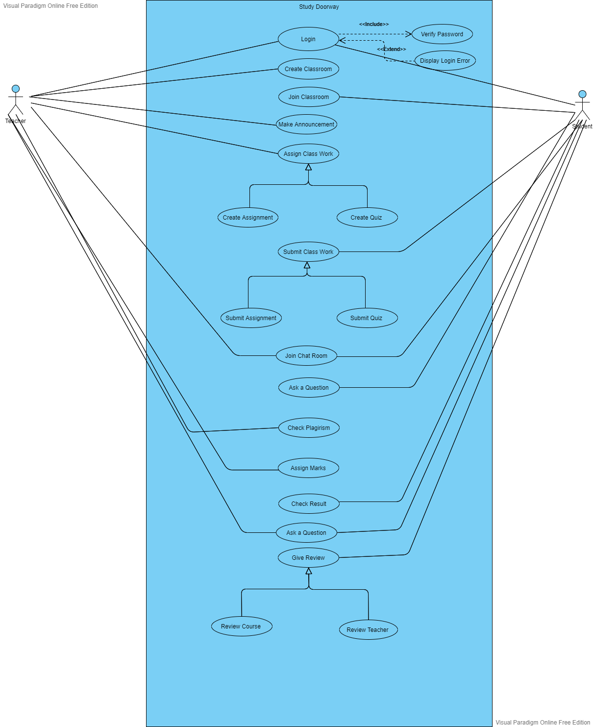

## 2.1 Use Case Description in Detail Format

Use Case-centric approach to requirements gathering.

### 2.1.1 Login

**Use case ID**: 01

**Use case Name**: Login

**Actor:** Teacher, Student

**Precondition:** The Teacher and Student must have register themselves on Portal

**Post Condition:**  System verifies the inputs validation and logged in the teacher and students. After login both users are redirected to their main dashboards with different Interfaces.

**Main Success Scenario:**

|  |  |
| --- | --- |
| **Actor’s Action** | **System Response** |
| 1: Teachers and student press the login button | System show them their login form |
| 2:Users fill the form | System verify their username and password |
| 3:Users submit the form by clicking submit button | System redirect them to main dashboard |

### 2.1.2 Create Classroom

**Use case ID**: 02

**Use case Name:** Create Classroom

**Actor:** Teacher

**Precondition:** The Teacher must have logged in to the system

**Post Condition:** Teacher create a class room online for their students along with secret key like Google class room. Only those students can join the class room who know the key

**Main Success Scenario:**

|  |  |
| --- | --- |
| **Actor’s Action** | **System Response** |
| 1: Teacher click on “create classroom” button | System display them a form |
| 2:Teacher fill the form | System verify the inputs validation |
| 3:Teacher submit the form | System redirect them to the classroom page. |

### 2.1.3 Join Class Room

**Use case ID**: 03

**Use case Name**: Join Class Room

**Actor:** Student

**Precondition:** Student must logged in to portal and must have class room secret key to join it.

**Post Condition:** After entering the key of class room provided by teacher the students will then join the class room.

**Main Success Scenario:**

|  |  |
| --- | --- |
| **Actor’s Action** | **System Response** |
| 1: After login the students will click the “Join Class Room” button in order to join it. | System verify the class room key and system show them their respective interface different from teacher side interface |

### 2.1.4 Submit Class Work

**Use case ID**: 04

**Use case Name**: Submit Class Work

**Actor:** Teacher

**Precondition:** Teacher must have created the classroom

**Post Condition:** Teacher will upload course materials files on Portal

**Main Success Scenario:**

|  |  |
| --- | --- |
| **Actor’s Action** | **System Response** |
| 1: Teacher will click on the “Make Announcement” button to create an announcement for the whole class room | System will show the form to make an announcement. |
| 2:Teacher write an announcement for student | System validate inputs |
| 3:Teacher will upload files such as audio, video etc. | System redirect the teacher again to the class room |

### 2.1.5 Assign Class Work

**Use case ID**: 05

**Use case Name**: Assign Class Work

**Actor:** Teacher

**Precondition:** The Teacher must have created class room and should be logged in.

**Post Condition:** Teacher will assign class work such as assignments and quiz

**Main Success Scenario:**

|  |  |
| --- | --- |
| **Actor’s Action** | **System Response** |
| 1: Teachers will click on the “Assign Class Work” button. | System will show the page for teacher to assign Class Work |
| 2:Teacher will upload assignment and quiz to class room | System verify the inputs information, redirect them to class room after submitting assignment or quiz |

### 2.1.6 Create Assignment

**Use case ID**: 06

**Use case Name**: Create Assignment

**Actor:** Teacher

**Precondition:**

* The Teacher and Student must have register themselves on Portal
* The Teacher must have created class room

**Post Condition:** Teacher will create assignment for the student of that class room along with start date and due date.

**Main Success Scenario:**

|  |  |
| --- | --- |
| **Actor’s Action** | **System Response** |
| 1: Teachers will click on “Create Assignment ” button | System will show the page for create assignment |
| 2:Teacher will enter assignment detail | System verify the detail. |
| 3: Teacher will provide the start and end date for assignment. | System will assign start and end date of assignment through calendar. |
| 4: Teacher click on “Submit” button to create assignment successfully. | System will create assignment and teacher is redirected to class room automatically. |

### 2.1.7 Create Quiz

**Use case ID**: 07

**Use case Name**: Create Quiz

**Actor:** Teacher

**Precondition:**

* The Teacher and Student must have register themselves on Portal
* The Teacher must have created class room

**Post Condition:** Teacher will create quiz for the student of that class room along with start date and due date.

**Main Success Scenario:**

|  |  |
| --- | --- |
| **Actor’s Action** | **System Response** |
| 1: Teachers will click on “Create Quiz” button. | System will show the page for create quiz. |
| 2: Teacher will enter questions of multiple choice quiz. | System will display the quiz. |
| 3: Teacher will provide multiple choices for a question and right answer. | System will save the question and their right answers against every question. |
| 4: Teacher will provide start time and end time for quiz. | System will start the quiz when student start will join it and it will end the quiz when the time is over. |
| 5: Teacher click on “Upload Quiz ” button to create a quiz | System will create a quiz and teacher is redirected to classroom. |

### 2.1.8 Submit Class Work

**Use case ID**: 08

**Use case Name**: Submit Class Work

**Actor:** Student

**Precondition:**

* The student must have login to the Portal
* The student must have Join class room

**Post Condition:** The student will submit their class work such as quiz and assignment.

**Main Success Scenario:**

|  |  |
| --- | --- |
| **Actor’s Action** | **System Response** |
| 1: Student will click “submit assignment” to submit assignment on portal. | System will redirect to the page for submitting assignment. |
| 2: Student will “upload quiz” button to upload quiz to the portal after finishing. | System will redirect him to a page to upload a quiz and is redirected back to class room again. |

### 2.1.9 Submit Assignment

**Use case ID**: 09

**Use case Name**: Submit Assignment

**Actor:** Student

**Precondition:**

* The Student must have register themselves on Portal
* The student must have join class room

**Post Condition:** Student will upload assignment on time successfully.

**Main Success Scenario:**

|  |  |
| --- | --- |
| **Actor’s Action** | **System Response** |
| 1: Student will click “upload assignment” button to upload assignment. | System will show the page for submitting assignment. |
| 2: Student will upload files to the portal. | System will validate the files. |
| 3: Student will click on “ submit ” button finally to submit assignment | System will save the student assignment successfully. |

### 2.1.10 Submit Quiz

**Use case ID**: 10

**Use case Name**: Submit Quiz

**Actor:** Student

**Precondition:**

* The Student must have register themselves on Portal
* The student must have join class room

**Post Condition:** Student will do quiz successfully.

**Main Success Scenario:**

|  |  |
| --- | --- |
| **Actor’s Action** | **System Response** |
| 1: Student will click on “start quiz” button. | System will show the quiz uploaded by teacher. |
| 2: Student will select the right answer for the question. | System will save the user answer and compare it with a right answer uploaded by teacher. |
| 3: Student will click on “submit quiz” button finally after the quiz is finished. | System will show the answers of all questions and student’s attempted answer and finally their score in the quiz. |

### 2.1.11 Join Chat Room

**Use case ID**: 11

**Use case Name**: Join Chat Room

**Actor:** Student, Teacher

**Precondition:**

* The students and teacher must have register themselves on Portal
* The student must have join class room
* The teacher must have created classroom

**Post Condition:** Students and Teacher will chat with each other successfully.

**Main Success Scenario:**

|  |  |
| --- | --- |
| **Actor’s Action** | **System Response** |
| 1: Users will click on “Join Chat Room” button. | System will open chat room. |
| 2: Users will type their message and click on “Send” button to send their message to the classroom. | System will pick the detail of users and save it to data base. |
| 3: Users will click on “Send” button to send their message to the classroom. | System will display all messages to all users. |

### 2.1.12 Ask a question

**Use case ID**: 12

**Use case Name**: Ask A Question

**Actor:** Student

**Precondition:**

* The students must have register themselves on Portal
* The student must have join class room

**Post Condition:** Students will post their questions like stack overflow for all users to help him in problem solving.

**Main Success Scenario:**

|  |  |
| --- | --- |
| **Actor’s Action** | **System Response** |
| 1: Students will click on “Ask A Question” button to ask a question. | System will display the page for asking a question |
| 2: Students will type their question and send it to the portal. | System will save the question in a database and display it for all students and teacher. |
| 3: Users who know the answer will click on “Answer” button to replay him. | System will save the answer in a database and display it for all students and teacher |

### 2.1.13 Check Plagiarism

**Use case ID**: 13

**Use case Name**: Check Plagiarism

**Actor:** Teacher

**Precondition:**

* The Teacher must have register themselves on Portal.
* The Teacher must have created class room successfully.

**Post Condition:** Teachers will check plagiarism in student’s assignment successfully.

**Main Success Scenario:**

|  |  |
| --- | --- |
| **Actor’s Action** | **System Response** |
| 1: Students will click on assignment submitted by the student. | System will compare student assignment and check Plagiarism in it. |
| 2: Teachers will click on “Check plagiarism” button to check plagiarism in it. | System will display the plagiarism in the document if found. |

### 2.1.14 Assign Marks

**Use case ID**: 14

**Use case Name**: Assign Marks

**Actor:** Teacher

**Precondition:**

* The teacher must have register themselves on Portal
* The teacher must have created class room

**Post Condition:** Teacher will assign marks to student in assignment and exams.

**Main Success Scenario:**

|  |  |
| --- | --- |
| **Actor’s Action** | **System Response** |
| 1: Teacher will check student question and click on “Assign Marks” button to assign marks to student. | System will display the student work for teacher. |
| 2: Teacher will assign marks to the student. | System will save marks of student and display it to student |

### 2.1.15 Check Result

**Use case ID**: 15

**Use case Name**: Check Result

**Actor:** Student

**Precondition:**

* The student must have register themselves on Portal
* The student must have join class room

**Post Condition:** Student will check their result

**Main Success Scenario:**

|  |  |
| --- | --- |
| **Actor’s Action** | **System Response** |
| 1: student will click on “check result” button. | System will calculate their result and display it to the user |

### 2.1.16 Review Course

**Use case ID**: 16

**Use case Name**: Review Course

**Actor:** Student

**Precondition:**

* The student must have register themselves on Portal
* The student must have join class room

**Post Condition:** Student will give review about review course

**Main Success Scenario:**

|  |  |
| --- | --- |
| **Actor’s Action** | **System Response** |
| 1: Student will click on “Review Course” button to give review about course. | System will save the rating given by student in data base. |
| 2: Student will give review about course and submit it | System will display rating given by student to all users. |

### 2.1.17 Review Teacher

**Use case ID**: 17

**Use case Name**: Review Teacher

**Actor:** Student

**Precondition:**

* The student must have register themselves on Portal
* The student must have join class room

**Post Condition:** Student will give review about review course

**Main Success Scenario:**

|  |  |
| --- | --- |
| **Actor’s Action** | **System Response** |
| 1: Student will click on “Review Teacher” button to give review about teacher. | System will save the rating given by student about teacher in data base. |
| 2: Student will give review about teacher and submit it | System will display rating given by student to teacher. |

## 2.2 Sequence Diagrams

### 2.2.1Login

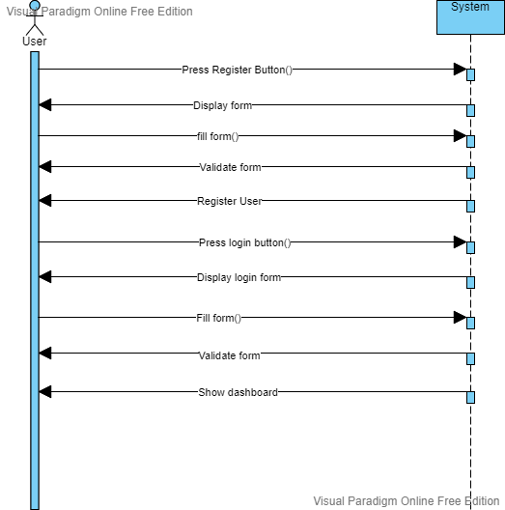

### 2.2.2 Create Class Room

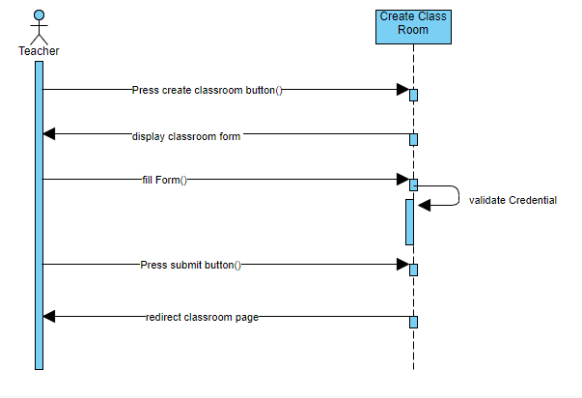

### 2.2.3 Join Class Room

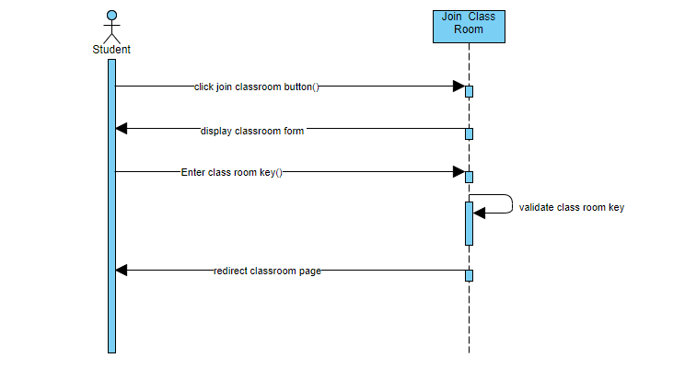

### 2.2.4 Create Quiz

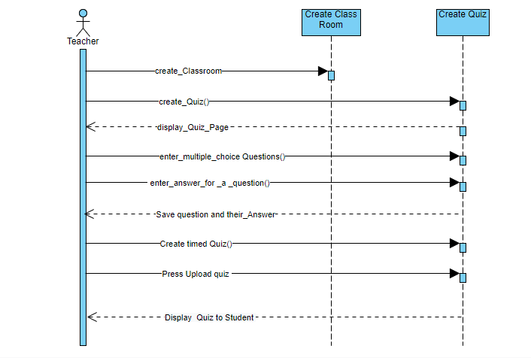

### 2.2.5 Create Assignment

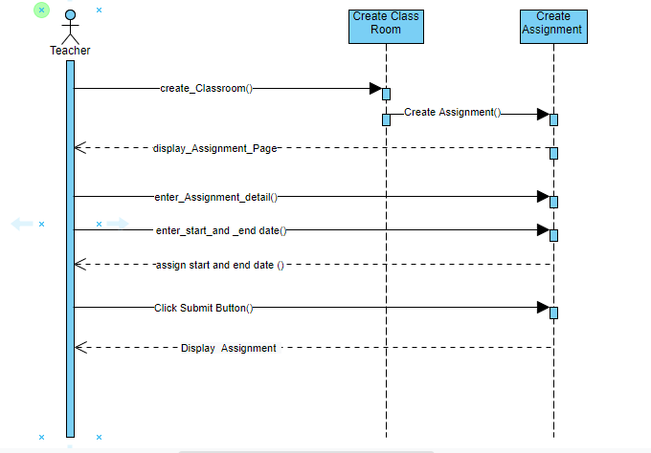

### 2.2.6 Submit Assignment

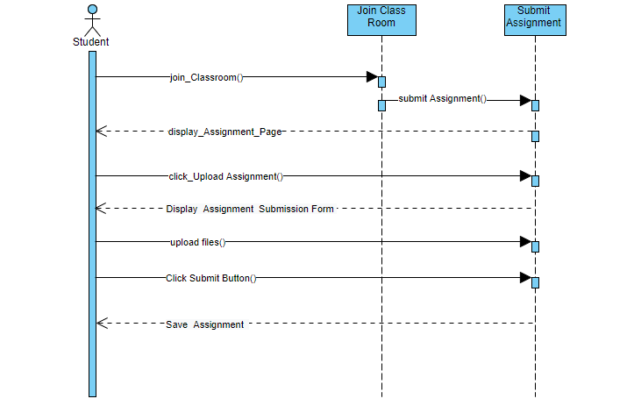

### 2.2.7 Submit Quiz

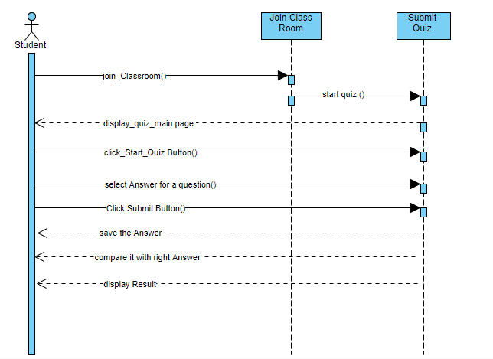

### 2.2.8 Join Chat room

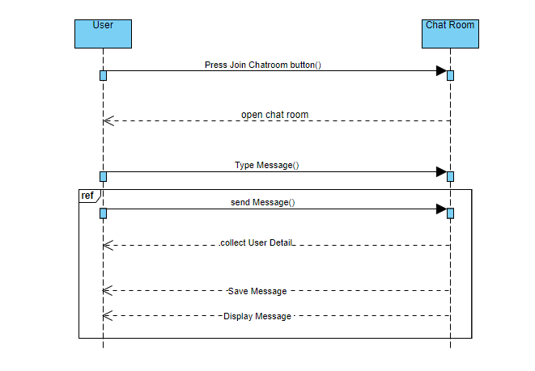

### 2.2.9 Ask Question

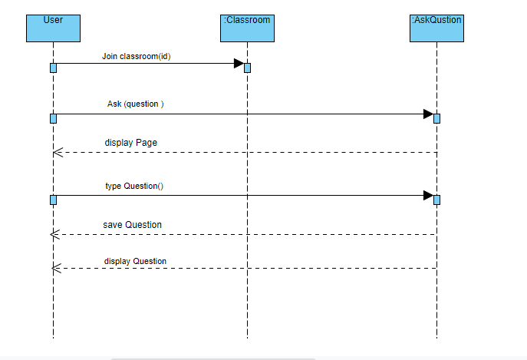

### 2.2.10 Check Plagiarism

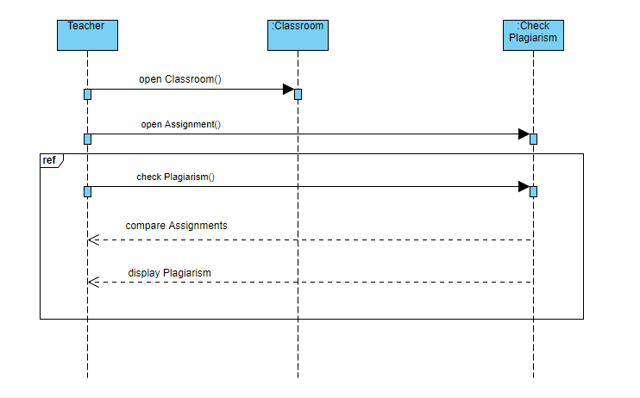

### 2.2.11 Assign Marks

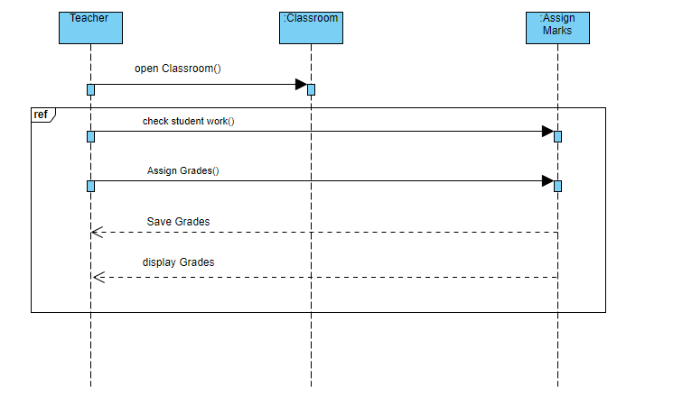

### 2.2.12 Check Result

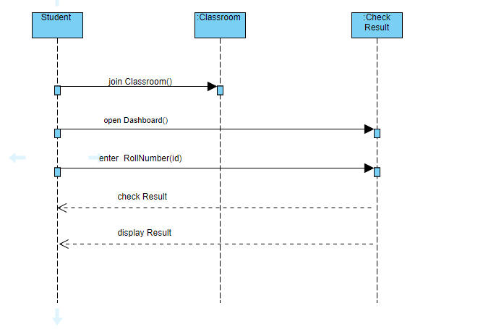

### 2.2.13 Review Course

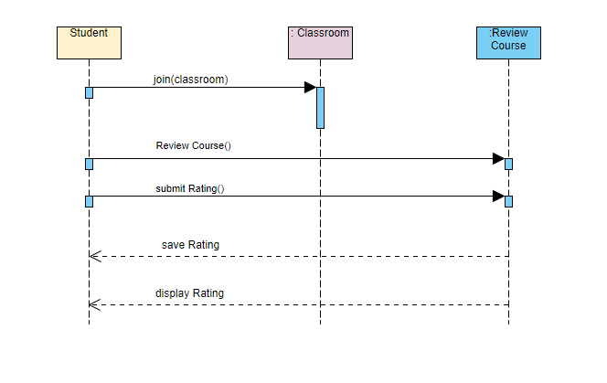

### 2.2.14 Review Teacher

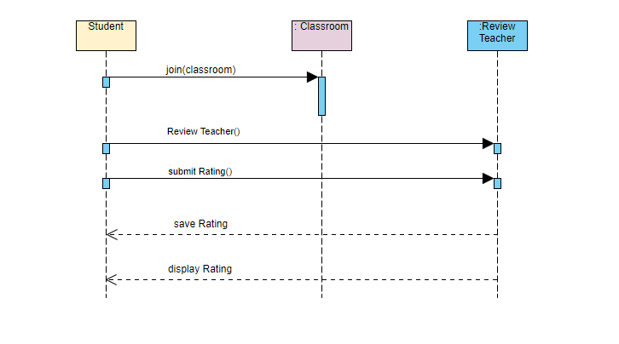

**CHAPTER 3**

**System Design**

# Chapter 3: System Sequence Design

## 3.1 Teacher

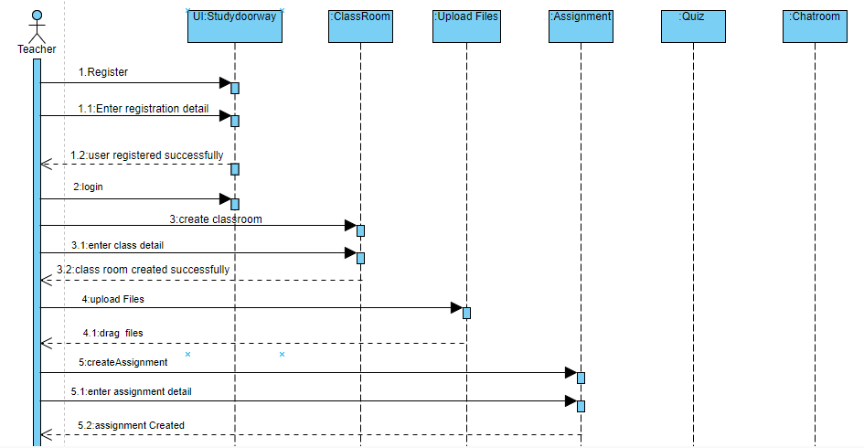

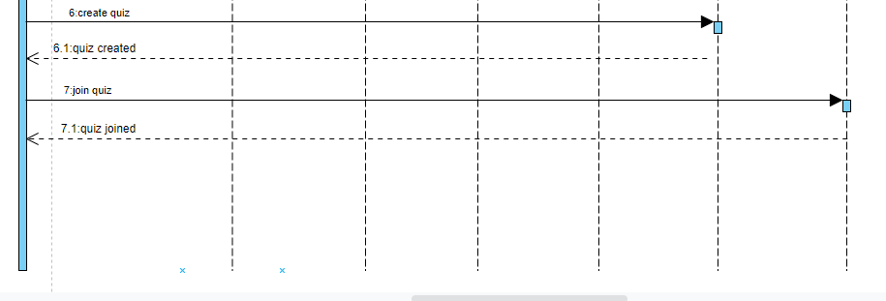

## 3.2 Student

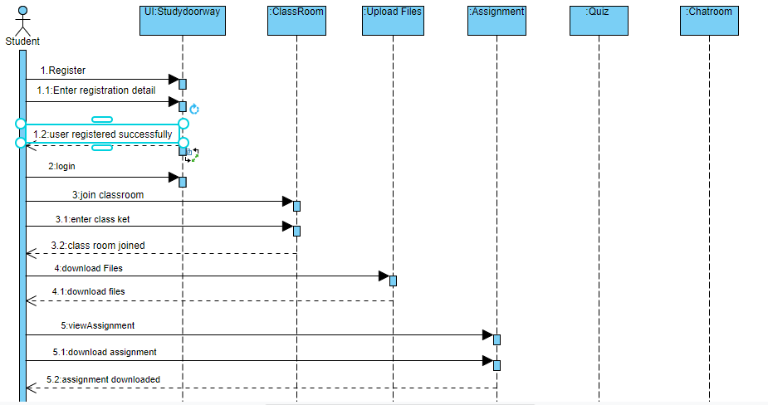

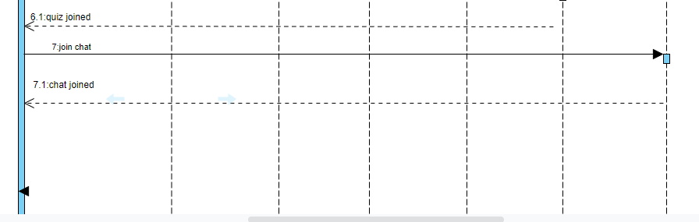

## 3.3 Class Diagram

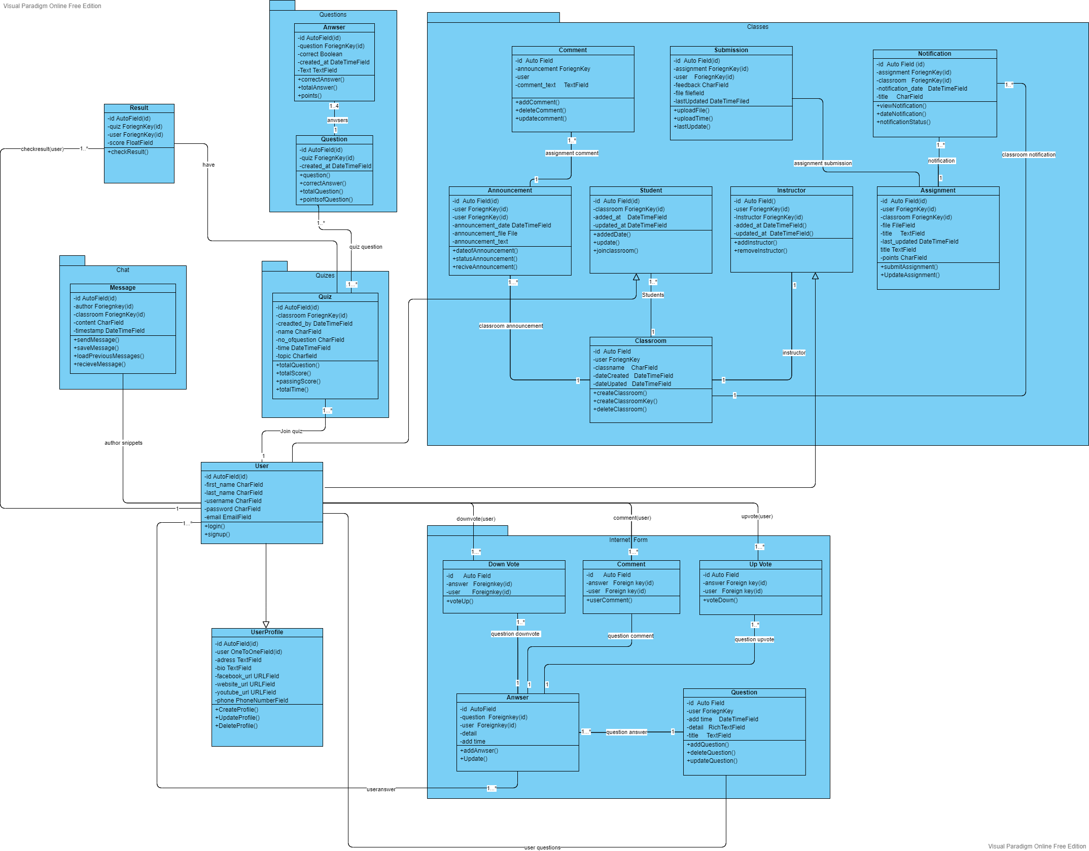

## 3.4 Entity Relationship Diagram

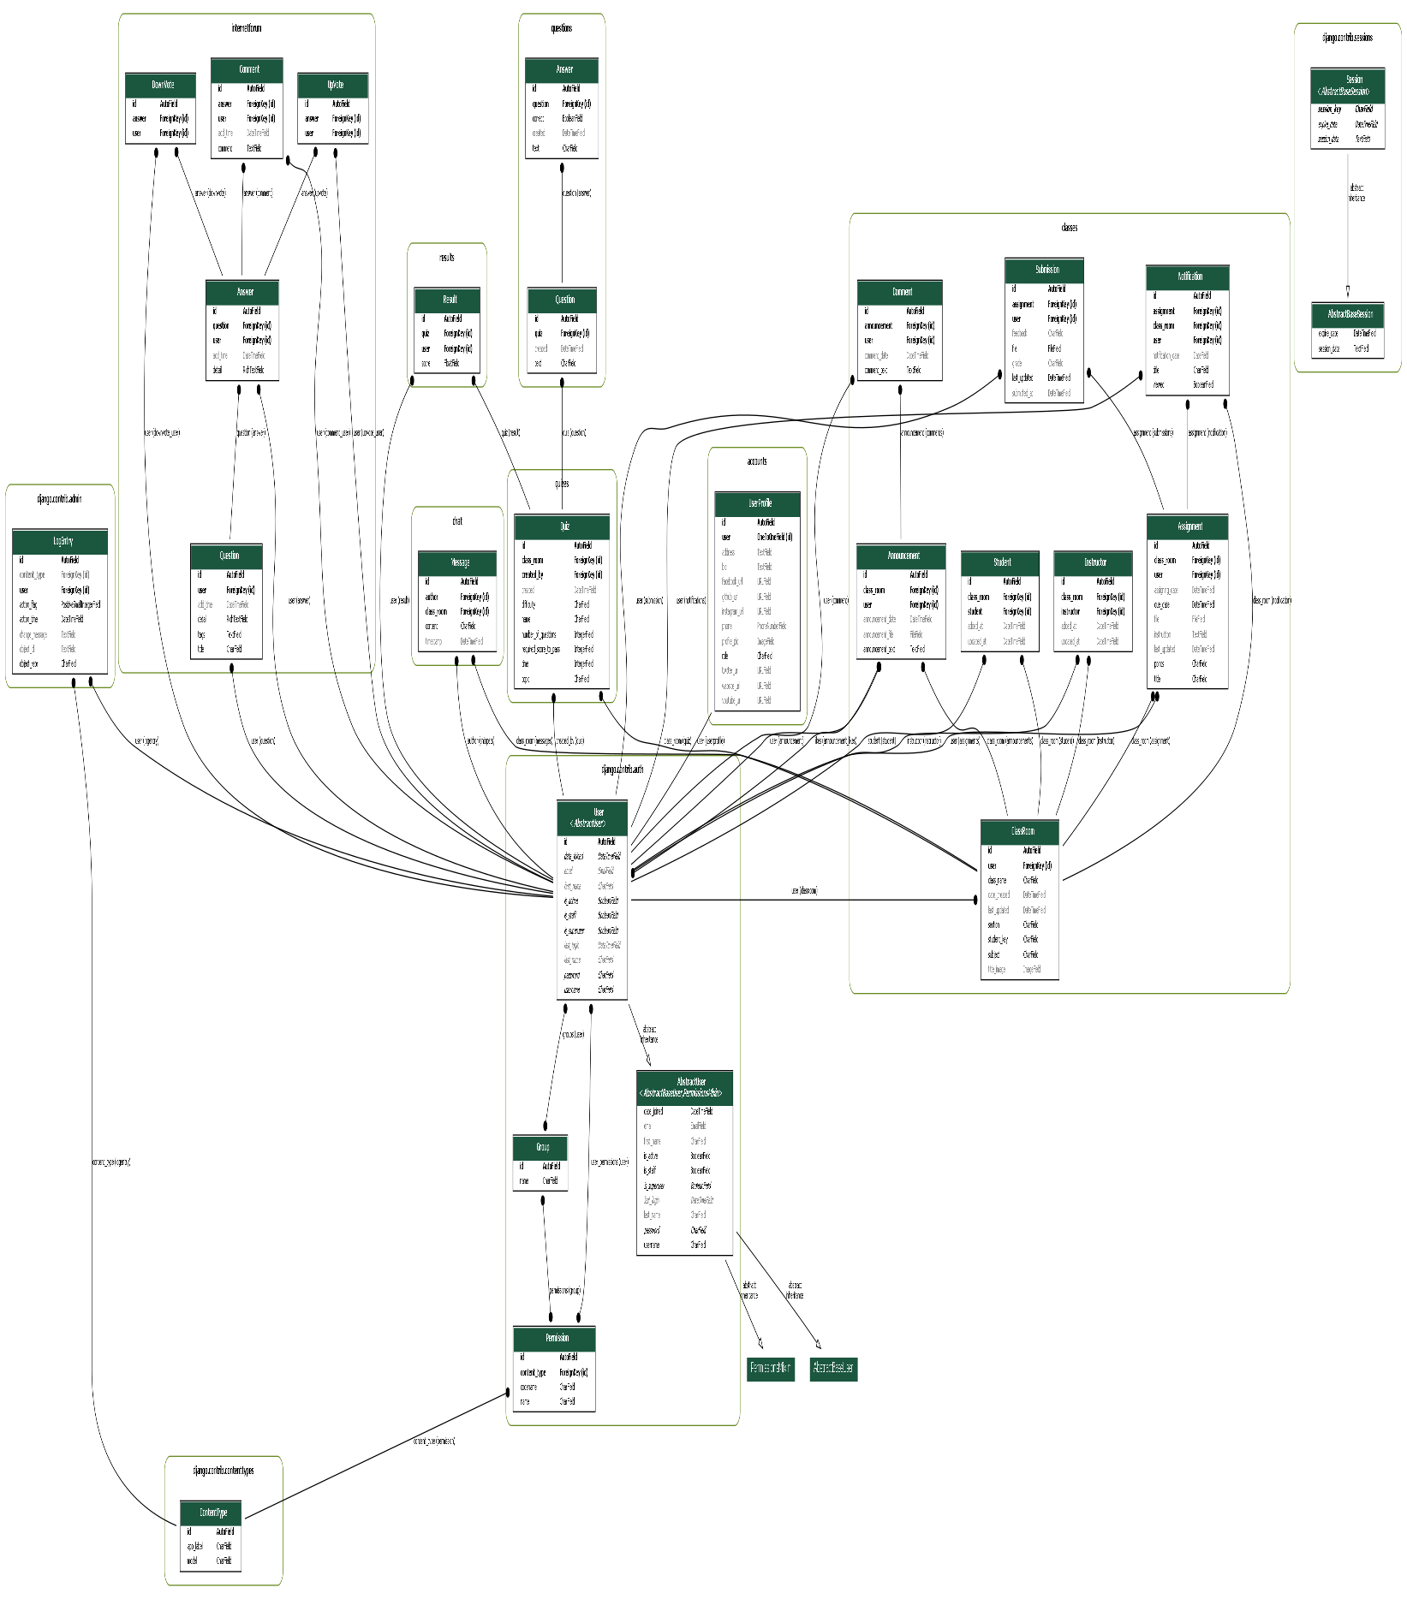

**CHAPTER 4**

**Implementation**

# Chapter 4: Implementation

Implementation is the part of the process where software engineers actually program the code for the project. We can anticipate fruitful effects from any concept if it'smiles conveyed properly, in anyother case it's miles useless .It could be very critical to deliver an concept and to putin force it .This chapter explain us about the interface, implementation and different simple concepts which might be kept in mind while designing this application

## 4.1 Features of Model

Our system consists of following features

1. User Friendly
2. Secure
3. Easy to use
4. Reliable
5. Responsive

## 4.2 Deployment Diagram

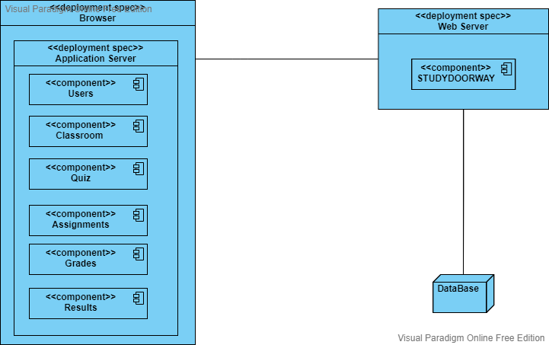

**CHAPTER 5**

**TESTING**

# Chapter 5: TESTING

## 5.1 Software Testing

Software testing is the process of testing the software or its components to check whether the actual software product matches the expected requirements and to ensure that it is defect free

Software testing is important because if there is bugs or errors in a software it can be identified by software testing team and can be solved before the delivery of software product to the client. Properly testing the software product confirms security, reliability and high performance which further advantages is save time, cost effectiveness and customer satisfaction. Testing is important because software bugs could be expensive or even dangerous. Software bugs can potentially cause monetary and human loss.

## 5.2 Unit Testing

This type of software testing approach is done by the developer to test the unit of the program or software. It helps developers to know whether the individual unit of the code is working properly or not.

Integration testing: This type of testing focus on the construction and design of the software. The components of software are combined and then it is check to see whether they are working without errors or not.

## 5.3 System Testing

In this method, the software is compiled as a whole and then it is tested as a whole. This testing strategy checks the functionality, security, portability, amongst other.

## 5.4 Black Box Testing

It is also known as functional testing .it treats the software as black box .it involves testing the software externally without any prior knowledge of internal implementation or without seeing the source code of a program.

In this type of testing the testing only checks the outputs of a system according to the inputs given to the system. The tester interact the interface of a system and he/she will not be allowed to the review the source code of the program.

## 5.5 Advantages

1. Anyone with a less knowledge of application can test it.
2. Knowledge of programming language is not necessary
3. Used in a large system testing

## 5.6 Disadvantages

1. Most part of software will be remain untested.
2. It is hard to design the test cases for a software.
3. It is not complete testing.

## 5.7 White Box Testing

White box testing is a type of testing in which the tester tests the software internally. It is also known glass box testing. In white box testing the tester needs to know a lot of knowledge about the application such as the programmed language its function and so many more thing to test the application. White box testing is different from black box testing, in white box testing the tester will be allowed to check the source code of the application and to review it. The tester the will test every test case, module and sub-system, basically he/she will test whole code line by line. White box testing is very efficient for the application and difficult for the tester.

## 5.8 Acceptance Testing

Acceptance testing is the final stage of testing in which the tester test the application for the last time. In this type of testing the system will be tested for the end user or customer requirements, which will help the tester to know the inputs errors in real time environments. After passing the acceptance testing the application will be delivered to its end user or customer.

## 5.9 Verification

Verification is the process of checking whether the software achieve its goal without any bug .In this process we identify that product developed is right or not. It ensure that the product developed meets the early requirements or not.

The verification process have following steps

Inspection

Walkthrough

Buddy checks

Reviews

## 5.10 Validation

Validation is the process of checking the validation of product i.e. it checks what we are developing is the right product. It is validation of actual and expected product. its simply mean are we building the right product.

## 5.11 Test Cases

Test cases are used to test the test whether the all modules of a system work properly or not. If all modules are working properly then it cover successfully all test cases otherwise there is bugs or errors in software.

### 5.11.1 Test Case 01: Registration

|  |  |
| --- | --- |
| **Test Case ID** | 01 |
| **Module** | Register |
| **Purpose** | To Register the user. Student and Teacher. |
| **Test Steps** | 1. The User will click on “Register Now” button. 2. User will click sign up button 3. Enter their valid details 4. User will registered successfully |
| **Prerequisite** | The user have internet access. |
| **Test Case Performed by** | Amir Sohail, Hamza Qazi. |
| **Expected Results** | The user should be registered successfully |
| **Actual Results** | Users were registered successfully |
| **Pass/Fail** | Pass |

### 5.11.2 Test Case 02: Login

|  |  |
| --- | --- |
| **Test Case ID** | 02 |
| **Module** | Login |
| **Purpose** | To Login the user. Student and Teacher. |
| **Test Steps** | 1. The User will click on “Login” button. 2. Enter their name and email 3. User will Logged in successfully |
| **Prerequisite** | 1. The user have internet access. 2. The user must be register to application |
| **Test Case Performed by** | Amir Sohail, Hamza Qazi. |
| **Expected Results** | The user should be login successfully |
| **Actual Results** | Users were logged in successfully |
| **Pass/Fail** | Pass |

### 5.11.3 Test Case 03: Create Classroom

|  |  |
| --- | --- |
| **Test Case ID** | 03 |
| **Module** | Create Classroom |
| **Purpose** | To create classroom for the students to join it. |
| **Test Steps** | 1. The Teacher will click on “Create Classroom” button.   2. Teacher will enter valid detail about classroom.  3. Classroom will be created successfully. |
| **Prerequisite** | 1. Must have internet access. 2. The teacher must be registered to application. |
| **Test Case Performed by** | Amir Sohail, Hamza Qazi. |
| **Expected Results** | The user should be login successfully |
| **Actual Results** | Users were logged in successfully |
| **Pass/Fail** | Pass |

### 5.11.4 Test Case 04: Join Classroom

|  |  |
| --- | --- |
| **Test Case ID** | 04 |
| **Module** | Join Classroom |
| **Purpose** | To join classroom |
| **Test Steps** | 1. The student will click on “Join Classroom” button.   1. Students will enter the secret key given by teacher during the creation of class room   3. Classroom will join class room successfully. |
| **Prerequisite** | 1. Must have internet access.  2. The student must be login to application. |
| **Test Case Performed by** | Amir Sohail, Hamza Qazi. |
| **Expected Results** | The user should be able to join class room successfully |
| **Actual Results** | Students joins class room successfully |
| **Pass/Fail** | Pass |

### 5.11.5 Test Case 5: Assign Marks

|  |  |
| --- | --- |
| **Test Case ID** | 5 |
| **Module** | Assign Marks |
| **Purpose** | To assign marks to the students |
| **Test Steps** | 1. The Teacher will click on “Assign Marks” button.   2. Teacher will assign marks to the student in assignment, quiz, class work.  3. Teacher will click on “Assign Grades” to assign marks.  4. Marks will be successfully assigned to the students. |
| **Prerequisite** | 1. Must have internet access.   1. The teacher must be log in to application. 2. The teacher must have created class room. |
| **Test Case Performed by** | Amir Sohail, Hamza Qazi. |
| **Expected Results** | Marks will be successfully assigned to the students. |
| **Actual Results** | Marks was successfully assigned to the students. |
| **Pass/Fail** | Pass |

### 5.11.6 Test Case 6: Check Result

|  |  |
| --- | --- |
| **Test Case ID** | 6 |
| **Module** | Check Result |
| **Purpose** | Students can check their result |
| **Test Steps** | 1. The student will click on “Check Result” button.   2. Student will see their result.  3. Finished |
| **Prerequisite** | 1. Must have internet access.   1. The student must be log in to application. 2. The student must have joined class room. |
| **Test Case Performed by** | Amir Sohail, Hamza Qazi. |
| **Expected Results** | Students will successfully see their result. |
| **Actual Results** | Students has successfully see their result. |
| **Pass/Fail** | Pass |

### 5.11.7 Test Case 07: Assign Class Work

|  |  |
| --- | --- |
| **Test Case ID** | 07 |
| **Module** | Assign Class Work |
| **Purpose** | To assign class work for the students |
| **Test Steps** | 1. The Teacher will click on “Assign Class Work” button.   2. Teacher will enter the detail of class work, assignment, Quiz, upload files.  3. Classwork will be assigned successfully for the students. |
| **Prerequisite** | 1. Must have internet access. 2. The teacher must be log in to application. 3. The teacher must have created class room. |
| **Test Case Performed by** | Amir Sohail, Hamza Qazi. |
| **Expected Results** | The teacher will assign class work for students successfully. |
| **Actual Results** | Teacher has successfully assigned class work |
| **Pass/Fail** | Pass |

### 5.11.8 Test Case 08: Submit Class Work

|  |  |
| --- | --- |
| **Test Case ID** | 08 |
| **Module** | Submit Class Work |
| **Purpose** | To submit class work. |
| **Test Steps** | 1. The Student will click on “Submit Class Work” button.   2. Student will submit class work, assignment, Quiz.  3. Student will submit “Submit” to submit their work.  4. Class work will be submitted successfully. |
| **Prerequisite** | 1. Must have internet access. 2. The student must be log in to application. 3. The student must have joined class room. |
| **Test Case Performed by** | Amir Sohail, Hamza Qazi. |
| **Expected Results** | The student will submit class work successfully. |
| **Actual Results** | Student has successfully submitted class work |
| **Pass/Fail** | Pass |

### 5.11.9 Test Case 09: Join Chat room

|  |  |
| --- | --- |
| **Test Case ID** | 09 |
| **Module** | Join Chat Room |
| **Purpose** | To join chat room |
| **Test Steps** | 1. The Users will click on “Join Chat Room” button.   2. Users will type their message.  3. Student will click on “Submit” to submit their message.  4. Message will be delivered to chat room and other users will see it. |
| **Prerequisite** | 1. Must have internet access. 2. The users must be log in to application. 3. The user must have joined class room. 4. Users must have joined chat room |
| **Test Case Performed by** | Amir Sohail, Hamza Qazi. |
| **Expected Results** | The user will chat successfully. |
| **Actual Results** | Users have chat successfully with each other |
| **Pass/Fail** | Pass |

### 5.11.10 Test Case 10: Ask a Question

|  |  |
| --- | --- |
| **Test Case ID** | 10 |
| **Module** | Ask a Question |
| **Purpose** | To Ask A Question |
| **Test Steps** | 1. The Student will click on “Ask a Question” button.   2. Student will enter the detail of Question.  3. Student will click on “Submit” to submit their Question.  4. Question will be posted on a portal. |
| **Prerequisite** | 1. Must have internet access.   1. The student must be log in to application. 2. The student must have joined class room. |
| **Test Case Performed by** | Amir Sohail, Hamza Qazi. |
| **Expected Results** | The Question will be posted successfully. |
| **Actual Results** | The Question was posted successfully. |
| **Pass/Fail** | Pass |

### 5.11.11 Test Case 11: Review Course

|  |  |
| --- | --- |
| **Test Case ID** | 11 |
| **Module** | Review Course |
| **Purpose** | To give review about course |
| **Test Steps** | 1. The Student will click on “Review Course” button.   2. Student will enter the point of review.  3. Student will click on “Submit” to submit their review.  4. Student review about course will be posted successfully on a portal. |
| **Prerequisite** | 1. Must have internet access.   1. The student must be log in to application. 2. The student must have joined class room. |
| **Test Case Performed by** | Amir Sohail, Hamza Qazi. |
| **Expected Results** | The Review will be posted successfully. |
| **Actual Results** | The Review was posted successfully. |
| **Pass/Fail** | Pass |

### 5.11.12 Test Case 12: Review Teacher

|  |  |
| --- | --- |
| **Test Case ID** | 12 |
| **Module** | Review Teacher |
| **Purpose** | To give review about Teacher |
| **Test Steps** | 1. The Student will click on “Review Teacher” button.   2. Student will enter the point of review.  3. Student will click on “Submit” to submit their review.  4. Student review about course will be posted successfully on a portal. |
| **Prerequisite** | 1. Must have internet access.   1. The student must be log in to application. 2. The student must have joined class room. |
| **Test Case Performed by** | Amir Sohail, Hamza Qazi. |
| **Expected Results** | The Teacher Review will be posted successfully. |
| **Actual Results** | The Teacher Review was posted successfully. |
| **Pass/Fail** | Pass |

### 5.11.13 Test Case 13: Create Assignment

|  |  |
| --- | --- |
| **Test Case ID** | 13 |
| **Module** | Create Assignment |
| **Purpose** | To create an assignment for students |
| **Test Steps** | 1. The Teacher will click on “Create Assignment” button.   2. Teacher will create assignment with due date and last date.  3. Teacher will click on “Submit” to create an assignment for the students.  4.Assignment will be uploaded successfully  5. Finished |
| **Prerequisite** | 1. Must have internet access.   1. The Teacher must be log in to application. 2. The Teacher must have create class room. |
| **Test Case Performed by** | Amir Sohail, Hamza Qazi. |
| **Expected Results** | The Teacher will be able to create assignment successfully. |
| **Actual Results** | The Teacher created assignment successfully. |
| **Pass/Fail** | Pass |

### 5.11.14 Test Case 14: Create Assignment

|  |  |
| --- | --- |
| **Test Case ID** | 14 |
| **Module** | Create Quiz |
| **Purpose** | To create an quiz for students |
| **Test Steps** | 1. The Teacher will click on “Create Quiz” button.   2. Teacher will create quiz for student by providing question and their right answer.  3. Teacher will click on “Submit” to create a quiz for the students.  4.Quiz will be uploaded successfully  5. Finished |
| **Prerequisite** | 1. Must have internet access.   1. The Teacher must be log in to application. 2. The Teacher must have create class room. |
| **Test Case Performed by** | Amir Sohail, Hamza Qazi. |
| **Expected Results** | The Teacher will be able to create quiz successfully. |
| **Actual Results** | The Teacher created quiz successfully. |
| **Pass/Fail** | Pass |

### 5.11.15 Test Case 15: Submit Assignment

|  |  |
| --- | --- |
| **Test Case ID** | 15 |
| **Module** | Submit Assignment |
| **Purpose** | To submit an assignment to the teacher |
| **Test Steps** | 1. The Student will click on “Submit Assignment” button.   2. Student will upload assignment.  3. Student will click on “Submit” to submit an assignment to the teacher.  4.Assignment will be submitted successfully  5. Finished |
| **Prerequisite** | 1. Must have internet access.   1. The Student must be log in to application. 2. The Student must have joined class room. |
| **Test Case Performed by** | Amir Sohail, Hamza Qazi. |
| **Expected Results** | The Student will be able to submit assignment successfully. |
| **Actual Results** | The Student has submitted assignment successfully. |
| **Pass/Fail** | Pass |

### 5.11.16 Test Case 16: Submit Quiz

|  |  |
| --- | --- |
| **Test Case ID** | 16 |
| **Module** | Submit Quiz |
| **Purpose** | To submit quiz to the teacher |
| **Test Steps** | 1. The Student will click on “Start Quiz” button.   2. Student will start quiz and solve each question.  3. Student will click on “Submit” button to Finish the question and jump to next question.  5. Finished |
| **Prerequisite** | 1. Must have internet access.   1. The Student must be log in to application. 2. The Student must have join class room. |
| **Test Case Performed by** | Amir Sohail, Hamza Qazi. |
| **Expected Results** | The Student will be able to submit quiz successfully. |
| **Actual Results** | The Teacher submitted the quiz successfully. |
| **Pass/Fail** | Pass |

## 5.12 Results

|  |  |
| --- | --- |
| Test Case Number | Results |
| TC-01 | Passed |
| TC-02 | Passed |
| TC-03 | Passed |
| TC-04 | Passed |
| TC-05 | Passed |
| TC-06 | Passed |
| TC-07 | Passed |
| TC-08 | Passed |
| TC-09 | Passed |
| TC-10 | Passed |
| TC-11 | Passed |
| TC-12 | Passed |
| TC-13 | Passed |
| TC-14 | Passed |
| TC-15 | Passed |
| TC-16 | Passed |

**CHAPTER 6**

**CONCLUSION**

# Chapter 6: Conclusion

Studydoorway.com is a web based application for Student and Teacher to manage their work online with efficiency and easily. It will benefit both teachers and students. This application provide best features for teachers to create classroom for the students, upload class materials, quiz, assignments successfully .Student will be also connect to whole class by joining classroom, receiving course materials on time ,submit their assignment online, to participate in a quiz. Students and teachers will be connect with each other with Chat room and discussing topic with each other and help students. Student will also be able to ask a question like “Stake Overflow” platform and post a question for the class students and teachers who know the answer of the question will replay to him. Student can give review about the course and also on the teachers. This web application”Studydoorway.com” was developed by both members with a lot of efforts and hard work. We are thinking to deploy our project in real life environment so that more teachers and student can get benefit of it .Our main purpose is to provide best platform and friendly environment with good services so that they can do their work in very easy manner.

**Appendix-A**

**User Manual**

# Appendix-A User Manual

Expalin How we design this system to be used it is easy to use etc …..how u will use this system …..

## A.1 Registration

Some text about registration how its done …… and valid email are required …… fake email does not work for registration ……. Unique username …….

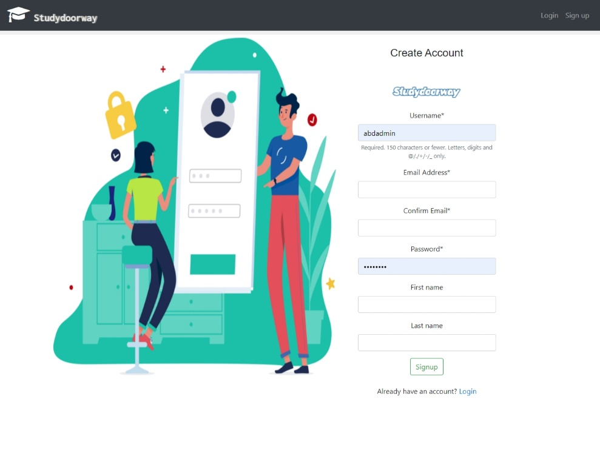

## A.2 Login

Some text here …..

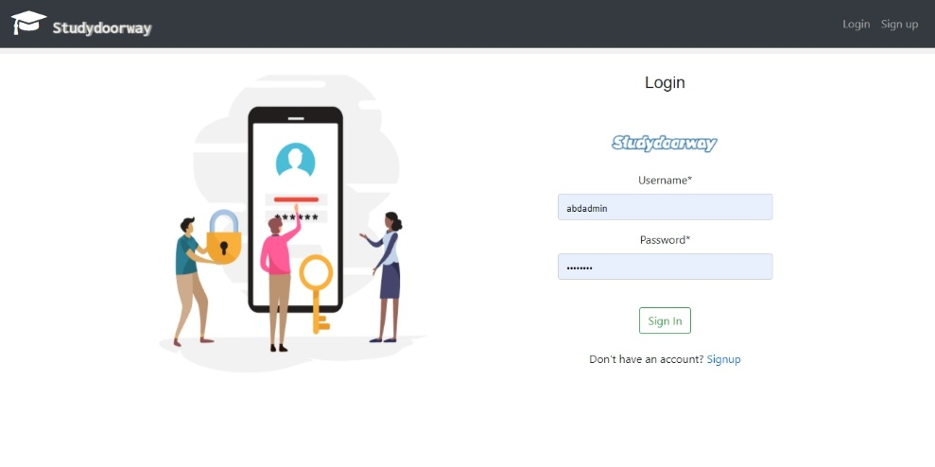

## A.3 Landing Page

Some text here ….. what it shows to the users ……

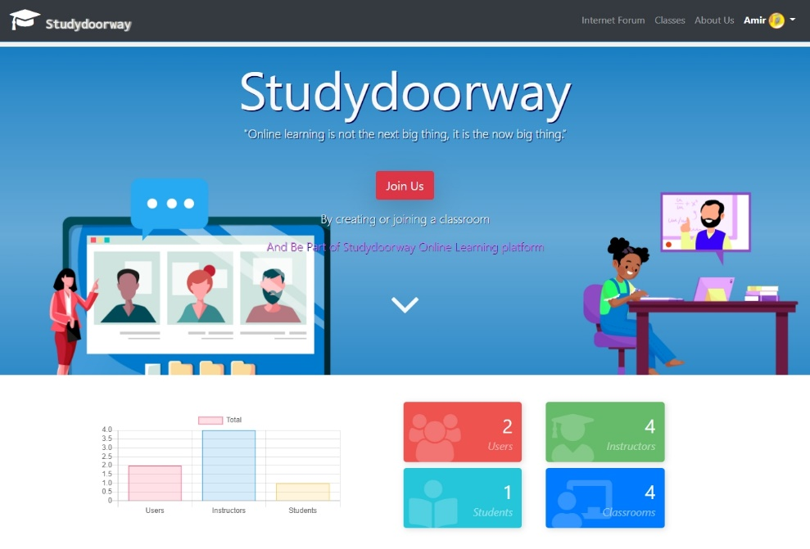

## A.4 User Profile

Some text here what user can change about there profile …….

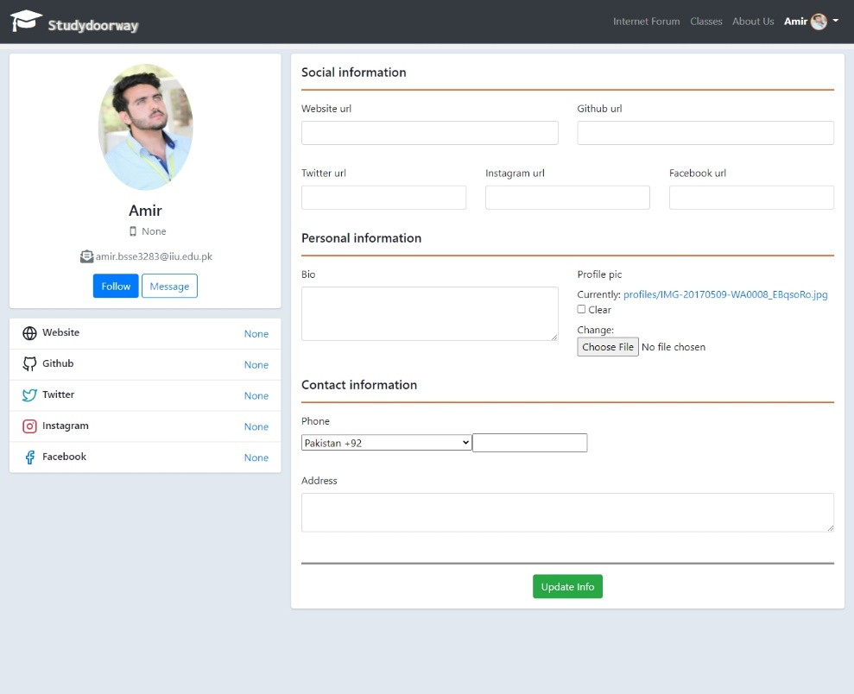

## A.5 Classes Management

Some text here about how it works how each button works and what is shown in the page means …….

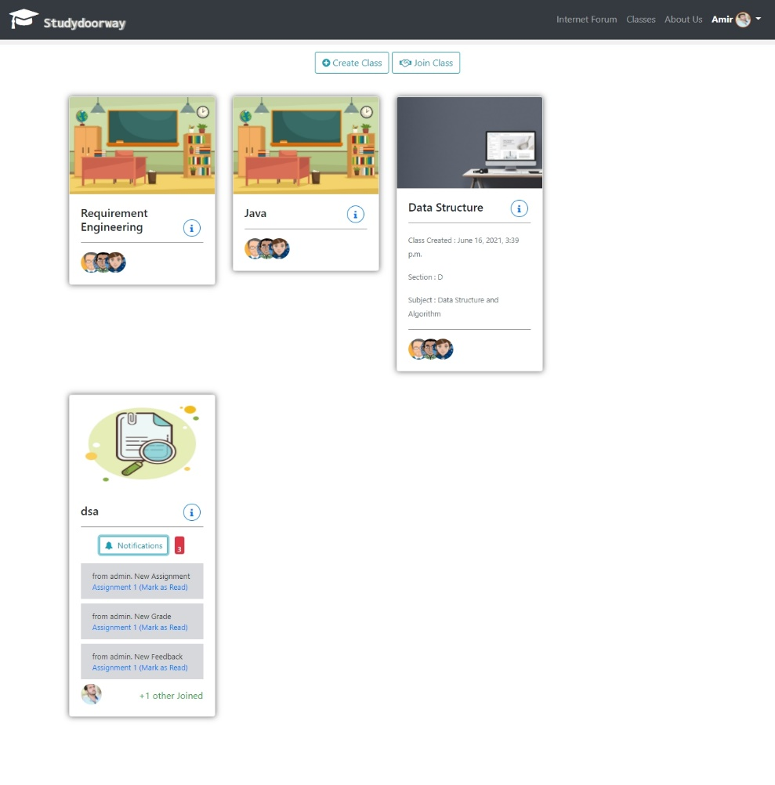

### A.5.1 Create Class

Some text about each field of the form what it means ……. And how a new classroom can be created …. What is the purpose of student key ….etc….

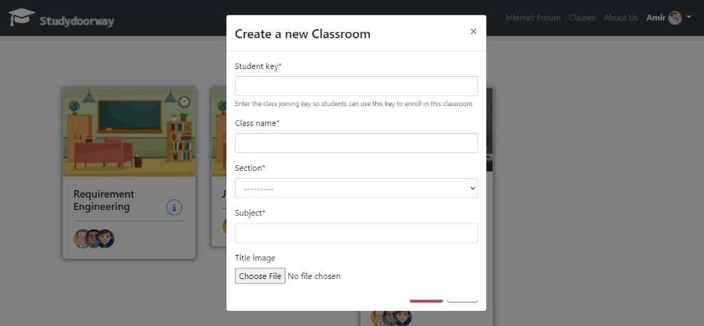

### A.5.2 Join Class

Some text how class can be joined …….

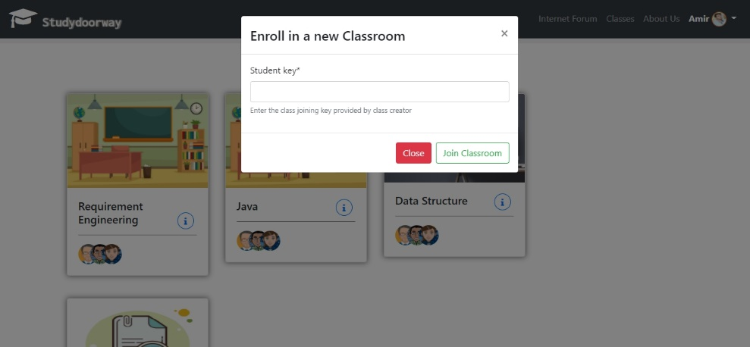

## A.6 Manage Created Classes (Teacher)

Some text about what is mean by manage created classes………

### A.6.1 Stream

Some text about what can be done in the STREAM page what can teacher do ….etc and explain the screen shot …..below ….

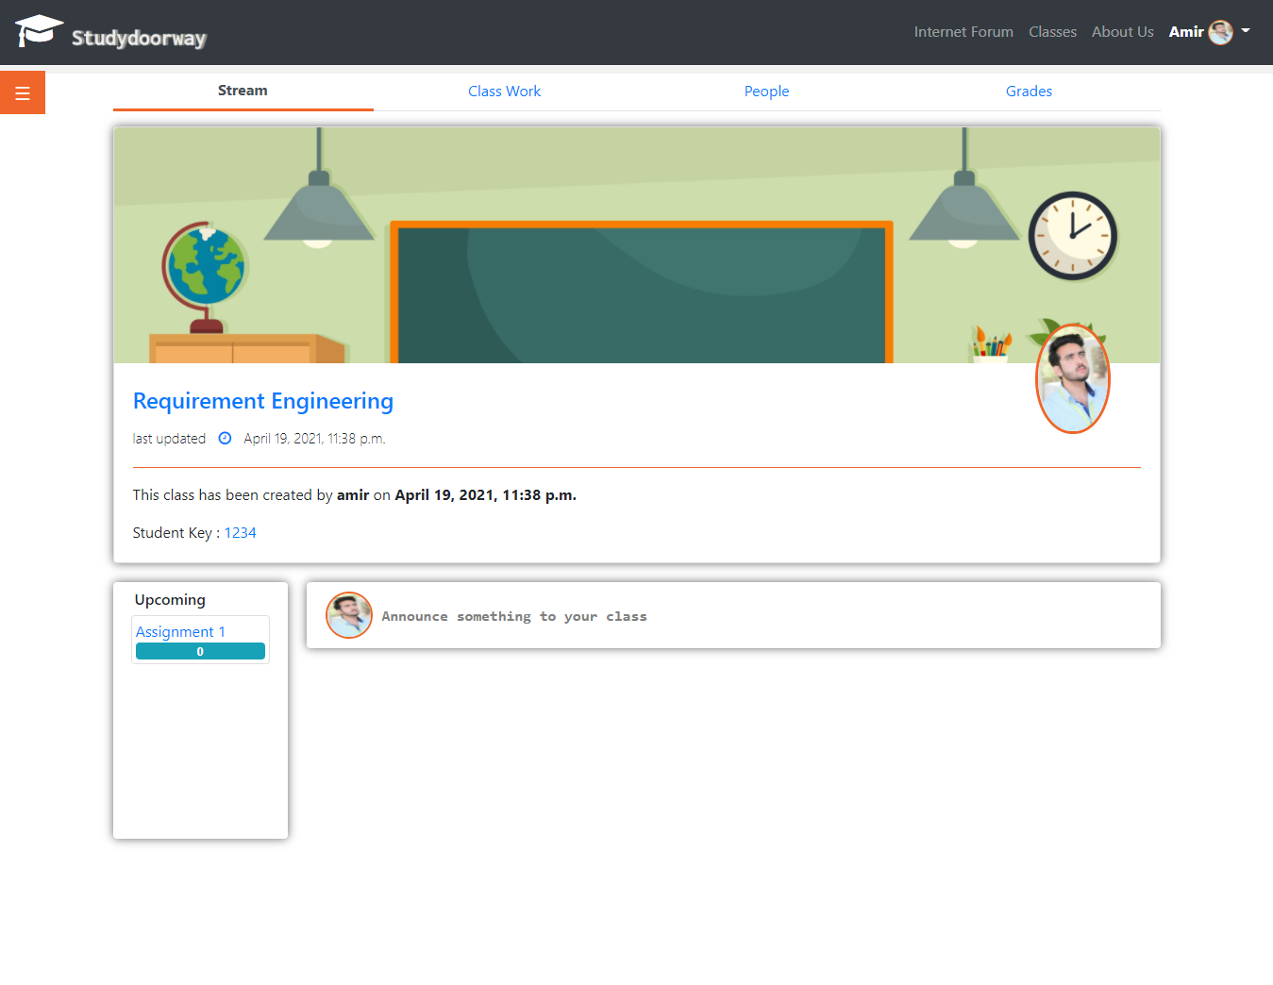

#### A.6.1.1 Announcement

Some text how teacher can make announcement …… teacher can add file and link etc in the announcement and then syudents and teacher can comment on each announcement and like dislike comments etc ……

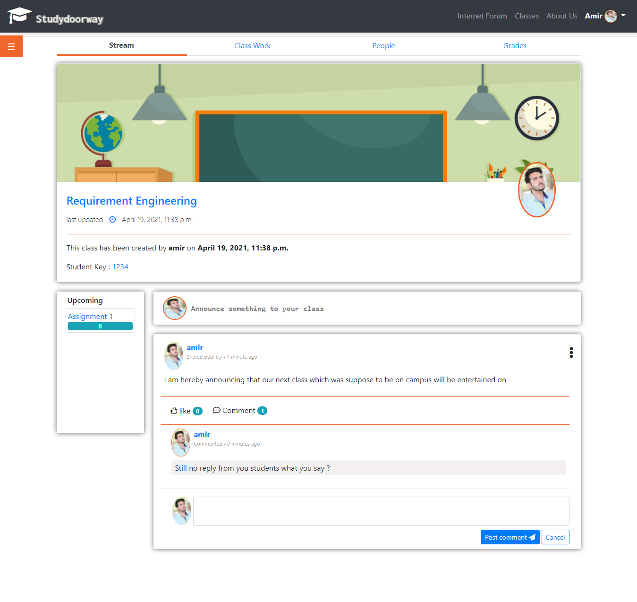

#### A.6.1.2 Announcement File

Some text about how teacher can add file to announcement….etc

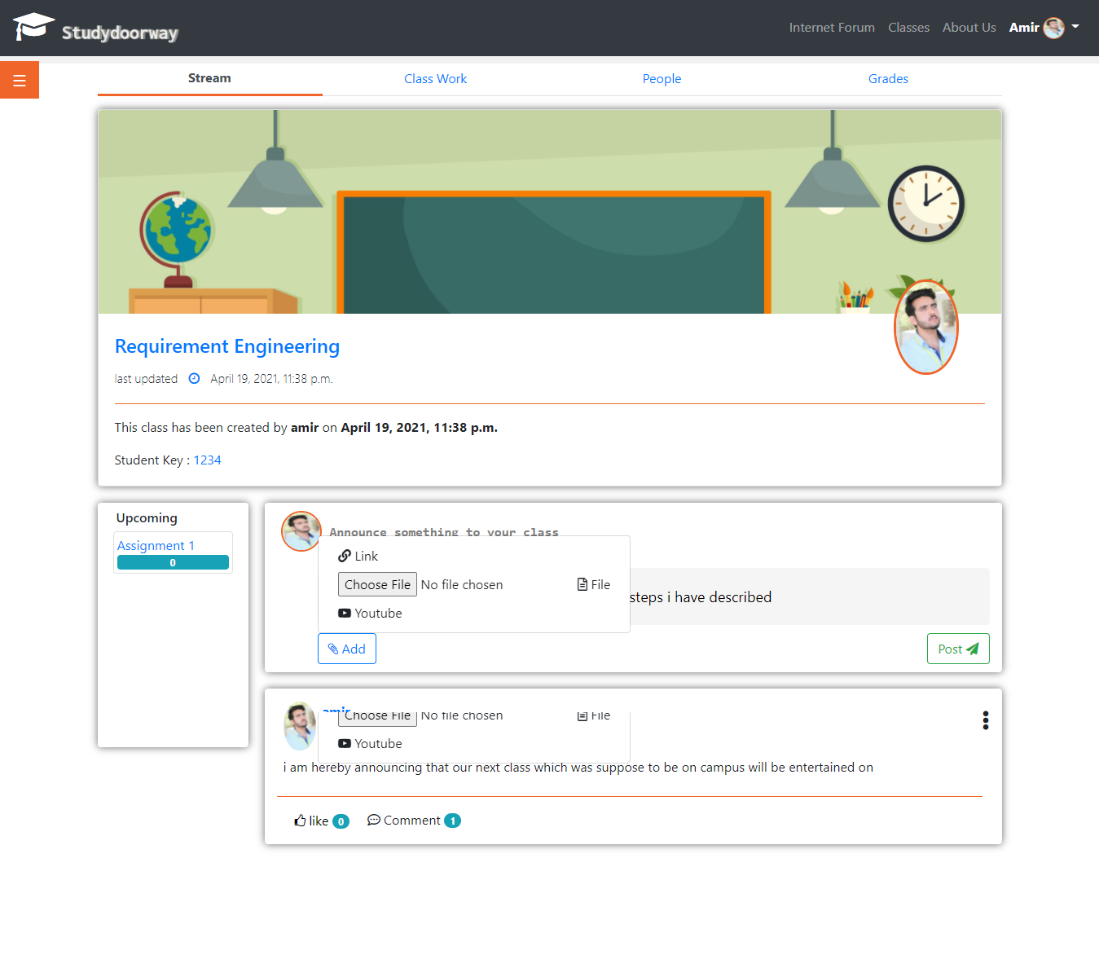

### A.6.2 Class Work

Some text about classwork page what and how can teacher do here ….

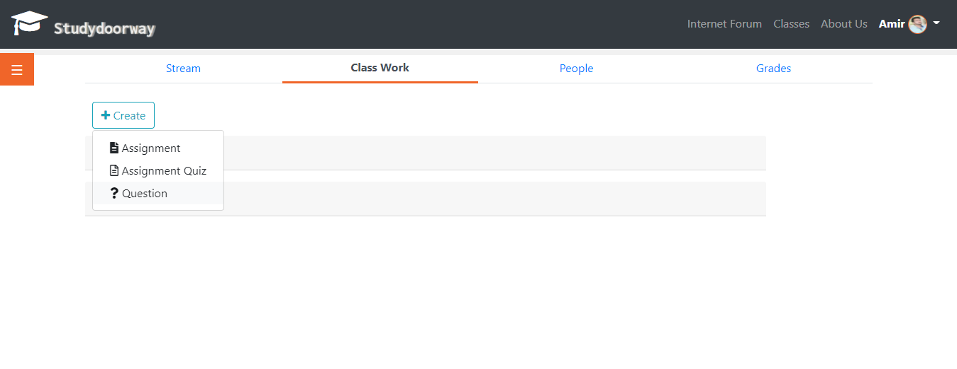

#### A.6.2.1 Create Assignment

Some text here …..

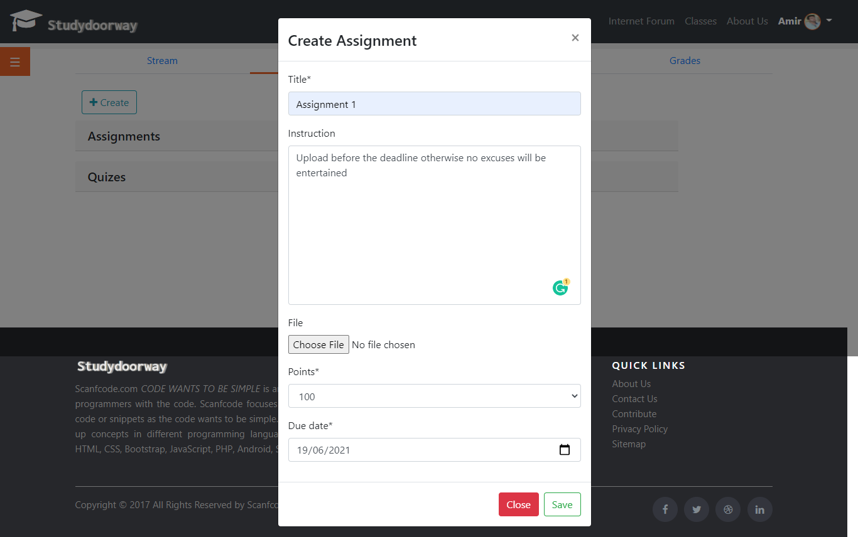

Teacher can then edit and delete assignment….

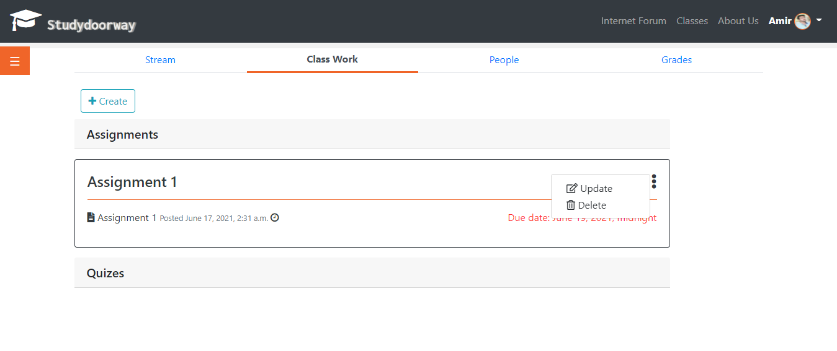

Update Assignment procedure ….

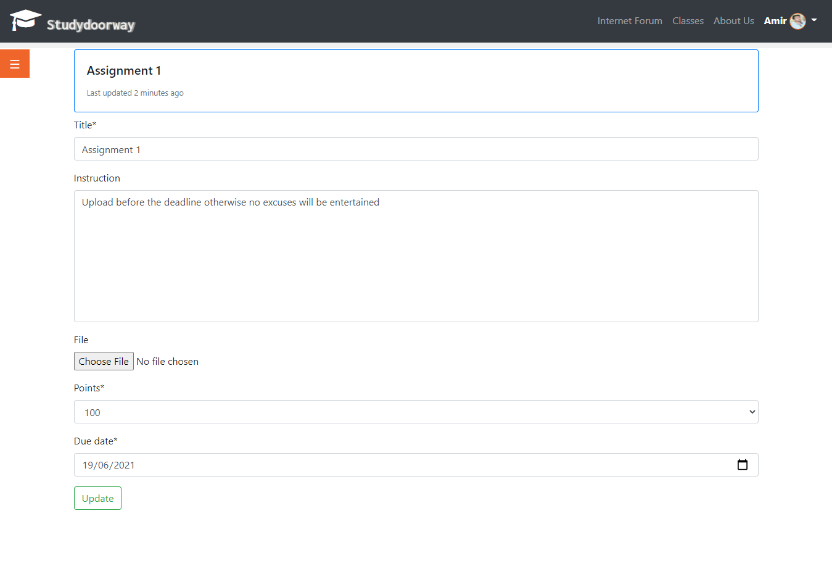

#### A.6.2.2 Create Assignment Quiz

Some text here ….. Amira tenga ka …haha…

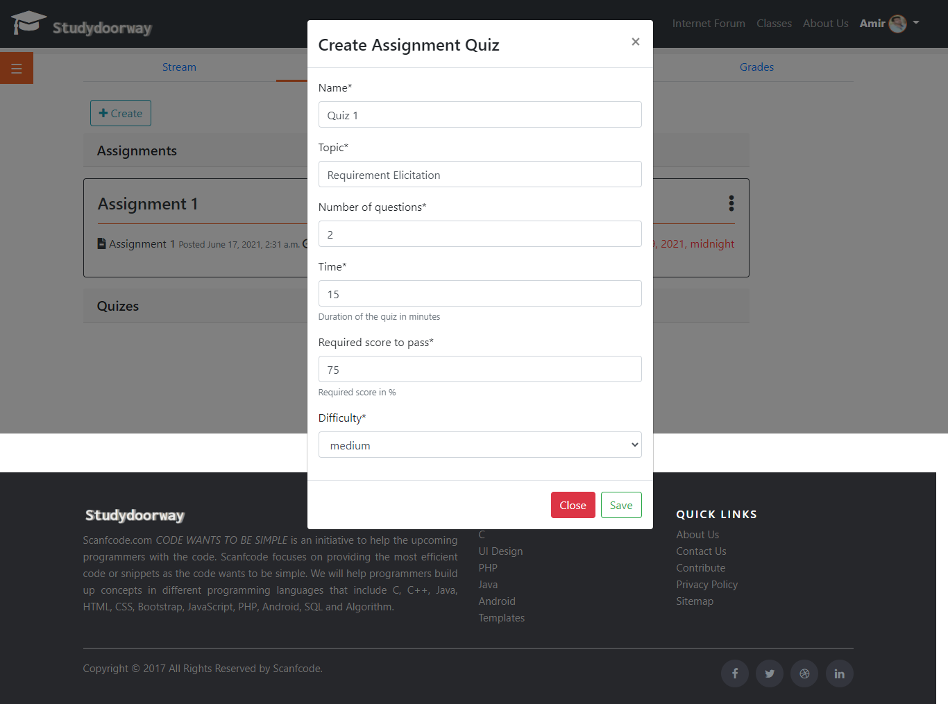

### A.6.3 People

Some text about people page ……

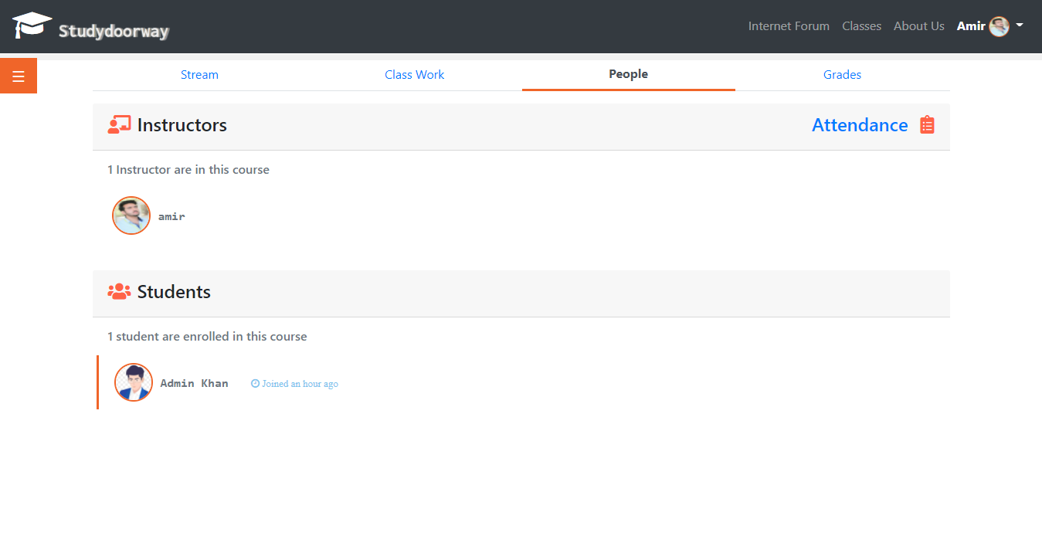

#### A.6.3.1 Student Attendance

Explain the attendance page teacher can take attendance …….

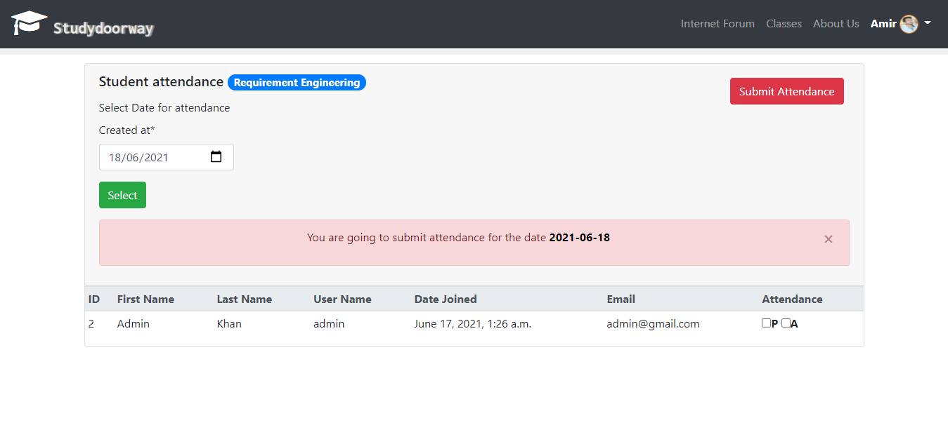

### A.6.4 Grades

Some text how teacher can grade each assignment of students …….and give feedback on assignment ….

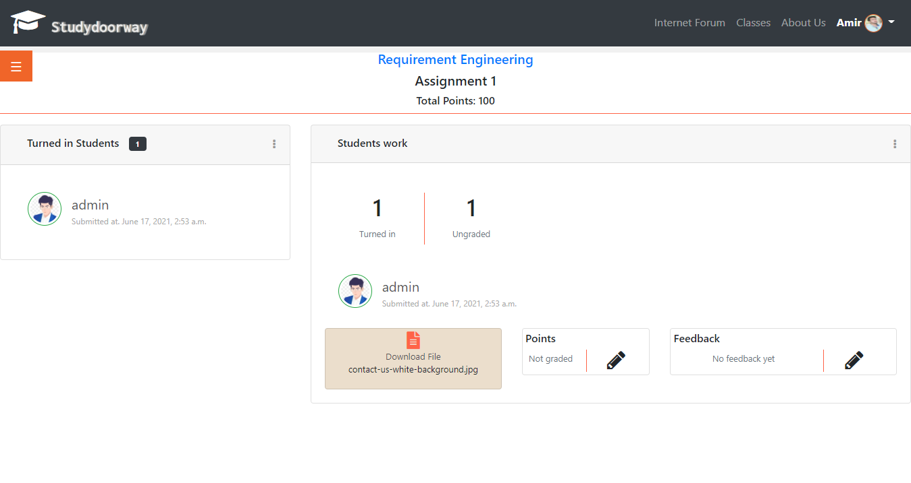

## A.7 Manage Joined Classes (Student)

Explain How students can manage there joined classes in this plateform ….

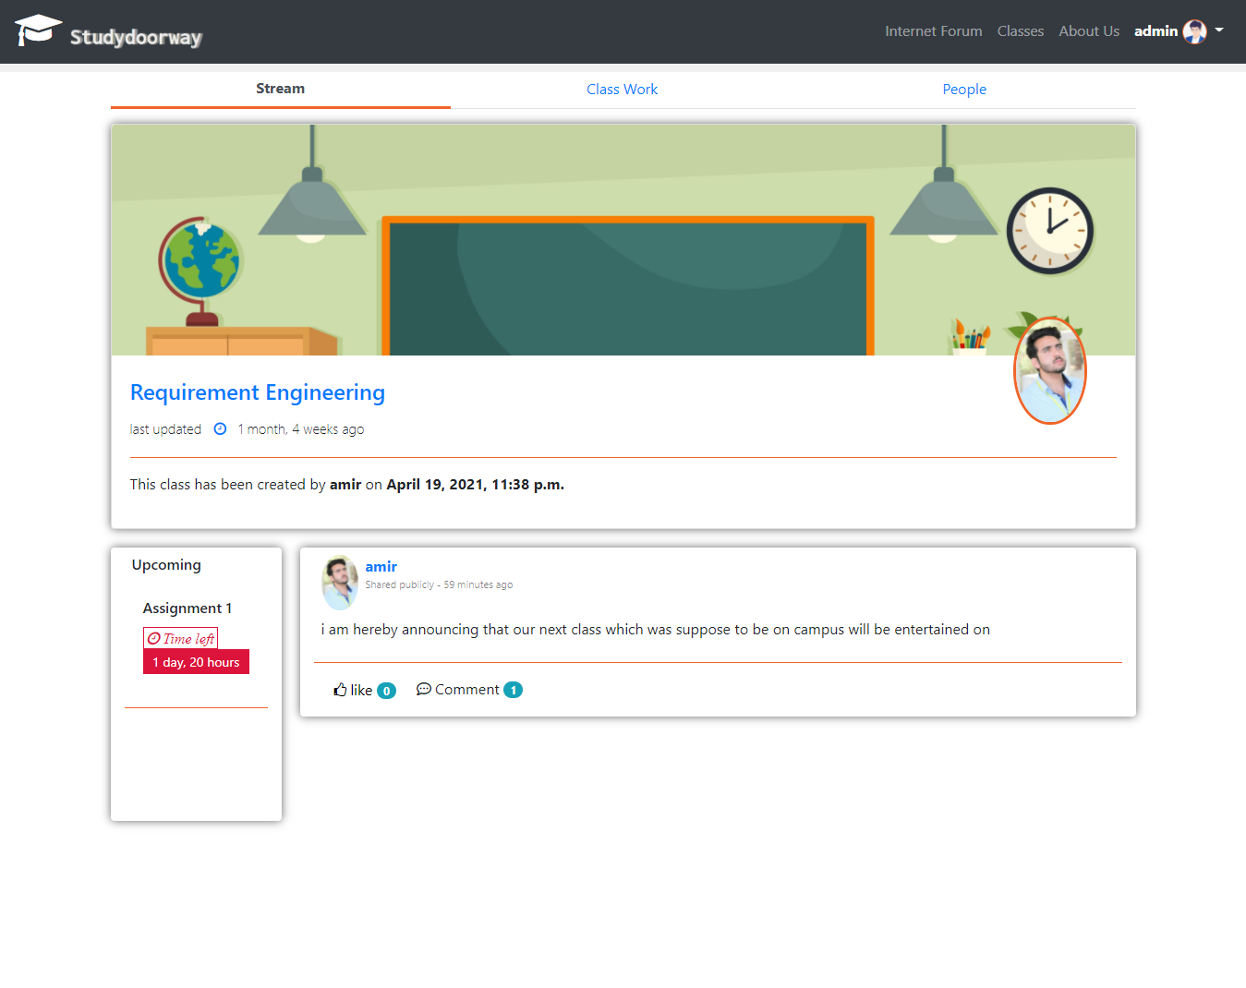

### A.7.1 Class Work

Student can submit assignment and can give quiz ….

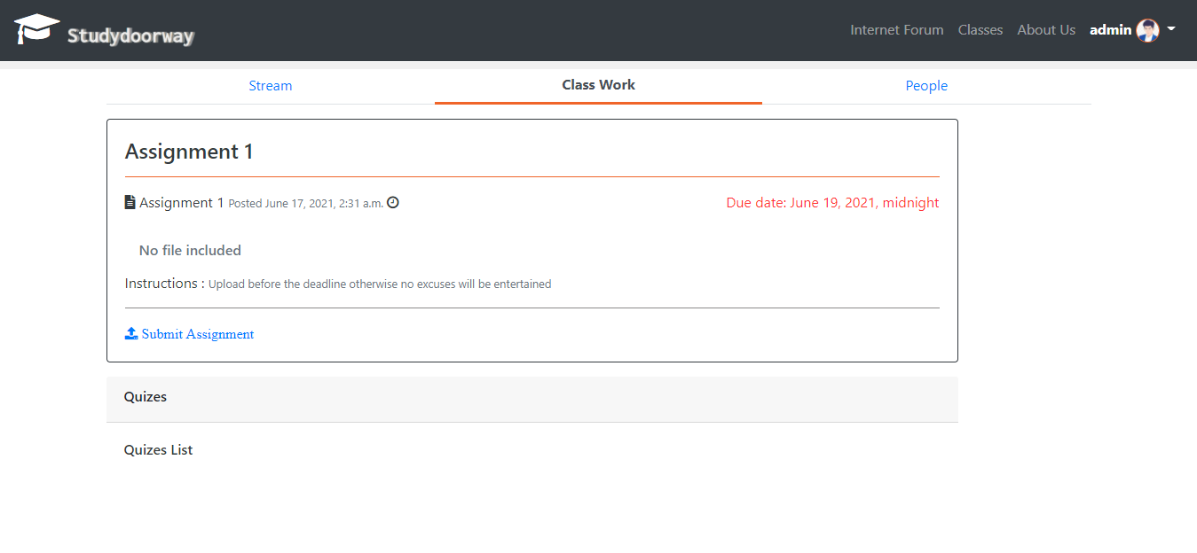

#### A.7.1.1 Submit Assignment (Student)

Here students can upload there assignments and here it shows that the assignment students have uploaded are graded or not ……

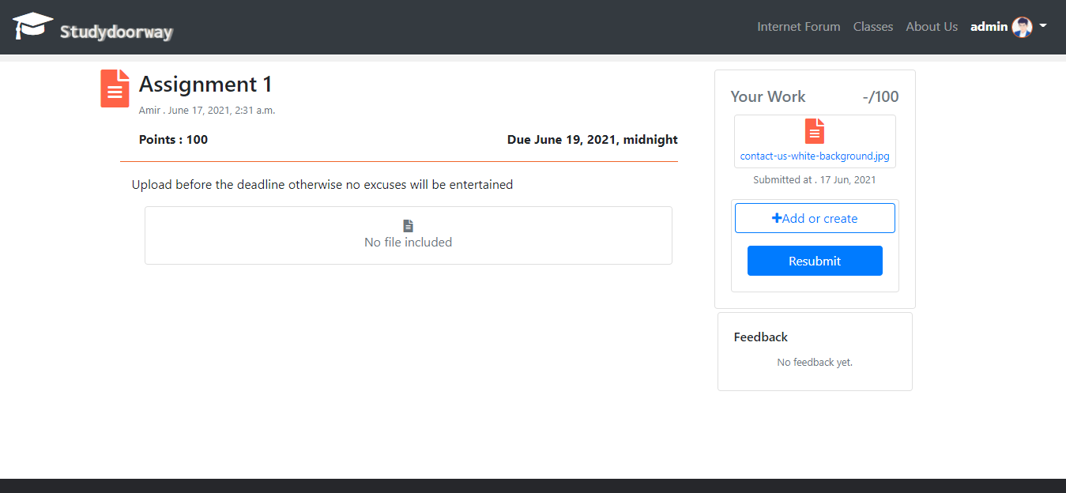

### A.7.2 People

Some text here what students can see here write about students chat …..after ….

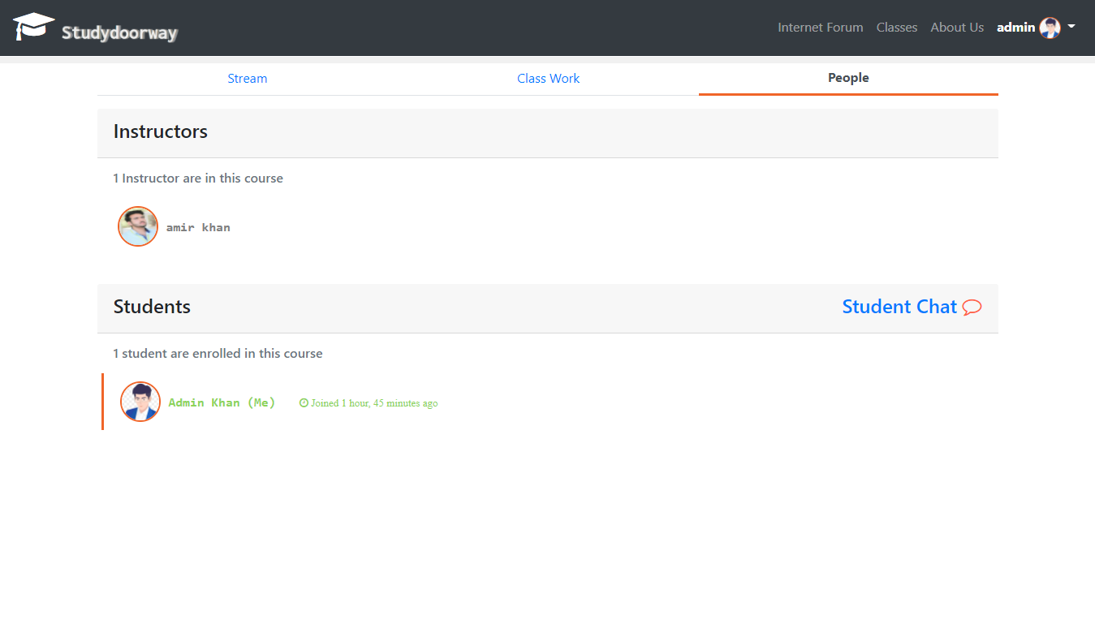

#### A.7.2.1 Student Chat

Some text here explain…..

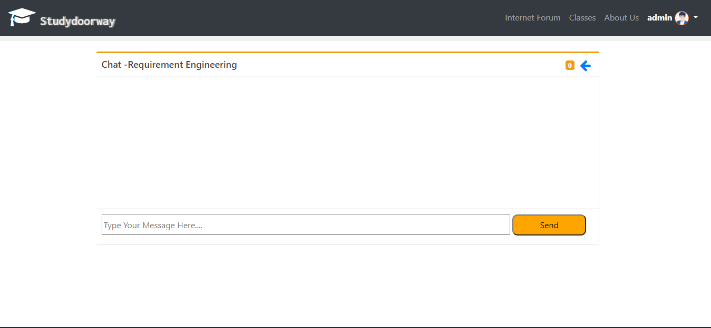

## A.8 Internet Form

Explain internet form …….please ..

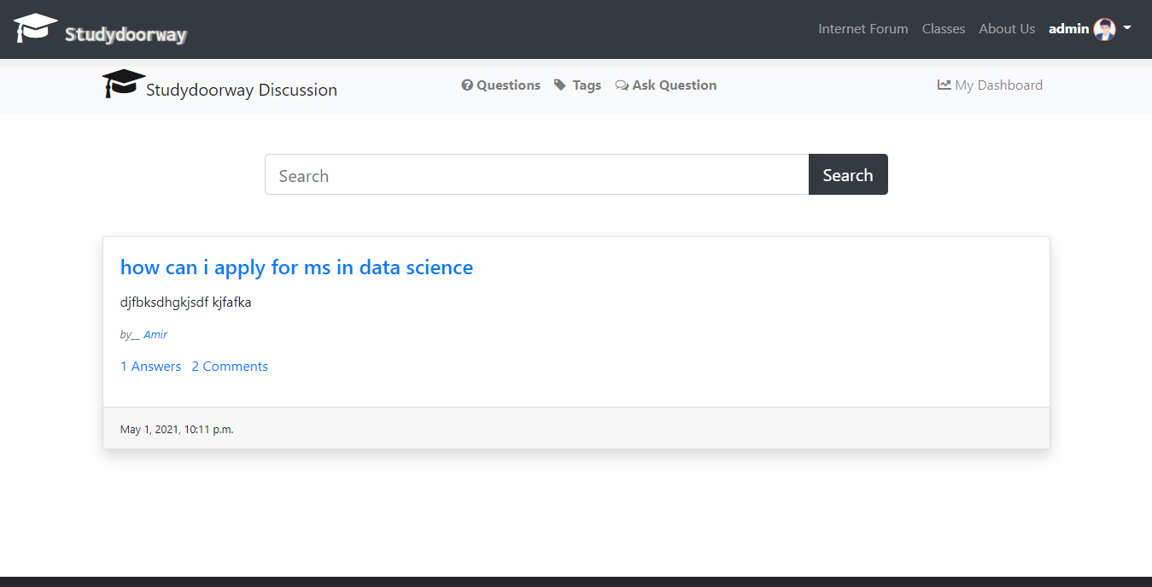

### A.8.1 Ask Question

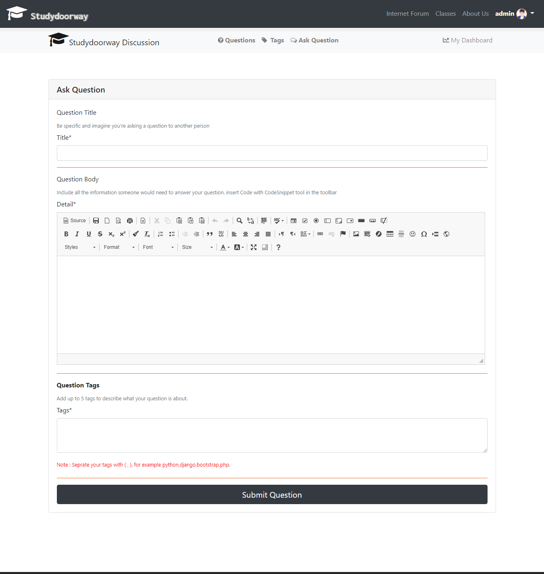

### A.8.2 Tags

What are tags explain …….click on tags and can see tag related questions asked here …..

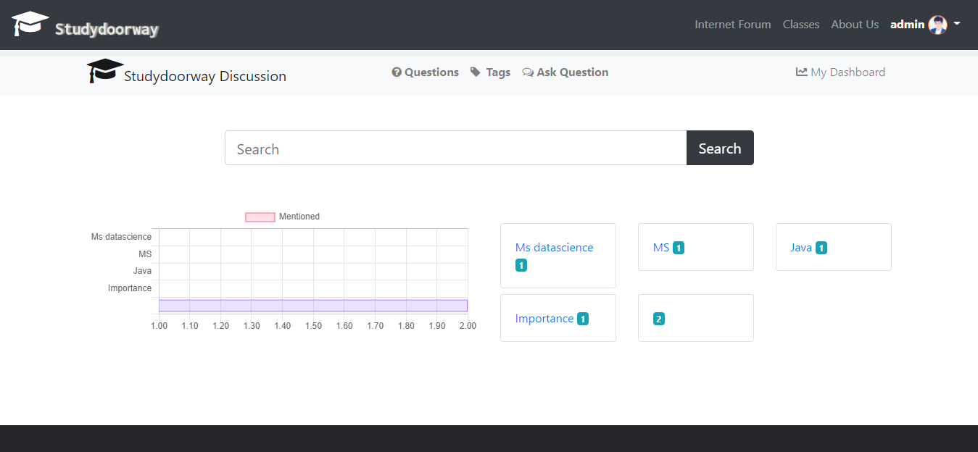

### A.8.3 Dashboard

Some text here explain what shows in the dashboard …..

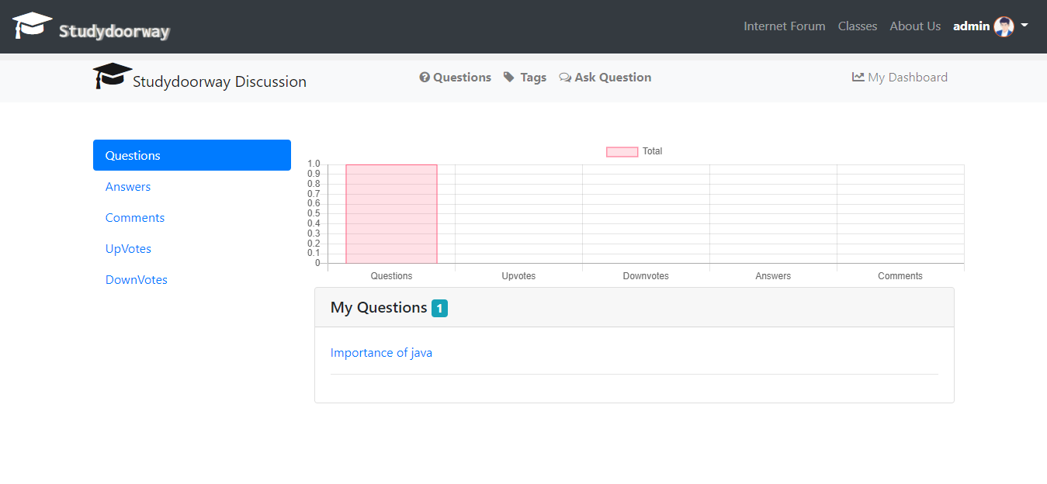

## A.9 Logout

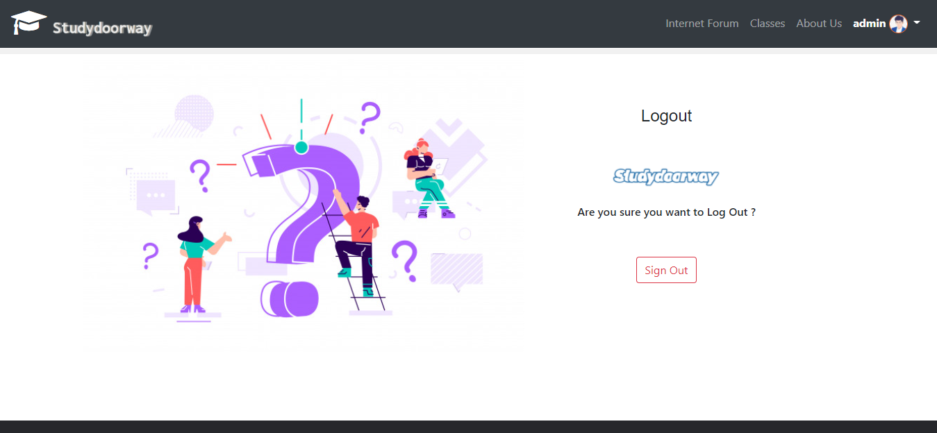

**Appendix-B**

**References**

# Appendix-B References

References here please Amira tenga ka ………….