**Project Topic: Lab Automation**

**Project Group Member**

|  |  |  |
| --- | --- | --- |
| **Enrollment Id** | **Name** | **Batch Code** |
| Student1279909 | Hamza Rashid | 2101B1 |
| Student1285259 | Taha Rafi | 2101B1 |
| Student1285257 | Ahsan Shaukat | 2101B1 |
| Student1285247 | Mohsin Shaukat | 2101B1 |

|  |
| --- |
|  |

**ACKNOWLEDGMENT**

We are thankful to almighty **ALLAH** with his grace and mercy to giving us strength and ability to make us complete this project. We hereby presenting, project on ***‘Lab Automation’*** in your hands. We have tried our best to take all relevant and important topics in consideration so that this project may become more effective & a better outlook to come. This project has been developed with the help of “MYSQL, PHP, MYAdminPanel, BOOTSTRAP”. We are earnestly hope that this project will provide all the necessary information required for the see to fulfill their requirement. However, suggestion for improvement of the project will be thankfully acknowledge.

**Thank you.**

Chapter 1

**Introduction**

The thirst for learning, upgrading technical skills and applying the concepts in real life environment at a fast pace is what the industry demands from IT professionals today. However busy work schedules, far-flung locations, unavailability of convenient time-slots pose as major barriers when it comes to applying the concepts into realism. And hence the need to look out for alternative means of implementation in the form of laddered approach.

The above truly pose as constraints especially for our students too! With their busy schedules, it is indeed difficult for our students to keep up with the genuine and constant need for integrated application which can be seen live especially so in the field of IT education where technology can change on the spur of a moment. *Well, technology does come to our rescue at such times!!*

Keeping the above in mind and in tune with our constant endeavour to use Technology in our training model, we at Aptech have thought of revolutionizing the way our students learn and implement the concepts using tools themselves by providing a *live and synchronous eProject learning environment*

Chapter 2

**Requirement & Specification**

**►Non-Financial :**

* The details of the products and the testing like the product code, product id, testing id, the revise, the testing performed, remarks provided, the result of the testing, etc…. are needed to be maintained in a separate database.
* Product id should be a unique 10 digit code as described by the manufacturing unit and the testing id should be a unique 12 digit code, which should be automatically generated.
* An advanced search option is to be included.
* The application should contain a modular and the sub-modular form based on the type of the product and as well based on the type of the testing.
* One should be able to capture the detailed description of the remarks that include about the testing and what should be the output for that testing and the result of testing performed and as well the remarks if any for that particular product.
* One should be able to check the status of the testing.
* After entering the record, it should even ask for the name of the person (s) who has tested the product.

**►Financial :**

After the product is subjected for testing and if it fails it is to be sent for re-making else it will be sent for further testing procedures that are held by the CPRI and get it approved from them so as to release the product in to the market.

Functional Requirements : –

* The details are needed to be captured based on the type of the testing and as well based on the product.
* The status of the testing and as well the detailed remarks is also needed to be captured.
* An advanced search option is needed to be included so that one can fetch the details of the testing at an ease.

Chapter 3

**Analysis**

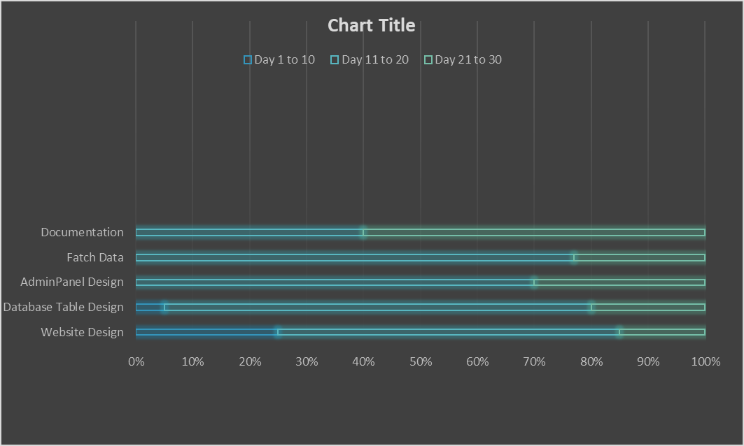

Chapter 4

**Screenshots (Front-end Design)**

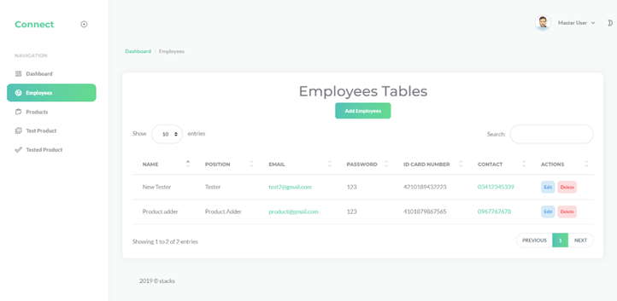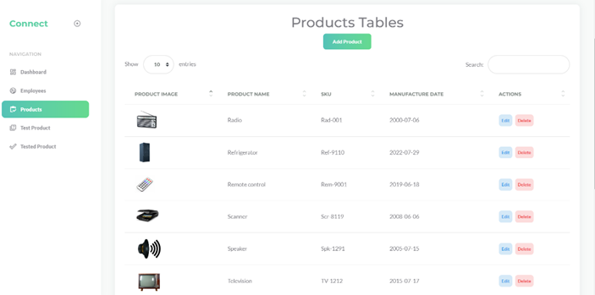

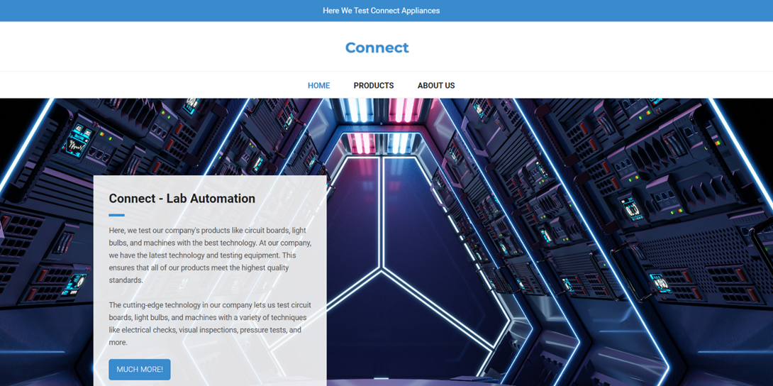

**Admin Panel**

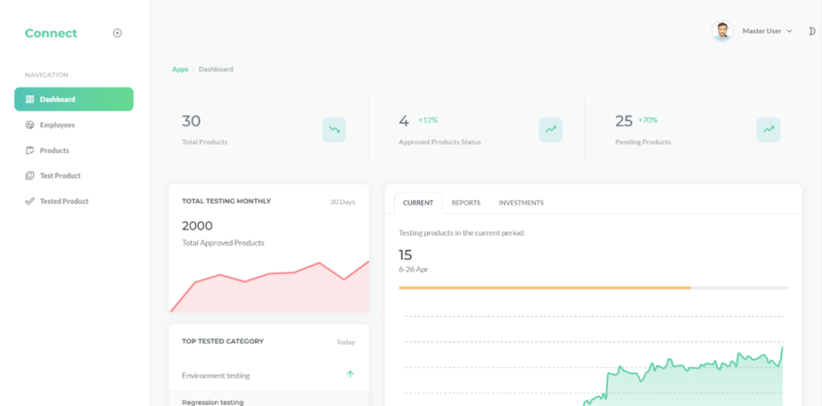

**(Lab Automation)**

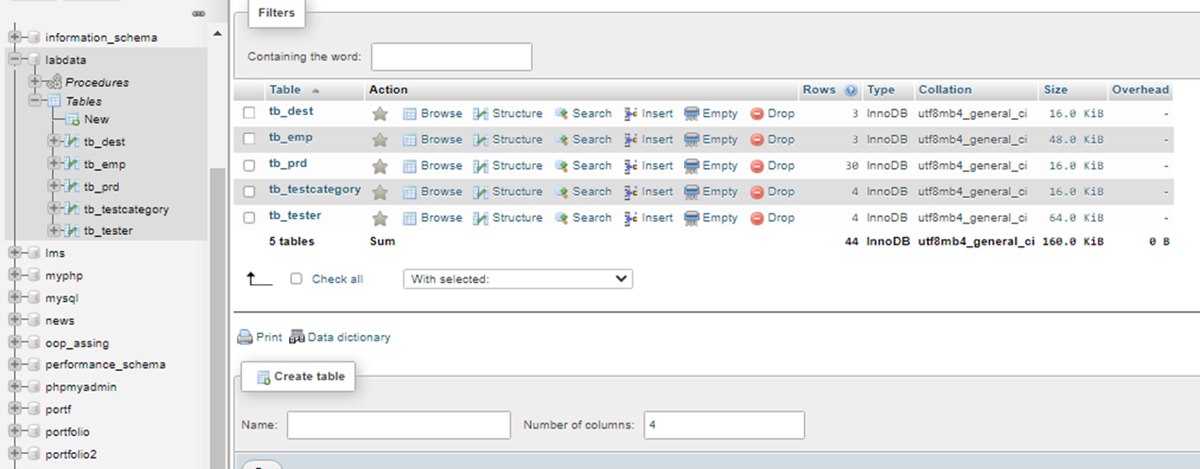

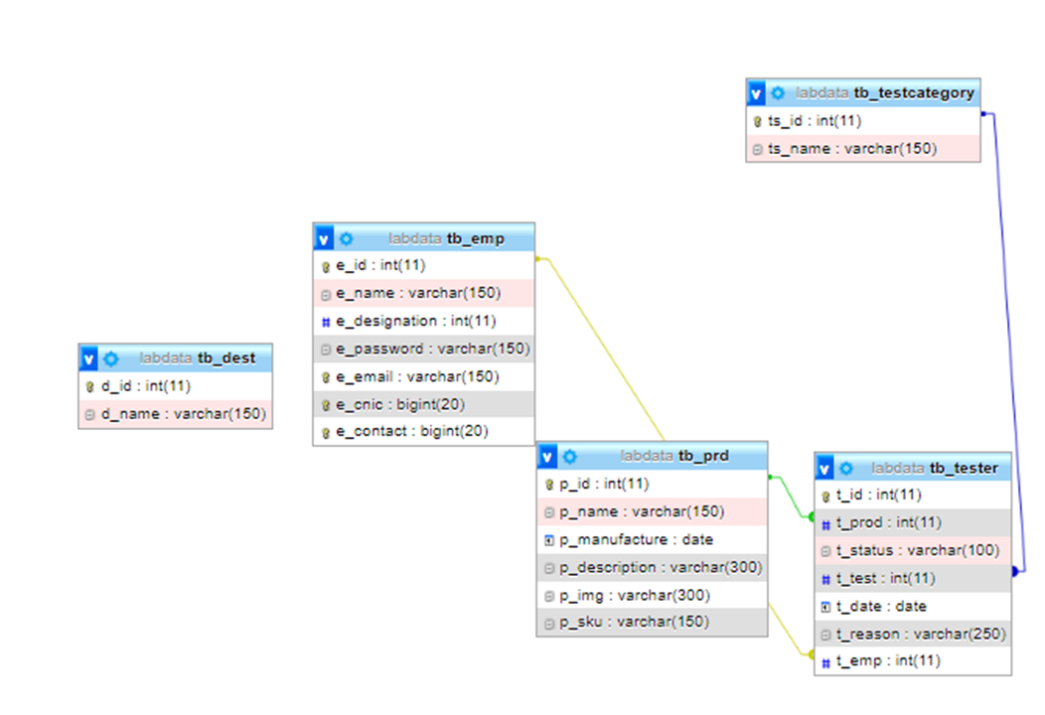

Chapter 5

**Task Sheet**

|  |  |  |  |
| --- | --- | --- | --- |
| **S. No** | **Task** | **Teammate name** | **Status** |
| 01 | Project Management | Hamza Rashid, Ahsan Shaukat, Taha Rafi, Moshin Khan |  |
| 02 | CMS Design | Hamza Rashid, Ahsan Shaukat, Taha Rafi, Moshin Khan |  |
| 03 | Database Design | Hamza Rashid, Ahsan Shaukat, Taha Rafi, Moshin Khan |  |
| 04 | Website Inner page | Hamza Rashid, Ahsan Shaukat, Taha Rafi, Moshin Khan |  |
| 05 | Website Development | Hamza Rashid, Ahsan Shaukat, Taha Rafi, Moshin Khan |  |
| 06 | Website Design | Hamza Rashid, Ahsan Shaukat, Taha Rafi, Moshin Khan |  |
| 07 | Logo Design | Hamza Rashid, Ahsan Shaukat, Taha Rafi, Moshin Khan |  |
| 08 | Problem Review | Hamza Rashid, Ahsan Shaukat, Taha Rafi, Moshin Khan |  |
| 09 | Admin Modules | Hamza Rashid, Ahsan Shaukat, Taha Rafi, Moshin Khan |  |
| 10 | Documentations | Hamza Rashid, Ahsan Shaukat, Taha Rafi, Moshin Khan |  |

Chapter 6

**Submission Checklist**

|  |  |
| --- | --- |
| Option | Validations |
| Hardware and software being correctly chosen |  |
| Admin can manage all information system website |  |
| Customer can view other customer profile after & without login in? |  |
| Do all the links navigate to the correct webpage |  |

**Thank You!**

We would like to give respect & special thanks to

***“Miss: Qurrat-ul-Ain”***

You have contributed a great deal to the successful of my project. We deeply thank you for your kindness support and thoughtful recommendations.

Although the time for the project is not long, we manage to finish on time. However, there is still room for improvement. Hence, we are appreciating for comments of teacher to make my project better