Scenario 1: Adding Patients:

Code:

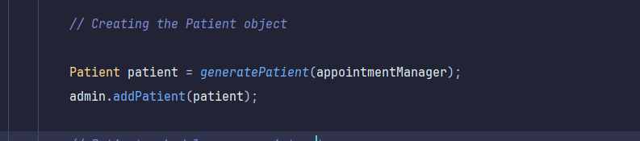

Output:

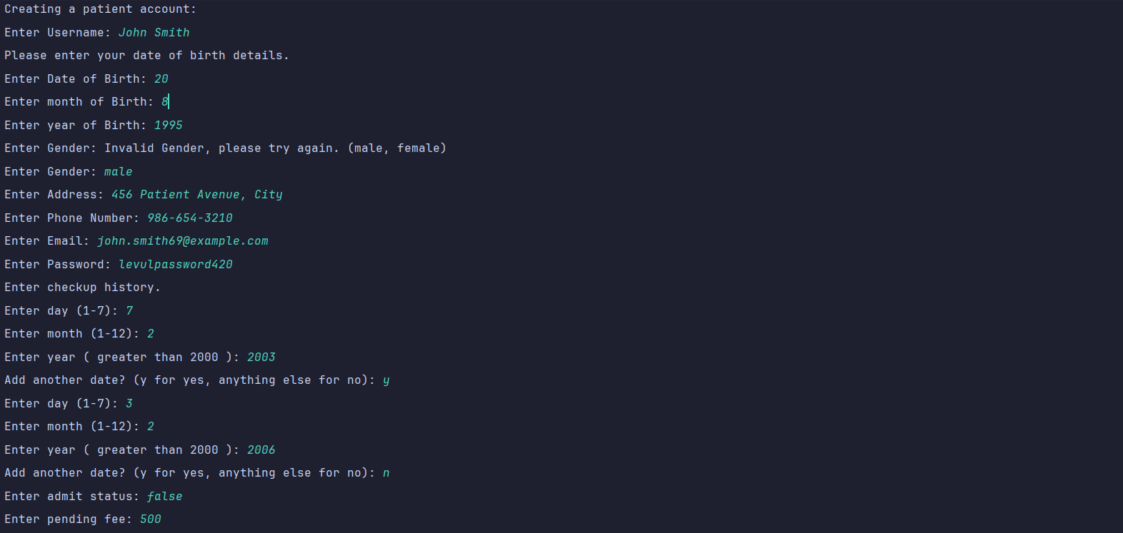

Scenario 2: Scheduling Appointment

Code:

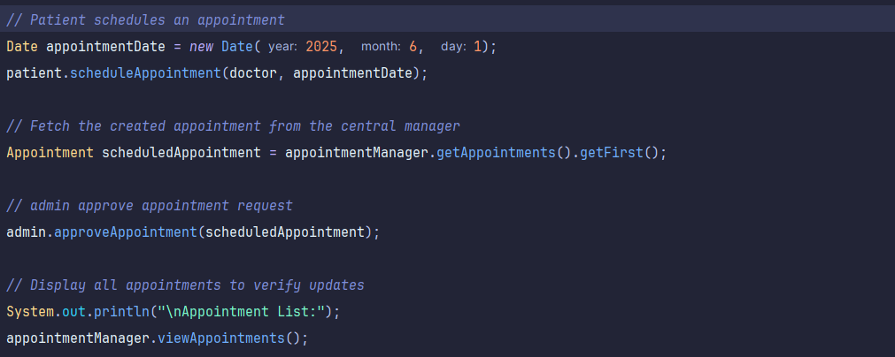

Output: 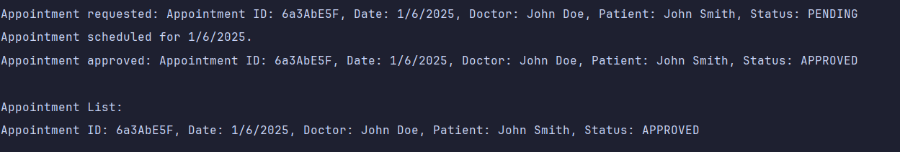

Scenario 3: Processing Vitals

Code:

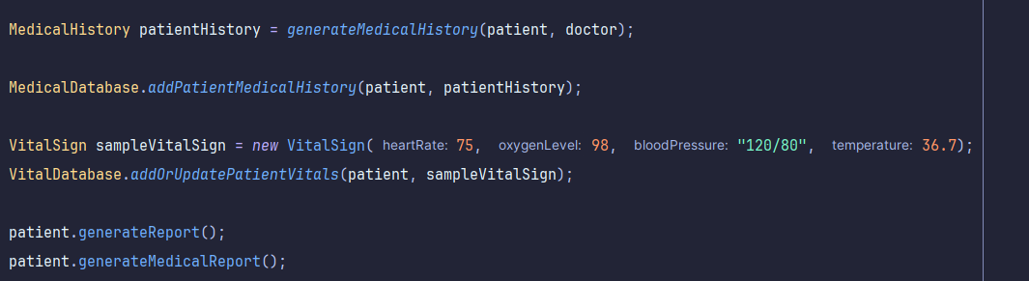

Output:

