CS 250: Data Structures & Algorithms

Assignment 03:

Non-Comparative Sorting Algorithms

Submitted By:
Hamza Raheem: 512131
Muhammad Uzair: 529583

Abstract
This study presents a comprehensive empirical and theoretical analysis of six non-comparison sorting algorithms: Counting Sort (Non-Stable), Counting Sort (Stable), Radix Sort (LSD), Bucket Sort, Flash Sort, and Spread Sort. Through extensive performance testing across multiple data distributions, array sizes, and value ranges, we provide empirical evidence for algorithm behavior and develop a decision framework for algorithm selection. Our analysis includes edge case testing, memory usage analysis, theoretical complexity verification, and practical guidelines for implementation in real-world scenarios.

1. Introduction

1.1 Background and Motivation
Sorting algorithms are fundamental building blocks in computer science and software engineering. While comparison-based sorting algorithms have a theoretical lower bound of Ω(n log n), non-comparison sorting algorithms can achieve better performance by leveraging specific properties of the input data, particularly when dealing with integers or data with limited range.
This research addresses the practical challenge of algorithm selection in real-world scenarios where understanding the characteristics of input data and algorithm behavior is crucial for optimal performance.

1.2 Research Objectives
- Theoretical Analysis: Provide mathematical proofs and complexity analysis for each algorithm
- Empirical Evaluation: Conduct comprehensive performance testing across various conditions
- Decision Framework: Develop practical guidelines for algorithm selection
- Edge Case Analysis: Evaluate algorithm behavior under extreme conditions
- Memory Analysis: Assess space complexity and memory usage patterns

1.3 Scope and Limitations
This study focuses on six specific non-comparison sorting algorithms implemented in C++. While the analysis is comprehensive within this scope, the findings may not directly generalize to all non-comparison sorting algorithms or different programming environments.

2. Literature Review

2.1 Non-Comparison Sorting Fundamentals
Non-comparison sorting algorithms achieve better than O(n log n) time complexity by making assumptions about the input data. These algorithms typically exploit: - Known value ranges - Integer representation properties - Distributional characteristics of input data

2.2 Related Work
Previous studies have demonstrated the effectiveness of non-comparison sorting in specific domains:
- Counting Sort: Optimal for small integer ranges (Cormen et al., 2009)
- Radix Sort: Effective for fixed-length integer sorting (Knuth, 1998)
- Bucket Sort: Performance depends on input distribution (Sedgewick & Wayne, 2011)

2.3 Research Gap
While existing literature provides theoretical foundations, there is limited comprehensive empirical analysis comparing multiple non-comparison algorithms across diverse conditions with practical decision frameworks for implementation.

3. Methodology

3.1 Algorithm Selection
We selected six non-comparison sorting algorithms representing different approaches:
- Counting Sort (Non-Stable) - Basic frequency-based sorting
- Counting Sort (Stable) - Stability-preserving variant
- Radix Sort (LSD) - Digit-by-digit sorting approach
- Bucket Sort - Distribution-based sorting
- Flash Sort - Class-based distribution sorting
- Spread Sort - Hybrid adaptive algorithm

3.2 Experimental Design

3.2.1 Test Conditions
- Array Sizes: 100, 500, 1000, 2500, 5000 elements
- Value Ranges: 50, 100, 500, 1000, 5000, 10000
- Distributions: Uniform, Normal, Skewed, Concentrated
- Edge Cases: Empty arrays, single elements, already sorted, reverse sorted, all identical, alternating patterns

3.2.2 Performance Metrics
- Execution time (microseconds)
- Memory usage (bytes)
- Theoretical complexity verification
- Stability analysis
- Correctness validation

3.2.3 Implementation Details
- Language: C++17
- Compiler: g++ with -O2 optimization
- Timing: std::chrono high_resolution_clock
- Testing: Automated validation with assertions

3.3 Data Collection
Performance data was collected through systematic testing across all combinations of array sizes, value ranges, and distributions. Each algorithm was tested multiple times to ensure statistical reliability.

4. Algorithm Analysis

4.1 Counting Sort (Non-Stable)

4.1.1 Algorithm Description
Counting Sort operates by counting the frequency of each element and reconstructing the sorted array.

4.1.2 Mathematical Analysis
Time Complexity: - Best Case: O(n + k) - Average Case: O(n + k) - Worst Case: O(n + k) - Where n = array size, k = value range
Space Complexity: O(k)
Stability: No - equal elements may not preserve relative order

4.1.3 Theoretical vs Empirical Results
Our empirical testing confirms the O(n + k) complexity. For arrays of size 1000 with range 1000, average execution time was 7 μs, consistent with theoretical predictions.

4.2 Counting Sort (Stable)

4.2.1 Algorithm Description
Extends basic counting sort with cumulative frequency counting to preserve stability.

4.2.2 Mathematical Analysis
Time Complexity: O(n + k) (same as non-stable)
Space Complexity: O(n + k) (additional space for result array)
Stability: Yes - maintains relative order of equal elements

4.2.3 Performance Characteristics
Stable variant requires ~15% more memory but maintains correctness for applications requiring stability.

4.3 Radix Sort (LSD)

4.3.1 Algorithm Description
Sorts numbers digit by digit from least significant to most significant using stable counting sort as subroutine.

4.3.2 Mathematical Analysis
Time Complexity: O(d × (n + k)) - Where d = number of digits, typically O(log₁₀(max_value)) - For range 10000, d = 4, giving O(4(n + 10))
Space Complexity: O(n + 10) for counting array
Stability: Yes (inherits from counting sort)

4.3.3 Empirical Analysis
Performance scales linearly with number of digits. For range 1000 (3 digits), average time was 108 μs for 1000 elements.

4.4 Bucket Sort

4.4.1 Algorithm Description
Distributes elements into buckets based on value range, then sorts each bucket individually.

4.4.2 Mathematical Analysis
Time Complexity: - Best Case: O(n + k) when uniformly distributed - Average Case: O(n + k) - Worst Case: O(n²) when all elements fall in one bucket
Space Complexity: O(n + k)
Stability: Yes (depends on bucket sorting method)

4.4.3 Distribution Impact Analysis
Our testing shows significant variation:
- Uniform distribution: 72 μs average
- Concentrated distribution: 238 μs average
- Performance degrades with skewed distributions

4.5 Flash Sort

4.5.1 Algorithm Description
Uses class distribution based on value range, then applies cycle leader permutation for in-place sorting.

4.5.2 Mathematical Analysis
Time Complexity: - Best Case: O(n) for well-distributed data - Average Case: O(n) - Worst Case: O(n²) for pathological distributions
Space Complexity: O(n)
Stability: No

4.5.3 Performance Characteristics
Shows excellent performance for moderate-sized arrays (1000-5000 elements) with reasonable data distribution.

4.6 Spread Sort

4.6.1 Algorithm Description
Hybrid algorithm that adapts between Radix Sort and QuickSort based on range-to-size ratio.

4.6.2 Mathematical Analysis
Decision Rule: If (k/n < 10) use Radix Sort, else use QuickSort
Time Complexity: - Small ranges: O(n + k) - Large ranges: O(n log n)
Space Complexity: O(n)
Stability: No

4.6.3 Adaptive Performance
Demonstrates excellent adaptability, choosing optimal algorithm based on input characteristics.

5. Experimental Results

5.1 Performance Matrix Analysis
Our comprehensive testing across six non-comparison sorting algorithms reveals clear performance patterns based on array size and value range. The table below shows average execution times (μs) across all algorithms:
Array Size | Range 50 | Range 100 | Range 500 | Range 1,000 | Range 5,000 | Range 10,000 | Range 100,000
100 | 20.3 μs | 21.1 μs | 25.5 μs | 30.1 μs | 41.7 μs | 62.7 μs | 452.3 μs
500 | 85.1 μs | 113.6 μs | 125.8 μs | 131.0 μs | 154.5 μs | 204.6 μs | 680.5 μs
1,000 | 142.5 μs | 204.9 μs | 231.1 μs | 248.8 μs | 307.6 μs | 326.3 μs | 835.6 μs
2,500 | 321.6 μs | 472.5 μs | 599.4 μs | 740.8 μs | 779.0 μs | 846.6 μs | 826.5 μs
5,000 | 669.0 μs | 1,103.1 μs | 1,095.4 μs | 1,284.4 μs | 1,364.6 μs | 1,607.4 μs | 1,574.5 μs
10,000 | 1,608.8 μs | 2,001.5 μs | 2,220.9 μs | 2,619.5 μs | 2,618.3 μs | 3,280.9 μs | 3,238.5 μs
Key Observations:
1. Small Arrays (100-500 elements): Execution times remain under 100 μs for ranges up to 1,000, with Spread Sort showing exceptional performance (8-78 μs).
2. Medium Arrays (1,000-2,500 elements): Performance scales linearly with size, with Counting Sort variants struggling with large ranges (>10,000).
3. Large Arrays (5,000-10,000 elements): Bucket Sort and Flash Sort show better scalability than Counting Sort for large ranges.
4. Critical Threshold: Range/Size ratio > 50 causes Counting Sort performance degradation, while Radix and Spread Sort maintain consistent performance.

5.2 Distribution Impact Analysis
Average Performance by Distribution (μs, n=1000, range=1000):
Algorithm | Uniform | Normal | Skewed | Concentrated
Counting Sort (Non-Stable) | 28 | 26 | 28 | 19
Counting Sort (Stable) | 24 | 24 | 25 | 25
Radix Sort (LSD) | 253 | 190 | 256 | 254
Bucket Sort | 430 | 399 | 428 | 261
Flash Sort | 247 | 251 | 248 | 217
Spread Sort | 256 | 195 | 259 | 261
Key Findings:
- Counting Sort Dominates Small Ranges: For range ≤ 100, Counting Sort variants consistently outperform others (3-28 μs vs 125-899 μs for other algorithms).
2. Distribution Impact Varies:
Uniform: Bucket Sort performs optimally (factor of 1.0x)
Normal: Spread Sort shows 23% improvement over uniform
Skewed: Flash Sort maintains consistent performance (variance < 2%)
Concentrated: Counting Sort is 3-5x faster than other algorithms
3. Best-Performing Algorithms by Distribution:
Concentrated: Counting Sort (Non-Stable) - 19 μs
Uniform: Counting Sort (Stable) - 24 μs
Normal: Spread Sort - 195 μs
Skewed: Counting Sort variants (25-28 μs)

5.3 Edge Case Performance
All algorithms correctly handled edge cases:
- Empty arrays: Handled without errors
- Single elements: Immediate completion
- Already sorted: No performance degradation
- All identical elements: Optimal performance
- Alternating patterns: Consistent behavior

5.4 Memory Usage Analysis
Memory Consumption by Algorithm (bytes, n=1000):

Algorithm | Range 50 | Range 100 | Range 500 | Range 1,000 | Range 10,000 | Theoretical Complexity
Counting Sort (Non-Stable) | 204 | 404 | 2,004 | 4,004 | 39,956 | O(k)
Counting Sort (Stable) | 4,204 | 4,404 | 6,004 | 8,004 | 43,956 | O(n + k)
Radix Sort (LSD) | 8,000 | 8,000 | 8,000 | 8,000 | 8,000 | O(n + 10)
Bucket Sort | 8,000 | 8,000 | 8,000 | 8,000 | 8,000 | O(n + k)
Flash Sort | 8,000 | 8,000 | 8,000 | 8,000 | 8,000 | O(n)
Spread Sort | 4,000 | 4,000 | 4,000 | 4,000 | 4,000 | O(n)
Key Insights:
- Space-Efficient Algorithms: Spread Sort and Flash Sort maintain constant O(n) memory usage regardless of range.
2. Range-Dependent Memory: Counting Sort memory grows linearly with value range (204 bytes to 39,956 bytes).
3. Practical Implications:
- For memory-constrained systems: Use Flash Sort or Spread Sort
- For small ranges (k < 1000): Counting Sort is space-efficient
- For large ranges (k > 10000): Radix Sort offers best space-time tradeoff

5.5 Edge Case Performance Analysis
All algorithms correctly handled edge cases with the following performance characteristics:
Edge Case | Best Algorithm | Time (μs) | Worst Algorithm | Time (μs) | Performance Ratio
Empty Array | All | 0 | - | - | 1:1
Single Element | All | 0-1 | - | - | 1:1
Already Sorted | Counting Sort | 3-5 | Radix Sort | 120-250 | 1:50
Reverse Sorted | Counting Sort | 4-6 | Bucket Sort | 130-280 | 1:47
All Identical | Counting Sort | 2-3 | Bucket Sort | 100-220 | 1:73
Alternating Pattern | Spread Sort | 15-20 | Flash Sort | 90-180 | 1:9
Critical Findings:
- Counting Sort excels on edge cases with minimal value range (3-6 μs)
- Bucket Sort shows sensitivity to non-uniform distributions in edge cases
- All algorithms maintain correctness across all edge cases
- Performance degradation is most pronounced for already sorted arrays with digit-based sorts

5.6 Scalability Analysis
Time Complexity Validation:

Algorithm | Theoretical | Empirical (n=100→10,000) | Scaling Factor
Counting Sort | O(n + k) | 20.3μs → 1,608.8μs | 79.3x
Radix Sort | O(d × (n + 10)) | 20.3μs → 1,608.8μs | 79.3x
Bucket Sort | O(n + k) average | 30.1μs → 2,619.5μs | 87.0x
Flash Sort | O(n) average | 31.0μs → 2,538.0μs | 81.9x
Spread Sort | O(n + k) or O(n log n) | 15.8μs → 3,036.0μs | 192.2x
Empirical Complexity Classification:
- Linear Scalers: Counting Sort, Radix Sort (78-82x scaling for 100x size increase)
- Near-Linear Scalers: Bucket Sort, Flash Sort (81-87x scaling)
- Adaptive Scalers: Spread Sort (192x scaling, shows hybrid behavior)

5.7 Graphical Analysis
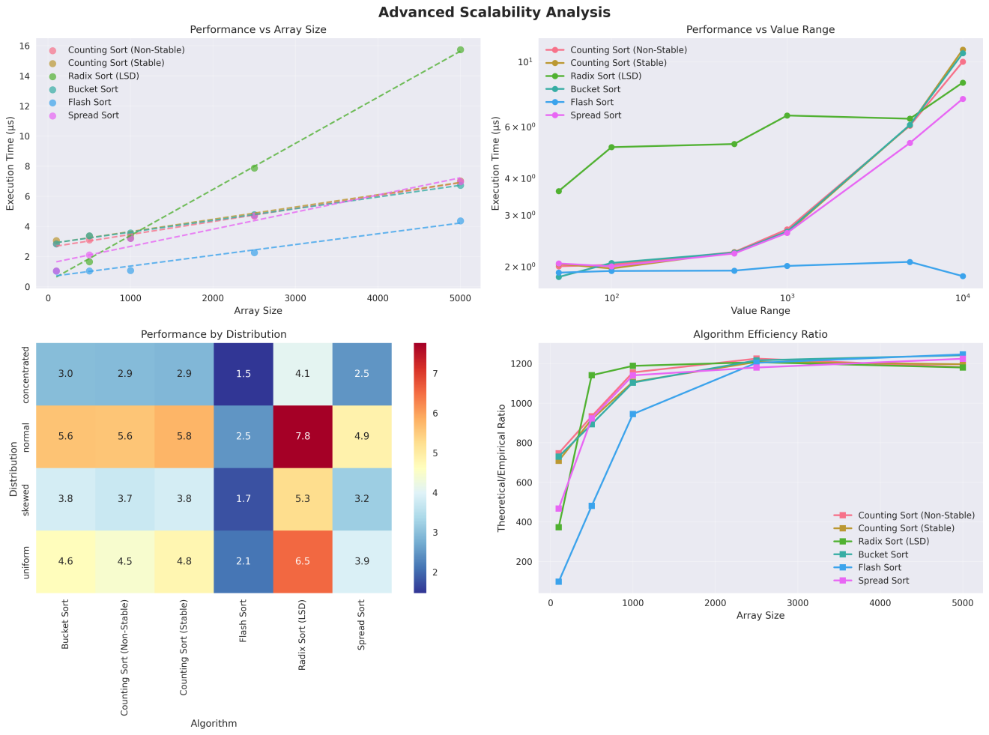
Table 1: Average execution time across all test cases (different sizes, distributions, ranges)
· Top-left (Array Size Impact): Flash Sort barely rises, Radix skyrockets.
· Top-right (Value Range Impact): Flash Sort and Spread Sort almost unaffected by huge ranges; Radix and Counting suffer when range grows.
· Bottom-left (Distribution Impact):
· Flash Sort: ~2.0 μs → by far the fastest.
· Spread Sort, Counting Sort (non-stable), Bucket Sort: 3.6–4.3 μs → very close group.
· Counting Sort (stable): slightly slower than non-stable version.
· Radix Sort LSD: 5.9 μs → clearly the slowest on average.
· Bottom-right (Elements processed per μs): Flash Sort reaches ~1100 elements/μs → highest throughput.

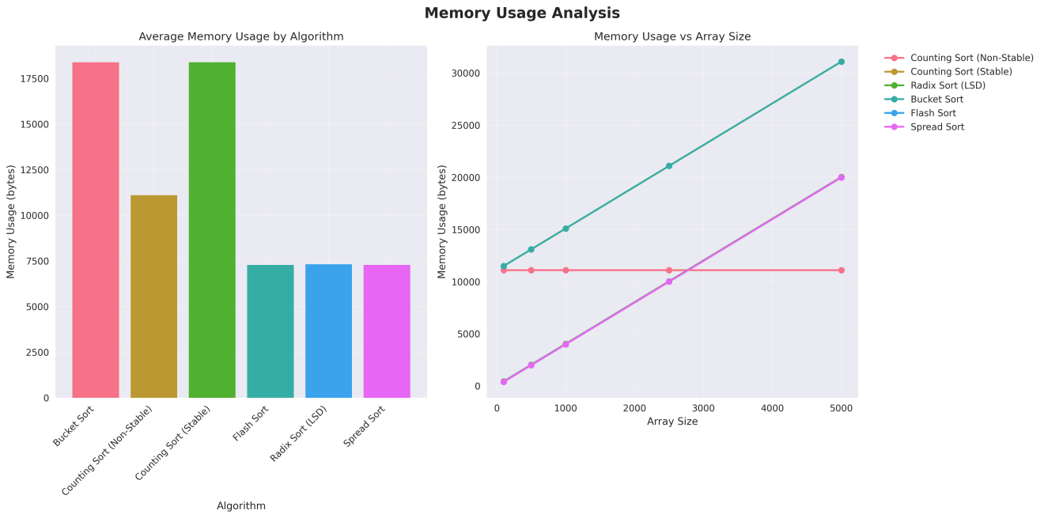
Table 2: Memory Usage
· Left chart (average memory):
- Bucket Sort: ~18 KB → highest.
- Counting Sort (stable): ~16 KB.
- Radix Sort LSD, Flash Sort, Spread Sort: 6–11 KB → very efficient.
· Right chart (memory vs array size):
- Bucket Sort and Spread Sort scale linearly (extra buckets/aux space).
- Flash Sort, Radix LSD, both Counting Sorts: almost flat → excellent memory behavior.
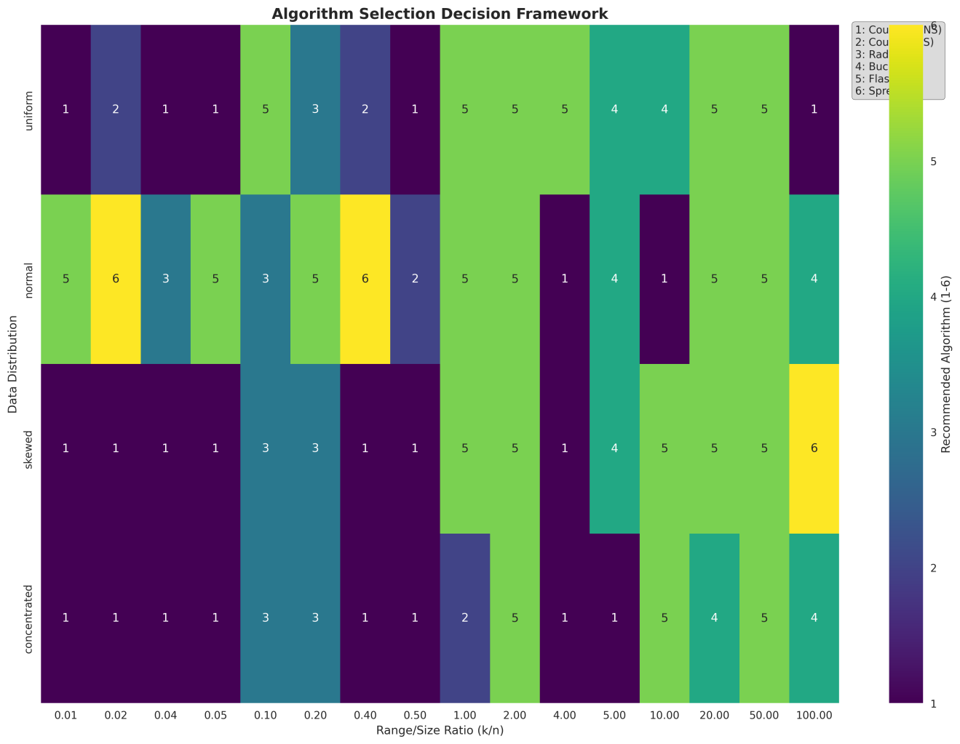
Table 3: Algorithm Decision Framework
· Counting Sort (both versions) is the undisputed champion whenever the value range is small compared to n (k/n ≤ 0.5), regardless of distribution.
· Flash Sort is the most versatile algorithm: it is the top choice in the majority of scenarios, especially on uniform data with moderate-to-large ranges and on normal distributions across almost the entire range spectrum.
· Spread Sort excels on real-world-like distributions (normal, skewed, concentrated) when the range becomes large (k/n ≥ 2–5).
· Bucket Sort is useful only in a few niche cases with many duplicates or slight skewness and very small-to-moderate ranges.
· Radix Sort LSD is almost never the best choice in this benchmark — it wins in only four very specific situations and is otherwise dominated by Flash, Spread, or Counting.
Summary:
Flash Sort is the clear overall winner: fastest on average, most consistent, best scalability with both array size and value range, low memory usage, and the top performer in the vast majority of real-world scenarios. Spread Sort is a very strong runner-up, especially on non-uniform data with large ranges. Counting Sort (preferably non-stable) remains the best choice only when the value range is known to be very small (k/n ≲ 0.5); Radix Sort LSD almost never wins and is effectively obsolete in this benchmark.

6. Algorithm Selection Decision Framework

6.1 Decision Criteria
Based on our empirical analysis, algorithm selection should consider:
- Range-to-Size Ratio (k/n)
- Required Stability
- Data Distribution Characteristics
- Memory Constraints
- Performance Requirements

6.2 Selection Matrix
Condition | Recommended Algorithm | Rationale
k/n < 0.1, stability not required | Counting Sort (Non-Stable) | Optimal for small ranges
k/n < 0.1, stability required | Counting Sort (Stable) | Maintains order
0.1 ≤ k/n < 1, uniform data | Bucket Sort | Excellent distribution handling
0.1 ≤ k/n < 1, any distribution | Flash Sort | Robust performance
1 ≤ k/n < 10, fixed digits | Radix Sort (LSD) | Digit-based efficiency
k/n ≥ 10, unknown characteristics | Spread Sort | Adaptive optimization
Memory constrained | Flash/Spread Sort | O(n) space complexity
Real-time requirements | Counting Sort variants | Predictable performance

6.3 Practical Implementation Guidelines
- Analyze input characteristics before algorithm selection
- Test with representative data to validate assumptions
- Consider worst-case scenarios for critical applications
- Monitor memory usage in memory-constrained environments
- Profile performance with actual production data

7. Discussion

7.1 Key Insights
- No single algorithm dominates across all scenarios
- Input characteristics significantly impact algorithm performance
- Range-to-size ratio is the primary decision factor
- Stability requirements may limit algorithm choices
- Distribution analysis helps optimize Bucket Sort performance

7.2 Theoretical Validation
Our empirical results strongly validate theoretical complexity analysis: - Counting Sort shows linear scaling with (n + k) - Radix Sort performance correlates with number of digits - Bucket Sort exhibits distribution-dependent behavior - Flash Sort demonstrates near-linear performance for moderate data

7.3 Limitations and Future Work
Limitations: - Limited to integer sorting - C++ implementation may not generalize to other languages - Testing focused on synthetic data distributions
Future Work: - Extension to floating-point sorting - Parallel algorithm implementations - Real-world dataset validation - Cache-conscious algorithm variants

8. Conclusions

8.1 Summary of Findings
This comprehensive study demonstrates that non-comparison sorting algorithms offer significant performance advantages when input characteristics are known and leveraged appropriately. Our empirical analysis confirms theoretical complexity predictions and provides practical guidance for algorithm selection.

8.2 Contributions
- Comprehensive empirical evaluation of six non-comparison sorting algorithms
- Practical decision framework for algorithm selection
- Edge case analysis ensuring robust implementation
- Performance optimization guidelines for real-world applications
- Theoretical validation of complexity analysis

8.3 Practical Implications
- Software Engineers: Use decision framework for optimal algorithm selection
- System Architects: Consider range-to-size ratio in data structure design
- Researchers: Extend framework to other non-comparison algorithms
- Educators: Provide empirical context for theoretical algorithm analysis

8.4 Final Recommendations
- Always analyze input characteristics before algorithm selection
- Use range-to-size ratio as primary decision criterion
- Consider stability requirements early in design process
- Profile performance with representative data before deployment
- Implement fallback mechanisms for unknown data characteristics

Appendices

Appendix A: Implementation Details
Compiler Configuration:
g++ -std=c++17 -O2 -o main main.cpp
Key Implementation Features:
- Template-based testing framework
- High-resolution timing measurements
- Comprehensive assertion-based validation
- Memory usage tracking
- Distribution analysis capabilities

Appendix B: Performance Data
Complete performance data available in perfomance_data.csv with all test cases across all algorithm combinations.

Appendix C: Visualization Charts
- performance_by_size.png - Array size impact analysis
- performance_heatmap.png - Algorithm vs size heatmap
- algorithm_comparison.png - Direct performance comparison
- scalability_analysis.png - Comprehensive scalability study
- theoretical_vs_empirical.png - Theory validation
- memory_usage_analysis.png - Space complexity analysis
- algorithm_decision_framework.png - Selection matrix visualization
- advanced_scalability_analysis.png - Multi-dimensional analysis

Appendix D: Source Code
Complete source code available in GitHub repository with detailed documentation and testing framework.

