DHANAK
DK-001(Formals)
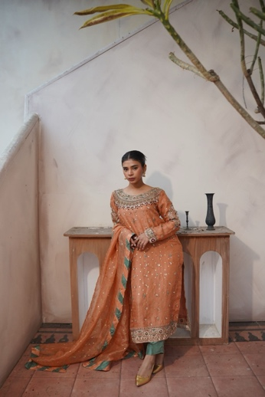
Short description:Hand embellished organza shirt paired with a straight pants and organza mukesh dupatta with chattapati borders.
Long Description:
Details
Shirt Fabric: Pure Mukesh-Embellished Organza (Hand Embellished)
Trousers Fabric: Tussle Silk (Straight Cut)
Dupatta Fabric: Pure Mukesh-Embellished Organza with Chatta Patti Borders
Design & Embellishment:
An elegant hand-embellished organza shirt paired with straight tussle silk trousers. The look is completed with a pure organza mukesh dupatta, finished with striking chatta patti borders—a perfect blend of tradition and sophistication.
Customization:
Color, fabric, and size can be customized to your preference.
Note: Prices may vary depending on fabric selection.
Delivery Time:
All pieces are made to order. Please allow 7–8 weeks for delivery.
Price: 87,500
DK-002(Formals)
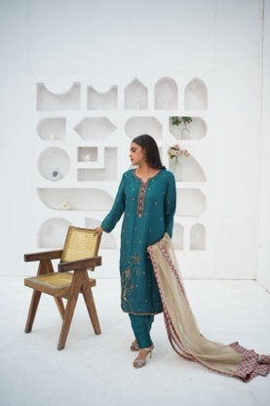
Short description:Hand embellished tassel silk shirt and trouser paired with zari net dupatta.
Long Description:
Details
Shirt Fabric: Tussle Silk (Hand Embellished)
Trousers Fabric: Tussle Silk
Dupatta Fabric: Zari Net
Design & Embellishment:
A graceful hand-embellished tassel silk shirt paired with matching tussle silk trousers. The look is elevated with a zari net dupatta, adding a touch of elegance and festive charm—perfect for formal gatherings and celebrations.
Customization:
Color, fabric, and size can be customized to your preference.
Note: Prices may vary depending on fabric selection.
Delivery Time:
All dresses are custom-made. Please allow 7–8 weeks for delivery.
Price: 39,500
Raw silk 80gm +16500

DK-003(Formals)
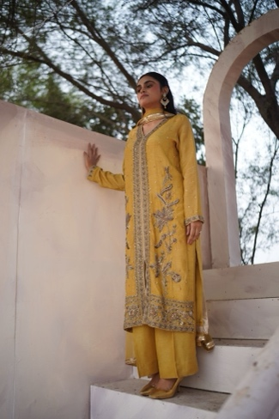
Short description:Hand embellished Korean raw silk long shirt with a front slit and flared pants with mukesh embellished bamber chiffon dupatta finished with a embellished lace
Long Description:
Details
Shirt Fabric: Korean Raw Silk
Pants Fabric: Korean Raw Silk (Flared)
Dupatta: Mukesh-embellished Bamber Chiffon, finished with embellished lace
Design & Embellishment:
Hand-embellished long shirt with front slit, paired with flared trousers. Dupatta features delicate mukesh work and is edged with an intricate embellished lace.
Customization:
Color, fabric, and size can be customized according to your preference.
Note: Prices may vary depending on the fabric selection.
Delivery Time:
Each piece is custom-made. Please allow 7–8 weeks for delivery.
Price: 66,500
Raw silk 80gm +16500
DK-004(Formals)
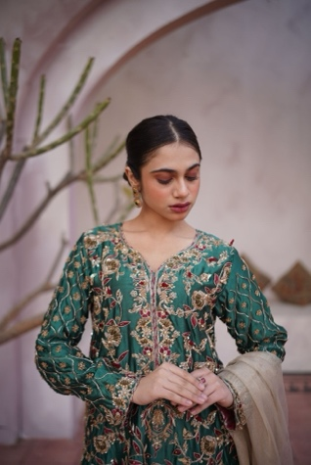
Short description:Heavily embellished sheesha silk shirt paired with flared pants and zari net dupatta.
Long Description:
Details
Shirt Fabric: Pure Sheesha Silk
Pants Fabric: Pure Sheesha Silk (Flared)
Dupatta: Zari Net
Design & Embellishment:
Heavily embellished Sheesha silk shirt paired with matching flared trousers. Styled with a delicate Zari net dupatta for an ethereal finish.
Customization:
Color, fabric, and size can be customized to your preference.
Note: Prices may vary based on fabric selection.
Delivery Time:
As all dresses are made to order, please allow 7–8 weeks for delivery.
Price: 84,500
Raw silk 80gm +16500

DK-005(Formals)
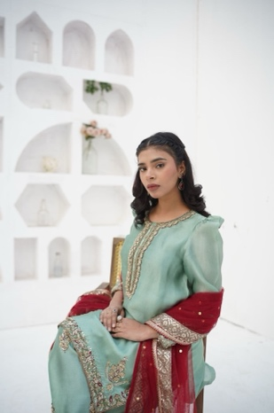
Short description:Hand embellished sheesha silk shirt and farshi shalwar paired with a mukesh net dupatta
Long Description:
Details
Shirt Fabric: Pure Sheesha Silk (Hand Embellished)
Farshi Shalwar Fabric: Pure Sheesha Silk
Dupatta Fabric: Mukesh-Embellished Net
Design & Embellishment:
An elegant hand-embellished sheesha silk shirt paired with a farshi shalwar for a regal silhouette. Styled with a mukesh net dupatta, this ensemble blends traditional craftsmanship with timeless sophistication.
Customization:
Color, fabric, and size can be customized to your preference.
Note: Prices may vary depending on fabric selection.
Delivery Time:
All our dresses are custom-made. Please allow 7–8 weeks for delivery.
Price: 56,500

DK-006(Formals)
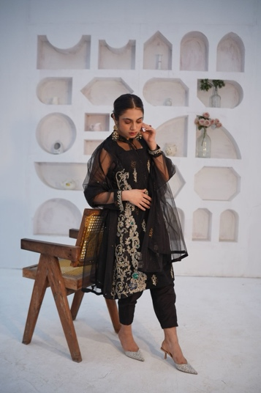
Short description:Hand embellished fine net A-line shirt with block printed cotton silk lining paired with a tapered korean raw silk shalwar and plain net dupatta.
Long Description:
Details
Shirt Fabric: Fine Net (Hand Embellished) with Block-Printed Cotton Silk Lining
Shalwar Fabric: Korean Raw Silk (Tapered)
Dupatta Fabric: Plain Fine Net
Design & Embellishment:
An elegant A-line shirt crafted in fine net, adorned with intricate hand embellishment and complemented by a block-printed cotton silk lining. Paired with a tapered Korean raw silk shalwar and a plain net dupatta for a graceful, understated look.
Customization:
Color, fabric, and size can be customized to your preference.
Note: Prices may vary depending on fabric selection.
Delivery Time:
All our dresses are custom-made. Please allow 7–8 weeks for delivery
Price: 59,500

DK-007(Formals)
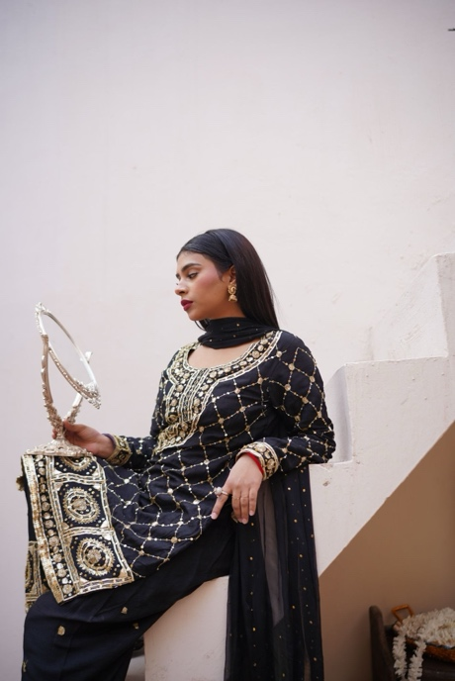
Short description: This article includes a heavily embellished shirt and shalwar with gota, zardozi and sequence work and a mukesh embellished bamber chiffon dupatta.
Long Description:
Details
Shirt Fabric: Korean Raw Silk
Shalwar Fabric: Korean Raw Silk
Dupatta: Mukesh-Embellished Bamber Chiffon
Design & Embellishment:
Heavily embellished shirt and shalwar adorned with intricate gota, zardozi, and sequin work. Paired with a mukesh-embellished bamber chiffon dupatta to complete the traditional look.
Customization:
Color, fabric, and size can be customized to your preference.
Note: Prices may vary based on fabric selection.
Delivery Time:
All our pieces are made to order. Please allow 7–8 weeks for delivery.
Price: 42,500

DK-008(Bridals)
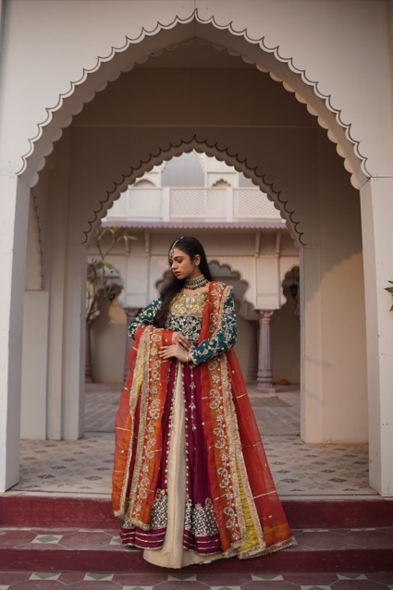
Short description:Heavily worked pishwas and dupatta with naqshi, pearls and zardozi paired with a plain brocade lehnga.
Long Description:
Details
Pishwas Fabric: Korean Raw Silk
Lehnga Fabric: Brocade
Dupatta Fabric: Pure Organza
Design & Embellishment:
A heavily worked pishwas and dupatta adorned with intricate naqshi, pearls, and zardozi, paired with a plain brocade lehnga for a regal and balanced look.
Note:
The dupatta features a heavy border on one side and lighter borders on the remaining three sides. Any customization to the border design will be charged additionally.
Customization:
Color, fabric, and size can be customized to your preference.
Note: Prices may vary depending on fabric selection.
Delivery Time:
All our dresses are custom-made. Please allow 7–8 weeks for delivery
Price: 120,000

DK-009(Formals)
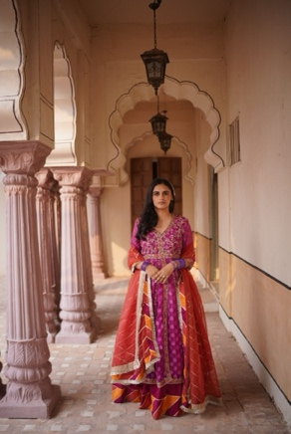
Short description:Heavily worked pishwas with resham, pearls and zardozi, korean raw silk lehnga and organza dupatta with chatta patti detailing.
Long Description:
Details
Pishwas Fabric: Self-Embossed Organza
Lehnga Fabric: Korean Raw Silk
Dupatta: Pure Organza with Chatta Patti Detailing
Design & Embellishment:
An elegant, heavily embellished pishwas featuring delicate resham embroidery, lustrous pearls, and intricate zardozi work. Paired with a graceful Korean raw silk lehnga and a pure organza dupatta finished with chatta patti detailing for a regal and timeless look.
Customization:
Color, fabric, and size can be customized according to your preference.
Note: Prices may vary depending on fabric selection.
Delivery Time:
All our pieces are custom-made. Please allow 7–8 weeks for delivery.
Price: 98,500
DK-0010(Bridals)
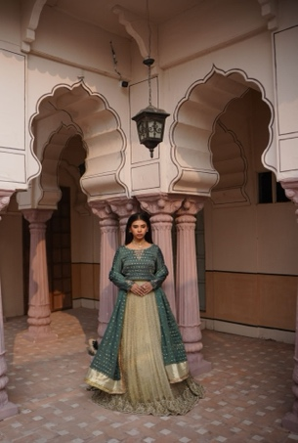
Short description:Pure organza lehnga hand worked with zardozi, pearls and sequins paired with a chiffon jamawar choli and dupatta in a striking combination of pistachio and teal green colors.
Long Description:
Details
Lehnga Fabric: Pure Organza
Choli Fabric: Chiffon Jamawar
Dupatta Fabric: Chiffon Jamawar
Design & Embellishment:
A regal pure organza lehnga intricately hand-worked with zardozi, shimmering sequins, and lustrous pearls. Paired with a chiffon jamawar choli and dupatta, presented in a striking pistachio and teal green color palette—perfect for making a statement at festive and wedding occasions.
Customization:
Color, fabric, and size can be customized to your preference.
Note: Prices may vary based on fabric selection.
Delivery Time:
Each piece is made to order. Please allow 7–8 weeks for delivery.
Price: 130,000

DK-0011(Bridals)
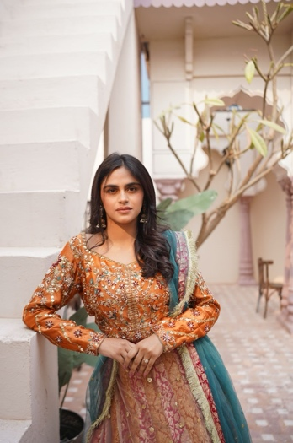
Short description:heavily worked choli with gota and zardozi paired with a double layered Lehnga embellished with gota work and a mukesh dupatta in a striking color combination
Long Description:
Details
Choli Fabric: Sheesha Silk
Lehnga Fabric: Double Layered — Jamawar (bottom), Mukesh Net (top)
Dupatta Fabric: Mukesh Net
Design & Embellishment:
A breathtaking mehndi bridal ensemble featuring a heavily worked choli adorned with gota and zardozi detailing. The look is completed with a double-layered lehnga—rich jamawar beneath and delicate mukesh net above—accented with intricate gota embellishments. Paired with a mukesh net dupatta, this striking color combination is perfect for a minimalist mehndi bride.
Customization:
Color, fabric, and size can be customized according to your preference.
Note: Prices may vary depending on fabric selection.
Delivery Time:
Each piece is custom-made. Please allow 7–8 weeks for delivery.
Price: 94,500

DK-0012(Bridals)
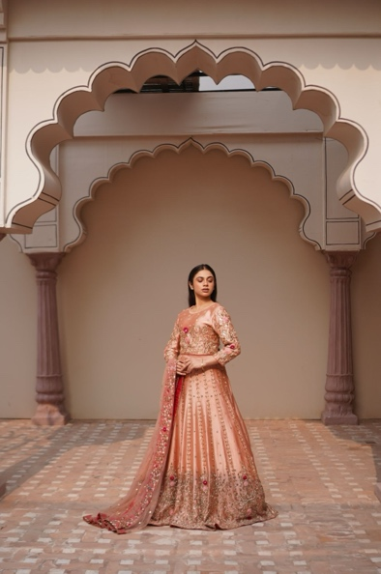
Short description:choli , lehnga and dupatta adorned with resham and zardozi handwork, meticulously finished; perfect for a minimalist bride
Long Description:
Details
Choli Fabric: Sheesha Silk
Lehnga Fabric: Sheesha Silk
Dupatta Fabric: Mukesh Net
Design & Embellishment:
An exquisite bridal ensemble featuring a choli, lehnga, and dupatta adorned with delicate resham embroidery and intricate zardozi handwork. Each piece is meticulously finished, creating a timeless look perfect for the minimalist bride.
Customization:
Color, fabric, and size can be customized to your preference.
Note: Prices may vary depending on fabric selection.
Delivery Time:
All dresses are made to order. Please allow 7–8 weeks for delivery.
Price: 220,000

DK-0013(Bridals)
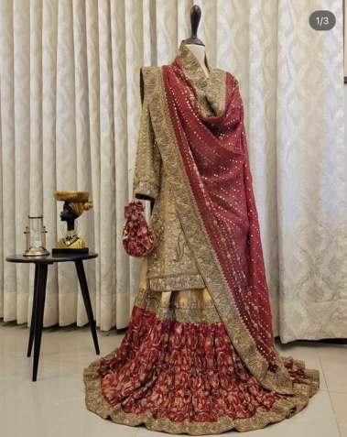
Short description:This stunning article consists of long shirt, lenga
and dupatta adorned with resham and zardozi
handwork, meticulously finished; perfect for heavy bride.
Long Description:
Details
Shirt Fabric: Pure organza
Lehnga Fabric: Brocade
Dupatta Fabric: Pure organza
Design & Embellishment:
This stunning article consists of long shirt, lenga
and dupatta adorned with resham and zardozi
handwork, meticulously finished; perfect for heavy bride.
Customization:
Color, fabric, and size can be customized to your preference.
Note: Prices may vary depending on fabric selection.
Delivery Time:
All dresses are made to order. Please allow 7–8 weeks for delivery.
Price:

DK-0014(Bridals)
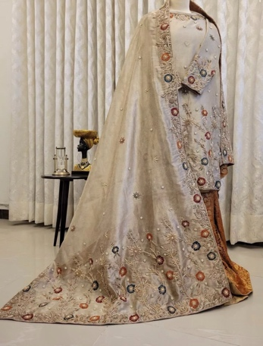
Short description:This stunning article consists of a short shirt, ghrara, and shawl adorned with resham and zardozi handwork, meticulously finished; perfect for nikkha bride.
Long Description:
Details
Shirt Fabric: pure tissue organza
Ghrara Fabric: Brocade/ Jamawar
Shawl Fabric: pure tissue organza
Design & Embellishment:This stunning article consists of a short shirt, ghrara, and shawl adorned with resham and zardozi handwork, meticulously finished; perfect for nikkha bride.
Customization:
Color, fabric, and size can be customized to your preference.
Note: Prices may vary depending on fabric selection.
Delivery Time:
All dresses are made to order. Please allow 7–8 weeks for delivery.
Price:

UJALA
UJ-001(Formals)
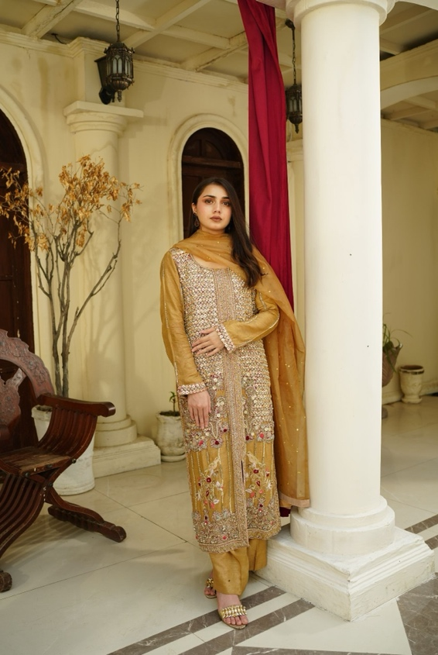
Short description:Hand embellished long shirt with front slit paired with flared pants and mukesh dupatta.

Long Description:
Details
Shirt Fabric: Korean Raw Silk (Hand Embellished, Long Shirt with Front Slit)
Pants Fabric: Korean Raw Silk (Flared)
Dupatta Fabric: Mukesh-Embellished Organza
Design & Embellishment:
A timeless hand-embellished long shirt with a contemporary front slit, paired with elegant flared trousers. The look is completed with a mukesh organza dupatta, creating a graceful balance of tradition and modern sophistication.
Customization:
Color, fabric, and size can be customized to your jpreference.
Note: Prices may vary depending on fabric selection.
Delivery Time:
Each piece is custom-made. Please allow 8–9 weeks for delivery.
Price: 3 piece 95,500
Fabric change to Raw silk 80gm +16500
UJ-002(Formals)
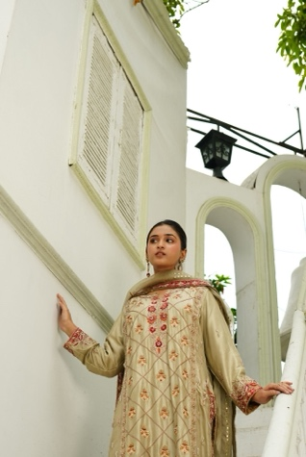
Short description:Hand embellished shirt paired with a traditional shalwar and embellished mukesh dupatta.
Long Description:
Details
Shirt Fabric: Raw Silk 80gm (with lining)
Shalwar Fabric: Raw Silk 80gm (Plain Dyed, Traditional Style)
Dupatta Fabric: Pure Organza with Mukaish Embellishment
Design & Embellishment:
An exquisite hand-embellished raw silk shirt, richly adorned on the front with intricate zardozi and resham handwork, and lightly detailed on the back for a graceful finish. Paired with a plain dyed traditional shalwar and a beautifully embellished mukaish organza dupatta, this ensemble strikes the perfect balance of elegance and tradition.
Customization:
Color, fabric, and size can be customized to your preference.
Note: Prices may vary depending on fabric selection.
Delivery Time:
Each piece is custom-made. Please allow 8–9 weeks for delivery.
Price: 96,500(as shown in picture)
Sheesha silk : 80,000
Price will be written as (80000-96500) on main page as range

UJ-003(Formals)
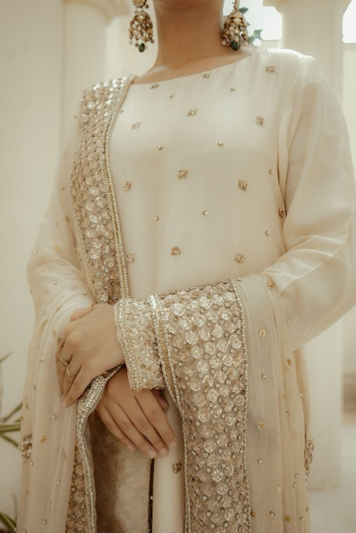
Short description:Hand embellished shirt paired with a straight pants and embellished mukesh dupatta.
Long Description:
Details
Shirt Fabric: Raw Silk 80gm (with lining)
Pants Fabric: Raw Silk 80gm (Straight Pants)
Dupatta Fabric: Pure Chiffon with Mukaish Embellishment
Design & Embellishment:
It includes a straight long shirt embellished with intricate naqshi, pearls, and Swarovski stones handwork on the front, back, and sleeves. The outfit is paired with plain dyed straight pants and a heavily embellished dupatta, creating an elegant and luxurious formal ensemble.
Customization:
Color, fabric, and size can be customized to your preference.
Note: Prices may vary depending on fabric selection.
Delivery Time:
Each piece is custom-made. Please allow 8–9 weeks for delivery.
Price: rawsilk with heavy duppata 110,500
Raw silk, Dupatta with minimal embellishment ( no borders) 69,500
Sheesha silk with heavy dupatta 94,000
Sheesha silk with minimal embellishment ( no borders) 54,000

UJ-004(Formals)
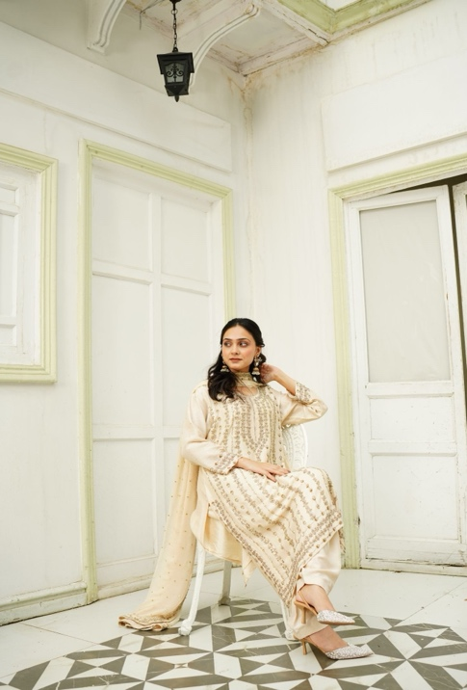
Short description:Hand embellished Raw silk shirt paired with a traditional shalwar and embellished mukesh dupatta.
Long Description:
Details
Shirt Fabric: Raw Silk 80gm (with lining)
Shalwar Fabric: Raw Silk 80gm (Plain Dyed, Traditional Style)
Dupatta Fabric: Pure Organza with Mukaish Embellishment
Design & Embellishment:
An exquisite hand-embellished raw silk shirt, richly adorned on the front with intricate zardozi and resham handwork, and lightly detailed on the back for a graceful finish. Paired with a plain dyed traditional shalwar and a beautifully embellished mukaish organza dupatta, this ensemble strikes the perfect balance of elegance and tradition.
Customization:
Color, fabric, and size can be customized to your preference.
Note: Prices may vary depending on fabric selection.
Delivery Time:
Each piece is custom-made. Please allow 8–9 weeks for delivery.
Price: 96,500
Sheesha silk: 80,000

UJ-005(Formals)
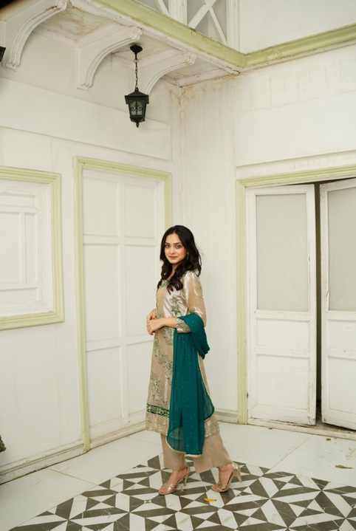
Short description:Hand embellished shirt adorned with intricate zardozi and resham handwork paired with plain straight pants and a mukaish-detailed chiffon dupatta.
Long Description:
Details
- Shirt Fabric: Tissue Lame (with lining)
- Pants Fabric: Korean Raw Silk (Plain Dyed Straight Pants)
- Dupatta Fabric: Chiffon with Mukaish Work
Design & Embellishment:
A timeless formal ensemble featuring a shirt adorned with intricate zardozi and resham handwork on the front, with delicate detailing at the back. It is paired with plain straight pants and a mukaish-detailed chiffon dupatta, making it a graceful yet versatile outfit suitable for festive and formal occasions.

Customization:=
Color, fabric, and size can be customized to your preference.
Note: Prices may vary depending on fabric selection.
Delivery Time:
Each piece is custom-made. Please allow 8–9 weeks for delivery.
Price: 64,500
UJ-006(Formals)
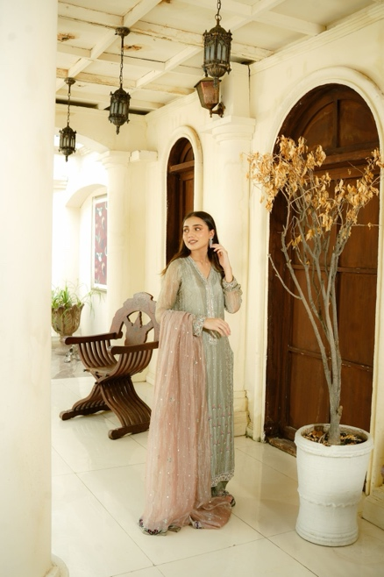
Short description:Hand-embellished shirt and dupatta embellished with zardozi sequences and resham handwork paired with classic straight pants and tissue dupatta .
Long Description:
Details
- Shirt Fabric: Pure Tissue
- Pants Fabric: Korean Raw Silk (Straight Pants)
- Dupatta Fabric: Pure Tissue
Design & Embellishment:
Hand-embellished shirt and dupatta embellished with zardozi sequences and resham handwork paired with classic straight pants. The ensemble is crafted in a sophisticated silver gray shade for the shirt and pants, complemented by a delicate lilac pink dupatta, making it a perfect choice for luxury occasions.

Customization:
Color, fabric, and size can be customized to your preference.
Note: Prices may vary depending on fabric selection.
Delivery Time:
Each piece is custom-made. Please allow 8–9 weeks for delivery.
Price: 89,500
UJ-007(Formals)
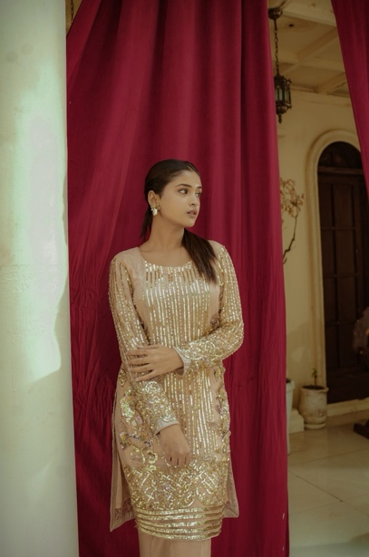
Short description:Hand embellished shirt adorned with pearls and sequins paired with bootcut pants and dupatta.
Long Description:
Details
Shirt Fabric: Soft Net
Pants Fabric: Korean Raw Silk (Bootcut Pants)
Dupatta Fabric: Soft Net
Design & Embellishment:
Hand-embellished shirt adorned with pearls and sequins, paired with plain dyed long bootcut pants and a matching dyed dupatta, creating an elegant and sophisticated formal ensemble.

Customization:
Color, fabric, and size can be customized to your preference.
Note: Prices may vary depending on fabric selection.
Delivery Time:
Each piece is custom-made. Please allow 8–9 weeks for delivery.
Price: 63,500
UJ-008(Formals)
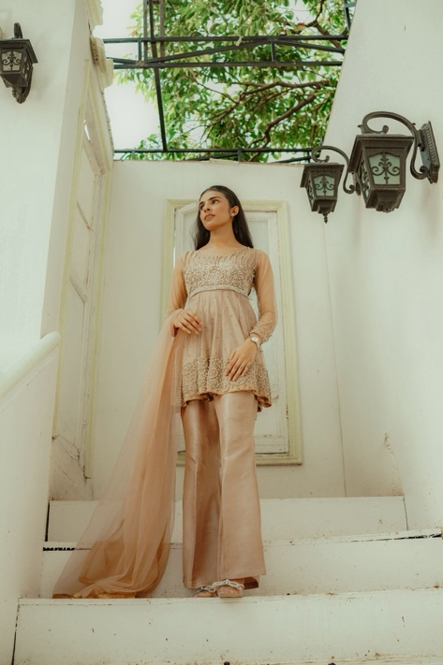
Short description:A heavily embellished short peplum dress adorned with delicate pearls and crystals, paired with plain dyed long bootcut pants and a matching dyed net dupatta.
Long Description:
Details
Peplum Fabric: Premium Net (heavily embellished with pearls & crystals)
Pants Fabric: Korean Raw silk
Dupatta Fabric: Net (plain dyed)
Design & Embellishment:
A heavily embellished short peplum dress adorned with delicate pearls and crystals, paired with plain dyed long bootcut pants and a matching dyed net dupatta. This timeless silhouette blends modern elegance with intricate craftsmanship, making it a statement piece for special occasions.

Customization:
Color, fabric, and size can be customized to your preference.
Note: Prices may vary depending on fabric selection.
Delivery Time:
Each piece is custom-made. Please allow 8–9 weeks for delivery.
Price: 64,500
Trousers Raw silk 80gm +8000
UJ-009(Formals)
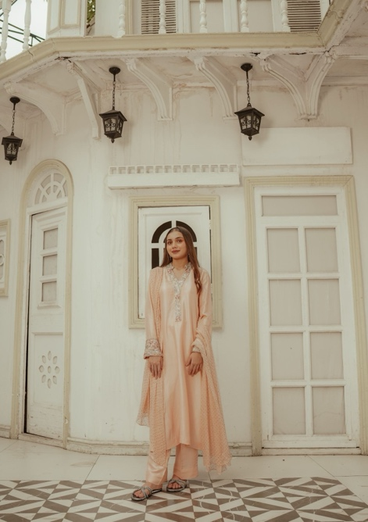
Short description:Hand-embellished Shirt minimally embellished with zardozi and resham handwork, paired with plain dyed straight pants and a mukaish dupatta.
Long Description:
Details
Shirt Fabric: Raw Silk 80gm
Pants Fabric: Raw Silk 80gm
Dupatta Fabric: Pure Chiffon with Mukesh
Design & Embellishment:
Shirt minimally embellished with zardozi and resham handwork, paired with plain dyed straight pants and a mukaish dupatta.
Optional Add-on:
This outfit can be paired with a matching embellished shawl (border on all sides + sleeves border).
- Shawl Fabric: Pure Raw Silk 80gm
Customization:
Color, fabric, and size can be customized to your preference.
Note: Prices may vary depending on fabric selection.
Delivery Time:
Each piece is custom-made. Please allow 8–9 weeks for delivery.
Price: 56,500

