Utilisation de ManagedBean

Création du projet et configuration
Arrêter Tomcat.
Click-droit sur BaseJSF puis Copy.
Renommer : Lab3
Changer comme suit le fichier pom.xml
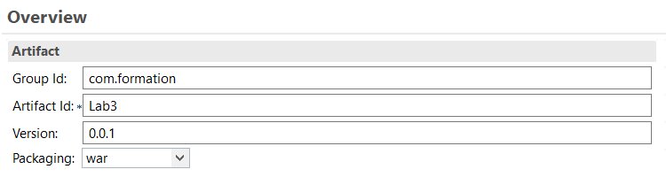

Navigation du site
Mauvais password ou id client

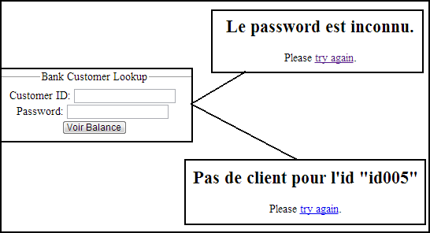

Bon password pour Jules/Marc/Jean

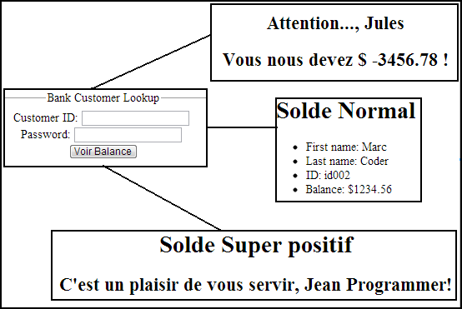

Structure du projet
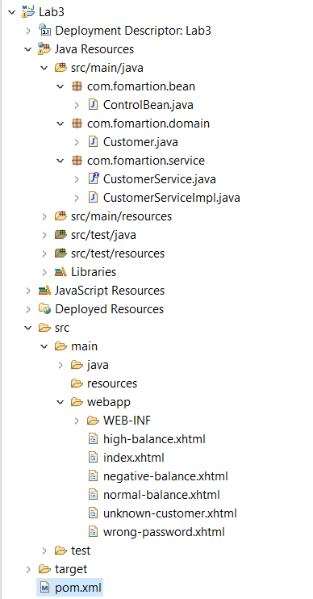

Code source
- Customer.java (les objets du domain)
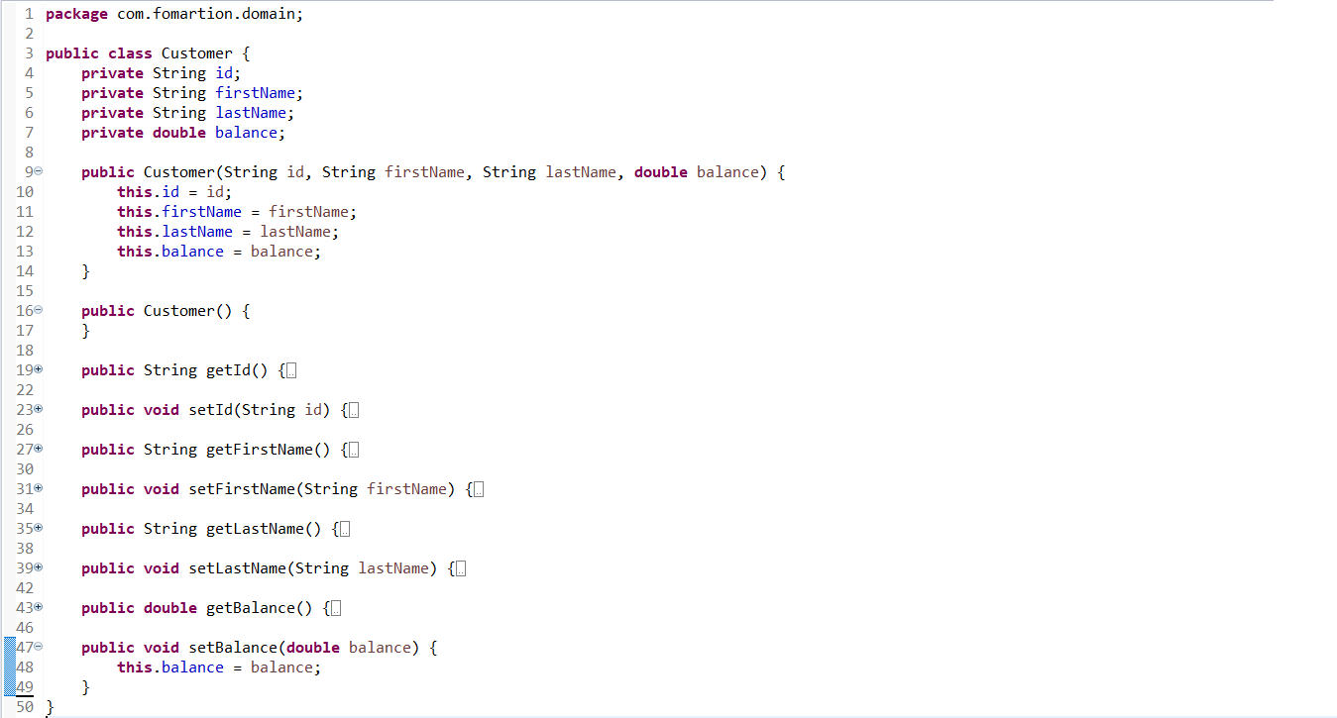
- CustomerService.java (Interface du Service)
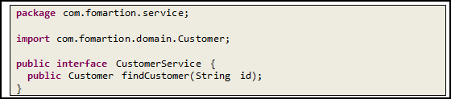
- CustomerServiceImpl.java (le service)
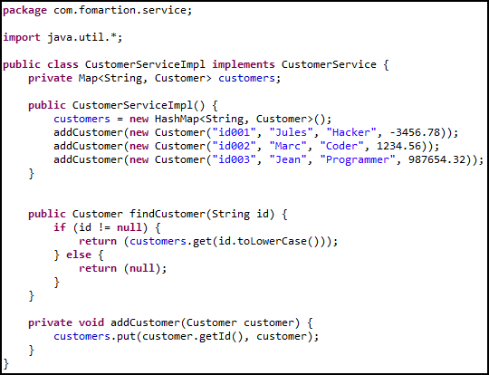

- ControlBean.java (votre mini controlleur)
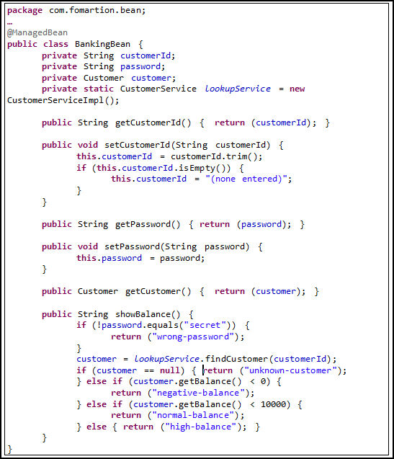

WebContent : les pages

Compléter le code en rouge

index.xhtml

<html xmlns="http://www.w3.org/1999/xhtml"
xmlns:f="http://xmlns.jcp.org/jsf/core"
xmlns:h="http://xmlns.jcp.org/jsf/html">

<h:head>
<title>Agir avec un formulaire</title>
</h:head>
<h:body bgcolor="white">
<div align="center">
<h1 class="title">JSF 2: Managed Beans</h1>
<br />
<fieldset>
<legend>Bank Customer Lookup</legend>
<h:form>
Customer ID:
<h:inputText value="#{...}" />
<br />
Password:
<h:inputSecret value="#{...}" />
<br />
<h:commandButton value="Voir Balance" action="#{...}" />
</h:form>
</fieldset>
</div>
</h:body>
</html>

Solution 1

unknown-customer.xhtml

<html xmlns="http://www.w3.org/1999/xhtml"
xmlns:f="http://xmlns.jcp.org/jsf/core"
xmlns:h="http://xmlns.jcp.org/jsf/html">
<h:head>
<title>Client inconnu</title>
</h:head>
<h:body>
<div align="center">
<h1 class="title">Client inconnu</h1>
<br />
<h2>Pas de client pour l'id "#{...id du submit}"</h2>
<p>
Please <a href="index.xhtml">try again</a>.
</p>
</div>
</h:body>
</html>

Solution 2

normal-balance.xhtml

<html xmlns="http://www.w3.org/1999/xhtml"
xmlns:f="http://xmlns.jcp.org/jsf/core"
xmlns:h="http://xmlns.jcp.org/jsf/html">
<h:head>
<title>Your Balance</title>
</h:head>
<h:body>
<h1 class="title">Solde Normal</h1>
<ul>
<li>First name: #{... firstname}</li>
<li>Last name: #{... lastName}</li>
<li>ID: #{... id}</li>
<li>Balance: $#{... balance}</li>
</ul>
</h:body>
</html>

Solution 3

negative-balance.xhtml

<html xmlns="http://www.w3.org/1999/xhtml"
xmlns:f="http://xmlns.jcp.org/jsf/core"
xmlns:h="http://xmlns.jcp.org/jsf/html">
<h:head>
<title>Vous devez de l'argent!</title>
</h:head>
<h:body>
<div align="center">
<h1 class="title">Solde negatif</h1>
<br />
<h2>Attention..., #{... firstName}</h2>
<h2>Vous nous devez $ #{... balance} !</h2>
</div>
</h:body>
</html>

Solution 4

high-balance.xhtml

<html xmlns="http://www.w3.org/1999/xhtml"
xmlns:f="http://xmlns.jcp.org/jsf/core"
xmlns:h="http://xmlns.jcp.org/jsf/html">

<h:head>
<title>Votre Balance</title>
</h:head>
<h:body>
<div align="center">
<h1 class="title">Solde Super positif</h1>
<h2>C'est un plaisir de vous servir,
#{... firstName} #{... lastName}!</h2>
</div>
</h:body>
</html>

Solution 5
wrong-password.xhtml

<html xmlns="http://www.w3.org/1999/xhtml"
xmlns:f="http://xmlns.jcp.org/jsf/core"
xmlns:h="http://xmlns.jcp.org/jsf/html">
<h:head>
<title>Wrong Password</title>
</h:head>
<h:body>
<div align="center">
<h1 class="title">Password Inconnu</h1>
<br />
<h2>Le password est inconnu.</h2>
<p>
Please <a href="index.xhtml">try again</a>.
</p>
</div>
</h:body>

</html>

Solution

Solution 1 :

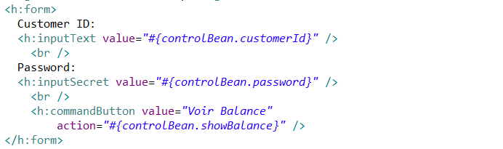

Solution 2:

Solution 3

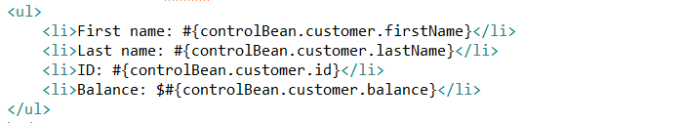

Solution 4

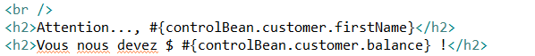

Solution 5

