Shopping Cart

Home

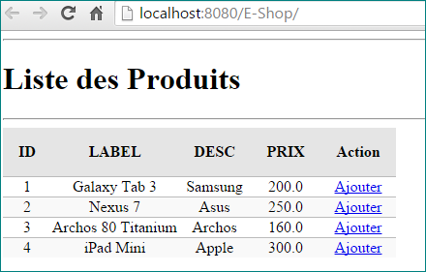

Ajouter un produit

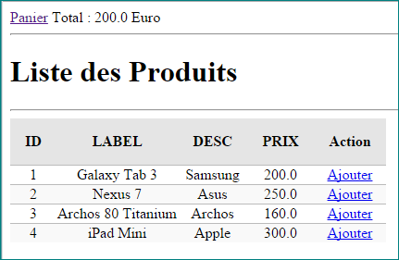

cart.xhtml

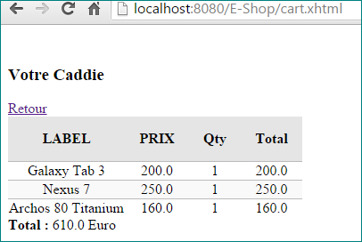

Structure du projet
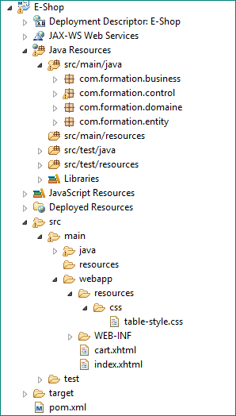

Création du projet
Créez un projet web maven nommé : E-Shop

Code source

Produit.java (Entity)

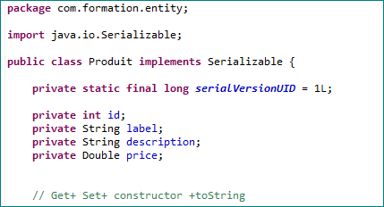

ProduitFacade.java (Interface du Service)

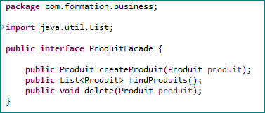

ProduitFacadeBean.java (Implémentation)

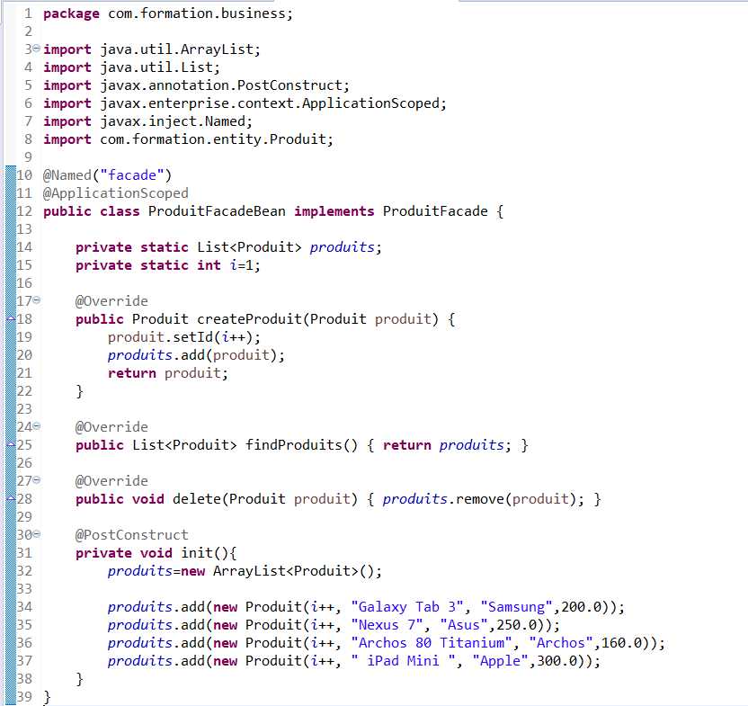

LineCart.java (LigneCaddie)

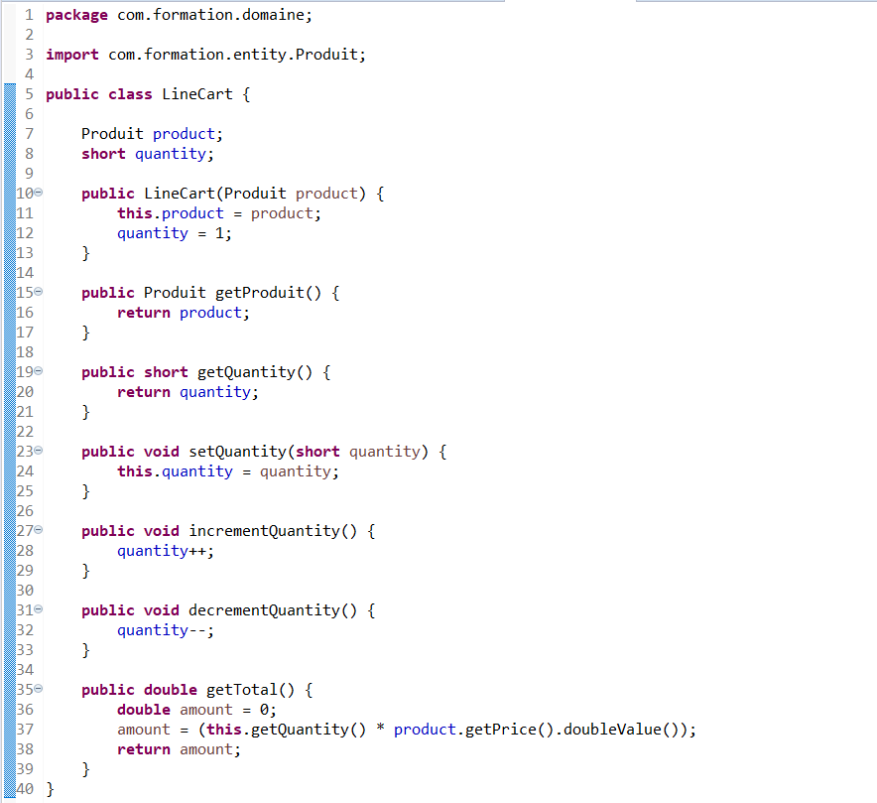

ShoppingCart.java (Caddie)

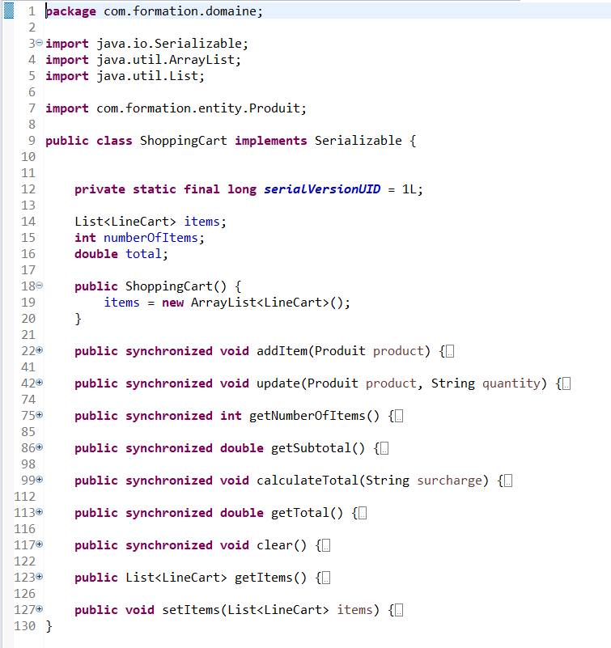

Les méthodes

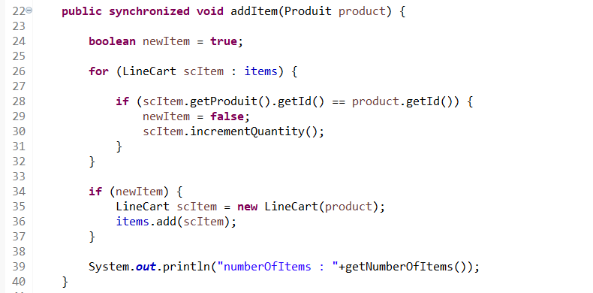

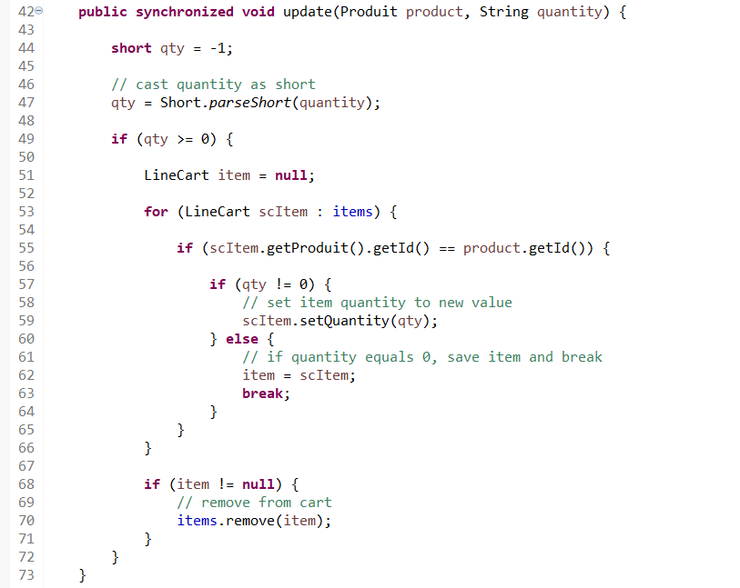
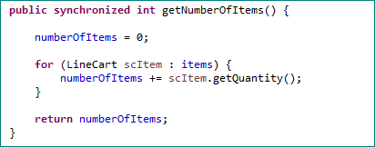

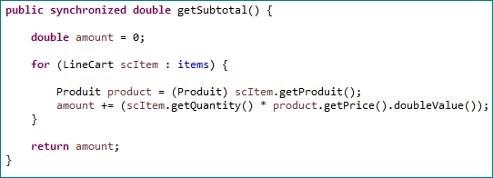

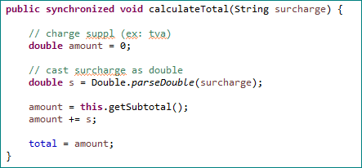

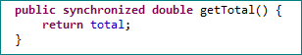

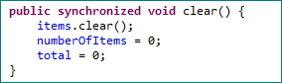

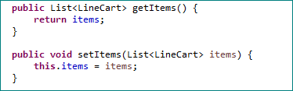

ProduitBean.java (mini controlleur)

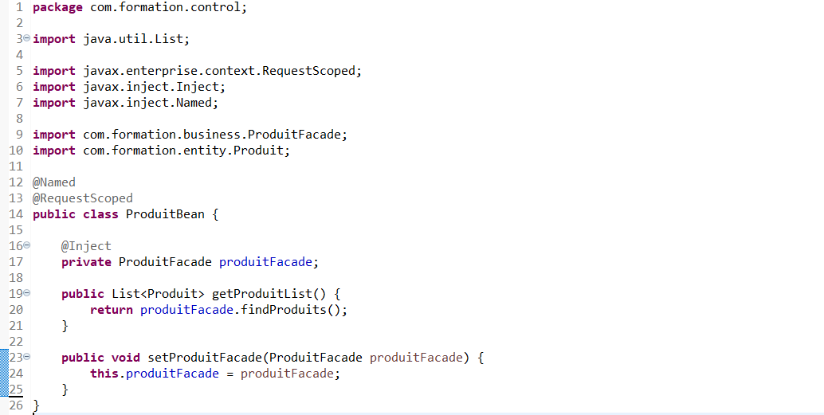

CaddieBean.java (votre mini controlleur)

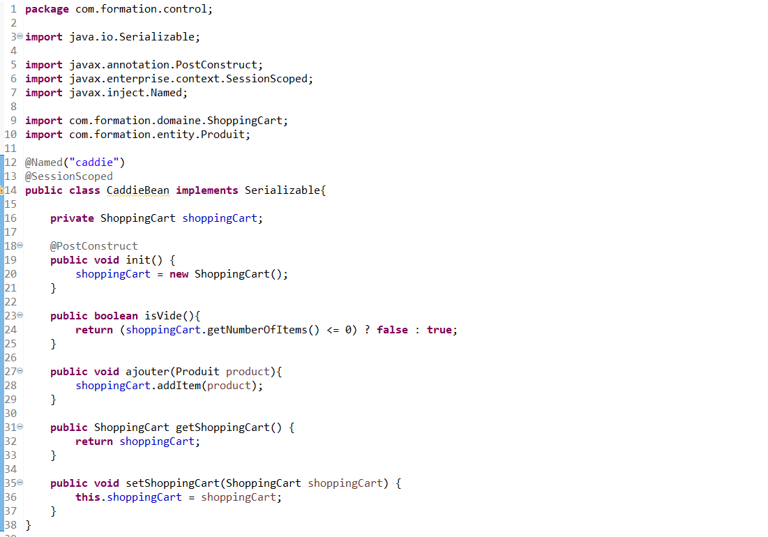

webapp : les pages

css à ajouter dans le répertoire resources\css\table-style.css

.client-table{
border-collapse:collapse;
}

.client-table-header{
text-align:center;
background:none repeat scroll 0 0 #E5E5E5;
border-bottom:1px solid #BBBBBB;
padding:16px;
}

.client-table-odd-row{
text-align:center;
background:none repeat scroll 0 0 #FFFFFFF;
border-top:1px solid #BBBBBB;
}

.client-table-even-row{
text-align:center;
background:none repeat scroll 0 0 #F9F9F9;
border-top:1px solid #BBBBBB;
}

cart.xhtml

<html xmlns="http://www.w3.org/1999/xhtml"
xmlns:f="http://xmlns.jcp.org/jsf/core"
xmlns:h="http://xmlns.jcp.org/jsf/html">
<h:head>
<title>Caddie Page</title>
<h:outputStylesheet library="css" name="table-style.css" />
</h:head>
<h:body>
<h3>Votre Caddie</h3>
<h:link value="Retour" outcome="index" />
<h:dataTable value="#{caddie.shoppingCart.items}" var="c"
styleClass="client-table" headerClass="client-table-header"
rowClasses="client-table-odd-row,client-table-even-row">

<h:column>
<f:facet name="header">
<h:outputLabel value="LABEL" />
</f:facet>
<h:outputText value="#{c.produit.label}" />
</h:column>

<h:column>
<f:facet name="header">
<h:outputLabel value="PRIX" />
</f:facet>
<h:outputText value="#{c.produit.price}" />
</h:column>

<h:column>
<f:facet name="header">
<h:outputLabel value="Qty" />
</f:facet>
<h:outputText value="#{c.quantity}" />
</h:column>

<h:column>
<f:facet name="header">
<h:outputLabel value="Total" />
</f:facet>
<h:outputText value="#{c.total}" />
</h:column>

</h:dataTable>

<b>Total : </b><h:outputText value="#{caddie.shoppingCart.subtotal}" /> Euro

</h:body>
</html>

index.xhtml

<html xmlns="http://www.w3.org/1999/xhtml"
xmlns:f="http://xmlns.jcp.org/jsf/core"
xmlns:h="http://xmlns.jcp.org/jsf/html"
xmlns:ui="http://xmlns.jcp.org/jsf/facelets">

<h:head>
<h:outputStylesheet library="css" name="table-style.css" />
</h:head>
<h:body bgcolor="white">
<h:link value="Panier" outcome="cart" rendered="#{caddie.vide}"/> <b> </b><h:outputText value="Total : #{caddie.shoppingCart.subtotal} Euro" rendered="#{caddie.vide}"/>
<hr />

<h1>Liste des Produits</h1>
<hr />
<h:form>
<h:dataTable value="#{produitBean.produitList}" var="c"
styleClass="client-table" headerClass="client-table-header"
rowClasses="client-table-odd-row,client-table-even-row">

<h:column>
<!-- column header -->
<f:facet name="header">
<h:outputLabel value="ID" />
</f:facet>
<!-- row record -->
<h:outputText value="#{c.id}" />
</h:column>

<h:column>
<f:facet name="header">
<h:outputLabel value="LABEL" />
</f:facet>
<h:outputText value="#{c.label}" />
</h:column>

<h:column>
<f:facet name="header">
<h:outputLabel value="DESC" />
</f:facet>
<h:outputText value="#{c.description}" />
</h:column>

<h:column>
<f:facet name="header">
<h:outputLabel value="PRIX" />
</f:facet>
<h:outputText value="#{c.price}" />
</h:column>

<h:column>
<f:facet name="header">Action</f:facet>
<h:commandLink value="Ajouter" action="#{caddie.ajouter(c)}" />
</h:column>

</h:dataTable>
</h:form>
</h:body>
</html>

