
De

Deep Learning–Based Semantic Segmentation of Skin Lesions
By: Raad Shraiedeh 161287
Abdelrahman Abu Naser 160825
Hamza Sawafta 161395

Course: Computer Vision – Fall 2025/2026
Course instructor: Dr. Abdullah Al-amaren

1 Problem statement
Semantic Segmentation is a fundamental computer vision task, for which considerable interest has been generated, especially in dermatological image analysis, for which proper segmentation of lesions is of critical importance. It is a laborious process undertaken by dermatologists, for which there may be inconsistencies due to observer variation. It thus becomes imperative for effective semantic segmentation solutions built on deep learning techniques.
The target of the project is to develop and train a deep learning model that does the binary semantic image segmentation of the skin lesions given the dermatoscopic image as an input and generates the binary pixel-level map between the lesions and the surrounding areas of the skin to differentiate between them.
The problem formulation is that of a binary semantic segmentation, where each pixel belongs to one of two classes:
- Lesion
- Background

2 Research on the Neural Networks and architectures

2.1 Neural Networks used for the problem

Convolutional neural networks (CNNs) continue to be the benchmark solution for learning hierarchical spatial representations (LeCun et al., 1998). Their ability to be applied to semantic segmentation tasks has been greatly enhanced by the introduction of Fully Convolutional Networks (FCNs) (Long et al., 2015), where fully connected layers were replaced by convolutions to allow dense mappings at the pixel level. Current day segmentation frameworks commonly involve encoder-decoders to handle conﬂicting goals of high-level feature abstraction and ﬁne-grained pixel-level localization: where the encoder is used to abstract input to feature points, while the decoders handle the upscale to form an image. This is well explained by the U-Net model proposed by Ronneberger et al. (2015), where skip connections play an essential part in mapping abstract semantic mappings to the spatial information necessary to mark boundaries.

2.2 Modern architectures
To find the most effective solution for skin lesion detection, we explored five modern deep learning models. Each was chosen for its unique way of handling image data and its proven track record in visual recognition:
- VGG16-based U-Net: This model uses a "contracting" path to understand context and a "symmetric" path to pin down exact locations. By using the VGG16 network—originally designed for large-scale image recognition (Simonyan and Zisserman, 2015)—as its foundation, this U-Net setup is particularly good at the precise mapping required in medical imaging (Ronneberger et al., 2015).

- DeepLabV3 (ResNet-50 backbone): Unlike standard models, DeepLabV3 uses "dilated" convolutions (Atrous Spatial Pyramid Pooling) to look at the image at multiple scales at once. This helps the system understand both small details and the overall structure of a lesion (Chen et al., 2017). It uses a ResNet-50 foundation to ensure the neural network remains stable during training (He et al., 2016).
- Fully Convolutional Network (FCN-ResNet50): This is a more streamlined, "lightweight" approach. It skips the traditional dense layers of a neural network to predict the class of every pixel directly from the visual features it finds (Long et al., 2015), backed again by the reliable ResNet framework (He et al., 2016).

- SegNet: The standout feature of SegNet is its memory efficiency. It remembers the positions of the most important pixels during the initial "look" and reuses those indices when drawing the final mask. This makes it a great candidate for high-performance segmentation without needing massive computing power (Badrinarayanan et al., 2017).

- ResNet34 U-Net: A U-Net variant that employs a ResNet34 backbone as the encoder. The use of residual connections enables deeper feature extraction while mitigating the vanishing gradient problem, resulting in improved learning stability and representational capacity (He et al., 2016). This architecture combines the strong feature extraction ability of ResNet with the localization strength of the U-Net decoder.

2.3 Modern architectures comparison

Architecture | Description and number/types of layers | Advantages | Disadvantages
VGG16 U-Net | Encoder–decoder with skip connections | Strong localization, stable training | High memory usage
DeepLabV3-R50 | Atrous convolutions + ASPP | Captures multi-scale context | Computationally expensive
FCN-R50 | Fully convolutional ResNet | Efficient, fewer parameters | Coarser boundaries
SegNet | Encoder–decoder with pooling indices | Memory efficient | Less precise edges
ResNet34 U-Net | U-Net with ResNet34 encoder | Strong feature extraction, deep residual learning | Increased model complexity

3 Models’ development and training

3.1 Dataset

For this project, we used the ISIC 2018 Skin Lesion Dataset, a globally recognized benchmark provided by the International Skin Imaging Collaboration. This collection is widely considered the "gold standard" for training medical AI because it pairs high-quality dermoscopic images with "ground-truth" masks—precise maps of the lesions drawn and verified by expert dermatologists.

Data Preparation & Processing

To ensure the model could handle the variety of images found in a real clinical setting, we performed several key preprocessing steps:

Standardizing Size: All images were resized to 256 × 256 pixels. This ensures the neural network receives a consistent input size, balancing the need for fine detail with computational efficiency.

Color Normalization: Because images are often taken under different lighting conditions or with different cameras, we standardized the pixel values. This helps the model focus on the actual texture and borders of the lesion rather than the lighting of the room.

Expanding the Dataset (Augmentation): To prevent the model from simply "memorizing" the training photos, we used data augmentation to create a more diverse training set of roughly 20,000 samples. By digitally flipping, rotating, and scaling the original images, we essentially showed the model the same lesions from multiple "angles." This teaches the system to recognize a lesion regardless of how a doctor holds the camera.

Mask Format

The output for every image is a Binary Mask. Think of this as a digital stencil where:

White pixels represent the lesion (the area of concern).

Black pixels represent the background (healthy skin).

3.2 Training and validation
To make sure our results were both fair and reliable, we followed a strict training and testing process. We didn’t want the models to just "memorize" the images, so we split our data into three distinct groups:

- Training (70%): This is where the models did their actual learning.

- Validation (15%): We used this set as a "practice test" to fine-tune our settings and see how the models were progressing.

- Testing (15%): We kept this data completely separate until the very end. This acted as the "final exam" to see how well our system would perform on skin images it had never encountered before.

Our Technical Approach
Our team built and trained these models using the PyTorch framework. For the "engine" behind the learning process, we chose the Adam optimizer. We went with Adam because it’s known for being stable and for automatically adjusting the learning speed, which helped our models converge more smoothly.
To guide the models toward better accuracy, we used a combination of two different "scoring" methods (Loss Functions):
- Binary Cross-Entropy (BCE): This focuses on getting every individual pixel right.
- Dice Loss: This focuses on how well the predicted shape overlaps with the actual lesion.
By combining these two, we ensured that our models didn't just guess pixels correctly but actually understood the overall shape and boundaries of the lesions—a crucial factor when dealing with medical images.

Keeping the Comparison Fair
One of our main goals was to see which architecture actually performed best. To do this, we kept almost everything the same across all five models. We only allowed ourselves to tweak a few specific "knobs" (hyperparameters), such as:
- Learning rate (how fast the model learns)
- Batch size (how many images it looks at at once)
Table 2: Description of the hyperparameters considered for each architecture
Architecture | Hyperparameter | Description | Value(s)
VGG16 U-Net |  | Optimizer step size
  Learning Rate
  {1e-4, 3e-5, 1e-5}
VGG16 U-Net | Batch Size
  Number of samples per batch
  {4, 8, 16}
DeepLabV3-R50 |  | Optimizer step size | {1e-4, 3e-5, 1e-5}
  Learning Rate
DeepLabV3-R50 | Batch Size
  Number of samples per batch
  {4, 8, 16}
ResNet34 U-Net |  | Optimizer step size | {1e-4, 3e-5, 1e-5}
  Learning Rate
ResNet34 U-Net | Batch Size
  Number of samples per batch
  {4, 8, 16}
SegNet |  | Optimizer step size | {1e-4, 3e-5, 1e-5}
  Learning Rate
SegNet | Batch Size
  Number of samples per batch
  {4, 8, 16}
FCN-R50 |  | Optimizer step size | {1e-4, 3e-5, 1e-5}
  Learning Rate
FCN-R50 | Batch Size
  Number of samples per batch
  {4, 8, 16}

For each architecture, at least nine hyperparameter combinations were evaluated by systematically varying the learning rate and batch size. This exceeds the minimum requirement specified in the project guidelines and provides a more reliable assessment of model sensitivity to training parameters.
The performance obtained for each tested combination was recorded on both the training and validation sets. For reporting clarity, only the top three performing combinations per architecture—based on validation Dice score—are presented.
Table 3: Combinations of the hyperparameter values and corresponding performance achieved
Architecture | Combination of hyperparameter values | Training performance | Validation performance
VGG16 U-Net | LR=3e-05 | BATCH=8 | 0.8906 | 0.8948
VGG16 U-Net | LR=3e-05 | BATCH=4 | 0.8903 | 0.8944
VGG16 U-Net | LR=3e-05 | BATCH=16 | 0.8888 | 0.8901
DeepLabV3-R50 | LR=0.0001 | BATCH=4 | 0.8858 | 0.8822
DeepLabV3-R50 | LR=0.0001 | BATCH=8 | 0.8901 | 0.8802
DeepLabV3-R50 | _ | _ | _
ResNet34_SE_UNet | LR=3e-05 | BATCH=16 | 0.9002 | 0.9041
ResNet34_SE_UNet | LR=3e-05 | BATCH=8 | 0.8998 | 0.9020
ResNet34_SE_UNet | LR=0.0001 | BATCH=8 | 0.8926 | 0.8987
FCN-R50 | LR=3e-05 | BATCH=16 | 0.9034 | 0.9036
FCN-R50 | LR=3e-05 | BATCH=8 | 0.9019 | 0.9034
FCN-R50 | LR=3e-05 | BATCH=4 | 0.8973 | 0.8975
SegNet | LR=0.0001 | BATCH=4 | 0.8137 | 0.7998
SegNet | - | - | -
SegNet | - | - | -

Note: Hyperparameter tuning was not performed for the SegNet model; however, 3-fold cross-validation was applied to evaluate its robustness and generalization performance.

Training and validation performance vs epochs:
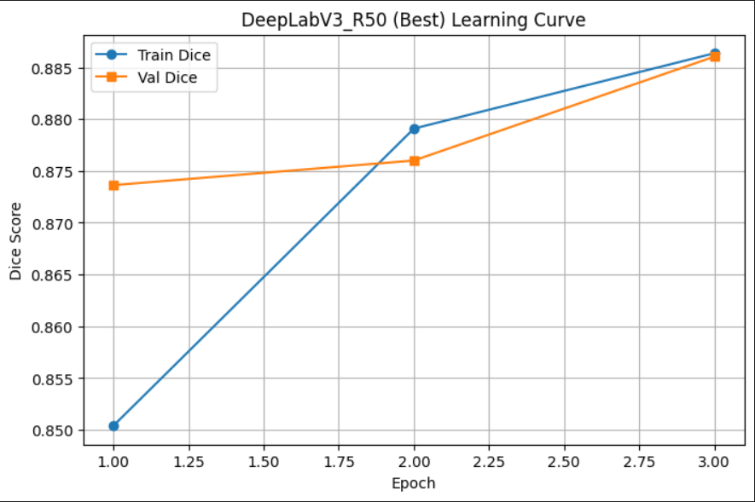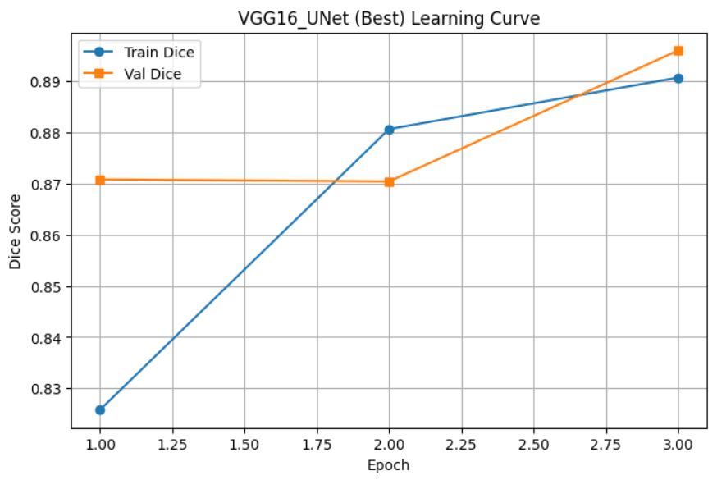
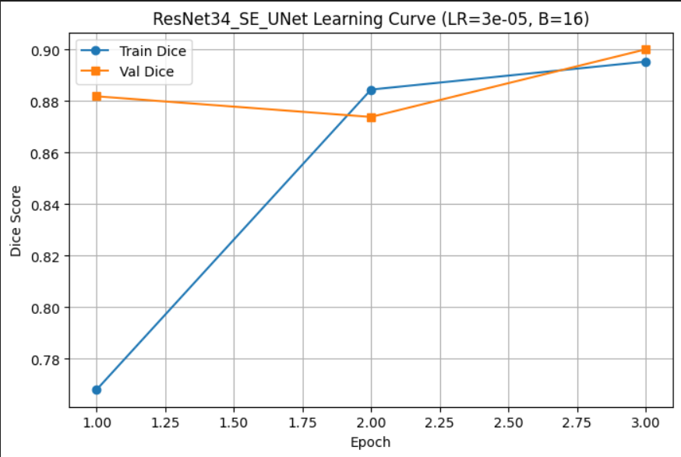
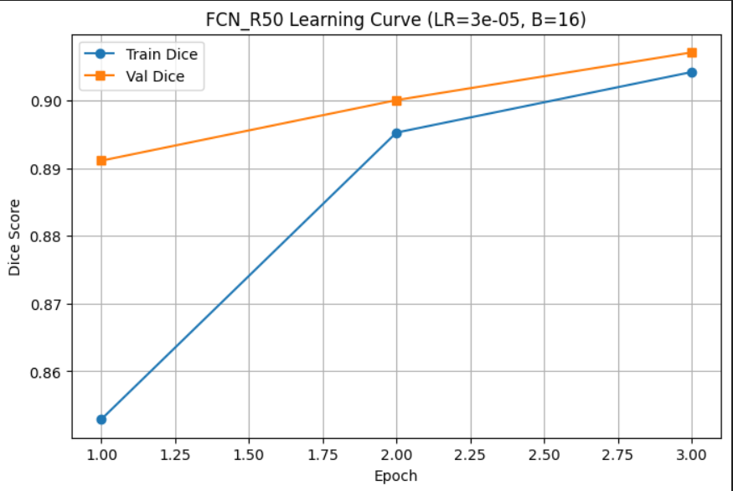

Training and validation performance vs the dataset size:

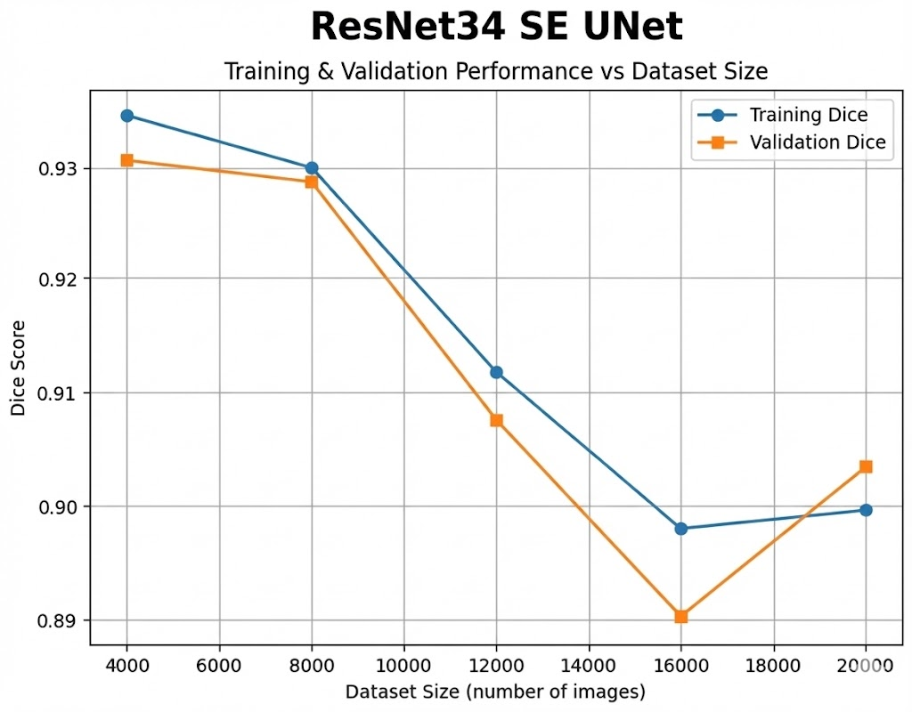

3.3 Model Optimization: From ResNet34 U-Net to ResNet34 SE-U-Net
Now that we had seen how well the ResNet34 U-Net worked, our group wanted ways to increase the accuracy even further. One area that we recognized the ResNet34 U-Net was not perfect with was "tricky" lesions. “Tricky” lesions referred to those lesions that have fuzzy edges or those that are colored in a way that they looked almost the same as the skin.

To assist with that, we introduced Squeeze-and-Excitation (SE) blocks to our model. These SE blocks can be looked at as an internal “attention” mechanism. They enable the neural network to learn how to apply weights to various visual elements itself, turning up the “volume” on the most informative aspects while filtering out the background noise (Hu, Shen and Sun, 2018).

It was essential that we, as researchers, maintained this fair test by avoiding alterations to the underlying architecture and our other training parameters. This was crucial as our results would strictly determine that the enhancement introduced by SE was responsible for the improvements we monitored. Results supported our hypothesis that the ResNet34 SE-U-Net was more accurate and robust when encountering novel images.

4 Models’ testing and evaluation

4.1 Testing
Once training was finished, we put the best version of each model to the test. We used a final set of images that the models had never seen before to see how they would handle real-world data.

To measure their success, we focused on two key scores:

Dice Score (DSC): This tells us how perfectly the model’s predicted shape overlaps with the actual lesion.

Binary Cross-Entropy (BCE): This tracks the mathematical error at the pixel level, showing us how confident and accurate the model’s guesses were.

Table 4: Values for the evaluation metrics achieved on the test set for the best model from each architecture.
Architecture | Best combination of hyper-parameter values | TEST Dice
VGG16 U-Net | LR=3e-05 | BATCH=8 | EPOCHS=3 | 0.8949
DeepLabV3-R50 | LR=0.0001 | BATCH=4 | EPOCHS=3 | 0.8834
ResNet34_SE_UNet | LR=3e-05 | BATCH=16 | EPOCHS=5 | 0.8981
FCN-R50 | LR=3e-05 | BATCH=16 | EPOCHS=3 | 0.9049

4.2 Cross-Validation

In addition to the standard split, a 3-fold cross-validation experiment was conducted for all architectures using a fixed configuration (LR=3e-5, Batch=4, Epochs=5) to evaluate robustness.
Architecture | Mean Dice | Std
VGG16 U-Net | 0.8997 | 0.0028
DeepLabV3-R50 | 0.8941 | 0.0090
ResNet34_SE_UNet | 0.9026 | 0.0017
FCN-R50 | 0.8955 | 0.0030
SegNet | 0.8908 | 0.0006

4.3 Over/under-fitting assessment
Following the experimental phase, the results indicate that the majority of evaluated models successfully reached a "sweet spot" in their learning regimes. Rather than merely memorizing the training samples or failing to recognize patterns entirely, these architectures effectively captured the foundational morphology of skin lesions, leading to reliable generalization on unseen test data.

The performance profiles across the different architectures are detailed below:
- Top-Tier Generalization: VGG16 and ResNet34_SE_UNet These architectures emerged as the most dependable performers in the study. Both models maintained a tight margin between training, validation, and test Dice scores, consistently averaging near 0.90. This stability suggests a well-calibrated learning process that avoided both the rigidity of overfitting and the superficiality of underfitting. Their performance underscores a robust ability to translate learned features to novel clinical imagery.

- Stable Feature Extraction: FCN-R50 Despite a more streamlined decoder architecture, the FCN-R50 displayed remarkable stability. The close alignment between its training and validation metrics indicates a balanced model with high generalizability. These findings confirm that the deep residual feature extraction backbone was, on its own, sufficient to drive robust segmentation without necessitating a more complex decoding path.

- High Capacity with Latent Instability: DeepLabV3-R50 The DeepLabV3-R50 demonstrated significant potential through its multi-scale modeling, yet its progression was marked by moderate performance fluctuations. Rather than traditional overfitting, these results point toward a subtle instability during the weight-optimization process. To fully capitalize on its high representational capacity, this model likely requires a more diverse dataset or an extended training schedule to achieve a more consistent state of generalization.

- Underfitting and Structural Limits: SegNet While SegNet was notably stable throughout the experiments, its overall Dice scores remained the lowest of the cohort. This discrepancy reveals a clear case of underfitting; while the model is reliable, it appears to lack the requisite architectural depth to resolve fine-grained lesion boundaries. In this specific context, the model’s complexity was insufficient to capture the intricate visual details necessary for high-precision segmentation.

4.4 Results analysis

After comparing the models, our team saw some clear differences in how each architecture handled the task. It became obvious that the way a model is designed directly impacts how well it can "see" a skin lesion.

The Top Performers (ResNet34 U-Net & FCN-R50): These two were our clear winners. The ResNet34 U-Net stood out because it uses "shortcuts" (residual connections) that keep the learning process stable. This, combined with its ability to reconstruct tiny details, made it excellent at finding the exact edges of a lesion. Even the FCN-R50, which has a simpler design, performed surprisingly well—proving that having a powerful "brain" (the ResNet-50 encoder) to identify features is often more important than a complex decoder.

The "Old Reliable" (VGG16 U-Net): This model was our steady hand. It didn’t quite beat the newer ResNet models, but it was incredibly consistent. It confirmed its reputation as a dependable "baseline"—the kind of architecture you can always trust to give you a solid, robust result.

The Big-Picture Thinker (DeepLabV3-R50): This model is designed to look at the image at several different scales at once. While this gave it a great "contextual" understanding of the skin, it was also a bit more temperamental. We noticed its performance shifted more between our practice runs and final tests, suggesting it might need more specific tuning to really reach its full potential.

The Precision Struggle (SegNet): SegNet unfortunately came in last. While it is very efficient, it lacks the "visual shortcuts" (skip connections) that the other models use to remember fine details. Because of this, it struggled to draw precise boundaries around the lesions, leading to more "blurry" results compared to our top models.

Ultimately, our team found that the best models for skin segmentation are the ones that can balance two things: deep thinking to identify the lesion and a "sharp eye" to reconstruct the fine details of its borders.

4.5 Effectiveness assessment

Beyond just getting the diagnosis right, our team looked at how much "brain power"—memory and speed—each model actually needs. If these tools are going to be used in a busy clinic or on a mobile device, they need to be fast and light.

Memory: How "Heavy" is the Model?
We looked at the physical size of each saved model to see how much storage they would take up. The results were quite surprising:

- The Heavyweight (VGG16 U-Net): This was our biggest model by far, taking up 528 MB. Because it uses very dense layers, it’s quite "heavy" and memory-intensive.

- The Mid-Range (FCN-R50 & DeepLabV3): These fell in the middle, requiring between 135 MB and 161 MB. While they are complex, they are still much leaner than the VGG model.

- SegNet required approximately 117 MB, making it more memory-efficient than DeepLabV3-R50 and FCN-R50, but still significantly heavier than the ResNet34-based models. Its reduced memory usage stems from its design choice of reusing pooling indices rather than storing full feature maps.

- The Efficiency Champions (ResNet34_SE_UNet): These were the winners here, taking up only about 83.3 MB. Our team found that these models offer a "best of both worlds" scenario: they are small enough to be portable but powerful enough to be accurate.

Speed: How Fast Can They Learn?
To see how much computing power they needed, we measured how long it took each model to finish one round of training (an "epoch"):

- The Slowest (FCN-R50 & DeepLabV3): These took the longest, clocking in at around 9 minutes per epoch. Their deep designs and complex "multi-scale" vision make them much more demanding on a computer's processor.

- The Middle Ground (VGG16 U-Net): This model took about 8.15 minutes. It’s faster than the most complex ones, but still relatively slow because of its huge size.

SegNet required approximately 117 MB, making it more memory-efficient than DeepLabV3-R50 and FCN-R50, but still significantly heavier than the ResNet34-based models. Its reduced memory usage stems from its design choice of reusing pooling indices rather than storing full feature maps.

- The Speedsters (ResNet34 Models): Our ResNet34 models were the fastest high-performers, finishing in just 5.53 minutes.

- Ultimately, our team found a clear trade-off between power and speed. While every model had its strengths, the ResNet34 SE-U-Net hit the absolute "sweet spot." It gives us high-tier accuracy without hogging memory or taking forever to run. For a real-world medical tool, this balance of speed, size, and skill makes it our top choice.

4.6 Interface development
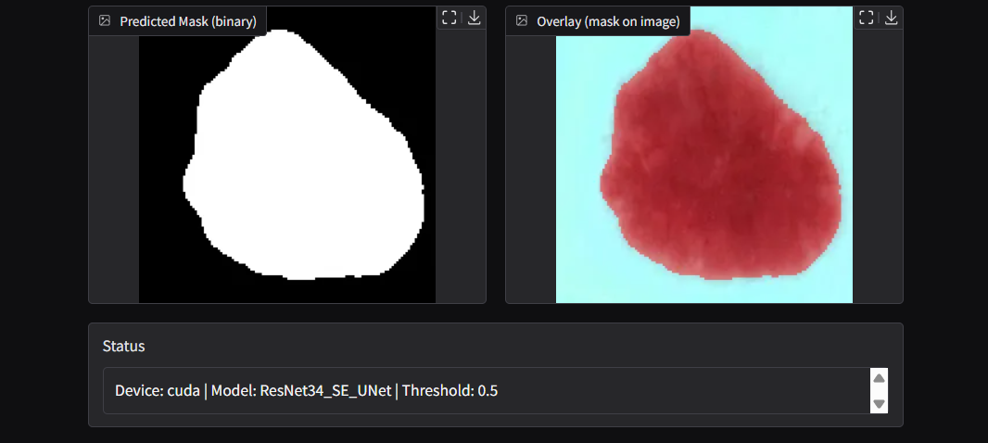
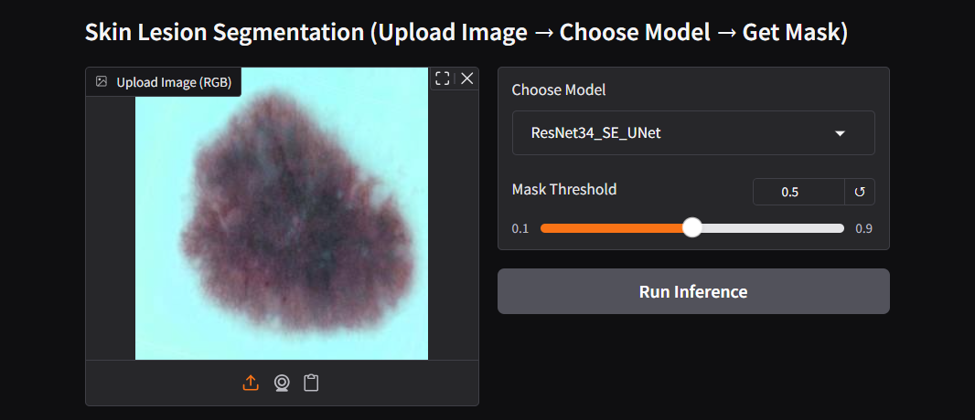

4.7 Critical evaluation of models
Looking at our results, our team is confident that the deep learning system we built successfully handles the challenge of identifying skin lesions with high accuracy. We’ve shown that modern neural networks are more than capable of learning the complex visual patterns needed for medical tasks.

However, we know there is still room to grow. Here is a look at the hurdles we faced and where we plan to go next:

Lessons Learned and Current Hurdles
The Resolution Trade-off: To keep things running smoothly, we resized all our images to 256 × 256 pixels. While this worked well, we realize that shrinking these images might cause the model to miss some of the very fine, microscopic details along the lesion's border.

Potential Data Biases: Even though we used a large dataset and various "training tricks" like augmentation, no dataset is perfect. There could still be subtle biases based on the type of lesion, its size, or the specific lighting used during the photo.

The "Real-World" Test: If a doctor is going to use this on a tablet or a phone, it needs to be incredibly fast and lightweight. While models like the FCN-R50 are efficient, we still need to push for even better optimization.

The Next Steps for Our Team
Moving forward, we are excited to explore a few new directions to make this tool even better:

Sharper Vision: We want to experiment with higher-resolution images to see if we can capture those tricky, fine-grained details we might be missing now.

New Tech: We are looking into "hybrid" models—combining our current designs with newer Transformer-based tech—to see if they can understand the "big picture" even better.

Speed & Reliability: We plan to use techniques like "pruning" (cutting out unnecessary parts of the model) to make it faster for mobile devices. We also want to add uncertainty estimation, which would allow the model to tell a doctor: "I'm 95% sure about this boundary, but only 60% sure about this one".

References

Badrinarayanan, V., Kendall, A. and Cipolla, R. (2017) ‘SegNet: A deep convolutional encoder–decoder architecture for image segmentation’, IEEE Transactions on Pattern Analysis and Machine Intelligence, 39(12), pp. 2481–2495.

Chen, L.-C., Papandreou, G., Schroff, F. and Adam, H. (2017) ‘Rethinking atrous convolution for semantic image segmentation’, arXiv preprint arXiv:1706.05587.

He, K., Zhang, X., Ren, S. and Sun, J. (2016) ‘Deep residual learning for image recognition’, Proceedings of the IEEE Conference on Computer Vision and Pattern Recognition (CVPR), pp. 770–778.

Hu, J., Shen, L. and Sun, G. (2018) ‘Squeeze-and-Excitation Networks’, Proceedings of the IEEE Conference on Computer Vision and Pattern Recognition (CVPR), pp. 7132–7141.

LeCun, Y., Bottou, L., Bengio, Y. and Haffner, P. (1998) ‘Gradient-based learning applied to document recognition’, Proceedings of the IEEE, 86(11), pp. 2278–2324.

Long, J., Shelhamer, E. and Darrell, T. (2015) ‘Fully convolutional networks for semantic segmentation’, Proceedings of the IEEE Conference on Computer Vision and Pattern Recognition (CVPR), pp. 3431–3440.

Ronneberger, O., Fischer, P. and Brox, T. (2015) ‘U-Net: Convolutional networks for biomedical image segmentation’, Proceedings of the International Conference on Medical Image Computing and Computer-Assisted Intervention (MICCAI), pp. 234–241.

Simonyan, K. and Zisserman, A. (2015) ‘Very deep convolutional networks for large-scale image recognition’, International Conference on Learning Representations (ICLR).

