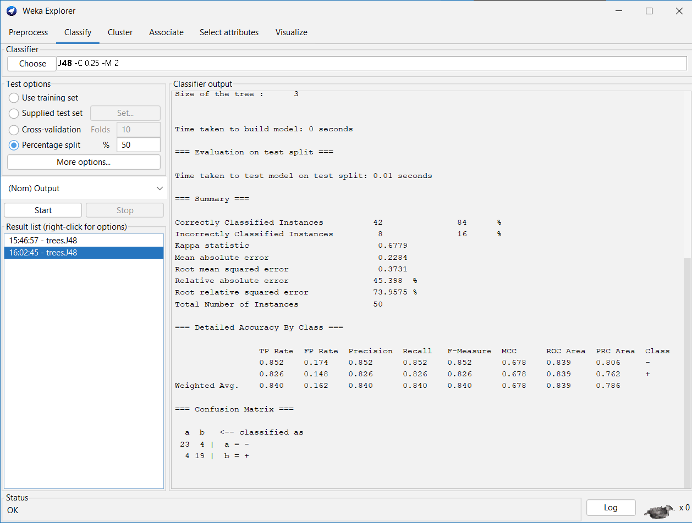

* **Write a paragraph about your experience of working with the standard ML pipeline in your own simple words**
* Working with a machine learning pipeline is like following a step-by-step recipe to teach a computer how to make predictions.
* First, you collect all the data and clean it up, like making sure there are no mistakes or missing parts.
* Then, you choose the most important information from the data, which helps the computer understand what to focus on.
* After that, you split the data into two parts:

1. One for training the computer and
2. One for testing it to see how well it learned.

* Next, you pick a method to teach the computer, let it learn from the data, and adjust settings to improve its performance.
* Finally, you check how well it can predict new information, and if needed, go back and make changes to improve it.
* It’s a process of learning, testing, and improving!