1. MATHEMATICAL MODEL

In order to characterize the variation of the exchange rates, we first need to assume that the exchange rate is only a function of time and hence it is a dynamic system. For ease of computation, we have neglected unhandled factors that could influence the exchange rates.

It is critical to be able to determine the equilibrium exchange rate now that currencies are freely convertible. When we say the exchange rate is in equilibrium, we mean that there are no opportunities for speculative profit while engaging in a closed sequence of currency purchase transactions. If the exchange rate is out of equilibrium, the task of determining a sequence of transactions yielding speculative profits arises.

We combine the concept of the logistic growth model and the dynamic integration to build dynamic models for exchange rates because we assumed that the logistic growth model could describe the rise and fall of exchange rates. The following are the differential equations for the model chosen.



where E(𝑡) is the Exchange Rate at time 𝑡. We can rewrite

(1) as



As a result, model A takes the form of the logistic growth model. Because the exchange rate changes dynamically in reality, we assume that the coefficients 1(t) and 1(t) are constant for a very short time. Then we look at the parameterized differential equation:



𝑆 (𝑡0) = 𝑆0,

𝑆 (𝑡1) = 𝑆1,

𝑡0 < 𝑡1,

With given values of two points at time 𝑡0 and 𝑡1.

Let,



and the solution is:





Model A describes the relationship between exchange rate, *E* (𝑡), and its velocity, 𝑑𝑆(𝑡)/𝑑𝑡. This model characterizes the mean reversion of the exchange rate if 𝛼1 is negative, 𝛽1 is positive and when the expected future exchange rate is higher than the current exchange rate. Under the circumstances, the implied equilibrium is at |𝛽1/𝛼1| and the exchange rate moves as how the logistic growth model describes.

There are three other models that could be used to forecast the exchange rate, namely: dynamic transformed logistic model, dynamic relative growth rate transformed logistic model and dynamic general Newton model [4].

Dynamic transformed logistic model describes the relation between the velocity and the acceleration of exchange rate, dynamic relative growth rate transformed logistic model describes the relation between the relative growth of the exchange rate and it’s derivative. Whereas the dynamic general model assumes that the coefficients alpha and beta remains constant between the short intervals, which is not actually the case.

Therefore, I have choose dynamic logistic model as it was closest to cover the entire scenarios of the exchange rate. In the following section, I have implemented the model.

1. SIMULATIONS AND RESULTS

In order to implement the model and compare the trends of the graphs with the previous years, I gathered the data for past 5 months. The following graph in fig.2 shows the trend followed by the exchange rate between USD and PKR.

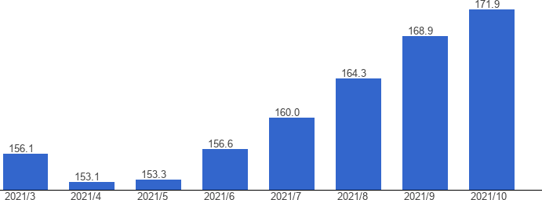

Figure 2: Exchange Rate Rise

The following result helps to tune the dynamic model in order to closely predict the exchange rate for the future. Using fig.2, I have tuned my model for the parameters alpha and beta.

First I have used alpha = 0.1 and beta = 0.5x10^-4, the result achieved was highly unacceptable and it is shown below in fig.3.

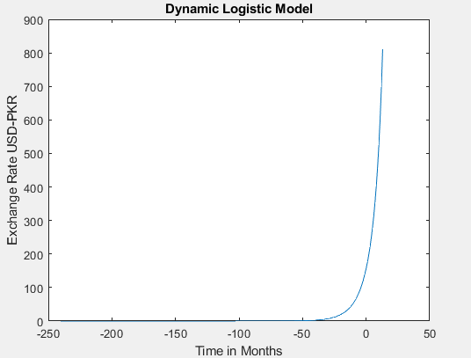

Figure 3: Exchange rate forecast

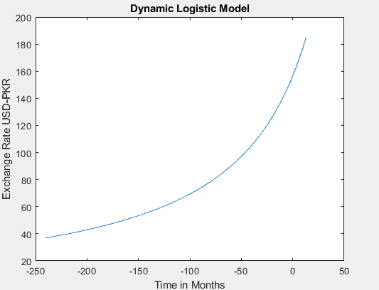

Figure 4: Exchange Rate

The model was further tuned, and the value of alpha was change to 0.001 and beta was increased to 0.7x10^-4, a

much better output was achieved as the model was getting closer to the trend shown in the actual trend of the exchange rate. Figure. 4 depicts the output of the model for updated values of alpha and beta. As it can be seen that the graph starts from -240 on the x-axis which is because I have also plotted the graph for past 20 years and it goes till July 2022.

After systematically tuning the model, for alpha 1x10^- 4 and beta 0.007, the model when given the initial exchange rate of 156.5, predicts 160.2. Below I have shown the output of the model for the month of July 2021.

After that in order to test the model against the second scenario, I have changed the value of t = 2. Since t0 was set equal to zero and it was considered as the 6th month of 2021. Setting t=2 means that the model predicts exchange rate for August 2021. As it can be seen from Figure 2 that the exchange rate in August 2018 was 168.9 and when it is compared with the results of the graph plotted using the new values of alpha as shown in figure.5, we see that the model makes more likely an accurate forecast of the exchange rate.

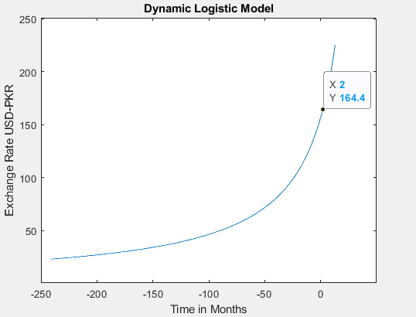

Figure 5: Final Model Output

The designed model did not gave accurate predictions but it was the closest to the accurate output.

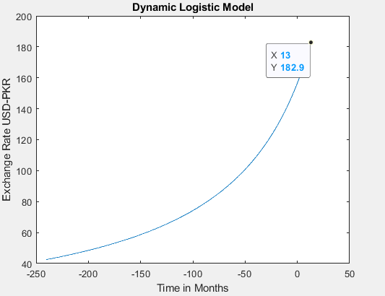

Figure 6: July 2022 Exchange Rate

Using this Model I have forecasted the exchange rate for July 2022. The value achieved for July 2022 was 182.9 dollars per rupee. Figure.6 shown the predicted result for July 2022.

The model predictions are quite close to the real trend of the exchange rate. As back In 2008, the exchange rate for USD-PKR was around 60 dollars, whereas the final model output shows the output to be around 58.67 which is quite close.

1. RECOMMENDATIONS

I would highly encourage you to use the model having the following parameters:

Alpha = 1x10^-4 Beta = 0.007

The model designed using the stated value of the alpha and beta results in very close approximate to the actual exchange rate. The table.1 shown below gives a more accurate comparison between the actual exchange rate and the predicted value for past several years.

**Table 1: Comparison**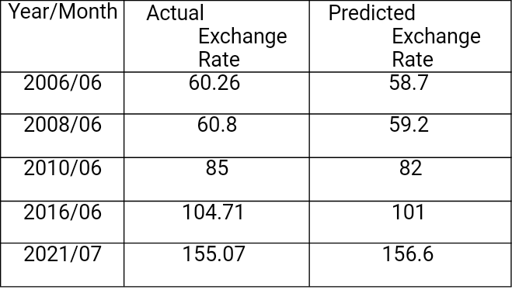

With the help of such an accurate model, we can make the right decisions for our company on the right time. We would be aware of when the dollar is expected to hit its lowest possible rate, which would help us in making our business decisions.

The Model, which I have designed, is quite simpler, it gives very pleasing results, and in future modifying this easier model to accurately predict the exchange rate will not really be difficult, as we would have to in cooperate the parameters, which could have an impact on the exchange rate for USD-PKR.

1. CONCLUSION

The Best possible approach to forecast the exchange rate is to model an ordinary differential equation. The results of Dynamic logistic model were accurate within 5% range; this could be improved further using the additional parameters into consideration. We could make the parameter alpha and beta dynamic to predict the trend more accurately. Making the parameter alpha and beta dynamic in a small interval will help the model to predict even a very small change make it more robust.

ACKNOWLEDGMENT

I would like to thank the instructor and the organization for providing me with the opportunity to explore the different techniques that could be used to predict the trend of the exchange rate.

The results shown in the table ensures that the model predicts quite closely to the real trend of the exchange rate and the percentage error is less than 5%, which is quite good. This model will help you forecast the exchange rate to within 5% error range. We can further analyses the accuracy of the results by observing the comparison plot shown in figure.6

REFERENCES

1. Han, Y. (2010). The Effects of US Macroeconomic Surprises on the Intraday Movements of Foreign Exchange Rates: Cases of USD-EUR and USD-JPY Exchange Rates. *International Economic Journal*, *24*(3), 375-396. doi: 10.1080/10168737.2010.504777
2. Tripathi, M., Kumar, S., & Inani, S. (2020). Exchange Rate Forecasting Using Ensemble Modeling for Better Policy Implications. *Journal Of Time Series Econometrics*, *13*(1), 43-71. doi: 10.1515/jtse-2020-0013
3. Gupta, N. (2014). Forecasting the Rupee-Dollar Exchange Rate Using the Monetary Model. *SSRN Electronic Journal*. doi: 10.2139/ssrn.2612206
4. Li, M., Chiang-Lin, T., & Lee, Y. (2018). Applications of Parameterized Nonlinear Ordinary Differential Equations and Dynamic Systems: An Example of the Taiwan Stock Index. *International Journal Of Differential Equations*, *2018*, 1-11. doi: 10.1155/2018/4762485.
5. Pakistan Exchange rate, USD, October, 2021 - data, chart | TheGlobalEconomy.com. (2021). Retrieved 7 November 2021, from https://[www.theglobaleconomy.com/Pakistan/Dollar_exchange_rate/.](http://www.theglobaleconomy.com/Pakistan/Dollar_exchange_rate/)