DLD Lab 4 Tasks
By: Hamza Shahid, 24K-0869

Task 1:
I) F = BC + AB + A'B'C'
F = A’B’C’+A’BC+ABC’+ABC
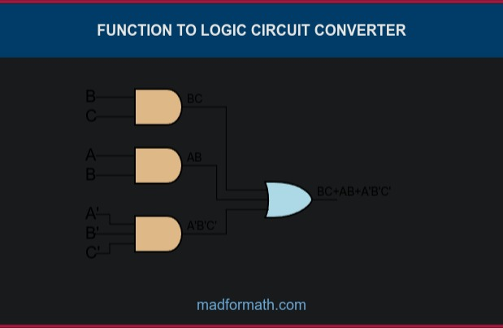
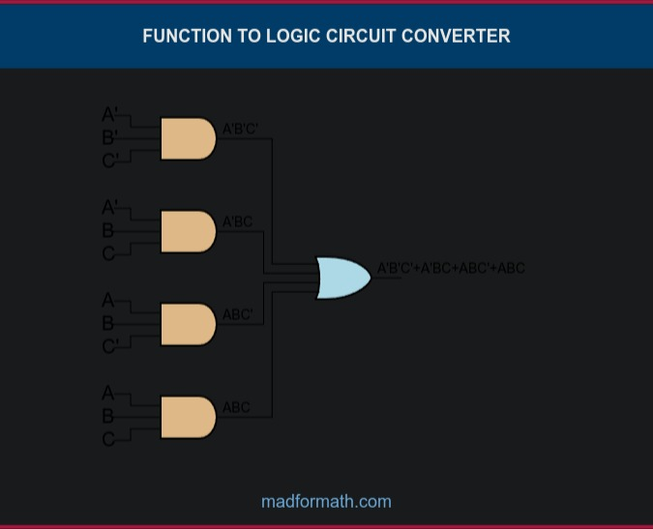

ii) F = B' + A'C' + AC
F = A'B'C'+A'B'C+A'BC'+ABC+AB'C'+AB'C
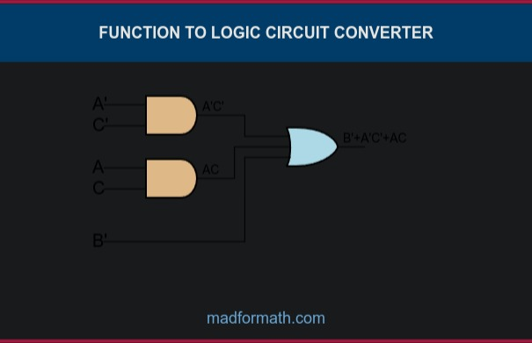
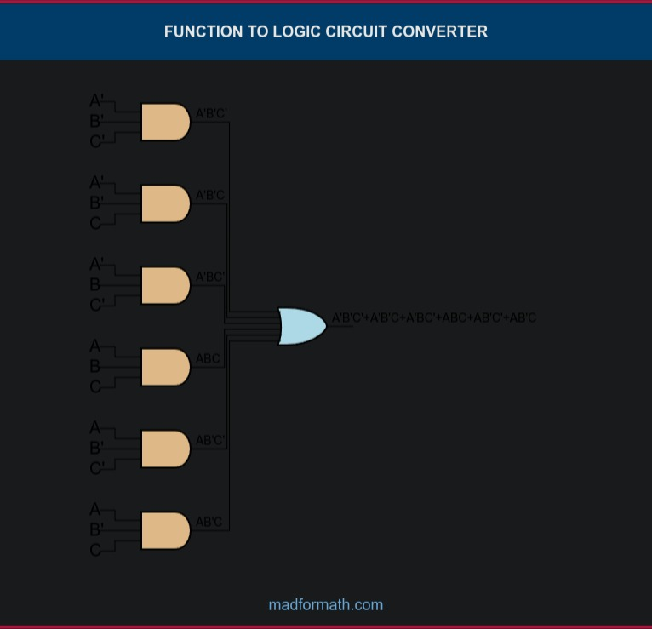
Task 2:
F = (A' + D)(A' + B')(A + B + C')
F = (B + C + D')(A + C' + D')(B' + C' + D')
Task 3:
F = B' + A'C
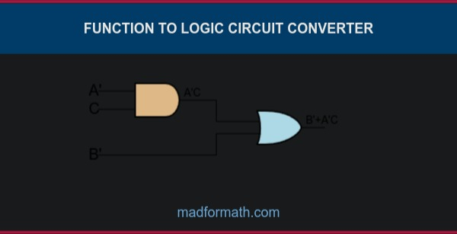
Task 4:
Normalizing part: B’C’D’A + B’C’D’A’ by ANDing w/ (A + A’)
F = D' + B'C
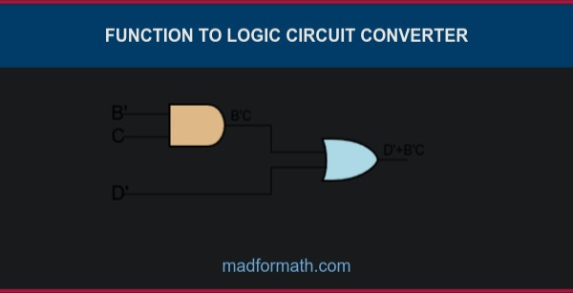
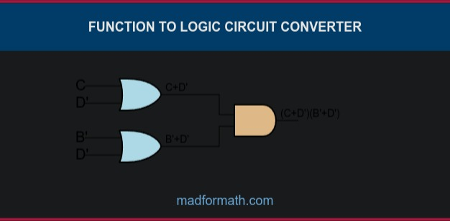
F = (C + D')(B' + D')

