ICT Week 2 Lab Task 2
Author: Hamza Shahid
Roll# 24K-0869

Home Task 2.1: Directory and Organization Challenge

Process
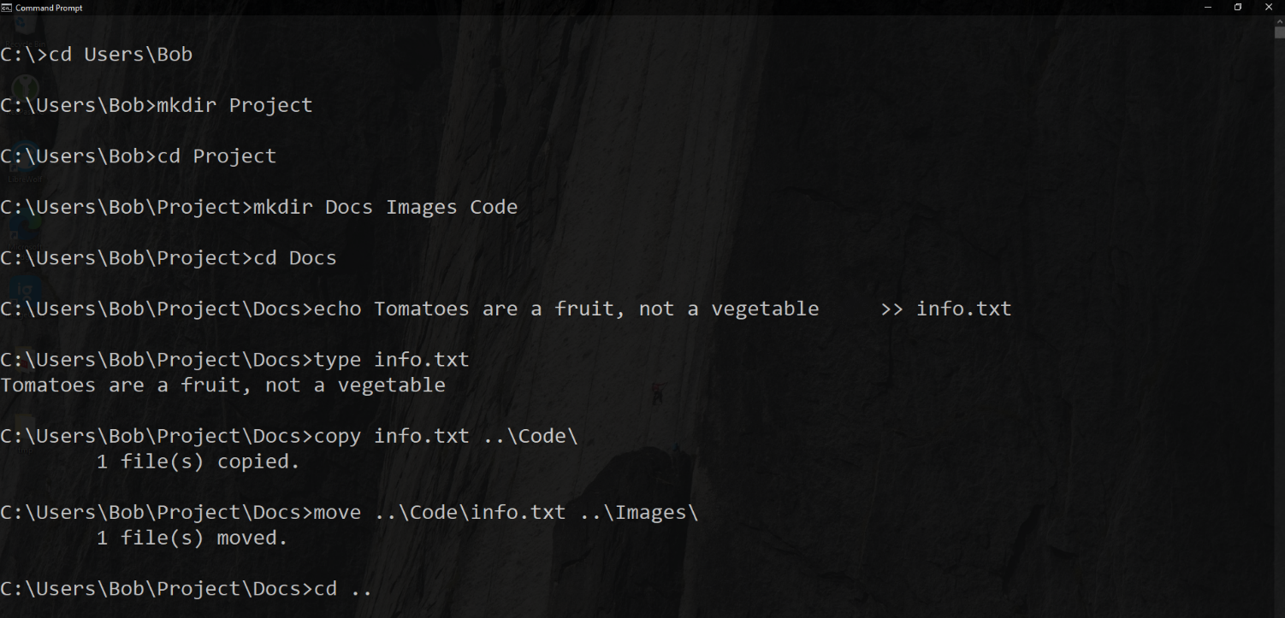
First, we create a directory named Project in our home folder and create three subdirectories by passing multiple arguments to mkdir. In the Docs subdirectory, we use the echo command which treats all of its arguments as input and use the >> operator to append that to a file named info.txt. The echo command creates this file if it does not exist. The type command subsequently TYPES out the data stored in a file as if from a keyboard. The copy command then copies this file to ..\Code\, where .. represents the parent directory and \ to mean inside the parent directory. We do this as Code is a sibling directory. We then use a similar command to move and change directory to the parent, i.e., Project.
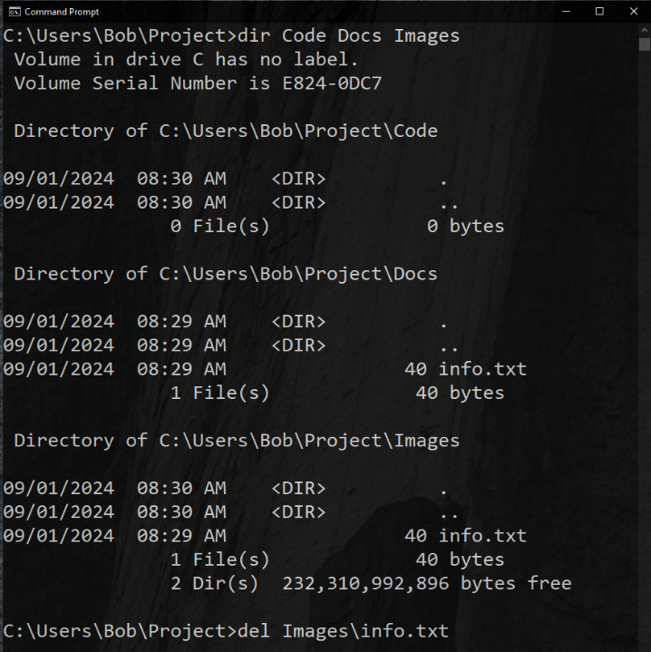
Passing multiple arguments to dir, like mkdir, allows us to list all of the subdirectories at once (Personally, like in Unix based systems, I would have used a globing pattern but cmd sucks at that, and you would probably think I cheated, sooo…). We then use the del command to delete the info.txt file inside Images.

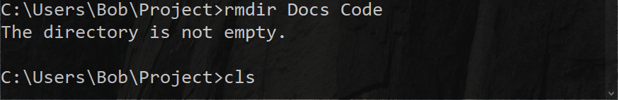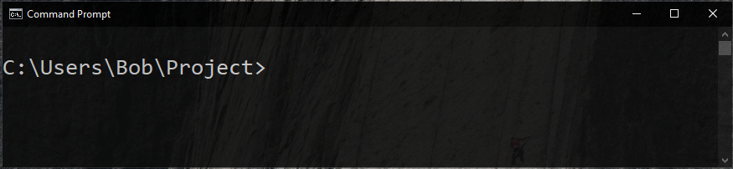
Again, even with rmdir, passing multiple arguments attempts to delete each subdirectory in one command. In this case Code was empty so it was deleted but Docs was not, hence the message. The last picture shows us clearing the screen using cls.

Command List
- cd
- mkdir
- echo
- type
- copy
- move
- dir
- del
- rmdir
- cls

Home Task 2.2: Backup and Cleanup

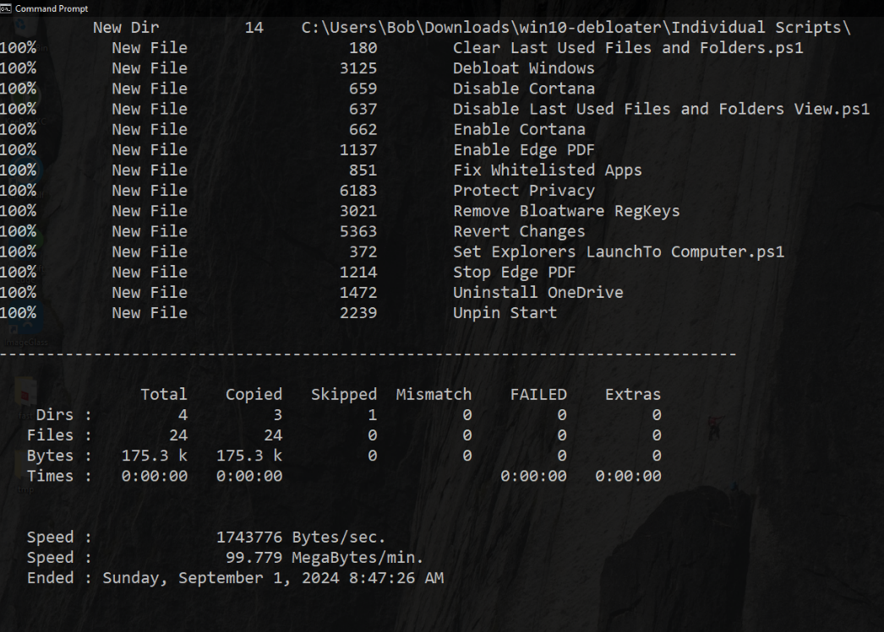
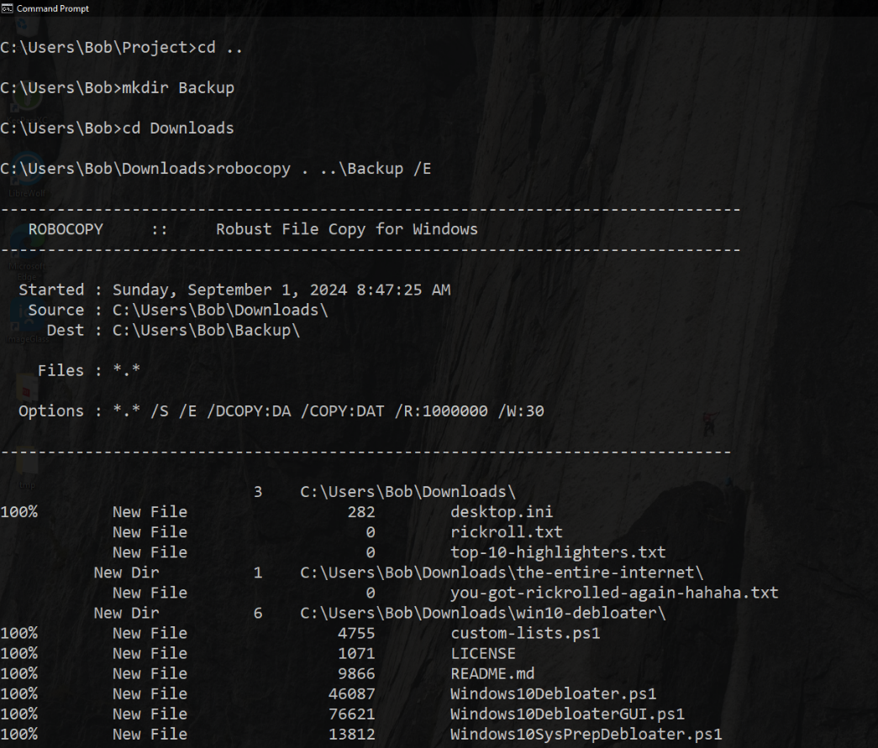
Process

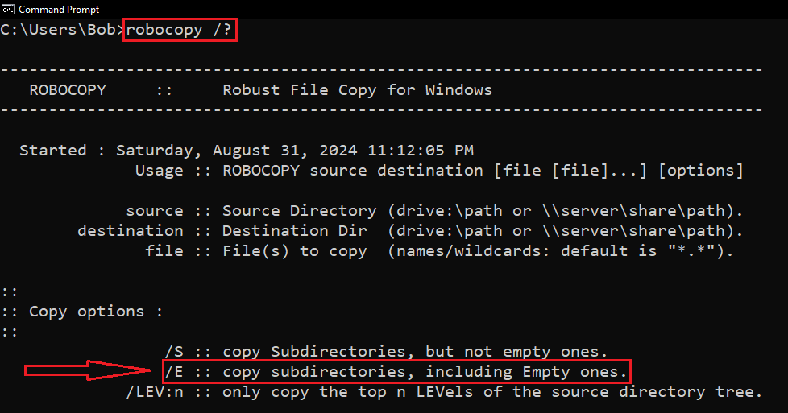
We create a Backups directory using mkdir and change directory to Downloads using cd. Unfortunately, cmd does not have an easy way to recursively (by going through each subdirectory in each subdirectory) copy all files and folders in a directory. The easiest way to do this is using robocopy (robust copy). Robocopy takes the source folder as the first argument and the destination as the second. For the source, we give it . which means the current directory we are in and for the destination, ..\Backup, where .. stands for the parent directory, as Backup is a sibling directory. We follow it command with the E flag. A flag is used to specify options to a command and is denoted by a forward slash. In this case, we can easily see what the /E flag does by running the command robocopy /?, where the ? flag is for displaying the help.

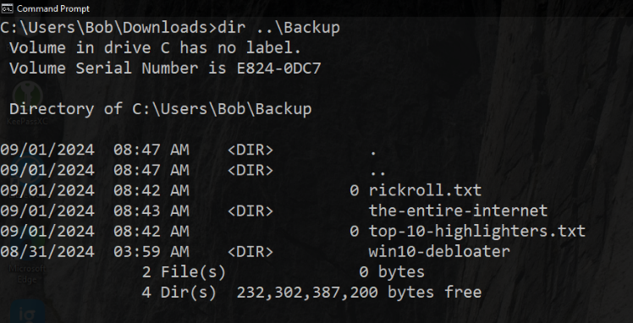
Now we can see that /E recursively copies subdirectories including empty ones. Note that the output is very long and is truncated for this screenshot.

After listing the sibling Backup directory using the dir command we can see that the command worked.

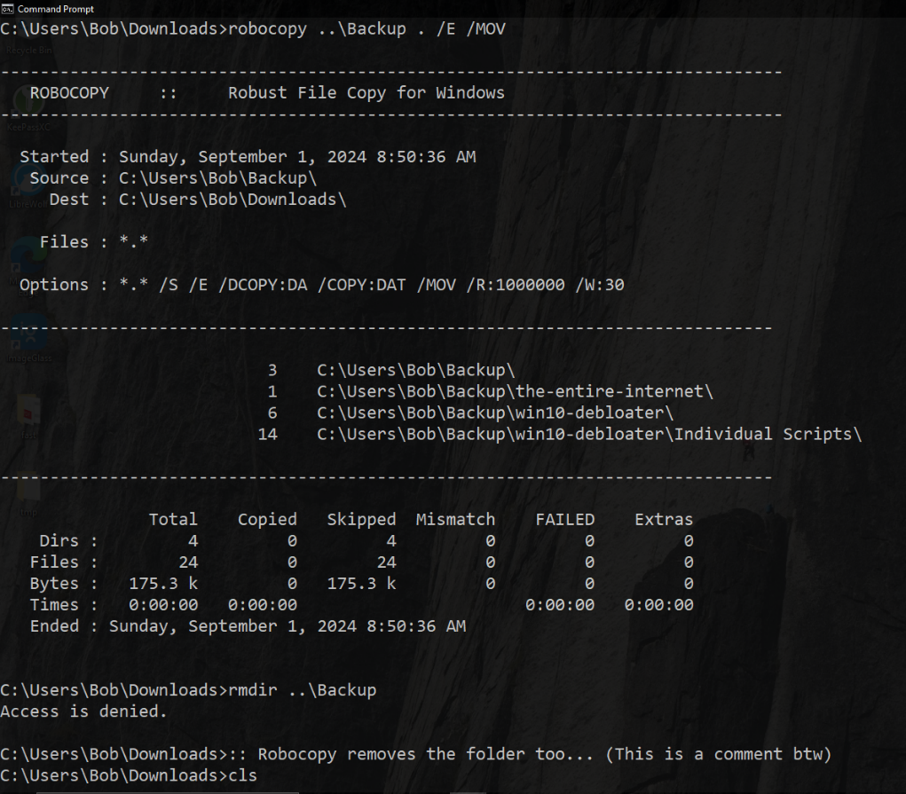
We again use the same command but this time with the /MOV flag which, according to the help printed by robocopy /?, deletes everything in the source directory after copying, essentially moving it.
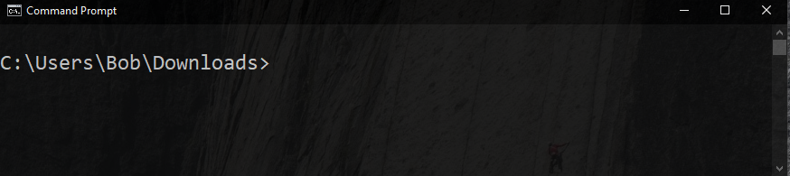
Using rmdir on Backup prints the message “Access is denied” which, in this case, means that the directory does not exist (because I am not trying to perform actions on a file that I require permissions for)
Finally, we use the cls command to clear the screen.

Command List
- cd
- mkdir
- robocopy
- dir
- rmdir
- cls

