ICT Week 2 Lab Task 2
Author: Hamza Shahid
Roll# 24K-0869

Task 2.1: Navigating Directories

Process
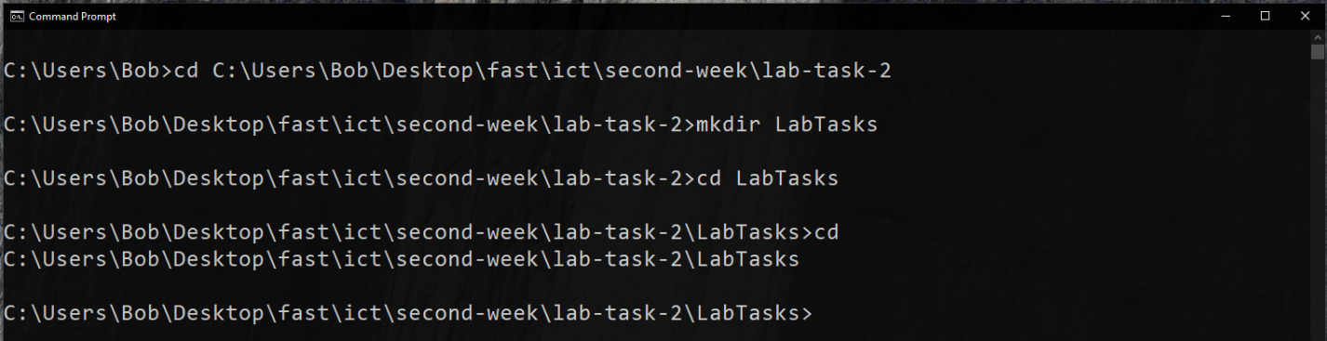
After going to a location using cd we create a folder named LabTasks. We then go into that folder using the same command and ensure task completion using cd .., where .. represents the parent directory.

Questions
- What command did you use to check your current directory? cd
- How can you go back to the previous directory? cd ..

Command List
- cd
- mkdir

Task 2.2: Listing and Managing Files

Process
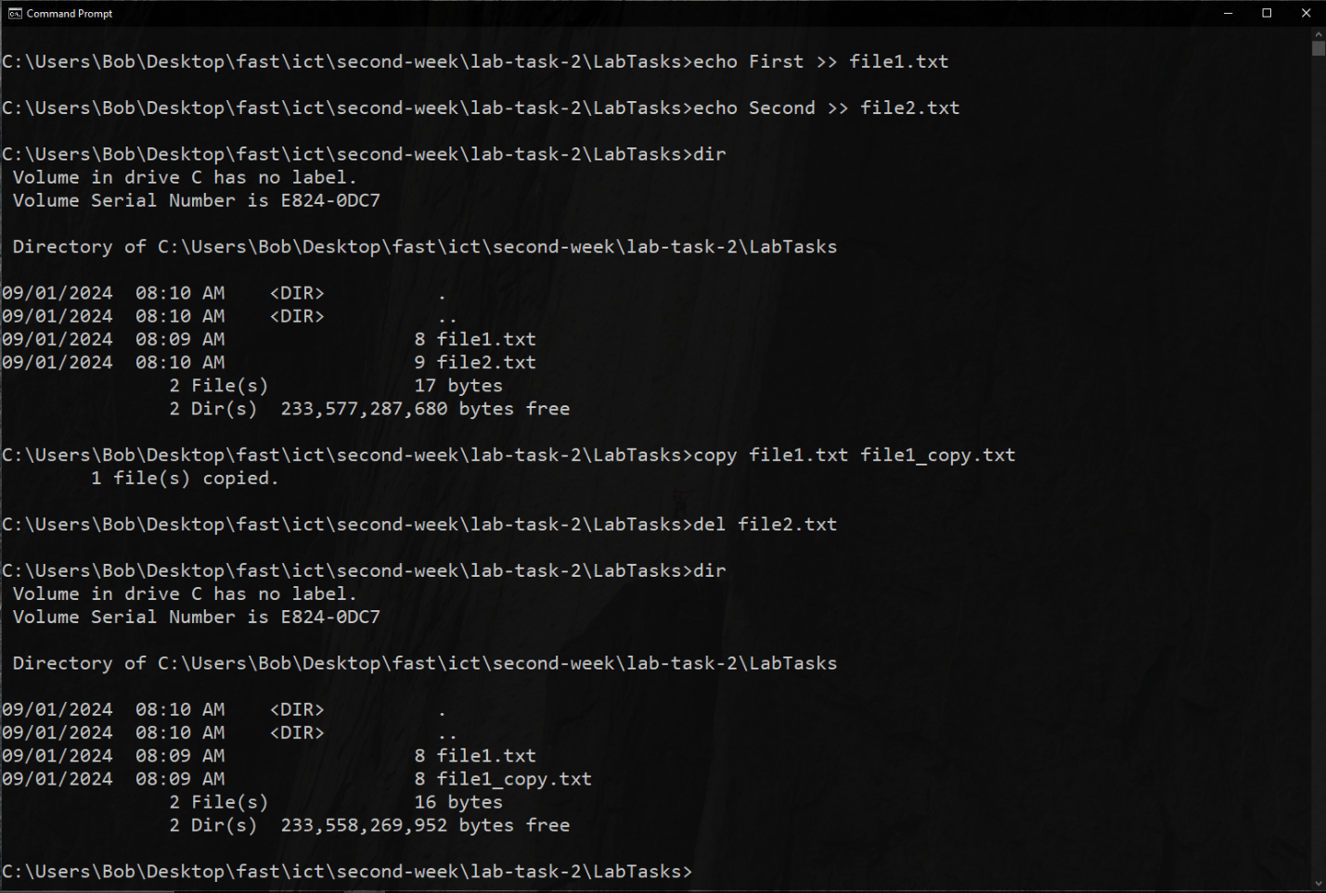
Pretty self-explanatory. Though one thing to note; the >> operator appends to the file while > replaces the contents of the file with the argument(s) to echo. echo also creates the file if it does not exist. Here del is used to delete a file and the copy command’s first argument is the file source and second is its destination.

Questions
- What does the dir command output show? It lists all the files and folders in the current directory.
- How did you confirm the deletion of file2.txt? By using the dir command, and seeing the file2.txt line replaced by file1_copy.txt.

Command List
- echo
- dir
- copy
- del

Task 2.3: Moving and Removing Directories

Process
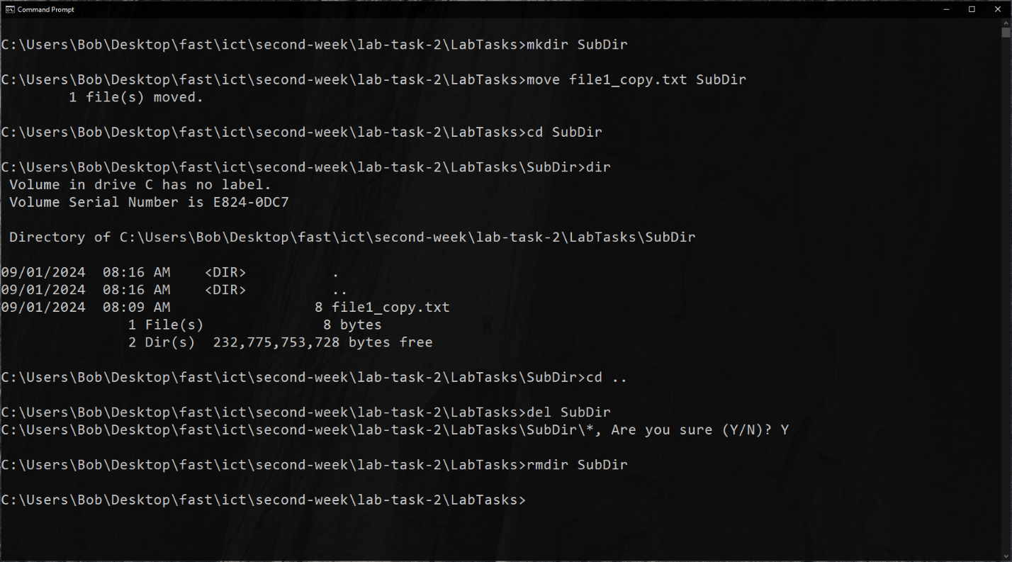
The move command, like copy, takes a source and a destination. In this case, since the destination is a directory, it moves the source file inside the directory. Now, del when given a file deletes it. However, when given a directory, it deletes all files NOT subdirectories NON-RECURSIVELY (meaning, it does not delete files and directories inside subdirectories) inside its argument directory. On the other hand, rmdir removes a directory only when it is empty.

Questions
- How did you ensure that the directory was empty before using rmdir? We could use dir, but I preferred to directly del everything inside the subdirectory and hit “Y” to ensure it.
- What command did you use to verify the file was moved? dir with no arguments.

Command List
- mkdir
- move
- cd
- dir
- del
- rmdir

Task 2.4/5: Clearing the Command Prompt Screen

Process
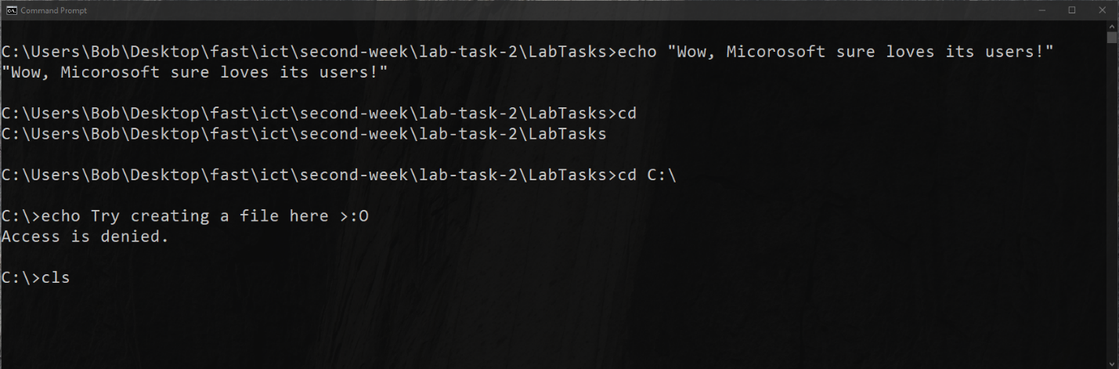
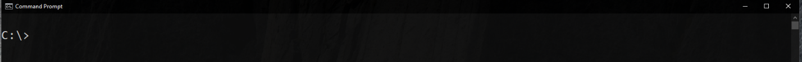
After running some commands, we use the cls command to clear the screen and make way for new commands.

Questions
- How did the cls command affect the display in Command Prompt? It cleared all previous output and commands.
- What is the benefit of using the cls command during a Command Prompt session? It clears the clutter caused by previous commands and gives space to perform other tasks.

Command List
- cls (duh)

