Lab Task #1:
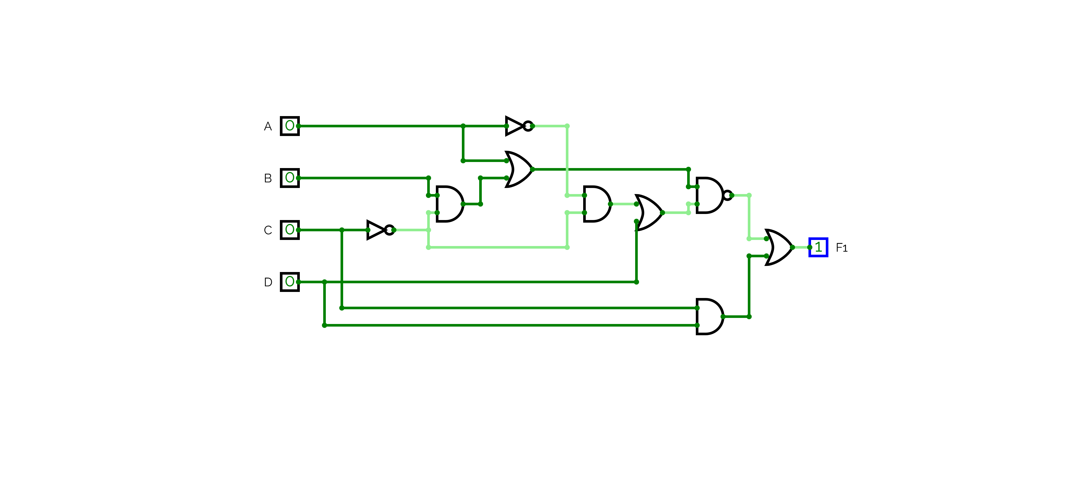


Task 2:
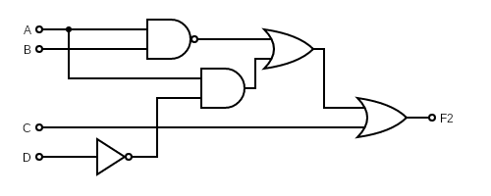




Task 3:
= A’(B xor C)

Task 5: X = (A xor B)’C + (A xor B)C’
Is equivalent to X = (A xor B) xor C

