# Nigeria’s Population Boom

Author: Hamza Shahid (**24K-0869**)

Document: BCS-1D ICT Home Task 1

Date: 25 August 2024

## Introduction

With 230 million people living there, Nigeria is the **most populous nation in Africa**. Given that **forty percent of the population is under fifteen**, the country has **one of the highest birth rates** in the world. Although a large population is necessary for a nation's economy to prosper, Nigeria's overcrowding may quickly grow to be a greater issue than is initially thought.

## Nigeria’s Population Statistics

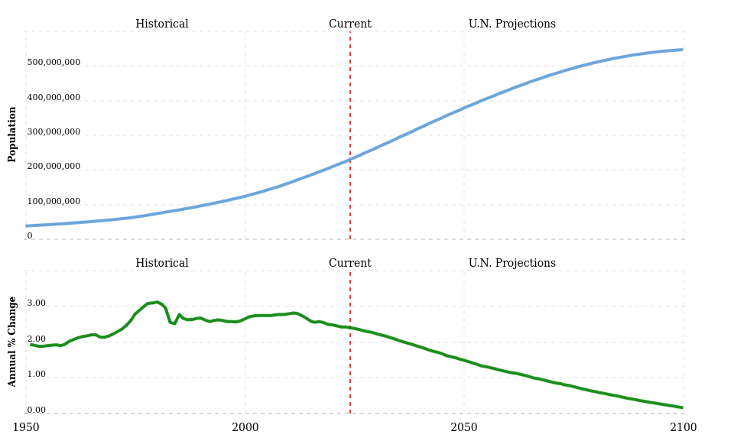Figure 1: Nigeria's population from 1950 to 2102 (www.macrotrends.net)

## Similarly Populated Countries

|  |  |
| --- | --- |
| **Country** | **Population (as of 2024)** |
| [Nigeria](https://www.macrotrends.net/global-metrics/countries/NGA/nigeria/population) | ≅229 million |
| Pakistan | ≅245 million |
| Indonesia | ≅280 million |

## Population Dynamics

Malthus’ population principle of population growth modeled as a logistic equation:

$\frac{dN}{dt}=aN\left(1−\frac{N}{K}\right)$

*where N is the biomass density, a is the maximum per-capita rate of change, and K is the carrying capacity of the population (*[*Source of formula*](https://en.wikipedia.org/wiki/Population_dynamics)*)*