Week 1
Working with pandas and data cleaning
Creating a series
Step 1 create a list
Data= [100,200,300]
Now add that in a series
series = pd.Seres(data)
Print(series)

Doing this will also show the index starting from the 0 we can also change that by using index keyword
Data= [100,200,300]
Series=pd.Series(data,index=[“a”,”b”,”c”]) // doing this will be disadvantage because we need to add the index that must match the original data
Index must match the length of the data

Loc[] mean location by label // important note we need to enter index here to output the data present in data list
We can also assign the value using loc[]
Series.loc[b]=1122

Add value using integer location, just like we do in arrays
Series.iloc[0]=23 // the iloc[0] mean that the value at 0 location and it is read only we can not write them

How to write condition in series
Use this series[series >= 200]
This will work as condition and will give the output according to the result

Let create series using dictionary (key:value )

We can also perform arithmetic operation on series using the index or key
Calories={“day1”:100,”day2”:200,”day”:300]
Series=pd.Series(Calories)
Series[“day2”]+=5000
Print(series2) // output day1 100, day2 5200 day3 300

Data Frame using dictionary
data={
“Name”:[“john”,”Doe”,”peter”],
“Age”:[30,40,50]
}
Df=pd.Dataframe(data)
Print(df)
print(df.loc[1])
print(df.iloc[1])

Add new column
Df[“JOB”]=[“Cook”,”Cahsier”,”N/A”]
Print(df) // this will output 3 column

Add new Row
For adding new row first create variable for it and then and atore new data in it
Then concanite it using concat(df, new_row)
Then print
New_row=pd.DataFrame([{“name”:”joe”, “Age”:34,”job”:”ser”}])
Df.concat([df,new_row])
Print(df)

Important note the Key value must be same other wise it will add in column

Add multiple rows
New_row= pd.DataFrame([{“Name”:”sal”,”Age”:40,”Job”:”manager”},{“Name”:”Q”,”Age”:50,”Job”:”Manager”}])

Condition in Data Frame
print(df[df["Age"]<50])

CSV
How to read CSV
import pandas as pd
df=pd.read_csv("pandas/data.csv")

path may give error

Print entire dataframe not a truncate version
Df.to_string()

If the file is json then use pd.read_json

Print single column
Df{“Column name”}.to_string()

Print Multiple column
Print(df[[“Name”,”Weight”,”Height”]].to_string())

Display using Column
We can display column and also print row form which row to end to where
We can also assign name column for search
Df=pd.read(“data.csv”,index_col=”Name”)
Now we can search the name using the pickachu
Print(df.loc[“Pickachu”])
We can also display the other column that we want
Print(df[“Pikachu”,[“Height”,”Weight”]])

Slice Operator (:) what it do is we can display the row from where to where
Df.loc[1:90]
If we want to display specific column then we need to add list there
This will show list from that index to the given index
print(df.loc[1:50,["Name","Height"]].to_string())

we can also display rows base on some condition uing iloc[]
df.iloc[1:20;2] this will start from 1st row and display the rows that are of odd number

we can also assign which column we want to print
df.loc[1:20:2,0:3]// the 0:3 will display the first 3 column

take user input and then we need to display the info of that pokemon
df=pd.read_csv(“data.csv”,col_name=”Name”)
pokemon=input(“print name of pokemon”)
try:
print(df.loc[pokemon])
except
print(f”{pokemon}” don’t exist)

Filtering using pandas in CSV
Mean keeping the row that match the conditions
Df=pd.read_csv(“data.csv”)
//show all tall hight greater then 2
Tall=df[df[“Heoght”]>=2]
Print(tall.to_string())
Using AND and OR

Tall = df[ (df[“Height”]>3 ) & (df[“type1”]=”water”)]
type1=df[(df["Height"]>=3) & (df["Type1"]=="Water")]

Aggregate Function Using pandas
Mean(numeric_oly=true), max(), min(), count()

Aggregate function for single column
.sum() — Total sum per group
.mean() — Average value per group
.count() — Number of non-null values
.min() / .max() — Lowest and highest values per group
.std() — Standard deviation

Df[“Height”].mean() // this will show the mean of average column

GroupBY same as SQL groupBy

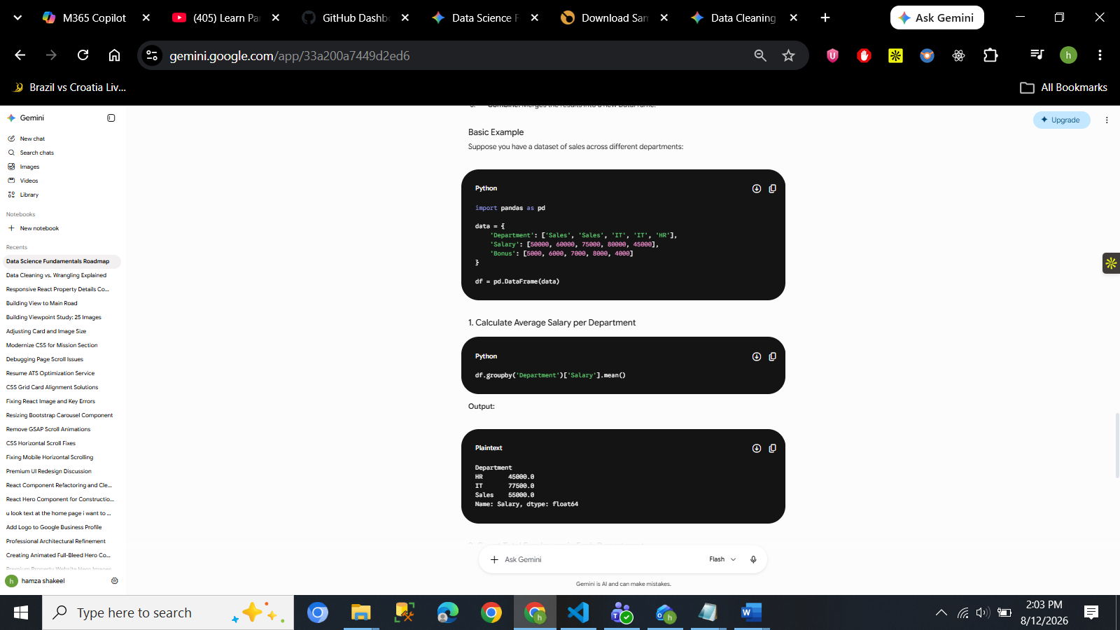
Group=df.groupby(“type1”)
Print(group[“Height”].mean())

Data Cleaning: the process of fixing and removing the incomplete data 75% of work is done using the pandas

Drop column
drop Is use to remove the col we can also remove multiple column at the same time
syntax
df=df.drop(columns=[“Legendary”])

drop row with null values
dropna() will drop the value of the selected column that has no value
syntax
dropna(subset=[“columnName”])

Missing values/ solution for missing values
Df=df.fillna({“type2”:”None”})

