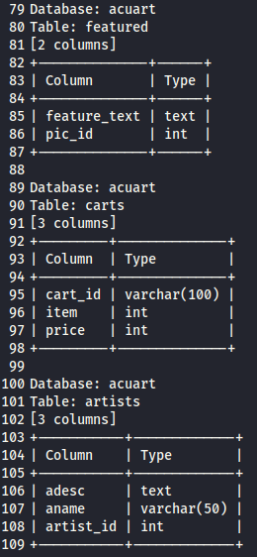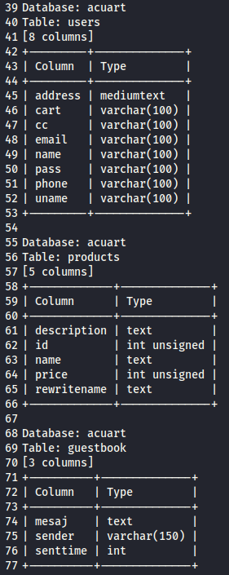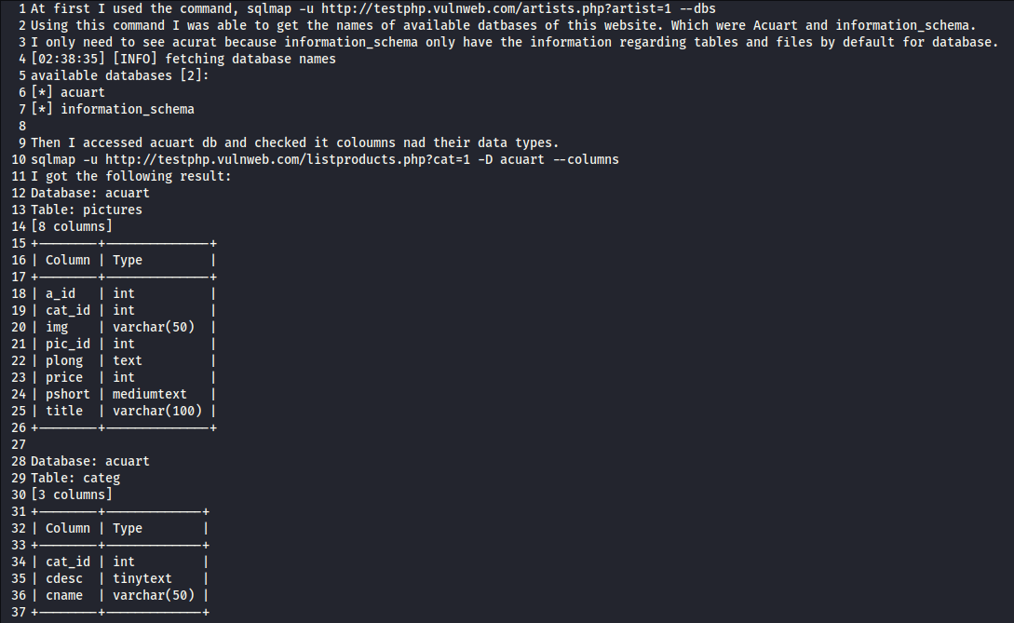   
  
  
  
  
  
  
  
  
  
  
  
  
  
  
  
  
  
  
  
  
  
  
  
  
  
  
  
  
  
  
  
  
  
  
  
  
  
  
  
  
  
  
  
  
  
  
  
  
  
  
  
  
  
  
  
  
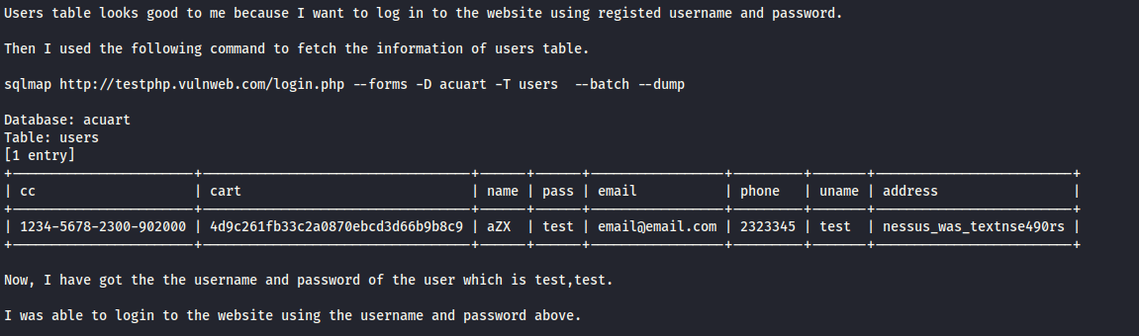

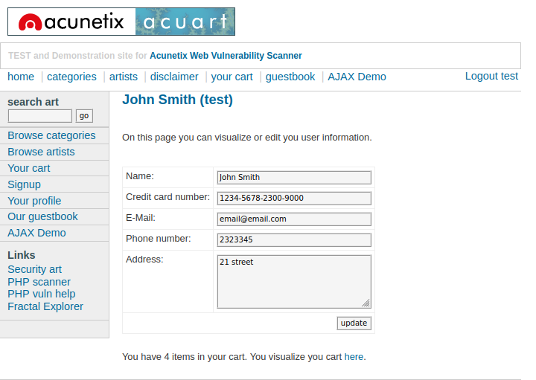

Now, I can see his record, name, credit card number, email, phone number and address.

I can even change this and update it.