EW Project

FPV Car using ESP NOW
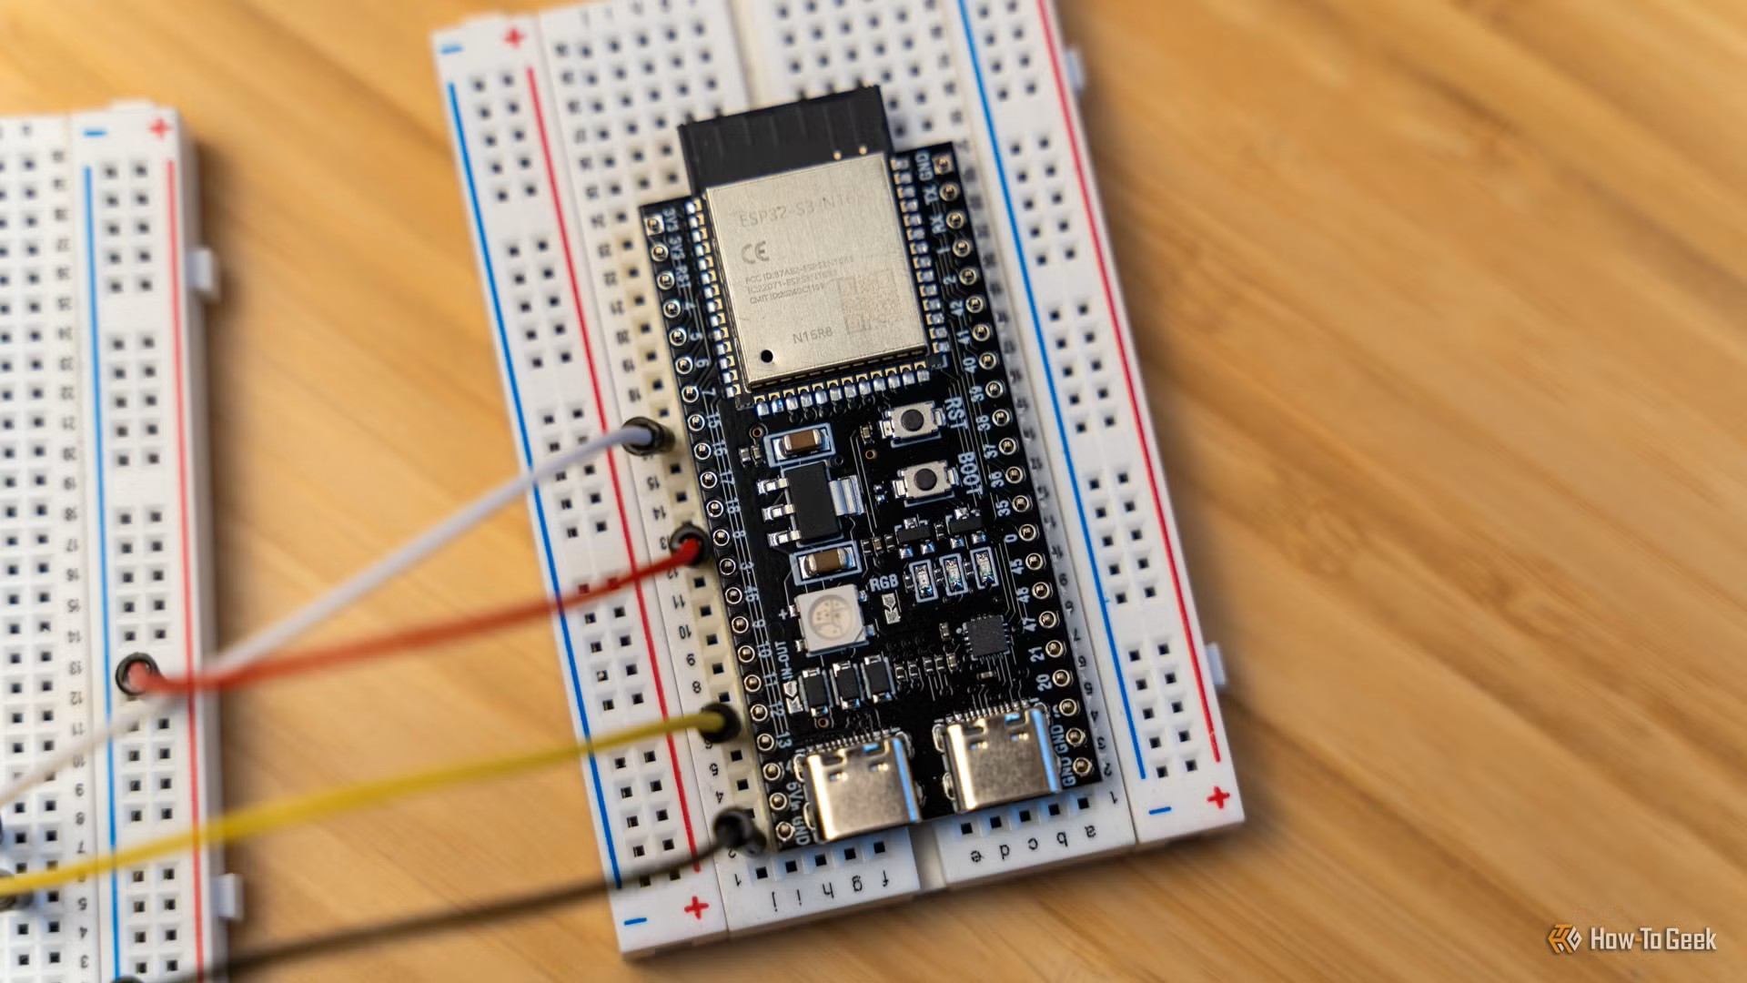
GROUP MEMBERS:
Hamza Shahzad – 25i-6520 – CE-C
M. Sarim Sajjad – 25i-6529 – CE-C
Problem Statement:
Inspection of hazardous or hard to reach areas require FPV (first person view) vehicles. But the commercially available options are usually very expensive and the hardware is of a closed eco-system. On the other hand, cheaper options rely on Wi-Fi and Bluetooth for communication, which results in significant latency, which might cause delayed video and sluggish controls, making the device prone to accidents in what was supposed to be an easy to do, safe, out of sight mission.
Proposed Solution:
We propose a cost effective FPV vehicle solution, which uses 2 ESP32 microcontrollers. By using the available peer-to-peer protocol ESP NOW, we minimize communication latency, making for instantaneous control. It will be paired with an ESP CAM for live video stream, and dual ultra sonic sensors for collision avoidance. Thus, enabling us a reliable, inexpensive device for remote inspection in hard-to-reach areas.
List of Components:
- DOIT ESP32 DEVKIT V1 (x2)
- AI Thinker ESP32 CAM
- 4WD Car Chassis kit with 4 DC Gear Motors
- Male to Male Jumper Wires
- Female to Male Jumper Wires
- Female to Female Jumper Wires
- 2 Axis Joystick Modules (x2)
- SG-90, 180-degree servo motor
- Li-ion Batteries
- Buck Convertor LM2596
- L298N motor driver
- AA battery housing
- Ultrasonic sensors (x2)
Circuit Diagrams:
Remote Control Diagram:
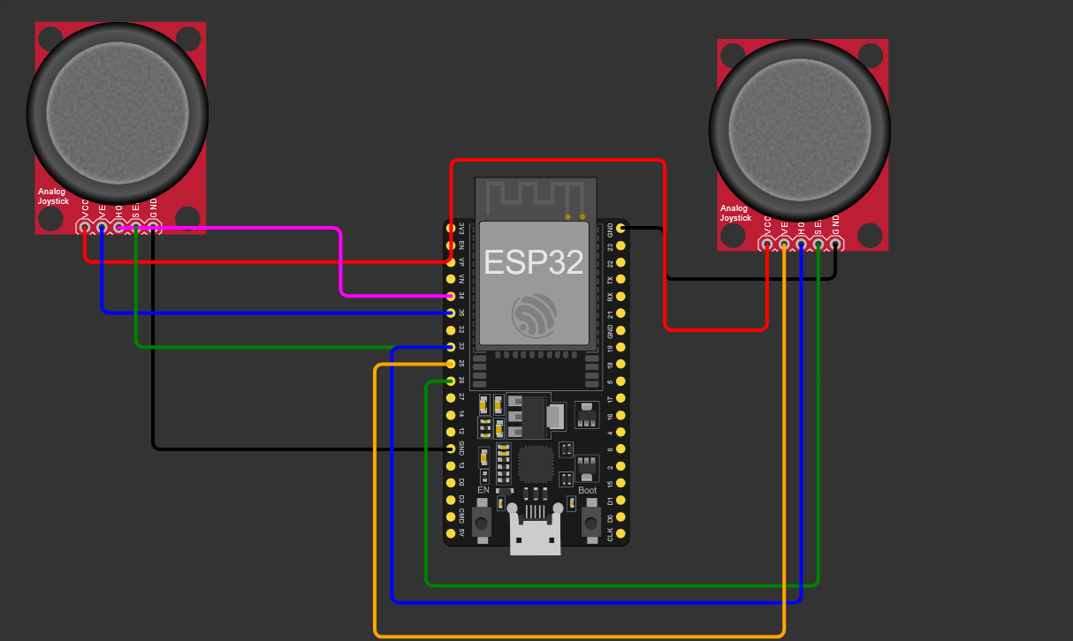
ESP-32 Cam:
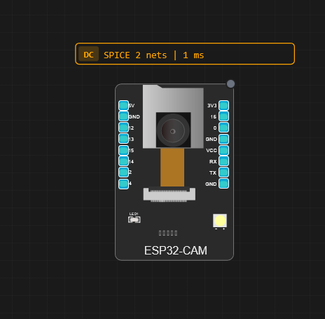
Main Car Circuit:
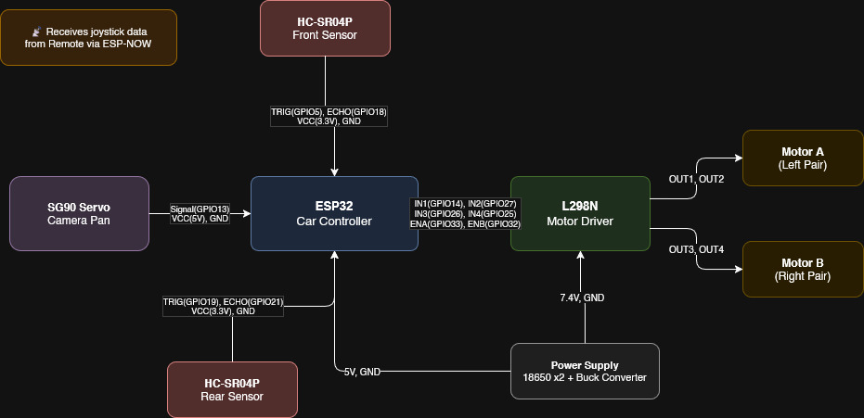

Timeline (Gantt Chart):
