# Fourth: Roles and responsibilities

The system constitutes Monitoring and evaluation tool Comprehensive Enable Institutions from Track Programs and projects Governmental and development, And guarantee Its compatibility with Policies National and plans Strategy and agenda development sustainable​

He does order on to gather And organization Data Basic For projects, including in that Budgets Estimated, authorities Funded, Ministries The official on implementation, Objectives Sectoral, Locations Geography, Tables Temporal, addition to Documents Supportive Associated With it

And during This is amazing Inputs, He does order By generation series from procedures Operational that Includes tracking Indicators performance, Censorship on Financing, Track Exchange, Monitoring Field, And issue Reports patrol minute . and show results This is amazing Operations in appearance Outputs clear like paintings tracking Detailed, Reports progress, Indicators Detailed For proportions Achievement, And measurements minute To level to implement Strategies National​

And with this mechanism, Supports order to improve Mechanisms planning, And it enhances Coordination between various Parties National and international, as raises level Transparency in administration Resources . And Range Far away, Contributes order in Strengthening efficiency Use Resources Finance, acceleration investigation Targets development sustainable, And building trust Donors and society With ability Institutions Governmental on investigation results Concrete​

**Distribution of roles and responsibilities**

**Interface 1 – Login Page**

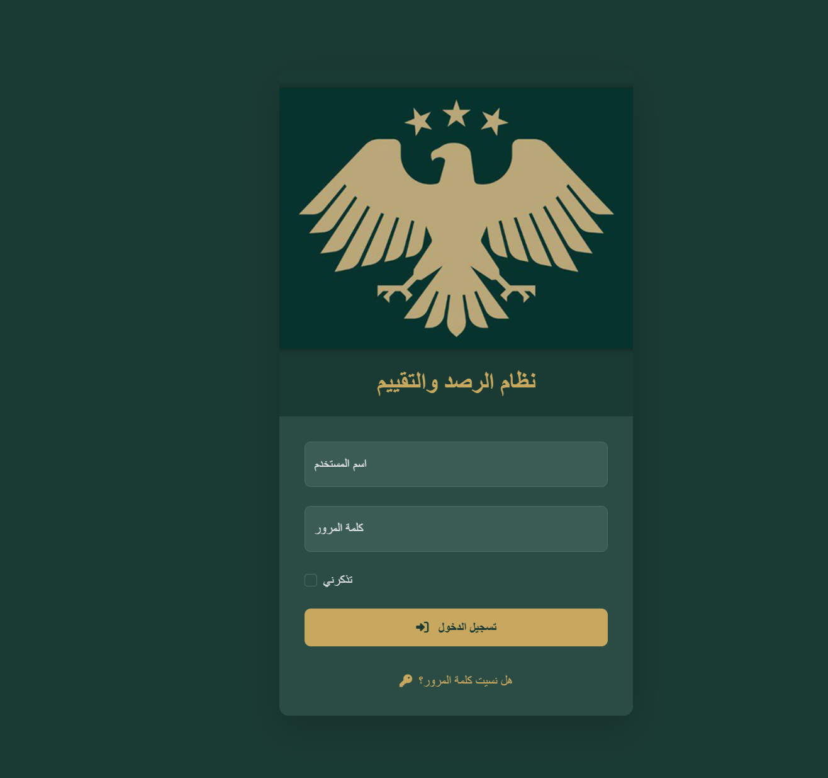

**Interface explanation :**

The login interface is the primary gateway to the system. Each user's credentials are entered to verify their access .

**Available jobs :**

* Enter your username and password .
* Enable the "Remember Me" option to keep data .
* Log in to the system .
* Recover your password if you forget it .

|  |  |  |  |  |
| --- | --- | --- | --- | --- |
| **Job** | **system administrator** | **Ministries User** | **Data entry** | **Reading user** |
| Log in | ✔️ | ✔️ | ✔️ | ✔️ |
| Recover your password | ✔️ | ✔️ | ✔️ | ✔️ |

**Matrix of powers :**

**Interface 2 – Strategy Management Interface**

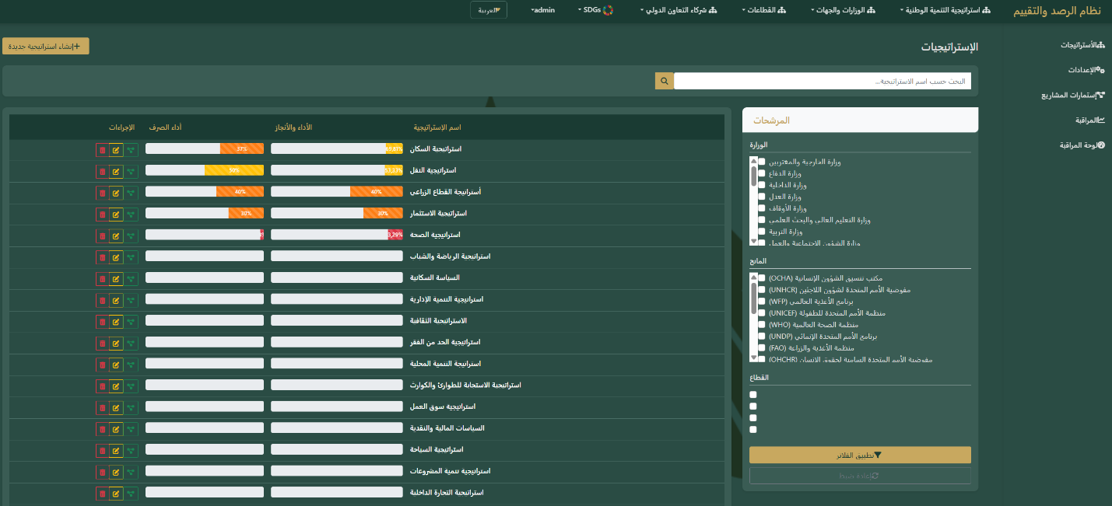**Interface explanation :**

The Strategy Interface represents the highest level in the system, through which all national strategies related to policies, programs, and projects are managed .

**Available jobs :**

* Add a new strategy .
* Modify existing strategy data .
* Delete strategies .
* Linking the strategy to specific policies .
* View progress and achievement details .

**Matrix of powers :**

|  |  |  |  |  |
| --- | --- | --- | --- | --- |
| **Job** | **system administrator** | **Ministries User** | **Data entry** | **Reading user** |
| Reading strategies | ✔️ | ✔️ | ✔️ | ✔️ |
| Add strategy | ✔️ | ✖️ | ✖️ | ✖️ |
| modify strategy | ✔️ | ✖️ | ✖️ | ✖️ |
| Delete strategy | ✔️ | ✖️ | ✖️ | ✖️ |

**Interface 3 – Policy Management Interface**

**Interface explanation :**

The policy interface represents the executive level of strategies, where policies that support the achievement of strategy objectives are created and managed .

**Available jobs :**

* Add a new policy .
* Modify existing policy data .
* Delete policies .
* Linking policies to specific programs .
* Display policy performance indicators .

**Matrix of powers :**

|  |  |  |  |  |
| --- | --- | --- | --- | --- |
| **Job** | **system administrator** | **Ministries User** | **Data entry** | **Reading user** |
| Reading policies | ✔️ | ✔️ | ✔️ | ✔️ |
| Add policy | ✔️ | ✖️ | ✖️ | ✖️ |
| Modify Policy | ✔️ | ✖️ | ✖️ | ✖️ |
| Delete Policy | ✔️ | ✖️ | ✖️ | ✖️ |

**Interface 4 - Program Management Interface**

**Interface explanation :**

The program interface allows the creation of main programs linked to policies, and through it sub-programs can be created to support the division and organization of activities .

**Available jobs :**

* Add a new program and link it to a specific policy .
* Modify program data .
* Delete programs .
* Create subprograms within the main program .
* Display performance indicators for each program .

**Matrix of powers :**

|  |  |  |  |  |
| --- | --- | --- | --- | --- |
| **Job** | **system administrator** | **Ministries User** | **Data entry** | **Reading user** |
| Reading programs | ✔️ | ✔️ | ✔️ | ✔️ |
| Add program | ✔️ | ✖️ | ✖️ | ✖️ |
| Edit program | ✔️ | ✖️ | ✖️ | ✖️ |
| Delete program | ✔️ | ✖️ | ✖️ | ✖️ |

**Interface 5 - Subprograms Interface**

**Interface explanation :**

The sub-programs interface allows users to create and manage programs that are sub-programs of the main programs to facilitate monitoring of activities and reports .

**Available jobs :**

* Add a new subprogram and link it to the main program .
* Modify subprogram data .
* Delete subprograms .
* View subprogram details and performance indicators .

**Matrix of powers :**

|  |  |  |  |  |
| --- | --- | --- | --- | --- |
| **Job** | **system administrator** | **Ministries User** | **Data entry** | **Reading user** |
| Reading subprograms | ✔️ | ✔️ | ✔️ | ✔️ |
| Add a subprogram | ✔️ | ✖️ | ✖️ | ✖️ |
| Edit subprogram | ✔️ | ✖️ | ✖️ | ✖️ |
| Delete a subprogram | ✔️ | ✖️ | ✖️ | ✖️ |

**Interface 6 - Project Management Interface**

**Interface explanation :**

The Project Management Interface is the interface for creating new projects, tracking their details, and linking them to relevant programs and policies .

**Available jobs :**

* Add a new project and link it to the subprogram .
* Modify current project data .
* Delete projects .
* Upload project attachments .
* View project data and progress .

**Matrix of powers :**

|  |  |  |  |  |
| --- | --- | --- | --- | --- |
| **Job** | **system administrator** | **Ministries User** | **Data entry** | **Reading user** |
| Reading projects | ✔️ | ✔️ | ✔️ | ✖️ |
| Add a project | ✖️ | ✖️ | ✔️ | ✖️ |
| Edit project | ✖️ | ✖️ | ✔️ | ✖️ |
| Delete project | ✖️ | ✖️ | ✔️ | ✖️ |

**Add a project verification step (project approval column)**

**Interface 7 - Project Forms Interface**

**Interface explanation :**

The project forms interface is used to fill out progress and achievement data for each project separately, including details of financial disbursements and implemented activities .

**Available jobs :**

* Filling out project forms .
* Upload supporting documents .
* Approval of forms by authorized users .
* View achievement reports .

|  |  |  |  |  |
| --- | --- | --- | --- | --- |
| **Job** | **system administrator** | **Ministries User** | **Data entry** | **Reading user** |
| Reading forms | ✔️ | ✔️ | ✔️ | ✖️ |
| Filling out the form | ✖️ | ✖️ | ✔️ | ✖️ |
| Edit form | ✖️ | ✖️ | ✔️ | ✖️ |
| Delete form | ✖️ | ✖️ | ✔️ | ✖️ |

**Matrix of powers :**

**Interface 8 – Project Metrics Interface**

**Interface explanation :**

The Project Metrics interface is used to enter target and achieved values for indicators for each project, and accurately displays the level of achievement .

**Available jobs :**

* Add target values .
* Enter the executed values .
* Edit metrics data .
* Delete values as needed .

**Matrix of powers :**

|  |  |  |  |  |
| --- | --- | --- | --- | --- |
| **Job** | **system administrator** | **Ministries User** | **Data entry** | **Reading user** |
| Reading the scales | ✔️ | ✔️ | ✔️ | ✖️ |
| Add value | ✖️ | ✖️ | ✔️ | ✖️ |
| Edit values | ✖️ | ✖️ | ✔️ | ✖️ |
| Delete values | ✖️ | ✖️ | ✔️ | ✖️ |

**Interface 9 - Action Plans Interface (Project Implementation Stages)**

**Interface explanation :**

The Action Plans interface provides a detailed view of project implementation plans, including completion rates and spending performance, and is used to track progress towards achieving objectives .

**Available jobs :**

* View project plan details .
* Comparing achievement rates with specified plans .
* Update the status of plan implementation .

**Matrix of powers :**

|  |  |  |  |  |
| --- | --- | --- | --- | --- |
| **Job** | **system administrator** | **Ministries User** | **Data entry** | **Reading user** |
| Reading plans | ✔️ | ✔️ | ✔️ | ✖️ |
| Modify plan status | ✖️ | ✖️ | ✔️ | ✖️ |
| Delete plan | ✖️ | ✖️ | ✔️ | ✖️ |

**Interface 10 - General Control Panel**

**Interface explanation :**

The general dashboard provides a comprehensive view of strategies, policies, programs, projects, and achievement rates, and is used by managers and supervisors to monitor performance .

**Available jobs :**

* Display key performance indicators .
* Review the progress of strategies and programs .
* Analysis of achievement rates .
* Comparing the performance of different entities .

**Matrix of powers :**

|  |  |  |  |  |  |
| --- | --- | --- | --- | --- | --- |
| **Job** | **system administrator** |  | **Ministries User** | **Data entry** | **Reading user** |
| View control panel | ✔️ |  | ✔️ | ✔️ | ✔️ |
| Indicator analysis | ✔️ |  | ✔️ | ✖️ | ✖️ |
| Export reports | ✔️ |  | ✔️ | ✖️ | ✖️ |

**Interface 11 - Ministries Management**

**Interface explanation :**

This interface displays all ministries and official entities participating in the system. It allows monitoring of each ministry's overall performance, achievement rates, and associated financial disbursements. It also allows the addition of a new ministry when necessary .

**Available jobs :**

* Create a new ministry .
* Modify ministries' data .
* Delete ministry .
* Display performance and expenditure indicators for each ministry .

**Matrix of powers :**

|  |  |  |  |  |
| --- | --- | --- | --- | --- |
| **Job** | **system administrator** | **Ministries User** | **Data entry** | **Reading user** |
| Establishing a new ministry | ✔️ | ✖️ | ✖️ | ✖️ |
| Modify Ministry data | ✔️ | ✖️ | ✖️ | ✖️ |
| Delete Ministry | ✔️ | ✖️ | ✖️ | ✖️ |
| Display indicators | ✔️ | ✖️ | ✖️ | ✖️ |

**Interface 12 – Project Dashboard**

**Interface explanation :**

This interface provides a comprehensive view of all projects included in the system, displaying progress status, completion rates, and disbursement performance for each project. Projects can also be filtered by ministry or funding agency .

**Available jobs :**

* Browse all ongoing or completed projects .
* Monitoring performance and achievement rates .
* View exchange details .
* Classification of projects according to the ministry or funding agency .

**Matrix of powers :**

|  |  |  |  |  |
| --- | --- | --- | --- | --- |
| **Job** | **system administrator** | **Ministries User** | **Data entry** | **Reading user** |
| Browse projects | ✔️ | ✔️ | ✔️ | ✔️ |
| Performance monitoring | ✔️ | ✔️ | ✖️ | ✖️ |
| Edit project data | ✖️ | ✖️ | ✔️ | ✖️ |
| Project classification | ✔️ | ✔️ | ✔️ | ✖️ |

**Interface 13 – Strategic Indicators Monitoring Dashboard**

**Interface explanation :**

This interface displays performance and achievement indicators at the national strategy level. Each card represents a specific strategy and outlines its associated policies, programs, and projects, along with achievement rates and spending performance .

**Available jobs :**

* View performance summary for each strategy .
* Follow up on the number of policies, programs and projects .
* Comparison of achievement rates and disbursement performance .
* Supporting decision makers with visual data .

**Matrix of powers :**

|  |  |  |  |  |
| --- | --- | --- | --- | --- |
| **Job** | **system administrator** | **Ministries User** | **Data entry** | **Reading user** |
| Display indicators | ✔️ | ✔️ | ✔️ | ✔️ |
| Performance comparison | ✔️ | ✔️ | ✔️ | ✖️ |
| Edit strategy data | ✔️ | ✖️ | ✖️ | ✖️ |

**Interface 15 – Comprehensive Performance Reporting Dashboard**

**Interface explanation :**

The comprehensive performance reporting dashboard displays advanced summaries of the financial and technical performance of all projects and strategies. It includes visual indicators such as graphs and percentages to illustrate overall progress .

**Available jobs :**

* Present comprehensive reports at the project and strategy level .
* Exchange versus performance analysis .
* Comparing the performance of different sectors .
* Export reports to support decision making .

**Matrix of powers :**

|  |  |  |  |  |
| --- | --- | --- | --- | --- |
| **Job** | **system administrator** | **Ministries User** | **Data entry** | **Reading user** |
| View reports | ✔️ | ✔️ | ✖️ | ✔️ |
| Performance analysis | ✔️ | ✔️ | ✖️ | ✖️ |
| Export reports | ✔️ | ✔️ | ✖️ | ✖️ |