Name:

Rollno:

User Requirements

I did a little research for the topic and gather the requirements as follows

**Functional requirement**

* A payment method that accept cash
* A payment method that accept cards
* The method should be able to calculate the surcharge
* The method should be able to add different payment method

**NON Functional requirement :**

* The system should be robust
* The system should be error less
* The system should be accurate

**Use case Diagram**

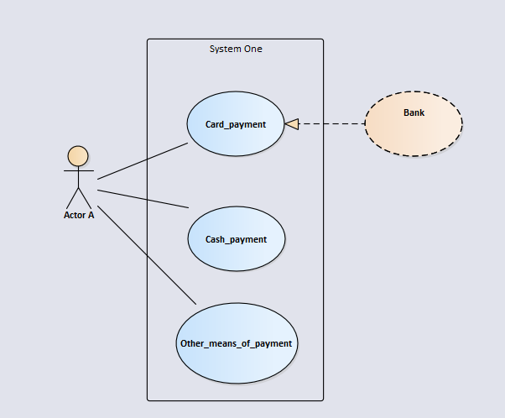

**Class Diagram:**

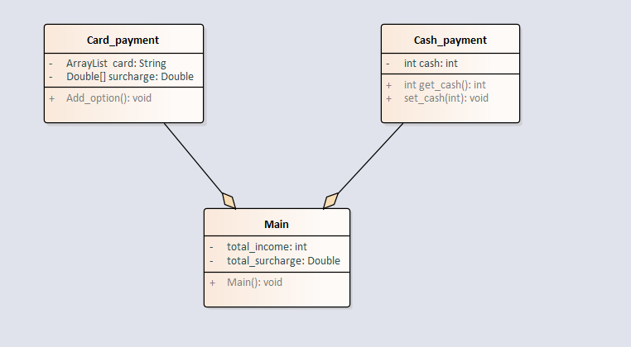

**Sequence Diagram**

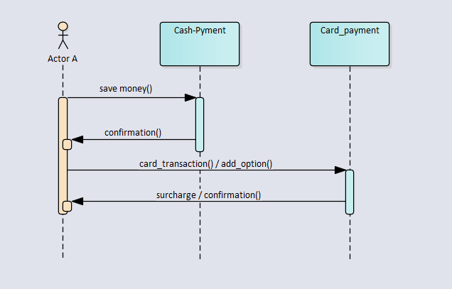

**Code**

**Main.java**

**import** java.util.Scanner;

**public** **class** main **extends** Cash_payment{

**public** **static** **void** main(String[] args) {

**int** total_income=0;

**double** total_surcharge= 0;

Cash_payment a= **new** Cash_payment();

Card_payment b= **new** Card_payment();

**int** choice;

**for**(choice=1;choice!=0;)

{

System.*out*.println("please select an option \n 1. Cash \n 2. Card \n 3. Add new option \n 4. Total income \n 0. Exit");

Scanner input1 = **new** Scanner(System.*in*);

choice= input1.nextInt();

**if**(choice==1)

{

System.*out*.println("please input the cash amount");

//Scanner input1 = new Scanner(System.in);

a.cash = input1.nextInt();

total_income+=a.cash;

}

**if**(choice==2)

{

System.*out*.println("please select an option " );

**for** (**int** i=0;i<b.surcharge.length;i++)

{

System.*out*.print(i);

System.*out*.print(" " );

System.*out*.print(b.card.get(i) );

System.*out*.println();

}

**int** c = input1.nextInt();

**double** price = b.surcharge[c];

System.*out*.println("please enter the amount " );

**int** prices = input1.nextInt();

total_income+=prices;

System.*out*.println("The surcharge amount is " );

total_surcharge=(price*prices)/100;

System.*out*.println((price*prices)/100 );

}

**if**(choice==3)

{

b.add_option();

}

**if**(choice==4)

{

System.*out*.print("Total income " );

System.*out*.print(total_income );

System.*out*.println();

System.*out*.print("Total surcharge " );

System.*out*.print(total_surcharge );

System.*out*.println();

}

}

}

}

**Cash_payment.java**

**public** **class** Cash_payment **extends** Card_payment {

**int** cash;

Cash_payment()

{

cash=0;

}

**int** get_cash()

{

**return** cash;

}

**void** set_cash(**int** a)

{

cash=a;

}

}

**Card_payment.java**

**import** java.util.ArrayList;

**import** java.util.Scanner;

**interface** printable{

**void** add_option();

}

**public** **class** Card_payment **implements** printable{

ArrayList card;

**double**[] surcharge;

Card_payment()

{

card=**new** ArrayList ();

surcharge=**new** **double**[2];

card.add("MasterCard");

card.add("visa");

card.add("Amex");

surcharge[0]=1.5;

surcharge[1]=1.5;

surcharge[2]=3.0;

}

**public** **void** add_option()

{

System.*out*.println("input the name of the new card or payment method ");

Scanner input = **new** Scanner(System.*in*);

String number = input.next();

card.add(number);

System.*out*.println("input the surharge of the new card or payment method ");

Scanner input2 = **new** Scanner(System.*in*);

**double** Surcharge = input2.nextDouble();

**double**[] newarr = **new** **double**[surcharge.length+1];

**for**(**int** i=0 ;i<surcharge.length ; i++)

{

newarr[i]=surcharge[i];

}

newarr[surcharge.length]=Surcharge;

surcharge=newarr;

}

}

**Learning outcome**

I learned a lot from this project I have pushed this to my git and will persue it in near future this function can be upgraded by adding gui to the system and I will do it in near future I learned a lot from this project about billing system and there are a lot of fields that can be done better on which I will work in the end I would say that the project was informative technical and had a lot of learning out comes