Assignment 2: Parallel Implementation

DOCUMENTATION

YOUR NAME

Contents

Requirements: 3

Class Diagram: 3

Use Case Diagram: 4

Sequence Diagram: 5

C language: 6

Features Used: 6

Advantages from other languages: 6

Lack of features or difficulty in implementing: 6

Lisp language: 7

Features Used: 7

Advantages like other languages: 7

Lack of features or difficulty in implementing: 7

Java Language: 8

Features Used: 8

Java Language Advantages: 8

Disadvantages: 8

Python language: 9

Features Used: 9

Python Language Advantages: 9

Disadvantages: 9

Comparative overview of the languages: 10

# Requirements:

* Calculate prices of order of pasta and pizza.
* Print total earnings.
* Print total sale.

# Class Diagram:

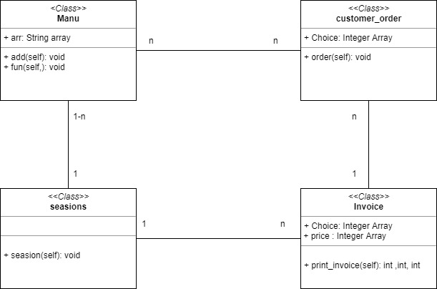

# Use Case Diagram:

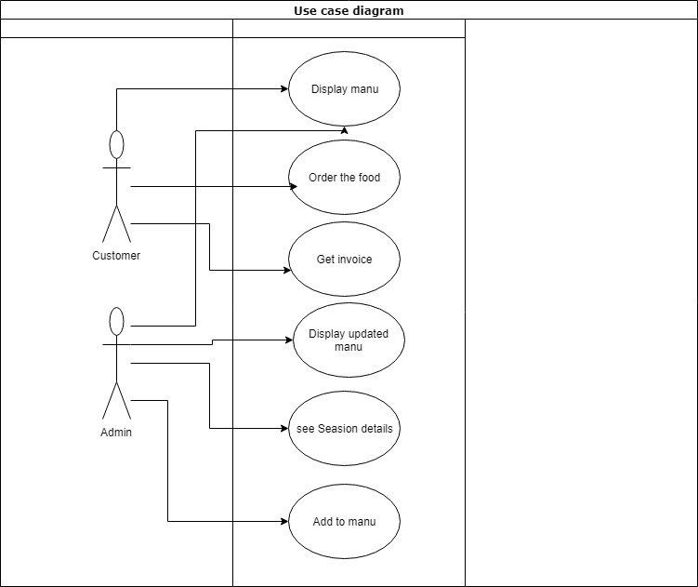

# Sequence Diagram:

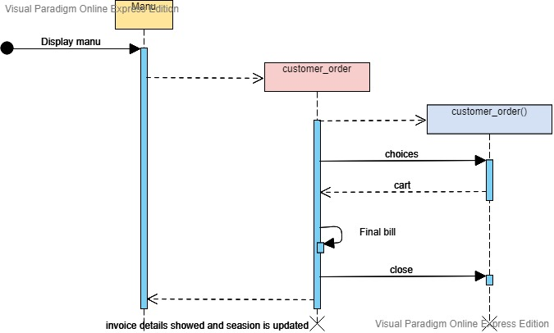

# C language:

## Features Used:

The features I used include:

• Arrays

• Loops

• Conditional statements if and while

• Break Statements

• Functions

• Return Statements

• PRINTF of all types

• SCANF Statements

• Variables of different types

## Advantages from other languages:

C was fast. Programs were directly executed form the terminal. There were lot of library support for doing the tasks. Modular programming was used as everything cam be broken into functions so it is quite easy. A lot of online support was also available and it was also convenient because of the syntax was easier than lisp. Another advantage was that it is not an indentation sensitive language so we can write code more easily without the problem of keeping the indentation in check. As c is dated back to 1979 so the support in books and online library support was a great help.

## Lack of features or difficulty in implementing:

There were two main issues in implementing the code. First one was that the c language doesn’t support object oriented programming and its principles. So it was quite hard in that matter to do polymorphism so that latter on the owner can change the menu according to their will. Secondly pointers in c are quite confusing and needs to be implemented carefully. This was one issue I faced while implementing. As it is also old and another improved language is C++ which supports low level programing so it is a little hectic to code in c and also as its structure / syntax resemble with C++ so some times its hard to differentiate .

# Lisp language:

## Features Used:

The features I used include:

• Variables

• Loops

• Conditional statements if and when

• Case statements

• Comparison statements

• Taking user input.

• Format t (print statement ) of all kind

• Set statements

## Advantages like other languages:

Lisp is very helpful in the sense that it doesn’t differ between the function and variables. Functions can be passed to other variables as it is. This is one feature which I didn’t find in any other language. Other languages also don’t give that much support in making list of elements Lisp is helpful because it can generate chunks of code that are useful its syntax is unique and power full in a sense that it is the most different from other languages Functions are manipulated as the data is manipulated it was ahead of its time when it was being used

## Lack of features or difficulty in implementing:

Programming in Lisp was difficult due to the not so common syntax. It was difficult to code and find errors as I programed it on sublime text edit so many errors were found only after compilation. Printing correctly on the console was other issue as there are different syntax to print an integer and different for printing strings. Usage of Tildas signs need to be mastered for ease. Starting and ending each statements with parenthesis was also hectic also online support for lisp language was also limited because it is old and somewhat obsolete there are no brackets other than round brackets so it was tough to see the scope of the different variables

# 

# Java Language:

## Features Used:

* Object oriented properties (inheritance and encapsulation)
* Conditional statements if and when
* Classes
* Print statements
* Polymorphism
* Comparisons
* Arrays
* All types of variables
* User input
* Loops

## Java Language Advantages:

The best part in implementing the problem in java was the ease to debug the errors as I codded in eclipse so it immediately tells us any run time errors. Moreover nature of implementation in java is already according to the principles of object oriented programming. So that means the code was reused. Inheritance allowed to make objects such as pizza and pasta moreover minimal code addition is required to add new products. The intelesense support for Java compiler was incredible Online support was easily and rapidly available as the syntax is easy and mostly resembles with other coding languages so I rather got no difficulty to implement the problem in Java

## Disadvantages:

* Slow in execution.
* Takes more memory than others
* Depends on the compiler
* All the concerned classes should be in the same package
* Low level programing is also missing that’s why we cannot use pointers etc
* Java does not support unsigned int , unsigned char etc

# Python language:

## Features Used:

• Inheritances

• Lists

• Encapsulation

• Functions

• Loops

• print statement

• Variables

• Classes

• Comparisons

• Conditional statements (if else)

• Input keyword for taking input from a user

• Typecasting

## Python Language Advantages:

Python was like java in the order of having support for object oriented implementation. The major advantage in python is of having the best easy to write syntax. It allows to perform certain operations very easily as compared to others. For example collecting multiple objects return from a function etc.

## Disadvantages:

• runtime errors is a pain in the neck because it compiles and executes at the same time.

• Slower than others.

• It also don’t support low level programing.

• Always have to make sure that we are using same indentation.

• Syntax is unique so had to go a lot for online support.

# Comparative overview of the languages:

As a personal perception, python was the easiest language to implement pizza shop in because of the fact that it was very helpful in syntax. The code is written in classes and it can be reused so it was very helpful. Secondly, I would rate java because of its easiness in debugging and closeness to the intelligence and of course it was very helpful in object oriented too. C language was next. C++ provides support for object oriented properties but C doesn’t so had to use functions and same functions for the different items. Lisp at the end was the least favorable due to the fact that the language didn’t had any object oriented support as well as the syntax was complex.