PREPARING THE LIVE DASHBOARD CONNECTED TO SQL SERVER IN POWER BI

A Dashboard can be created in Power BI with data from the SQL server. However, the trick in this work is that the report is automatically refreshed. This can only be accomplished by the Direct Query method of the data. Therefore, the data set must be prepared in SQL.

Step-1: Prepare the data set for SQL Server to analyze.

No changes can be made to the data received with the Direct Query method on Power BI. Therefore, the data must be transferred directly as it will be visualized.

Step-2: Write the Query that will create the data in the format to be visualized.

After cleaning your data, you need to export it to the appropriate format for the report. For this data set, we visualized total sales by country or customer. Prepare the Queries that give these in SQL Server

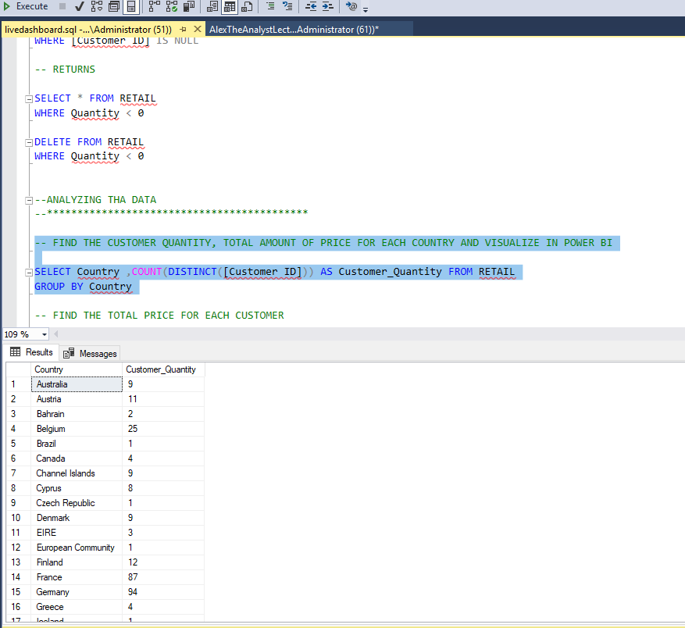

Step-3: Transfer the data to Power BI.

For this data transfer, SQL Server is selected from the data tab. Direct Query is selected from the window that opens. The server information to be used to connect to SQL Server is entered and data is retrieved by typing the Query we prepared in Step 2 into the Query box.

metin, ekran görüntüsü, yazılım, bilgisayar simgesi içeren bir resim

Açıklama otomatik olarak oluşturuldu

Step-4: Visualize the incoming data, set the page automatic refresh setting, and observe the results by making changes to the data set using SQL Server.

In order for the Power BI report to be automatically updated, the page refresh setting must be set. You can do it as shown below:

metin, ekran görüntüsü, yazı tipi, sayı, numara içeren bir resim

Açıklama otomatik olarak oluşturuldu

After this setting is made, any changes in the data set will be automatically reflected in the report.