Software Requirement Specifications
Online Voting System with Admin Dashboard



Submitted by
Muhammad Hamza(S23BINFT1M01136)

Submitted to
Dr. Syed Ali Nawaz Shah

Department of Information Technology
Faculty of Computing
The Islamia University of Bahawalpur

Meeting Details
Sr No | Details | Date | Supervisor Signature
Summary
This document presents the Software Requirements Specification for an Online Voting System with an Admin Dashboard. The system is designed to replace traditional paper-based voting with a secure, efficient, and transparent electronic alternative. The document covers the background of the problem, the system's intended users, its functional and non-functional requirements, use cases with flow diagrams, and diagrams. The platform allows registered voters to securely cast one vote per election after verifying their identity, while administrators manage elections, candidates, and results through a dedicated dashboard. Real-time vote counting and result display are central features of this system.

Table of Contents
1. Introduction 6
1.1. Purpose 6
1.2. Scope 6
1.3. Product Perspective 7
1.4. User Characteristics 7
1.5. Similar apps and systems/Literature Review 8
1.6. Proposed Technologies 9
2. Requirements 10
2.1. Function Requirements 10
2.1.1. Voter Registration 10
2.1.2. Admin Verification of Voter 11
2.1.3. Voter Login 11
2.1.4. Create and Manage Elections 11
2.1.5. Manage Candidates 12
2.2. Non-Functional Requirements 12
Security: 12
Integrity: 12
Performance: 13
Usability: 13
Availability: 13
Scalability: 13
Maintainability: 13
3. Use Cases and Flow of Processes 14
3.1. Voter Registration 14
3.2. Cast Vote 15
3.3. Admin Creates Election 17
3.4. Verify Voter Registration 18
3.5. Publish Election Results 19
4. References 21

- Introduction
Elections are among the most important civic activities in any institution or organization. Whether it is a university student council election, a community representative vote, or a corporate board election, the process needs to be fair, transparent, and tamper-resistant. Traditional paper-based voting suffers from several well-documented problems. Ballot boxes can be manipulated. Manual counting is slow and error-prone. Voter turnout tends to drop when physical attendance is required. These issues undermine trust in the entire process.
This project builds an Online Voting System that addresses all of these problems by moving the voting process to a secure and accessible web-based platform. The system is designed so that a voter can register, verify their identity, review available candidates, and cast their vote entirely online. A strict one-vote-per-voter enforcement mechanism ensures that no individual can vote more than once in a given election. Votes are tallied in real time, and results are displayed as the election progresses. The Admin Dashboard gives election organizers complete control over the process, from setting up elections and adding candidates to monitoring live vote counts and generating final result reports.

  - Purpose
The purpose of this project is to design and develop a secure, reliable, and user-friendly online voting system. The system aims to eliminate the inefficiencies and security risks associated with traditional voting. It will provide voters with a simple and accessible interface to participate in elections from any device with an internet connection. It will provide administrators with a powerful dashboard to create and manage elections, monitor voting activity in real time, and produce accurate results. The system enforces identity verification and one-vote-per-voter rules to maintain the integrity of every election conducted on the platform.

  - Scope
The system will include voter registration with identity verification, a secure login mechanism, an election management module, a candidate management module, a ballot submission interface, real-time vote counting, and a results display feature. The Admin Dashboard will allow administrators to create elections, define their start and end dates, add candidates with descriptions, monitor participation, and view or publish results.
The following items are outside the scope of this project.
- The system will not support biometric authentication such as fingerprint or facial recognition.
- It will not handle postal or proxy voting.
- It will not integrate with any government or national identity database.
- Multi-round ranked-choice voting methods are not included in the current version.
- Email or SMS notification systems are also not within scope for this release.

  - Product Perspective
This system is a standalone web application that operates independently. It does not plug into an existing institutional system but can be adopted by any organization that needs to run a managed election process. The architecture follows a three-layer model.
- The frontend built with HTML, CSS, and JavaScript serves the user interface for both voters and administrators.
- The middle layer built with Django handles all business logic including authentication, vote validation, and data processing. MySQL serves as the relational database at the backend, storing all records for users, candidates, elections, and votes in a structured and queryable format.
The system is designed so that each layer can be maintained or updated independently without breaking the others. This makes it practical for long-term use and future extension.

  - User Characteristics
There are two types of users who interact with this system.
- The first type is the Voter. A voter is any eligible individual who has been registered in the system. Voters interact with the public-facing part of the application. They are expected to have basic digital literacy, meaning they should be able to fill an online form, navigate between pages, and click a button to submit their vote. No technical knowledge is required. Voters will use the system only during active election periods.
- The second type is the Administrator. The administrator is the election organizer or a trusted person authorized to manage the platform. The administrator accesses the Admin Dashboard and has full control over elections, candidates, and voter records. Administrators are expected to have a moderate level of computer proficiency since they will be creating structured election data, managing timelines, and reading analytics. Only one or a very small number of administrators are expected to use the system at any given time.

  - Similar apps and systems/Literature Review
Several electronic voting systems and platforms have been developed and deployed, each with varying degrees of success and notable limitations.
- Voatz is a blockchain-based mobile voting application used in some United States elections. It gained attention for allowing overseas citizens to vote via smartphone. However, security researchers at MIT identified multiple vulnerabilities in the application including the ability for a server-side attacker to alter votes. The platform also raised concerns about transparency since the source code was not publicly available.
- Helios Voting is an open-source web-based voting system used by academic institutions and small organizations. It uses cryptographic techniques to allow public verification of results without revealing individual votes. Its main limitation is usability. The interface is not intuitive for non-technical voters, and the setup process requires significant technical knowledge from administrators.
- Polyas is a German commercial online voting platform used for organizational and institutional elections. It offers strong security features and a clean interface. However, it is a paid proprietary service, which makes it inaccessible for small institutions or students on limited budgets. It also offers limited customization for specific organizational workflows.
- OpaVote is another commercial election platform that supports multiple voting methods. It is relatively easy to use but again requires a paid subscription for most features and offers no self-hosted option.
The proposed system addresses the limitations of these existing tools by being free, self-hosted, customizable, and designed with usability as a primary concern for both voters and administrators. It does not require any third-party subscription and gives the organization complete ownership of its data.

  - Proposed Technologies
The following technologies will be used to build this system.
- For the frontend, HTML5, CSS3, and JavaScript will be used to build all voter-facing and admin-facing pages. These technologies are lightweight, universally supported, and sufficient for building an interactive and responsive web interface.
- For the middle layer, Django will be used as the web framework. Django handles URL routing, form processing, session management, and the REST API that connects the frontend to the backend. Its built-in admin interface also provides a foundation on top of which the custom Admin Dashboard is built.
- For authentication and voting management, Django's authentication system will be extended to support voter identity verification and vote session control.
- For the database, MySQL will be used. MySQL is a mature and reliable relational database management system that is well-suited for structured data like voter records, candidate details, election metadata, and vote logs.
For version control, Git and GitHub will be used throughout the development process.

- Requirements
The system revolves around two core experiences. The voter experience begins with registration, where an eligible individual creates an account and submits identity details for verification. Once verified and logged in, the voter can view active elections, read candidate profiles, and cast exactly one ballot per election. After voting, the system confirms the submission and prevents any further votes in the same election. The voter can also view published results.
- The administrator experience begins with logging into the Admin Dashboard.
- From there the admin can create new elections by specifying a name, description, start date, and end date.
- Candidates can be added to any election with a name, photograph, and brief description.
- The admin can monitor live vote counts as the election progresses and can close or extend elections as needed.
- Once an election closes, the admin can generate and publish the final results.
- The admin can also manage voter accounts, verify pending registrations, and deactivate accounts if needed.

  - Function Requirements
    - Voter Registration
- Name: FR001
- Purpose: The registration feature allows an eligible individual to create an account on the platform so they can participate in elections.
- User(s): Voter
- Input:
- Full Name: The voter's complete legal name
- National Identity Number: A unique identifier to prevent duplicate registrations
- Email Address: A valid and working email address
- Password: Must be at least 8 characters long and must include at least one number and one special character
- Date of Birth: To verify age eligibility
- Profile Photo: A recent photograph of the voter for identity verification purposes
- Output: The voter account is created in the system with a pending verification status. The admin must approve the account before the voter can log in and cast votes.
    - Admin Verification of Voter
- Name: FR002
- Purpose: Purpose: This requirement ensures that only verified individuals are allowed to vote, protecting the integrity of the election.
- User(s): Administrator
- Input:
- Voter registration record submitted through FR001
- Admin decision to approve or reject the registration
- Output: On approval the voter's account becomes active and the voter can log in. On rejection the voter is notified and their account remains inactive.
    - Voter Login
- Name: FR003
- Purpose: The login feature allows a verified voter to authenticate into the system and access active elections.
- User(s): Voter
- Input:
- Email Address: The email used during registration
- Password: The password set during registration
- Output: On successful authentication the voter is redirected to the election’s dashboard. On failure an appropriate error message is shown.
    - Create and Manage Elections
- Name: FR004
- Purpose: This requirement allows the administrator to create new elections and manage their lifecycle including start, monitoring, and closure.
- User(s): Administrator
- Input:
- Election Name: A descriptive title for the election
- Election Description: A brief explanation of what the election is about
- Start Date and Time: When voting begins
- End Date and Time: When voting closes
- Status: Active, Scheduled, or Closed
- Output: The election is created and stored. Active elections are visible to verified voters on their dashboard.
    - Manage Candidates
- Name: FR005
- Purpose: This requirement allows the administrator to add candidates to an election so voters can review and choose among them.
- User(s): Administrator
- Input:
- Candidate Name: Full name of the candidate
- Candidate Photo: A photograph uploaded by the admin
- Candidate Description: A brief profile or manifesto statement
- Associated Election: The election this candidate is being added to
- Output: The candidate is stored and displayed on the ballot for the corresponding election. Candidates can be edited or removed before the election begins.

  - Non-Functional Requirements

Security:
All passwords must be stored using cryptographic hashing. Communication between the browser and server must use HTTPS to prevent data interception. API endpoints that process votes or return sensitive data must require authentication tokens. The system must protect against common web vulnerabilities including SQL injection, cross-site scripting, and cross-site request forgery.

Integrity:
The one-vote-per-voter rule must be enforced at the database level, not just the application level, so that even direct database access cannot result in a duplicate vote being counted without detection.

Performance:
The system must handle concurrent vote submissions from multiple voters without data corruption or significant slowdowns. Vote submission and confirmation must complete within two seconds under normal load conditions.

Usability:
The voter interface must be simple enough for first-time users to navigate without any instructions. Buttons, forms, and feedback messages must be clearly labeled. The Admin Dashboard must present data in an organized and readable way with charts where appropriate.

Availability:
The system must be available throughout the duration of any active election with a minimum uptime target of 99 percent. Scheduled maintenance should be performed outside active election windows.

Scalability:
The system must be able to scale to support a growing number of voters and elections. The database schema and Django application structure must be designed with this in mind from the beginning.

Maintainability:
The codebase must follow Django's standard project structure with separate apps for elections, voters, candidates, and administration. Code must be adequately documented to support future developers.

- Use Cases and Flow of Processes
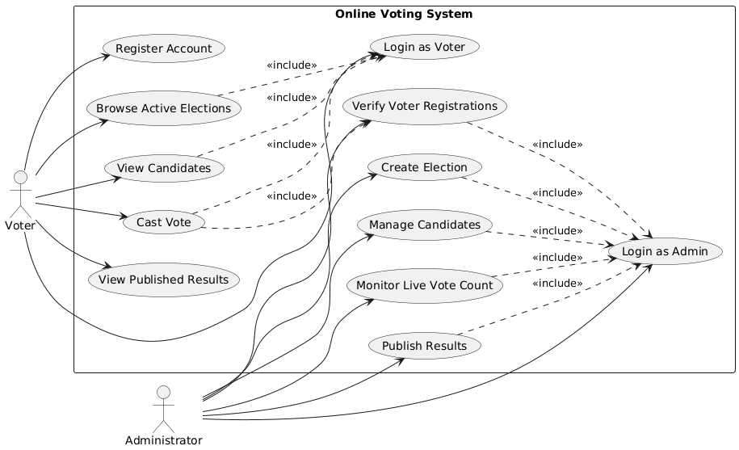
Figure 1: System Level Use Case Diagram

  - Voter Registration
ID | UC001
Name | Voter Registration
Description | This use case describes the process by which an eligible individual registers an account on the voting platform
Requirement(s) | FR001
Actor(s) | Voter
Precondition | The individual must not already have a registered account with the same identity number
Postcondition | A new voter account is created with a pending status and awaits admin approval
Basic Flow | Basic Flow  1. The voter navigates to the registration page.  2. The voter fills in full name, national identity number, email, password, date of birth, and uploads a profile photo.  3. The system validates all inputs.  4. On successful validation the system creates the account with a pending status.  5. The voter sees a confirmation message saying their registration is under review.
Diagrams
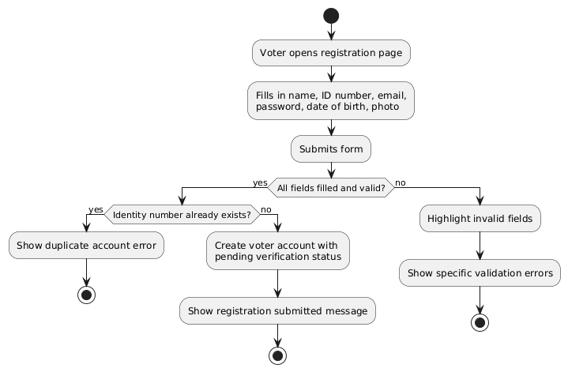
  - Cast Vote
ID | UC002
Name | Cast Vote
Description | This use case describes the process by which a verified and authenticated voter selects a candidate and submits their ballot in an active election
Requirement(s) | FR002, FR003
Actor(s) | Voter
Precondition | The voter must be logged in, their account must be verified, and there must be an active election available
Postcondition | The vote is recorded and the voter is marked as having voted in this election
Basic Flow | Basic Flow  1. The voter navigates to the active elections page.  2. The voter selects an election and views the candidate list.  3. The voter selects their preferred candidate.  4. The system asks the voter to confirm their selection.  5. The voter confirms.  6. The system records the vote, marks the voter as having voted, and displays a confirmation.
Diagrams
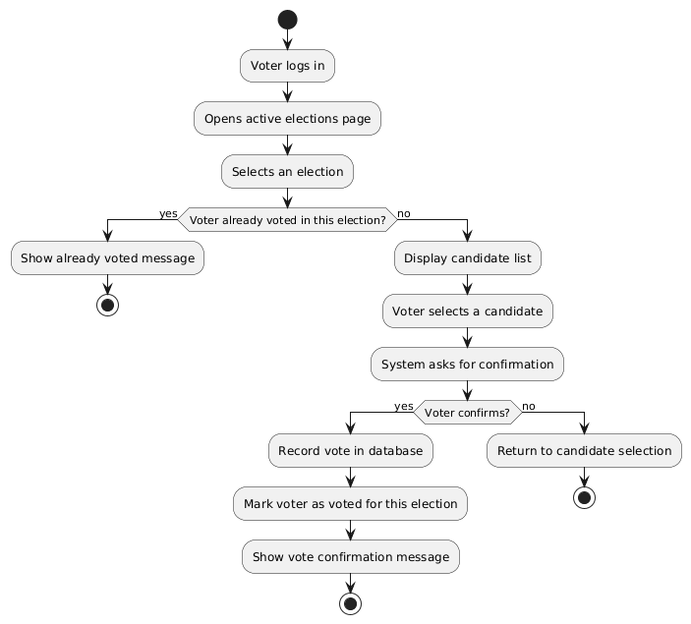
  - Admin Creates Election
ID | UC003
Name | Admin Creates Election
Description | The administrator creates a new election by entering its details and setting its schedule
Requirement(s) | FR003
Actor(s) | Administrator
Precondition | The election is created and stored in the system. If the start date is current it becomes immediately active. Otherwise it remains in scheduled status.
Postcondition | The administrator must be logged in
Basic Flow | Basic Flow  1. Admin navigates to Create Election in the dashboard.  2. Admin enters the election name, description, start date, and end date.  3. System validates the inputs.  4. System saves the election record.  5. Election appears in the elections list with the appropriate status.
Diagrams
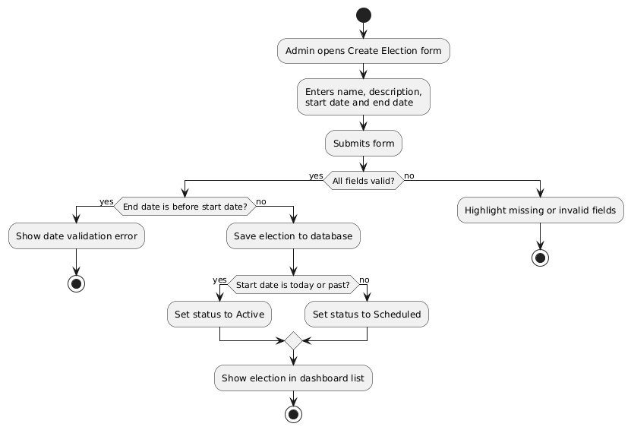
  - Verify Voter Registration
ID | UC004
Name | Verify Voter Registration
Description | The administrator reviews pending voter registration requests and approves or rejects them
Requirement(s) | FR004
Actor(s) | Administrator
Precondition | One or more voter registrations must be pending review
Postcondition | Approved voters can log in and participate. Rejected voters remain inactive.
Basic Flow | Basic Flow  1. Admin opens the Pending Registrations section in the dashboard.  2. Admin reviews each voter's submitted details and photo.  3. Admin approves or rejects the registration.  4. System updates the voter's account status accordingly.  5. Approved voter can now log in.

Diagrams
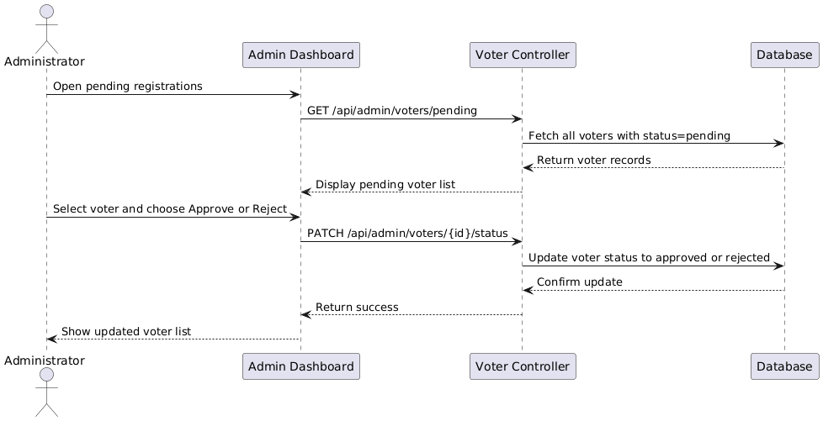
  - Publish Election Results
ID | UC005
Name | Publish Election Results
Description | After an election closes the administrator views the final tally and publishes the results for voters to see
Requirement(s) | FR005
Actor(s) | Administrator, Voter
Precondition | The election must be closed
Postcondition | Results are published and visible to all verified voters on the results page
Basic Flow | Basic Flow  1. Admin navigates to a closed election in the dashboard.  2. Admin views the final vote counts and percentages per candidate.  3. Admin clicks Publish Results.  4. System marks the results as public.  5. Voters can now view the results from their dashboard.

Diagrams
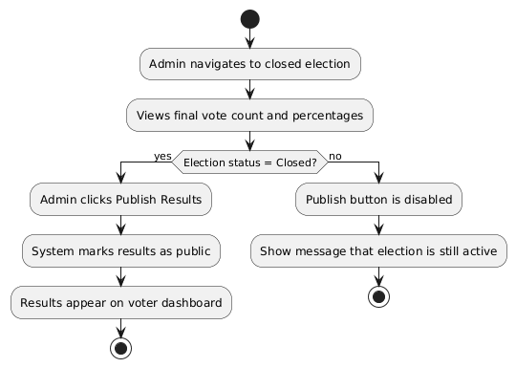
- References
[1] I. Sommerville, Software Engineering, 10th ed. Pearson, 2015.
[2] S. Nakamoto and others, "Security Analysis of the Democracy Live Online Voting System," MIT Computer Science and Artificial Intelligence Laboratory, 2020.
[3] B. Adida, "Helios: Web-based Open-Audit Voting," in Proceedings of the 17th USENIX Security Symposium, 2008.
[4] Polyas GmbH. (2024). Polyas Online Voting Platform. [Online]. Available: https://www.polyas.com
[5] OpaVote. (2024). OpaVote Online Voting. [Online]. Available: https://www.opavote.com
[6] Django Software Foundation. (2024). Django Documentation. [Online]. Available: https://docs.djangoproject.com
[7] MySQL AB. (2024). MySQL 8.0 Reference Manual. [Online]. Available: https://dev.mysql.com/doc
[8] IEEE. (1998). IEEE Recommended Practice for Software Requirements Specifications, IEEE Std 830-1998.

