# Expense Tracker Project Report

GitHub Link:  
https://github.com/hamzatpc/JFXExpenseTracker

## Group Members

Hamza Mert Topçu - 23040102032  
Gürhan Soytürk - 23040102060

## Project Description

Our project is a JavaFX-based Expense Tracker application designed to help users manage their personal expenses efficiently. Users can register, log in, add, view, filter, and delete their expenses easily. The application stores all data locally in JSON files to maintain simplicity and data privacy.

## Key Features

* User Authentication: Secure login and registration system that ensures users’ data is private and only accessible by themselves.
* Add Expenses with Custom Dates: Unlike many simple trackers, users can set the date for each expense manually, enabling accurate tracking.
* Expense Listing with Total: All entered expenses are displayed in a list with a running total of the amounts shown directly below the list for quick reference.
* Monthly Filtering: Users can filter expenses by month within the same dashboard screen via a dropdown, allowing easy review of monthly spending without navigating to different screens.
* Delete Expenses: Each expense entry can be deleted individually with a delete button, giving users control to manage and correct their data easily.
* Local JSON Storage: All user and expense data are saved in JSON files, making the application lightweight and easy to use offline.

## Application Flow

1. Start: The application opens with the login screen.
2. Authentication: Users can log in or navigate to the registration screen to create a new account.
3. Dashboard: After login, the dashboard displays user expenses and allows input of new expenses, including setting custom dates.
4. Filtering: Users can select a month from a ComboBox to filter expenses shown in the list.
5. Total Display: The total sum of currently displayed expenses is shown under the list.
6. Delete Functionality: Each expense in the list includes a delete button to remove unwanted entries.
7. Data Persistence: All changes (add/delete/filter) update the locally stored JSON files.

## Screenshots

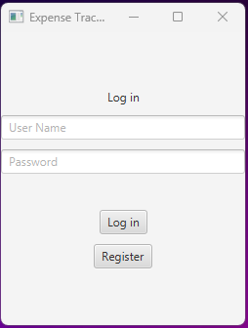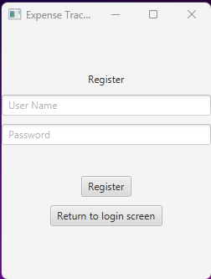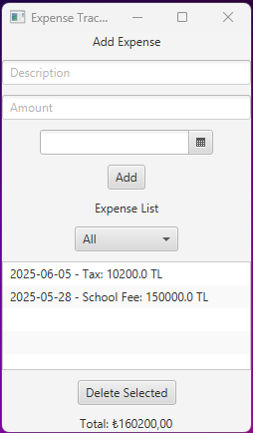

## Installation Instructions

1. Clone the repository from GitHub:  
 `git clone https://github.com/yourusername/ExpenseTrackerProject.git`  
2. Open the project in an IDE supporting JavaFX (e.g., IntelliJ IDEA, Eclipse).  
3. Ensure JavaFX libraries are added to the project dependencies.  
4. Run `MainApp.java` to start the application.  
5. Data files (`users.json`, `username_expenses.json`) will be automatically created in the project directory after first use.

## Feature Implementation Table

|  |  |  |
| --- | --- | --- |
| Feature | Successfully realized (Yes/No) | Source Code File(s) |
| Basic functionality | Yes | MainApp.java, DashboardController.java |
| Authentication | Yes | LoginController.java, RegisterController.java, UserService.java |
| File processing | Yes | FileManager.java, ExpenseService.java |
| Additional feature 1 (Total) | Yes | DashboardController.java, dashboard.fxml |
| Additional feature 2 (Monthly filter) | Yes | DashboardController.java, dashboard.fxml |
| Additional feature 3 (Delete expense) | Yes | DashboardController.java, dashboard.fxml |
| Additional feature 4 (Custom date for expense) | Yes | DashboardController.java, dashboard.fxml |