|  |  |
| --- | --- |
|  | **AIR UNIVERSITY** |
| **DEPARTMENT OF COMPUTER SCIENCE** |
| **LAB MID EXAM** |

**Student Name: Hamza Umer Farooq Reg. No: 200789**

**Subject: Full Stack Web Development Semester: VI**

**ASSESSMENT:**

|  |  |  |  |  |  |
| --- | --- | --- | --- | --- | --- |
| **Attributes** | **Excellent**  **(5)** | **Good**  **(4)** | **Average**  **(3)** | **Satisfactory**  **(2)** | **Unsatisfactory (1)** |
| **Ability to Conduct**  Task |  |  |  |  |  |
| **Ability to assimilate the results** |  |  |  |  |  |
| **Effective use of theorems/postulates/formulas** |  |  |  |  |  |

Total Marks:

Obtained Marks:

**REPORT ASSESSMENT:**

|  |  |  |  |  |  |
| --- | --- | --- | --- | --- | --- |
| **Attributes** | **Excellent**  **(5)** | **Good**  **(4)** | **Average**  **(3)** | **Satisfactory**  **(2)** | **Unsatisfactory**  **(1)** |
| **Data presentation** |  |  |  |  |  |
| **Experimental results** |  |  |  |  |  |
| **Conclusion** |  |  |  |  |  |

Question 1:

HTML:

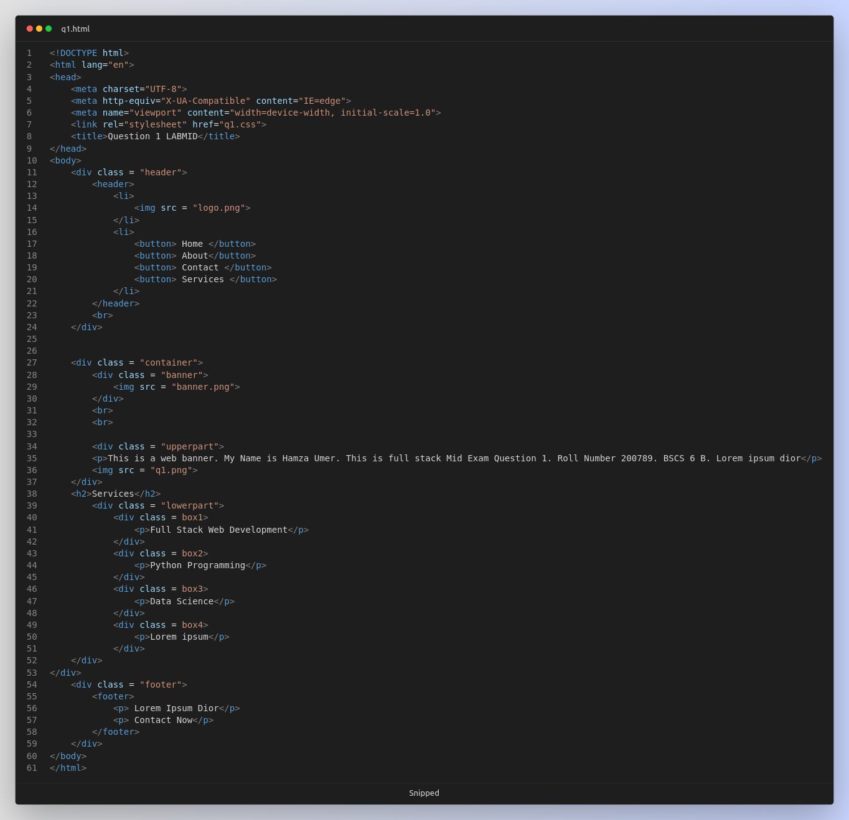

CSS:

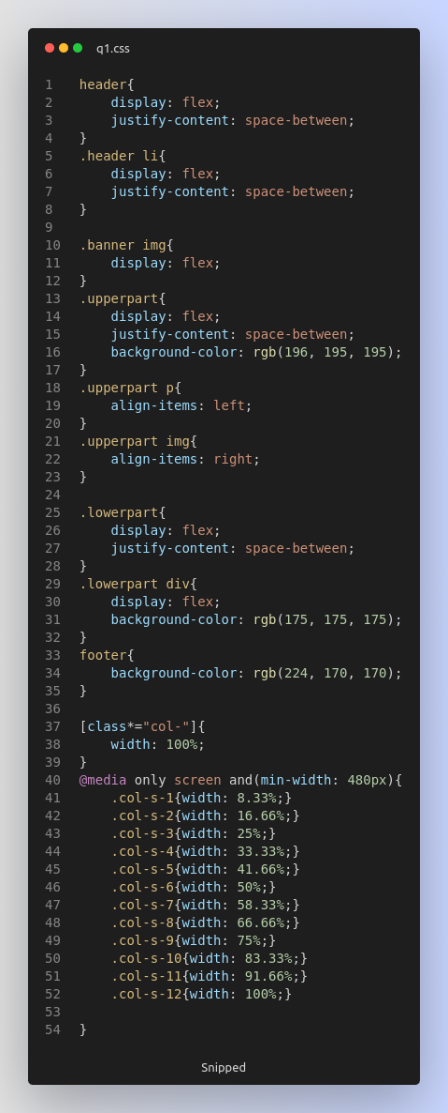

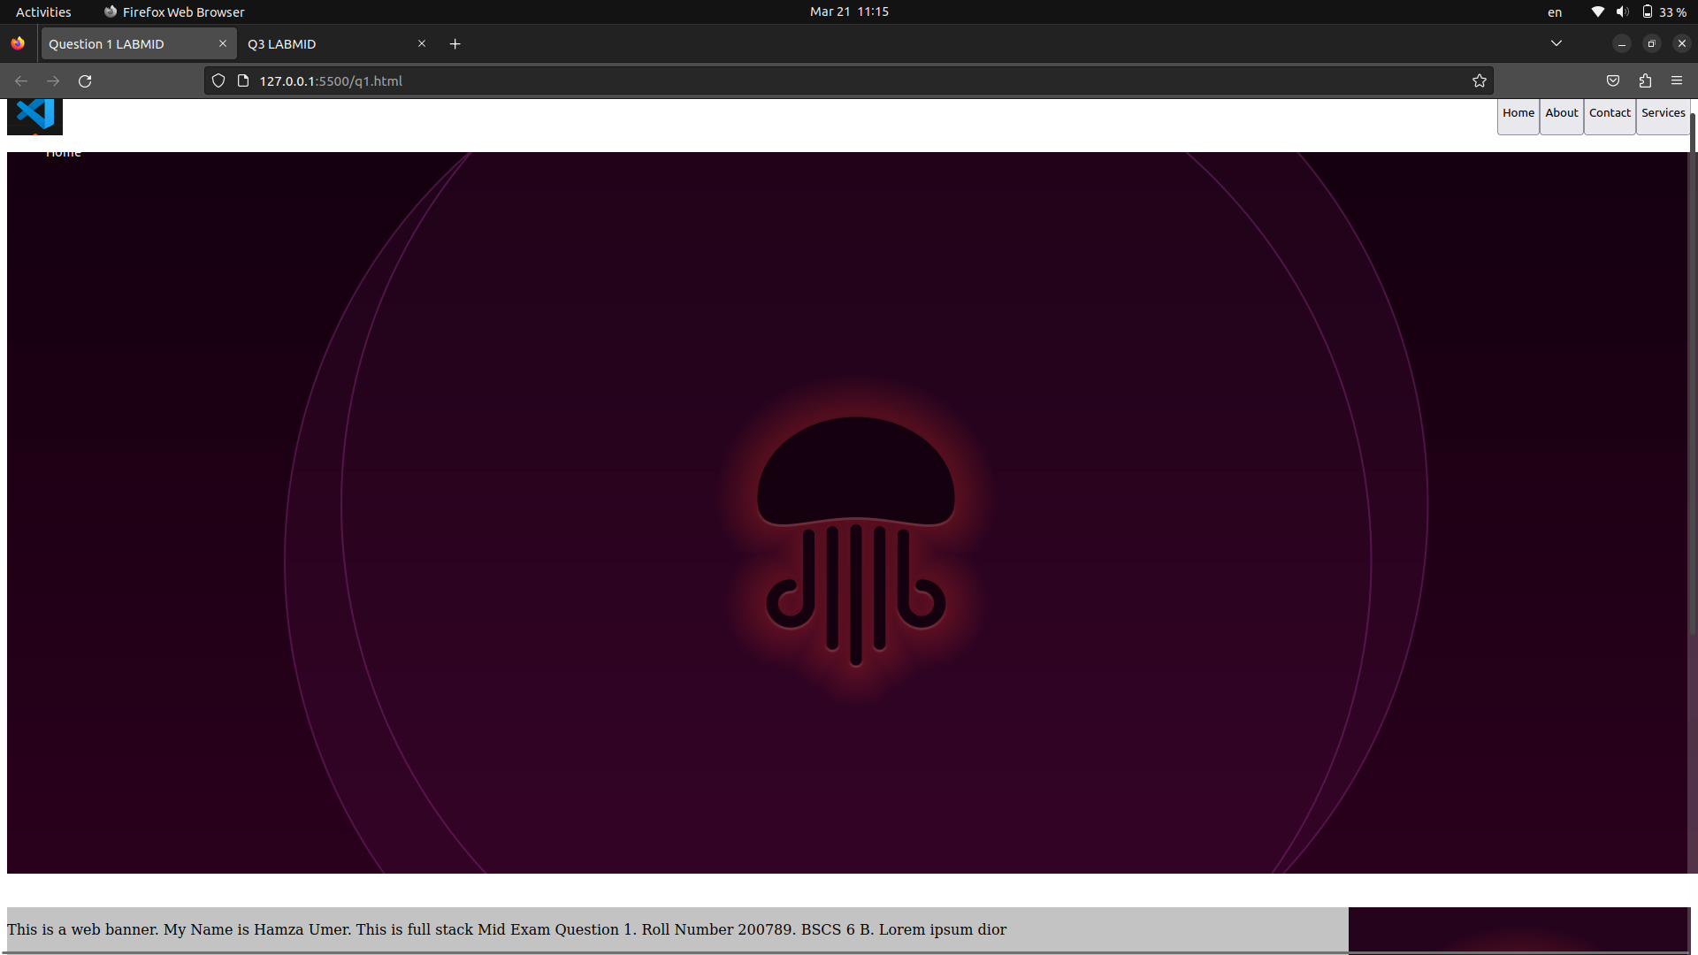OUTPUT:

Question 2:

HTML:

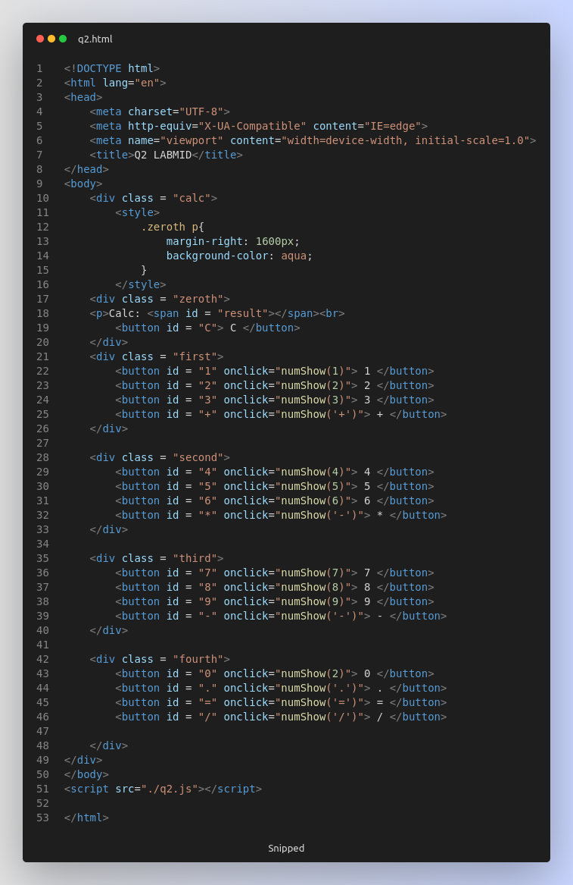

JS:

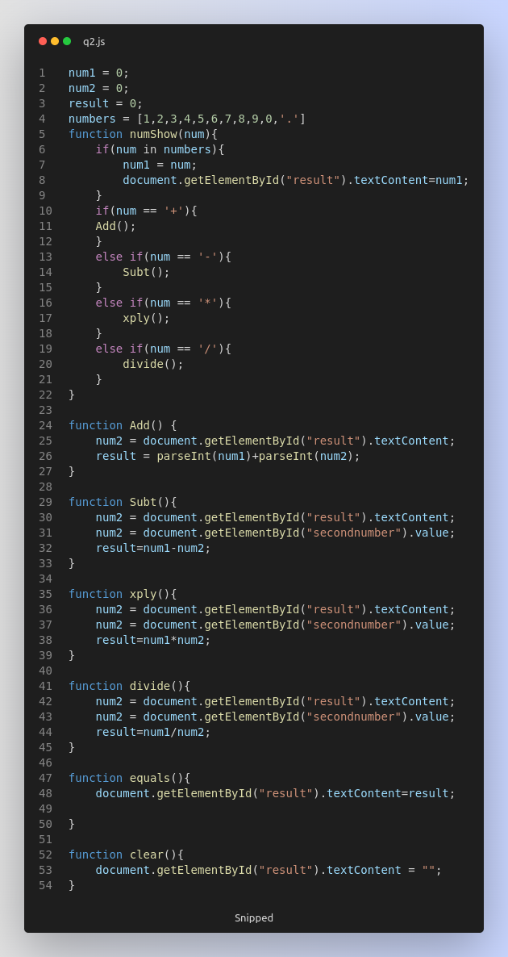

OUTPUT:

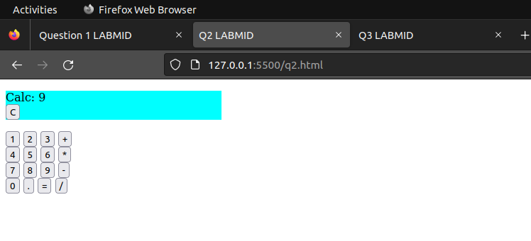

Question 3:

HTML:

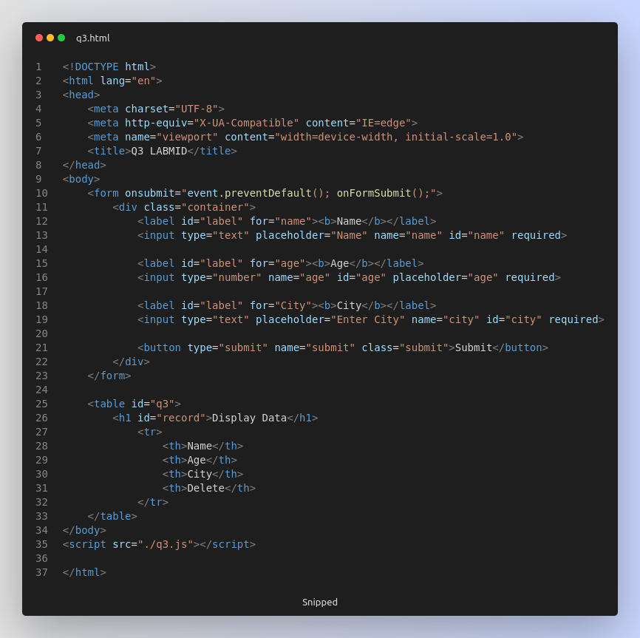

JS:

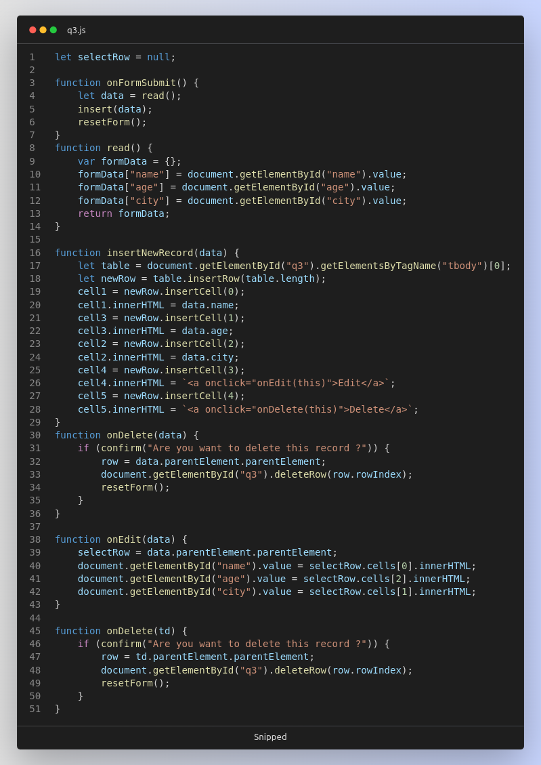

OUTPUT:

