Udacity DSND Dog Breed Classifier-Project
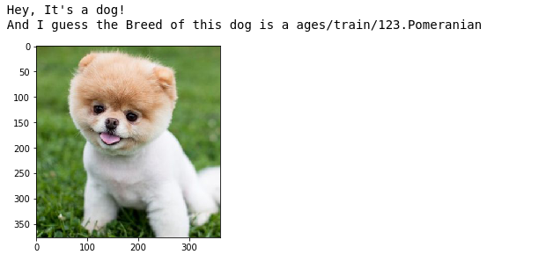

Overview:
This DOG breed classifier project is the part of the udacity Data Science nanodegree program and it is one of the most popular project of udacity

This is the CAPSTONE project that Udacity suggest for the students who confused to select their capstone project which is the final project for graduate from Data Science Nanodegree program .The aim of the project is to create an application that is able to identify a dog breed identify a breed of dog if given a photo or image as input. If the photo or image contains a human face (or alien face), then the application will return the breed of dog that most resembles this person or alien .

The mechanism a deep learning technique is used in this project to classify the breed is Convolutional Neural Network (CNN).

Convolutional Neural Network (CNN):
CNN is the type of Artificial Neural Network which is a machine learning technique used for image classification ,recognition .CNN follows a hierarchical model which works on building a network,and gives an out of fully connected layer with each other .

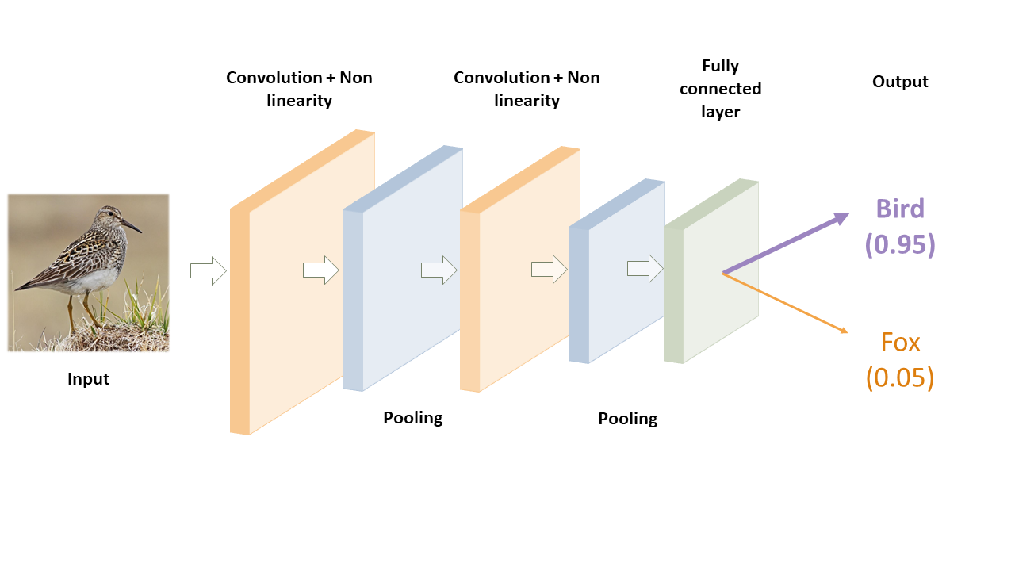
The Jupyter notebook of project comes with some pre-proccessed code provided by Udacity and have some steps to complete the project which is follows:

- Step 0: Import Datasets
- Step 1: Detect Humans
- Step 2: Detect Dogs
- Step 3: Create a CNN to Classify Dog Breeds (from Scratch)
- Step 4: Use a CNN to Classify Dog Breeds (using Transfer Learning)
- Step 5: Create a CNN to Classify Dog Breeds (using Transfer Learning)
- Step 6: Write your Algorithm
- Step 7: Test Your Algorithm

Step 0 : Import Datasets :
In this step we import the dataset and python tensorflow libraries that Udacity provided us .The name of the dataset is ,

- dog images for training the models
- human faces for detector
after importing dataset and libraries we got output .
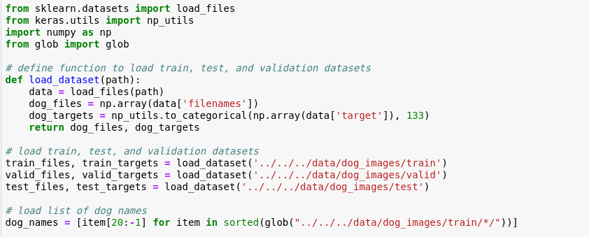
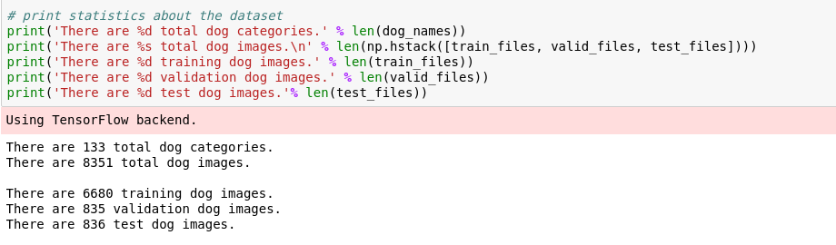

Step1:Detect Human
We use OpenCV's implementation of Haar feature-based cascade classifiers to detect human faces in images. OpenCV provides many pre-trained face detectors, stored as XML files on github.

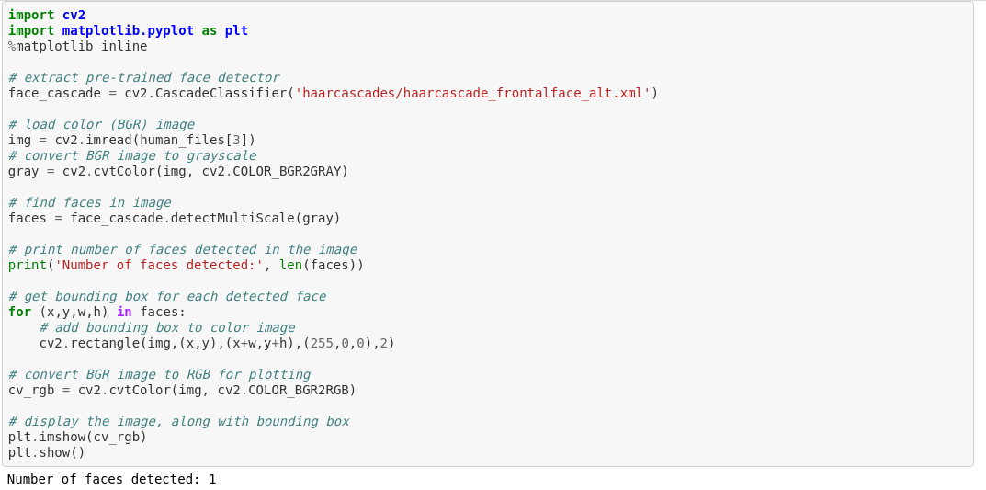

Before using any of the face detectors, it is standard procedure to convert the images to grayscale. The detectMultiScale function executes the classifier stored in face_cascade and takes the grayscale image as a parameter.from the above image of code the

- Number of humans correctly identified: 100
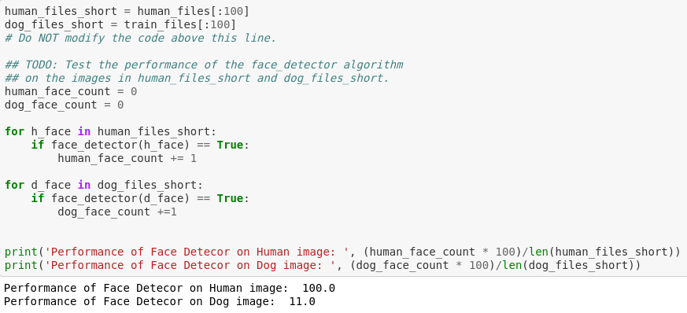
- Number of dogs recognised has humans: 11

The results are not perfect but acceptable.
Step2:Detect Dogs
In this step, we use a pre-trained ResNet-50 model to detect dogs in images. Our first line of code downloads the ResNet-50 model, along with weights that have been trained on ImageNet, a very large, very popular dataset used for image classification and other vision tasks
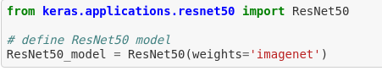

Keras CNNs require a 4D array (which we'll also refer to as a 4D tensor) as input, with shape
(nb_samples,rows,columns,channels),
for keras paths_to_tensor function takes a numpy array of string-valued image paths as input and returns a 4D tensor with shape
(nb_samples,224,224,3).
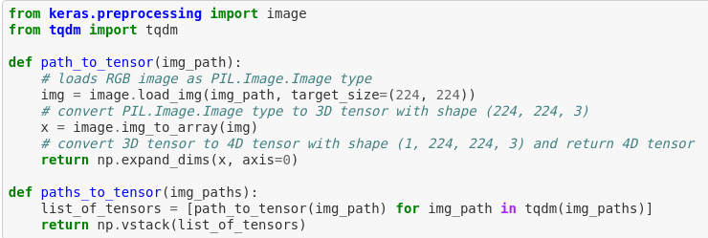
keras has a built in function preprocess_input which takes the output from image processing steps and then reverses the colors to blue green red (RGB to BGR), that is the order keras expects.

Step 3: Create a CNN to Classify Dog Breeds (from Scratch)
So, we have used some pre-defined function to detect human and dogs ,but what should we use for identify or classify the dog breed? Yes, CNN is the best choice to identify or classify the dog and its breed ,it is an interesting step because in this step we used CNN from scratch with some filters below image shows the model we used for ,
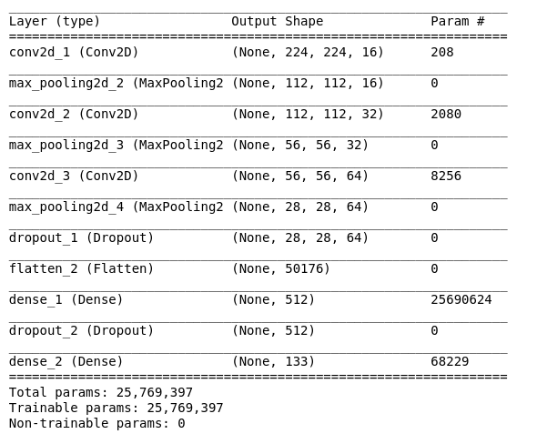
The target was to achieve a CNN with >1% accuracy. The network described above achieved 8.6% without any fine-tuning of parameters and without any augmentation on the data.

Step 4: Use a CNN to Classify Dog Breeds (using Transfer Learning)
In this part of the notebook the most important part to understand is Transfer Learning ,
- “Transfer learning (TL) is a research problem in machine learning (ML) that focuses on storing knowledge gained while solving one problem and applying it to a different but related problem”
In this part transfer learning is the use of bottleneck features.ABottleneck features is the concept of taking a pre-trained model ,The model uses the the pre-trained VGG-16 model as a fixed feature extractor, where the last convolutional output of VGG-16 is fed as input to our model.
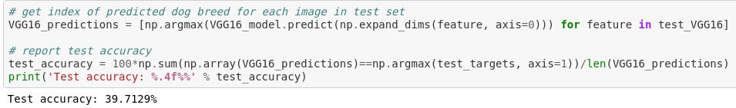
The accuracy of bottlenec_feature of VGG16 is 39.71 % which is better than the accuracy of above model
Step 5: Create a CNN to Classify Dog Breeds (using Transfer Learning)
Ok, so let’s build our model in keras.we used transfer learning to create a CNN using VGG-16 bottleneck features. In this section, we used the bottleneck features from a different pre-trained model have pre-computed the features for all of the networks that are currently available in Keras:
- VGG-19 bottleneck features
- ResNet-50 bottleneck features
- Inception bottleneck features
- Xception bottleneck features
here , I used Inception bottleneck features for classification for which I define the model architecture ,
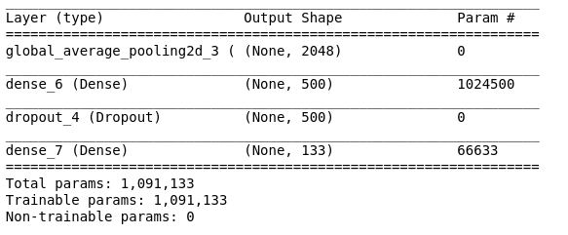
which gives the accuracy of 79.30 % with epoch = 40,
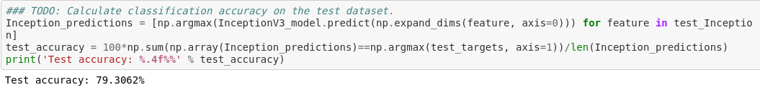
Step 6: Write your Algorithm
in this part we are going to write our algorithm to anlayze image and gives the output as per Udacity’s Instructions that is ,
- if a dog is detected in the image, return the predicted breed.
- if a human is detected in the image, return the resembling dog breed.
- If neither is detected in the image, provide output that indicates an error.
Below image shows the code of our algorithm .
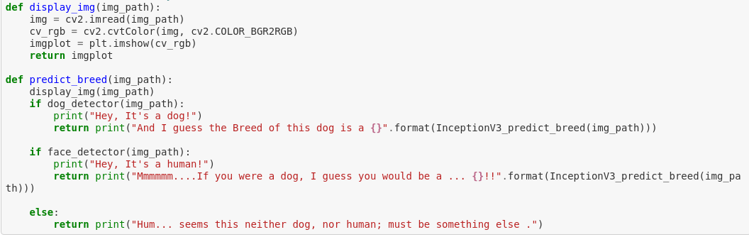

Step 7: Test Your Algorithm
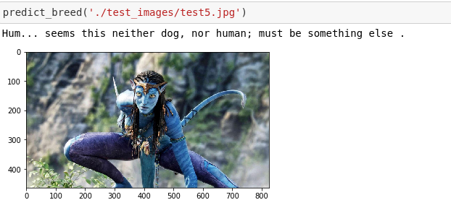
So here is the final step of the project which is testing phase of algorithm which we wrote ,the result of the model gives pretty good output .
Conclusion:
In this project we used image data for classification ,as we used text,numeric data in our DSNS program for classification or regression problem. The problem for which we use the deep learning technique for classification is to identify the dog breed by analyzing the image .we used different libraries for learning ,collecting and for accuracy .In Data Science projects we were used sklearn library for machine learning algorithm ,but here we used keras and openCV library for images ,here we build our own CNN for classify the breed and got the accuracy of 79% on a bottleneck_features InceptionV3 data

Refrences:

Udacity Dog Breed Classifier — Project Walkthrough by Paul Stancliffe

- Udacity Dog Breed Classifier Notebook

Project-Notebook :

