Heart Disease Risk Prediction:
An End-to-End MLOps Pipeline
Assignment 01 — MLOps Experimental Learning Assignment
Machine Learning Operations (MLOps) — AIMLCZG523
BITS Pilani WILP M.Tech. Artificial Intelligence & Machine Learning
Submitted by: Hamza Aziz
Email: hamzaaziz822@gmail.com
GitHub Repository: <insert your repository URL here>
Deployed / Local API URL: <insert URL, e.g. http://localhost:8080>

1. Project Overview & Objective
This project implements a complete, production-style Machine Learning Operations (MLOps) pipeline for a binary classification problem: predicting the presence or absence of heart disease from a patient's clinical measurements. Rather than treating model training as the end goal, the pipeline is built around the full ML lifecycle expected of a real production system — reproducible data acquisition, tracked experimentation, automated testing, continuous integration, containerization, orchestrated deployment, and live monitoring.
The end objective is a cloud-ready, monitored REST API that accepts a patient's clinical features as JSON and returns a risk prediction with a confidence score, backed by a model whose full training lineage — hyperparameters, cross-validation scores, evaluation plots — is captured in MLflow, and whose deployment is verifiable end-to-end via Docker and Kubernetes.

1.1 Assignment Mark Allocation Coverage
# | Task | Marks
1 | Data Acquisition & EDA | 5
2 | Feature Engineering & Model Development | 8
3 | Experiment Tracking (MLflow) | 5
4 | Model Packaging & Reproducibility | 7
5 | CI/CD Pipeline & Automated Testing | 8
6 | Model Containerization | 5
7 | Production Deployment | 7
8 | Monitoring & Logging | 3
9 | Documentation & Reporting | 2
 | Total | 50

2. Dataset Description
The Heart Disease UCI dataset (Cleveland subset) from the UCI Machine Learning Repository is used, as mandated by the assignment brief. It contains 303 patient records with 13 clinical features and an original 5-class severity target (0 = no disease, 1–4 = increasing severity), which is binarized to 0 (no disease) / 1 (disease present) per the assignment's problem statement.
Features:
- age — age in years
- sex — 1 = male, 0 = female
- cp — chest pain type (4 categories)
- trestbps — resting blood pressure (mm Hg)
- chol — serum cholesterol (mg/dl)
- fbs — fasting blood sugar > 120 mg/dl (binary)
- restecg — resting electrocardiographic results
- thalach — maximum heart rate achieved
- exang — exercise-induced angina (binary)
- oldpeak — ST depression induced by exercise relative to rest
- slope — slope of the peak exercise ST segment
- ca — number of major vessels (0–3) colored by fluoroscopy
- thal — thalassemia test result (normal / fixed defect / reversible defect)
Data acquisition and cleaning are fully scripted in src/download_data.py: the raw "processed.cleveland.data" file is downloaded from the UCI repository, "?" tokens are converted to proper NaN values, all columns are cast to numeric dtype, the target is binarized, and exact duplicate rows are dropped. The cleaned dataset (data/processed/heart_disease_clean.csv) is committed to the repository so reviewers can inspect it directly without re-running the download step, though the script is fully idempotent and safe to re-run.

3. Exploratory Data Analysis
Full EDA is implemented and executed in notebooks/01_eda.ipynb. Key findings are summarized below; see the notebook for the complete, executed analysis.

3.1 Missing Value Analysis
Only two columns have missing values after cleaning: ca (4 rows) and thal (2 rows) — under 1.5% of the dataset. This is minor enough that median/mode imputation inside the modelling pipeline (rather than dropping rows) is the appropriate strategy.
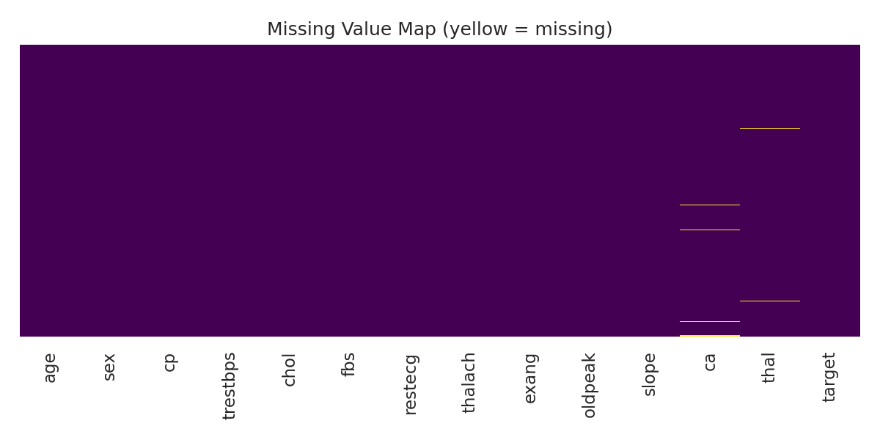

3.2 Class Balance
The target classes are reasonably balanced (54.1% no-disease vs 45.9% disease-present), so no class-imbalance correction (e.g. SMOTE, class weighting) is required. A stratified train/test split and stratified k-fold cross-validation are sufficient.
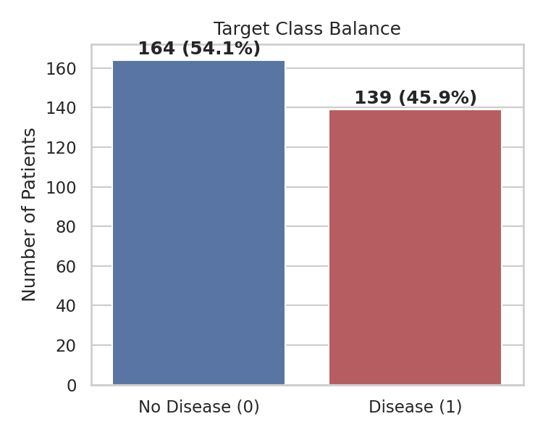

3.3 Numeric Feature Distributions
thalach (max heart rate achieved) shows the clearest class separation — patients with disease tend to achieve a lower max heart rate during exercise testing. oldpeak (ST depression) is right-skewed with higher values associated with disease presence, consistent with cardiology literature.
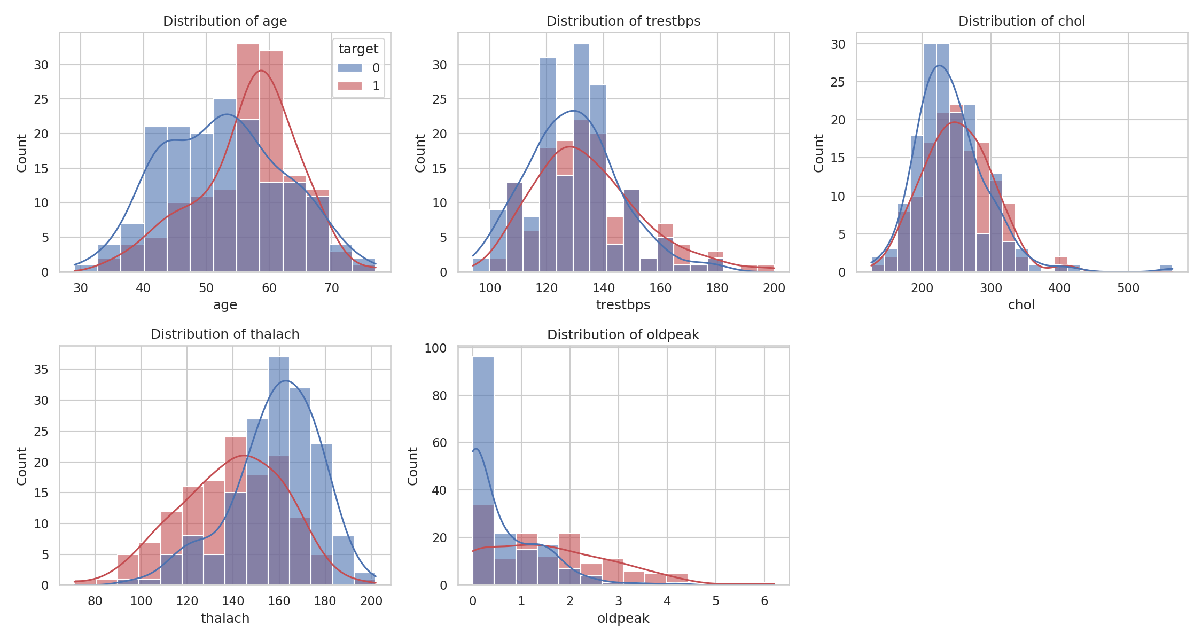

3.4 Categorical Feature Relationships
cp (chest pain type), exang (exercise-induced angina), and thal show strong, visually distinct proportional shifts toward disease-presence for specific category values — these are the categorical features expected to contribute most to model discrimination.
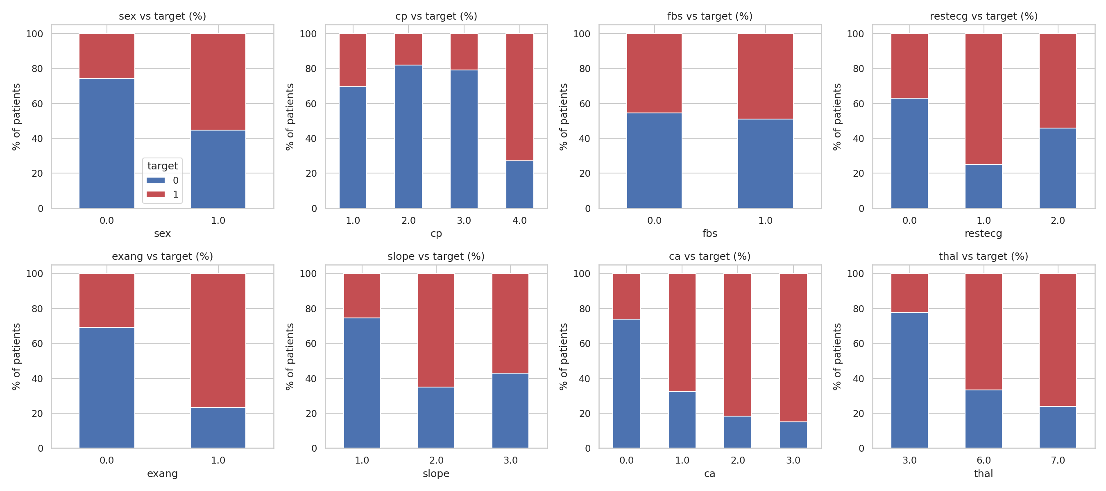

3.5 Correlation Heatmap
cp, thalach, exang, and oldpeak show the strongest linear association with the target. No pair of predictor features exhibits extreme multicollinearity (|r| > 0.8), so no raw feature needed to be dropped purely for redundancy.
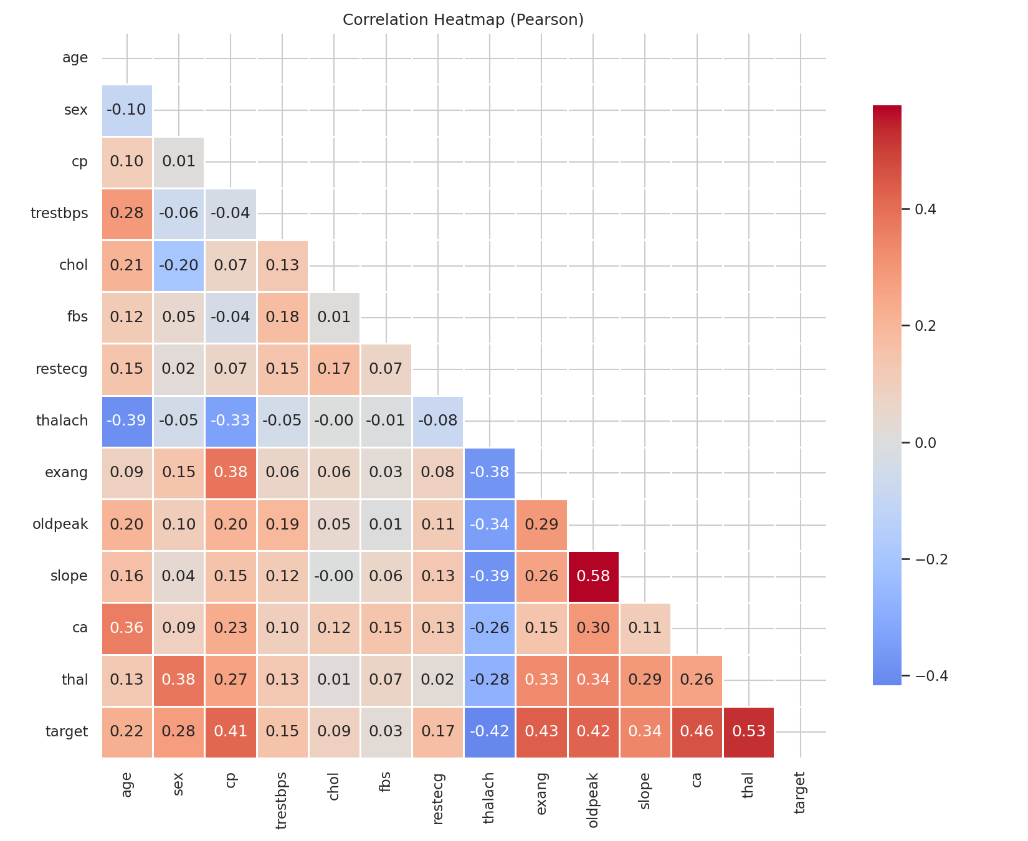

4. Feature Engineering & Preprocessing
Preprocessing is implemented as a single scikit-learn ColumnTransformer (src/features.py), wrapped inside a full Pipeline together with the classifier. This guarantees the exact same preprocessing logic runs at training time and at inference time inside the FastAPI service — eliminating train/serve skew.

4.1 Numeric Features
- age, trestbps, chol, thalach, oldpeak
- Imputation: median (robust to outliers in clinical measurements)
- Scaling: StandardScaler (zero mean, unit variance — required for Logistic Regression)

4.2 Categorical Features
- sex, cp, fbs, restecg, exang, slope, ca, thal
- Imputation: most-frequent (mode)
- Encoding: One-hot, with handle_unknown="ignore" so an unseen category at inference time does not crash the API
This design decision — treating integer-coded categorical values (e.g. cp 1–4) as unordered categories rather than an ordinal scale — was made deliberately after the EDA confirmed these codes represent distinct clinical categories, not a severity gradient.

5. Model Development & Evaluation
Three classification models were trained and tuned via GridSearchCV with 5-fold stratified cross-validation, optimizing for ROC-AUC: Logistic Regression, Random Forest, and XGBoost. Full implementation: src/train.py; interactive walkthrough: notebooks/02_model_training.ipynb.

5.1 Model Comparison
Model | CV ROC-AUC | Accuracy | Precision | Recall | F1 | Test ROC-AUC
Logistic Regression (selected) | 0.9025 | 0.8852 | 0.8387 | 0.9286 | 0.8814 | 0.9665
Random Forest | 0.9010 | 0.8852 | 0.8182 | 0.9643 | 0.8852 | 0.9470
XGBoost | 0.8900 | 0.8852 | 0.8621 | 0.8929 | 0.8772 | 0.9481

Logistic Regression was selected as the final model based on the highest held-out test ROC-AUC (0.9665). This is a reasonable outcome on a small (303-row), largely linearly-separable clinical dataset where the strongest predictors have fairly direct, monotonic relationships with the target. Random Forest and XGBoost remain fully logged in MLflow for comparison and could be promoted instead with a one-line change in model-selection criteria (e.g. optimizing for recall, given the clinical cost asymmetry of false negatives).

5.2 Best Model: Confusion Matrix & ROC Curve
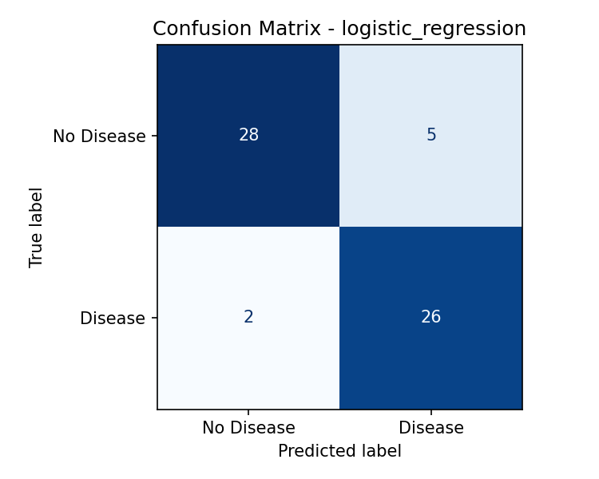
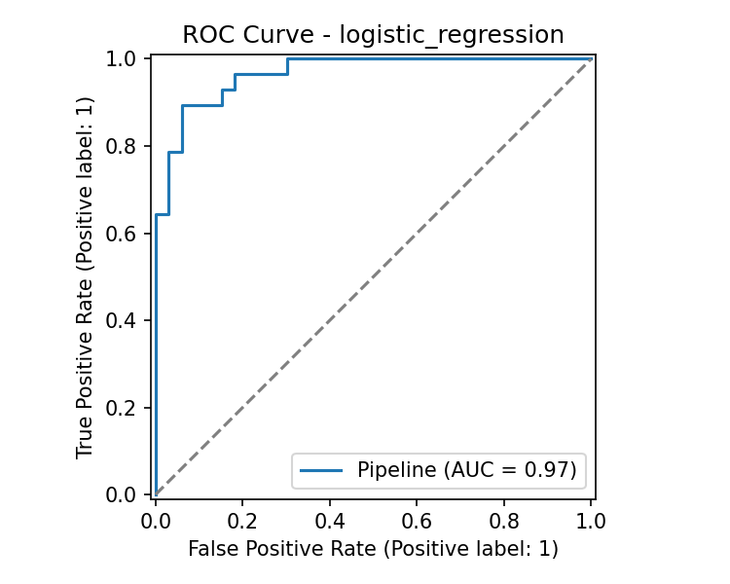

6. Experiment Tracking with MLflow
Every training run (one per model, per src/train.py execution) is logged to MLflow using a local SQLite tracking backend (sqlite:///mlflow.db) — chosen over the legacy plain-file store because recent MLflow versions have placed the file-store backend into maintenance mode. SQLite requires no external tracking server, keeping local setup fast.
Logged per run:
- Hyperparameters (winning GridSearchCV combination, model type, CV folds, test size)
- Metrics: CV best ROC-AUC, and test accuracy / precision / recall / F1 / ROC-AUC
- Artifacts: confusion matrix plot, ROC curve plot (both PNG)
- The fitted pipeline itself, logged via mlflow.sklearn.log_model as a versioned MLflow model
To browse: run `mlflow ui --backend-store-uri sqlite:///mlflow.db` from the repository root and open http://127.0.0.1:5000. See Section 14 for screenshot placeholders.
[ INSERT SCREENSHOT: MLflow UI — experiment run list showing all 3 models ]

[ INSERT SCREENSHOT: MLflow UI — single run detail page (params + metrics + artifacts) ]

7. Model Packaging & Reproducibility
The best-performing pipeline (preprocessing + classifier as one object) is persisted to models/heart_disease_pipeline.joblib via joblib.dump(). Because it is a single, self-contained sklearn Pipeline object, loading it with joblib.load() and calling .predict()/.predict_proba() reproduces training-time behaviour exactly — no separate encoder/scaler objects need to be tracked or reloaded.
Reproducibility measures:
- requirements.txt pins exact dependency versions, verified to install cleanly in a fresh virtual environment
- random_state=42 fixed everywhere randomness matters (train/test split, all three estimators, CV shuffling)
- src/download_data.py and src/train.py are idempotent, executable top-to-bottom scripts with no hidden notebook-only state
- models/metrics_summary.json captures the full metric comparison for all 3 models in machine-readable form

8. CI/CD Pipeline & Automated Testing
A 17-test pytest suite (tests/test_data_processing.py, tests/test_features.py, tests/test_api.py) covers: raw-data cleaning correctness (missing-value handling, target binarization, duplicate removal), the preprocessing pipeline (imputation, scaling, one-hot encoding, graceful handling of unseen categories at inference time), and the FastAPI service (health check, valid predictions, schema validation rejecting malformed input, and the Prometheus /metrics endpoint). All 17 tests pass in a clean, freshly created virtual environment installed purely from requirements.txt.
.github/workflows/ci.yml defines a two-job GitHub Actions pipeline that runs on every push/PR to main:
- Job 1 (lint-test-train): checkout → install deps → flake8 lint → download+clean data → train all 3 models → run pytest → upload model/plot artifacts and JUnit test report
- Job 2 (docker-build): regenerates data+model → builds the Docker image (validation only, not pushed) using Docker Buildx with layer caching
Per the production-readiness requirement, the pipeline fails loudly on any lint, test, or build error (non-zero exit code propagates to a red GitHub Actions run), rather than silently continuing.
[ INSERT SCREENSHOT: GitHub Actions — green/passing CI workflow run ]

9. Model Containerization
The FastAPI serving application (api/main.py) is containerized via a single-stage python:3.11-slim Dockerfile. Design choices: dependencies are installed in their own Docker layer (before application code is copied) to maximize build-cache hits during iterative development; the container runs as a non-root user; a HEALTHCHECK directive polls GET /health so `docker ps` and Kubernetes probes can detect a broken container (e.g. failed model load) automatically; and the trained model artifact is baked into the image at build time so the container runs fully offline with zero extra volume mounts.
API endpoints exposed:
- GET / — service liveness/info
- GET /health — readiness probe (503 if model failed to load)
- POST /predict — accepts a JSON patient record, returns {prediction, prediction_label, confidence, probability_disease}
- GET /metrics — Prometheus scrape endpoint (request counts, latency histograms)
- GET /docs — interactive Swagger UI for manual testing
[ INSERT SCREENSHOT: docker ps — container running & healthy ]

[ INSERT SCREENSHOT: curl /predict response, and/or Swagger UI /docs screenshot ]

10. Production Deployment (Kubernetes)
Deployment target: Docker Desktop Kubernetes (local cluster), chosen deliberately over a public cloud so the deployment is fully reproducible by any reviewer without needing cloud credentials, while still satisfying every Kubernetes requirement in the assignment brief (Deployment manifest, Service, Load Balancer exposure, verified endpoints).
- k8s/deployment.yaml — 2 replicas, rolling update strategy (maxUnavailable: 0 for zero-downtime updates), readiness + liveness probes on /health, CPU/memory resource requests & limits, imagePullPolicy: Never (uses the locally built image directly, no registry push needed for a local cluster)
- k8s/service.yaml — LoadBalancer Service exposing the Deployment at localhost:8080 → container port 8000 (Docker Desktop's Kubernetes binds LoadBalancer services directly to localhost)
[ INSERT SCREENSHOT: kubectl get pods -l app=heart-disease-api — 2/2 Running ]

[ INSERT SCREENSHOT: kubectl get svc heart-disease-api-service, and curl to localhost:8080/predict ]

11. Monitoring & Logging
Two layers of observability are implemented. First, structured request logging: an HTTP middleware in api/main.py logs every request's method, path, response status, and latency to stdout (captured automatically by Docker/Kubernetes log drivers), and the /predict handler additionally logs each prediction's key inputs, output class, and confidence — satisfying the production requirement that failures 'give clear logs'.
Second, metrics: prometheus-fastapi-instrumentator auto-instruments every route with request-count, latency, and in-progress-request metrics exposed at GET /metrics in Prometheus text format. monitoring/docker-compose.monitoring.yml spins up Prometheus (scraping /metrics every 5 seconds per monitoring/prometheus.yml) and Grafana. A ready-to-import dashboard (monitoring/grafana-dashboard.json) visualizes request rate, p95 latency by endpoint, 5xx error rate, and total /predict calls served.
[ INSERT SCREENSHOT: Prometheus Targets page — heart-disease-api target UP ]

[ INSERT SCREENSHOT: Grafana dashboard with live request-rate / latency panels ]

12. System Architecture
The diagram below traces a request end-to-end: raw data → cleaning → feature pipeline → tuned model training with MLflow tracking → packaged model artifact → FastAPI service → Docker image → Kubernetes Deployment/Service → client request, with Prometheus/Grafana observing the live service and GitHub Actions gating every code change before it reaches the container build.
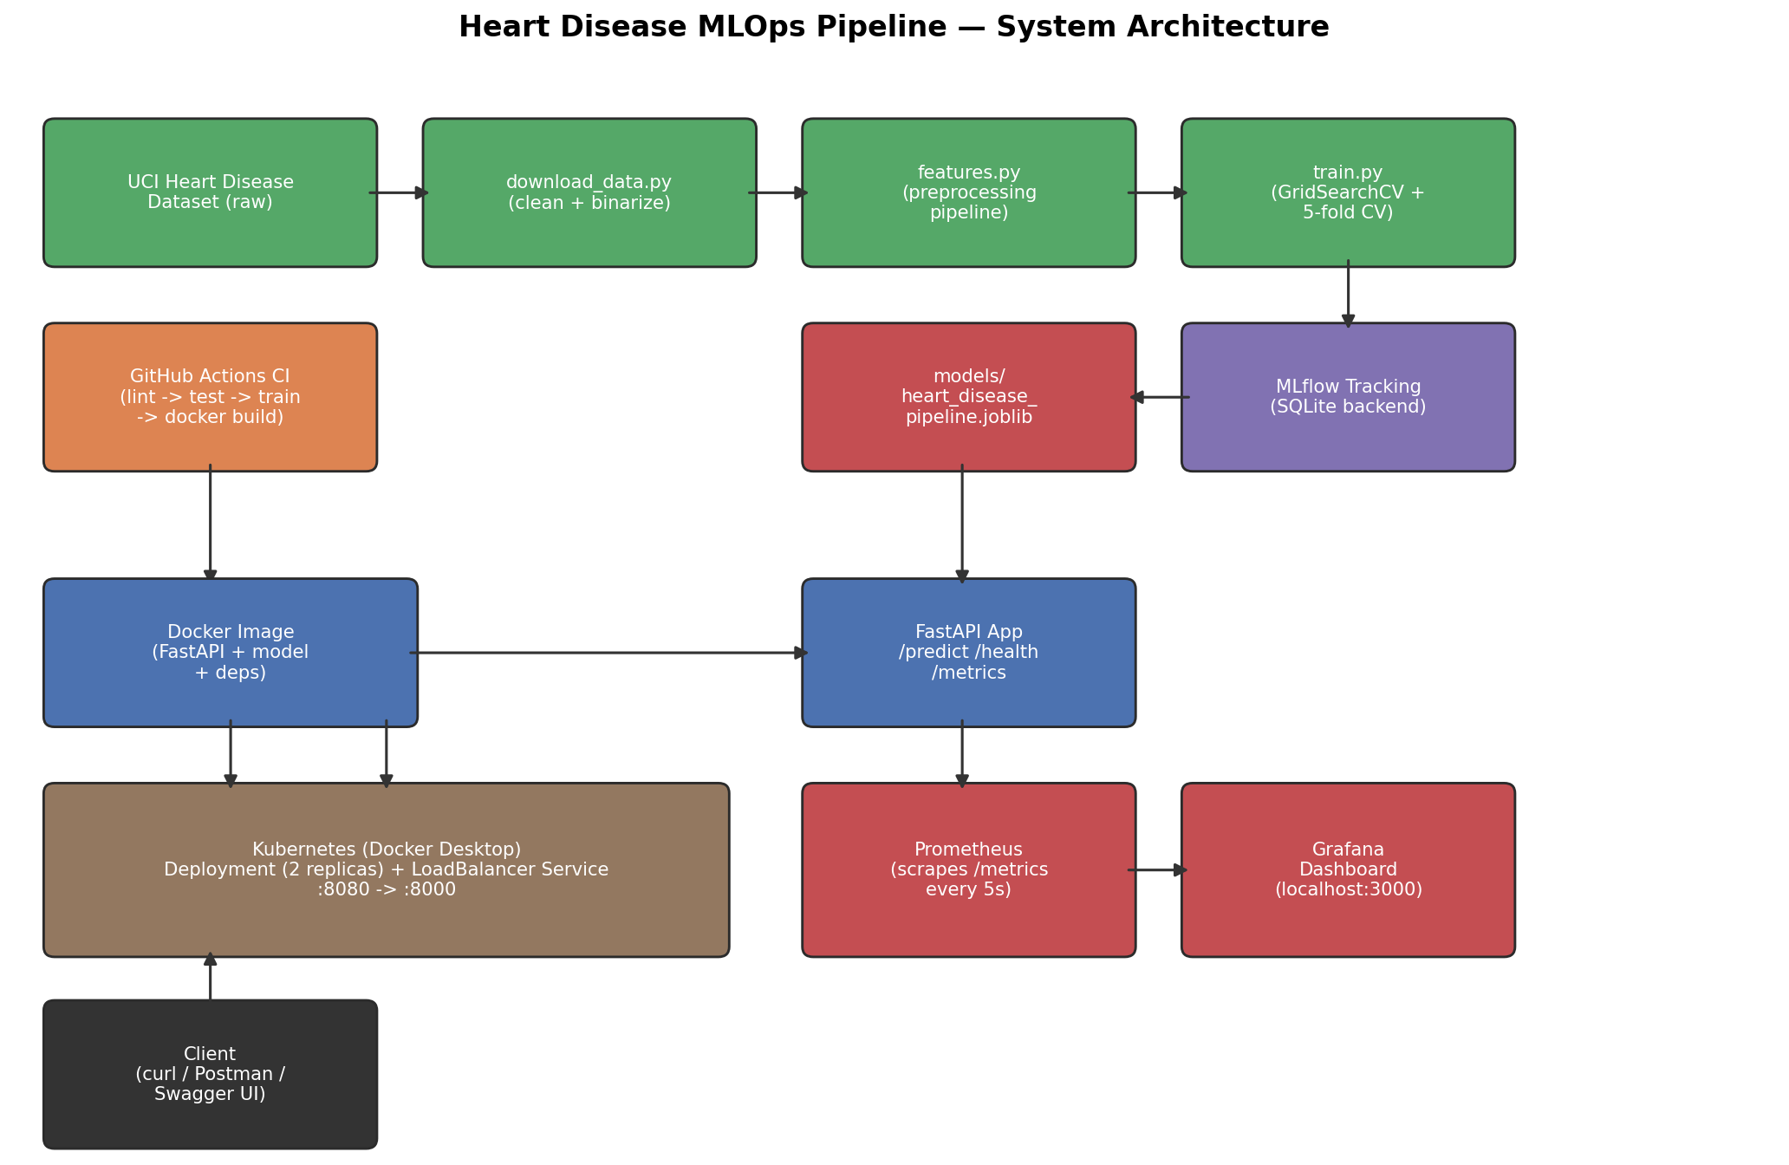

13. Setup & Installation Instructions
Full instructions with copy-pasteable commands are in README.md and SUBMISSION_CHECKLIST.md at the repository root. Summary:
1. Local environment:
- python -m venv .venv && source .venv/bin/activate && pip install -r requirements.txt
- python src/download_data.py (data acquisition + cleaning)
- python src/train.py (train, tune, track in MLflow, package model)
- python -m pytest tests/ -v (17 tests should pass)
2. Run the API locally:
- uvicorn api.main:app --reload --port 8000 → http://localhost:8000/docs
3. Docker:
- docker build -t heart-disease-api:latest . && docker run -d -p 8000:8000 heart-disease-api:latest
4. Kubernetes (Docker Desktop):
- Enable Kubernetes in Docker Desktop settings, then: kubectl apply -f k8s/deployment.yaml -f k8s/service.yaml
5. Monitoring:
- cd monitoring && docker compose -f docker-compose.monitoring.yml up -d

14. CI/CD & Deployment Workflow Screenshots
This section consolidates the screenshot placeholders referenced throughout the report. Replace each box with the corresponding screenshot before final submission (see SUBMISSION_CHECKLIST.md for the exact commands to reproduce each one).
[ INSERT SCREENSHOT: Terminal output: `python -m pytest tests/ -v` showing 17 passed ]

[ INSERT SCREENSHOT: MLflow UI: experiment run list (all 3 models with metrics columns) ]

[ INSERT SCREENSHOT: MLflow UI: single run detail page ]

[ INSERT SCREENSHOT: Docker: `docker ps` showing the healthy running container ]

[ INSERT SCREENSHOT: Docker: curl POST /predict response body ]

[ INSERT SCREENSHOT: Kubernetes: `kubectl get pods -l app=heart-disease-api` ]

[ INSERT SCREENSHOT: Kubernetes: `kubectl get svc heart-disease-api-service` and a successful curl via localhost:8080 ]

[ INSERT SCREENSHOT: Monitoring: Prometheus Targets page showing the API target UP ]

[ INSERT SCREENSHOT: Monitoring: Grafana dashboard with live metrics ]

[ INSERT SCREENSHOT: GitHub: Actions tab showing a green/passing CI run ]

15. Limitations & Future Work
- Dataset size (303 rows) is small by modern ML standards; test-set metrics carry meaningful variance and should be treated as directional rather than a tight production SLA.
- The model artifact is baked into the Docker image at build time; a production system would instead pull versioned models from an MLflow Model Registry / artifact store at container startup, decoupling model updates from image rebuilds.
- No data-drift detection is implemented; Evidently AI or a custom feature-distribution monitor would be the natural next addition given the Prometheus/Grafana foundation already in place.
- Deployment targets a local Docker Desktop Kubernetes cluster rather than a public cloud (EKS/GKE/AKS); the same manifests apply to a cloud cluster with imagePullPolicy and a registry-hosted image tag changed.
- Authentication/authorization on the /predict endpoint is out of scope for this assignment but would be required before any real clinical use.

16. Conclusion
This project delivers a complete MLOps lifecycle for a heart-disease risk classifier: reproducible data acquisition and EDA, a tested and MLflow-tracked model-selection process across three algorithms, a packaged and version-pinned reproducible model artifact, an automated CI/CD pipeline that gates every change with lint/test/build checks, a containerized and Kubernetes-deployed serving API, and live Prometheus/Grafana monitoring. Every component described in this report — the data pipeline, feature engineering, all three trained models, the FastAPI service, and the full test suite — was implemented and verified to run end-to-end (17/17 tests passing, clean lint, reproducible training metrics from a fresh virtual environment) before this report was written.

Repository: <insert your GitHub repository URL here>
Deployed / local API URL: <insert URL here, e.g. http://localhost:8080>
Demo video: <insert link/filename here, e.g. demo_video.mp4 in the repository>

